1. Which of the following is present in members of the Prokaryotes?

A. Nuclear envelope
B. Chloroplast
C. Ribosomes
D. Plasmodesmata
E. Cilia

2. The most prominent organelle within most eukaryotic cells is the ______, and the largest structure within this organelle is the ______ .

A. cytosol ; ribosome
B. chloroplast ; thylakoid membrane
C. mitochondria ; cristae
D. endoplasmic reticulum ; vesicle
E. nucleus ; nucleolus

3. You isolate a membrane bound organelle containing hydrolytic enzymes. It is most likely a

A. chloroplast.
B. vacuole.
C. nucleolus.
D. lysosome.
E. ribosome.

4. Thylakoid membranes and the stroma are all components found in

A. vacuoles.
B. chloroplasts.
C. mitochondria.
D. lysosomes.
E. nuclei.

5. The membrane that surrounds the large central vacuole in some plant cells is termed the

A. tonoplast.
B. nucleoid.
C. pilus.
D. ER.
E. planaria.

6. From the information below, determine the length of the specimen in mm.

Ocular lens = 10x
Objective lens = 10x
1 stage division = 10µm
Diameter of the field = 3.5mm
Length of the specimen = 25 ocular divisions
25 ocular division = 20 stage divisions

A. 1.6
B. 2.0
C. 3.5
D. 0.16
E. 0.20

7. Which of the following is probably the most common route for membrane flow in the endomembrane system?

A. Golgi lysosome rough ER plasma membrane
B. tonoplast plasma membrane nuclear membrane smooth ER
C. nuclear membrane lysosome Golgi apparatus plasma membrane
D. rough ER vesicles Golgi apparatus plasma membrane
E. smooth ER chloroplasts mitochondrion plasma membrane

8. Which of the following cell structures would most likely be visible with a light microscope that had been manufactured to the maximum resolving power possible?

A. chloroplast
B. microtubule
C. ribosome
D. pili
E. nuclear pore

9. Which of the following contain the 9 + 2 arrangement of microtubules?

A. cilia
B. centrioles
C. pili
D. muscle fibres
E. anchoring junctions

10. The primary objective of cell fractionation is

A. to view the structure of cell membranes.
B. to identify the enzymes outside the organelles.
C. to determine the size of various organelles.
D. to separate the major organelles so their particular functions can be determined.
E. to crack the cell wall so the cytoplasmic contents can be released.

11. Small molecules can travel directly from the cytoplasm of one animal cell to the cytoplasm of an adjacent cell through

A. plasmodesmata.
B. tight junctions.
C. anchoring junctions.
D. gap junctions.
E. flagella.

12. Under which of the following conditions would you expect to find a cell with a predominance of free (non ER bound) ribosomes?

A. A cell that is secreting proteins.
B. A cell that is producing cytoplasmic enzymes.
C. A cell that is enlarging its plasma membrane.
D. A cell that is digesting food particles.
E. A cell that is enlarging its vacuole.

13. Which of the following statements about cell division is false?

A. Mitosis produces new nuclei with exactly the same chromosomal endowment as the parent nucleus.
B. Mitosis may occur without cytokinesis.
C. Mitosis is used by some organisms for asexual reproduction.
D. All cells come from a preexisting cell.
E. The mitotic spindles in prokaryotic cells are composed of microfilaments.

14. What is the name for the special region on a duplicated chromosome that holds the sister chromatids together?

A. centrosome
B. centromere
C. kinetochore
D. chromatin
E. desmosomes

15. During which phase(s) of mitosis do we find chromosomes composed of two chromatids?

A. from interphase through anaphase
B. from G1 of interphase through metaphase
C. from metaphase through telophase
D. from anaphase through telophase
E. from G2 of interphase through metaphase

16. The correct sequence of steps in the M (Mitosis) phase of the cell cycle is

A. prophase, prometaphase, metaphase, anaphase, telophase.
B. prophase, metaphase, prometaphase, anaphase, telophase.
C. prophase, prometaphase, anaphase, metaphase, telophase.
D. prometaphase, prophase, anaphase, metaphase, telophase.
E. anaphase, telophase, metaphase, prometaphase, prophase.

17. A particular cell has half as much DNA (by weight in grams) as some of the other cells in a mitotically active tissue. The cell in question is most likely in

A. G₁
B. G₂
C. prophase
D. metaphase
E. S

18. Cells (such as nerve cells for example) that are in a nondividing stage are in which phase?

A. G₀
B. G₂
C. G₁
D. S
E. M

Use the following diagram of the cell cycle to answer Questions 19, 20 and 21.
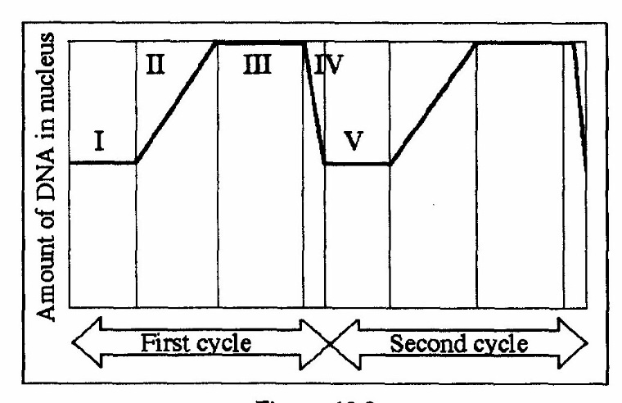

19. In the figure, mitosis is represented by which Roman numeral?

A. I
B. II
C. III
D. IV
E. V

20. Which Roman numeral represents G₁?

A. I and V
B. II and IV
C. III
D. IV
E. V

21. Which Roman numeral represents DNA synthesis?

A. I
B. II
C. III
D. IV
E. V

22. If both parents are carriers of a lethal autosomal recessive gene, the probability that their child will inherit and express the disorder is

A. 1/8
B. 1/4
C. 1/2
D. 1/2 x 1/2 x 1/4 = 1/16
E. 2/3 x 2/3 x 1/4 = 1/9

23. Eukaryotic sexual life cycles show tremendous variation. Which of the following elements do all sexual life cycles have in common?

I alternation of generations
II meiosis
III fertilization
IV gametes
V spores

A. I, IV and V
B. I, II and IV
C. II, III, and IV
D. II, IV and V
E. All of the above.

For Questions 24 and 25, match the key event of meiosis with the stages listed below.

1. prophase I 5. prophase II
2. metaphase I 6. metaphase II
3. anaphase I 7. anaphase II
4. telophaseI 8. telophase II

24. Tetrads of chromosomes are aligned at the centre of the cell; independent assortment soon follows.

A. 1
B. 2
C. 3
D. 4
E. 5

25. Synapsis of homologous pairs occurs; crossing over may occur.

A. 1
B. 2
C. 4
D. 6
E. 7

26. The number of human chromosomes in a cell in prophase I of meiosis is ___ and in telophase II is ___ .

A. 92 : 46
B. 46 : 23
C. 23 : 23
D. 23 : 16
E. 46 : 46

27. A 1 : 1 phenotypic ratio in a testcross indicates that

A. the alleles are dominant.
B. one parent must have been homozygous dominant.
C. the dominant phenotype parent was a heterozygote.
D. the alleles show incomplete dominance.
E. the alleles are codominant.

28. Meiosis of a cell containing the chromosomes illustrated below (at the end of metaphase) would most likely produce a sperm cell with the genetic combination

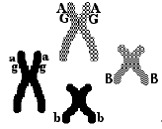

A. AaGgBb
B. AgB
C. AGBb
D. AGb
E. AG

29. In the diagram above in Question 28 how many loci are indicated?

A. 2
B. 3
C. 4
D. 6
E. 8

30. Two planarians are crossed, resulting in offspring with a 3:1 ratio for a particular trait. This indicates

A. that multiple alleles are involved.
B. incomplete dominance.
C. that a blending of traits has occurred.
D. that the parents were both heterozygous.
E. that each offspring has the exact same alleles.

31. How many unique gametes could be produced through independent assortment by an individual with genotype Aa Bb CC Dd EE ?

A. 1
B. 4
C. 8
D. 16
E. 32

32. In the cross Aa Bb Cc DD EE x Aa Bb Cc DD EE, what is the probability of producing genotype AA BB CC DD EE ?

A. 1/8
B. 1/16
C. 1/32
D. 1/64
E. 1/128

33. In snapdragons, heterozygotes have pink flowers, whereas homozygotes have red or white flowers. When plants with red flowers are crossed with plants with white flowers, what proportion of the offspring will have pink flowers?

A. 0 %
B. 25 %
C. 50 %
D. 75 %
E. 100 %

34. A woman who has blood type A, has a daughter who is type O and a son who is type B. Which of the following is a possible genotype for the mother?

A. I^{A}I^{A}
B. I^{B}I^{B}
C. ii
D. I^{A}i
E. I^{A}I^{B}

35. In the cross in Question 34 which of the following is a possible phenotype for the father?

A. A
B. O
C. B
D. AB
E. Impossible to determine

36. Gene S controls the sharpness of spines in a type of cactus. Cactuses with the dominant allele, S, have sharp spines, whereas homozygous recessive ss cactuses have dull spines. At the same time, a second gene, N, determines whether cactuses have spines. Homozygous recessive nn cactuses have no spines at all. The relationship between S and N is an example of

A. incomplete dominance.
B. epistasis.
C. complete dominance.
D. pleiotropy.
E. codominance.

37. Which principle states that alleles separate during gamete formation?

A. principle of multiple alleles
B. principle of dominance and recessiveness
C. principle of independent assortment
D. principle of segregation
E. principle of polygenic inheritance

38. A recessive allele is one that

A. is not present as often as a dominant allele.
B. is expressed only in a homozygote.
C. cannot be inherited from a heterozygote.
D. may be co-dominant with another allele.
E. can only be inherited from a homozygous parent.

39. There is good evidence for linkage when

A. two genes occur together in the same gamete.
B. a gene is associated with a specific phenotype.
C. two genes work together to control a specific characteristic.
D. genes do not segregate independently during meiosis.
E. two characteristics are caused by a single gene.

40. The following sex linked pedigree shows the pattern of inheritance of red-green colour-blindness in a family. Females are shown as circles and males as squares; the squares or circles of individuals affected by the trait are filled in black. What is the chance that a son of the third-generation female indicated by the arrow will be colour-blind if the father has normal vision?

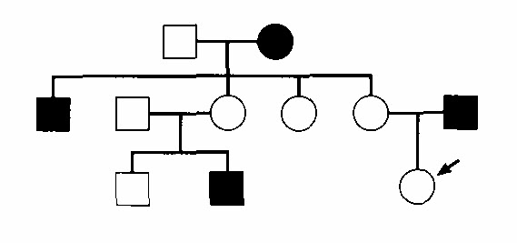

A. 0
B. 1/3
C. 1/2
D. 1/4
E. 1

41. A number of genes carried on the same chromosome are tested and show the following crossover frequencies. What is their sequence in the map of the chromosome?

Genes Crossover
Frequency

C and A 7%
B and D 3%
B and A 4%
C and D 6%
C and B 3%

A. A-D-B-C
B. D-C-B-A
C. A-B-C-D
D. B-C-D-A
E. C-A-D-B

42. New combinations of linked genes are due to

A. nondisjuction.
B. crossing-over.
C. independent assortment.
D. mixing of sperm and egg.
E. environmental changes such as temperature extremes.

43. If a pair of homologous chromosomes fails to separate during anaphase of meiosis I, what will be the chromosome number of the four resulting gametes with respect to the normal haploid number (n)? (Assume MII proceeds normally.)

A. n + 1; n + 1; n – 1; n - 1
B. n + 1; n – 1; n ; n
C. n + 1; n – 1; n – 1; n - 1
D. n + 1; n + 1; n; n
E. n – 1; n – 1; n ; n

44. A man who carries an X-linked allele will pass it on to

A. all his daughters.
B. half of his daughters.
C. all of his sons.
D. half of his sons.
E. all of his children.

45. A Barr body is normally found in the nucleus of which kind of human cell?

A. unfertilized egg cells only
B. sperm cells only
C. somatic cells of a female only
D. somatic cells of a male only
E. both male and female somatic cells

46. The frequency of crossing over between any two linked genes is

A. higher if they are recessive.
B. different between males and females.
C. determined by their relative dominance.
D. the same as if they were not linked.
E. proportional to the distance between them.

47. The picture below depicts which of the following changes in chromosome structure

A. deletion
B. duplication
C. translocation
D. aneuploidy
E. polyploidy

48. A man with hemophilia (a recessive, sex-linked condition) has a daughter of normal phenotype. She marries a man who is normal for the trait. What is the probability that a daughter of this mating will be a hemophiliac?

A. 0 %
B. 25 %
C. 50 %
D. 75 %
E. 100 %

49. Linda samples 2 different populations of a single fish species and wants to use the
chi-square test to determine if there is a difference in schooling behaviour between the
two populations.

Using a 5% rejection level, which critical chi-square value should she use from this table?

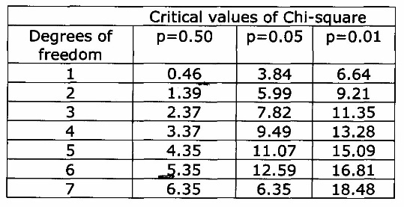

A. 3.84
B. 5.99
C. 0.46
D. 9.49
E. None of these values is appropriate in this situation.

50. A wild-type fruit fly (heterozygous for gray body colour and normal wings) was mated with a black fly with vestigial wings. The offspring had the following phenotypic distribution:

Wild type 778
Gray-vestigial 162
Black-vestigial 785
Black normal 158

What is the recombination frequency between these genes for body colour and wing type?

A. 17 %
B. 50 %
C. 9 %
D. 8 %
E. 25 %

