Lecture 2

Managers and Managing
Management: The process of achieving organizational goals through people and other resources
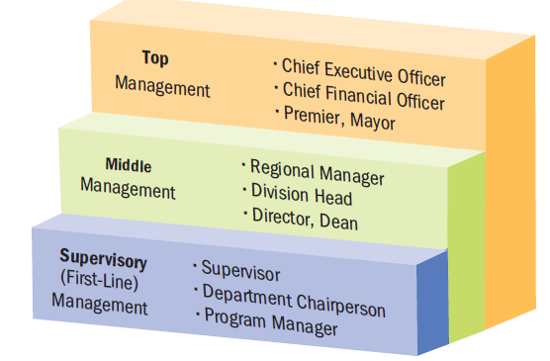
A process:
- series of activities and operations
- involves (flowing inputs to outputs) assembling and using resources (human/financial/information)
- involves acting in a goal-directed manner to accomplish tasks
- activity with purpose and direction
- activities carried out in an organizational setting (not by oneself)
- by people with different structures, intentionally structured and coordinated
What Do Managers Do? Understand staff, what makes them tick, feel rewarded.
Management: All about the people. (satisfaction)

Top Management
- develop long-range strategic plans for the organization
- inspire executives and employees to achieve their vision for the company’s future
  - mission statement
Middle Management
- focus on specific operations/products/customer groups within an organization
- responsible for developing detailed plans and procedures to implement the firm’s strategic plans
  - making it happen
  - developing more detailed plans as to how to achieve that long range plan
Supervisory (First-Line) Management
- implement the plans developed by middle managers
- responsible for non-manager employees
- motivate works to accomplish daily, weekly and monthly goals
  - supervise the first line worker (the window/public face of the company, portrays the image)
Efficiency “Doing things right”
- Getting the most output from the least amount of inputs.

Effectiveness “Doing the right things”
- Completing activities so that organizational goals are achieved

Analogy to Car Producing
  - LOW EFFICIENCY AND LOW EFFECTIVENESS Low quality product that nobody wants
  - HIG EFFICIENCY AND LOW EFFECCTIVENESS high quality product that nobody wants
  - LOW EFFIECIENCY AND HIGH EFFECTIVENES high quality product that is not affordable
  - HIGH EFFIECIENCY AND HIGH EFFECTIVENESS good quality that is affordable

Efficiency, Effectiveness, and Performance in Organizations

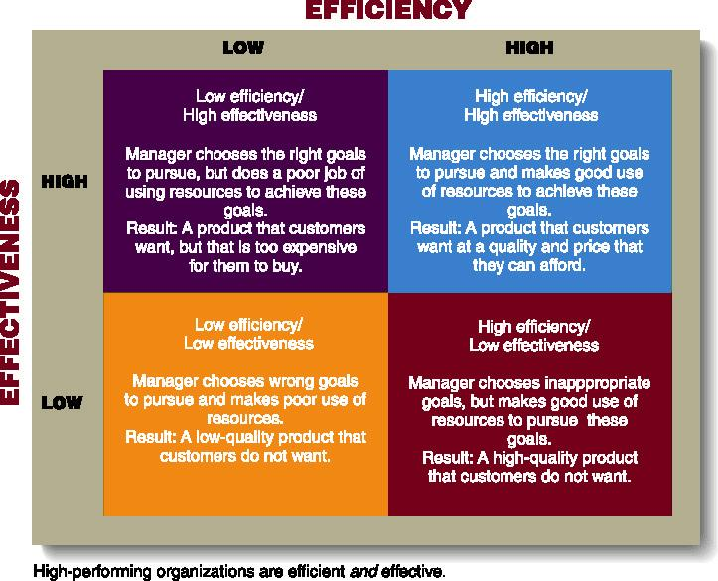

- Effective = doing the right things
- Efficient = doing things right
- Efficiency and effectiveness are not always attributed to money!
- To manage efficiently and effectively you need to get the best out of people which may require different management styles (which is very difficult for most managers) one does not fit all
Management Functions leads to achieving the organization’s stated purpose
Planning
- process of looking forward to future events and conditions and deciding on the courses of action for achieving organizational goals
  - defining goals
  - establishing strategy
  - developing sub-plans to coordinate activities
Organizing
- process of blending human and material resources through a formal structure of tasks and authority
  - determining ‘what needs to be done’, ‘how it will be done’, and ‘who is to do it’
Leading/Directing
- Guiding and motivating employees to accomplish organizational goals
  - Directing and motivating all involved parties and resolving conflicts
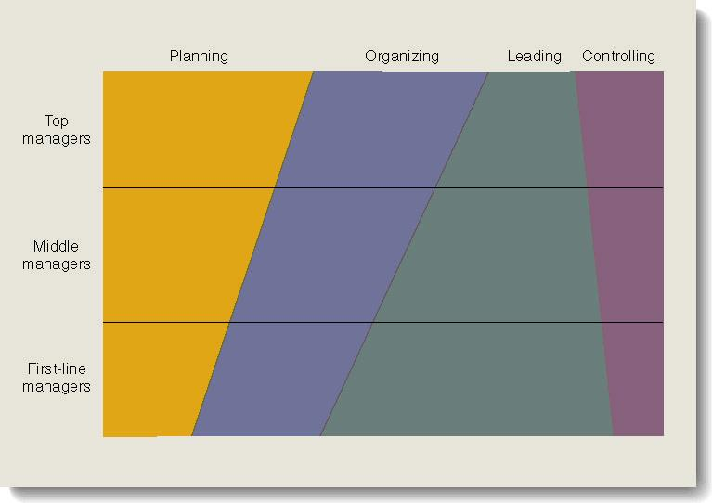
Controlling
- function of assessing an organization’s performance against its goals.
- involves four basic steps:
  - Setting performance standards
  - Monitor actual performance
  - Compare actual performance with the standards
  - Making corrections if needed
- monitoring activities to ensure that they are accomplished as planned

Management Styles
Autocratic Style
- Characteristics
  - Communication one way (top down)
  - Motivation (threat of job loss)
  - E.g. manufacturing mangers
- Advantages
  - Fast Decisions
  - Well defined procedures
  - Roles clearly defined (strong and powerful to get things done)
- Disadvantages
  - No two way communication to discuss problem
  - Employee initiative discouraged (ineffectual, weak, powerless)
  - Undue stress on staff
  - Potential loss of skilled staff
  - Dependent on manager overlooking the workplace (fall apart if absent)

Persuasive Style
- Characteristics
  - Strong central authority
  - Communication one way (persuading the other person what is required)
  - No employee feedback
- Advantages
  - Better relationship with employees
- Disadvantages
  - Employee attitude can still be negative
  - May not have full support of employees
  - Communication one way

Consultative Style
- Characteristics
  - Manager prepared to consult
  - Two way communication (manager asking employee for input)
- Advantages
  - Staff input can improve quality of decisions
  - Employees start to have ownership (more valued and involved in day-to-day running of the business)
  - Increased staff motivation
  - Decisions easier to implement
- Disadvantages
  - Time to consult can slow decisions
  - Consulted staff can still be unhappy with decision

Participative Style
- Characteristics
  - Employees involved in management decisions
  - Employees empowered
- Advantages
  - Motivation and commitment
  - Employees gain confidence and skills
  - Management employee relations positive
  - Change more likely to be accepted
- Disadvantages
  - Communication can be too informal
  - Decisions can be delayed
  - Can mean compromise vs. clear decisions

Laissez Faire Style
- Characteristics
  - Responsibility and control passed to employees
  - Manager establishes guidelines (taking a backseat and letting staff make management decisions)
  - Manager responsible for resources
  - In new industries: computer software development (huge emphasis on creativity)
- Advantages
  - Can work well with creative highly qualified and committed staff
  - Self-directed staff can achieve high job satisfaction
- Disadvantages
  - Risk of disorganized time and money
  - Personal conflicts could be significant

Skills Needed for Managerial Success motivate people to work (support and trust)
- Technical skills
  - manager’s ability to understand and use the techniques, knowledge, tools, and equipment of a specific department or area of study (support and trust of people under)
- Human skills
  - Interpersonal skills that enable a manager to work effectively with and through people
- Conceptual skills
  - Ability to see the organization as a unified whole and to understand how each part of the overall organization interacts with other parts.

Skills Needed at Different Management Levels

Importance of Planning
- There are different types and levels of plans.
- Organizations should have a comprehensive planning framework
  - Each step should fit into overall plan
  - Broad/long-range: mission statement; objectives and goals
  - Narrow/short-range: functional plans for specific employees/areas
- Plans outline the steps the company will take to meet goals and objectives

Planning at Different Management Levels
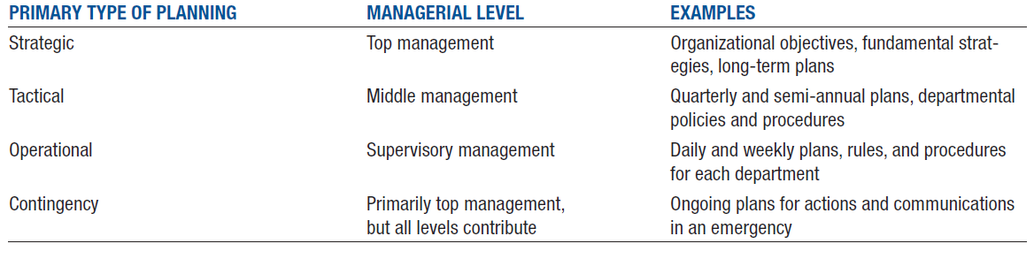
Steps in the Strategic Planning Process
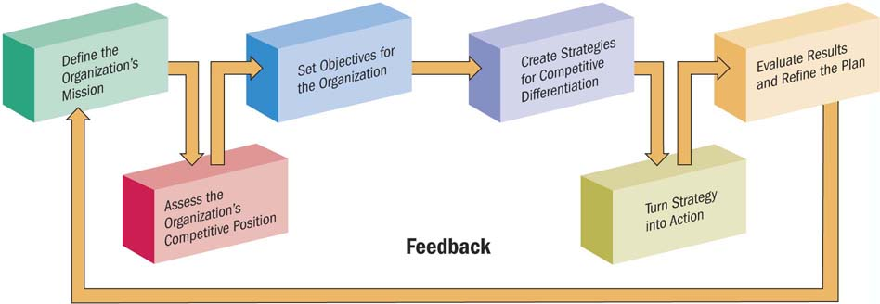

Elements of SWOT Analysis
- SWOT = strengths, weaknesses, opportunities, threats (by accessing all four factors one by one, a firm can then develop the best strategies for gaining a competitive advantage)
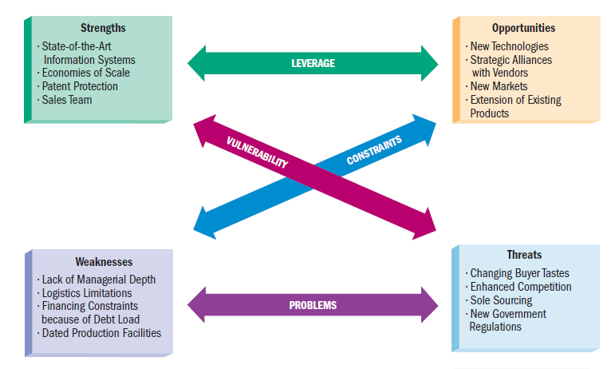

Contingency Planning and Crisis Management
- “What if” scenarios
- Dealing with emergencies

Managers as Decision Makers
- Decision making: process of seeing a problem or opportunity, assessing possible solutions, selecting and carrying out the best-suited plan, and assessing the results
- A programmed decision involves simple, common, and frequently-occurring problems that already have solutions.
- A non-programmed decision involves a complex and unique problem or opportunity with important results for the organization.
- Leadership: The ability to direct or inspire people to reach goals
- Involves the use of influence or power
- Three traits are common among many leaders:
  - Empathy
  - Self-awareness
  - Objectivity in dealing with others

Leadership Style
- Autocratic leadership
  - Leader-centred
  - make decisions on own without consulting employees
- Democratic leadership
  - Involves employees in decisions, delegate assignments, and ask them for suggestions.
- Free-rein leadership
  - Involves minimal supervision; leave most decisions to employees.

Organizational Structures
- Organization: A structured group of people working together to achieve common goals
- Three key elements:
  - Human interaction
  - Goal-directed activities
  - Structure
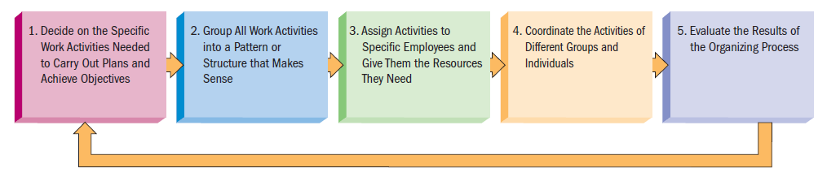

Sample Organizational Chart
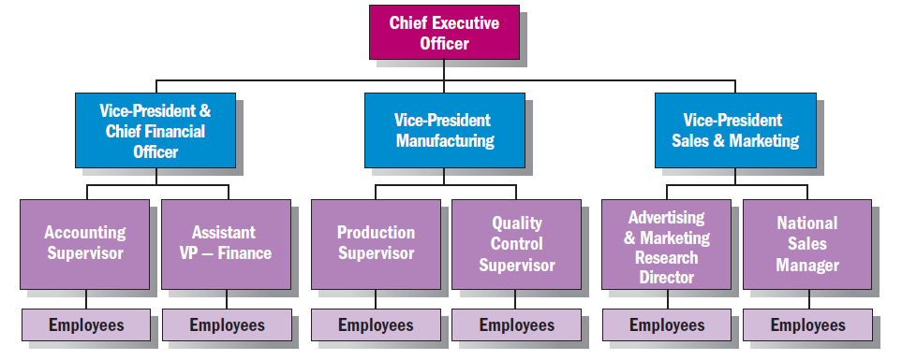

Departmentalization
The process of dividing work activities into units within the organization
- Product departmentalization: Organized based on the goods and services a company offers.
- Geographical departmentalization: Organized by geographical regions within a country or, for a multinational firm, by region throughout the world.
- Customer departmentalization: Organized by the different types of customers the organization serves.
- Functional departmentalization: Organized by business functions such as finance, marketing, human resources, and production.
- Process departmentalization: Organized by work processes necessary to complete production of goods or services.

Different Forms of Departmentalization
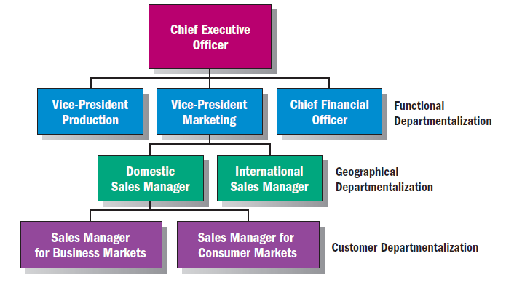

Delegating Work Assignments
- Delegation: The managerial process of assigning work to employees.
  - Providing employees with the responsibility and necessary authority for completing tasks
  - Employees have accountability, or responsibility, for their actions and decisions
- Span of management is the number of employees a supervisor manages
- Centralization means that decision-making is retained at the top of the management hierarchy.
- Decentralization means that decision-making is shifted to the lower levels. Many firms believe it enhances their flexibility and responsiveness to customer needs

Types of Organizational Structures
- Line organizations
  - Oldest and simplest form; direct flow of authority from CEO to employees.
  - Chain of command indicates who directs which activities and who reports to whom
- Line-and-staff organizations
  - Combines line departments and staff departments.
  - Line departments participate directly in decisions that affect the core operations of the organization
  - Staff departments lend specialized technical support

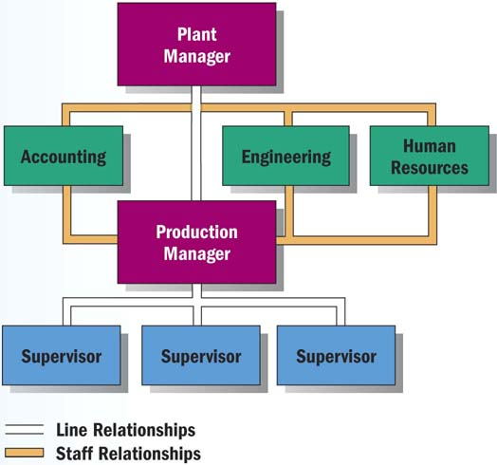
Line-and-Staff Organizations

Matrix Organizations
- Project management structure that links employees from different parts of the organization to work together on specific projects.
- Employees report to both a line manager and a project manager
- Advantages
  - Flexibility in adapting to changes
  - Focus on major problems/products
  - Outlet for employees’ creativity and initiative
- Disadvantages
  - Integrating skills of many specialists into a coordinated team
  - Team members’ permanent functional managers must adjust the employees’ regular workloads

Lecture 3 OPTIONS FOR ORGANIZING A BUSINESS

Small Business
- owner-managed business with fewer than 100 employees
- 2.3 million in Canada
- 97.7% of all employer businesses in Canada are “small”
- Account for over 2/3 employment in four industries:
  - Non-institutional health care
  - Construction
  - Accommodation and food
  - Other services

The Entrepreneur and the Entrepreneurial Process
- Entrepreneur: people who recognize and seize opportunity
- Entrepreneurship: the process of identifying an opportunity in the marketplace and accessing the resources necessary to capitalize on that opportunity

The Entrepreneurial Process
- Identify Opportunities
    - Idea generation
  - Screening:
    - Idea creates or adds value(future/increasing demand)
    - Idea provides a sustainable (long-term) competitive advantage (higher quality/better service/lower cost)
    - Idea is marketable and financially viable (will it generate profit)
    - Idea has low exit costs
  - Develop the opportunity
- Access the necessary resources (capital)

VIDEO: Montreal Sandwich (describe the entrepreneurship)
- IDEA: high end sandwich from high end area
- VALUE: providing service which there is demand (or a future demand/expectation of an increasing demand)
- SCREENING (Sustainable competitive advantage)
  - Higher quality
  - Better service
  - Greater convenience
  - Lower price
- MARKETABLE AND FINANCIALLY VIABLE
  - Will people buy his sandwiches? (marketable)
  - Will it be profitable? (financially)
- LOW EXIT COST
  - Lease
  - Equipment
- RESOURCES (where did he get the money?)

The Canadian Private Sector Forms of Business Ownership
- Sole Proprietorship
- Partnership
  - General
  - Limited
  - Joint Venture
- Incorporation
  - Under Federal Laws
  - Under Provincial Laws
    - Public Corporation
    - Private Corporation – (including most “Family Businesses”)
- Alternative Business Forms
  - Crown Corporations
  - Cooperatives
  - Non-Profit

Sole Proprietorship (SPs)
- simplest form of business organization available to any individual who is legally able to enter into a binding contract
- SPs fall under provincial and municipal jurisdiction
- Filing a name declaration is not required provided the proprietorship operates under a person’s name
- Owned and operated by one person

Advantages of the Sole Proprietorship
- Ease and cost of starting and ending the business (easy)
- Secrecy (no need to share)
- Flexibility and control
- Pride of ownership
- Distribution and use of profit (all profit is yours)
- No special taxes – profits are “personal income” and taxed at individual tax rates
- No government regulation

Disadvantages of the Sole Proprietorship
- Unlimited liability (use personal asset to pay off debt)
- Limited financial resources
- Limited skills pool (only you)
- Overwhelming time commitment (work 24/7)
- Few fringe benefits
- Limited growth
- Limited life span (if you die, company dies)

Partnership
- Arrangement whereby two or more persons combine some or all of their resources in a business undertaking with a view to sharing profits among partners
  - How money/profit/loss is divided
  - How to get in/rid of partners
  - Good partnership agreement anticipates and lays out situations to resolve issues
- Provincial laws require that a partnership must legally register its name and give information about the partners

Types of Partnerships
- General partners (needs at least one)
  - Senior Partners (major management roles, largest share of profits)
  - Junior Partners (major management roles, smaller share of profits)
- Limited partners
  - Silent Partner (known to public but no management)
  - Secret Partner
  - Dormant Partner (lend their name but no active role)
  - Nominal Partner (lend their but not involved at all)

- General Partnership – complete sharing in the management of the business
  - Partners are not only liable in equal share for the debts of the partnership (jointly liable) but in addition, each partner is liable for the full amount (jointly and severally liable)
  - Each member can bind the partnership without consent of the other partners
- Limited Partnership
  - Composed of one or more general partners who conduct the business, and one or more persons who contribute an amount in actual cash (special or limited partners)
  - The special partner’s liability is normally limited only to the amount of the cash s/he contributed to the partnership
- Joint Venture
  - Partnership established for a specific project or a limited time

Advantages of Partnerships
- Ease of organization
- More financial resources (capital and credit) from partners
- Shared management
- Combined knowledge and skills
- Faster decision making relative to corporation
- Few regulatory controls

Disadvantages of Partnerships
- Unlimited liability
- Partners are responsible for the business activities of all others
- Division of profits (share)
- Disagreements among partners – can be difficult to get rid of a partner
- Life of a partnership

Corporation
- A corporation is recognized as a separate legal entity under the law
- A corporation incorporated under the laws of Canada (a federally incorporated business) can carry on business in all parts of Canada
  - Federally incorporated businesses include 150 of the 200 largest corporations in Canada
  - A federal company cannot be prevented by a provincial government from exercising the powers that have been validly conferred on the company by federal authority (e.g., doing business in a province)
- Governance of a corporation is the responsibility of a Board of Directors
- Ownership of a corporation is through stock or “shares” – either “preferred” shares or “common” shares (typically the “voting” shares)

A Private Corporation:
- The right to transfer shares is restricted
- Number of shareholders limited to 50
- May not sell shares or debentures (bonds or debt instruments) to the public

A Public Corporation:
- Sells shares to the public on a stock exchange
- Is subject to stricter regulations for filing financial reports, must follow certain audit procedures
- Must file a prospectus if shares are being sold to the investing public

A Subsidiary Corporation:
- One that has the majority of its stock owned by another corporation known as the parent company (e.g., IBM Canada, Hewlett-Packard Canada)

A Holding Company:
- A corporation that controls one or more other corporations through ownership of their common stock
- Legal control (51% of shares)
- Effective control (less than 51% shares)
- Depends on how widely held the shares are (how many shareholders)

Advantages and Disadvantages of Corporations
- More money for investment (raise money by selling shares)
- Limited liability (lose only what you invest)
- Separation of ownership/management (shareholders do not manage)
- Ease of ownership change (sell your shares)
- Perpetual life (share can be transfer to another)
- Size

Disadvantages of Corporations
- Initial cost
- Paperwork
- Two tax returns (Income tax, corporation income tax)
- Termination difficult
- Double taxation

Other Types of Corporations
- Non-profit - universities, hospitals, charities
- Cooperative – The Farmers COOP
- Crown Corporations – Export Development Corporation, VIA Rail (tax payer’s money)

Other Types of Corporations – Non-Profit
- Non-profit - universities, hospitals, charities
- Focus more on providing a service than making a profit, but NOT owned by a government entity
- Funded through private donations and grants from government

Other Types of Corporations – Cooperatives
- A Cooperative or Co-op – an organization composed of individuals or small businesses that have banded together to reap the benefits of belonging to a larger organization
  - Gay Lea – a Co-op of Ontario Dairy Farmers
  - Ocean Spray – a Co-op of cranberry farmers
- A Co-op is expected to operate without profit
- Pass savings on to members because the Co-op buys in bulk and advertising efforts are pooled

Other Types of Corporations – Crown Corporations
- A Crown Corporation – a “for profit” corporation owned and operated by the federal, provincial or local government whose focus is providing a service
- Operate in areas where the private sector either could not or would not operate because of high infrastructure or other costs:
  - Mail delivery in downtown and remote communities at the same cost
  - Areas where return on investment occurs only in the long-term (Atomic Energy and Candu Reactors)
  - Areas where the risk involved would make it necessary for a private sector organization to charge an unaffordable price (Export Development Corporation)
  - Areas where a service is intended to make all businesses more profitable (Business Development Bank)

The Family Business
- About 2/3 of Canadian business enterprises are controlled by families (usually through private corporations)
- It is estimated there are 10,000 family businesses in Canada with two or more generations as owners or managers
- Family businesses control about 1/3 of the 100 largest companies in Canada
- Founder or family members are in executive positions
- Family members hold sufficient shares to make decisions and control operations
- Approximately 25% of family businesses survive the founder’s demise; about 10% survive beyond two generations and 3% beyond the third generation

Corporate Expansion – Mergers, Acquisitions and Leveraged Buy-Outs
- Mergers - two or more companies join to form one company
- Vertical merger - firms merge that are involved at different levels of the same business, i.e., Chrysler and a steel company
- Horizontal merger - firms at the same level of the business merge, i.e., Chrysler and Daimler Benz
- Conglomerate Merger – the merger of two firms in unrelated industries

Corporate Expansion – Mergers, Acquisitions and Leveraged Buy-Outs
- An acquisition occurs when one company purchases another by buying most of its stock
- The acquired company may become a subsidiary or its assets may be merged
- The buying company gains control of the acquired company’s assets but also assumes responsibility for its liabilities
- A leveraged buy-out occurs when a group of investors borrows money from banks and other lending institutions to acquire a company, using the assets of the acquired company as security for repayment of the loan
- Friendly vs. hostile take-overs
  - Corporate raider offers to buy some or all of the company’s stock at a premium over its current price
  - Friendly = both groups agree
  - Hostile = when the second company does not wish to be taken over
- Fending off a hostile takeover attempt:
  - Ask shareholders not to sell to the raider
  - File a lawsuit
  - Poison pill – allow shareholders to buy more shares of stock at prices lower than market value
  - Shark repellent – requiring a large majority of shareholders to approve the takeover
  - White knight – a more acceptable firm that is willing to acquire the threatened company

The Canadian Private Sector
- Over the last century the Canadian business sector has seen a shift from a system of enterprises more or less loosely connected by competition through the marketplace to a corporate system that now dominates the scene
- The distribution of business organizations in Canadian manufacturing industries has changed dramatically (from Sexty, Prentice Hall 1998):

% in 1950 % in 1980 % Today
- Sole proprietorships 45.6 11.5 2.4
- Partnerships 15.0 3.3 0.5
- Corporations 36.3 84.3 96.6
- Co-operatives 3.3 0.9 0.5

Lecture 4 Evolution of Management Thought/ Environment of Business

Evolution of Management
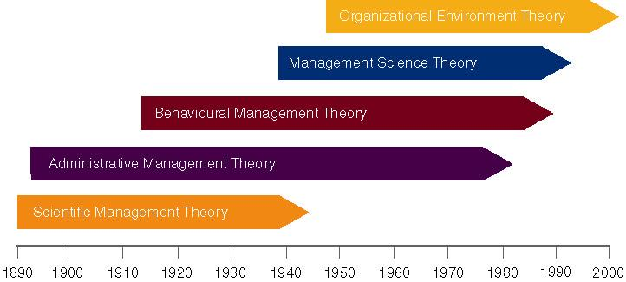

Scientific Management – Frederick Taylor
- Defined scientific management
  - Systematic study of the relationships between people and tasks to redesign the work for higher efficiency
- Reduce the time a worker spent on each task by optimizing the way the task was done.
- In 1911, Taylor’s work, The Principles of Scientific Management described how applying the scientific method could be applied to improve productivity by:
  - Optimizing the way tasks were performed
  - Simplifying the jobs to allow for training in specialized sequence of motions in the “best” way

Taylor’s Principles
- Principles to increase efficiency:
  - Replace prevailing “rule-of-thumb” work methods with methods based on a scientific study of the way the job is performed now & determine new ways to do it, codifying the new method into rules
  - Scientifically select workers whose skills match the rules set in Step 1 and train and develop each worker and cooperate with the workers to ensure the developed methods are being followed
  - Establish a fair level of performance and pay for higher performance.
  - Study –> Codify –> Select & Train –> Reward
  - For every job develop a science that includes:
    - 1. rules of motion
    - 2. Standardized work implements
    - 3. proper working conditions
  - Carefully select workers with the right abilities to perform the job
  - Train workers to do the job and give them proper incentives to cooperate with the job science
  - Support workers by carefully planning their work
  - Study and codify select and train reward

Problems of Scientific Management
- Managers often implemented only the increased output side of Taylor’s plan.
  - They did not allow workers to share in increased output.
  - Specialized jobs became very boring, dull.
  - Workers ended up distrusting Scientific Management.
- Workers could purposely “under-perform”
- Management responded with increased use of machines.

Scientific Management – Frank and Lillian Gilbreth
- Frank and Lillian Gilbreth refined Taylor’s methods.
  - Made many improvements to time and motion studies.
- Time and motion studies:
  - 1. Film and break down each action into components.
  - 2. Find better ways to perform it.
  - 3. Reorganize each action to be more efficient.
- Gilbreths also studied fatigue problems, lighting, heating and other worker issues.

The Gilbreths vs. Taylor (popular question)
- Gilbreths’ studies were more focused on how a task was done, and how to best eliminate unneeded, fatiguing steps in any process
- Gilbreths’ form of scientific management had a more developed view of the worker and his/her interests vs. Taylor’s predominant view of the worker as driven solely by pay
- Gilbreths used photography as a means to study human motion in completing tasks (micro motion films)

Administrative Management – Max Weber
- Max Weber developed the concept of bureaucracy.
  - A formal system of organization and administration to ensure effectiveness and efficiency (getting the right things done through the right people)
  - Developed five principles of bureaucracy
- Bureaucratic Principles
  - A manager’s formal authority derives from his/her position
  - People should occupy positions because of performance, not social connections
  - The authority, responsibility of each position relative to every other position should be made clear
  - Positions should be arranged hierarchically
  - Managers must create a well-defined system of rules standard operating procedures, and norms
- Key Points of Bureaucracy
  - Authority is the power to hold people accountable for their actions.
  - Positions in the firm should be held based on performance not social contacts.
  - Position duties are clearly identified. People should know what is expected of them.
  - Lines of authority should be clearly identified. Workers know who reports to who.
  - Rules, Standard Operating Procedures (SOPs), & Norms used to determine how the firm operates.
- Sometimes, these lead to “red-tape” and other problems.

Administrative Management – Henri Fayol
- Fayol postulated that all administrative activities could be divided into 6 groups:
- Technical operations (production/manufacturing)
- Commercial operations (purchases, sales)
- Financial operations (finding & controlling capital)
- Security operations (protecting property & persons)
- Accounting operations (stock-taking, costing)
- Administrative Operations or managerial activities:
    - “foresight, organizing, commanding, coordinating, controlling”
- Fayol’s Principles
- Fayol also developed a set of 14 principles:
- Division of Labour: allows for job specialization.
    - Fayol noted firms can have too much specialization leading to poor quality and worker involvement.
- Authority and Responsibility: Fayol included both formal and informal authority resulting from special expertise.
- Unity of Command: Employees should have only one boss.
- Line of Authority: a clear chain from top to bottom of the firm.
- Centralization: the degree to which authority rests at the very top.
- Unity of Direction: One plan of action to guide the organization.
- Equity: Treat all employees fairly in justice and respect.
- Order: Each employee is put where they have the most value.
- Initiative: Encourage innovation.
- Discipline: obedient, applied, respectful employees needed.
- Remuneration of Personnel: The payment system contributes to success.
- Stability of Tenure: Long-term employment is important.
- General interest over individual interest: The organization takes precedence over the individual.
- Esprit de corps: Share enthusiasm or devotion to the organization.

Behavioural Management Theory – Mary Parker Follett (Opposite of Taylor)
- Suggested workers help in analyzing their jobs for improvements.
- The worker knows the best way to improve the job.
- If workers have the knowledge of the task, then they should control the task.
- Elton Mayo – The Hawthorne Studies
  - Occurred at the Hawthorne Plant of the Western Electric Company in Cicero, Illinois
  - Initially examined the physical and environmental influences of the workplace (brightness of lights, humidity) and later examined the psychological aspects (breaks, group pressure, working hours, managerial leadership)
  - Four General Conclusions:
    - The aptitudes of individuals are imperfect predictors of job performance
    - The informal organization affects productivity
    - Work-group norms affect productivity
    - The workplace is a social system

Douglas McGregor
- Proposed the two different sets of worker assumptions.
  - Theory X: Assumes the average worker is lazy, dislikes work and will do as little as possible.
    - Managers must closely supervise and control through reward and punishment.
  - Theory Y: Assumes workers are not lazy, want to do a good job and the job itself will determine if the worker likes the work.
    - Managers should allow the worker great latitude, and create an organization to stimulate the worker.

Theory X versus Theory Y
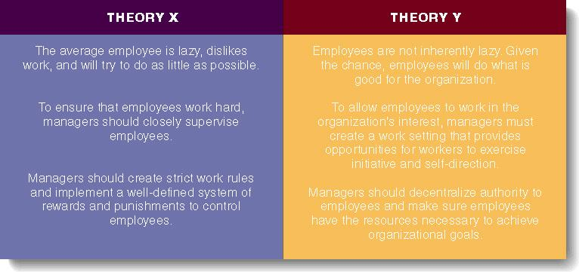

Management Science
- Uses rigorous quantitative techniques to maximize resources.
  - Quantitative management: utilizes linear programming, modeling, simulation systems.
  - Operations management: techniques to analyze all aspects of the production system.
  - Total Quality Management (TQM): focuses on improved quality.
  - Management Information Systems (MIS): provides information about the organization.

Organization-Environment Theory
- Considers relationships inside and outside the organization.
  - The environment consists of forces, conditions, and influences outside the organization.
- Systems theory considers the impact of stages:
  - Input: acquire external resources.
  - Conversion: inputs are processed into goods and services.
  - Output: finished goods are released into the environment.

What is Business?
- Business: All profit-seeking activities and enterprises that provide goods and services necessary to an economic system
- Profits: Rewards for businesspeople who take the risks involved to offer goods and services to customers

The Private Enterprise System
Capitalism
  - Adam Smith known as father of capitalism
  - “invisible hand”
- Economic system determines business ownership, profits, and resources
- Firms rewarded for their ability to serve the needs of consumers
- Minimizes government intervention
- Competition: The battle among businesses for consumer acceptance

Basic Rights within a Private Enterprise System

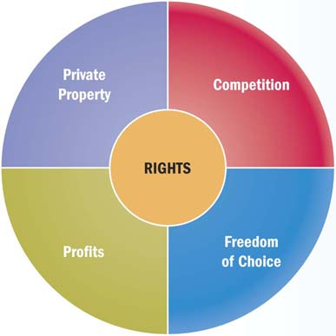

Today’s Business Workforce
- Reliable workers dedicated to promoting strong ties with customers and partners
- Capable of efficient, high-quality production
- Able to compete in global markets
- Technically savvy and innovative

Changes in the Workforce
- Aging of the Population/Shrinking Labour Pool
  - Many baby boomers are hitting the peak of their careers, while Generations X and Y are launching their careers.
  - More generations mixing in the workplace than ever before.
  - Technology has intensified the hiring challenge by requiring workers to have ever-more advanced skills.
- Increasingly Diverse Workforce
  - Two-thirds of Canada’s population growth is due to international immigration, particularly from Asia.
  - Employee teams with individuals of different genders, ethnic backgrounds, cultures, religions, ages, and physical and mental abilities are more effective.

The 21st Century Manager
- Vision
- Vision is the ability to perceive marketplace needs and what an organization must do to satisfy them
- Today’s companies look for managers who are intelligent, highly motivated people with the ability to create and sustain a vision for the organization.
- Critical thinking and creativity
- Critical thinking is the ability to analyze and assess information to pinpoint problems or opportunities.
- Creativity is the capacity to develop novel solutions to perceived organizational problems.
- Guide employees and organizations through changes
- Ability to lead change
  - Managers must be comfortable with tough decisions in fluctuating conditions
  - Factors that require organizational change can come from external and internal sources

Economics
- The social science that studies the choices people and governments make when dividing up their scarce resources
  - Demand: The willingness and ability of buyers to purchase goods and services
  - Supply: The willingness and ability of sellers to provide goods and services

Capitalism – The Private Enterprise System and Competition
- Businesses meet needs and demands of consumers and are rewarded through profit.
- Government favours a hands-off approach. (letting the market sort itself out)
- Marketplace competition regulates economic life.
- Four degrees of competition:
  - Pure competition
  - Monopolistic competition
  - Oligopoly
  - Monopoly

Types of Competition
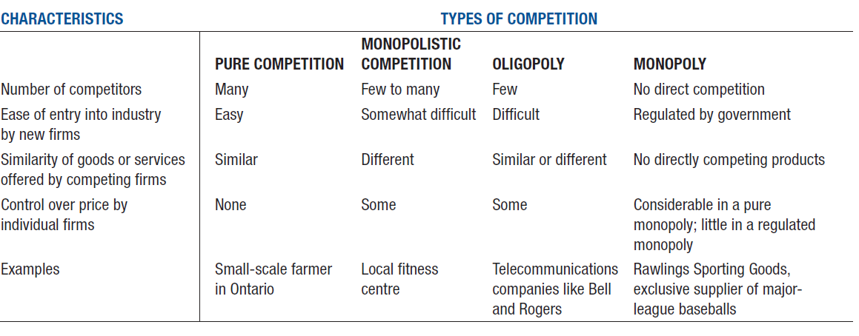

Evaluating Economic Performances
- An economic system should provide a stable business environment and sustained growth as benefits for its citizens.
- Business decisions and consumer behaviour differ at various stages of the business cycle (not applicable to every part of the world at the same time):
  - Prosperity—Unemployment low, consumer confidence/purchasing high, businesses expanding
  - Recession—A cycle of economic contraction that lasts for six months or longer; consumers careful about purchases, businesses slow production/expansion
  - Depression—Extended recession
  - Recovery—Declining unemployment, increasing business activity, renewed consumer confidence

Global Economic Challenges
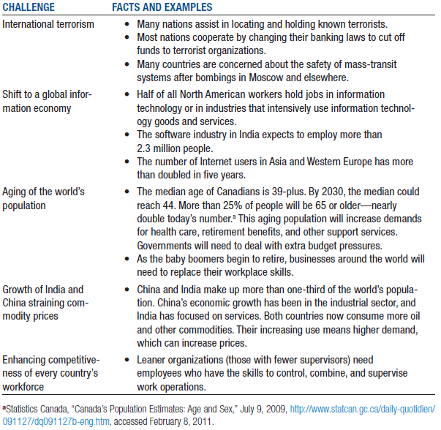

Imports and Exports: Why Nations Trade
- Boosts economic growth
- Expands markets
- More efficient production systems
- Less reliance on the economies of home nations
- Exports: Domestically produced goods and services sold in other countries
- Imports: Foreign goods and services purchased by domestic customers

International Sources of Factors of Production
- Decisions to operate abroad depend upon availability, price, and quality of:
  - Labour
  - Natural resources
  - Capital
  - Entrepreneurship
- Companies doing business overseas must make strategic decisions.
- Operating abroad can yield benefits if other countries are at different stages of the business cycle

Additional Environmental Factors To Which Companies Are Exposed
- New social and cultural practices
- Economic and political environments
- Legal restrictions
- Companies can expand their markets, seek growth opportunities in other nations, make their production and distribution systems more efficient, and reduce their dependence on the economies of their home nations.

Exchange Rates
- Foreign currency is the biggest market in trading currencies
- Currency rates are influenced by:
  - Domestic economic and political conditions
  - Central bank intervention
  - Balance-of-payments position
  - Speculation over future currency values
- Values fluctuate, or “float,” depending on supply and demand.
- National governments can deliberately influence exchange rates.
- Business transactions are usually conducted in the currency of the region where they happen.
- Exchange rates can quickly create or wipe out competitive advantages.

Barriers to International Trade
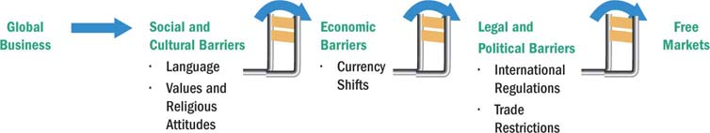

Social and Cultural Differences
- Language: Potential problems include mistranslation, inappropriate messaging, lack of understanding of local customs, and differences in taste.
- Values and Religious Attitudes: Differing values about business efficiency, employment levels, importance of regional differences, and religious practices, holidays, and values about issues such as interest-bearing loans.

Economic Differences
- Infrastructure: The basic systems of a country’s communication, transportation, and energy facilities
- Currency Conversion and Shifts: Fluctuating values can make pricing in local currencies difficult, and affect decisions about market desirability and investment opportunities.

Political and Legal Differences
- Political Climate
  - Stability is a key consideration (if government corrupt)
  - Nationalize property within the nation (cannot bring if you leave)
- Legal Environment
  - Canadian law
  - International regulations
  - Country’s law in which trade is planned
  - Climate of corruption (see Canada Takes Aim At Foreign Corruption)
- International Regulations
  - Treaties between Canada and other nations
  - Tariffs: Taxes imposed on imported goods
  - Enforcement issues

Types of Trade Restrictions
- Tariffs: taxes, surcharges, or duties on foreign products
  - Revenue tariffs generate income for the government.
  - Protective tariffs raise prices of imported goods to level the playing field for domestic competitors.
- Nontariff barriers: also called administrative trade barriers
  - Quota: A limit set on the amounts of particular products that can be imported
  - Dumping: Selling products in other countries at prices below production costs or below typical prices in the home market (to get rid of it)
  - Embargo: A total ban on importing specific products or a total stop to trading with a particular country
  - Exchange control: a restriction on important certain products or a restriction against certain companies to reduce trade and the spending of foreign currency
    - In accordance with national policy, through central banks or government

Going Global
- Determining which foreign market(s) to enter
- Analyzing the expenditures required to enter a new market
- Deciding the best way to organize the overseas operations

Levels of Involvement
- Risk increases with the level of involvement
- Many companies employ multiple strategies
- Exporting and importing are entry-level strategies
  - Importing is the process of bringing in goods produced abroad
  - Exporting is the act of selling home goods overseas

Counter Trade and Franchising
- Countertrade: A barter agreement whereby trade between two or more nations involves payment made in the form of local products instead of currency
- Franchising: A contract-based agreement in which a franchisee can produce and/or sell the franchisor’s products under that company’s brand name if the franchisee agrees to the operating terms and requirements
- Foreign licensing agreement: An international agreement in which one firm allows another firm to produce or sell its product, or use its trademark, patent, or manufacturing processes, in a specific geographical area, in return for royalties or other compensation
- Subcontracting: An agreement that involves hiring other companies to produce, distribute, or sell goods and services

Offshore and International Direct Investment
- The relocation of business processes to lower-cost overseas locations
  - Not initiating business but gaining cost savings to stay competitive
  - Extremely controversial
- The ultimate level of global involvement is direct investment
  - Directly operating production and marketing in a foreign country
  - Acquisition (purchase firm from host country)
  - Joint venture (partnership between companies)
  - Overseas division (set up offices overseas)

Lin Huang Electronics
- Which challenges of “going global” are evident in this case?
  - Suppliers
  - Competitors
  - Cultural
  - Government
  - Technological
  - Political-legal

The Claussen Shoe Company
- Which challenges of “going global” are evident in this case?
  - Government
  - Culture
  - Suppliers
  - Currency fluctuations

Lecture 5 Ethics and Social Responsibility/Decision Making

Business Ethics
- “…the study of business situations, activities, and decisions where issues of right and wrong are addressed.”
- “… rules, standards, codes or principles which provide guidelines for morally right behaviour and truthfulness in specific situations.”
- “the application to business activity of ethics, the study of morals or principles of what is right or wrong in human behaviour” “…concerned with the beliefs that determine what is acceptable (and what is not) in business”
- “applies a group’s standards of right and wrong to the decisions and actions of business organizations, managers, and employees

Ethics and ethical behaviour
- Ethics: beliefs about what is right and wrong; good and bad
- Ethical Behaviour: behaviour that conforms to individual beliefs and societal norms about what is right and good

Common Themes Emerging From Definitions of Business Ethics
- Right and wrong
- Moral standards (each individual has different values)
  - The means by which individuals judge their actions and the actions of others based upon accepted behaviour in society
- Value judgements
  - Subjective evaluations of what is considered important, based on how managers intuitively feel about the goodness or rightness of various goals

Basic Approaches to Ethical Decision-Making
- Utilitarian Approach:
  - An approach that focuses on the consequences of a decision – the intention is to make a decision that results in the greatest good for the greatest number.
- Moral Rights Approach:
  - An approach that focuses on examining the moral standing of actions independent of their consequences (some things are just “right” and some things are just “wrong” regardless of the consequences)
- Universal Approach:
  - Choosing a course of action that you believe can apply to all people under all situations (“do unto others as you would have them do unto everyone, including yourself”)
- Justice Approach:
  - Focuses on how equitably the costs and benefits of actions are distributed.
    - Procedural Justice
      - the impartial application of rules or procedures
    - Corrective Justice
      - Appropriate compensation for wrongdoings that are suffered
    - Retributive Justice
      - The punishment should fit the offence
    - Distributive Justice
      - Concern for how all stakeholders are treated

Influences on Ethical Behavior
- Individual morals
- National and ethnic cultures
- Government legislation and regulation
- The legal system
- Religion
- Colleagues or peers
- Education
- Media
- Corporate mission, vision, and values statements
- Union contracts
- Competitive behaviour
- Activist or advocacy groups
- Business or industry organizations
- Professional associations

Business Ethics (Two Key Branches of Ethics)
- Descriptive ethics involves describing, characterizing and studying morality
  - “What is”
- Normative ethics involves supplying and justifying moral systems
  - “What should be”

Making ethical judgements: Deciding what is ethical
- Ethical dilemmas:
  - Situations where a decision must be made between two equally valid but mutually exclusive courses of action

Corporate Social Responsibility
- The degree of moral obligation that may be ascribed to corporations beyond simple obedience to the laws of state
- An organization’s obligation to maximize its positive impact and minimize its negative effects in being a contributing member to society, with concerns for society’s long-run needs and wants. CSR means being a good steward of society’s economic and human resources
- The intelligent and objective concern for the welfare of society that restrains individual and corporate behaviour from ultimately destructive activities, no matter how immediately profitable, and leads in the direction of positive contributions to human betterment, variously as the latter may be defined
- The way a corporation achieves a balance among it economic, social, and environmental responsibilities in its operations so as to address shareholder and other stakeholder expectations.
- “…the capacity of a corporation to respond to social pressures.”

Case for Social Responsibility
- Business must satisfy society’s needs (if no needs no business).
- CSR prevents public criticism and government regulation.
- Business and society are interdependent.
- CSR is good for the bottom line.
- Investors and consumers support CSR (group of them who would pay higher for CSR).
- Addressing social problems can become financial opportunities (e.g., pollution abatement).
- Business should take long-term CSR approach.
- Social actions improve public image and goodwill (for perception?).
- Business can solve problems as well as government.
- Proactive approach is better than reactive.
- Businesspeople are also concerned citizens.

Case against Corporate Social Responsibility
- Profit maximization is the primary purpose of business.
- Business is responsible to shareholders.
- Social policy is role of government.
- Business lacks training in social issues.
- CSR would give too much power to business.
- Business involvement in social matters increases costs.
- No reliable guidance for business in CSR matters.
- Business cannot be held accountable unlike social institutions.
- There is divided support in business community for social involvement.

Areas of Social Responsibility
- The Natural Environment
- Customers
- Employees
- Investors

The Natural Environment and Business: every sector of business in every country leaves an environmental footprint

Natural Environment Issues
- Ozone depletion
- Global warming
- Solid and hazardous wastes
- Freshwater quantity and quality
- Degradation of the marine environment
- Deforestation
- Land degradation
- Endangerment of biological diversity
- Other Environmental Issues:
  - Acid Rain
  - Air pollution
  - Energy inefficiency
  - Production of toxic substances
- Responses of Governments in Canada
  - Canadian Environmental Protection Act (Federal government)
  - Air Quality Legislation (Provincial governments)
  - Water Quality Legislation (Federal government)
    - Canada Water Act
    - Fisheries Act
    - Navigable Waters Protection Act
    - Arctic Waters Pollution Prevention Act
    - Canada Shipping Act
    - Dominion Water Power Act
  - Land-Related Legislation
- After the Exxon Valdez oil spill the CERES organization was formed. CERES developed ten principles that have been advanced as models for businesses to express and practice environmental sensitivity
- Many major companies have endorsed these principles:
  - E.g., Coca-Cola, American Airlines, General Motors, Sunoco
- CERES Principles:
  - Protection of the biosphere
  - Sustainable use of natural resources
  - Reduction and disposal of waste
  - Energy conservation
  - Risk reduction
  - Safe products and services
  - Environmental restoration
  - Informing the public
  - Management commitment
  - Audits and reports
- http://www.ceres.org/flash/vision-and-accomplishments/2020_view

Responsibility towards CUSTOMERS
- Rights of Consumers
  - Safe products
  - Product information
  - Be heard
  - Choose
  - Be educated about the purchase
  - Courteous service
- Advertising
  - Truth
  - Counterfeit brands
  - Stealth advertising
  - Morally objectionable advertising

Responsibility towards EMPLOYEES
- Legal and social commitments

Responsibility towards INVESTORS
- Improper financial management (WorldCom, Enron, etc.)
- Misrepresentation of finances

Lecture 6 Human Resources Management Motivation

Human Resource Management
- Includes all activities used to attract & retain employees and to ensure they perform at a high level in meeting organizational goals.
- Strategic Human Resource Management is the process by which managers design the components of an HRM system or process to be consistent with:
  - Each other
  - Other elements of the organizational architecture
  - The organization’s strategy and goals
- Components of a Human Resources Management System
  - Recruitment and selection
  - Training and development
  - Performance appraisal
  - Pay and benefits
  - Labour relations
  - But before you can do any of this, you need to perform human resource planning and job analysis
- Human Resources Planning
  - Includes all activities that managers use to forecast their current and future human resources needs
  - Demand forecasts and supply forecasts
  - Outsourcing
    - Flexibility (fills an immediate or temporary need)
    - Cheaper than hiring an employee (no benefits)

Job Enlargement, Job Design, Job Specialization
- Job Enlargement: increasing the scope of the job through extending the range of duties and responsibilities
- Job Design: Organizing tasks, duties and responsibilities into a unit of work
- Job Specialization: the degree to which tasks are separated into separate jobs

Job Analysis
- The process of identifying
  - (1) the tasks, duties and responsibilities that make up a job (job description)
  - (2) the knowledge, skills, and abilities needed to perform the job (job specifications)

Identifying and Selecting Competent: Employees
- Job Analysis: An assessment that defines a job and the behaviours necessary to perform the job including knowledge, skills, and abilities.
- Requires conducting interviews, engaging in direct observation, and collecting the self-reports of employees and their managers
- Job Description: A written statement of what the jobholder does, how it is done, and why it is done.
- Job Specification: A written statement of the minimum qualifications that a person must possess to perform a given job successfully.

From Planning to a Human Resources Management System
- Human resources planning provides a supply forecast and demand forecast
- Job analysis provides a measure of what the jobs are and what knowledge, skills and abilities are needed to actually do the job
- With this information, the HRM System begins…

Components of a HRM System
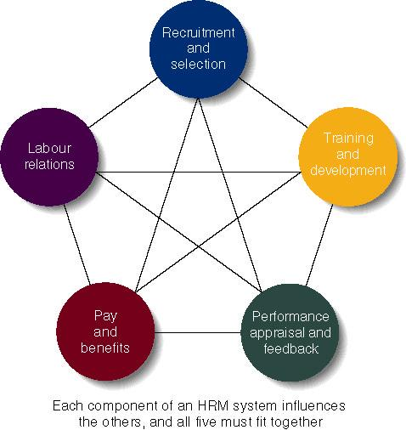

External Recruitment
- Managers look outside the firm for people who have not worked at the firm before
- Sources:
  - Advertisements
  - Open houses
  - Informal networks
  - Employment agencies
- Advantages:
  - Large applicant pool
  - Hire people with the necessary skills, knowledge and abilities
  - New ideas and latest technology
- Disadvantages:
  - Lowering moral of current employees
  - High costs
  - Performance of new recruits is nebulous

Internal Recruitment
- Managers look inside the firm at existing employees to fill the vacancy
- Sources:
  - Employees looking for lateral moves
  - Employees looking for promotion
- Advantages:
  - Employees already familiar with the organization
  - Managers already know internal candidates
  - Boost level of employee morale and motivation
  - Less time-consuming and less expensive
- Disadvantages:
  - Limited pool of candidates
  - Candidates set in organization ways
  - No new ideas

Identifying and Selecting Competent Employees
- Types of Selection Devices
  - Application Forms
  - Written Tests
  - Performance Simulations
  - Interviews
  - Background Investigations
  - Physical Examinations
- Selection Process
  - After a pool of applicants are identified, candidates’ qualifications related to the job requirements are determined:
    - Background Information: includes education, prior employment, etc.
    - Interview: almost all firms use one of two types:
      - Structured interview: managers ask each person the same job-related questions.
      - Unstructured interview: held like a normal conversation.
  - Testing: includes testing of ability, personality, physical ability, and performance
    - Ability test: assess if applicant has right skills for the job.
    - Personality test: seek traits relevant to job performance.
    - Physical ability test: assesses whether applicant has physical ability to do job task
    - Performance Tests: measure job performance.
        - Typing speed test is one example.
  - References: outside people provide candid information about candidate.
- Selection Tools: Reliability & Validity
  - Selection tools must be reliable and valid.
  - Reliability: the degree to which the tool measures the same thing each time it is used.
    - Scores should be close for the same person taking the same test over time.
  - Validity: Does the test measure what it is supposed to measure?
    - Example: does a physical ability test really predict the job performance of a firefighter?
  - Managers have an ethical and legal duty to develop good selection tools.
- Validity (of Prediction):
  - A proven relationship between the selection device used and some relevant criterion for successful performance in an organization.
    - High test scores equate to high job performance; low scores to poor performance.
- Reliability (of Prediction):
  - The degree of consistency with which a selection device measures the same thing
    - Individual test scores obtained with a selection device are consistent over multiple testing instances

Training & Development
- Training: teach organizational members how to perform current jobs.
    - Help worker’s acquire skills to perform effectively.
- Development: build worker’s skills to enable them to take on new duties.
    - Training used more often at lower levels of firm, development is common with managers.
    - A Needs Assessment should be taken first to determine who needs which program and what topics should be stressed.
- Types of Training and Development
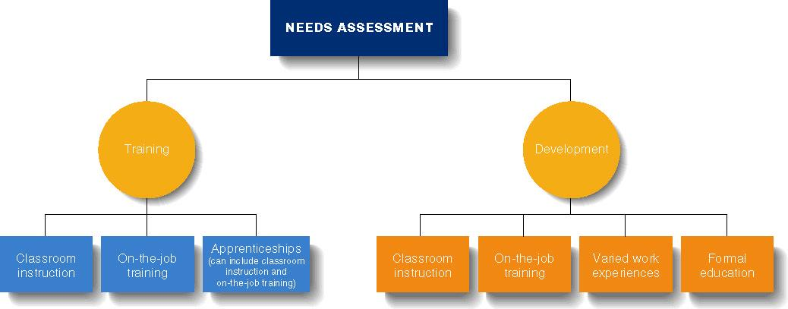
- Types of Training
  - Classroom Instruction: workers acquire skills in classroom.
    - Includes use of videos, role-playing and simulations.
  - On-the-Job Training: learning occurs in the work setting as worker does the job.
      - Training given by co-workers and can be done continuously.
  - E-training: online training helps employees keep up with skills and new products.
    - Includes online text, live presentations, slide shows, taped lectures, and video on demand.
  - Varied Work Experiences: Top managers must build expertise in many areas.
      - Workers identified as possible top managers given many different tasks.
  - Formal Education: tuition reimbursement is common for managers taking classes for MBA or similar.
  - Whatever training and development efforts used, results must be transferred to the workplace.

Performance Appraisal & Feedback
- Performance appraisal is the evaluation of an employee’s job performance and contributions to their organization
- Performance feedback is the process through which managers share performance appraisal information with their subordinates and develop a plan for the future
- Steps in the Performance Appraisal Process
  - Establish performance standards
  - Communicate the standards
  - Evaluate performance
  - Review results with employee
  - Take corrective action
  - Plan for the future
- Evaluating Performance – The Graphic Rating Scale
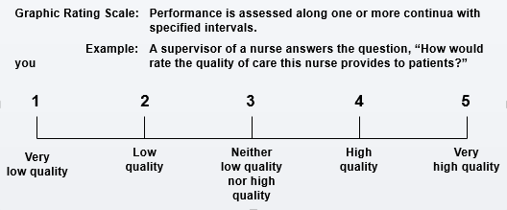
- Evaluating Performance – The Behaviourally Anchored Rating Scale (BARS)
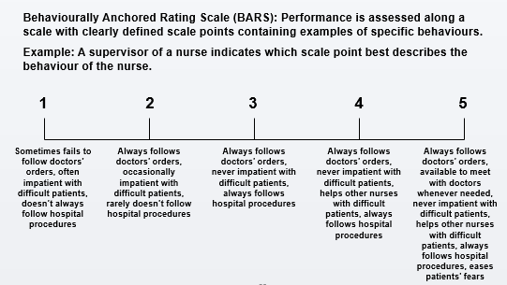
- Evaluating Performance – The Behavioural Observation Scale (BOS)
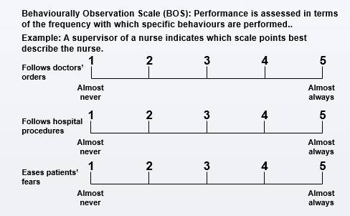
- Who Appraises Performance?
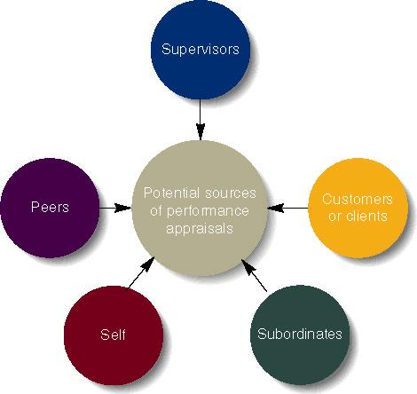

Effective Feedback
- Be specific and focus on correctable behaviour. Provide a suggested improvement.
- Focus on problem-solving and improvement, not criticism.
- Express confidence in worker’s ability to improve.
- Use formal and informal feedback.
- Treat subordinates with respect and praise achievements.
- Set a timetable for agreed changes.

Pay and Benefits
- Pay level: how the firm’s pay incentives compare to other firms in the industry.
    - Managers can decide to offer low or high relative wages.
- Pay Structure: clusters jobs into categories based on importance, skills, and other issues.
- Benefits: offered to employees in addition to their pay and are considered part of the compensation package
    - Some are required by law (social security, workers comp).
    - Others are provided at the employers option (extended health insurance, dental insurance, pension plans, life insurance, flexible working hours, daycare, wellness programs)

Retaining Competent and High Performance Employees
- Types of Compensation
  - Base wage or salary
  - Wage and salary add-ons
  - Incentive payments
  - Skill-based pay
    - A pay system that rewards employees for the job skills and competencies they can demonstrate

Motivation:
- The processes that account for an individual’s willingness to exert high levels of effort to reach organizational goals, conditioned by the effort’s ability to satisfy some individual need.
- Effort: a measure of intensity or drive
- Direction: toward organizational goals
- Need: personalized reason to exert effort
  - Motivation works best when individual needs are compatible with organizational goals.
- The Motivation Process
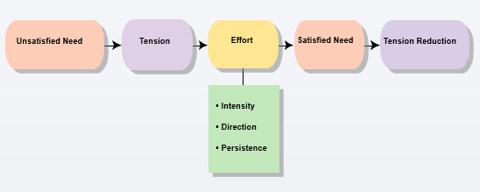

Early Theories of Motivation
- Maslow’s Hierarchy of Needs Theory
- Needs were categorized as five levels:
  - Individuals must satisfy lower-order needs before they can satisfy higher order needs.
  - Satisfied needs will no longer motivate.
  - Motivating a person depends on knowing at what level that person is on the hierarchy.
- Hierarchy of Needs
  - Lower-order (external): physiological, safety
  - Higher-order (internal): social, esteem, self-actualization
- McGregor’s Theory X and Theory Y
  - Theory X
    - Employees have little ambition, dislike work, avoid responsibility, and require close supervision.
  - Theory Y
    - Employees can exercise self-direction, desire responsibility, and like to work.
  - Motivation is maximized by participative decision making, interesting jobs, and good group relations.
- Herzberg’s Motivation-Hygiene Theory
  - Job satisfaction and job dissatisfaction are created by different factors:
    - (Theory X) Hygiene factors: extrinsic (environmental) factors that create job dissatisfaction (Satisfying hygiene does not lead to higher satisfaction but not satisfying hygiene will lead to lower satisfaction)
    - (Theory Y) Motivators: intrinsic (psychological) factors that create job satisfaction
  - Attempted to explain why job satisfaction does not result in increased performance.
    - The opposite of satisfaction is not dissatisfaction, but rather no satisfaction.
- McClelland’s Three-Needs Theory
  - Three acquired (not innate) needs—achievement, power, and affiliation—are major motives in work.
    - Need for Achievement (nAch): The drive to succeed and excel in relation to a set of standards.
    - Need for Power (nPow): The need to make others behave in a way that they would not have behaved otherwise.
    - Need for Affiliation (nAff): The desire for friendly and close interpersonal relationships.

Contemporary Theories of Motivation
- Goal-Setting Theory
  - The proposition that specific goals increase performance and that difficult goals, when accepted, result in higher performance than do easy goals.
    - Working toward a goal is a major source of job motivation.
    - The specificity of the goal itself acts as an internal stimulus.
  - Factors that influence the goal–performance relationship:
    - Feedback
    - Goal commitment
    - Self-efficacy
    - National culture
- Reinforcement Theory
  - The theory that behaviour is a function of its consequences.
  - Reinforcers - Consequences immediately following a behaviour that increase the probability that the behaviour will be repeated
- Job Design Theory
  - How tasks can be combined to form complete jobs
  - Factors influencing job design:
    - Changing organizational environment/structure
    - The organization’s technology
    - Employees’ skills, abilities, and preferences
- Job Enlargement: Increasing the scope (number of tasks) in a job.
- Job Enrichment: Increasing responsibility and autonomy (depth) in a job.
- Job Characteristics Model (JCM): A framework for designing motivating jobs.
  - Five primary job characteristics:
    - Skill variety: how many skills and talents are needed?
    - Task identity: does the job produce a complete work?
    - Task significance: how important is the job?
    - Autonomy: how much independence does the jobholder have?
    - Feedback: do workers know how well they are doing?
- Equity Theory
  - Proposes that employees perceive what they get from a job situation (outcomes) in relation to what they put in (inputs) and then compare their inputs-outcomes ratio with the inputs-outcomes ratios of relevant others.
  - If the ratios are perceived as equal then a state of equity (fairness) exists.
  - If the ratios are perceived as unequal, inequity exists and the person feels under- or over-rewarded.
  - When inequities occur, employees will attempt to do something to rebalance the ratios (seek justice).
  - Employee responses to perceived inequities:
    - Distort own or others’ ratios
    - Induce others to change their own inputs or outcomes
    - Change own inputs (increase or decrease efforts) or outcomes (seek greater rewards)
    - Choose a different comparison (referent) other (person, systems, or self)
    - Quit their job
  - Distributive Justice: The perceived fairness of the amount and allocation of rewards among individuals (i.e., who received what?)
  - Procedural Justice: The perceived fairness of the process used to determine the distribution of rewards (i.e., how who received what).
- Expectancy Theory
  - Individuals act based on the expectation that a given outcome will follow and whether that outcome is attractive.
  - Key to the Expectancy theory is understanding and managing employee goals and the linkages among and between effort, performance, and rewards.
    - Effort: employee abilities and training/ development
    - Performance: valid appraisal systems
    - Rewards (goals): understanding employee needs
  - Expectancy Relationships
    - Expectancy (effort-performance linkage)
      - The perceived probability that an individual’s effort will result in a certain level of performance.
    - Instrumentality
      - The perception that a particular level of performance will result in attaining a desired outcome (reward).
    - Valence
      - The attractiveness/importance of the performance reward (outcome) to the individual.

