Universtié d’Ottawa
Faculté de génie

Departement de
génie civil
L’Université canadienne
Canada’s university

GNG 1105
ENGINEERING MECHANICS
University of Ottawa
Faculty of Engineering

Civil engineering
Department

Final Examination
13 December 2010
Profs. Skaff, Van Blaeren and Flores-Vera
Time: 3 hrs
Page 1 of 2

___________________________________________________________________________________
Closed Book Examination. Programmable calculators are not allowed.
Free-body diagrams must be drawn where appropriate.
_________________________________________________________________________________
Problem 1 (16/60)
Mast ABC is being supported by a ball-and-socket joint at base A and by three cables BE, BG and CD as shown.
- Draw the free-body diagram for mast ABC
- Write the tensions in cables BE, BG and CD in vector form.
- If the tension in cable CD is 500 N, determine the tensions in cables BE and BG.
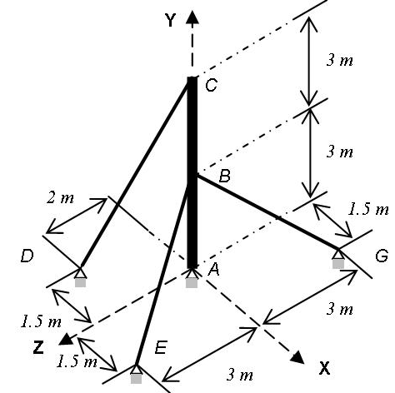

Problem 2 (11/60)
For the truss shown and assuming that all joints are pinned,
- Calculate the reactions at supports A & E.
- Determine the forces in members CD, GD and GF using the method of sections. State whether each member is in tension or compression.

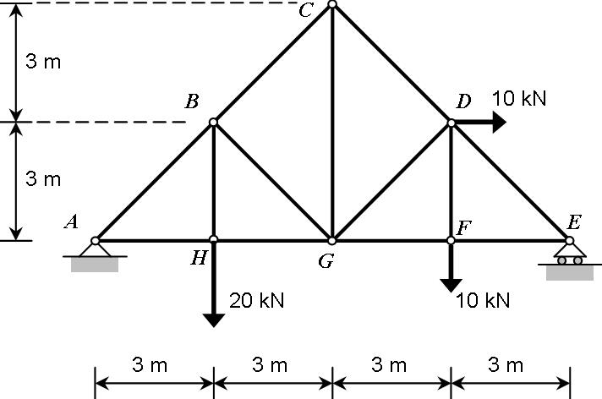

Problem 3 (11/60)
Two boxes are hanging from the frame shown to the right. The mass of each of these boxes is 30 Kg.
- Determine the reactions at the supports A and E.
- Determine all the forces acting on member ABC.
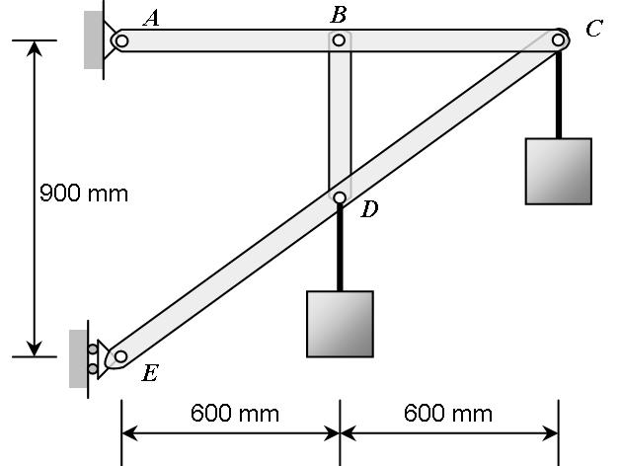

Problem 4 (11/60)
To level a wood deck, wood wedges A&B are placed under a corner of the deck. Wedge B rests on a wood board as shown, and a bar clamp is used to apply equal an opposite forces to the wedges. The load transmitted from the deck to the wedges is 8 kN. Knowing that θ=18° and that the coefficient of static friction between all wood surfaces is 0.35 and between the board and the ground is 0.6, determine the magnitude of P of the clamping forces for which upward motion of the deck is impending.

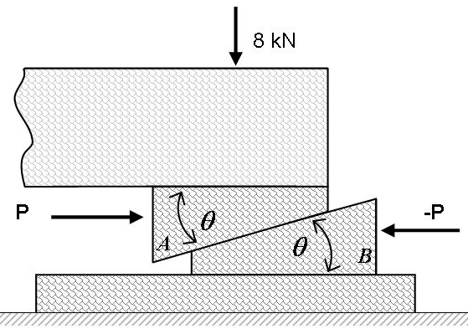

Problem 5 (11/60)
A projectile is fired from point A, located at h₀ = 2m above the ground, with an initial velocity v₀ and at an angle α=50°.
(a) What should be the minimum value of v₀ for the projectile to clear the wall if its height is H=5 m?
(b) For the value of v₀ obtained in part (a), determine the distance L that separates point A from the wall.


