Renal

Renal Overview
- Filtration occurs in the cortex
- Inner and outer medulla- concentrating effects of kidneys occurs- ex.. Removing salt from urine
- Urine gets collected in renal pelvis and exits through ureter to bladder
- Kidneys are constantly being profused with blood.. Need a lot of blood to filter
- 99% of what is filtered gets reabsorbed
- 1% gets excreted as urine
- Renal blood flow=1200ml/minute
- 25% cardiac output:
  - 1-2% medulla
  - 90% cortex
- 99% (180L filtered/24hrs) absorbed
  - 1% (1-1.8L of urine) excreted
- 1 million nephrons in each kidney… normal distribution between individuals, some have more some have less
- fewer nephrons leads to issues later on
- Filtration occurs in glomerulus of nephron

Glomerulus
- Blood enters afferent arteriole
- Endothelial layer in capillary loop… full of wholes (fenestrated) which enable it to filter large volumes of fluid and electrolytes
- Podocyte… epithelial cells which act as a final barrier for filtration
- Bowmand capsule encases glomerulus
- Mesangial cells give strength to glomerulus… can contract and relax to increase/decrease the size.. Can control how much is being filtered at a time
- Podocytes can contract and relax also.. Can prevent capilaries from ballooning out

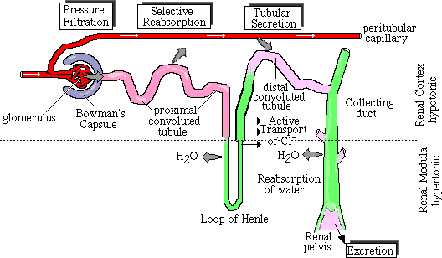

- Proximinal Convoluted Tubule… where bulk of glucose amino acids proteins water and salt are reabsorbed… 65-80% is reabsorbed at PCT

Glomerular Filtration Rate
- Used to know how well kidneys function
- Rate at which plasma moves through glomerular capillaries
- Units - ml/min
- Females 85-125 ml/min, Males 97-140 ml/min for two kidneys
- Children reach adult proportions by 2 years of age

Driving force for GFR
- Glomerular capillary hydrostatic pressure
- Force going into the glomerulus… force things in a positive direction through the filter

Determinants of GFR
- GFR = K_{f} (P_{GC} - (P_{T} + COP_{GC}))
- K_{f} = ultrafiltration coefficient. Includes capillary surface area and fluid permeability
- P_{GC} = glomerular capillary pressure
- P_{T} = tubular pressure
- COP = colloid osmotic pressure
- UFP= net filtration pressure (ultra)
- Ultrafiltration coefficiant… surface area that there is for filtration, can shrink
- Tubular pressure… pressure in opposite direction back into the filter
- Ufp.. Difference in all of the forces

GFR = K_{f} x (P_{GC} – P_{BC}) – (π_{GC} - π_{BC})

Ultrafiltration pressure decreases along the length of the glomerular capillaries
- Ultrafiltration pressure does decrease along the glomerular capillaries due to the rise in colloid osmotic pressure as filtration takes place. There is evidence that a point occurs along the glomerular capillaries when the ultrafiltration pressure falls to zero and filtration stops. This is called filtration equilibrium. I have included a figure of this in your notes and an explanation. The existence of filtration equilibrium explains why increases and decreases in renal plasma flow affect GFRi.e. the net driving forces favoring and opposing filtration are unchanged but the rate at which renal plasma enters the glomerulus does affect the total amount filtered. Filtration equilbrium normally occurs when 20% of the plasma has been filtered. That is because the point at which the net forces opposing filtration equal the forces driving filtration i.e. colloid osmotic pressure has risen occurs when about 20% of the plasma has been filtered. So it is possible for the pressures not to change but the amount of plasma entering the glomerulus decreases by from lets say a normal adult value of 700 ml/min where GFR = 140 ml/min, to a RPF of 600 ml/min, filtration equilbrium will occur when the colloid osmotic pressure rises to equal the outwardly directed forces favoring filtration which will be when about 20% is filtered and GFR now will only be 120 ml/min.
- Negative cause it’s a force drawing fluid back into the capillary
- Gets more concentrated moving from afferent to efferent end

How is GFR measured?
- Reminder: Glomerular filtration rate (GFR) is the volume of fluid filtered from the glomerular capillaries into Bowman’s capsule per unit time. Clinically, GFR is measured to determine renal function.

Characteristics of a substance used to measure GFR
- Must be freely filtered
- Must not be reabsorbed or secreted
- Must not be synthesized or catabolized by the kidney
- Must not alter GFR

Substances used to measure GFR
- Inulin-Gold standard
- Creatinine-Clinical standard
  - Creatinine is excreted mainly by filtration
  - Creatinine is produced by skeletal muscle at a constant rate from creatine-phosphate
- Cystatin C
  - -produced by nucleated cells

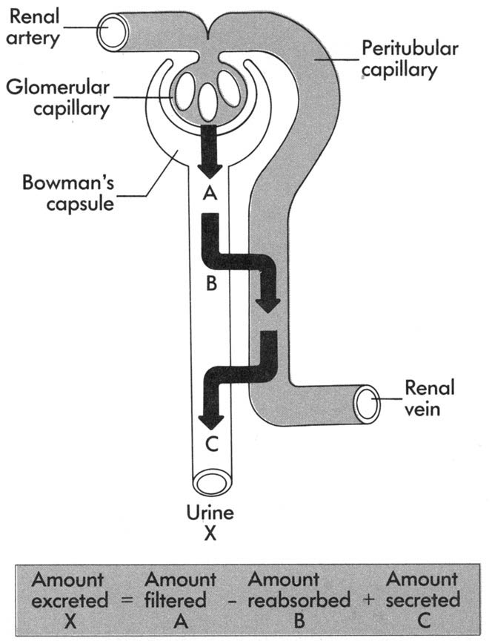
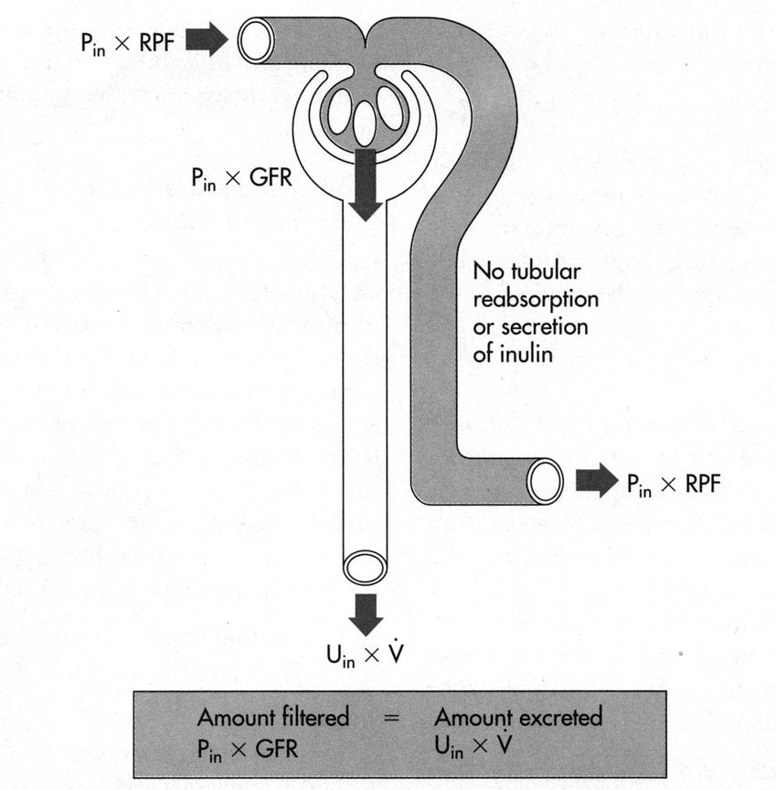

Measuring GFR Creatine
- C_{Creatinine} = GFR
- GFR= [Cr] urine X Urine flow rate
[Cr] plasma
- Requires
  - 12-24 hr urine collection (timed)
  - mid-point blood sample
  - [Cr] in urine and plasma

Creatine Clearance: slightly overestimates GFR
- C_{In} = GFR
  - Inulin is excreted at the rate at which it is filtered
- C_{Creatinine} > GFR
  - creatinine is also secreted by proximal tubules

Plasma [Creatinine] reflects GFR in Steady-State Conditions
- Creatinine is produced by skeletal muscle at a constant rate
- Creatinine is excreted mainly by filtration I.e. GFR X plasma [Cr]
- Renal excretion = Muscle production
- Therefore, Plasma [Cr] is constant under normal circumstances
- Range of normal plasma [Cr] is 50-110 µmol/L
- If kidney function declines creatinine is going to build up in plasma

Plasma [Creatinine] Reflects GFR in Chronic Kidney Disease (CKD)
- If GFR decreases, then excretion < (less than) production, so plasma [Cr] increases
- New steady-state is reached, excretion = production
- Plasma [Cr] is now increased

Plasma [Creatinine] does not Accurately Reflect GFR in Acute Kidney Injury (AKI)
- If GFR suddenly decreases e.g. to zero, a new steady state will not be reached since excretion will be zero and production continues
- Plasma [Cr] continuously increases
- The increase plasma [Cr] will always underestimate the loss of GFR- lags behind

What equation do we use?
- Don’t forget that the units of urine and plasma [Cr] must be the same
- The units of urine flow rate will become the units of GFR. For these problems GFR will be in ml/min.
- Serum and plasma concentrations can be considered to be the same

Renal Pathophysiology

Renal failure- definitions
- Acute Kidney Injury AKI-Sudden decrease in GFR to a level insufficient to maintain homeostasis.
- May be caused by factors:
-upstream of the kidney i.e. pre-
-intrinsic renal failure i.e. primary
-downstream of the kidney i.e. post-renal failure

AKI
- Pre-renal failure: usually related to decreased perfusion (GI losses, burns), CHF or low BP
- Intrinsic renal failure (vascular, glomerular or tubular): toxins i.e. mercury or iron, obstruction to blood flow i.e. arterial stenosis, renal embolism/ thrombosis –arterial or venous, RPGN (ANCA, αGBM)
- Post-renal failure: obstruction of urine flow–e.g.prostatic enlargement, uretheral obstruction (renal stone lodged in the urethra)
- GFR is reduced in every nephron and depending on the extent of damage may be reversible in nature
- Depending on the damage, AKI can lead to chronic Kidney Disease (CKD)
- RIFLE criteria:
- Risk: serum creatinine increased 1.5 times or urine production of <0.5 ml/kg for 6 hours
- Injury: doubling of creatinine or urine production <0.5 ml/kg for 12 hours
- Failure: tripling of creatinine or creatinine >355 μmol/l (with a rise of >44) (>4 mg/dl) OR urine output below 0.3 ml/kg for 24 hours
- Loss: persistent AKI or complete loss of kidney function for more than 4 weeks
- End stage renal disease: complete loss of kidney function for more than 3 months

Renal Disorders- obstructive
- Stones (nephrolithiasis) – calcium oxalate/struvite/uric acid etc.
- Prostate enlargement (cancer or BPH)
- Renal artery stenosis

Kidney stones
- Cause by
  - Low fluid intake
  - Dietary protein/sodium, oxalate, grapefruit juice
  - Calcium oxalate is a major component
- Treatment
  - Alkalinazaton of the urine
  - Diuretics
  - Removal of the stone

Urinary tract infections
- Low ph and flow rate typically discourage bacterial growth in the urinary tracts
- Risk factors
  - More common in women
  - Reflux
  - Stones
  - Pregnancy
  - Catheters
- Typical organisms include
  - Gram negative E coli
  - Klebsiella
  - Proteus
  - Staphylococcus saprophyticus
- Treatment
  - Antibiotics

VUR (vesicouretheral reflux)
- The two types of VUR are primary and secondary;
- Most cases of VUR are primary and typically affect only one ureter and kidney. With primary VUR, a child is born with a ureter that did not grow long enough during the child’s development in the womb. The valve formed by the ureter pressing against the bladder wall does not close properly, so urine refluxes from the bladder to the ureter and eventually to the kidney. This type of VUR can get better or disappear, as a child gets older. As a child grows, the ureter gets longer and function of the valve improves.
- Secondary VUR occurs when a blockage in the urinary tract causes an increase in pressure and pushes urine back up into the ureters. Children with secondary VUR often have bilateral reflux. VUR caused by a physical defect typically results from an abnormal fold of tissue in the urethra that keeps urine from flowing freely out of the bladder.
- VUR is usually classified as grade I through V, with grade I being the least severe and grade V being the most severe.

Molecular Sieving
- Glomerular capillaries are molecular sieves
- Molecules > 10,000 MW are not freely filtered (too big)
- Glomerular capillary basement membrane has fixed negative charges
- Albumin is negatively charged
- Charge repulsion contributes to low albumin permeability

Proteinuria
- Indicates glomerular damage
  - Microalbuminuria: >150mg/day < 1 gm
    - Cause: Glomerular Hypertension
  - Gross proteinuria : >2-3 gm/day
    - Cause: Autoimmune (loss of fixed negative charge) Nephrotic syndrome
  - Nephritis: > 1 gm
    - Cause: Glomerular inflammation
- The higher level of urinary protein the more at risk you are for disease

CKD
- Gradual decline in GFR that progresses over a period of years. Eventually End Stage Renal Disease (ESRD) occurs where renal function is insufficient to maintain homeostasis
- If the primary disease process causes nephron loss, one sees hyperfiltration in the remaining nephrons with a continual steady reduction in the number of nephrons
- CKD may be slowed but can never be reversed

Nephrotic vs. Nephritic syndromes
- Nephrotic syndrome is a group of symptoms including proteinuria (more than 3.5 grams per day), low blood protein levels, high cholesterol levels, high triglyceride levels, and edema.
- Nephritic syndrome is a group of disorders that cause swelling or inflammation of the internal kidney structures (specifically, the glomeruli).

Nephrotic syndrome
- Excessive leakage of protein through the glomerular filtration barrier
- 3gm protein / day
- Edema
- Hypertension
- Usually no hematuria
- Can be caused by a number of glomerular diseases
  - FSGS, congenital conditions, membranous nephropathy, diabetic kidney disease, minimal change disease

Causes of CKD
- Diabetes
- Hypertension
- FSGS
- Genetic mutations

Focal segmental glomerulosclerosis (FSGS)
- Blue is the glomerulus scar… made up of a collagen material produced by cells inside
- Scaring because podocytes have become injured and fallen off causing a denuted membrane.. Capillarly loop balloons up and comes in contact with cells on bowmans capsule.. Without scar material blood would leak out, scar cuts off filtration in the area.. GFR capacity drops

Mininmal change disease
- More common in children
- Can be treated with steroids
- No change in gross glomerular architecture
- Podocyte foot process effacement
- Heavy proteinuria

Diabetic kidney disease
- Most common cause of CKD (~33-40% of new cases)
- 1/3 of diabetics will develop DKD (takes many years for onset)
- Tx = glycemic and BP control (ACEi / ARBs)
- 10-15 years from diagnosis until first signs of kidney disease pop up
- Blood sugar levels drop because they are peeing out all of the glucose
- As a global epidemic:
  - Diabetes — or complications from the disease — now kills 3.8 million people a year
  - 40-45% of new ESRD cases (85-90% loss of renal function)
  - DKD
    - Progressive GFR decline
    - Persistent proteinuria
    - Increased BP
    - ↑Risk of CV disease
  - Heavy economic burden

Clinical manifestation of DKD
- Functional injury
  - Early microalbuminuria and increased GFR
  - Progressive decrease in GFR due to structural damage
- Structural injury
  - 1st change : increase GBM width and mesangial index
  - Podocyte loss or damage
  - Progressive glomerular scaring/collapse
  - Tubular lumen obliteration
- When you lose a podocyte it is difficult to replace because they don’t divide

Nephritic system
- Can be caused by…
- …think infection or immune system (itic)
- Glomerulonephritis (e.g., Goodpasture disease, membranoproliferative GN etc)
- Lupus nephritis
- IgA nephropathy
- Hemolytic uremic syndrome
- Poststreptococcal GN
- Symptoms:
  - Hematuria
  - Proteinuria
  - Rapid reduction in GFR
  - Hypertension

IgA nephropathy
- Can produce abnormal types of IGA which find their way to the kidney
- Sangial cells.. Gets lodged in and cause an immune response

Membrane nephropathy
- Antibodies that find their way to glomerular basalar membrane
- Immune complexes that form disrupting filtration barrier

Disorders caused by renal failure
- Hyperkalemia
- Elevated Plasma [K]- above 5.0 mM
- Develops rapidly in AKI
- Develops late in CKD when only about 25% of kidney function remains
- The most life-threatening disorder caused by renal failure
- Causes sustained sub-threshold depolarization of cardiac muscle
- This inactivates Na channels and makes the heart unexcitable
- The heart can stop in severe hyperkalemia
- Edema and hypertension
- Increased intravascular volume
- Our diet is rich in NaCl
- The kidney is the main route (99%) of excretion
- Na is filtered and reabsorbed extensively
- As nephrons are lost, the remaining nephrons have to reabsorb more Na
- There is a limit to this process
- Metabolic acidosis
- The kidney is one of the main organs that controls the pH of body fluids
- As [H⁺] increases-pH decreases
- Brain function decreases as pH decreases
- Disorientation progressing to coma is the main concern
- Uremia
- Increased blood urea nitrogen (BUN)
- All unregulated solutes excreted by the kidney will be increased
- Creatinine is the most reliable reflection of GFR since BUN is affected by other variables e.g. protein intake and state of hydration
- Urea and creatinine are non-toxic
- Severe itching is due to other substances
- Protein is metabolized to urea in the liver
- Only route of urea elimination is by the kidney
- As GFR decreases, Blood Urea Nitrogen (BUN) increases
- Anemia
- Reduced production of RBCs
- Is the most debilitating disorder caused by CRF– it has major negative effect on the quality of life
- Fatigue due to anemia is frequently the main clinical presentation of CRF i.e. brings the patient to medical attention
- Erythropoietin is the main hormone controlling RBC production and is produced exclusively by the kidney in response to decreased oxygen delivery
- Erythropoietin stimulates bone marrow production of RBCs
- Erythropoietin levels decrease with decreased functional renal mass
- Recombinant human hormone- Epo- eliminates anemia in CRF
- Must be injected and is expensive
- Huge impact on quality of life
- Bone disease in CFR
- Is due to loss of calcium phosphate from bone that can not be replaced from dietary intake due to deficiency of active Vitamin D – 1-25-diOHVitD3
- Calcium depletion from bone is stimulated by Parathyroid hormone- PTH.
- PTH increases as GFR decreases
- This is a negative consequence of a normal homeostatic mechanism
- Referred to as “A Trade-off Hypothesis”
- Unable to concentrate or dilute urine-isothenuria
- Characteristic of End Stage Renal Disease
- Must consider either transplantation or dialysis
- Not a major problem in and of itself, but indicates that the remaining nephrons are unable to compensate to maintain normal homeostasis
- Due to increased excretory burden per nephron which impairs diluting and concentrating ability

Angiotension Converting Enzyme Inhibitors and AngII Antagonists have a Special Role in the Treatment of CRF
- Ang II receptor stimulation contributes to the resistance of the efferent arteriole
- Decreased production of Ang II or receptor blockade allows the efferent arteriole to dilate
- This offsets the effect of afferent arteriole dilatation and causes glomerular capillary pressure to fall back to normal!

Kidney Disease treatment options
- BP control (target <130-140 mmHg systolic) ACEi / ARBs
- Diet
- Dialysis (hemodialysis / peritoneal dialysis)
- Transplant (age / chance of recurrence – ie primary FSGS / rejection / length of time to find appropriate donor)

