Unit 5 notes:
- Elasticity is a numerical measure of the responsiveness of Q^{d} or Q^{s} to one of its determinants.
- Price elasticity of demand measures how much Q^{d} responds to a change in price.
- Demand is said to be elastic if the quantity demanded responds substantially to changes in price.
- Demand is said to be inelastic if the quantity demanded responds slightly to changes in price.
- The Price elasticity of demand for any good measures how willing consumers are to buy less of the good as its price rises.
- There various factors that determine the elasticity of a good:
  - Availability of close substitutes:
    - Goods with close substitutes tend to have a more elastic demand.
  - Whether the good is a necessity or a luxury
    - Staples/ necessities tend to have an inelastic demand, but luxuries have elastic demand.
  - Definition of market
    - Narrowly defined market tend to have more elastic demand than broadly defined markets because it’s easier to find close substitutes for narrowly defined goods.
  - Time horizon
    - Elasticity is higher in the long run than the short run.

- Midpoint method of finding elasticity:
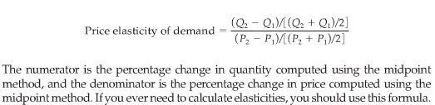
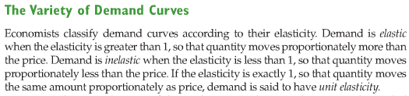
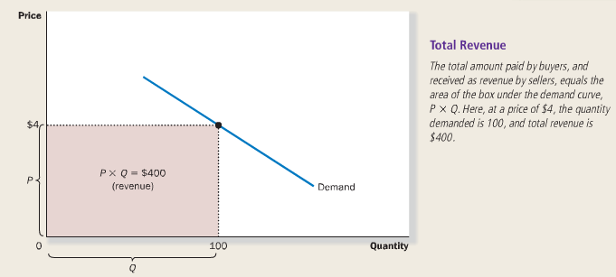
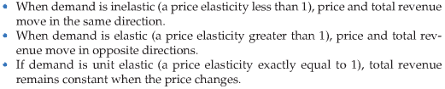
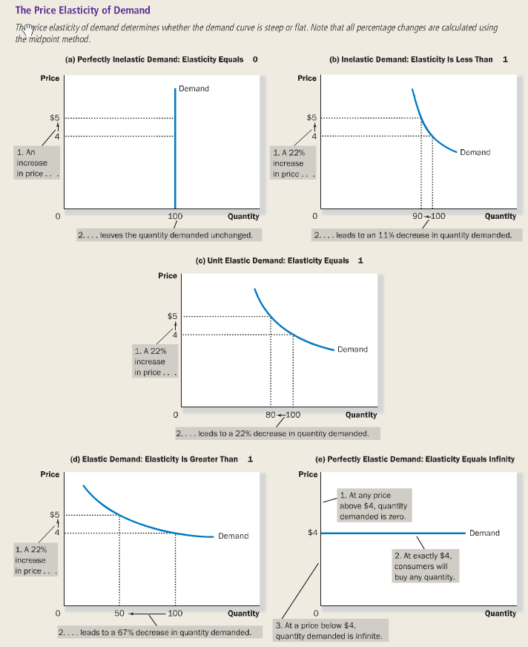
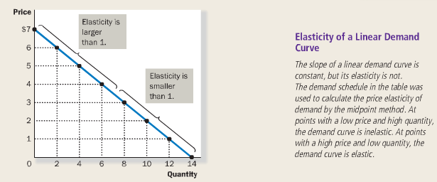

- Income elasticity of demand: a measure of how much the quantity demanded of a good responds to a change in consumers’ income, computed as the percentage change in quantity demanded divided by the percentage change in income.

- Cross-price elasticity of demand: a measure of how much the quantity demanded of one good responds to a change in the price of another good, computed as the percentage change in quantity demanded of the first good divided by the percentage change in the price of the second good

- Price elasticity of supply: a measure of how much the quantity supplied of a good responds to a change in the price of that good, computed as the percentage change in quantity supplied divided by the percentage change in price
- Supply of a good is said to be elastic if the quantity supplied responds substantially to changes in the price, and inelastic if the quantity supplied responds only slightly to changes in the price.
- Supply is usually more elastic in the long run than in the short run.

