Marketing notes
Module 1 –
What is marketing ?
-> Organizational Function and a set of processes that subject to constrains, attempts to establish mutually satisfying product exchange relationships between any 2 interesting parties.

Any 2 interesting parties :
Places, properties, organizations, information, ideas, goods, services, experiences, events, persons.

Product Exchange Relationship Marketing View of a Product

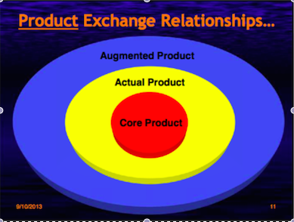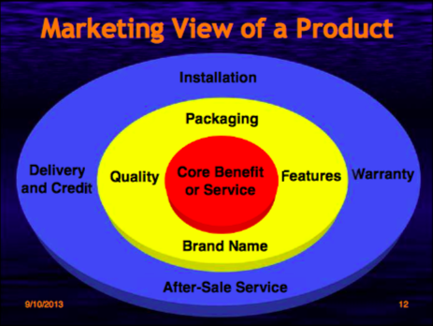

- Does Marketing Satisfy Needs?
  - Needs: difference between a consumer’s actual and some ideal or desired state.
  - Wants: Desire to satisfy need in ways that are influenced by culture and society.
  - Benefits: Outcome sought by a consumer that motivates buying behavior.
- Does Marketing create Needs?
  - Who is most likely to be victimized by marketers?
  - Have you ever been influenced by a marketer to buy something you didn’t need?
    - …Stated needs
    - ...Real needs
    - …Delight needs
    - …Secret needs
- Are All Consumers Alike?
  - Quality or quantity,
    - Walmart < --- > Lord Piana
Everytown, USA Madison Ave. NYC
Smalltown, CAN Venice, Italy
Kotler on Marketing
- It is no longer enough to satisfy customers. You must delight them.

Business Evolution:
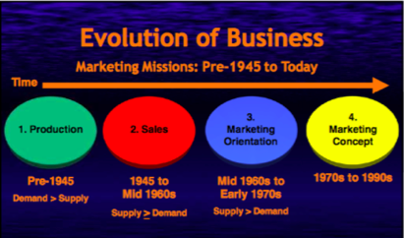

Marketing Concept:
Identify and Satisfy customer needs while making a profit.
- Satisfaction of consumer wants and needs… super-ordinate goal
- Coordinated with other business functions
- Profit Maximization

Where is Marketing Today ?
Marketing Realities of Today
- Information Clutter
- Declining Brand Loyalty
- Consumer Cynicism
- Need for Knowledge
- Internet Based Customization
- Globalization

Business Today
- Super Fast Marketing
  - Motorola
  - TD bank
  - Levi-Strauss
- Super Value Marketing
- Guarantee Marketing Relationship Building
  - Warranty Marketing
  - Service Contracts
  - Extraordinary Guarantee
- Network Marketing
- Synergistic Marketing
- Marketing Engineering
- Upside down/Crowd Marketing
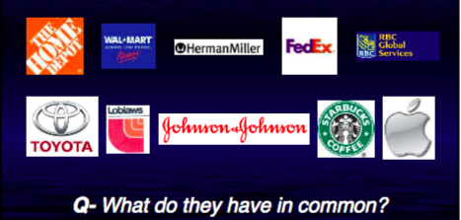
Most Admired Companies

Satisfy Needs to Relationship Marketing
Consumer Satisfaction Consumer Relationship
One off (Money) Relationship Building
Investment in products Investment in customers
Market Segmentation . Customer Analysis
Short Term Profit Max Long term Wealth Max.

Change in Focus ….
- A 5% increase in customer retention can significantly increase profitability, ranging from :
25% on bank deposit
85% on Car Servicing
- A 2% rise in customer retention has the same effet on profitability as a 10% reduction in overheads

Attracting and Retaining Customers
- Forming strong customer bonds
  - Listen to the Voice of the Customer
  - Create superior offering
  - Reward Outstanding offering
  - Reward outstanding employees
- Adding Financial Benefits
  - Frequency programs
- Adding Structural Ties
  - Create long-term contracts
  - Lower Price for High Volume
  - Turn product into long term service

Relationship Marketing
Relationship Marketing
- Form of marketing developed from direct response marketing campaigns, which emphasizes customer retention and satisfaction, rather than a dominant focus on sales transactions.
- Drivers of Relationship Marketing
  - Technology
  - Need for real time MR
  - Need for integrating design and Manufacturing
  - Need for Knowledge
  - Need for Dialogue and integrated communications

Need for Knowledge ……..Made Possible by Technology

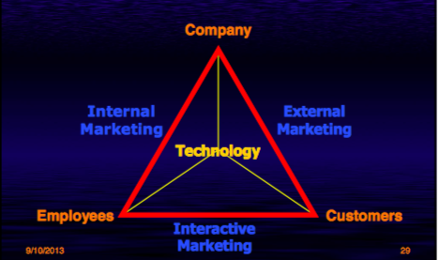

The 4P’s Are Changing
- Product
  - Content, context, infrastructure, Branding
- Price
  - Perceived Value, Dynamic, Auctions
- Promotion
  - Dialogue, buzz marketing, viral marketing, placement, PR, Co-promo.
- Place
  - Networks, Alliances, Organic Structures.

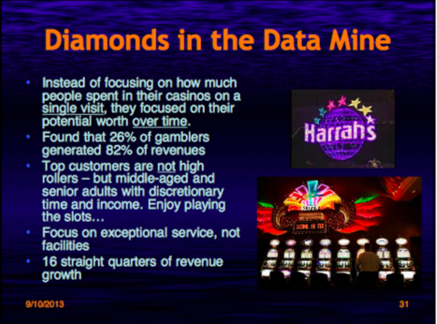
Text Book chapter 1 –
Marketing
- Is a set of business practices designed to plan for and present an organization’s products or services in ways that build effective customer relationships.
- Requires thoughtful planning with an emphasis on the ethical implications of any of those decisions on consumers and society in general.
- Firms develop marketing plans that specifiy the marketing activities for a specific period of time.
  - How will the product be promoted
  - How will it be designed
  - How will it get to the consumer

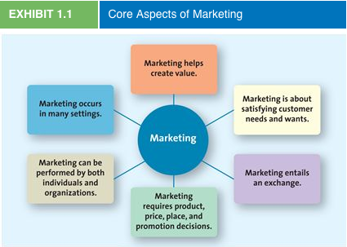

Marketing Is About Satisfying Customer Needs and Wants
Understanding and satisfying consumer needs and wants is fundamental to marketing success.
Need – When a person feels deprived of the basic necessity
Want – The particular was a person chooses to fulfill his or her need.
To Understand consumer needs, one must look at the Market
Market- Consists of all consumers who need or want a company’s products or services and have the ability and willingness to buy them.
Target Market – The customer segment or group to whom the firm is interested in selling its products and services.

Marketing Entails Value Exchange
Exchange – Trade of things of value between the buyer and the seller so that each is better off as a result.
Buyers complete an exchange by giving money and information to the seller.
When you make a purchase on ITUNES for example, other than paying them you have provided them with information to facilitate future exchanges and relationships when something new is released that you may be interested in.

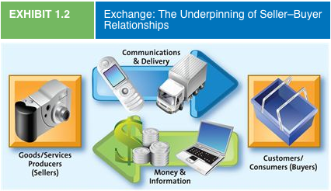

Marketing’s 4P’s
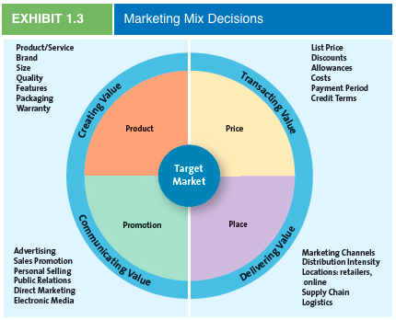
Product : Creating Value
- by developing a variety of offerings, including goods, services, and ideas, to satisfy customer needs.
- Example: Water bottles; Give people impressions that they are great and better than others. Some take it as socially unacceptable that they banned water from being on property.
- Goods: items that you can physically touch.
- Services: Intangible customer benefits that are produced by people or machines and cannot be separated from the producer.
- Ideas: include thoughts, opinions, philosophies and intellectual concepts that also can be marketed.

Price: Transacting Value
- Everything has a price though it does not always have to be monetary.
- Price: is everything the buyer gives up- money, time, energy- in exchange for the product.
- Example: buying your ticket for a business class seat on the last minute, you end up paying double the price as if u had it planned a head of time.
  - You have traded off a lower price for convenience.
Marketers key determining prices of figuring out how much customers are willing to pay so that they are satisfied with the purchase and the seller achieves a reasonable profit.

Place: Delivering Value
- All activities to get the product from the manufacturer or producer to the right customer when that customer wants it .
- Intentionally overlook the importance of distribution management because of a lot of distribution activities occur behind the scenes.
Promotion: Communicating Value
- Promotion is communication by a marketer that informs persuades and reminds potential buyers about a product or service to influence their opinions or elicit a response.
- Can enhance a product or service’s value, as happened for Parasuco jeans
  - Provocative advertising has helped them create an image that says more than “ Use this product and you’ll look good “

- The 4P’s Work together
- They can deliver greater value to consumers by configuring the 4P’s as a while rather than by treating them as separate components.

Forcing and Players With the Firm shape marketing
- Marketing activities are shaped by factors that are both internal to the firm and external.

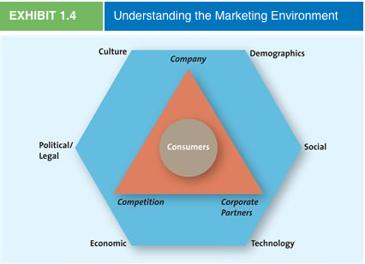

Forces and Players External shape marketing to the Firm
External forces such as cultural, demographic, social, technological economic and political and legal changes shape a company’s marketing activities.
Concerned with environment: use environmental packaging
Obesity: Make health-attracting labels, DIABETES FREE, FAT FREE.

Individuals and Organizations perform marketing
B2C- business to consumer
Business sells to consumer
B2B – Business to Business
Selling service or merchandise from business to business
C2C- Consumer to Consumer
Consumers sell to consumers

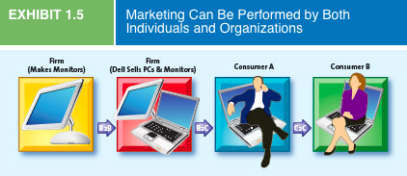

Social Media :
Important for marketers
- So many people are engaged on the social media.
- High level of interactions online
- Promoting and building customer relation

Marketing occurs in any Setting
Hospitals, theaters, charities, museums, religious institutions, politicians, and even governments rely on marketing to communicate their message to their constituents.
Marketing is often designed to benefit an entire industry, which can help many firms simultaneously.

Creating Value
- 4 marketing orientations or philosophies:
  - Product orientation
    - Focus on the developing and distribution of innovative products with little concern about whether the products best satisfy customers’ needs.
    - “Customers have any color they want so long as its black”
good products would sell itself and retail stores tyoically were considered places to hold the merchandise until a consumer wanted it.
    - They try to sell after it is developed rather than planning what customers would need.
  - Sales orientation
    - Companies try to sell as many of their products as possible rather than focus on making products consumers really want.
    - Tend to focus on heavy dose of personal selling and advertising to sell new products.
    - Focus on sales rather building a customer relation.
    - Believe customer will like their products if purchased.
  - Market orientation
    - Focus on what consumers want and need
    - Base their products on quality, convenience, and price.
    - Marketers’ role is to focus on customer needs and do anything to satisfy them.
  - Value based orientation
    - Gone beyond a production or sales orientation and attempt to discover and satisfy their customers’ needs and wants
    - To compete, they must give their customers greater value and their competitors.

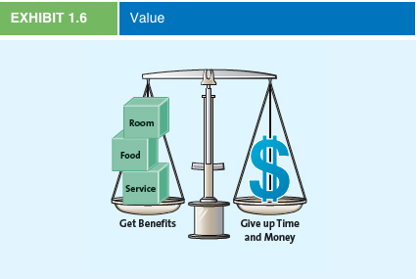
      - Value : reflects the relationship of benefits to costs or what you get for what you give.
    - Customers seek a fair return in goods and/or services for their hard earned money and scarce time.

Value Based Marketing
- A business must also understand what customers view as the key benefits of a given product or service and how to improve them.
- Some critical benefits may be service quality, convenience and merchandise quality.
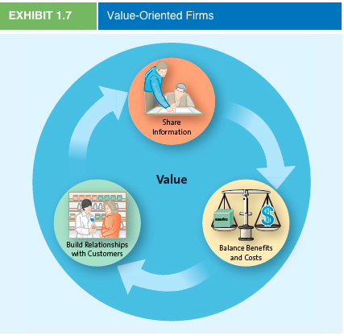
How firms Compete on the Basis of Value

- Good Value is not limited to low prices. Walmart Carries low priced products compared to Paderno, but customers of Padero say they are satisfied wit their products because of the price and expert advice given to the, at the moment of purchase.

How Firms Become Value Driven
- 3 Activities :
  - Share information
  - Balance Benefit Costs
              - Build Customer Relation
Building Relation with Customers
- Transactional Orientation: Buyer-seller relationship as a series of individual transactions, so everything that happens before or after the transaction is of little importance.
- Relational Orientation: Based on the philosophy that buyers and sellers should develop a long-term relationship.
- Customer Relationship Management ( CRM ): a business philosophy and set of strategies, programs and systems that focus on identifying and building loyalty among the firm’s most values customers.

Importance of Marketing
- It creates valuable relationships between the company and the suppliers and the 3rd parties.
- It identifies those elements that local customers value and makes it possible for the firm to expand globally.

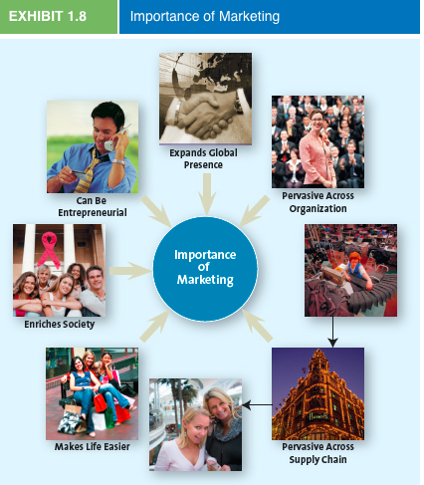
Marketing is Pervasive Across the Supply Chain
- Supply Chain: The group of firms and set of techniques and approaches firms use to make and deliver a given set of goods and services
- Some supply chain participants take a transactional orientation in which each link in the chain is out for its own best interest.
  - Manufacturers want the highest price, whereas retailers want to buy the product at the lowest cost.
  - Managing supply chain relationships often has a huge impact on a firm’s ability to satisfy the consumer, which results in increased profitability for all parties.
Marketing Makes life Easier
- Ensures your needs are met
- Ensures a price that satisfies the product
- Provide a good and pleasant offering place to shop with good opening hours.

