Ecology Lecture Notes

Lecture 1

- ecology is (two definitions):
- the scientific study of interactions between organisms and their environment
- the scientific study of interactions that determine the distribution (geographic location) and abundance of organisms
- other meanings in public usage
- differs from environmental activism and environmental science (solutions to environmental problems)
- doesn’t have to be a natural setting
- certain organisms that are beneficial to us and that we value and want in our systems
- a lot of ecological questions ask why organisms are distributed in certain ways
- most common misconception is putting ecology with environmental activism
- environmental science is what pulls in solutions to environmental problems
- general misconceptions:
- balance of nature: return to original preferred state after disturbance
- each species has a distinct role to play in maintaining that balance
- ecological maxims are guiding principles for how you study ecology
- organisms interact and are interconnected
- everything goes somewhere
- no population can increase in size forever (eventually it has to level off)
- finite energy and resources result in trade offs (determine why one organisms benefits over the other)
- organisms evolve (evolutionary process)
- communities and ecosystems change over time (everything changes)
- spatial scale matters

Key Terms for studying connections in nature:
- adaptation: a characteristic that improves survival or reproduction
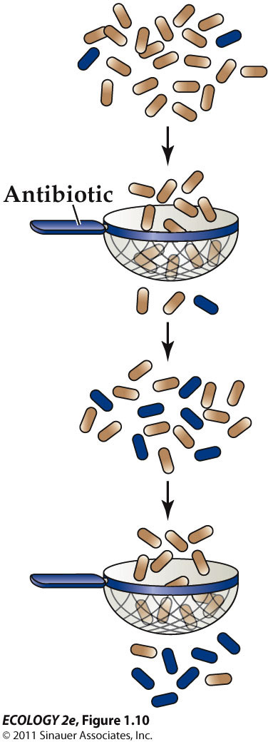
- natural selection: individuals with certain adaptations tend to survive and reproduce at a higher rate than other individuals
- if the adaptation is heritable, the frequency of the characteristic may increase in a population over time
the blue happened as a result of mutation or they moved into the population. over time the ones that could adapt and resist were the survivors
Ecological hierarchy: organism population community ecosystem biosphere

- population: group of individuals of a species that are living and interacting in a particular area
- community: association of populations of different species in the same area
- you can have two populations that have intermixing which can make it complicated sometimes
- ecological studies often include both the biotic (living components), and abiotic (physical components) of natural systems
- ecosystem: community of organisms plus the physical environment
- landscapes: areas with substantial differences, typically including multiple ecosystems
- all of the world’s ecosystems comprise the biosphere – all living organisms on Earth plus the environments in which they live

Ecosystem processes:
- producers capture energy from an external source (e.g. the sun) and use it to produce food
- Net primary productivity (NPP): energy captured by producers, minus the amount lost as heat in cellular respiration
- consumers get energy by eating other organisms or their remains

How ecosystems work
- energy moves through ecosystems in a single direction only – it cannot be recycled
- but nutrients are continuously recycled from the physical environment to organisms and back again – this is the nutrient cycle
- Nutrients tend to cycle throughout ecosystems, find their way into biologically available forms and get eaten by animals and when the animals die they go back into the soil
- Energy flow only goes in one direction till its lost, lose energy every step of the way
- ecological experiments can be done at different scales (in a lab, small area, large area)
- problem with ecosystem study: don’t have a lot of control, lots of ecosystems involved

Ecological Experiments: design and analysis
- assignments of treatments and control
- replication
- random assignment of treatments
- statistical analyses (statistical vs. biological significance)

Scientists use a series of steps called the scientific method:
1. Make observations and ask questions.
2. Use previous knowledge or intuition to develop hypotheses.
3. Evaluate hypotheses by experimentation, observational studies, or quantitative models.
4. Use the results to modify the hypotheses, pose new questions, or draw conclusions about the natural world.
The process is iterative and self-correcting.

Case Study:
- half the frogs in the population had deformities (extra leg, etc)
- scientists are noticing that there was a declining population of amphibians in general
- amphibians are “biological indicators” of environmental problems
- skin is permeable; pollutant molecules can pass through easily
- eggs have no protective shell
- they spend part of life on land and part in water – exposed to pollutants and UV in both environments
- Idea of canary in a coal mine: certain species are more sensitive than others, the decline of amphibians could indicate that other species will have the same problem over time
- Observation of Pacific tree frogs suggested that a parasite can cause deformities.
- Small glass beads implanted in tadpoles to mimic the effect of cysts of Ribeiroia ondatrae, a trematode flatworm, also produced deformities.
- Further studies: Deformities of Pacific tree frogs occurred only in ponds which also had an aquatic snail, Planorbella tenuis, the intermediate host of the parasite.
- idea that maybe a parasite could be causing deformities
- cysts that were implanted produced deformities
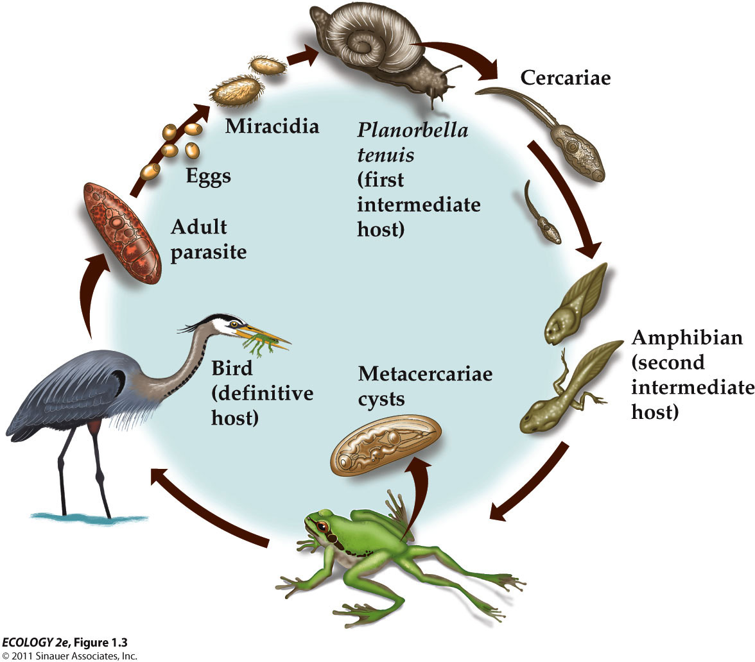the life cycle of ribeiroia
Controlled experiment:
- tree frog eggs were exposed to Ribeiroia parasites in the lab
- four treatments: 0 (the control group), 16, 32, or 48 Ribeiroia parasites

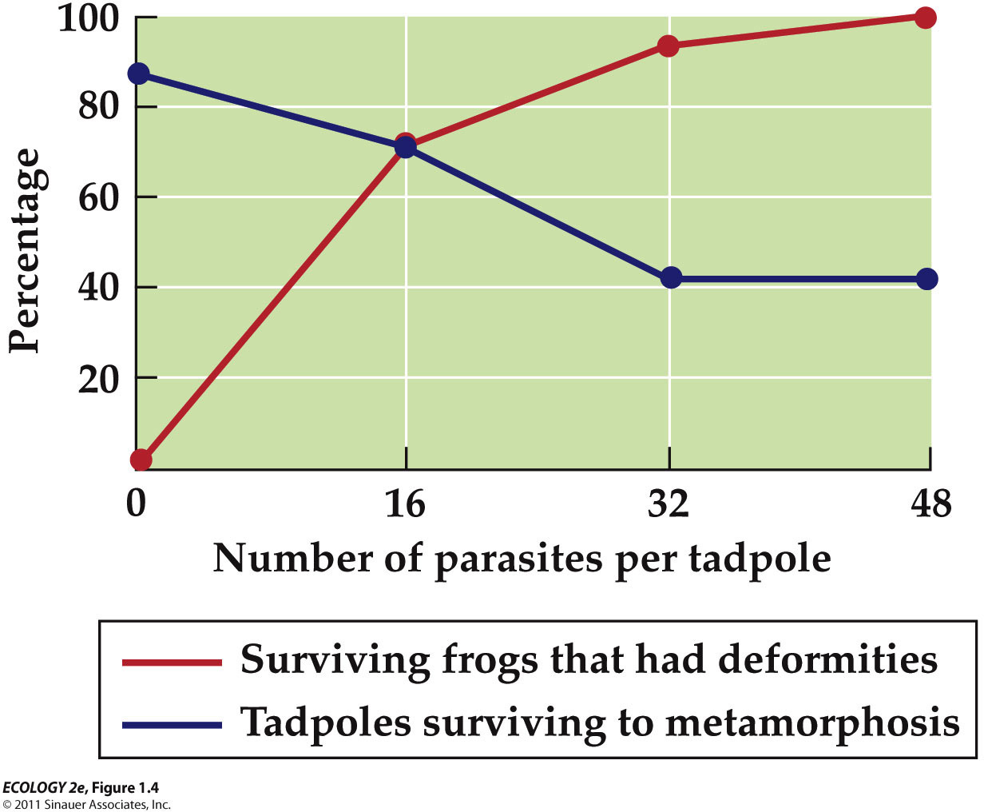
- shows that we can have a decline in the survival of tadpoles so maybe the parasites are linked in the survival of amphibians
- synthetic pesticide use began in 1930’s; use has increased dramatically
- amphibian exposure to pesticides has also increased
- any action (increased use of pesticides) can have unanticipated side effects (more frequent deformities in amphibians)
- possible that pesticides could be part of the reason for decrease

A field experiment:
- six ponds, three with pesticide contamination
- six cages in each pond, three with mesh size that allowed parasite to enter
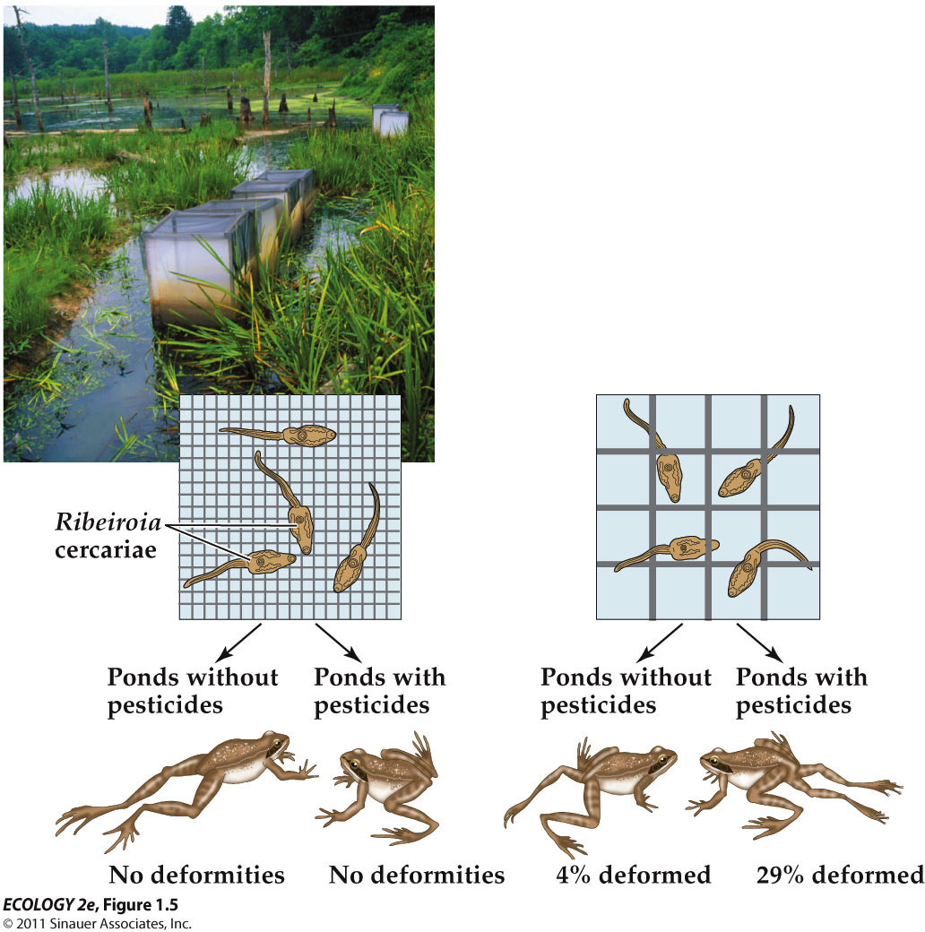
- hypothesis: pesticides decrease the ability of frogs to resist infection by parasites
- another lab experiment: tadpoles reared in presence of pesticides had fewer white blood cells (indicating a suppressed immune system) and a higher rate of Ribeiroia cyst formation
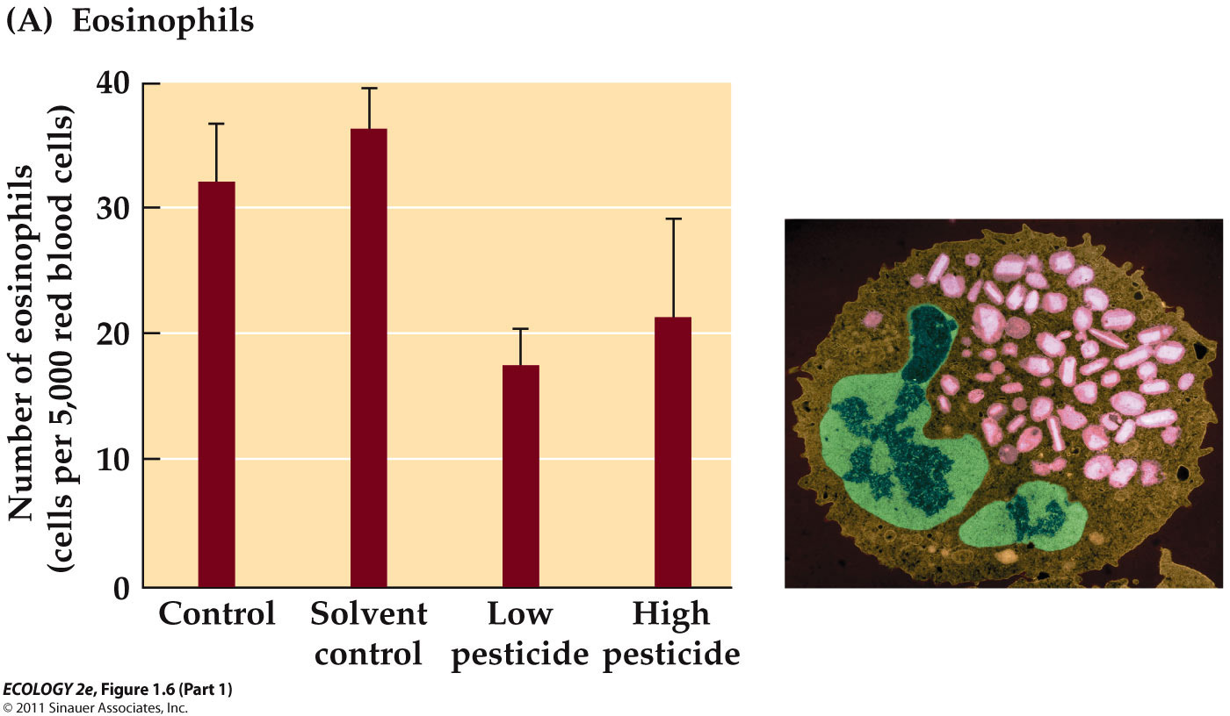
- if pesticide exposure is bad, why is low pesticide exposure worse than high? What you’re looking at here is not really much of a statistical difference, not really considered a real different
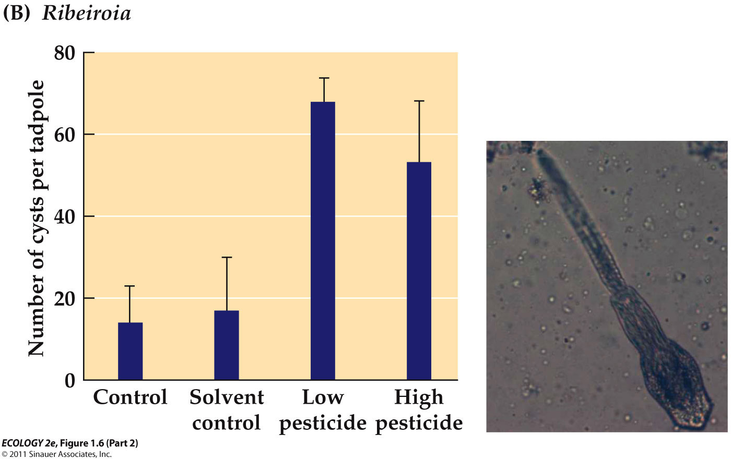
- a lot more cysts when you have pesticides
- Fertilizer use may also be a factor: Fertilizer in runoff to ponds increases algal growth.
- Snails that harbor Ribeiroia parasites eat algae.
- Greater numbers of snails result in greater numbers of Ribeiroia parasites.
- if you have presence of pesticides, then you most often have feritilizer present
- studies suggest a range of factors may be responsible for amphibian declines: The relative importance of factors such as habitat loss, parasites and diseases, pollution, UV exposure, and others still being investigated.
- studies on 435 species: habitat loss was the primary cause for 183 species, overexploitation (hunting) for 50, remaining 207 not understood
- In lab studies, it has been difficult to link pesticides to increase in frog deformities (couldn’t properly see the deformities). Relyea (2003) showed that pesticides were up to 46 times more lethal if tadpoles sensed the presence of a predator.
- The predators were kept separate from the tadpoles by netting, but the tadpoles could smell them (declining their immune function).

Lecture 2

- the biosphere is the zone of life on Earth
- biomes are large-scale biological communities shaped by the physical environment, particularly climate
- biomes are categorized by dominant plant forms, not taxonomic relationships
- Plants occupy sites for a long time and are good indicators of the physical environment, reflecting climatic conditions and disturbances. Animals are constantly moving, hiding, etc
- Terrestrial biomes are characterized by growth forms of the dominant plants, such as leaf deciduousness or succulence.
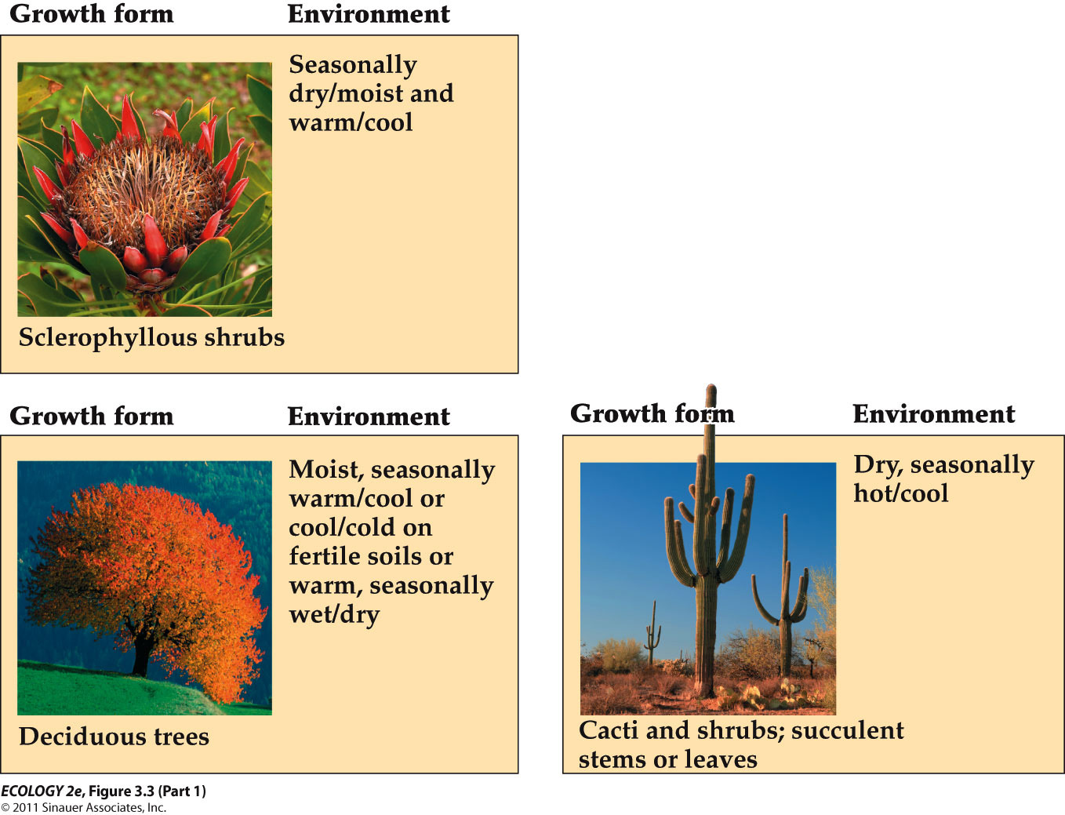
deciduous trees change colour over time

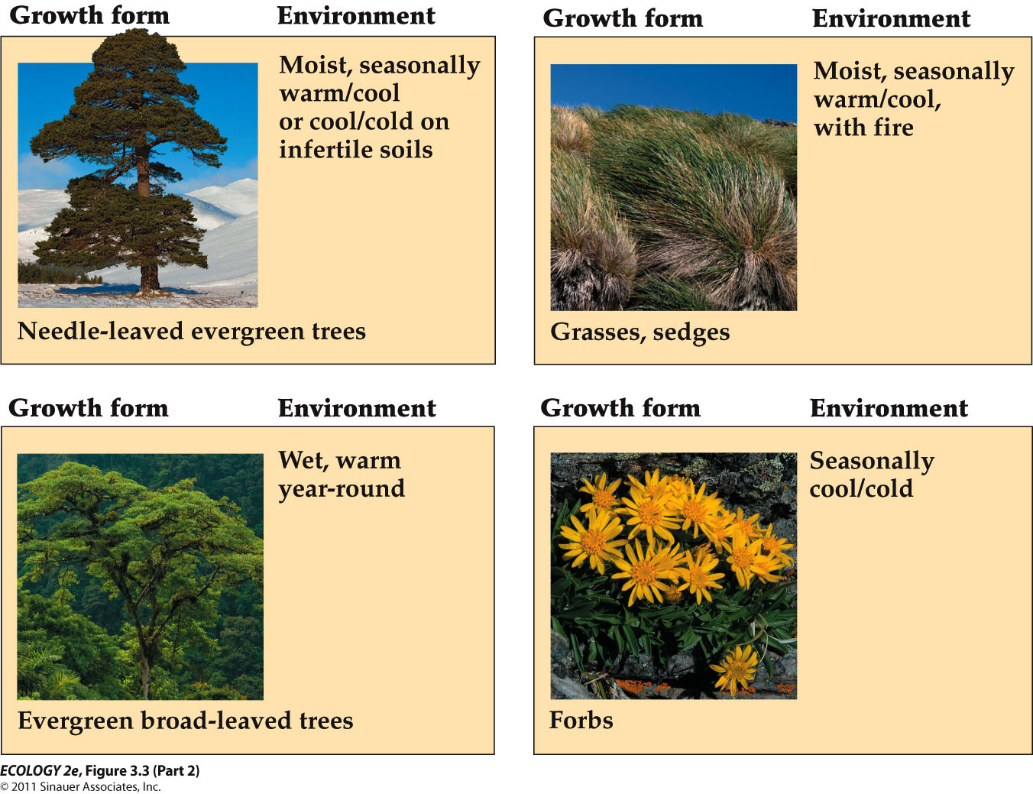
grasses, sedges are the ones that grow from the base of plant

evergreens are in the tropical rainforest,
forbs ex. dandelions

shrubs deter herbivores

- Plants have taken many forms in response to selection pressures such as aridity, extreme temperatures, intense solar radiation, grazing, and crowding.
- Similar growth forms can be found on different continents, even though the plants are not genetically related.
- Convergence: Evolution of similar growth forms among distantly related species in response to similar selection pressures.
- similar growth form even though the plants aren’t related because the pressure of a certain environment can force you to survive
- Temperature has direct physiological effects on plant growth form (hotter environment = higher evaporation)
- Precipitation and temperature act together to influence water availability and water loss by plants.
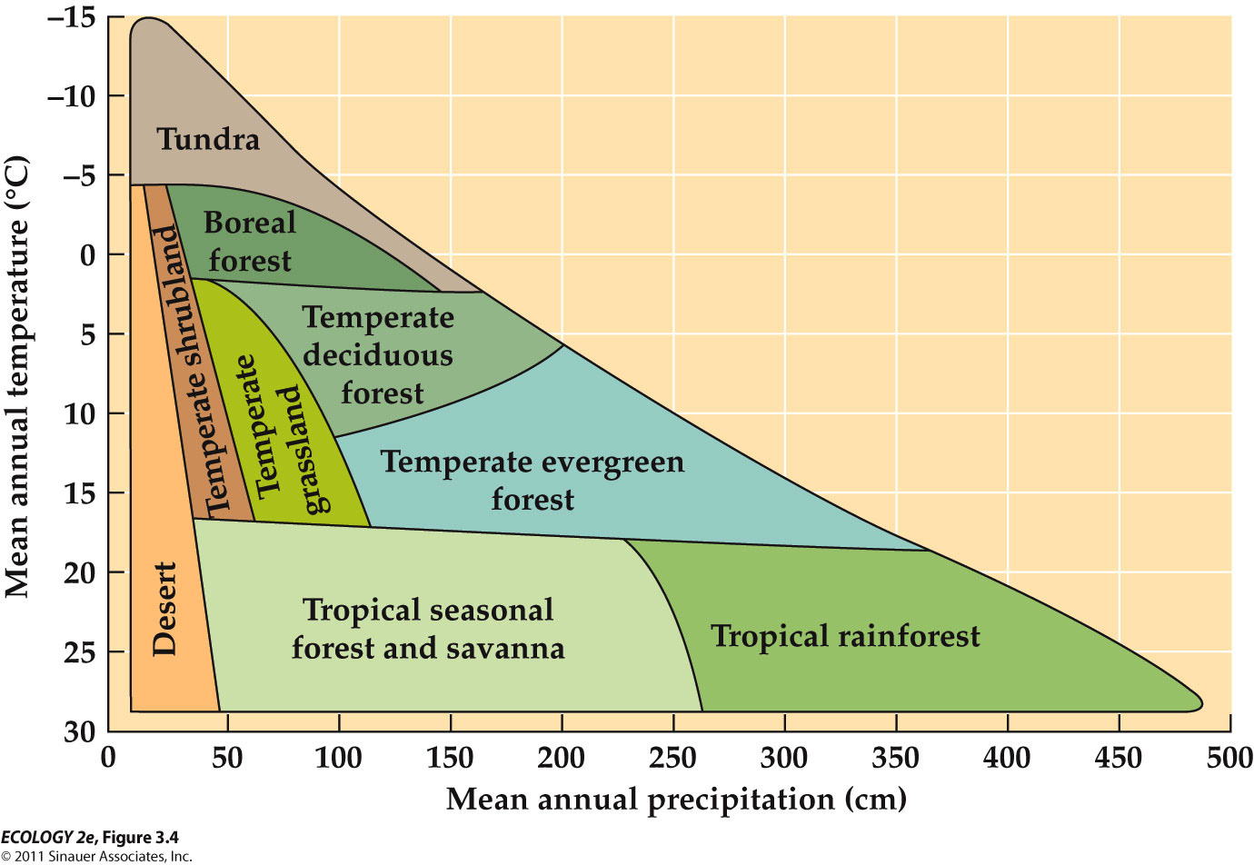
- Water availability and soil temperature determine the supply of nutrients in the soil.

- doesn’t account for seasonal variation
- many biomes have seasonal variation

- human activities influence the distribution of biomes
- land use change: conversion of land to agriculture, logging, resource extraction, urban development
- the potential and actual distributions of biomes are markedly different
- there are 9 major terrestrial biomes
- climate diagrams show the characteristic seasonal patterns of temperature and precipitation at a representative location

uniformly warm throughout the year and uniformly wet

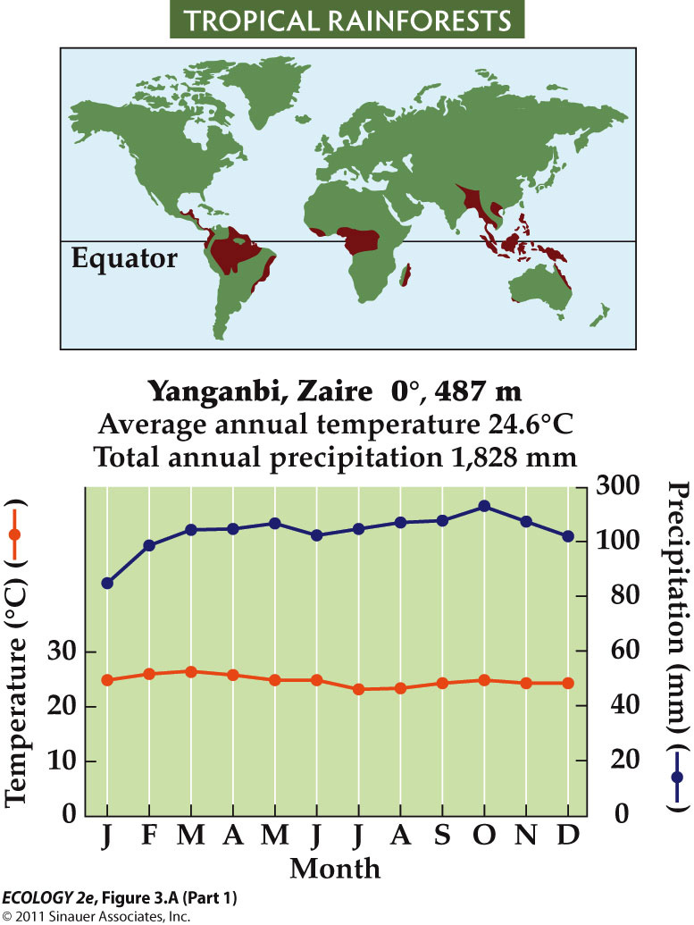

- high biomass, high diversity – about 50% of Earth’s species located in rainforest
- light is a key factor – plants must grow very tall above their neighbours or adjust to low light levels
- emergent rise above the canopy, lianas (woody vines) and epiphytes go higher up and use the trees for support
- understory trees grow in the shade of the canopy and shrubs and forbs occupy the forest floor
- Tropical rainforests are disappearing due to logging and conversion to pasture and croplands.
- About half of the tropical rainforest biome has been altered.
- Recovery of rainforests is uncertain: Soils are nutrient-poor, and recovery of nutrient supplies may take a very long time. Nutrients have washed away from the rocks
- over decades can go from a very in tact forest to fragmented

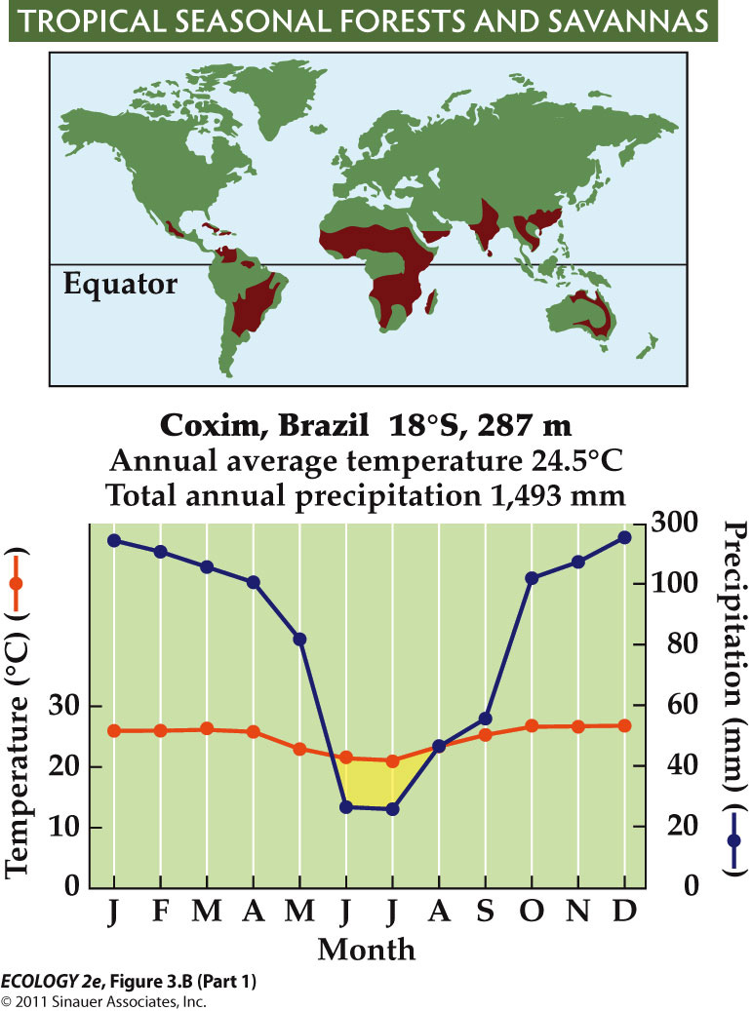

- fairly warm throughout the year
- wet like tropical rainforest but also really dry at times (summer months)
j

- wet and dry seasons associated with movement of the ITCZ
- shorter trees, deciduous in dry seasons (lose their leaves), more grasses and shrubs
- baobab trees in Zambia and semi-evergreen in Ecuador during dry season
- fires promote establishment of savannas; some are set by humans
- in Africa, large herbivores – wildebeests, zebras, elephants and antelopes – also influence the balance of grass and trees (rip out trees)
- on the Orinoco river floodplain, seasonal flooding promotes savannas
- less than half of seasonal tropical forests and savannas remain
- human population growth in this biome has had a major influence, large tracts have been converted to cropland and pasture

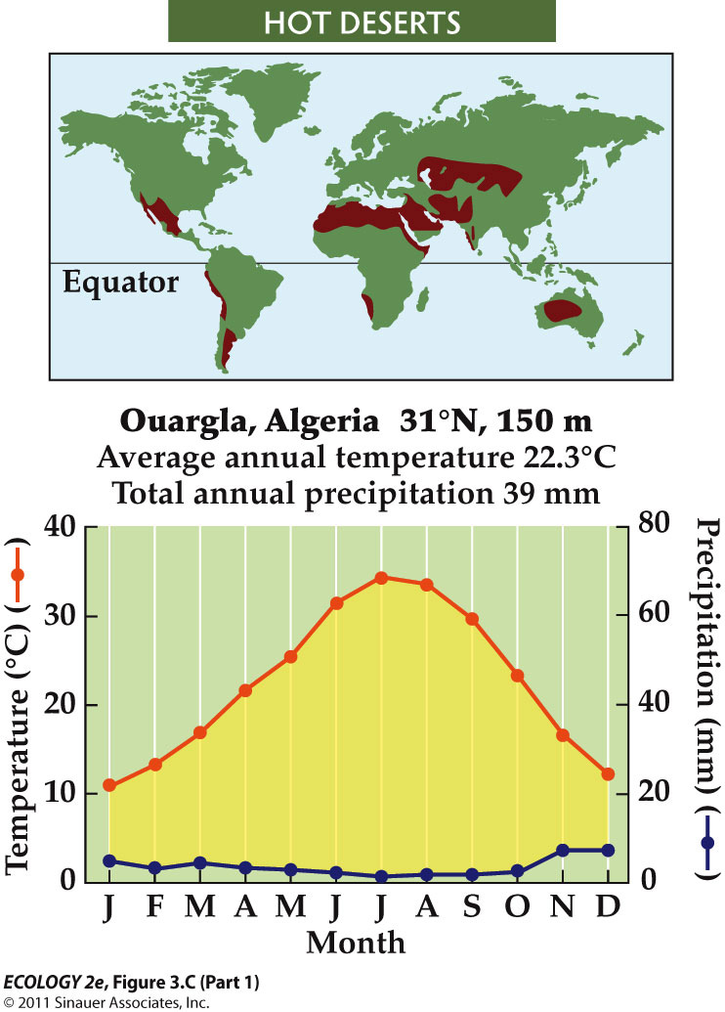
-extremely dry
- high temperatures, low moisture
- sparse vegetation (due to low moisture) and animal populations (not enough food)
- low water availability constrains plant abundance and influences form
- many plans have succulent stems that store water (because low moisture)
- convergence of this form is shown by cactic (Western Hemisphere) and euphorbs (Eastern Hemisphere)
- humans use deserts for agriculture and livestock grazing
- agriculture depends on irrigation, and results in soil salinization
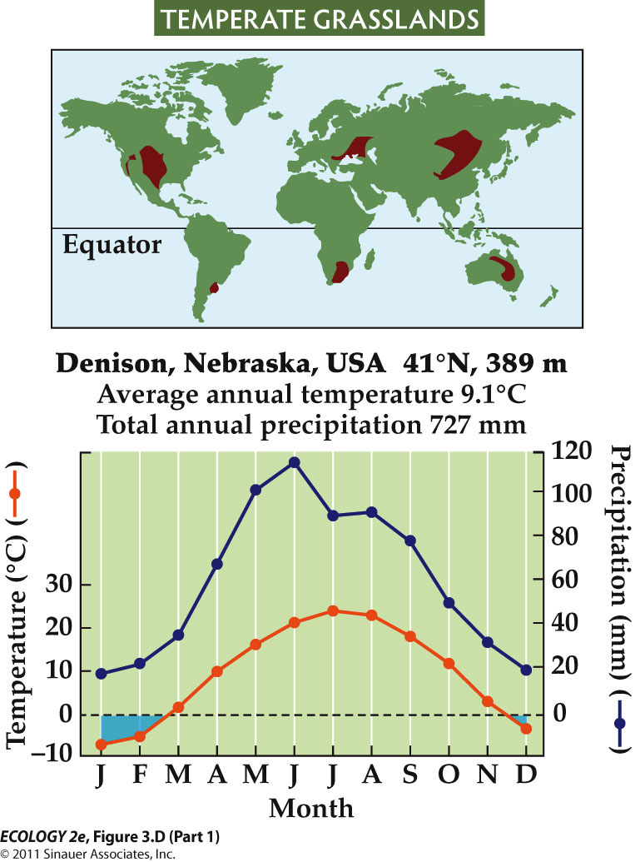
- long term droughts and unsustainable grazing can result in desertification – loss of plant cover and soil erosion (plans cant grow in salty conditions)

- defined by a very cold season (freezing) in the winter and then a wetter summer
- warm, moist summers and cold, dry winters
- grasses dominate; maintained by frequent fires and large herbivores such as bison
- grasses grow more roots than stems and leaves, to cope with dry conditions
- this results in accumulation of organic matter and high soil fertility
- most fertile grasslands of central North America and Eurasia have been converted to agriculture

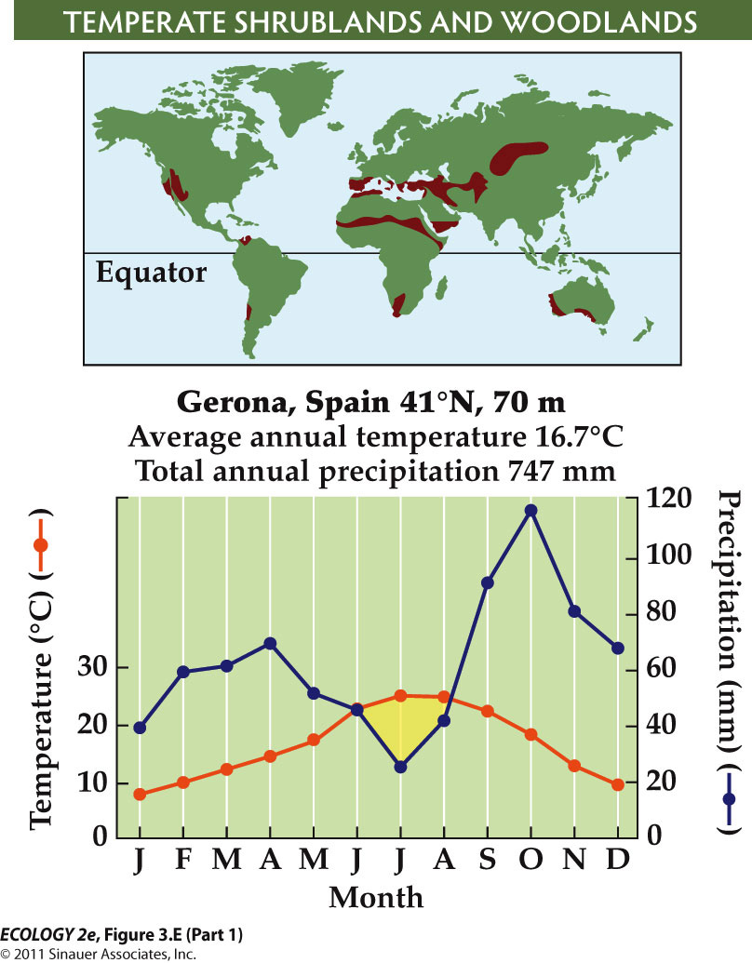
- water stress during warmer months
- California and Meditteranean
- evergreen leaves allow plans to be active during cooler, wetter periods
- they also lower nutrient requirements – the plants don’t have to develop new leaves every year (conserve nutrients)
- Sclerophyllous leaves – tough and leathery – deter herbivores and prevent wilting

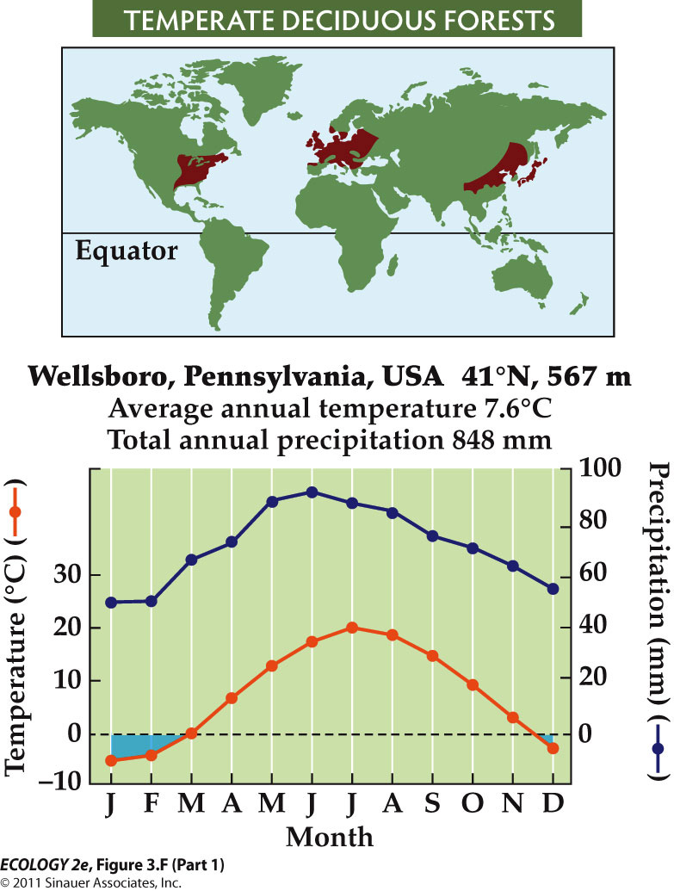
- deciduous leaves in response to extended periods of freezing
- need fertile soils and enough water to support tree growth
- Fertile soils and climate make this biome good for agriculture. Very little old-growth temperate forest remains.
- As agriculture has shifted to the tropics, temperate forests have regrown.
- Shifts in species composition are due to nutrient depletion by agriculture and invasive species, causing damage such as chestnut blight.
- ash trees which were very dominant in north east north America are being decimated

- Vancouver and California along the ocean
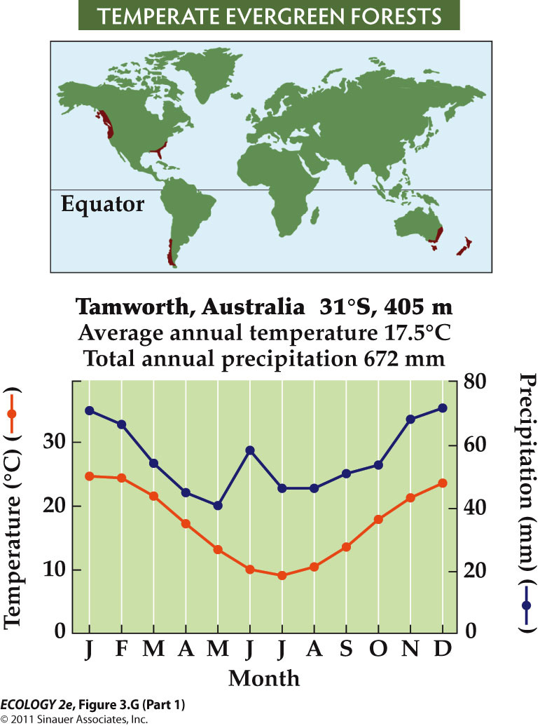
- quite wet
- includes temperate rainforests, but spans a wide range of environmental conditions
- commonly found on nutrient-poor soils
- Very little old-growth temperate evergreen forest remains because of logging.
- Suppression of fires in western North America has increased the density of forest stands, which results in more intense fires when they do occur (unstoppable).
- It also increases the spread of insect pests and pathogens.
- Air pollution has damaged some temperate evergreen forests.

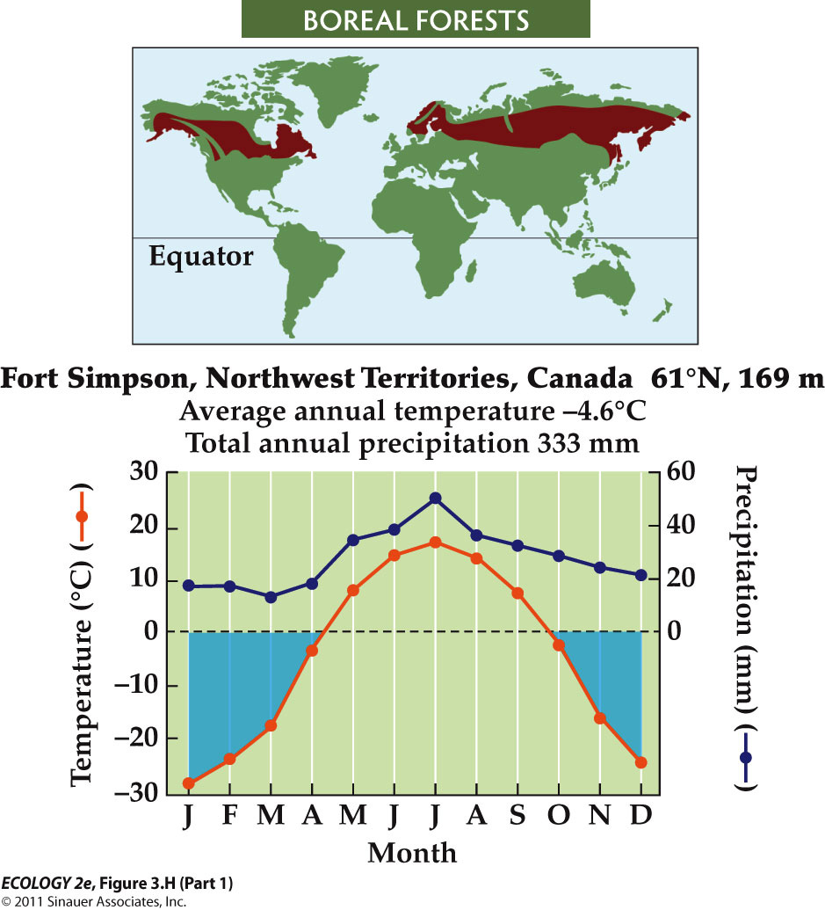
- long, severe winters
- permafrost (soil that remains frozen year-round) prevents drainage and results in saturated soils
- trees are conifers – pines, spruces, larches
- cold, wet conditions in boreal soils limit decomposition, so soils have high organic matter
- in low-lying areas, extensive peat bogs form
- in summer droughts, forest fires can be set by lightning, and can burn both trees and soil
- Boreal forests have not been as affected by human activities.
- Logging, and oil and gas development, occur in some regions. Impacts will increase as energy demands increase.
- Climate warming may increase soil decomposition rates, releasing stored carbon and creating a positive feedback to warming.
- positive feedback = self sustaining, self propagating
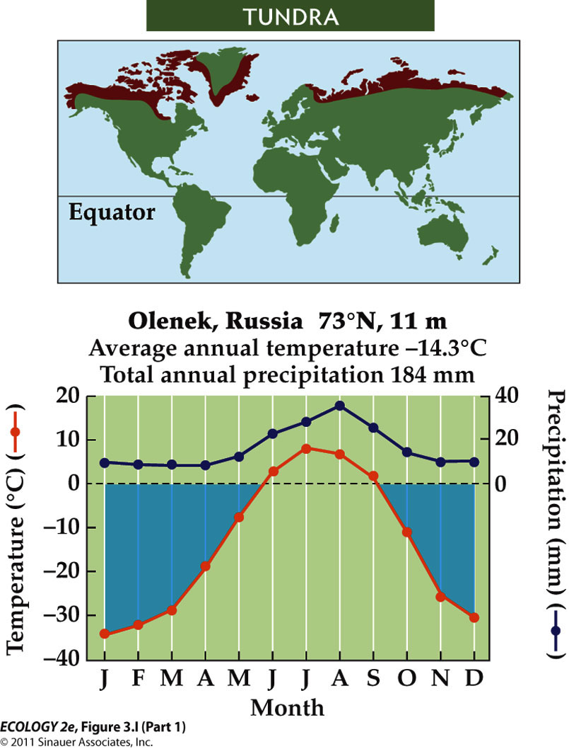

- where growing season length and temperatures decrease, trees cease to be the dominant vegetation (the tree line marks the boreal to tundra transition)
- characterized by sedges, grasses, forbs and low growing shrubs
- human influence is increasing as exploration and development of energy resources increases
- the arctic has experienced significant climate change, with warming almost double the global average
- arctic systems are very vulnerable

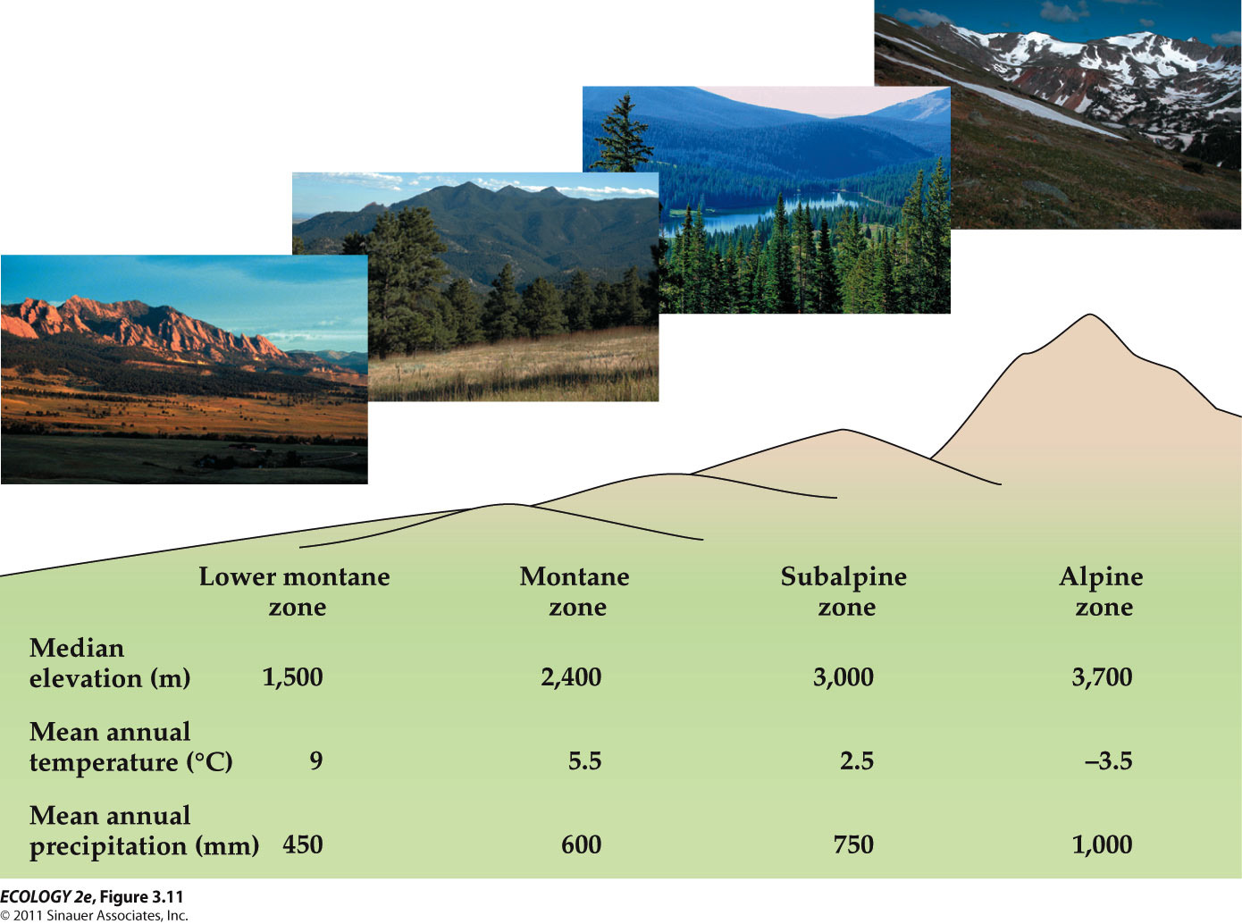

on mountains, temperature and
precipitation change with elevation, resulting in zones similar to biomes.

Streams and Rivers:
- Streams and rivers are lotic (flowing water) systems.
- Benthic organisms are bottom dwellers, and include many kinds of invertebrates.
- Some feed on detritus (dead organic matter), others are predators.
- Some live in the hyporheic zone—the substratum below and adjacent to the stream
- streams get a lot of leaf fall, whole groups of organisms that shred up the leaves and eat them
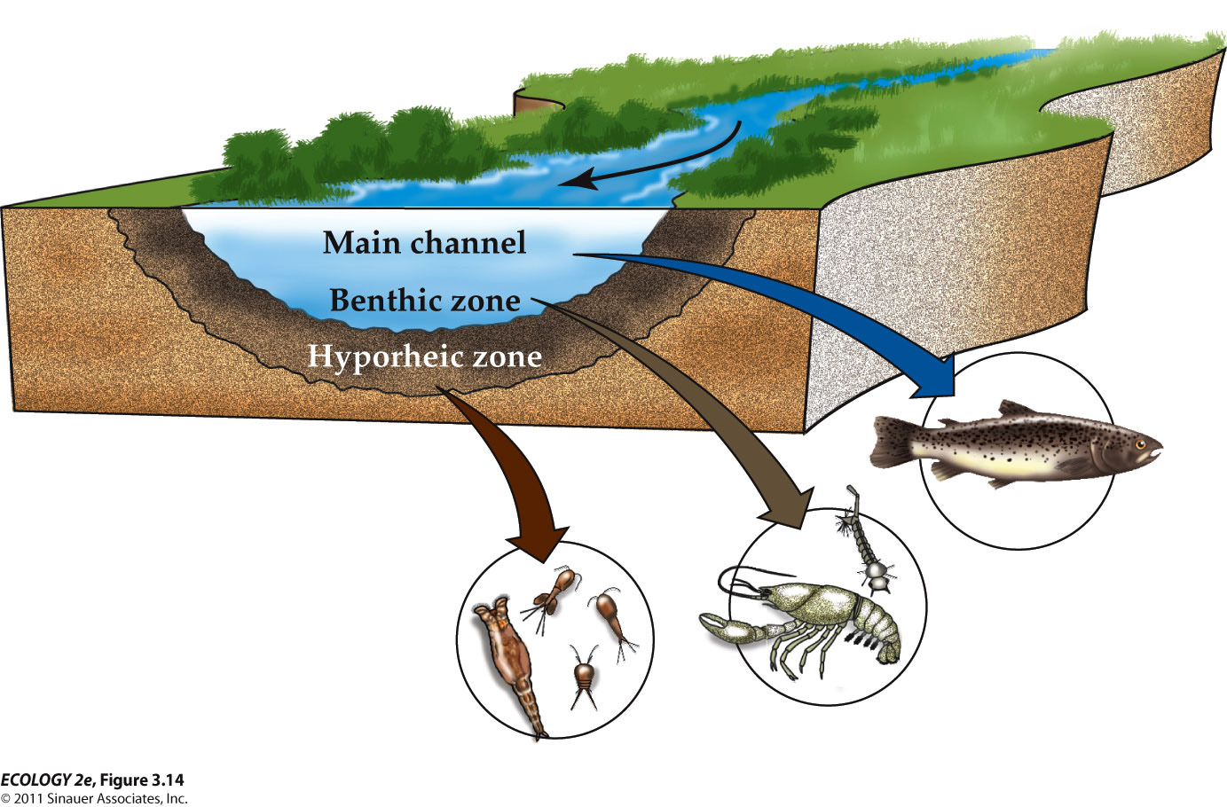
- Lakes and still waters (lentic) occur where depressions in the landscape fill with water.
- The littoral zone is near shore, where the photic zone reaches the bottom. Macrophytes occur in this zone.
- Pelagic zone: Open water; dominated by plankton (small and microscopic organisms suspended in the water).
- Phytoplankton are photosynthetic, restricted to the upper layers through which light penetrates (photic zone).
- Zooplankton are non-photosynthetic protists and tiny animals.
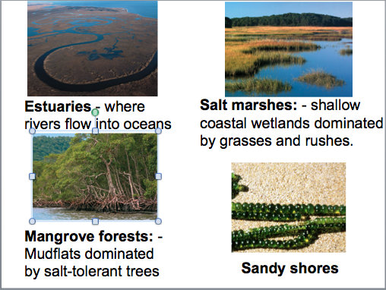

- these areas are highly impacted by humans
- tend to congregate on coasts
- kelp forests, coral reefs, rocky intertidal are areas with high diversity
- marine systems located on the coast

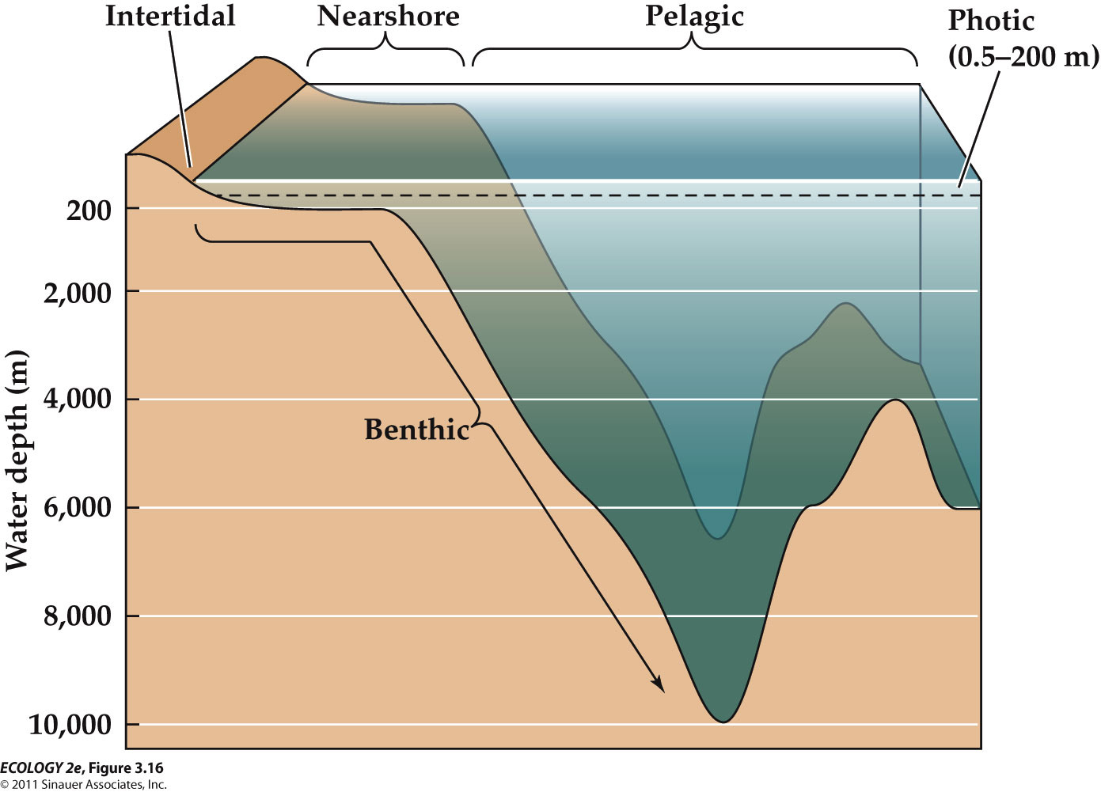
- pelagic = open water outside the continental shelf
- the photic zone, which supports the highest densities of organisms, extend to about 200m depth
- Below the photic zone, energy is supplied by falling detritus, temperatures drop and pressure increases.
- Crustaceans such as copepods graze on the rain of falling detritus from the photic zone.
- Crustaceans, cephalopods, and fishes are the predators of the deep sea.
- only way you can get food is if it drops there
- humans have had a very high impact on the oceans

Lecture 3

- the physical environment influences an organism’s ecological success in tow ways:
- availability of energy and resources – impacts growth and reproduction
- extreme conditions can exceed tolerance limits and impact survival
- energy supply can influence an organism’s ability to tolerate environmental extremes
- the actual geographic distribution of a species is also related to other factors, such as disturbance and competition
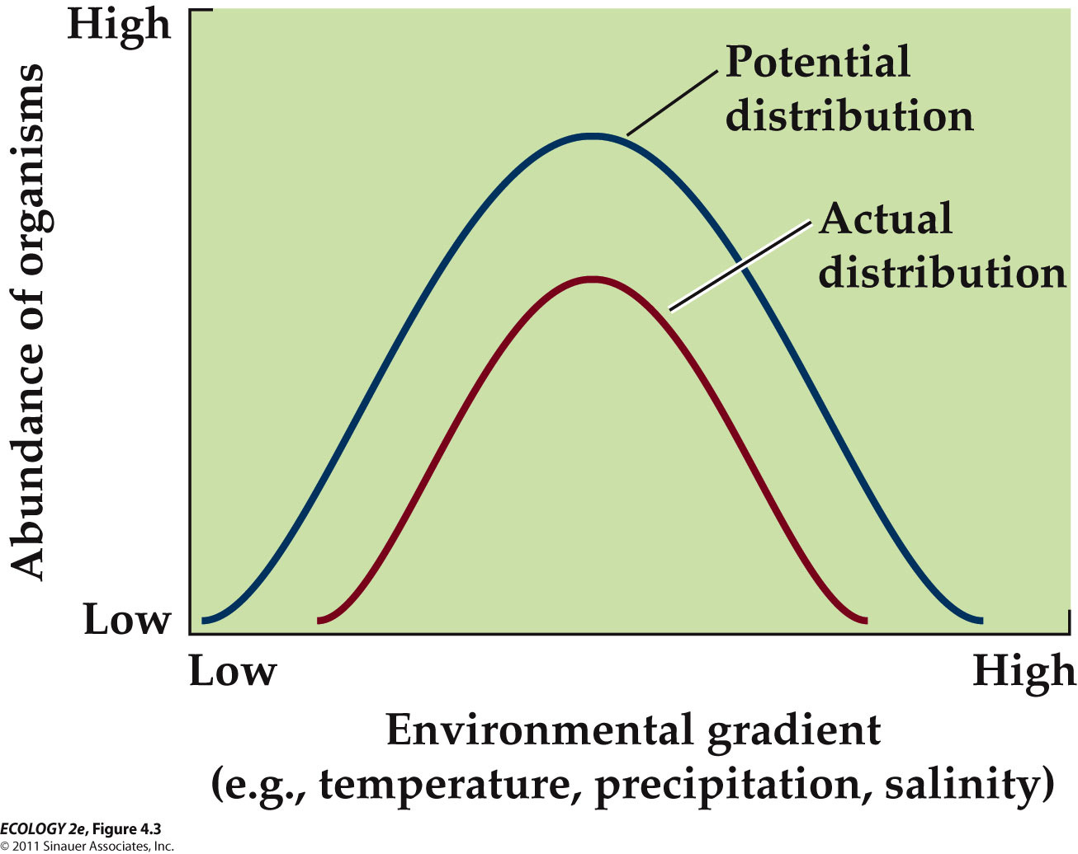
- for any environmental gradient, youre going to have this potential distribution of an organism

- because plants don’t move, they are good indicators of the physical environment
- example: aspen distribution can be predicted based on climate. Low temperatures and drought affect reproduction and survival
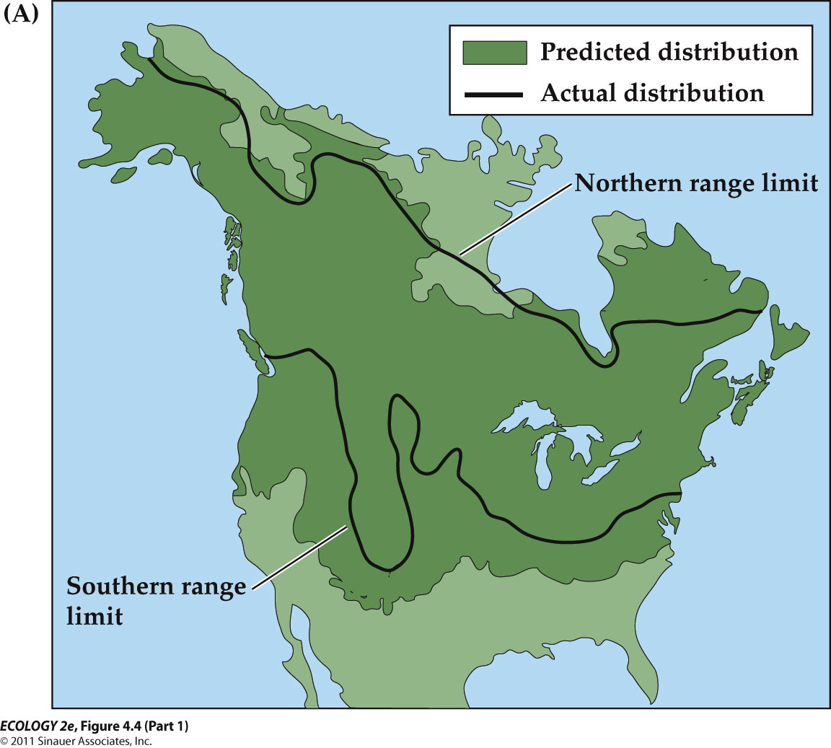

- a species climate envelope is the range of conditions over which it occurs
- fairly good match

- physiological ecology is the study of interactions between organisms and the physical environments that influence their survival and persistence
- physiological processes have optimal conditions for functioning
- deviations from the optimum reduce the rate of the process
- stress – environmental change results in decreased rates of physiological processes, lowering the potential for survival, growth, or reproduction
- for example: plants might not photosynthesize properly if you put stress on them, might not kill the organism just reduce their performance
- Acclimatization: Adjusting to stress through behavior or physiology. It is usually a short-term, reversible process.
- Acclimatization to high elevations involves higher breathing rates, greater production of red blood cells, and higher pulmonary blood pressure.
- Over time, natural selection can result in adaptation of a population to environmental stress.
- Individuals with traits that enable them to cope with stress are favored. Over time, these genetic traits become more frequent in the population.
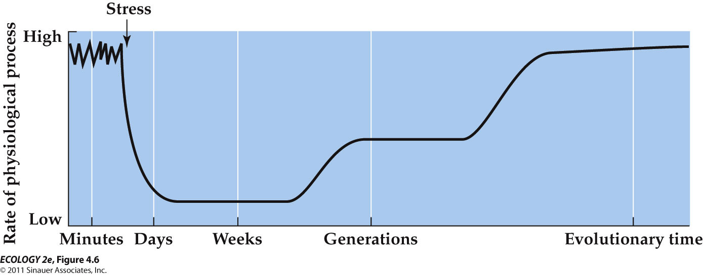
- high rates of performance but over time it is introduced to a stress so it plummets down, then we see acclimatization by the individual
- Over generations we move to individuals to populations
- Acclimatization and adaptation require investments of energy and resources, representing possible trade-offs with other functions that can also affect survival and reproduction.
- Ecotypes: Populations with adaptations to unique environments (same species, local populations)
- Ecotypes can eventually become separate species as populations diverge and become reproductively isolated.
- Environmental temperatures vary greatly throughout the biosphere.
- Survival and functioning of organisms is strongly tied to their internal temperature.
- Some archaea and bacteria in hot springs can function at 90°C.
- Lower limits are determined by temperature at which water freezes in cells (–2 to –5°C).
- Freezing point determines lower limit, boiling point determines upper limit
- internal heath generation as a defense: hornets smother the bees, causing heat generation, hornet dies
- ectotherm surface area to volume ratio of the body is an important factor in exchanging energy with the environment
- a larger surface area allows great heat exchange, but makes it harder to maintain internal temperature
- Small aquatic ectotherms remain the same temperature as the water.
- Some large ectotherms can maintain higher body temperature: Skipjack tuna use muscle activity and heat exchange between blood vessels to maintain a body temperature 14°C warmer than the surrounding seawater.
- Many terrestrial ectotherms can move around to adjust temperature.
- Many insects and reptiles bask in the sun to warm up after a cold night, but this increases predation risk, increasing benefits of camouflage
- Ectotherms in temperate and polar regions must avoid or tolerate freezing. Avoidance behavior includes seasonal migration to lower latitudes or to microsites that are above freezing (e.g., burrows in soil).
- Tolerance to freezing involves minimizing damage associated with ice formation in cells.
- Some insects have high concentrations of glycerol, a chemical that lowers the freezing point of body fluids.
- Vertebrates generally do not tolerate freezing temperatures.
- Cryonics is the preservation of bodies by freezing, in hope that they can be brought back to life in the future.
- Two frog species (rana sylvatica, pseudacris maculate) live in the Arctic tundra and can survive winter in a semi-frozen state.
- They overwinter in shallow burrows, with no heartbeat, no blood circulation, and no breathing.
- In most organisms, freezing results in tissue damage as ice crystals perforate cell membranes and organelles.
- In animals that withstand freezing, the freezing water is limited to the space outside the cells.
- Ice-nucleating proteins outside cells serve as sites of slow, controlled ice formation.
- Additional solutes, such as glucose and glycerol are made inside the cells to lower the freezing point.
- Endotherms can remain active at subfreezing temperatures.
- The cost of being endothermic is a high demand for energy (food) to support metabolic heat production.
- Metabolic rates are a function of the external temperature and rate of heat loss.
- Rate of heat loss is related to body size and surface area-to-volume ratio.
- Small endotherms with large surface area-to-volume ratio have higher metabolic rates, and require more energy and higher feeding rates than large endotherms.
- Thermoneutral zone: The range of environmental temperatures over which a constant basal metabolic rate can be maintained (can adjust to temperature easily, requires little energy)
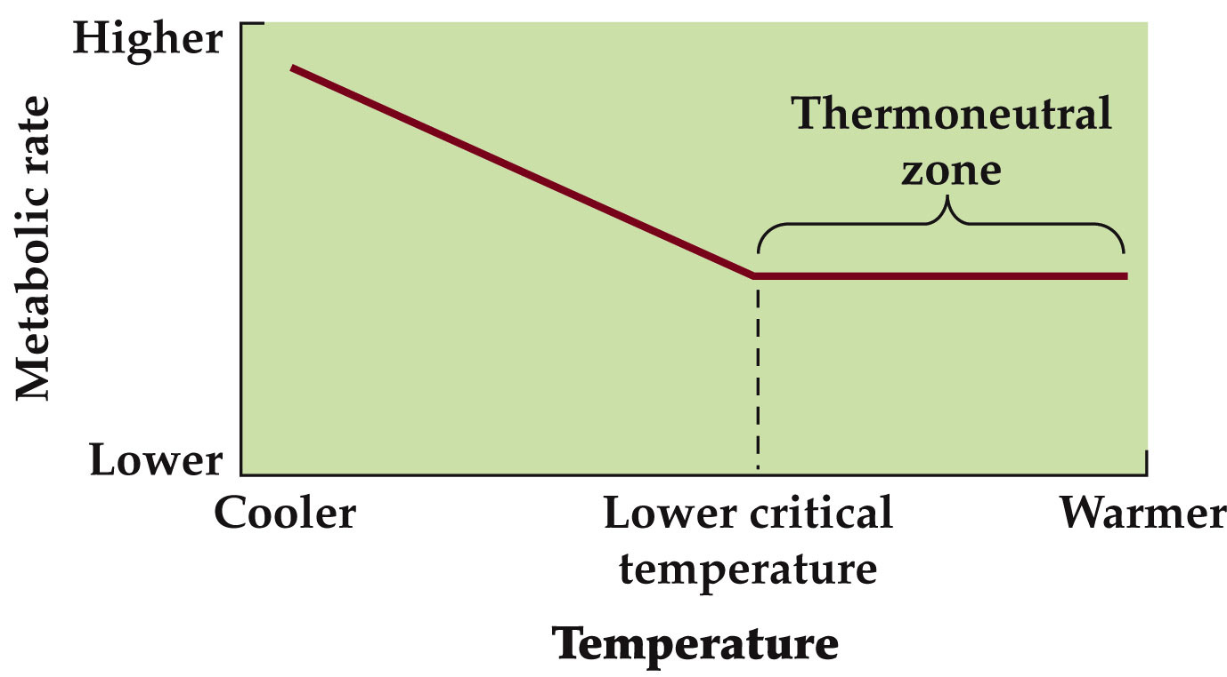
- Lower critical temperature: When heat loss is greater than metabolic production; body temperature drops and metabolic heat generation increases.

- Mammals in the Arctic have lower critical temperatures than mammals in tropical regions.
- The rate of metabolic activity increases more rapidly below the lower critical temperature in tropical mammals as compared to Arctic mammals.
- Evolution of endothermy required insulation—feathers, fur, and fat. Insulation limits conductive and convective heat loss.
- conduction is heat that you lose when youre in contact with another surface
- convection is heat lost through water/air around you
- Fur and feathers provide a layer of still air adjacent to the skin. Some animals grow thicker fur for winter.
- Some organisms can survive periods of extreme heat or cold by entering a state of dormancy, in which little or no metabolic activity occurs.
- Small mammals have thin fur and not much fat for energy storage, but high demand for metabolic energy below the lower critical temperature.
- They survive in cold climates by entering a dormant state called torpor. Body temperature and basal metabolic rates are low, which conserves energy.

