Caroline Ross (6563554)
Osman Aganagic (6561802)

HYDROLOGY – GEOG 375/2

ASSIGNMENT 4: MEAN VELOCITY AND DISCHARGE

November 25th, 2013

1) Study on Eaton-Nord River (Eastern Townships)

- Estimate the values of each n_{i} of Manning and determine the resulting Manning n:

Material involved no = 0.024 (fine gravel)
Degree of irregularity n1 = 0.005 (minor)
Variations of channel cross-section n2 = 0.0025 (Minor)
Relative effect of Obstruction n3 = 0.005 (Minor)
Vegetation n4 = 0.005 (Low)
Degree of sinuosity m = 1 (minor)

Manning’s n = (n₀+n₁+n₂+n₃+n₄) * m
= (0.0024 + 0.005 + 0.0025 + 0.015 + 0.005) * 1
= 0.042

- Calculate the mean velocity (V) and discharge (Q) using Manning equation:

S=0.0015 Y=0.40m W=8m

Q=WYV V=(R^{2/3} * S0^{½})/n R=wy/(2y+w)

- $R=\frac{wy}{\left(2y+w\right)}=\frac{(8 × 0.40)}{(2\left(0.402\right)+8)}=0.36m$

2. V=(R^{2/3} * S0^{½})/n
= ((0.36)^{2/3} * (0.0015) ^{½})/0.042
= 0.47m/s

3. Q=WYV
= 8 * 0.40 * 0.47
= 1.50 m/s

- The value of Manning n would decrease, because according to Dingman (1984), “roughness elements become relatively less effectual in retarding the flow, so that n tends to decrease as discharge increases” (pg. 170). As such, the value for channel conditions such as “relative effect of obstructions” would be characterized as “negligible”, resulting in a smaller n.

2) i) Plot this cross section and calculate the mean depth (Y) and width (W) for 5 different water levels: when maximal depth (Y_{max}) is equal to 0.4, 0.6, 1.0, 1.5 and 2.8m.

Y_{max} | Mean Depth | Width
0.4 | 0.21 | 6
0.6 | 0.34 | 12
1.0 | 0.57 | 21.5
1.5 | 0.64 | 23
2.8 | 0.86 | 26

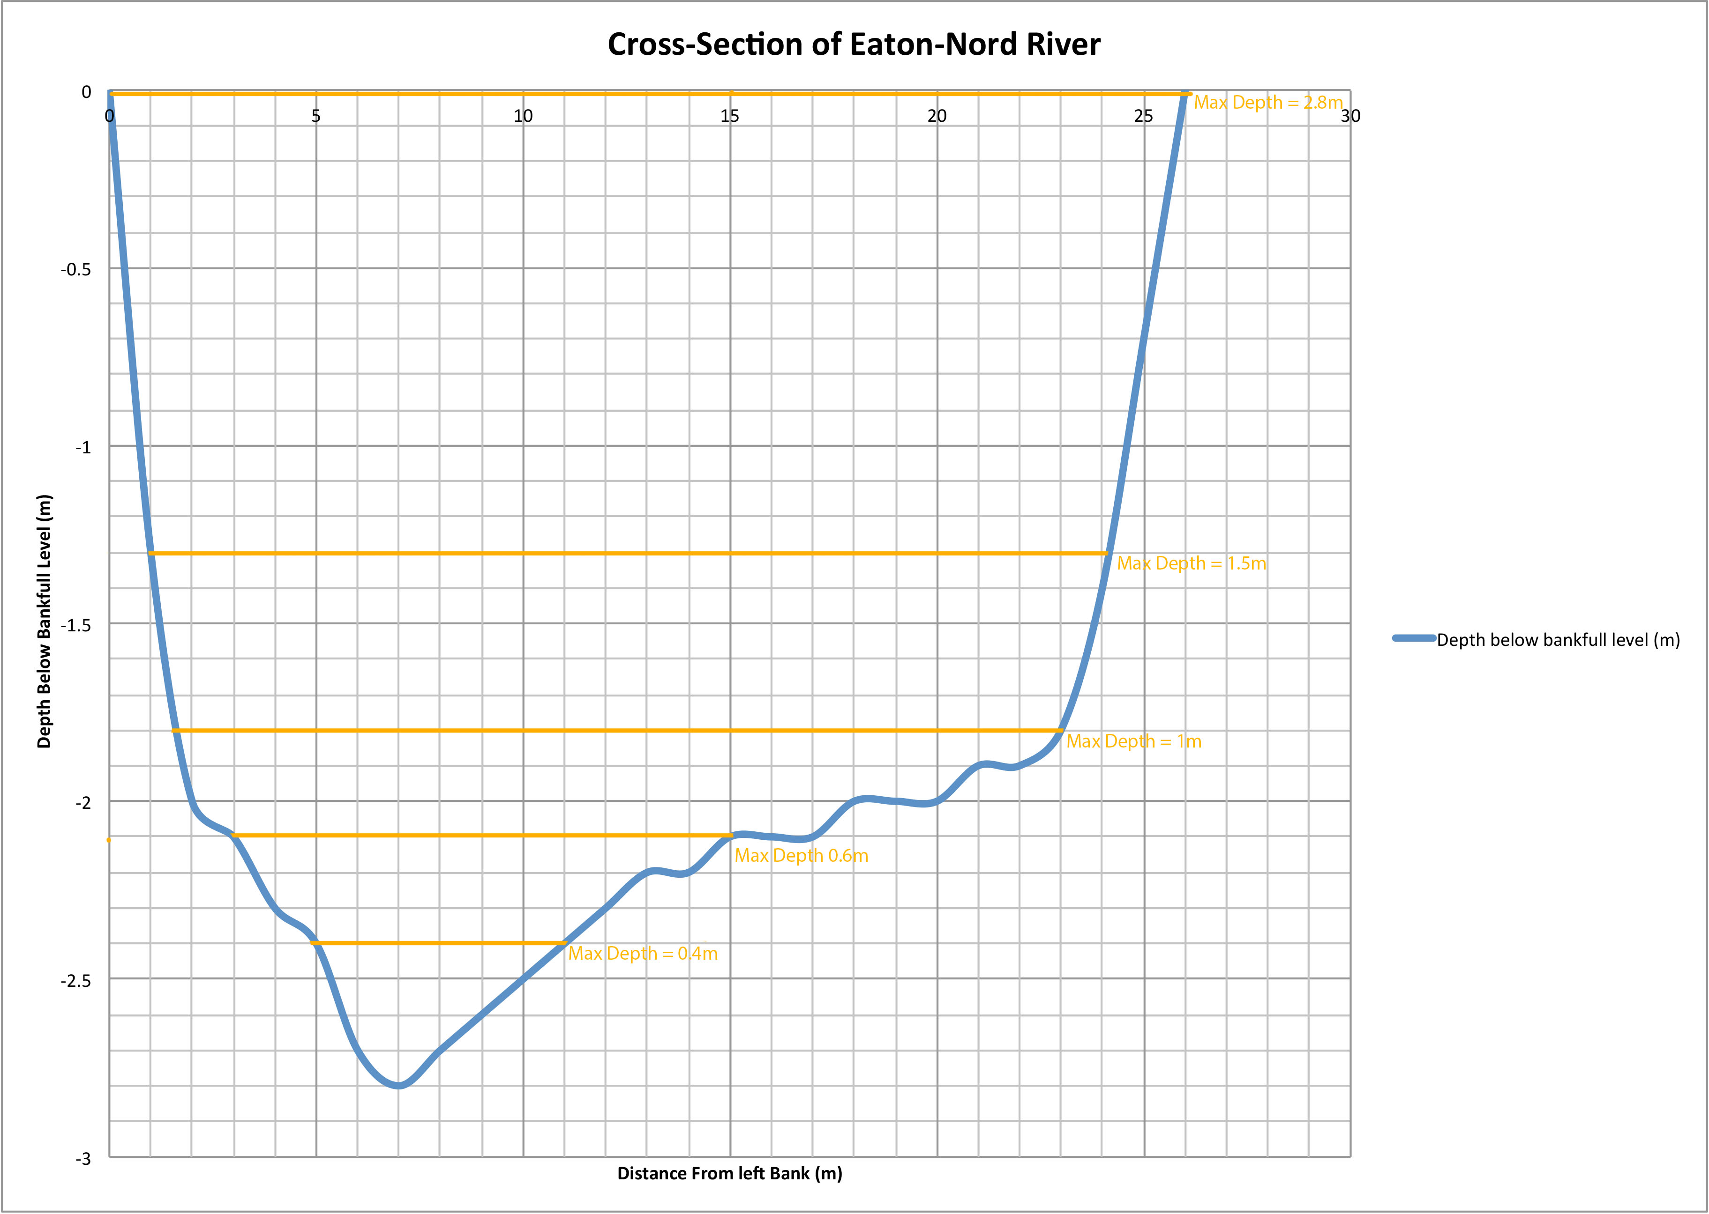

ii) Assuming that: (a) The slope does not vary with water level; (b) Manning n found in (1) is valid for the two shallower depths (Y_{max} = 0.4 and 0.6m); (c) Manning n for the other three depths (Y_{max} = 1.0, 1.5, ad 2.8m) can be estimated by Strickler’s equation knowing that D₅₀ = 41mm

(c) N can be estimated using strickler when y > D₅₀
N = 0.0151 D₅₀ ^{1/6} = 0.0151 (41) ^{1/6} = 0.028

Ymax(m) | MeanY(m) | Width (m) | Slope | Manning n | R | V | Q=WYV | LogQ | LogW | LogY | LogV
0.4 | 0.21 | 6 | 0.0015 | 0.042 | 0.196 | 0.311 | 0.25 | -0.61 | 0.78 | -0.68 | -0.51
0.6 | 0.34 | 12 | 0.0015 | 0.042 | 0.322 | 0.433 | 1.31 | 0.12 | 1.08 | -0.47 | -0.36
1 | 0.57 | 21.5 | 0.0015 | 0.028 | 0.541 | 0.919 | 6.63 | 0.82 | 1.33 | -0.24 | -0.04
1.5 | 0.64 | 23 | 0.0015 | 0.028 | 0.606 | 0.991 | 8.92 | 0.95 | 1.36 | -0.19 | 0.00
2.8 | 0.86 | 26 | 0.0015 | 0.028 | 0.807 | 1.199 | 18.04 | 1.26 | 1.41 | -0.07 | 0.08

iii) Log Y = cQ^{f} f = 0.32
Log W = aQ^{b} b = 0.35
Log V = kQ^{m} m = 0.33

Log Y = Y Intercept + (Slope)(LogQ) 10^^{(Y Intercept)} Q^^{(slope)}
Y = -0.49+ 0.32LogQ 10^{-0.49} Q^{0.32}
Y = 0.32Q^{0.32}

Log W = 1.01 + 0.35(LogQ) 10^{1.01}Q^{0.35}
W = 10.23Q^{0.35}

Log V = -0.34 + 0.33(LogQ) 10^{-0.34}Q^{0.33}
V = 0.46 Q^{0.33}

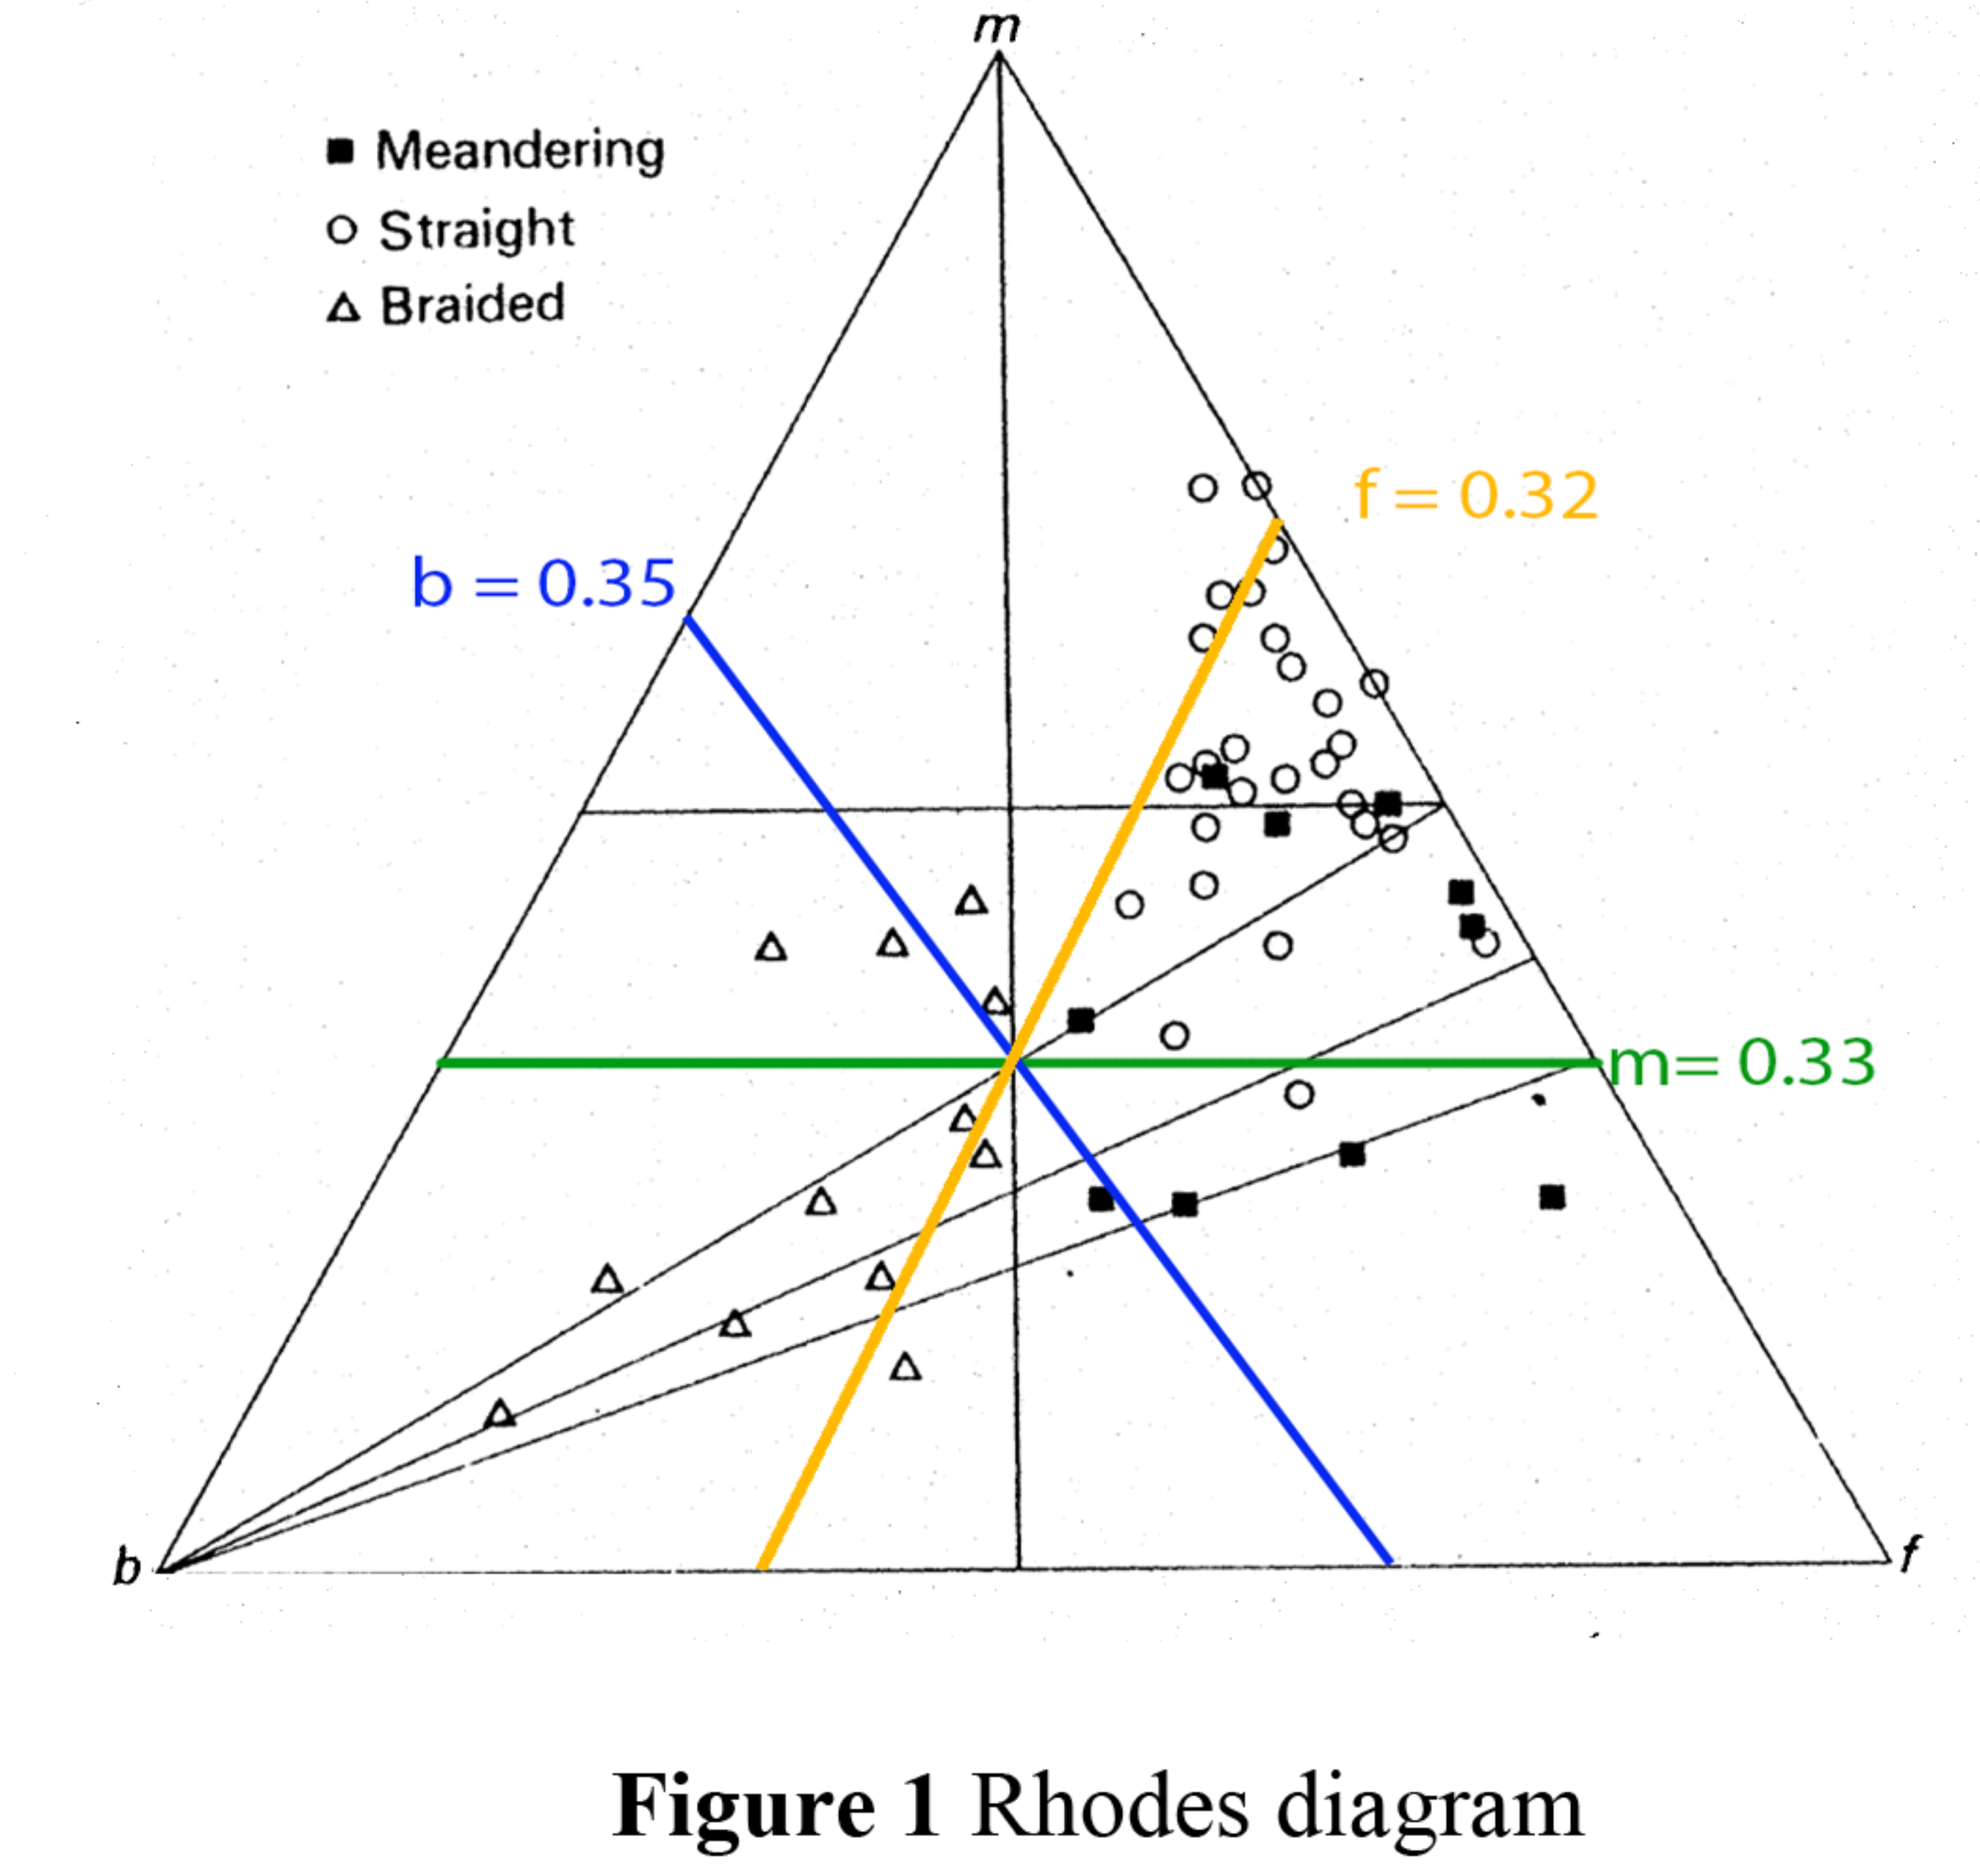

According to the picture given, the values calculated, and Rhode’s Diagram (Figure 1) we believe the river is meandering. Based on the visual picture we see meandering, so our results are consistent with our expectations.

3 i) Compute the discharge and mean velocity from these data

Panel | 1 | 2 | 3 | 4
Distance from bank (m) | 6 | 8 | 12 | 18
Y Max Depth | 1.0 | 1.0 | 1.0 | 1.0
Area (m²) | 1.9 | 1.9 | 2.05 | 2.8
V Measurements | 0.85 | 0.9 | 0.7 | 0.55
q (m³/s) | 1.62 | 1.71 | 1.44 | 1.54
Q(m³/s) | 6.31
Mean V (m/s) | 0.51

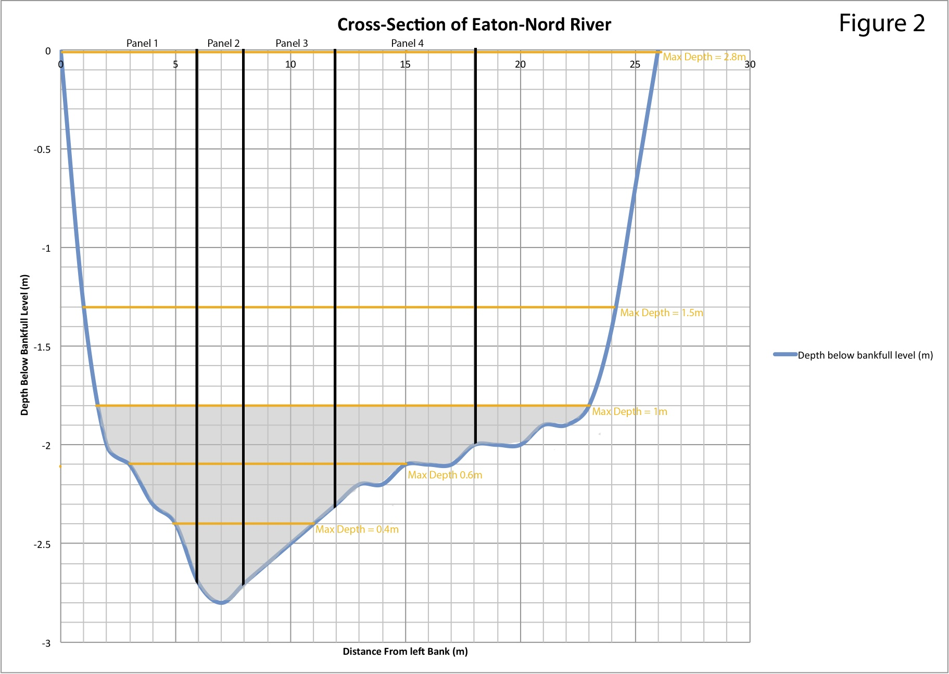

Compute discharge:

Panel 1: q = 0.85 m² * 1.9 m/s = 1.62 (m³/s)
Panel 2: q = 0.90 m² * 1.9 m/s = 1.71 (m³/s)
Panel 3: q = 2.05 m² * 0.7 m/s = 1.44 (m³/s)
Panel 4: q = 2.80 m²* 0.55 m/s = 1.54 (m³/s)

Q = q1 + q2 + q3 + q4
= 1.62 + 1.71 + 1.44 + 1.54
= 6.31 (m³/s)

Compute mean velocity

Q = WVY V = Q/WY

V = Mean Discharge / (Width at Y_{max} 1m) (Mean Depth at Y_{max} 1m)
= (6.31 m³/s) / (21.5m) (0.57m)
= 0.51 m/s

ii) Find Froude (Fr) and Reynolds (Re) numbers knowing that the water temperature is 20C.

Froude (Fr) = $\frac{V}{\sqrt{g*Y}}=\frac{0.51}{\sqrt{9.8*0.57}}=0.$22
Because Froude’s number is less than one, it is subcritical.

Reynolds (Re) = VR/$ν$ = (0.51*0.36) / ((1.787 * 10⁻⁶)(0.5616)) = 182, 945.20

The flow is turbulent because it is greater than 4000 (University of Leeds, 2009)

REFERENCES

Dingman, L. S. (1984) Fluvial Hydrology, San Francisco, Freeman

"Laminar and Turbulent Flow." <i>School of Civil Engineering</i>. University of Leeds, n.d. Web. 24 Nov. 2013. &lt;http://www.efm.leeds.ac.uk/CIVE/CIVE1400/Section4/laminar_turbulent.htm&gt;.

