MACROECONOMICS

Chapter 1

ECONOMICS IS….

- the study of how scarce resources are allocated among alternative uses to satisfy human wants

- resources are scarce(limited in supply) in most situations

- the price of resources reflects their value/ importance and is the mechanism by which they are allocated among economic agents (consumers, firms, resource owners)

- resources (labour, capital, natural) may be consumed or used to produce various goods in alternative uses

- economics is concerned only with how much people are willing to pay for what they want

ECONOMISTS STUDY…

- how people make decisions
ex. how much to work and save, what to buy and how to invest their savings; what resources and technology to use to produce a good, and what to produce

- how people interact with each other
how prices and quantities of a good are determined

- the forces and trends that affect the economy as a whole
business cycles, growth, unemployment, inflation and events in other economies

MACROECONOMICS & MICROECONOMICS

The two traditional subfields of economics

- Microeconomics: studies how households and firms make decisions and interact e.g..,
how market power affects production and price
how tariffs affect consumers, producers, and society
- Macroeconomics: studies the overall economy e.g.,
how a tax cut can stimulate economic growth
how increasing the money supply causes inflation

- Both are closely intertwined
the overall economy is composed of millions of households and firms
any policy to promote economic growth needs to understand how that policy affects individual household and firms

UNIFYING IDEAS

While multifaceted, economics is unified by 10 central ideas or principles

Principle # 1: People face tradeoffs

All decisions involve tradeoffs.

ex. Going to a party the night before your midterm leaves less time for studying- this may be career limiting! Having more money typically means working more, which leaves less time for leisure. Protecting the environment rakes resources away from producing other goods and may take time away from other activities.

A noted tradeoff exists between efficiency and equity because theses desirable goals often conflict

efficiency : getting the most from resources (size of the pie)
equity: sharing resources fairly within a society (who eats it)

ex. a progressive tax system reduces the incentive to work

Principle # 2 : The Cost of something is what you give up to get it

Making decisions requires comparing the costs and benefits of alternative choices

The opportunity cost of any item is whatever must be given up to obtain it
it is the relevant cost for decision making

ex. The opportunity cost of….

- going to college for a year is not just the tuition, books, and fees, but also forgone wages
- seeing a movie is not only the price of admission, but also the value of time spent in the cinema instead of elsewhere

Principle # 3 : Rational People think at the margin

Rational people: systematically and purposefully do the best they can to achieve their objectives & make decisions by evaluating costs and benefits of MARGINAL changes— incremental adjustments to an existing plan

ex. When a student considers whether to go to college for an additional year, he may compare the fees and foregone wages to the extra income he could earn with the extra year of education

Principle # 4 : People respond to incentives

An incentive is something that induces a person to act, i.e. , the prospect of a reward or punishment

Rational people respond to incentives

ex. When gas prices rise, the consumers buy more hybrid cars and fewer gas guzzling SUVs; when cigarette taxes increase, teen smoking fails

Principle # 5 : Trade can make everyone better off

Rather than being self-sufficient (do everything themselves) people can specialize in producing one good or service, and exchange it for other goods to improve their well-being

Countries also benefit from trade and specialization:
- get a better price abroad for goods they produce
- buy other goods more cheaply from abroad than could be produced at home
- access a greater variety of goods, including goods they may not be able to get at all

ex. fresh produce year round

Principle # 6 : Markets are usually a good way to organize economic activity

A market is a group of buyers and sellers of one good (may be geographically dispersed)

Organizing economic activity entails determining:
-what goods to sell
-how to produce them
-how much of each to produce
-who gets them

A market economy :

Allocates resources through the free, decentralized and self-interested decisions of buyers and sellers as they interact in markets to determine market prices. Sets market prices that reflect each good’s value to buyers and cost of production to sellers. Often organizes economic activity in a way that maximizes economic well-being(is efficient).

Principle # 7 : Governments can sometimes improve market outcomes

Key roles for government are to define property rights and to enforce them (wth the police and the courts) -> people are less inclined to work, produce, invest, or purchase if the risk is large that their property will be stolen

Markets can sometimes fail to allocate society’s resources efficiently.

Cause of market failure include:

—> externalities: when the production or consumption of a good affects third parties (e.g. pollution imposes costs on society)

—> market power: small numbers of buyers or sellers have substantial influence on market price ( e.g. a monopoly is a single seller)

In such cases, public policy may promote efficiency. Of course, government may also alter market outcomes to promote a more desirable distribution of resources (equity)- possibly at the expense of efficiency

Principle # 8 : A country’s standard of living depends on its ability to produce goods & services

Living standards vary greatly across countries and over time
- Average income in rich countries is more than 10 times average income in poor countries
- Canada’s standard of living today is 8 times larger than 100 years ago

Productivity: the most important determinant of living standards
- it is the amount of goods produced per hour of a worker’s time
- it depends on the equipment, knowledge and skills, natural resources, and technology available to workers

Other factors (e.g., labour unions, foreign competition) have far less impact on living standards

Principle # 9 : Prices rise when the government prints too much money

Inflation is the increase in the general level of prices

In the long run, inflation is almost always caused by excessive growth in the quantity of money, which causes the value of money to fall

The faster the government creates money, the greater is the inflation rate

Inflation per year in Canada averaged about:

  - 8% per year in the 1970s (overall price level more than doubled)
  - 2% per year in the 1990s (overall price level rose by 22%)

* If π is the inflation rate and n is the number of years, then (1+π)^n tells us how much the price level increases *

Principle # 10 : Society faces a short-run tradeoff between inflation and unemployment

Many economic policies push unemployment and inflation directions in the short-run (a few years)

ex. An income tax cut can increase consumer demand and output and reduce unemployment, but will also increase the overall price level

ex2. By reducing interest rates, an increase in the money supply can increase investment and output, and reduce unemployment, but will also increase the overall price level

The costs of inflation can become huge if inflation is too high
How policy instruments should be used to control an economy is subject to much debate

RECAP: Ten principles

Four principles of how people make decisions
- People face tradeoffs
- The cost of something is what to give up to get it
- Rational people think at the margin
- People respond to incentives

Three principles of how people interact
- Trade can make everyone better off
- markets are usually a good way to organize economic activity
- governments can sometimes improve market outcomes

Three principles of how the economy as a whole works
- A country’s standard of living depends on its ability to produce goods and services
- Prices rise when the government prints too much money
- Society faces a short-run tradeoff between inflation and unemployment

Chapter 2

Economists play 2 roles
- As scientist, economists make POSITIVE statements, which try to describe/explain the world as it is.
-> to do so, they use the scientific method, the dispassionate development and testing of theories about how the world works
- As policy advisors, economists make NORMATIVE statements, which try to prescribe how the world should be, to improve it
->The government of Canada, like other governments, relies on the advice of economists
-> They are employed in many government agencies and departments, including the Bank of Canada and the Department of Finance
*Positive statements can be confirmed or refuted; normative statements cannot*

Positive vs. Normative Statements

- Prices rise when the government increases the quantity of money.
- Positive: describes a relationship, could use data to confirm or refute
- The government should print less money.
- Normative: this is a value judgment, cannot be confirmed or refuted.
- A tax cut is needed to stimulate the economy
- Normative: another value judgment
- An increase in the price of burritos will increase in consumer demand for video rentals
- Positive: describes a relationship
- A statement need not be true to be positive

Models & Assumptions
Like scientists, economists use models to study economic issues
- to draw logical conclusions (deductions)
- to predict real world behaviour
A model is a highly simplified representation of a more complicated reality.
Captures key features to be investigated, uses reasonable simplifying assumptions about reality

Assumptions simplify the complexity of the world- make the world easier to understand.

ex. To study international trade, we often assume two countries and two goods
-unrealistic, but simple to learn and provides useful insights about the real world
-results can often be generalized

OUR FIRST MODEL
The Circular Flow Diagram : a visual model of the economy that shows how dollars flow through markets among households and firms

Two markets
- For goods and services
- For factors of production- the resources the economy uses to produce goods&services
—>land, labour, capital, natural resources

Two types of economic agents
- Households: own factors of production and sell/rent them to firms in exchange for income; buy and consume goods and services
- Firms: buy/hire factors of production and use them to produce goods and services; sells goods and services

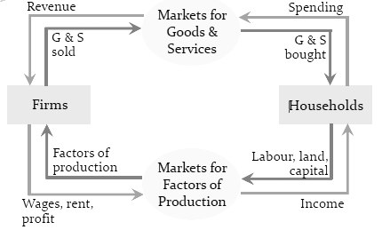
Our Second Model
The Production Possibilities Frontier (PPF): A graph that shows the maximum combinations of two goods an economy can produce given its available resources
and technology
ex. - Assume the two goods are computers and wheat
- Assume one resource is used to produce each of the two
goods
->Labour (measured in hours)
- Assume the economy has 50,000 labour hours per month available for production
- Assume producing one computer requires 100 hours of labour
- Assume producing one ton of wheat requires 10 hours of labour 7

PPF Example: Step 1
Calculate alternative combinations of computers and
wheat that can be produced using labour

(50,000 hrs of available labour; 100 hrs of labour = 1 computer;
10 hrs of labour = 1 ton of wheat)

PPF Example: Step 2
Graph the alternative combinations of computers and wheat that can be produced using labour

PPF Example: Extensions

On the graph, find the point that represents 100 computers and 3,000 tons of wheat, and label it F
- Would it be possible for the economy to produce this combination of the two goods? Why or why not?

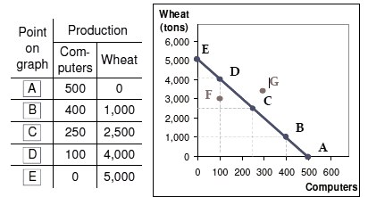
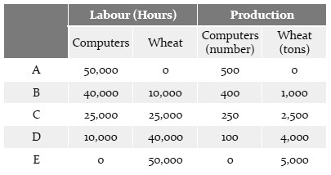
Point F requires 40,000 hours of labour in total. Possible but not efficient: could get more of either good without sacrificing any of the other. Some labour is unemployed

On the graph, find the point that represents 300 computers and 3,500 tons of wheat, and label it G
-Would it be possible for the economy to produce this
combination of the two goods? Why or why not?

Point G requires 65,000 hours of labour in total. Not possible because economy has only 50,000 hrs of labour.

PPF Example: Summary

Points on the PPF (like A – E)
-Possible
-Efficient – all resources are fully utilized

Points under the PPF (like F)
-Possible
-Not efficient – some resources underutilized
* For example, workers unemployed and/or factories idle

Points above the PPF (like G)
-Not possible

The PPF and Opportunity Cost
Recall Principle #2: The opportunity cost of an item is what you must give up to get it
Moving along a PPF involves shifting resources (e.g.,labor) from the production of one good to the other
So society faces a tradeoff (Principle #1): Getting more of one good requires sacrificing some of the other
The slope of the PPF tells you the opportunity cost of one good in terms of the other
The slope of a line equals the “rise over the run”, the amount the line rises (positive or negative) when you move to the right by one unit

Since the PPF in our example is a straight line, its slope can be calculated using any two points on the PPF

Here, the opportunity cost of one computer is 10 tons of wheat

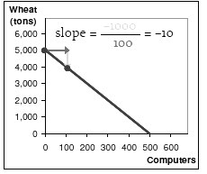
To get an additional computer, society must give up 10 tons of wheat

-In which country is the opportunity cost of cloth lower?
England, because its PPF is not as steep as France’s
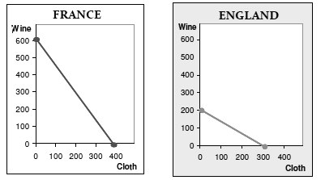

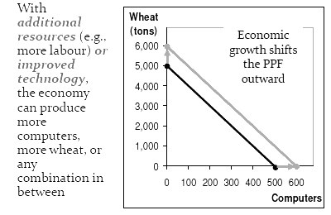
PPF AND ECONOMIC GROWTH

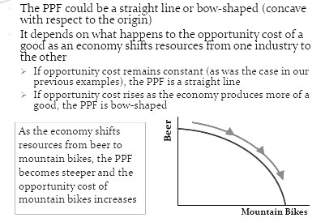
THE SHAPE OF THE PPF

WHY MIGHT THE PPF BE BOW SHAPED
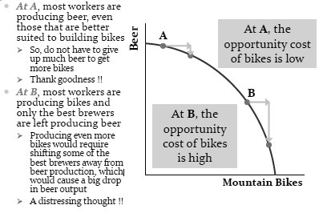

… when different workers have different skills, so that there are different opportunity costs of producing one good in terms of the other. Or when there is some other resource, or mix oF resources with varying opportunity costs

For example, different types of land suited for different uses

ECONOMISTS AS POLICY ADVISORS

- Economists often give conflicting policy advice;
they disagree
As human beings, is this really so surprising?
Are there not many ways to achieve any single goal (e.g.,
weight loss), and as many opinions as to which is the best way to do so?
- Sometimes economists disagree about the validity of
alternative positive theories about the world
- Sometimes they have different values and, therefore,
different normative views about what policy should
try to accomplish
- Yet, there are many propositions about which most
economists agree

PROPOSITIONS ON WHICH MOST ECONOMISTS AGREE

-Rent controls reduce the quantity and quality of housing
(93% agree)
-Tariffs and import quotas usually reduce economic welfare
(93% agree)
-A large federal budget deficit adversely affects the
economy (83% agree)
-Flexible and floating exchange rates offer an effective
international monetary arrangement (90% agree)
-Cash payments increase the welfare of recipients to a
greater degree than do in-kind transfers of equal cash
value (84% agree)
-A minimum wage increases unemployment among young
and unskilled workers (79% agree)
-Effluent taxes and marketable pollution permits represent
a better approach to pollution control than the imposition
of pollution ceilings (78% agree)

RECAP

As scientists, economists try to explain the world using models with appropriate assumptions – they make positive statements

Two simple, but very useful, models are:
1. the Circular-Flow Diagram – shows how dollars flow through markets among households and firms
2. the Production Possibilities Frontier (PPF)-shows all combinations of two goods that an economy can possibly produce, given its existing resources and technology. Illustrates the concepts of tradeoffs and opportunity cost, efficiency and inefficiency, unemployment, and economic growth

A bow-shaped PPF illustrates the concept of increasing opportunity cost

As policy advisers, economists offer advice on how to improve the world – they make normative statements

While disagreements often arise, there are many propositions on which most economists agree

Chapter 3

Income & Expenditure
We begin our study of macroeconomics – the study of the economy as a whole – with the country’s total income and expenditure

Gross Domestic Product (GDP) measures both:
- The total income of everyone in the economy
- The total expenditure (or spending) on the economy’s production of goods and services

For the economy as a whole, income equals expenditure because every dollar a buyer spends is a dollar of income for the seller.

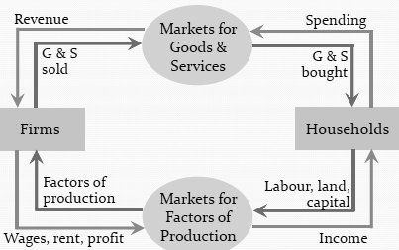
This is what the Circular-Flow Diagram tells us

Model Characteristics

Two markets
For goods and services
For factors of production – the resources the economy uses to
produce goods & services
Land, labour, capital (machinery & equipment), natural resources

Two types of economic agents
Households:
Own factors of production & sell/rent them to firms in exchange for income
Buy and consume goods and services
Firms:
Buy/hire factors of production & use them to produce goods and services
Sell goods and services

What the diagram omits
The government:
Collects taxes, buys goods and services
The financial system:
Matches savers’ supply of funds with borrowers’ demand for loans
The foreign sector:
Trades goods and services, financial assets, and currencies with the country’s
residents

GDP Defined
- The market value of all final goods & services produced within a country in a given period of time

- All goods are valued at their market prices and measured in the same units (e.g., dollars in Canada)
Things that don’t have a market value are excluded (e.g., housework), as are illicit activities

-Final goods and services intended for the end user
The value of intermediate goods – goods used in the production of other goods – are already included in the value of final goods

-Both tangible goods (e.g., mountain bikes, beer) and intangible services (e.g., cell phone service, haircuts)

-Only newly produced goods
Not goods produced in the past (e.g., sales of existing houses)

-All production that occurs within a country’s borders, whether done
by its own citizens or by foreigners located there
Production by Canadians that takes place in other countries is notincluded

-Usually a year or a quarter (3 months)

The Expenditure Components of GDP
Recall: GDP is total spending (or expenditure)
There are four components of spending:
Consumption (C)
Investment (I)
Government Purchases (G)
Net Exports (NX)
These four components add up to GDP (denoted Y):
Y = C + I + G + NX
This is an identity; it is true by definition

Consumption (C)
Total spending by households on goods and services
Goods include:
- Durable goods such as cars and appliances
- Non-durable goods such as food and clothing
- Services include intangible items such as haircuts and
- health care
Note on housing costs:
- For renters, consumption includes rent payments
- For homeowners, consumption includes the imputed rental value of the house, but not the purchase price or mortgage payments
- Expenditures on new housing are treated as investment
- spending

Investment (I)
-Total spending on goods that will be used in the future
to produce more goods

Includes spending on:
Capital equipment (e.g., machines, equipment, tools)
Structures (factories, office buildings, new houses)
Inventories (goods produced but not yet sold)
When inventories are sold, they are recorded as negative
inventory investments offset by a positive expenditure

Note: Investment does not mean the purchase of
financial assets like stocks and bonds. Such
investments are rather saving.

Government Purchases (G)

Include spending on goods and services by all levels
of government
Local, territorial, provincial and federal
Include both the salaries of government workers and
spending on public works
Exclude transfer payments to persons (e.g., Canada
Pension Plan benefits to seniors or Employment
Insurance benefits to those who lose their job)
Transfer payments are not made in exchange for
currently produced goods or services
Note: Government is not a person !!

Net Exports (NX)
Exports minus imports
Exports represent foreign spending on an economy’s
goods and services
Imports are those portions of C, I, and G that are spent
on goods and services produced abroad
Imports are subtracted from exports because imports
are included elsewhere in GDP
Example: You purchase grub killer made in the US.
This increase in consumption expenditures is exactly
offset by a decrease in net exports and Canadian GDP is
unaffected.

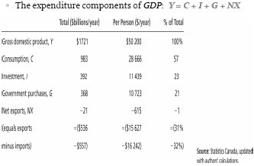
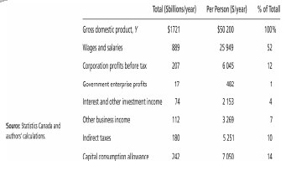
Some Questions about GDP & its Components
In each of the following cases, determine how much GDP
and each of its components is affected (if at all)
1. Debbie spends $200 to buy her husband dinner at the finest
restaurant in Boston
Consumption and GDP rise by $200
2. Sarah spends $1,800 on a new laptop to use in her publishing
business. The laptop was built in China
Investment rises by $1,800, net exports fall by $1,800, GDP is
unchanged
3. Jane spends $1,200 on a computer to use in her editing
business. She got last year’s model on sale for a great price
from a local manufacturer.
Current GDP and investment do not change because the computer
was built last year
4. General Motors builds $500 million worth of cars, but
consumers only buy $470 million worth of them
Consumption rises by $470 million, inventory investment rises by
$30 million, and GDP rises by $500 million
Real versus Nominal GDP
Inflation can distort economic variables like GDP, so we
have two versions of GDP
One is corrected for inflation; the other is not
Nominal GDP values output using current prices. It is
not corrected for inflation.
Suppose nominal GDP grows both because prices rise and
because the economy produces more goods
The increase will overstate the increase in society’s well-being
(or income) because part of these increases are due to
inflation
We need a way to take out the effects of inflation, to see how
much people’s incomes are growing in terms of purchasing
power
Real GDP values output using the prices of a base year
so prices do not change
It answers the question: “How much would GDP have grown
if there had been no inflation?”
Thus, real GDP is corrected for inflation
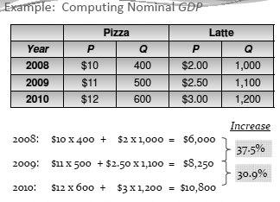
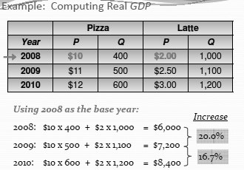
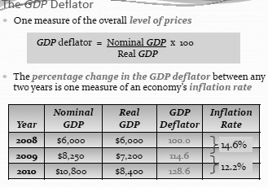

GDP & Well-Being
Real GDP per capita (or real income per capita) is the main indicator of the average person’s standard of living
But it is not a perfect measure of well-being

It does not measure, for example, the quality of the environment, leisure time, non-market activities (e.g., the care a parent provides his or her child at home) and how equitable is the distribution of income
As Robert Kennedy said very eloquently (and harshly) in
1968:
GDP “… does not allow for the health of our children, the
quality of their education, or the joy of their play. It does not
include the beauty of our poetry or the strength of our
marriages, the intelligence of our public debate or the
integrity of our public officials. It measures neither our
courage, nor our wisdom, nor our devotion to our country. It
measures everything, in short, except that which makes life
worthwhile, and it can tell us everything about America
except why we are proud that we are Americans.”

