Evolution of Eukaryotes
- Formation of Endomembrane System
  - Ancient prokaryotic cell
  - Through gradual in-folding of plasma membrane
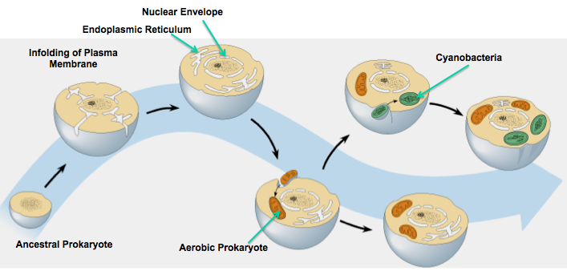
  - Endomembrane system formed
    - Golgi apparatus
    - ER
    - Nuclear envelope
- Energy-Transducing Organelles
  - Endosymbiosis
    - Prokaryotic ancestors of mitochondria and chloroplasts were engulfed by larger prokaryotic cells
    - Formed mutually advantageous relationship – symbiosis
    - Mitochondria came first - capable of using oxygen for aerobic respiration
    - Chloroplasts developed from ingested cyanobacteria
  - Theory Evidence
    - Morphology
      - Form or shape of both organelles is similar to prokaryotic cells
    - Reproduction
      - Mitochondria or chloroplasts are derived only from preexisting mitochondria and chloroplasts – divide by binary fission
    - Genetic Information
      - Both organelles contain their own DNA – codes for the proteins essential for the organelles function
    - Transcription & Translation
      - Contain a complete transcription and translational machinery – enzymes and ribosomes
      - Similar ribosomes to prokaryotic cells
    - Electron Transport
      - Can generate energy in the form of ATP through their own ETC

Driving Evolution of Eukaryotes
- Earliest prokaryotes were anaerobic
- 2.2 bya cyanobacteria evolve
  - Oxygenic photosynthesis
  - Atmosphere contains oxygen
- Oxygen as terminal electron acceptor
  - Prokaryotes that undergo aerobic respiration
- Oxygenic Phosphorylation
  - More ATP

Eukaryotic Cells Are Bigger & More Complex
- Endosymbiosis cells overcame energy barrier
- Prokaryotic cells made enormous amounts of ATP through mitochondrion
- Prokaryotes
  - High plasma membrane surface area to support volume of cell
    - Energy supplied by plasma membrane supports volume of cell
    - Transporters also need enormous PM
  - Don't have a lot of energy
    - Make less protein
- Eukaryotes
  - Low plasma membrane surface area to volume ratio
  - ETC is in mitochondrion membrane
  - More ATP = greater function
  - Complexity
    - Processes (Proteins are linked to function)
      - Tissue development
      - Multicellularity
      - Endomembrane system
    - Energy Required
      - Maintaining DNA & DNA replication
        - 2% of cell energy budget
      - Protein Synthesis
        - 75% of cell energy budget
  - Lots of ATP = lots of protein = greater function & bigger genome (genes code protein)

Lateral Gene Transfer
- Million years after endosymbiosis
- Lots genes in both mitochondria and nucleus
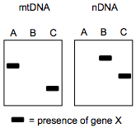
- Lateral Gene Transfer
  - Some genes in chloroplastic genome and mitochondrion genome have relocated into nucleus
- Ex. Southern Blot (see picture)
  - Species B – lateral gene transfer has occurred
  - Species C – lateral gene transfer is occurring
  - Species A – lateral gene transfer has not occurred

Earliest Eukaryotes
- Diplomonads
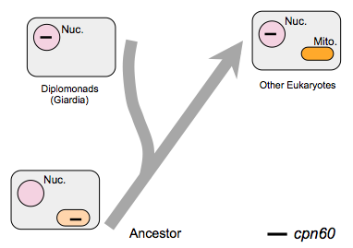
  - Very primitive eukaryotes
  - Contains nucleus but lack mitochondria
  - Question: did it have them and then lost them or did it not have them at all?
  - Ex. Giardia

Giardia & cpn60
- cpn60 gene
  - Chaperone
  - Other Eukaryotes
    - Found in nucleus
    - Translated
    - Imported and functions in mitochondria (helps proteins fold)
  - Diplomonads (Giardia)
    - Found in nucleus
    - Not in mitochondrio
  - Ancestral Eukaryote
    - Had mitochondrion
    - Lateral gene transferred occur cpn60 imported into nucleus
    - Evidence that mitochondrion were present in diplomonads but they lost them

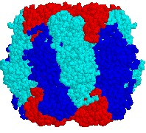
Rubisco Assemply
- Mitochondrion & chloroplasts
  - Need 3,000 genes
  - Most proteins are coded by genes now in nucleus
  - Some proteins are coded by both genomes
    - Some coded by mitochondria genome
    - Some coded by nuclear genome
- Ex. Rubisco Assembly
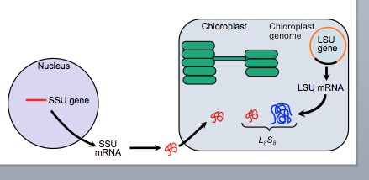
    - 8 Large Subunits (LSU)
    - 8 Small Subunits (SSU)
  - Coded by different genomes
  - Requires elaborate control
  - Only large subunits are coded by chloroplast genome in chloroplast
  - Small subunits are coded by nuclear genome in nucleus
    - Imported into chloroplast
  - Combine to make functional protein
- Evidence very strong
  - Ex. Rubisco
- Elysia
  - Has chloroplasts from Vaucheria
  - Contains Rubisco
  - Nuclear genome
    - Does it have small subunits to make Rubisco?
      - No evidence of nuclear genome genes of Vaucheria in the nucleus of Elysia
    - Unclear as to how it maintains functional chloroplasts

Reason for Lateral Gene Transfer
- Can’t have free living (uncontrollable) cell in another cell
  - Nuclear genome has to control overall cellular function
  - Has to transfer genes to shift control
- Reactive molecules (REDOX)
  - Energy-transducing organelles – lots of high energy electrons, powerful reductants & oxidants
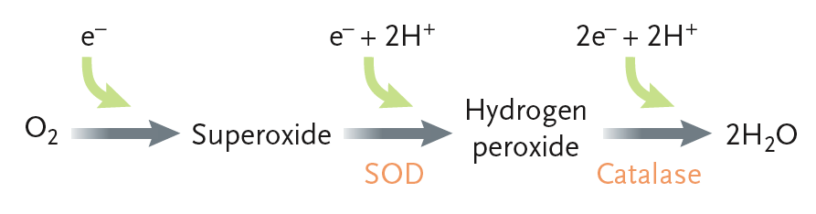
  - DNA sensitive to oxidation (induce mutations)
  - Mitochondrion and chloroplasts can create reactive oxygen species (ROS)
    - Toxic molecules
      - Hydrogen peroxide
      - P680+
  - Shift DNA to nucleus – better protected from reactive environments
- Sexual Recombination
  - Only occurs in nucleus
  - Chromosomes can get rid of mutations genomes can be repaired

Bacterial Genome
- Why hasn't the entire genome relocated?
- Bacterial genome 5, 144 genes & 4,639,625 base pairs
- Mitochondrial genome 37 genes & 13 proteins & 16,500 base pairs
- Chloroplast genome 133 genes & 89 proteins & 160,129 base pairs

Should I Stay or Should I Go?
- Most genes have been lost redundant
- Some relocated to nucleus (95%)
- Some retained in organelle
  - Advantage
    - Function of genes code for components ETC
    - Local production and control
      - ND5 subunit of NADH dehydrogenase
  - Reasoning
    - Many some cannot be imported because of membrane permeability
    - Proteins get degraded faster
      - Very sensitive to reduction & oxidation
      - Turn over quickly
        - To repair protein - might need local control to be efficient at repairing
        - Too much effort to go to nucleus for repair instructions
    - Just hasn't moved yet (gradual evolutionary process)
- Genetic code is not universal – organelles (some codons have different meanings)

