Cellular Respiration

Energy Coupling
- Energy released from DOWNHILL (exergonic) reactions used to drive UPHILL (endergonic) reactions

Metabolic Pathways
- Catabolic pathway
  - Breaks molecules down
  - Free energy is released
  - Exergonic (overall 0>G)
  - Ex. cellular respiration
- Anabolic pathway
  - Builds molecules
  - Free energy is consumed
  - Endergonic (overall 0<G)
  - Ex. photosynthesis and biosynthetic reactions

ATP/ADP Cycle
- Energy to change ADP+Pi to ATP comes from catabolic processes
- Amount of ATP synthesized in body = GIGANTIC
- Use energy released from ATP ADP + Pi used to drive anabolic processes

Food as Fuel
- _{o}Food has:
  - C-H bonds (lots of energy)
  - Ex. glucose and octane

Overall reaction
- C₆H₁₂O₆ + 6O₂ = 6CO₂ + 6H₂O
  - Redox reaction
    - C₆H₁₂O₆ – oxidized to CO₂
    - O₂ – reduced to H₂O
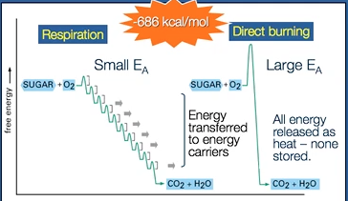
  - Glucose takes the whole respiratory pathway
  - Reaction is accompanied by a decrease in potential energy (downhill process)
  - ∆G = -2870 kJ/mol

Goals of Cell Respiration
- Extract energy from Glucose and convert to ATP
  - Controlled combustion (just like burning glucose)
    - Change in free energy is the same
    - Respiration – Small E_{A}
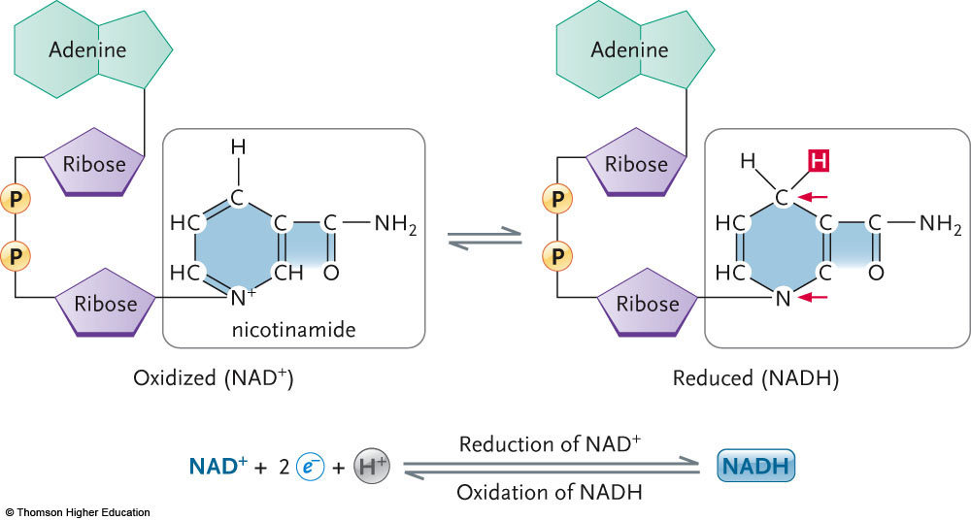
      - Energy is stored and transferred to energy carriers
    - Direct Burning – Large E_{A}
      - Energy is released as heat
- Breaks the bonds between the 6 C to yield 6CO₂
- Move H atoms from glucose to oxygen to yield 6H₂O

NAD+ as Electron Shuttle
- Energy carriers
- In catabolic reactions
  - NAD+
- In anabolic reactions
  - NADP

Energy Transfer
- First law of Thermodynamics
  - Energy cannot be created or destroyed, it can be changed from one form to another
- Change from glucose to ATP
- Goal: Make as much ATP as possible from ADP (2 possible ways):
  - Substrate-level Phosphorylation
  - Oxidative Phosphorylation

Substrate-level Phosphorylation
- ATP is made directly
- An enzyme medicated process
- The phosphate is transferred directly to ADP to make ATP

Oxidative Phosphorylation
- ATP is made indirectly
- Multi-step process
- Involves Redox reaction (reduction-oxidation reactions)
  - Leo – Ger
    - Leo – loss electrons oxidation
    - Ger – gain electrons reduction
- Involves:
  - Mobile energy carrier molecules (energy is transferred through ETC and chemiosmosis)
    - NAD⁺ (nicotinamide adenine dinucleotide)
    - FAD (flavin adenine dinucleotide)
  - 1. Starts with NAD⁺
    - Reacts with 2H from glucose
    - NAD⁺ gains 2 electrons and a proton

Mitochondria
- Powerhouse of cell
- Single: mitochondrion
- Found in eukaryotic cells only
- Double membrane
- Folded inner membrane called cristae
- Matrix fluid filled interior
- Intermembrane space is between two membranes

Stages of Cellular Respiration
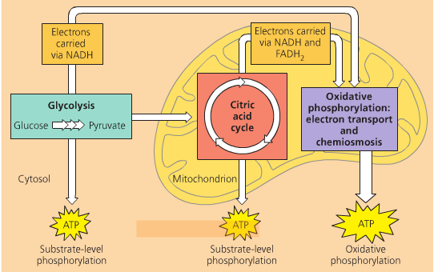
- Glycolysis
  - Glucose pyruvate
  - 6C + 23C
  - 10 steps, in the cytoplasm
- Pyruvate Oxidation
  - 1 step, in the matrix of the mitochondria
- Krebs cycle (TCA cycle or Citric Acid cycle)
  - 8 steps, in the matrix of the mitochondria
- Electron Transport and Chemiosmosis
  - Many steps, in membrane of mitochondria

Summary of Stage One
- First biochemical pathway to evolve – no oxygen needed – all living cells
- Substrate level phosphorylation – enzyme requiring
- 10 steps, in cytoplasm
- Starts with glucose (6C molecule)
- Ends with 2 pyruvate (3C molecule)
- Energy
  - 4 ATP directly produced
  - 2 ATP used
  - 2 NADH produced (will go on to yield more ATP)
- Why Phosphorylate?
  - You make molecules more reactive
  - Compartmentalize molecules
    - Phosphate group is negatively charged – do not like to cross membranes

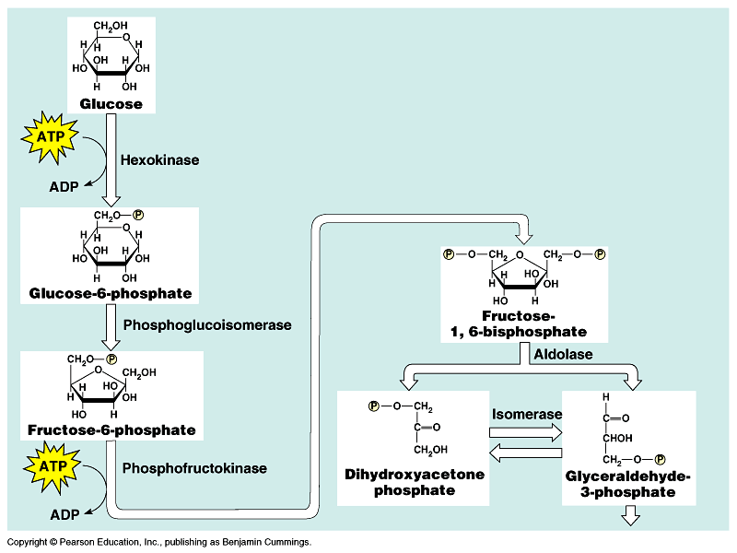

Energy Investment

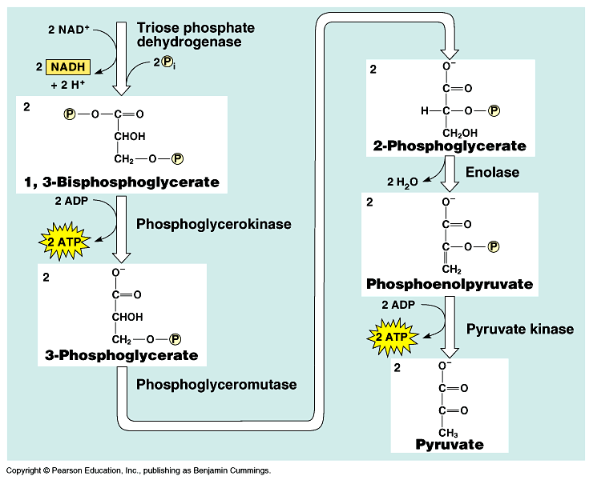

Energy Payoff

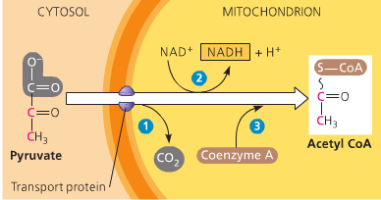
Summary of Stage Two
Dehydrogenase
- One step that brings pyruvate into the mitochondrion using a carrier protein
- Pyruvate is oxidized (LeO – electrons removed)
- CO₂ is produced (so now it is acetyl, a 2C molecule)
- Coenzyme, called coA is attached
- Occurs TWICE (2 pyruvates are produced in glycolysis)
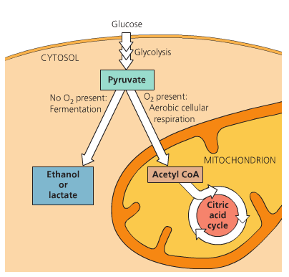
Pyruvate Dehydrogenase
Complex

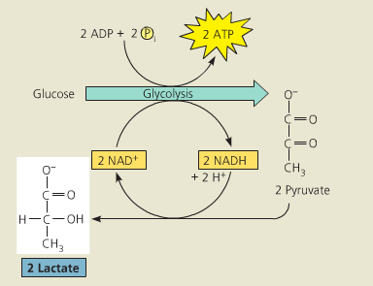

Restarts glycolysis with the production of NAD⁺

Transition before Stage Three
- Acetyl-coA is a key molecule in energy metabolism
- Can also be made from lipids, proteins (when you are on a low carb diet)
- Can be used to make fat if you have enough cell energy
- This stage is the turning point for aerobic vs. anaerobic
- Note: No O₂ has been used yet
- Note: Overall, only 2 ATP made

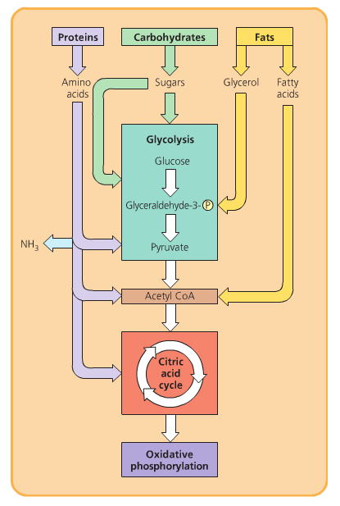
Disorders of Energy Metabolism
- Lots of genes encoding enzymes in cellular metabolism
- Inborn errors of metabolism occur (severe)
  - Pyruvate Dehydrogenase Deficiency
    - Can be treated
    - Causes severe mental retardation
      - ATP deprived
    - Overcome by ketogenic diet
      - 88% fat, 10% protein, 2% carbohydrate
  - Enzyme mutations
- Shifts in Ratios
  - Lactate/Pyruvate Ratio
    - Lactate or ethanol
      - Oxygen deprived environment
  - ATP/ADP ratio

Summary of Stage 3: Krebs Cycle
- 8 step, in matrix, cyclical process
- Oxaloacetate – the final product of step 8 is used as a reactant in step 1
- By the end of the cycle the glucose is fully used (2 more CO₂ are released for each acetyl-coA, or a 4 more CO₂ for each glucose
- Per pyruvate
  - Reactants
    - Oxaloacetate (4C molecule) + acetyl-coA (2C) + ADP + Pi + 2NAD + FAD
  - Products
    - coA + ATP + 2NADH + 3H⁺ + FADH₂ + 2CO₂ + oxaloacetate (4C)
  - Energy
    - 1 ATP
    - 3 NADH
    - 1 FADH₂
- Per glucose
  - Reactants
    - Oxaloacetate + acetyl-coA + ADP + Pi + 2NAD + FAD
    - Oxaloacetate + acetyl-coA + ADP + Pi + 2NAD + FAD
  - Products
    - coA + ATP + 2NADH + 3H⁺ + FADH₂ + 2CO₂ + oxaloacetate
    - coA + ATP + 2NADH + 3H⁺ + FADH₂ + 2CO₂ + oxaloacetate
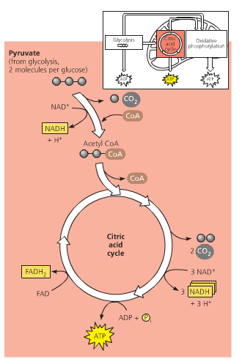
  - Energy
    - 2 ATP
    - 6 NADH
    - 2 FADH₂

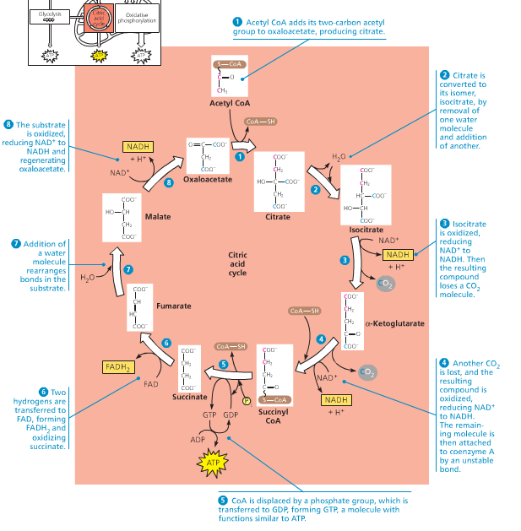
Energy Count
- Reminder – goals for cell respiration
- C₆H₁₂O₆ + 6O₂ 6CO₂ + 6H₂O
  - Break the bonds between the 6 C to yield 6CO₂
    - Already done, in Pyruvate oxidation (2) and Krebs cycle (4)
  - Move H atoms from glucose to oxygen to yield 6H₂O
    - Now in oxidative phosphorylation (which is stage 4)
  - Trap as much energy and transfer to ATP
- Reminder – energy summary
  - Already produced from 1 glucose
    - Stage 1: Cytoplasm
      - 2 ATP (4 made, 2 used, ergo 2 net)
        - by direct phosphorylation
      - 2 NADH + H⁺
        - Needs to be moved & converted
    - Stage 2: Mitochondrion
      - 2 NADH + H⁺
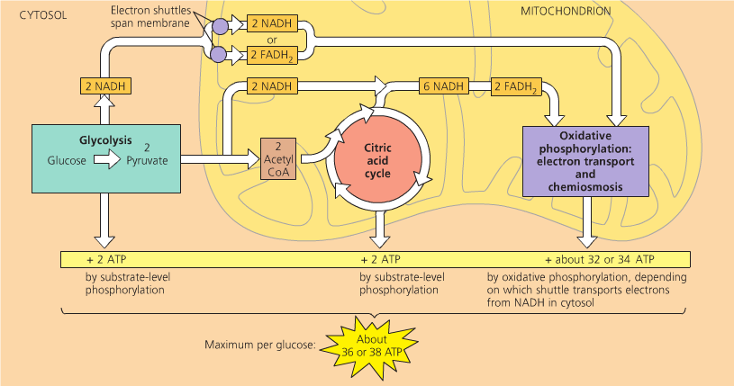
        - Needs to be converted
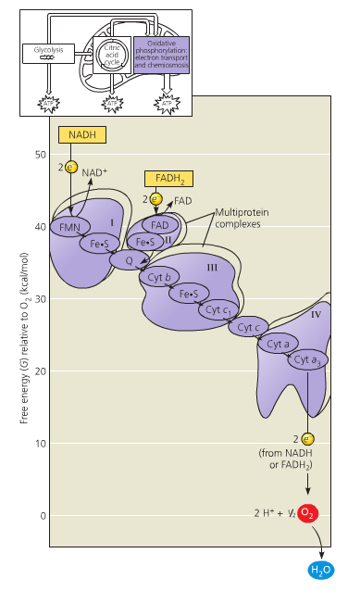
    - Stage 3: Mitochondrion
      - 2 ATP
        - by direct phosphorylation
      - 6 NADH + H⁺
        - Needs to be converted
      - 2 FADH₂
        - needs to be converted

Stage 4: Electron Transport & Chemiosmosis

To make more ATP:
- Oxidative phosphorylation (indirect method)
  - Electron Transport Chain
    - Moving electrons by oxidation & reduction (where do they ultimately go? To oxygen!)
    - Moving protons to set up a concentration gradient in the mitochondrion
    - See diagram

    - Xe_ + Y X + Ye⁻

      - Bold becomes reduced
      - Non-bold becomes oxidized
    - Carriers are proteins that are embedded in the inner membrane of the mitochondrion
    - NADH +H⁺ enters at one point (yields the most ATP), FADH₂ enters at a different point (yields less ATP)
      - Proteins
        - Q – Ubiquinone
        - Cyt C – Cytochrome C
        - I – NADH Dehydrogenase
        - II - Cytochrome X
        - III – Cytochrome Complex
        - IV – Cytochrome Oxidase
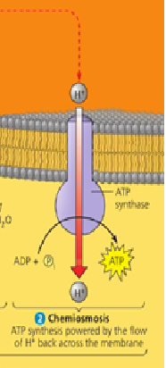
      - By the time NADH is done:
        - 3 protons have been pumped into the intermembrane space by protein complexes I,III,IV
        - The final acceptor of the electrons is oxygen to make water
    - FADH₂
      - Enter ETC via protein complex II
      - Protein complex II doesn’t pump a proton
      - Move through cytochrome X, complex III & IV will pump protons
      - By the time FADH₂ is done
        - 2 protons have been pumped into the intermembrane space by protein complexes III & IV
        - The final acceptor of the electrons is oxygen
  - Chemiosmosis
    - Using the proton gradient to make ATP (do work)
    - From NADH, there are 2 protons in the space
    - From FADH₂ there are 2 protons in the space
    - As the protons move back across the membrane, they “drive” ATP synthesis each proton causes an ADP to be phosphorylated
    - Proton Motive Force
      - Two components to it
      - PMF = ΔΨ -59 (ΔpH)
        - Charge difference (ΔΨ)
        - Concentration difference (ΔpH)
      - PMF = 160mV – 59(7.0-8.0)
      - PMF = 220 mV

Energy Summary
Produced from 1 glucose

- Stage 1: in cytoplasm
  - 2 ATP (4 made, 2 used, ergo 2 net)
    - by direct phosphorylation
  - 2 NADH + H⁺
    - Converted to 6 ATP*
- Stage 2: in mitochondrion
  - 2 NADH + H⁺
    - Converted to 6 ATP
- Stage 3 & 4: in mitochondrion
  - 2 ATP
    - By direct phosphorylation
  - 6 NADH + H⁺
    - Converted to 18 ATP
  - 2 FADH₂
    - Converted to 4 ATP
- Total
  - 4 ATP
    - By direct phosphorylation
  - 36 ATP – 2 ATP*
    - 34 ATP
      - Indirect, oxidative phosphorylation
- But 2 ATP are used to bring the cytoplasmic 2 NADH into the mitochondrion

Uncoupler & Inhibition
- Oligomycin - ATP synthase inhibitor
- Uncoupler (just like short circuit)
  - Permeable to protons
  - Inhibits action of ATP synthase
  - Energy is not conserved - heat released
- Natural Uncouplers
  - Brown Adipose (Fat) Tissue
    - Lots of mitochondrion
    - Highly expressed uncoupling protein (UCP1)
    - Proton gradient flows back
    - Lose energy as heat
    - Regulating heat production for hibernation & newborns
    - Thin people have high expression of UCP
      - Mitochondrion slightly more uncoupled
  - 2,4 Dinitrophenol (DNP) & Weight Loss
    - Weightlifters by uncouplers
    - Can kill humans
    - Lost weight but don't make enough ATP

Respiratory Control
- Rate of respiration (of ETC) (rate of oxygen consumption) is linked to the abundance of ADP
  - High abundance = high rate of respiration
- Measure oxygen consumption in isolated mitochondrion
  - Have to add substrate (NADH) (no glycolysis)
  - Add ADP rate of respiration increases
  - Add Oligomycin – rate drops
  - DNP – rate increases (highest rate of respiration in presence of uncoupler)

How the Cell Know to Make Acetyl CoA or Lactate/Ethanol?
- Redox Homeostasis
  - NAD⁺/NADH switches on and off enzymes that control flow of carbon
  - Lots of oxygen lots of NAD⁺
- Hypoxia-Inducible Factor
  - Protein complex (HIF-1)
    - HIF-1α & HIF-1β = HIF-1
  - Constitutive Expression of both proteins
    - HIF-1β – accumulates in nucleus
    - HIF-1α – enzyme under oxygen degrades it (does not accumulate)
  - Under Hypoxia
    - Under low oxygen - HIF-1α becomes stable – doesn't get degraded – combines with HIF-1β to make functional HIF-1
  - HIF-1 – transcription factor
    - Regulates transcription
    - Actives transcription of over 100 genes
      - Activates enzyme pyruvate dehydrogenase kinase
        - Acts at the level of pyruvate dehydrogenase complex
        - Shuts down complex – pyruvate is not metabolized in mitochondria

Fermentation
- Expansion of glycolysis that allows the continuous generation of (limited) ATP by the substrate-level phosphorylation
- Must be a sufficient supply of NAD+ to accept the electrons during the oxidation step of glycolysis. Without some mechanism to recycle NAD+ from NADH, glycolysis would soon deplete the NAD+
- Transfer electrons from NADH to pyruvate
- Final electron acceptor is an organic molecule such as pyruvate (lactic acid fermentation) or acetaldehyde (alcohol fermentation)
- Energy still stored in pyruvate is unavailable to the cell
  - Alcohol Fermentation
    - Pyruvate is converted to ethanol in two steps
      - Releases carbon dioxide from the pyruvate, which is converted to the two-carbon compound acetaldehyde
      - Acetaldehyde is reduced by NADH to ethanol
        - Regenerates the supply of NAD+ needed for the continuation of glycolysis
  - Lactic Acid Fermentation
    - Pyruvate is reduced directly by NADH to form lactate as an end product, with no realse of CO₂ (lactate is the ionized form of lactic acid)



