Photosynthesis
- Major biological process that allows for energy to enter biosphere
- Chlorophyll is abundance in aquatic and land environments
  - Aquatic environments that are very cold are photosynthetic hotspots
- Transforming light energy into chemical energy (sugar)

Carbon Dioxide vs. Sugar
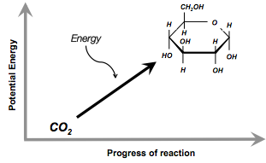
- Metabolic process
- Light dependent conversion of CO₂ (inorganic) into organic form
- No useable energy in CO₂
  - Can get electrons away from molecule – oxygen too electronegative
- Sugar
  - Calories
  - C-H bonds – not electronegative easier to pull electrons away and therefore work can be done
- Endergonic reaction

Redox Process
- Redox process in which water is oxidized, carbon dioxide is reduced

  - The Light Reactions
    - Occurs in grana
    - Split water
    - Release oxygen
    - Produce ATP
    - Form NADPH
    - Powered by energy of the sun

  - Calvin Cycle
    - Occurs in stroma
    - Forms sugar from CO₂
    - Use ATP for energy and NADPH (electron source) for reducing power from light reactions

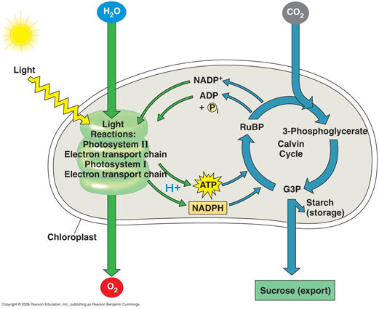

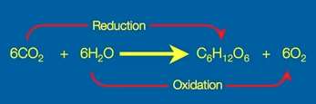

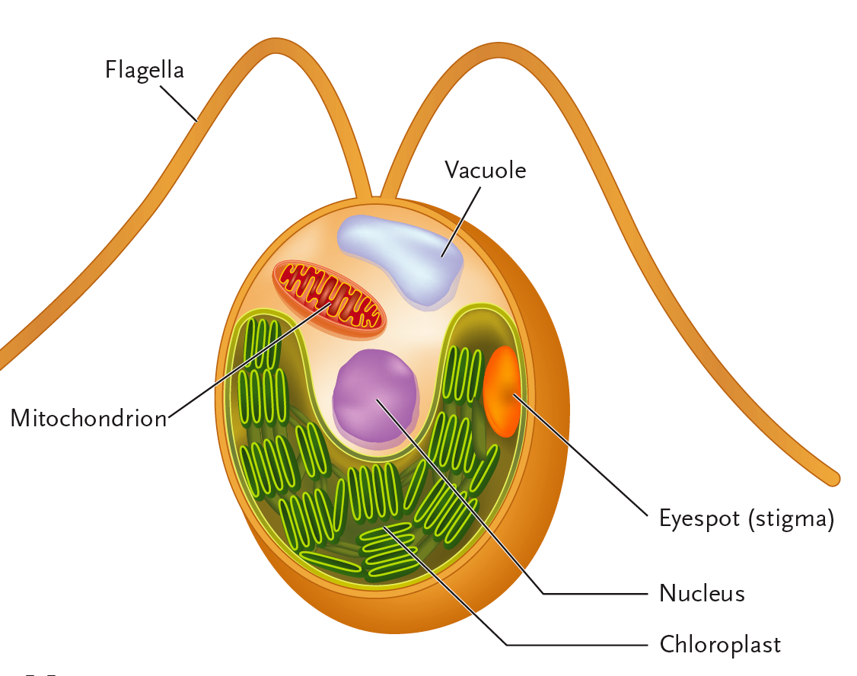
Energy & Information
- Light – Photosynthesis – Energy Source
- Light – Vision – Information
- Chlamydomonas Reinhardtii
  - Photoplankton (algae)
  - Eyespot
    - Phototaxis – alter distance from light source based on amount needed

Light
- Key concept
  - Light reactions convert solar energy to chemical energy (ATP, NADPH)
- Light
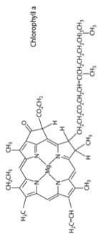
  - Form of electromagnetic energy which travels in waves
  - Also behaves as particles of light (photons)
  - Wavelength
    - Is the distance between the crests of waves
    - Determines the type of electromagnetic energy
    - Inversely related to energy
      - E = hc/λ
  - Photons must be absorbed
- Pigments
  - Substances that absorb visible light (photons) (light receptors)
  - Chlorophyll a & b and carotenoids
  - Conjugated double bonds
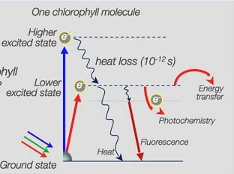
    - Way to represent electrons that are not involved in bonding
    - π – orbital electrons
    - Can be used for light absorption
  - Bound to proteins (cofactor like)
    - Chromophore

Light Absorbed
- Process
  - Single molecule of chlorophyll
  - Expose chlorophyll to white light (full visible spectrum)
    - Specifically red, green and blue light
  - Chlorophyll can absorb blue light (high energy)
  - Energy transferred to electron from ground state to higher excited state
    - One photon excites one electron
    - For absorption to take place – energy required to get from ground state to excited state must match energy of photon
  - Unstable excited state – decays as heat – reaches lower excited state (state where electron if it absorbed red photon of light – lower energy than blue)
- Fate of Excited Electron
  - Could be emitted as heat
  - Could be emitted as little heat
  - Could emit of photon (fluoresce – lower energy than initial absorbed photon)
  - Electron used for photochemistry
    - Drive photosynthesis light reactions
    - Getting electron to leave – oxidize chlorophyll
    - Reduce another molecule
- Excited state (energy) transfer to adjacent pigment molecules
- Chlorophyll is green
  - Photons of green light that come from the plant that enter our retina
  - Chlorophyll can absorb red and blue light – photons energy match perfectly
  - Cannot absorb green because of mismatched energies (no excited state) – appear green
- Absorption Spectra
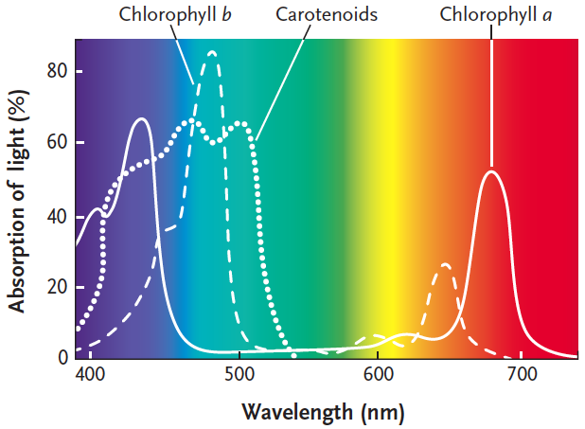
  - Chloroplast pigments provide clues to the relative effectiveness of different wavelengths for driving photosynthesis
  - How much used in photosynthesis and what is used
  - Graph plotting light absorption versus wavelength
  - Measure transmission
    - High transmittance – low absorption
    - Low transmittance – high absorption

Visible Light
- 400-700 nm wavelength
- Drives photosynthesis in every photosynthetic system
- Used for vision – colour
- Why so special?
  - Dominate wavelengths that hit the earth
  - Unlike other wavelengths – just enough (not too much or too little) energy to excite electron with pigments

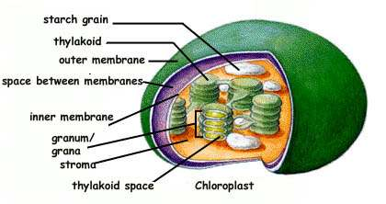
Chloroplasts

Photosystems & Light Harvesting
- Pigments (green dots) bound to integral proteins
- Light Harvesting Complex
  - Resonance energy transfer
  - Oxidizing and reduction of chlorophyll happens in reaction center
  - Electron moves from individual pigments to acceptor
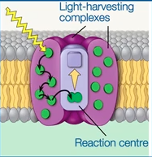
Inside thylakoid membrane – thylakoid lumen

Photosynthetic Electron Transport
- 8 photons of light to make a single molecule of oxygen
- 4 photons required making half an oxygen molecule
- Process
  - Photon of light strikes pigment molecule in light harvesting complex, boosting one of its electrons to a higher energy level
  - As electron falls back to ground, electron in nearby pigment is raised to excited state
  - Energy transfers until it reaches P680 chlorophyll molecules in PSII
  - Electrons are excited and then is transferred to primary electron acceptor
    - Oxidizing P680
    - Splitting of water molecule – electrons supplied to P680+ - generates a oxygen
  - Photoexcited electron passes from PSII to PSI via ETC (made up of PQ, Cytochrome complex and PC)
  - Exergonic fall of electrons to lower energy – provides energy for the synthesis of ATP
    - PQ picks up H⁺ from stroma and an electron
    - Proton converts oxidized PQ to reduced PQ
    - Dumps electron & proton from stroma into lumen (becomes acidic)
    - Protons go through ATP synthase to go back into the stroma
  - Light energy transferred to PSI reaction-center complex. Excites an electron of P700
  - Electron transferred to primary electron accepter
    - Oxidizing P700
    - Accepts an electron that reaches the bottom of the ETC chain from PSII
  - Photoexcited electrons are passed in a series of redox reactions from primary electron acceptor of PSI down a second ETC through protein ferredoxin (Fd) (ATP is not produced)
  - Enzyme NADP⁺ reductase catalyzes transfer of electrons from Fd to NADP+
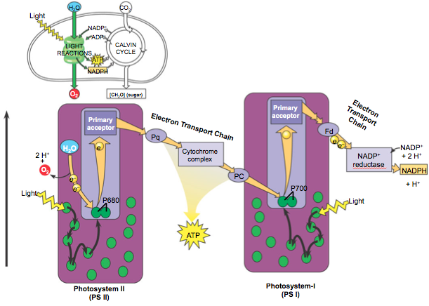
  - Two electrons are required for its reduction to NADPH – molecule is at a higher energy level than water and electrons are ready for Calvin cycle

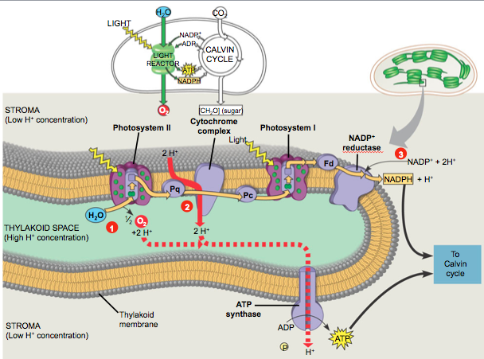
Function of Light
- All ETC are redox components attached to proteins – organized very specifically
  - Allowing for spontaneous flow of electrons (low to high redox potential)
- Redox Potential
  - More positive – molecule is oxidizing (pulls electrons away)
  - More negative – molecule is reducing (donates electrons)
- PSII ETC
  - PQ (negative redox potential) Cytochrome Complex (positive redox potential) PC (more positive redox potential)
  - Problem: Reaction center chlorophylls are not negative
    - P680/P700 cannot spontaneously donate electrons (redox potential >1)
    - Light absorption - electron P680/P700 gets excited (P680*/P700*)
      - Redox potential changes (negative)

Oxidation-Reduction of P680
- Light absorption changes redox potential
- Very easy to remove electrons
- e- removed and then drives ETC
- P680+ is reduced back to P680 due to water
  - Enzyme complex rips electron away from water
- P680+
  - Very positive redox potential
  - Strongest biological oxidant
  - Ability to oxidize H₂O – oxygen is produced and released
  - Leads to term: oxygenic photosynthesis

Anoxygenic Photosynthesis
- Found only in bacteria
- Don't evolve oxygen (oxygen is not released)
- Only requires a single photosystem
  - Use H₂S – easier to oxidize
- Evolutionary Advantage to Oxygenic Photosynthesis
  - Oxygen itself is not important – aerobic respiration was not existent yet
  - Evolve the ability to use water as electron donor (water is more common on earth)
  - Lead to increase in oxygen in atmosphere

Lecture 9 - Photosynthesis II

Global CO₂ Fixation (105 Gt/year)
- Terrestrial – 56.4 Gt
- Oceanic – 48.5 Gt
  - Single-celled – phytoplankton
  - Ectotherms
    - Near the equator there’s no phytoplankton (warm)
      - Less dissolved gas (CO₂)
      - Part of a food web (animals consuming phytoplankton)
      - Nutrients (low iron near equator)
        - Need iron for cofactors etc.
        - Experiment
          - Dumping iron into water bodies near the equator
          - More chlorophyll

Calvin Cycles
- Set of reactions that are pulling CO₂ out of the atmosphere
- Enzymes in the stroma – catalyze fixation of CO₂
- 3 Phases
  - Carboxylation reaction
    - RuBP + CO₂ PGA: initial step
  - Reduction
    - NADPH & ATP
  - Regeneration
    - RuBP produced again
- Endergonic
  - Need ATP from light reactions
  - Needs reducing power NADPH from light reactions
- Substrate
  - Ribulose Biphosphate (RuBP)
    - 5 carbon sugar – phosphate on each end
  - 1 molecule of RuBP reacts with 1 CO₂
  - Three cycles (three molecules of RuBP & 3 CO₂) – 1 G3P produced
- First stable product
  - 3-Phospho-Glycerate (PGA)
  - 3 cycles – 6 PGA produced
- 6 ATP incorporated into cycle
  - Driving reduction
- 6 NADPH incorporated into cycle
  - Reducing power to produce (G3P)
- 6 molecules of Glyceraldehyde-3-Phosphate (G3P) every 3 cycles
- 1 molecule of G3P is removed from the cycle and produced as a product every 3 cycles
  - 2 G3P combine to produce 6 glucose (6 cycles needed to produce 1 molecule of glucose)
- 15 carbons left over are regenerated into RuBP
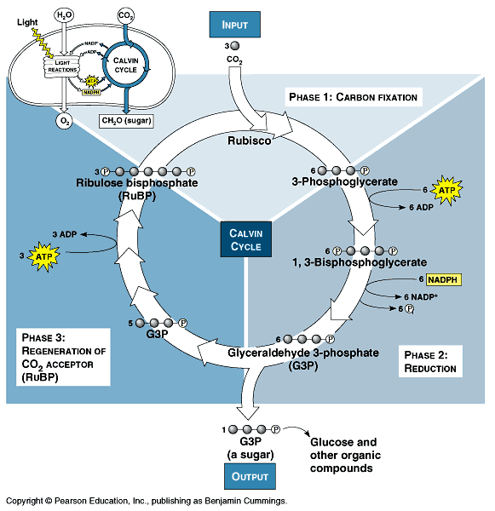

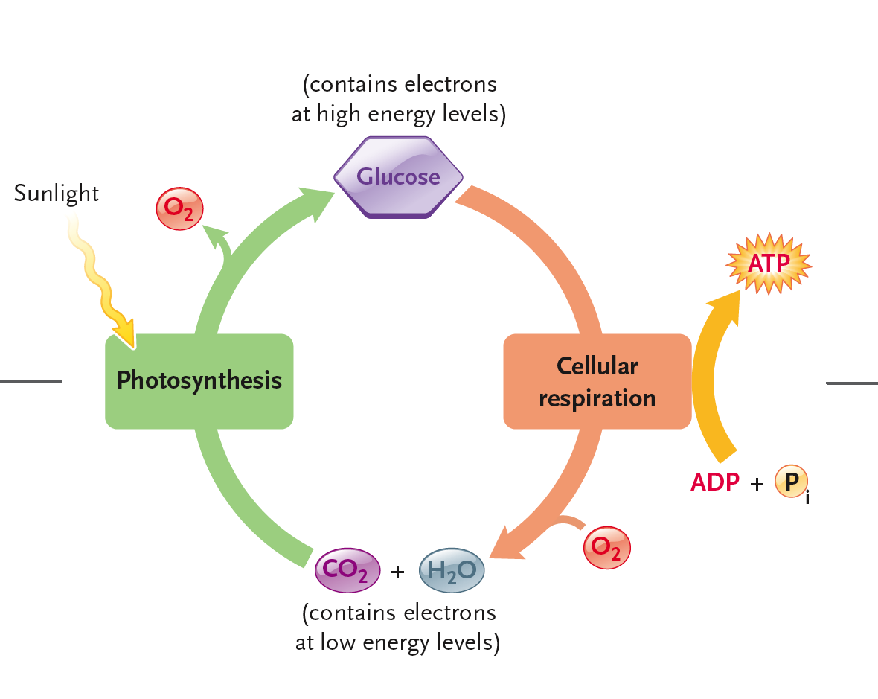

Gas Exchange in Elysia
- Gas exchange in humans
  - O₂ in, CO₂ out
- Elysia gas change more complicated
  - Light reactions of photosynthesis produce ATP
  - ATP doesn't leave chloroplast
    - Reduces CO₂ into glucose
  - Glucose then breaks down through mitochondrion processes and used for cellular functioning
  - Measure Photosynthesis
    - CO₂ consumption (Calvin cycle)
    - O₂ release (PSII)
  - Measure Respiration
    - CO₂ release
    - O₂ consumption
  - Measuring Rates
    - Ricky in Elysia both processes occur at the same time

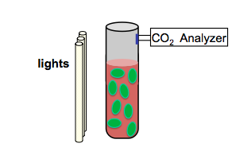
Measuring Carbon Fixation in Elysia
- Put culture of Elysia into a cuvette
- CO₂ analyzer
  - Detecting CO₂ concentration above solution of Elysia
  - Adjust light
    - Lots of light – high rates of photosynthesis
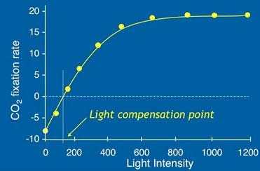
      - Concentration CO₂ would decrease
    - Low light – no photosynthesis only mitochondrion processes
  - Light Compensation Point
    - Light intensity when both process have the same rate therefore there is no net change in concentration of CO₂
- CO₂ Fixation Rate
  - μmol C/chlorophyll/sec
- Light Saturation Curve
- Growth
  - Gain in carbon
  - Above the point of light compensation

O₂ Can Compete with CO₂
- Rubisco
  - Carboxilating enzymes
  - Most abundant enzyme in biosphere
- Oxygen can compete with CO₂ in active site of Rubisco – BAD
  - Reason:
    - Ribosco is ancient (3 bya) enzyme
      - Oxygen was not existent in the atmosphere
      - Development of enzyme did not consider oxygen

Photorespiration
- Carboxilation
  - RuPB + CO₂ 2 PGA (3 carbons each)
- Oxygenation - Photorespiration
  - RuBP + O₂ PGA + Phosphoglycolate (2C)
  - Phosphoglycolate – waste (lost as CO₂ by respiration)
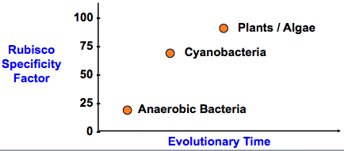
  - Lose carbon

Evolution of Rubisco
- Built for carboxylation reaction
- Carboxylation versus oxygentation:
  - Greater affinity for CO₂ (for plants today)
    - CO₂
      - (K_{m} - 10μM)
    - O₂
      - (K_{m} – 535 μM)
    - But atmosphere is 21% oxygen and 0.05% CO₂
- Natural selection caused the enzyme to change a little overtime
  - Primitive bacteria (anaerobic)
    - Rubisco is different than ones for plants and algae
  - Difference: Rubisco Specificity Factor for CO₂
    - Anaerobic – same as 3bya
    - Cyanobacteria – more discriminating
    - Plants-Algae – even more discriminating for CO₂
- 25% of the time oxygenic reaction occurs

CO₂ – Concentrating Mechanisms
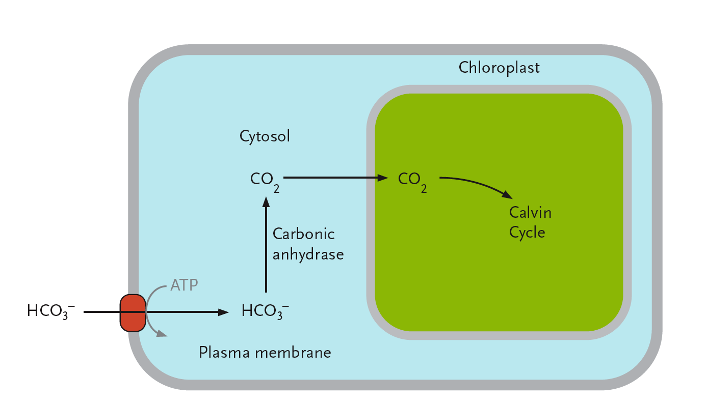
- Mechanisms to counteract oxygenation
- Change the relative abundance of CO₂ and O₂ near the active site of Rubisco
- Aquatic Photoautotrophs
  - Bicarbonate – dissolved CO₂
  - Active transport pumps bicarbonate ion into cytosol of cell
  - Carbonic anhydrase (fastest catalytic rate) converts it back into CO₂
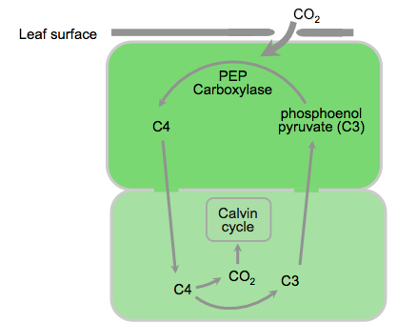
  - CO₂ in high levels diffuse into chloroplast (low oxygenation reactions)
- C4 Plants
  - Two cells
  - Calvin cycle localized to lower cell
  - CO₂ gases enter through stomata
  - PEP carboxylase fixes CO₂ (C3 + CO₂) into C4
  - C3 – plants have normal 3 carbon Calvin Cycle
  - C4 – plants have a 4 carbon molecule
  - PEP – has no affinity for oxygen
  - Decarboxylation reaction releases CO₂ in lower cell

Ecophysiology of C3 Versus C4 Plants
ATP
- Need more ATP – need to absorb more light
- Ex. Corn & Sugar Cane (C4 plant)
- C4 plants more common than C3 plants in climates that are hot and sunny
  - Increase in temperature – solubility of gas decreases
  - Stroma have less CO₂ and less O₂ dissolved
  - Drop in CO₂ is faster than O₂
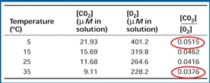
- Photorespiration is a bigger problem in hot, sunny environments – C3 plants cannot deal with that & C4 plants tend not to photorespire – greater abundance of C4 plants

