Membranes & Transports

Overview
- Over evolutionary time – membranes have come more complex
- Plasma membrane
  - Selectively permeable barrier
  - Allowed for the uptake of key nutrients and elimination of waste
  - Protected environment in which metabolic processes can occur
- Internal membranes
  - Allowed for compartmentalization of processes and increased complexity
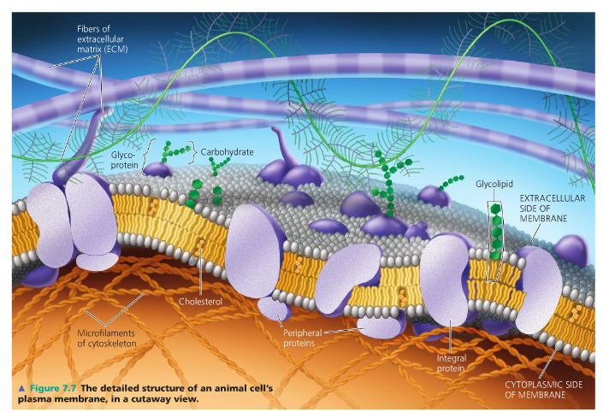
  - Ex. nuclear envelope

Fluid Mosaic Model
- Consist of fluid lipids in which proteins are embedded and float freely
- Lipid molecules exist in a double layer – called bilayer that is less than 10nm
- Molecules vibrate, flex back and forth, spin around their long axis, move sideways and exchange places within the same bilayer half
- Fluidity is a necessity to function
- Embedded Proteins
  - Move slowly in membrane
  - Transport
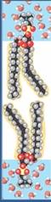
  - Attachment
  - Electron transport
  - Anchor cytoskeleton filaments to the membrane and thus do not move
  - Have carbohydrate groups linked to them, forming glycolipid and glycoproteins
- Proportions of lipid and protein vary depending on type of membrane
  - Ex. inner mitochondrial membrane – lots of proteins for ETC
  - Ex. plasma membrane - contains equal protein and lipid amounts
- Layers differ in type of protein
  - Ex. internal membrane – cytoskeleton
  - Ex. external membrane – hormones and glycolipids and carbohydrate groups

Lipid Fabric of a Membrane
- Adjust types of lipids in the membranes such that membranes do not become too viscous or too fluid
- Phospholipids
  - Two fatty acid “tails” linked to one several types of alcohols or amino acids by a phosphate group
  - Amphipathic – emulsifier: work together to stop the oil from separating out
    - Molecule consists of a hydrophilic and hydrophobic region
    - Fatty acid tail (three makes a triglyceride)
      - Hydrophobic (nonpolar)
    - Phosphate containing head
      - Hydrophilic (polar)
  - In aqueous environment – assemble a bilayer spontaneously
    - Hydrophobic tails to aggregate together, polar heads associate
    - Represent lowest energy state
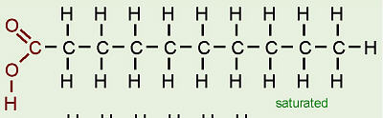
- Membrane Fluidity
  - Dependent on how packed together molecules are
  - Influenced by two major factors
    - Composition of saturated hydrocarbons
      - Saturated fatty acids
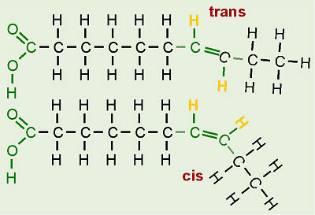
        - Carbon is bound to maximum number of hydrogen atoms
        - Straight shape – pack closely
        - Always start as saturated
      - Unsaturated fatty acids
        - Enzymes desaturase introduces double bonds that kinks or bend the structure
        - Less straight & less packed
        - Cis-Unsaturated
          - Very severe kink
          - Very common in nature
        - Trans-unsaturated
          - Not severe kink
          - Very rare in nature
          - Used to be common in baking industry (cheap and unhealthy)
    - Temperature
      - Endotherm – Human
      - Ectotherm – Reptiles
      - Very low
        - Closely packed – highly viscous gel – ETC cease
      - Very high
        - Membrane leakage – ions freely pass – cell death
    - ** Also influenced by sterol (cholesterol)
      - Membrane buffers
      - High temperature – help restrain the movement of lipid molecules – reducing fluidity
      - Low temperature – disrupt acids from associating by occupying space between lipids– slowing gel state
    - Physiological Importance
      - Transcriptional control of desaturase enzymes to maintain fluidity
      - Ex. Bacterial infection (lowering temperature, greater abundance of desaturase)
  - Membrane: mixed population of saturated and unsaturated

Membrane Proteins
- Classification:
  - Function
    - Transport
      - Hydrophilic channel that allows movement of substance
      - Change shape & shuttle molecules across membrane
    - Enzymatic Activity
      - Respiratory and photosynthetic electron transport chains
    - Signal Transduction
      - Receptor proteins on outer surface that bind to specific chemicals (hormones) that trigger changes on inside – transduction of signal
    - Attachment/Recognition
      - Attachment points for range of cytoskeleton elements
      - Cell-cell recognition
  - Location
    - Integral
      - Embedded in bilayer
      - Most are transmembrane– span the entire length of membrane
      - Interaction with hydrophobic core by producing alpha helix structures that minimize charges of backbone
      - Given primary sequence, prediction of which proteins will span membranes is possible
        - Non-polar (hydrophobic) amino acid sequence (20 AA: cross membrane)
    - Peripheral
      - Positioned on the surface
      - Do not interact with hydrophobic core
      - Held to membrane by noncovalent bonds – H & ionic
      - Interact with exposed portions of integral proteins
      - Parts of the cytoskeleton
      - Hold some integral proteins in place
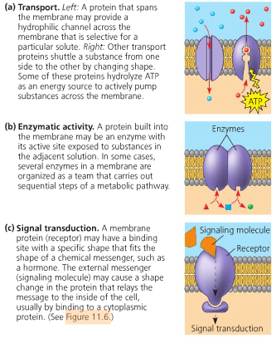
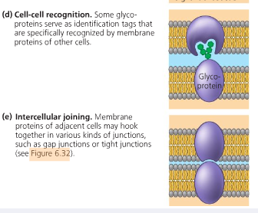
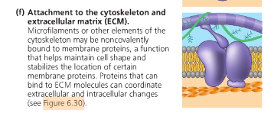

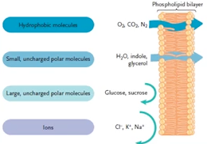
Passive Membrane Transport
- Diffusion
  - More concentrated to where it is less concentrated
  - Diffuse down their concentration gradient
  - In a state of low entrophy – increases until equilibrium
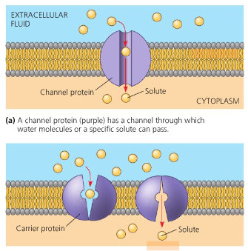
- Simple Diffusion
  - Some molecules diffuse readily across – depends on size and charge
  - Ex.
    - Hydrophobic molecules (O₂, CO₂)
    - Small, uncharged polar molecules (H₂O or glycerol)
- Facilitated Diffusion
  - Transport proteins speed up movement of molecules across membrane
  - Channel proteins
    - Allow a specific molecule or ion to cross the membrane (hydrophilic)
    - Most are gated – open or close (change in voltage) (corridors)
    - Ex. Aquaporins for allowing H₂O across the membrane
    - Ex. Ions channels
  - Carrier proteins
    - Undergo a subtle change in shape that translocates the solute-binding site across the membrane
    - Conformational changes – substrate specificity
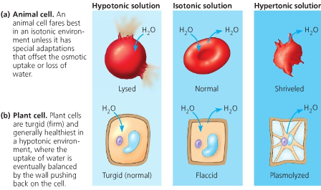
    - Ex. Glucose transporter
- Osmosis
  - Net movement of water molecules across a selectively permeable membrane by diffusion
  - From a solution of lesser solute concentration to a solution of greater solute concentration

Active Membrane Transport
- Active transport
  - Moves substances against their concentration gradient
  - Requires energy, usually in the form of ATP
  - Ex. The sodium-potassium pump is an active transport system used to re-set nerves after an “action potential” (nerve message)
  - Ex. A proton pump is a key part of the electron transport chain and chemiosmosis (Cellular respiration)
- Primary
  - Same protein that transports a substance also hydrolyzes ATP to power the transport directly
  - Ex. moves positively charged ions – H⁺, Ca²⁺, Na⁺, K⁺
- Secondary
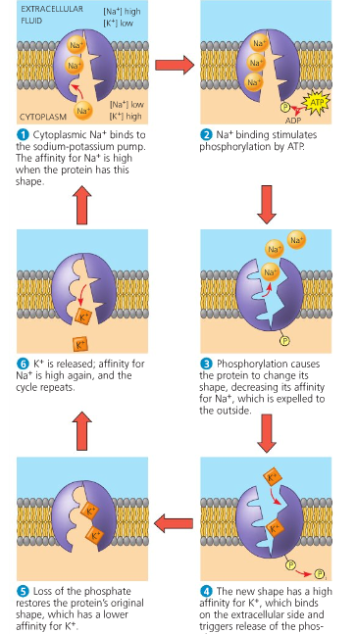
  - Transport is indirectly driven by ATP hydrolysis
  - Transport proteins do not break down ATP – use favourable concentration gradient of ions, built up by primary active transport, as their energy source
  - Antiport
    - Driving ion moves through the membrane – another molecule goes in the opposite direction (exchange diffusion)
  - Symport
    - Driving ions and other molecule move in the same direction

Bulk Transport

Exocytosis
- Vesicle membrane and plasma membrane come into contact, lipid molecules of the two bilayers rearrange so that the two membranes fuse
- Contents of vesicle spill to the outside & vesicle becomes plasma membrane
- Ex. Pancreas makes insulin and secrete it into the blood
- Ex. Neuron releases neurotransmitters that signal other neurons or muscle cells
- Ex. Plant cells are making walls, delivers proteins and carbohydrates from golgi vesicles to the outside of the cell

Endocytosis
- A small area of the plasma membrane sinks inward to form a pocket
- Forming a vesicle containing material that had been outside the cell
- Three types
  - Phagocytosis: Cellular eating
  - Pinocytosis: Cellular drinking
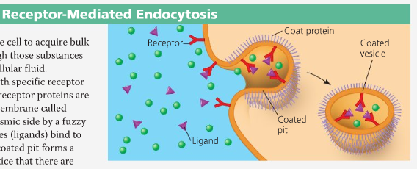
  - Receptor-mediated endocytosis

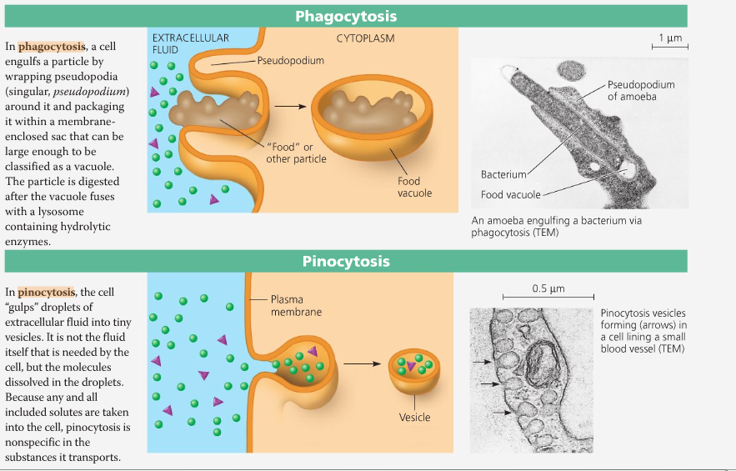

Cystic Fibrosis
- Most common inherited disease (autosomal recessive)
  - Average life expectancy is <40 years
  - Impairment of lung & intestinal function
- CFTR (gene)
  - HUGE gene - 6000 bases, 1480 amino acids, 27 exons
  - 400 different mutations
  - Defective in people who have CF
    - ΔF508 (deletion of single amino acid phenylalanine) (70% of cases)
- Physiology of CFTR Function
  - Found on plasma membrane
  - Expressed heavily in lung tissue and intestinal tract
  - CFTR sits on membrane (ABC transporter)
  - Mucus lining is dry in individuals with CF (trouble breathing)
    - Mucus gets rid of bacteria, dirt, debris that you breathe in
    - Works because mucus is wet
    - CF – susceptible to bacterial infections, and cannot breathe
  - CFTR pumps chloride from epithelial cells into epithelial lining (of lung) – shift in ionic balance - driving osmotic action of water from epithelial cell into lining (keeps mucus wet)
- CF – Very Common
  - 1/2500 Caucasians (European ancestry) have CF
  - 1/22 Canadians carry the CF gene (heterozygous)
    - 50% of transporters are perfectly normal – good enough
  - Heterozygote Advantage
    - Cholera (dehydration)
      - Bacterial Infection (Vibrio Cholarae)
      - Kills by massive water loss (dehydration)
      - Outbreaks common in Europe (dirty water)
      - Carrier – less susceptible to Cholera (50% transporters don't work, limited water loss)
- Fate of ΔF508-CFTR
  - Biochemical consequence
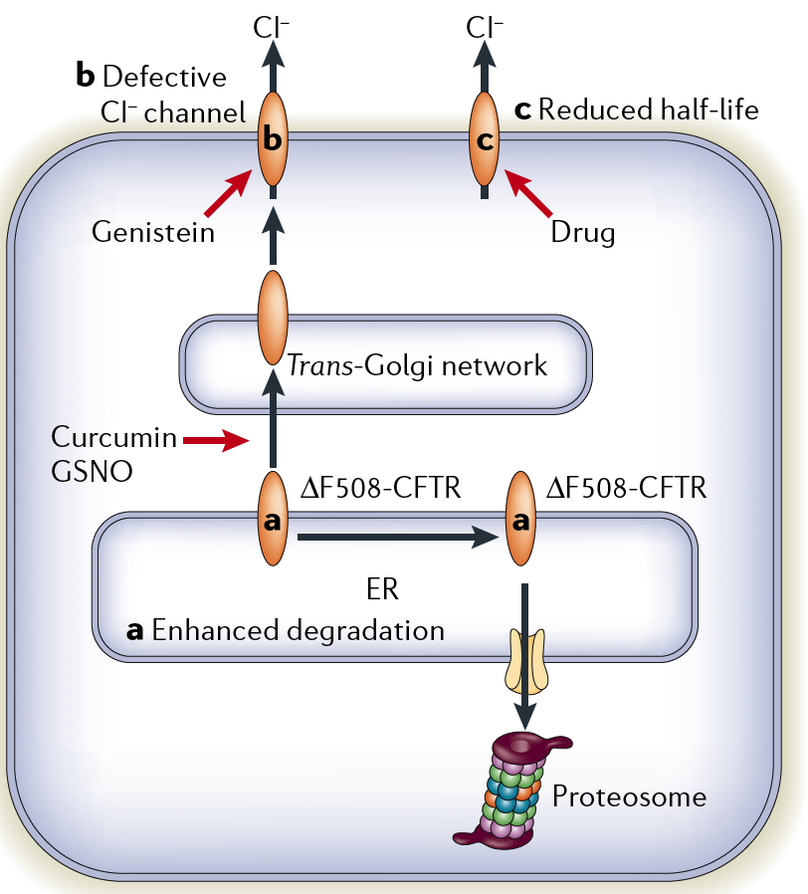
    - Defective protein does work in a lab (outside the body)
    - Normal Protein
      - Protein synthesized in ER
      - Transported to Golgi and then incorporated into plasma membrane
    - ΔF508-CFTR
      - Problem: Never makes it to plasma membrane
      - Protein Quality Control:
        - Doesn't fold properly in ER – chaperone cannot fold the ΔF508-CFTR – gets tagged for degradation
      - Drugs to cure CF – interfering with and less rigid quality control

