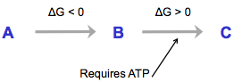
Enzymes

What Enzymes Do And Do Not Do
- Speed up a spontaneous reaction
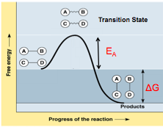
- Cannot provide energy therefore can not induce an endergonic reaction

Exergonic Reaction
- ΔG is negative
  - Substrates need more free energy
- E_{A} – Activation Energy
  - Represents a barrier
  - Few molecules possess enough energy to overcome kinetic barrier
- Thermodynamically unstable
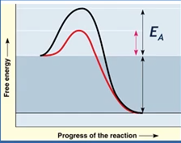
  - Propane - thermodynamically unstable but kinetically stable (slow reaction)
- Kinetic Barrier (speed)
  - Explains why spontaneous reactions are not always rapid
- Transition state
  - Higher energy state
  - Bonds break

Enzymes Lower Activation Energy
- Energy required to get to transition state is lowered in presence of catalyst
- Change the path of reaction
- Rate is proportional to the number of activated molecules
- Enzymes increase the number of molecules able to overcome barrier
- Life Needs Enzymes
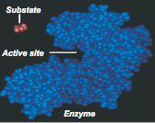
  - Cannot increase temperature, pressure etc. to drive reactions

Enzyme Structure
- Enzymes must be flexible
- Active site only apparent when enzyme in its native conformation
- Conformation of enzyme changes upon substrate binding to active site (induced fit)
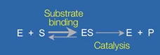
- Biological catalysts
- Binds to its substrate, forming an enzyme-substrate complex
- Rate of catalysis = varies but FAST

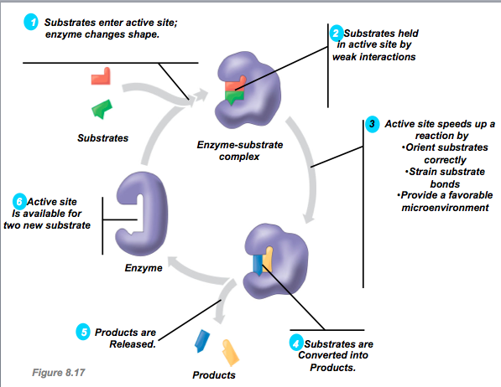

How Enzymes Lower Activation Energy
- Brings chemical groups of the active site into positions that:
  - Orient substrates correctly (transitional state conformation)
  - Charge interactions
  - Strain substrate bonds (conformational strain)
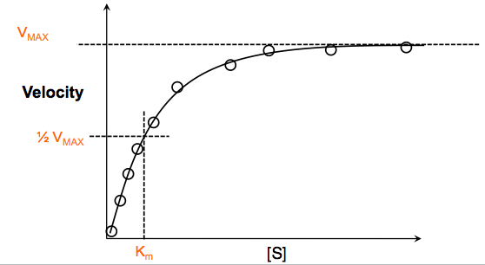
  - Provide a favorable microenvironment

Enzyme Kinetics
- 10 Reaction Tubes
- Enzyme concentration is constant
- Turnover rate is different for every enzyme
- Saturation = high substrate concentration

Enzyme Inhibition: Competitive
Overcome by high substrate concentration
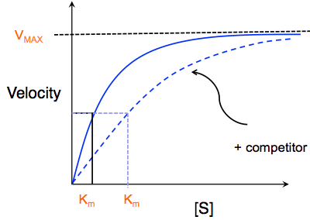
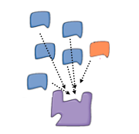
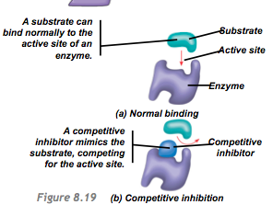

- Reversible and Irreversible
  - Inhibitors can stick to active site and cause permanent damage

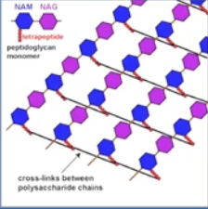
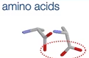
Example: Penicillin
- Antibiotic
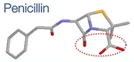
- Affects cell wall called peptidoglycan
- Transpeptidase (enzyme) makes peptide bonds of the cell wall
- Penicillin has the same active site shape as amino acids that make peptide bonds
- Penicillin binding to transpeptidase = irreversible

Enzyme Inhibition – Non-Competitive
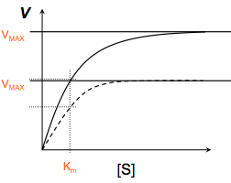
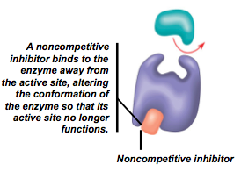
- Doesn’t compete for active site
- Changes conformation of active site
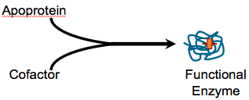
- Shuts down enzyme
- Reduces functional enzymes – V_{MAX} lowered

Enzymes Require Cofactors
- Cofactors (prosthetic groups)
  - Non protein group
- Nitrogen is needed in the form of ammonia for cells
  - Incorporated into amino acids
- Common nitrogen form: nitrate
- Algae have nitrate reductase that converts nitrate to ammonia
  - Humans don't have enzyme
- Isolated Mutant
  - Gene is defective in nitrate reductase – cells die
  - Western blot – shows as Wild Type
    - Genome is exactly the same
  - Defective in cofactor (Moco-Molybdenum Cofactor)
- Humans
  - 4 Moco requiring enzymes
  - Ex. Sulfite Oxidase deficiency cannot convert one step in biochemical pathway
  - Solution: Feeding newborns with Sulfite Oxidase Deficiency, CPMP to synthesize Moco
  - Major role in catalysis
- Regulate enzyme by regulating cofactor
  - Posttranslational control

Example
- Nitrogen Assimilation
  - Chlamydomonas (Green Algae)
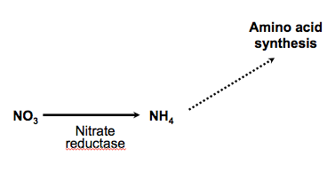
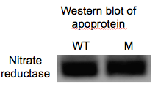

Temperature & pH are Regulating Factors
- Effects of pH
  - Each enzyme has an optimal pH where it operates at peak efficiency
  - Most common: pH = 7
- Temperature Changes
  - Temperature rises – rate of chemical typically increases
  - Effect reflects increases in kinetic motion
  - Kinetic motions of amino acid chains of an enzyme increases
  - Motions can become too strong and denature enzymes

