Protein
- One of the 4 main biochemical families
  - Carbohydrates
  - Proteins
  - Nucleic acids
  - Lipids
- Macromolecules (= big molecules)
- Polymers (a category of big molecules, a long chain of nearly identical smaller molecules joined in a long chain)

Amino Acid
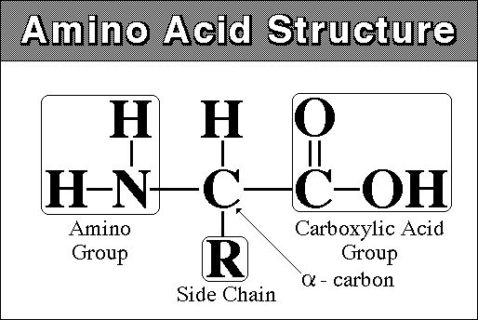
- Proteins are composed of amino acids
- Amino acids are the Monomer= the smaller building block molecule
- 20 different amino acids
- Different: side chains (called R groups), giving different properties
- Same: Small organic molecules with both carboxyl (acid) and amino (base) groups
- 3 categories (based on the chemistry of the R group):
  - Polar
    - O or OH in R group
  - Charged
    - Charges
  - Non-polar (hydrophobic)
    - Don’t work well in human bodies because of water
    - C & H
- You need to eat protein to make protein
- We break protein down to yield building blocks for our cells
- Pepsin: protein digesting enzyme in the stomach cuts protein at very specific places
- Trypsin: Protein digesting enzyme in the small intestine, cuts protein at very specific places

Amino Acid Structure
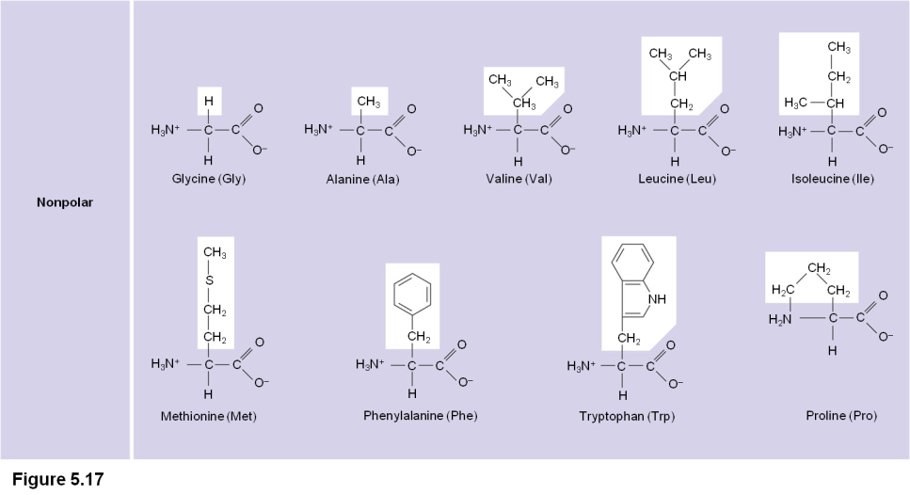
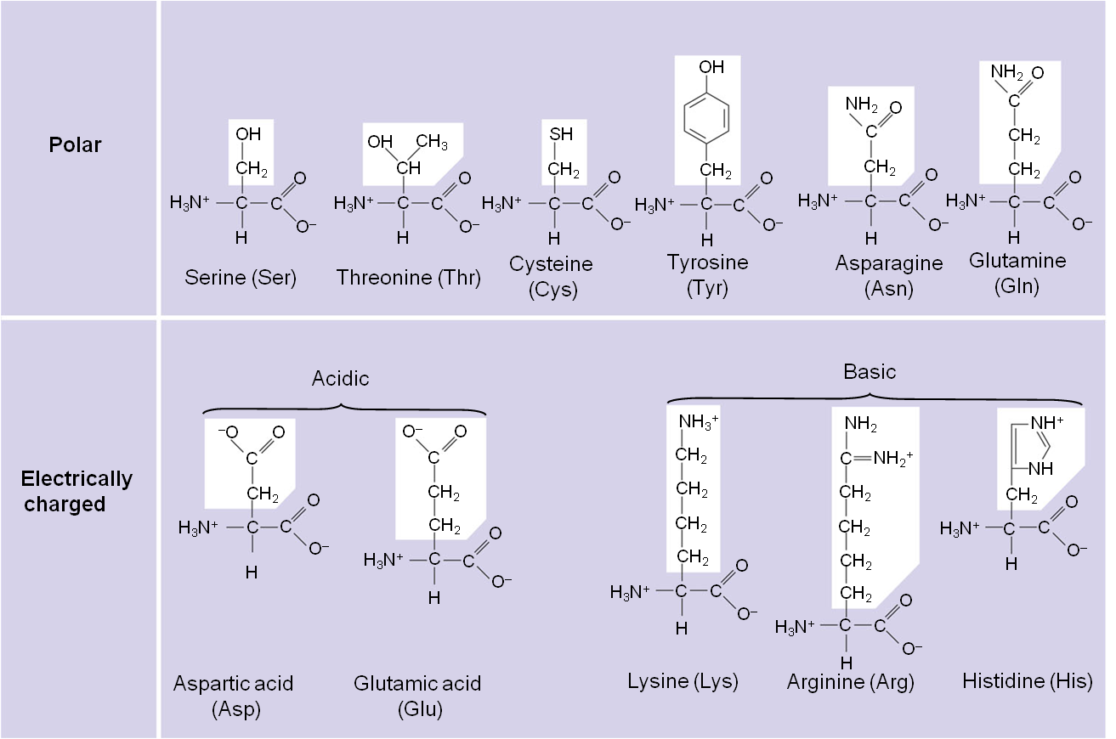

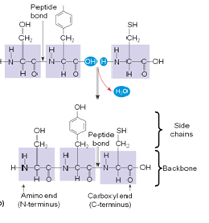
Peptide Bonds
- Amino acids are linked by peptide bonds
- Proteins are more than just chains of amino acids; they have a very complex 3 dimensional structure

Protein Structure: Primary Structure
- Primary structure is the unique sequence of amino acids in a polypeptide

Protein Structure: Secondary Structure
- Is the folding or coiling of the polypeptide into a repeating configuration
- Includes the α helix and the β pleated sheet
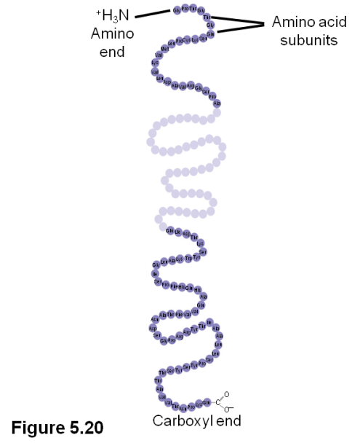

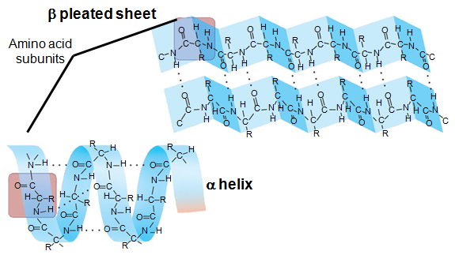

Structure

Protein Structure: Tertiary Structure
- Is the overall three-dimensional shape of a polypeptide
- Results from interactions between amino acids and R groups
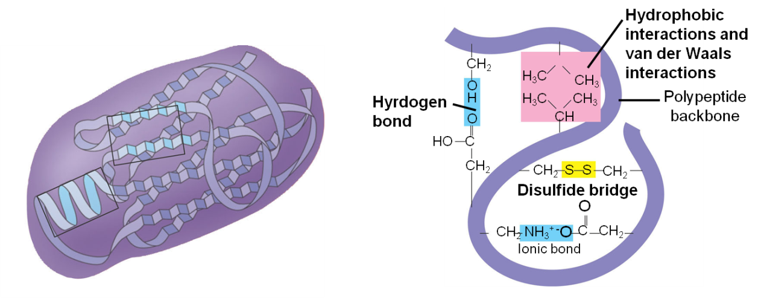

Protein structure: Quaternary Structure
- Quaternary structure is the overall protein structure that results from the combination of two or more polypeptide subunits

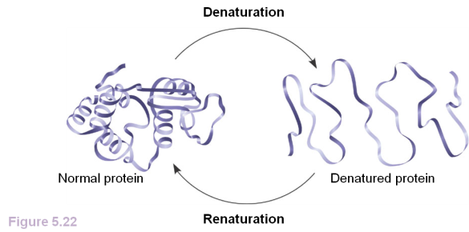
What Determines Protein Conformation?
- Protein conformation depends on the physical and chemical conditions of the protein’s environment
- Denaturation is when a protein unravels and loses its native conformation
- Coagulation occurs as someone’s blood clots – clotting and is permanent

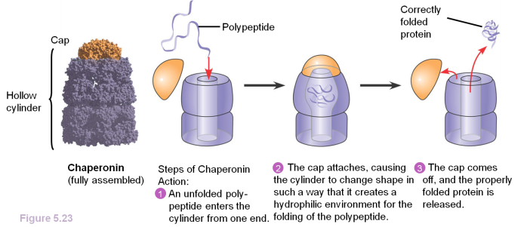
Chaperonins
- Are protein molecules that assist in the proper folding of other proteins

Protein Synthesis
- DNA contains the coded information for making proteins
- The sequence of nucleotides contains the code
- DNA directs RNA synthesis = transcription
- RNA directs protein synthesis = translation
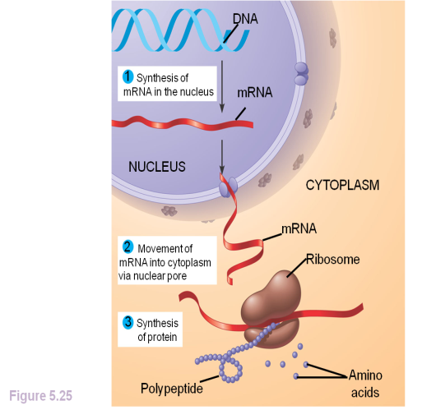

Sickle-Cell Disease
- Is the result of a single amino acid substitution in the protein hemoglobin (a change in primary structure)


