The Drake Equation

The Universe, The Galaxy
- Andromeda M31 – another galaxy
- Speed of light = 1.1 billion km/h
- Light year = 9,460,730,472,580

Proxima Centauri
- Closet star
- 4.22 light years (39,922,000,000,000 km)
- 150,000 years away

Radio Astronomy
- Only means by which to travel fast enough to reach the closet star and observe whether or not there is evidence of extraterrestrial life
- “Listening” to other intelligent life forms
- SETI – search for extraterrestrial intelligence


The Drake Equation
N = Number of advanced civilizations in our galaxy
N_{s} = Number of stars
f_{p} = the fraction of those stars that have planets
n_{e} = number of planets that can potentially support life
f_{l} = the fraction of those planets that develop life
f_{i} = the fraction of planets that develop intelligent life
f_{c} = the fraction of planets willing and able to communicate
L = average lifetime of a civilization

N_{s}
- 100 billion stars (good estimate)

F_{p}
- What fraction of stars have planetary systems?
  - Planet formation is a natural consequence of star formation
  - 0.5
  - 10¹¹ x 0.5 = 50 billion planets
- Can we detect extrasolar planets?
- Kepler Mission
    - Observatory in space (does not move)
    - Observe planets
    - Observing at 150,000 stars
    - Transit Method
- Observing decrease of brightness when planet transits in front of the star in relation to Kepler observatory (miniscule & regular pattern)
- 2,326 planets orbiting binary stars
- planet formation is a natural consequence of star formation

N_{e}
- For each planetary system how many habitable planets?
  - Two factors
    - Mass and distance from parent star (big enough to house an atmosphere but not big enough to be a big ball of gas)
  - Habitable Zone: temperature conducive to life (goldilocks phenomenon)
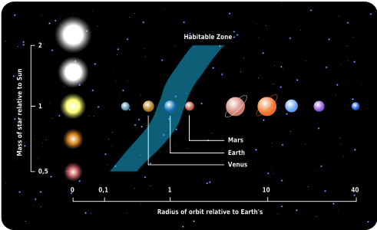

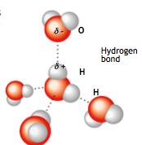

- Set n_{e} as 2 - Two habitable planets per system
  - 10¹¹ x 0.5 x 2
  - 100 billion planets can support life

Water
- Defines habitable zone
- Oxygen is electronegative
- Water is polar-covalent but unequal sharing
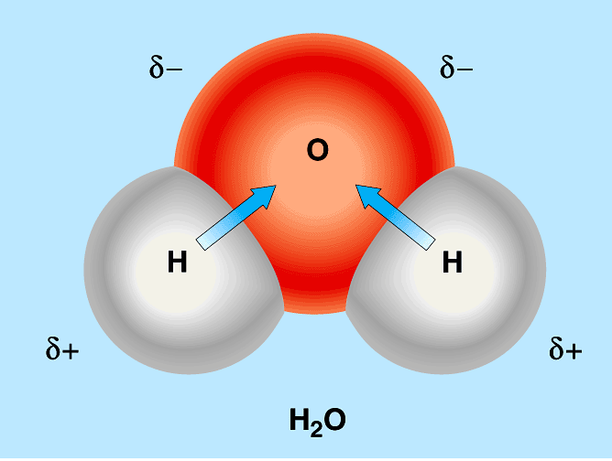
- Based on its molecular weight
- Water should not be a liquid at 0 & 100 degrees but it is

Properties of Water

Key Property: Cohesion
- Many water molecules are attracted together form H bonds
- Causes water to be a liquid at moderate temps
- Caused surface tension – a measure of how hard it is to break the surface of a liquid
- Ex. Water strider

Key Property: Adhesion
- Is the attraction of water to other polar substances
- Due to H bonding
- Capillary action
  - When water is drawn into a narrow tube, rises against gravity
- Adhesion and cohesion forces combine to pull water up plants

Key Property: High Specific Heat Capacity
- Amount of heat that must be absorbed or lost for 1 g of that substance to change its temperature by 1°C
- Water’s specific heat is 9x that of iron
- Water has a high specific heat, which allows it to minimize temperature fluctuations because
  - Heat is absorbed when hydrogen bonds break
  - Heat is released when hydrogen bonds form
- Water absorbs heart from air that is warmer or releases the stored heat to air that is cooler
- Ocean temps stay stable despite lots of sunshine
- Our body temps stay stable despite many ongoing chemical reaction

Key Property: High Heat of Vaporization
- The quantity of heat a liquid, most absorb for 1 g of it to be converted from a liquid to gas
- Evaporative cooling allows water to cool a surface (due to waters high heat of vaporization)

Key Property: Low Density of Solid
- Solid water is less dense than liquid water so it floats
- Due to lattice structure formed as it bonds keep molecules more “ordered” than in liquid water, making ice less dense
- Life can exist under the frozen surface of lakes, ice acts as insulation

Key Property: Solubility
- A versatile solvent due to its polarity
- It can form aqueous solutions
- The different regions of the polar water molecule can interact with ionic compounds called solutes and dissolve them
- Water can also interact with polar molecules such as proteins, forms a hydration shell
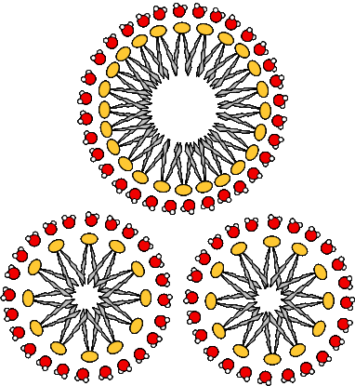
- Allows movement of molecules, facilitates chemical reactions
- Also causes hydrophobic exclusion
  - Aggregation of hydrophobic substances which do not have affinity for water
Hydration Shell
- Fatty tails go to the middle
- Heads are agreeable with water
- Important in the formation of membranes
- Shields electrostatic interactions - minimizes charges on proteins etc. so they interact through other means

Key Property: Dissociation of Water
- Water can occasionally dissociate, when a hydrogen shifts so a hydronium ion & hydroxide ion is formed
- It is a reversible reaction
- It is actually very rare (one molecule in 554 million is dissociated)

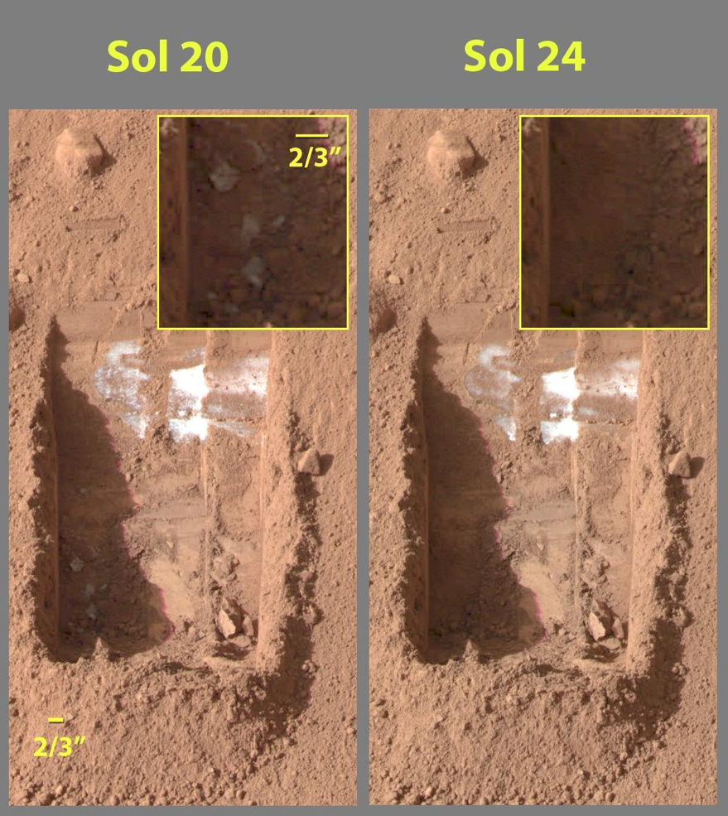
Life Elsewhere in Solar System
- Geological evidence that liquid water used to exist on Mars
- Polar ice caps on Mars
- Sublimation (white=frozen H₂O)
- Europa & Titan (moons orbiting Jupiter & Saturn) could have life as they have ice shells

NO EVIDENCE OF LIFE ANYWHERE ELSE IN THE UNIVERSE AS OF YET

F_{l}
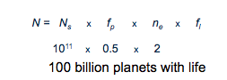
- No good idea
- All planets (in habitable zone) are capable

F_{i} & F_{c}
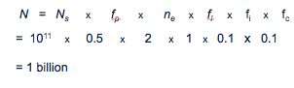
- Proportion of planets with intelligent, communicating life.
  - Not easy to estimate
  - 10% for each

L – The Lifetime of a Civilization
- The longer a civilization is around the greater the likelihood of finding it.
- How old is our "communicating civilization"? (radio waves)
  - 100 yrs/10 billion yrs
- If civilization lasts 1000 yrs...
L = 1000 /10 billion or 1/10,000,000, then
N = N_{s} x f_{p} x n_{e} x f_{l} x f_{l} x f_{l} x L
N = 10¹¹ x 0.5 x 2 x 1 x 0.1 x 0.1 x 0.0000001
N = 100
- If civilization lasts 100,000,000 yrs...
N = 10,000,000 civilizations in Milky Way

(Enrico) Fermi Paradox
- Trying to find a message through the noise of the solar system from intelligent communicating life
- Can’t detect them
- Distances are too great
- N = 100 distance = 10,000 light years separating them
- Technological incompatible (radio waves only makes sense for life on earth)
- No other civilizations exist

