Cell Biology & Origin of Life

Seven Characteristics of Life
- Display Order
  - Arranged in a highly ordered manner
  - Cell: fundamental unit of life
- Harness & Utilize Energy
  - Acquire energy from the environment and use it to maintain state
- Reproduce
  - Have the ability to make more of their own kind
- Respond to Stimuli
  - Can make adjustments to their structure, function and behavior in response to changes to external environment
- Exhibit Homeostasis
  - Regulate internal environment so that conditions stay relatively constant
- Growth & Development
  - Increase their size by increasing the size/number of cells
- Evolve
  - Populations change over generations to become better adapted to the environment

The Fundamental Unit of Life
- Cell Theory
  - All organisms are composed of one or more cells
  - The cell is the smallest unit that has the properties of life
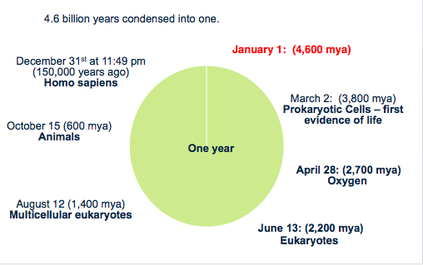
  - Cells arise only from the growth and division of preexisting cells

LUCA
- Last Universal Common Ancestor
- Evidence:
  - Lipid membranes
  - Genetic system based on DNA
  - Reproduction
  - ETC – ATP & Glucose
  - DNA to RNA to Protein transfer of information
  - Common system of protein assembly: ribosomes, mRNA, tRNA
  - Cytoplasm

Earliest Life
- Stromatolites dated to 3.5 billion years ago represent the earliest fossil evidence of life
  - Layered rock that is formed when microorganisms bind articles of sediment together, forming thin sheets
  - Formed by cyanobacteria – modern – posses a sophisticated metabolism
- Panspermia is the hypothesis that very simple forms of life are present in space and seeded the earth soon after it cooled

Stages of Prebiotic Evolution
- So what do you need?
  - Abiotic synthesis
  - Heritable Information
  - Formation of Cells
  - Assembly of complex organic molecules from simple molecules, including protein, RNA or both
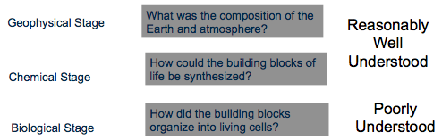
  - Aggregation of complex organic molecules inside membrane-bound protobionts

Geophysical Stage
- Conditions On Young (Primordial) Earth
  - Chemicals: H₂O, H₂, CH₄, NH₃, H₂S
  - Energy Sources: ultraviolet light, lightening
  - Reducing atmosphere
    - Allow for building up of highly reduced compounds (electrons)

Chemical Stage
- Abiotic Synthesis: organic molecules from inorganic molecules
- No abiotic synthesis today – oxidizing environment
- Miller-Urey experiment demonstrated that abiotic synthesis of biologically important molecules such as amino acids, sugar, nucleotide bases, lactic, acetic, formic acid, is possible
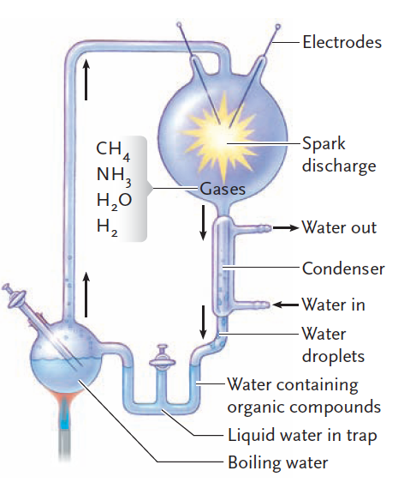
- 1953: Miller and Urey tested this theory and produced organic molecules from inorganic ingredients
  - Reactants
    - Water vapor
    - Ammonia
    - Methane gas
    - Hydrogen gas
  - Conditions
    - Heating by sun
    - Cooling at night
    - Radiation from the sun
    - Energy from electrical storms
  - Results (after 1 week)
    - Aldehydes, carboxylic acids formed
    - Glycine and alanine formed
    - Amino acids
    - Sugars
    - Purines & pyrimidines
- Life may have evolved in deep sea vents, atmosphere or surface of earth

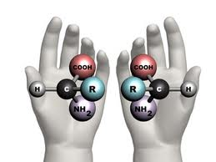
Chirality
- Chiral molecule: not superimposable on its mirror image (come in two forms)
  - Two enantiomers (optical isomers)
  - Handedness
  - Same chemical and physical properties
  - Different biological properties
- Thalidomide
  - Used as a “morning sickness” drug in 1960s
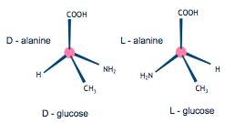
  - Antiemetic & readily convert to the other chiral form (teratogen causing birth defects)
  - Approved in 20 European countries not in NA
  - Side effect: deformed children
- Chirality Problem
  - Miller-Urey experiment = racemic (50% of both chiral forms mixture)
  - Biology is homochiral (only one form, no mixture)
  - L amino acids, D sugars

Origin of Homochirality
- Homochirality
  - Essential to the evolution of life
  - Specificity is required = one chiral form
    - Random chance
    - Extraterrestrial origin
      - Murchison meteorite
        - Contains 7 amino acids
        - 9% more L isomer (bias led to life)

Biological Stage
- Development of DNA, RNA and protein triad
- Synthesis of polymers
- Monomers not polymers – first cells (Miller-Urey experiment)

The Origins of Information & Metabolism
- All organisms contain deoxyribonucleic acid (DNA)
- DNA is copied onto ribonucleic acid (RNA)
- RNA directs the production of protein molecules
- Enzymes catalyze all reactions

Enter RNA World
- RNA: information, structure, catalysis
  - Speed up rate of reaction
- How can RNA catalyze?
  - RNA can fold
    - Complementary base pairing
  - Ribosome
    - Ancient organelle – required for all cells
    - 2/3 RNA, 1/3 protein
- Ribozymes
  - RNA molecule that has catalytic properties
    - Self-splicing introns – catalyze own excision
    - Can catalyze reactions on the precursor RNA molecules that lead to their own synthesis, as well as on unrelated RNA molecules
  - Ribosome aminotroinferase activity
  - Can fold into very specific shapes and are single-stranded
  - Function depends on folding
  - RNA was the first molecule from which both DNA and proteins developed
  - Ribosome aminotransferase activity

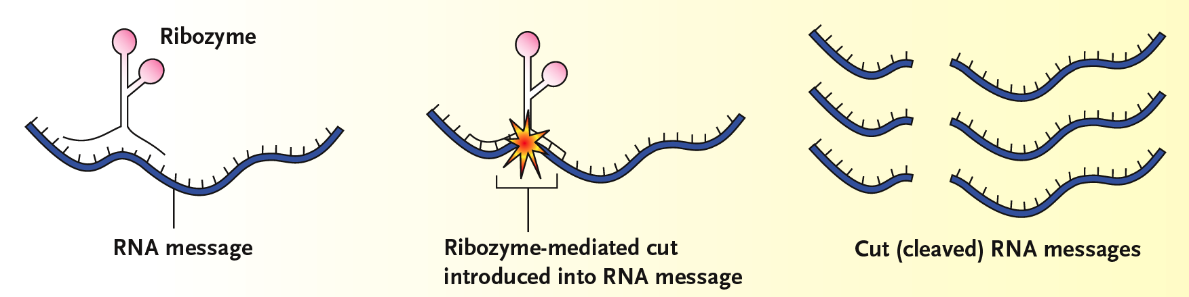

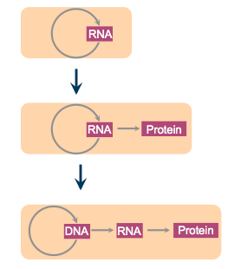
Evolution of Information Transfer
- RNA
  - Information, catalysis & structure
- Proteins
  - Structure & catalysts
  - Diversity (20 amino acids)
- DNA
  - DNA is more stable than RNA
    - Deoxyribose more stable then ribose
  - Base uracil found in RNA is not found in DNA; replaced by thymine – common mutation in DNA is the conversion of cytosine into uracil – by utilizing thymine in DNA, any uracil is easily recognized as a damaged cytosine and can be repaired
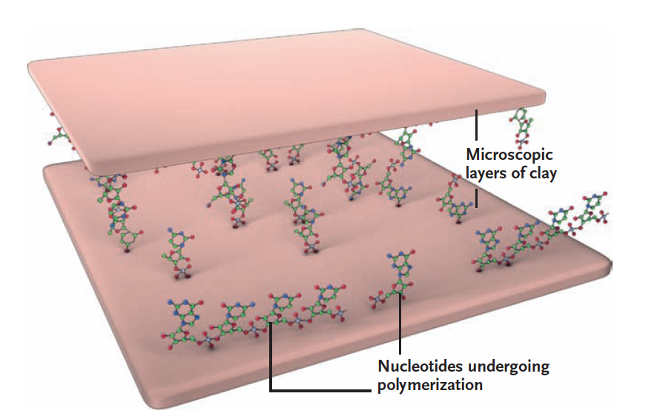
  - DNA is double-stranded - complementary strand can be used to repair the damaged strand

The First Cells
- Monomers polymers: abiotic synthesis of cell molecules
- Hypothesis
  - Clay particles creating a surface upon which polymerization reactions could occur
    - Accelerated spontaneous reaction by clay particles (montmorillionite)
    - High surface area & charged surface
    - Charged components of the molecules are attracted to the charged surface of the clay
    - Facilitate formation of SHORT nucleotide/amino acid chain (still function and have a selective advantage)

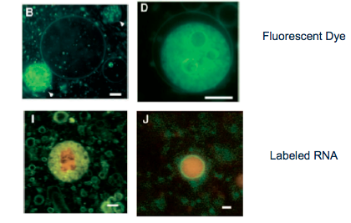
- Flourescent Dye Evidence
  - Purpose: how long fluorescent dye is retained in an abiotically synthesized vesicle
  - Separates biological environment from outside environment
  - Retain macromolecules inside so their concentrations are higher inside

- Protobionts: The First Cells
  - Abiotically produced organic molecules that are surrounded by a membrane or membrane-like structure
  - Formation allowed for an internal environment to develop that was different than external environment

