Chapter 1: Critical Success Factors & Diamond-E

Critical Success Factors
- vital to the success of a company
- Achieving financial performance
- to make a goal and achieving it
- survival + growth money necessary
- Meeting customer needs
- to satisfy what the market wants/needs
- People do not always know what they need. You discover what your market wants and you give it to them, or you create their wants/needs by creating something
- Building quality products and services
- consistently giving a customer good value
- It does not have to be the best; it just has to be worth the money it costs.
- Everyone needs a certain amount & quality of that product, and the company only needs to give that much (not surpass the expectations)
- Make them come back for more
- Encouraging innovation and creativity
- putting something new out there to capture the customers’ attention
- anticipating trends
- not just about what you give the customers but about how you create the product
- Apple doesn’t just throw everything out at once. They do it step by step every time they produce something, people will talk about it, and hence by constantly producing new things, people are always talking about Apple
- Gaining employee commitment
- Employees should be proud of their business, know that it’s “cool”
- Keep employees so they do not switch to competitors
- Enthusiasm = better business
- Happy employee will do more than what they are paid for
- Creating a distinctive competitive advantage
- Businesses want monopoly
- By providing something that other companies don’t provide, consumers are willing to pay more for that specific product you can set your own prices (not easy with competition)

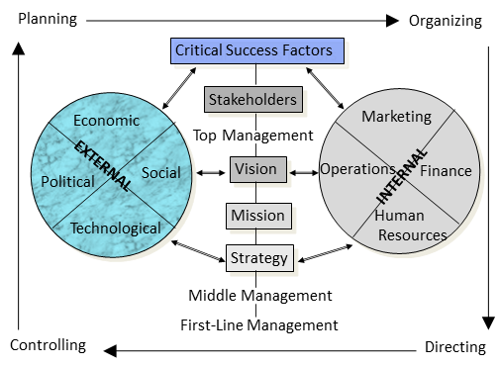

Diamond-E Framework
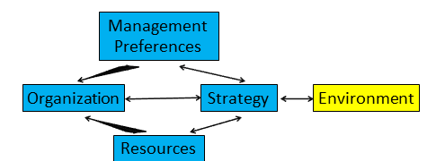
- Identifies key variables to be considered in strategic analysis
- Double headed arrows mean that everything influences each other

Strategy-Environment linkage
- Strategy: what opportunities the business is pursuing
- determines the resources, organizational capabilities, and the management preferences
- The critical linking variable in the model Any variable can either drive or constrain strategy
- Principal logic: consistency or alignment
- strategy must be consistent with internal workings of company (preferences, resources, etc.)
- strategy must align with the external environment; you may have the best strategy but it may not be right for that environment environment is changing, so strategy must be shifting
- First task: deal with strategy-environment linkage assess forces at work, and their implications

Organization influences…
- Organization refers to culture, leadership, structure, and capabilities (CLSC)
- Strategy: you have to have the right CLSC in order to have the right strategy you may not have the leadership/structure/etc appropriate for the strategy you prefer

Management Preferences influence…
- They are the biases & preferences within organization bias creeps into everything
- Environment: There should be a double-headed arrow between management preferences and environment because how the managers view the environment influences their preferences
- Strategy: your strategy must satisfy your personal preferences you lean toward a strategy
- Organization: how you prefer to organize your business affects the organization

Resources influence…
- Resources are the financial, capital, and human resources of the organization
- Organization: resources determine the capabilities, investments and how we spend money, type of human resources (culture) and hence organization
- Strategy: you have to have the right resources to do certain things

External analysis
- Process of scanning + evaluating the external environment look for data, stats, trends, forecasts…
- SWOT: strengths, weaknesses, opportunities, threats
- How managers determine
- opportunities (positive external trends/changes)
- threats (negative external trends/changes)
- Firms face multiple environments (must analyze both environments)
- General environment: affect all businesses
- PEST model identifies general trends/changes
- Specific environment: affects industry participants every industry has its own environment
- Porter’s 5 Forces analyzes 5 important sources of competitive pressure and intensity predicts profitability of industry

