ANP 1105
October 1st 2014

3. HOMEOSTASIS: CONTROL MECHANISMS
3.1 Define & identify the principal characteristics of homeostasis (pp.8-11)
3.2 Introduction to the Nervous System (pp. 525-527, 535-538)
3.3 Introduction to the Endocrine System (pp. 591-603)

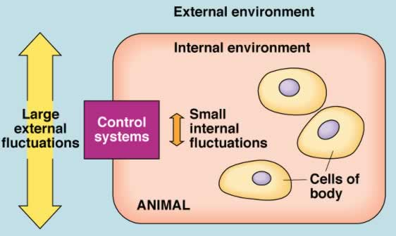

3.1.1 define homeostasis, giving at least 2 physiological examples
Walter Cannon: ability of the body: “to maintain relatively stable internal conditions even though there is continuous change in the outside world”
• not unchanging - rather a dynamic state of equilibrium involving many systems:
(i) adequate blood levels of vital nutrients
(ii) heart activity/blood pressure monitored & adjusted as needed
(iii) wastes must not accumulate
(iv) body temperature

Homeostasis:
- Maintaining a relatively internal environment in our body/cells even if the external environment is varying greatly.
- Maintain stable heart rate, blood pressure, constantly making urea that needs to be removed from our body

• 3 essential characteristics:
receptor: senses change (stimulus) & sends info (afferent pathway) to:
control centre: determines set point for variable maintenance; analyzes info & determines correct response
effector: provides means for response (output along efferent pathway)
feedback (negative/positive) allows for regulation within a range/enhanced response

- We need to have a control unit to maintain homeostasis - receptor, control centre, effector
Control system: includes a stimulus acting on a receptor
*Temperature increases ( stimulus ), thermostate (receptor) picks up the change, effector (air conditioning) , response (temperature going back down) 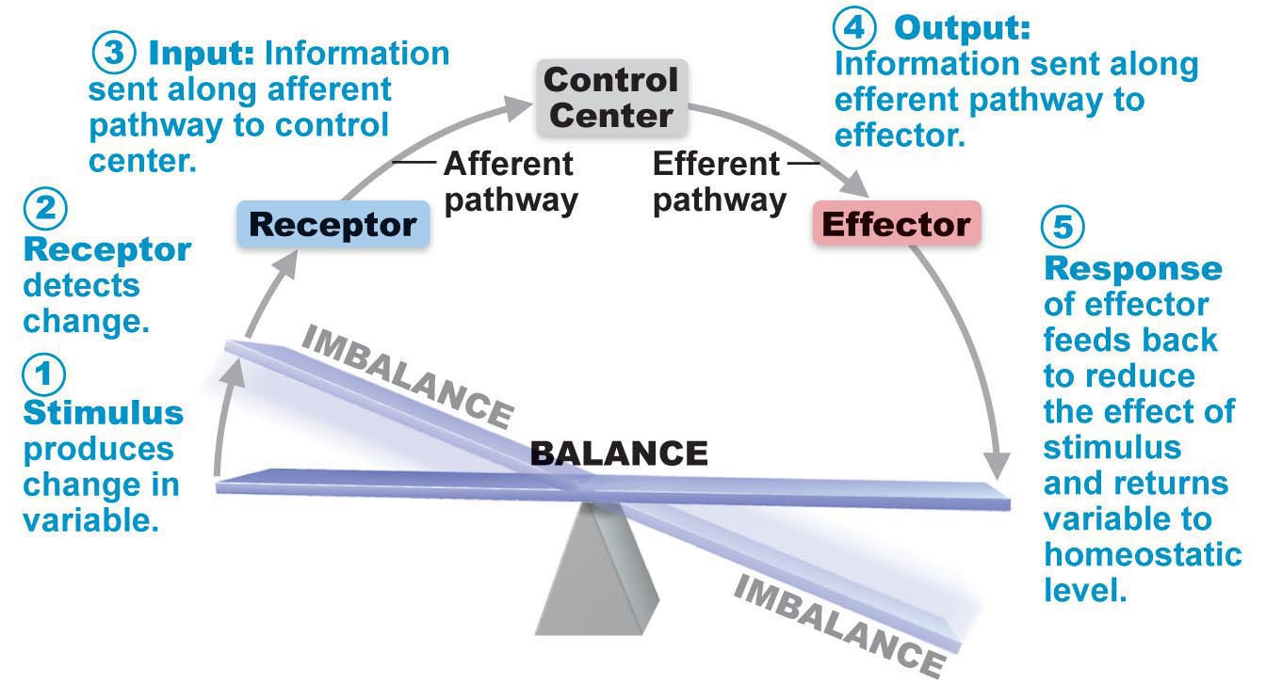
Receptors are neurons that are sensitive to temperature change.
Control centre has an output (neurons) to effectors
Control centre sends messages through the neurons to make us sweat to get back to homeostasis

Negative Feedback Mechanisms
• output reduces or shuts off stimulus – 2 options:
- 1 hormone regulating a process: negative feedback ↓ secretion
- process regulated in opposite directions by 2 different hormones – eg: blood glucose

Most control centres contain negative feedback- response that corrects things

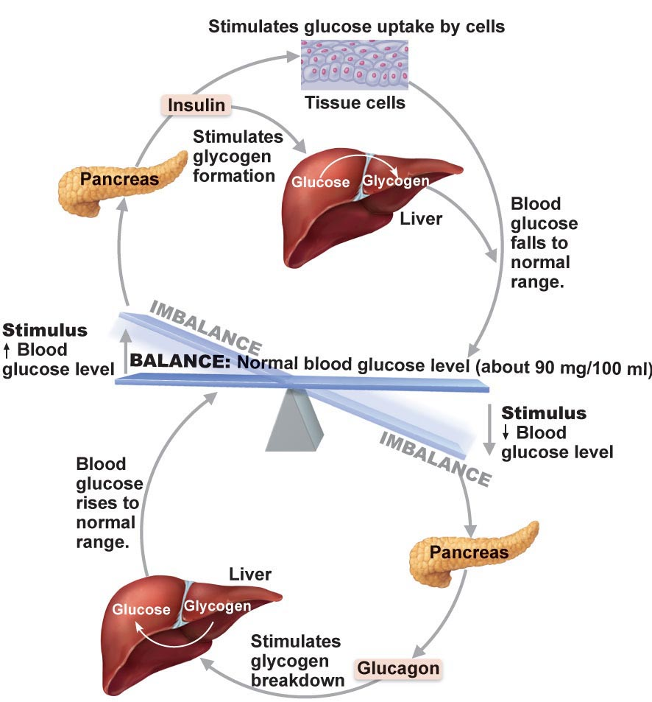Two hormone system
- Blood glucose goes up and we have cells I nthe pancreas that detects this
- The pancreas cells release insolin which response to an increase in glucose
- Causes glucose to be take up by the liver, fat cells,
- If blood glucose drops cells in the pancreas detect that decrease in blood glucose and the pancreatic cells release a hormone glucagon which acts on the liver to release stored glucose
- ULTIMATE GOAL IS TO PREVENT SUDDEN SEVRE CHANGES IN THE BODY
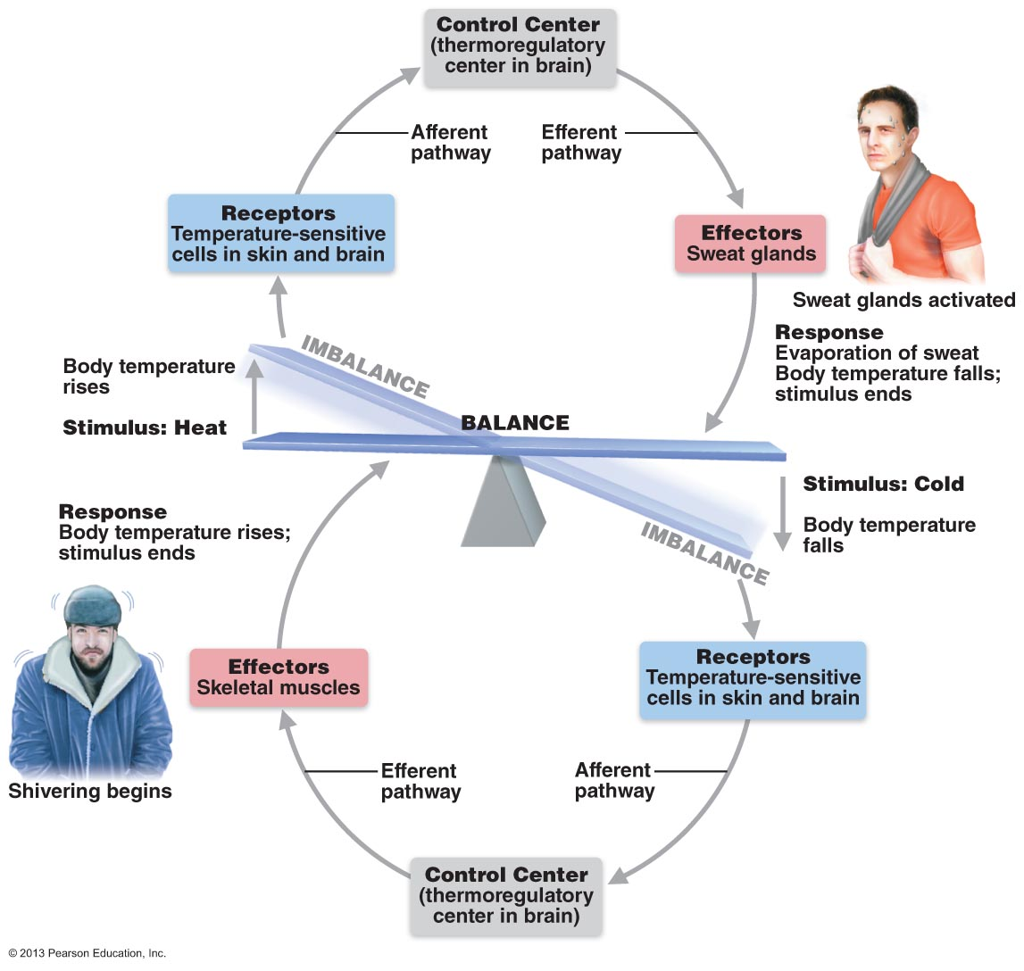
Temperature control system – neuro control system,
Temperature goes upp
Receptors in our skin detect it
Control centre response by stimulating sweat glands

Positive Feedback – ultimate goal is to reach a goal (clotting, delivery) when the goal is reached the positive feedback stops
Mechanism
• response of mechanism enhances original stimulus output is further stimulated
• change occurs in same direction as original response
• goal to be attained
• eg: blood clotting - how is this still, overall, maintaining homeostasis??

Only 2 main examples: when you cut yourself – collagen fibres in the blood vessel are exposed and causes platlets to stick, the platlets release factors that attract more platlets and causes a platlet plug which stops you from bleeding out. – cycle continues till the blood stops

What happens during labour/deleivery – gets triggered by the prosteglands that come from a very stretched uterus which causes it to contract and sends signals to the brain cells – releases oxycotine which causes more contractions of the uterus to occur
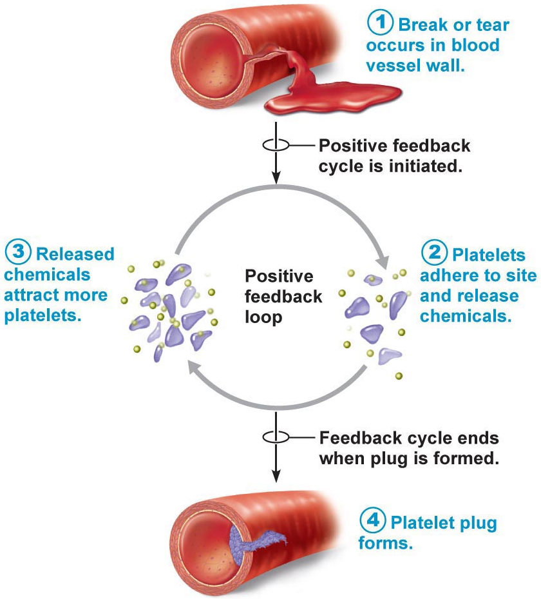
Homeostatic Imbalance
most disease seen as a disturbance of homeostasis = homeostatic imbalance
aging associated with progressive decrease in our ability to maintain homeostasis greater risk for illness
A lot of diseases is from the imbalance of homeostasis

3.2.1.1 Using a flow chart, indicate the positions of the autonomic and somatic nervous systems in the structural organization of the nervous system as a whole
• auto = self; nom = govern
• ANS = system of motor neurons to smooth & cardiac muscle & glands to allow responses usually without our awareness
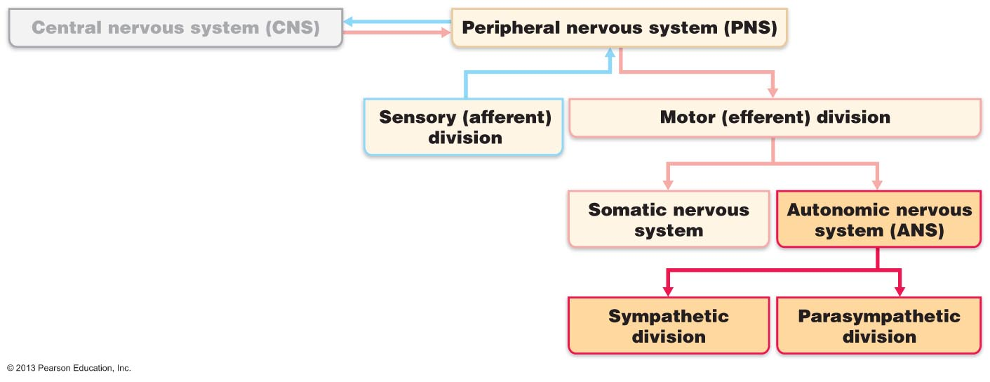
(i) shunt blood to more needy areas
(ii) speed/slow heart & respiratory rates
(iii) adjust blood pressure, body temp
(iv) increase/decrease gastric secretions

Sensory – bringing sensory information in through the nerves to the brain and spinal cord
Motor- Output from the central nervous system
2 branches:
Somatic – Innervates skeletal muscles ( we have voluntary control over)
Autonomic- Carries information from the spinal cord/brain to other effector organs, effects cardiac muscle, smooth muscle and glands (we don’t have voluntary control over) – occurs without us being aware
2 Divisions:
Sympathetic – when we are in flight or fight situation – causes the response that is need ( heart rate goes up, blood pressure increases, we start to sweat, pupils dialate, increase blood flow to the brain, release too much glucose, we release fat)
Parasympathetic- Taking care of housekeeping functions – digesting food, kidneys are cleaning our blood, we have more blood flow to the skin (skin tends to be warm), pupils constrict,

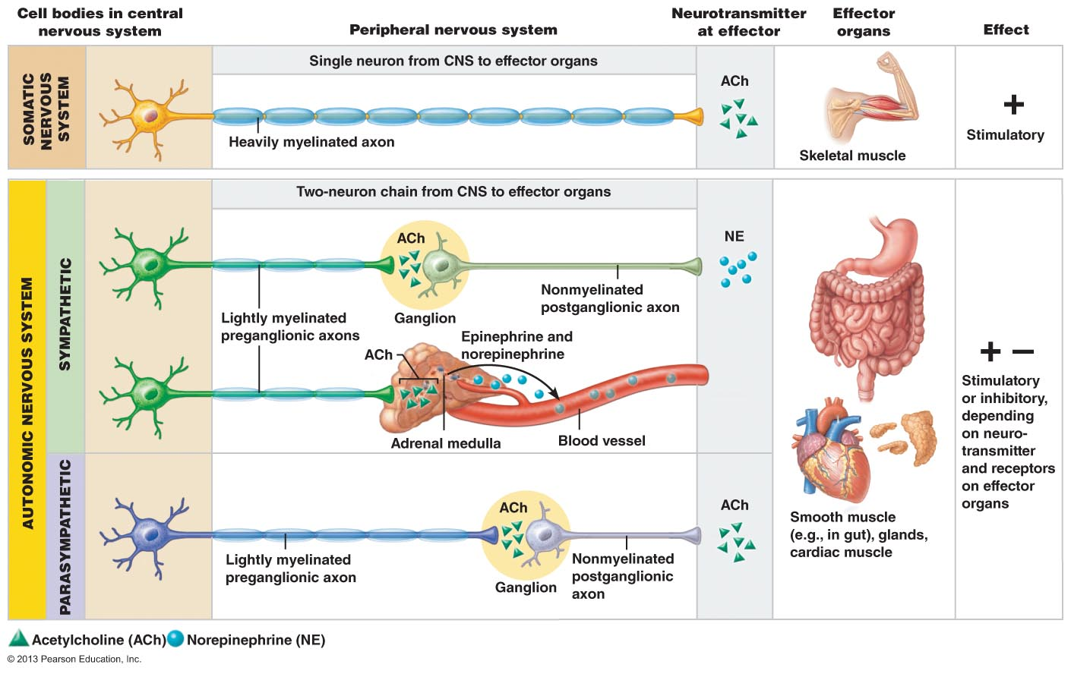
Arrangement of neurons in different parts of the nervous system
Effectors:
• somatic: skeletal muscle; ANS: smooth muscle, cardiac muscle & glands
Autonomic - Smooth muscle, cardiac muscle and glands - could be excitatory or inhibitory
Somatic- Skeletal muscle

Any time a motor neuron stimulates skeletal muscle it contracts

Somatic- When we want to response, move, or do anything with skeletal muscles we need the information to get from the brain to our spinal cord and nerves very quickly. (playing an instrument, the signal needs to get from the brain to the nerves quickly, we need heavily active neurons to make it happen quickly)

Autonomic – information doesn’t have to get from the brain to the effector organs as quickly,

Ganglion – collection of nerve cell bodies in the Peripheral Nervous System (any where you have synapses from one neuron to another)

Nicotinic Receptor – when you smoke cigarettes and get nicotine the nicotine reacts with cells – plant chemical that mimics the effect of Ach. On an Ach. Receptor
Nicotine has the same effect Ach. has.

Sympathetic system – what happens when you have an adrenaline rush – Norepinephrine is produced

Pathways & Ganglia:
• somatic: thick, myelinated axon from spinal cord to skeletal muscle; rapid conduction of impulses (no ganglia)
• ANS: two-neuron chain: preganglionic neuron: originates in brain or spinal cord; preganglionic axon synapses with 2nd motor neuron (postganglionic) in ganglion outside CNS postganglionic axon to effector organ
• conduction is slow; preganglionic axons are thin & lightly myelinated; postganglionic axons are thinner & unmyelinated

3.2.2.1 Distinguish between the PNS and SNS in terms of the types of processes regulated
Parasympathetic Division:
• active in non-stressful situations - « resting & digesting system »
• keeps body’s energy use low while regulating « housekeeping » activities (digestion, elimination of feces & urine)
what are the predominate effects of the parasympathetic ns when reading a newspaper after a meal??
• “D” system: digestion, defecation, diuresis

B2. Sympathetic Division:
• “ fight or flight” system; also important during exercise: increased heart rate, rapid, deep breathing, cold sweaty skin(why?), dilated eye pupils
• “E” system: exercise, excitement, emergency, embarrassment

3.2.2.2 Define: sympathetic tone, parasympathetic tone
SNS and vascular tone: alpha blocking drugs to treat hypertension; blood shunting possible via vasoconstriction/vasodilation
PNS & tone: heart, smooth muscle of GI & urinary tracts- can be overridden by SNS
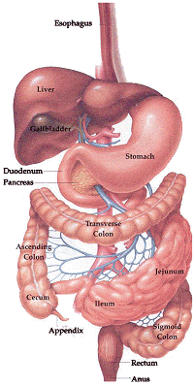
Alphabloocking drugs- bind to a specific receptor (epinephrine receptor- different kinds – greater variety – alpha and batta)

PNS- tonic stimulation or organs – maintains tone in some organs

3.2.2.3 identify: (i) systems regulated in opposite directions by the SNS and PNS, (ii) cooperative effects of the SNS & PNS, (iii) unique regulatory roles of the SNS
Interactions of the Autonomic Divisions
• most visceral organs receive dual innervation
Antagonistic Interactions:
• eg: activity of heart, GI system, respiratory system

most organs receive dual innervation (from parasympathetic and sympathetic system)

 | PNS | SNS
Heart | Slows the heart down | Increase heart rate and makes it beat harder
GI System | Increase motility (increase smooth muscle contractions- push them through faster)  Increase the secretion by glands  Increase the contrasinity | (Opposite)  Decrease secretion  Decrease motility  When relaxed will decrease sympathetic tone – more blood flow to the gut but when activated it will decrease blood flow to the gut (fight or flight situation)
Resp. System | Decrease  Contract the airways – constriction of the airways | Fight or flight situation – will increase the airways
Cooperative Effects: Only in sex.
• eg: regulation of external genitalia during intercourse:
a) PNS: dilation of blood vessels in penis
b) SNS: ejaculation, reflex peristalsis of female’s vagina

PNS- must be dominate
SNA- when you reach your climax (orgasm)

Unique Roles of Sympathetic Nervous System:

SNS regulation only: adrenal medulla, sweat glands (when you are sweating it is because the sympathetic system is activated) , arrector pili (controls each hair) muscles of skin, kidneys, most blood vessels
also:
> thermoregulatory responses to heat
> renin release from kidneys - result will be increased blood pressure
metabolic effects: From the Sympathetic Nervous System
(i) increases metabolic rate of body cells
(ii) raises blood glucose levels
(iii) stimulates mobilization of fats
(iv) increases mental alertness
(v) increases speed/strength of muscle contraction

Control of blood pressure and body temperature is a sympathetic nervous system function

The PNS and ANS differ as to:
- Sites where nerves originate
- Relative lengths of pre- and post-ganglionic fibers
- Locations of ganglia
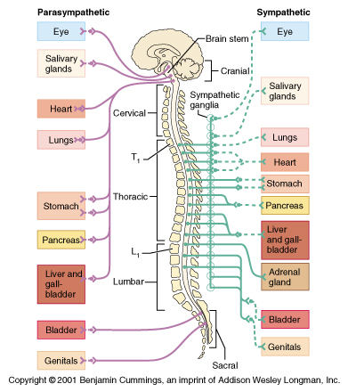
Nerves are either cranial or Spinal.
12 cranial nerves (from your brain)
- # of them are parasympathetic
Sympathetic nerves from T1 – L2 (Thoracic 1 and Lumbar 2)

Need to know:
Where the nerves are originated
Length of pre and postganglionic fibres
Locations of ganglia

3.2.2.4 List the 3 levels of regulation of autonomic function, giving examples

1. Brain Stem & Spinal Cord Controls
- significant direct effects on ANS-regulated activities
- motor centres in ventro-lateral medulla (eg: cardiovascular centre heart rate, blood vessels; also GI, respiratory centres)
- Brain stem: Midbrain, Pons, Medulla oblongata
- 80% of the brain is made up of Cerebrum
- Within the brain stem there are nuclei that act as control centres

2. Hypothalamic Controls:
• hypothalamus = integration centre of ANS
> anterior regions parasympathetic – near the front
> posterior areas sympathetic – near the back
• hypothalamus contains centres to coordinate heart activity, blood pressure, body temp, water balance, endocrine activity; also centres that help mediate emotions & biological drives
- Hypothalamus- another collection of nuclei, specialized cluster of neurons, AUTONOMIC MASTER CONTROL CENTRE, communications with the nuclei in the brainstem

HYPERTHALAMUS COMMUNICATES WITH THE CARDIO VASCULAR CONTROL CENTRE COMMUNICATES WITH THE VAGAL W. PNS AND THE SNS, SNS INCREASES CARDIOVASCULAR ACTIVITY AND PNS WOULD DECREASE HEART RATE

Hypathalumus is below the level of the cortex
Anything below the cortex you are unaware of!!

3. Cortical Controls:
• e g: meditation & biofeedback allow some conscious control over visceral activities
> e g: during meditation, can lower heart & breathing rates, oxygen use, metabolic rate
> biofeedback to improve management of migraine headaches, stress & cardiac function
Homeostatic Imbalances of ANS
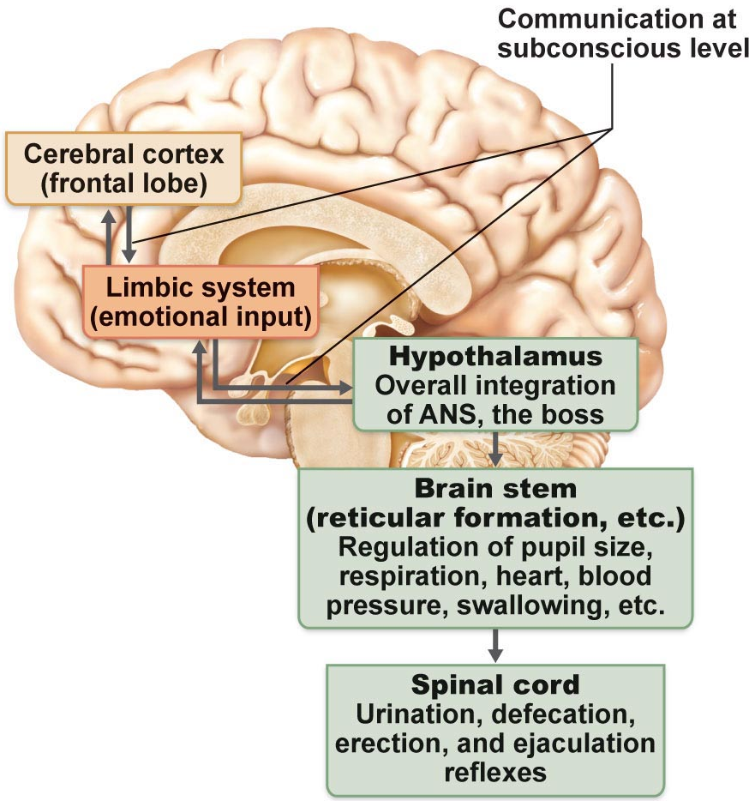
• e g: hypertension:

Limbic system effects what is going on in the hypathalumus

Your emotions and consciousness effect what is happening in the rest of your brain
Nuclei control what is going on in the autonomic system
- Our emotions effect what’s going on in the hypothalamus, which effects all of our organs- blood pressure, heart rate,
- Emotions effect all autonomic functions but our conscious brain (more analytical brain – prefrontal cortex) can influense our emotions – can often talk yourself down when you are stressing about something
- We don’t have control but we have a huge influence

1. After surgery, patients are often unable to urinate and bowel sounds are absent. What division of the ANS is affected by anaesthetic?
- Parasympathetic- resting and digesting system
2. A risk factor for ulcers can be stress and the associated excess activity of the sympathetic nervous system. eg: one contributing factor to ulcers is a severe reduction in blood flow to the stomach wall. How is this related to sympathetic function?

THE ENDOCRINE SYSTEM
3.3.1.1 Hormones: define receptor, specificity, affinity
3.3.1.2 List the 3 structural groups of hormones & differentiate between steroid hormones and protein/peptide hormones in terms of their mechanisms of action
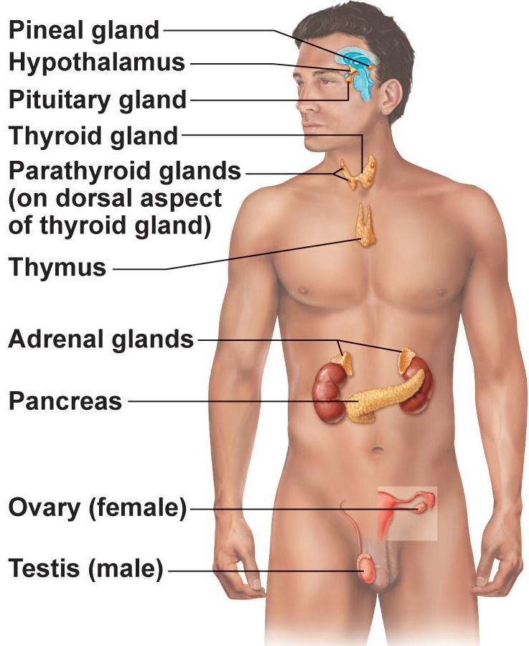
What is a hormone?
Chemical substance released into the ECF that regulates the metabolic function of other cells in the body
Remember:
• hormones must bind to specific receptors to influence target cell function
• hormones are specific; level of target cell activation depends on:
(i) hormone concentration
(ii) target cell receptor content
(iii) affinity of hormone for receptor

- Endocrine - secretions into the body
- Cells in various organs that are secreting their products into the extra cellular fluids which get into the blood strem
- All endocrine secretions end up in the blood stream
- Hormone- chemical that is released by an endocrine gland and carried by the blood stream to distant targets, that then alters the activity or target tissues/target organs
- Adrenal glands- epinephrine
- How much of a response the target tissue has depends on how much hormone is being secreted. – Effects the activity
Mechanism of Hormone Action:
• hormones alter levels of cell activity:
» membrane permeability/potential (channels)
» synthesis of enzymes within cells
» enzyme activation/deactivation
» induction of secretory activity
» stimulation of mitosis

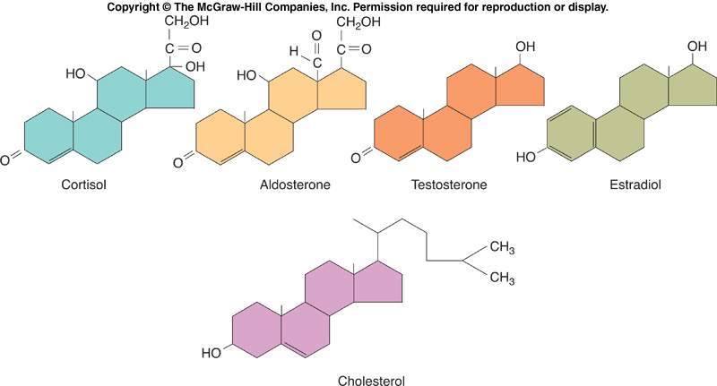
3 structural groups of hormones:
(i) amino acids, peptides, proteins
(ii) steroid hormones (derivatives of cholesterol)
(iii) eicosanoids (from arachadonic acid)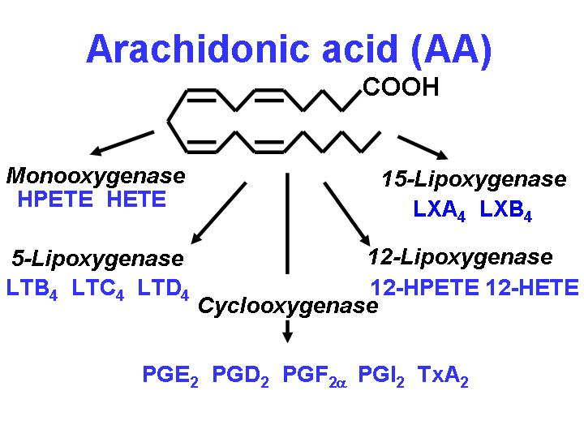

- All steroid hormones can pass directly through cell membranes and then bind on receptors inside the cell
- Amino acids- bind to receptors in the cell wall
- Eicosanoids – from a fatty acid- classified as local messengers – that act right close to where they are being produced

- They all work by altering the activity level of the cell – do not cause a complete change in the activity just change the level of activity in the cell – by changing membrane potential or causing the target cell to synthesize a new product such as an enzyme, secrete something or cause them to divide

2 main mechanisms of action:
Peptide/protein hormones: bind to cell surface receptor » activation of membrane-bound G protein » production of 2nd messenger (eg: cyclic AMP (cAMP), calcium) activation of protein kinases to regulate activity of key enzymes
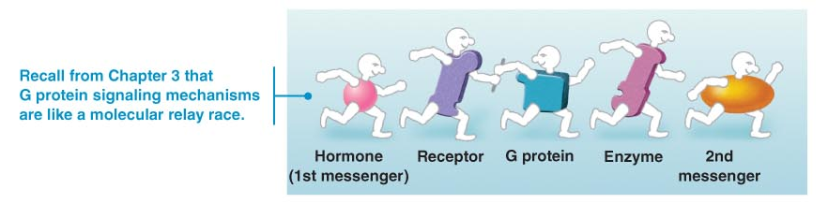

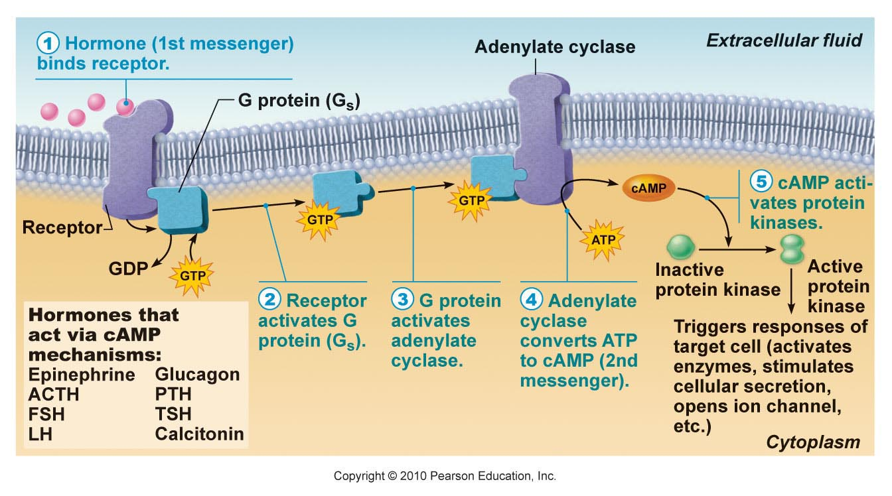
- Hormone binds to a receptor
- Interacts with a g-protein
- When g-protein gets activated the g-protein will bind to another membrane and the secondary protein – Adenylate cyclase (catalyses ATP into cAMP)
- Hormone- primary messanger
- cAMP – secondary messenger, made in the cell
- cAMP is the most common
- other secondary messenger is IP₃ and Ca 2+
- If we have a protein based hormone, the hormone cant get through the cell, it has to bind to a membrane receptor – all peptide hormones must bind to membrane bound receptors

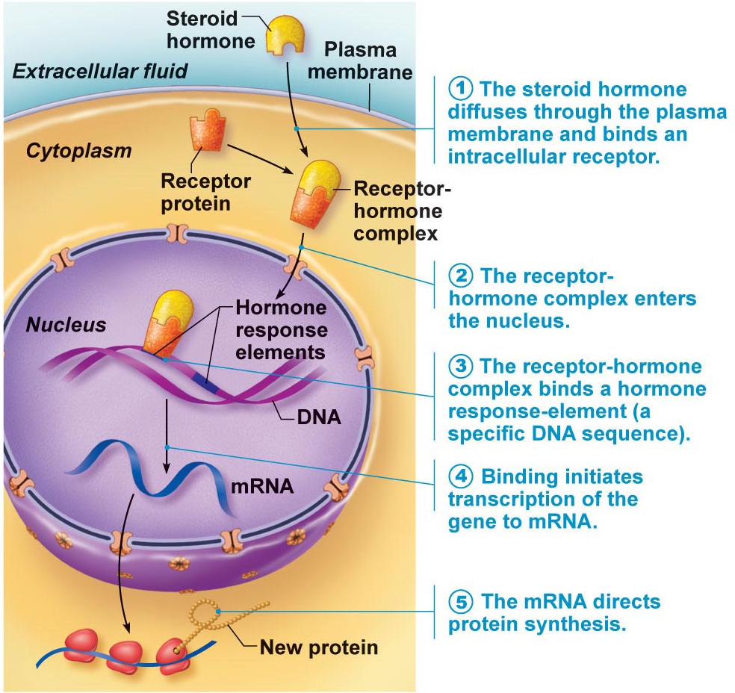
Steroid hormones:
entry into nucleus and activation of gene transcription
- hormone can pass right throguh the membrane and will bind to a receptor inside the cell
- when the receptor horminf complex forms it will bind to the nuceus and start the transcition of DNA to mRNA
- mRNA will leave the nucleus and interact with new protein
- Helps with Gene transcription and protein synthesis

3.3.1.3 differentiate between positive and negative feedback as well as between humoral vs neural vs hormonal regulation of hormone release
Half-life, Onset & Duration of Hormone Activity
• hormones are potent
• blood level of hormone depends on:
» rate of synthesis
» rate of degradation/clearance from blood
• half-life: persistence of a hormone in the blood; usually < 1 min to 30 min
• time to onset of hormone action variable: enzyme activation - rapid (minutes); enzyme synthesis - hours to days
• some hormones secreted as prohormones; activated once reach target cell
• duration of hormone action also variable (hours to days)

- hormones are potenent – don’t need many to stimulate
- level of a hormone in the bllod depends on how fast it is being made, released and cleared from the blood
- Broken down differently
- Cleared out of blood stream by liver or excresion of the kidneys
- How long they last in the blood stream = half life (length it takes to clear half of the hormone from the blood – anywhere from a few seconds to a half an hour)
- Onset time – if involves enzymes it will happen quicker
- Some hormone are secreted as prohormones – prevents them from being activated throughout the body (example : thyroid – gets activated at the target tissue – advange = only gets activated where it is required, doesn’t distribute effects throughout the body)
- Steriod hormones have a longer duration of action then protein hormones

Control of Hormone Release
• usually negative feedback (setpoint); sometimes positive feedback (goal)
• 3 types of stimuli: humoral, neural & hormonal
a) Humoral stimuli: hormone secretion in direct response to change in blood level of a nutrient, ion [eg: parathyroid hormone (PTH) & blood calcium; insulin & blood glucose]
- Humor - old fashioned term for body fluids , involves something that is dissolved in the blood or body fluids (ex: glucose)
b) Neural stimuli: not as common, eg: sympathetic ns & epinephrine release by adrenal medulla, hypothalamic neurons & oxytocin release
-
c) Hormonal stimuli: 3-tiered system involving hypothalamus, pituitary & target endocrine gland - concept of hypothalamic-pituitary axis
- typically involved in hypothalamic pituitary axis
Under negative feedback control, but sometimes can be under positive (oxytosis during labour and delievery, from neuro stimulation)

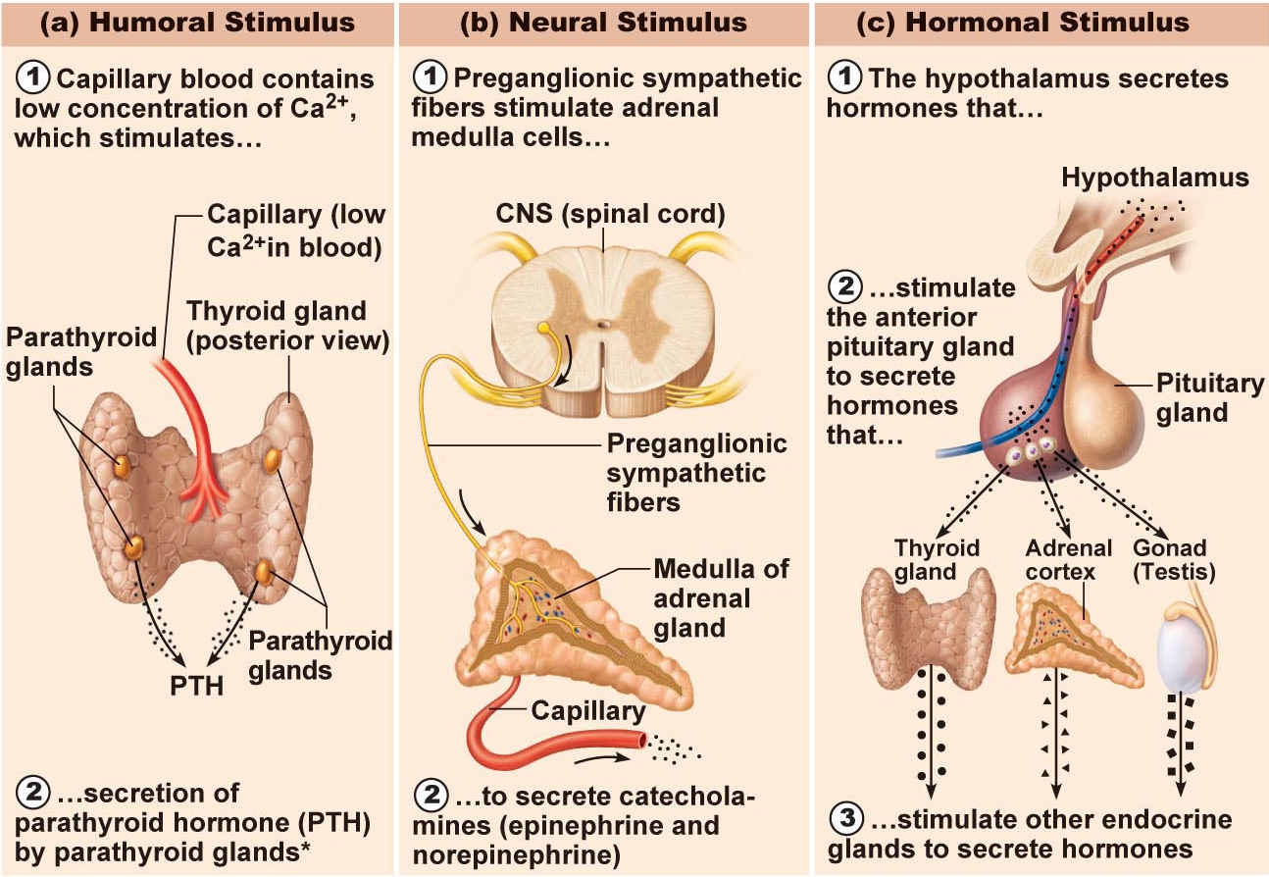
Endocrine stimulation – 3 mechanisms of stimulation
- Humoral – something in the blood goes out of wack – disturbance in homeostasis
- Neural – Ex; control of oxytocin, autonomic nervous system, when you get stressed out signals get sent from your brain to your spinal cord,
- Hormonal – example: thyroid – if your metabolic processes are low, if you have a decrease in body temperature it will stimulate the hypothalamus to produce more thyroid hormone
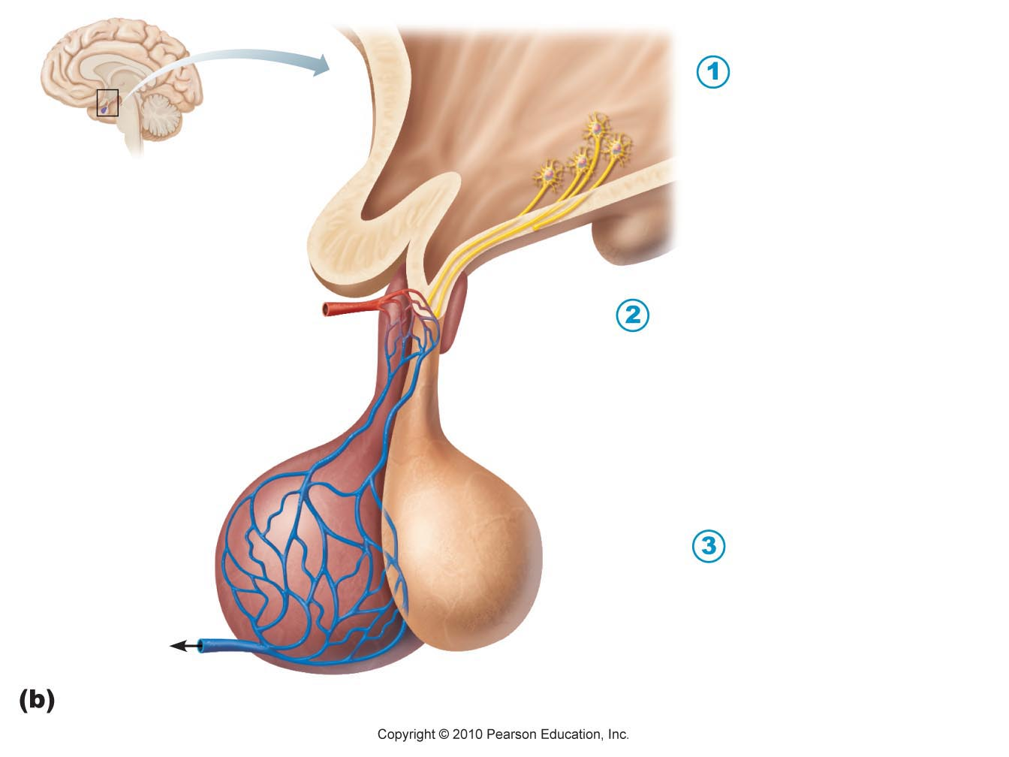
Thyroid-releasing hormone (TRH)

(hypothalamus)

Thyroid-stimulating hormone (TSH)
(anterior pituitary)

Thyroid hormones (T₃ & T₄)
(thyroid gland)
Hypothalamus is neural; produces a number of releasing factors (hormones) which travel to anterior pituitary via hypophyseal portal system
(what is a portal system?)

CRH (Hypothalamus) ACTH Cortisol
(Corticotropin-Releasing-Hormone) (Adrenocorticotropic H.) (Adrenal Cortex, Steroid hormone)
-Hypothalams is NEURAL
- Hormones enter the blood stream by the hypophyseal portal system
-2nd place in your body is the LIVER

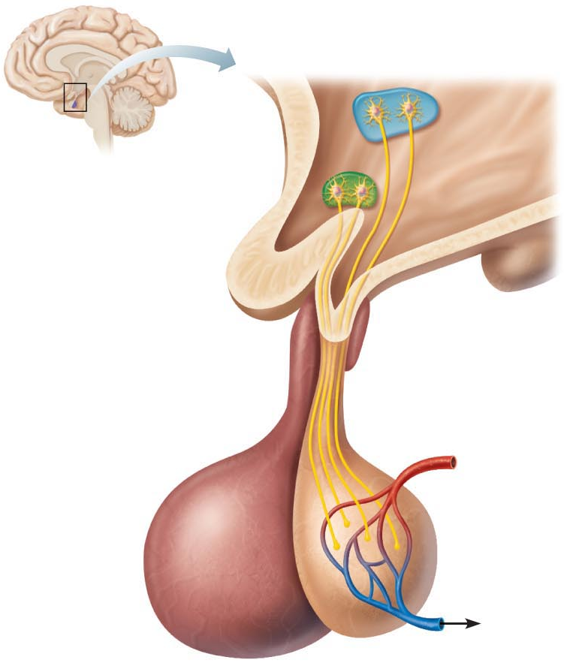
Pituitary Gland:
• size & shape of a pea
• infundibulum connects pituitary to hypothalamus
posterior lobe:
• axon terminals
• hormone storage area
• antidiuretic hormone (SON)
oxytocin (PVN)
Structurally similar (both are nonapeptides); but very different functions!!

- pituitary gland has two lobes
- posterior pituitary is the ending of neurons that originate in neurons in the hypothalamus
- Nuclei stimulate release of two hormones
- Posterior releases – antidiuretic hormone (acts on your kidneys, DIURETIC- peeing, produced urine production, released anytime you become dehydrated) and oxytocin

KNOW ALL TERMS IN BOLD IN ALL SLIDESHOWS

To Summarize:
2 key homeostatic regulatory systems:
- Autonomic nervous system
  - sympathetic versus parasympathetic
  - sensory and motor neural pathways
  - fast response – respond to changes really quickly
  - Endocrine system
  - hormones released into extracellular fluid and often travel to target organs via bloodstream
  - slower response time but response can be long-lived – slower processes, things must go through the blood stream
  - different chemical classes of hormones with associated mechanisms of action

-WHAT HOMEOSTASIS IS – Keeping internal stable – water balance, ion balance, nutrient balance, temperature control, regulated through the:
Autonic nervous system
And
Endocrine system

