Chapter 7- October 16

Finances of Housing

Evaluating Housing Alternatives
- Traditional financial guidelines suggest you spend no more than 25-30% of take-home pay on housing
- Or no more than 2 ½ times yours annual income

Opportunity Costs of Housing Choices
While the opportunity costs of your housing decision will vary, some common trade-offs include:
- Interest earnings lost on money used for a down payment or the interest on a security deposit for an apartment
- Time and cost of commuting to live in an area that offer less costly housing or more space
- Loss of equity growth when you rent
- Time and money to repair and improve a lower-priced home
- Time and effort when you have a home built to your personal specification
Renting vs Buying Housing
Advantages
- Mobility
  - Easier to move when changing jobs, rent increases or you prefer a different community
- Fewer maintenance/repair responsibilities
- Lower initial costs
Disadvantages
- Few financial benefits
- Restricted lifestyle
- Legal concerns of a lease
- Costs including security deposit, utilities and renter’s insurance
- Renting rights

The Lease
- A lease is a legal document that defines the conditions of a rental agreement
- The lease should provide the following information:
  - Description and address of property
  - Name and address of the owner/landlord
  - Name of tenant
  - Effective date and length of the lease
  - Amount and due date of rent
  - Location where rent is due
  - Date and amount for late rent payments
  - List of included utilities, appliances, furniture and other facilities included
  - Restrictions on certain activities
  - The right to sublet the unit
  - Conditions under which landlord may enter the rental unit
  - Charges or damages for moving out before lease expires
- Negotiate with landlord about lease terms you consider unacceptable
- The provincial Residential Tenancies Act protects you rights even if your lease does not cover all the details
  - Oral leases are also valid
- Lease provides protection to both landlord and tenant during the term
  - Rent increases, unless provision in contract allows
  - Lock out or eviction
  - Right of legal action for non payment/destruction

Home Buying Process
Step 1: Determine home ownership needs
Advantages of Owning
- Pride of ownership
  - Stability of residence
  - Personalized living location
- Financial Benefits
  - Increase in value of property
  - No capital gain on sale of principal residence
  - Borrowing against equity
- Lifestyle flexibility
  - Express your individuality

Disadvantages of Owning
- Financial uncertainty
  - Get down payment and financing
  - Home values could drop
- Limited mobility
  - Can take time to sell
- Higher living costs
  - Maintenance
  - Repairs and improvements
- Higher property taxes

Assess Types of Housing Available
- Single family dwelling
- Multi-unit dwelling
  - Duplex, townhouse
- Mobile homes
  - A type of manufactured home often less than 1000 square feet
  - Offer same features as a conventional house
  - They tend to depreciate
- Build a new home

Consider Form of Home Ownership
- Most common form of ownership is when individual/couple are sole owners of entire property
- Condominium: an individually owned housing unit in building with several such units
  - Not a type of structure, but a form of ownership
  - As well, become co-owner of common areas
- Co-Operative housing: a type of subsidized housing in which half the units have geared-to-income rental prices
  - Member owned communities where residents make decisions on how co-operative operates

Determine Amount of Down Payment
- Down Payment
  - Will affect the size of mortgage loan required
  - Larger down payment (20%) will make it easier to get a mortgage
- Source of your down payment
  - Savings, pension plan fund, sale of investments or other assets, assistance from relatives
  - First time buyers can use up to $25,000 of RRSP
- Less than 20% down payment is a high ratio mortgage
  - Insured through CMHC

Calculate Your Affordable Home Purchase Price
- Mortgage is a long-term personal loan used to purchase property
  - Repaid over 15, 20, 25 years
  - Available from banks, credit unions, trust companies or mortgage brokers
  - Must meet certain criteria to qualify
    - Income, other debts, amount of down payment, length of loan, current mortgage rates
- Gross Debt Service Ration (GDSR)
  - Monthly shelter costs as a percentage of your gross monthly income
  - P-Principal
  - I-Interest
  - T-Taxes
  - H-Heat
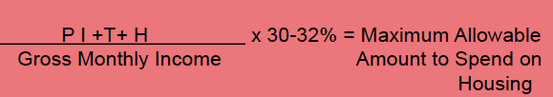

- Total Debt Service Ratio (TDSR)
  - Your monthly shelter costs plus any outstanding debt payments and obligations
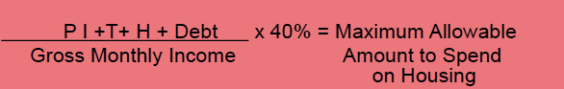

Step 2: Find and Evaluate a Property to Purchase
- Select a location
  - Compare your values and lifestyle with those of current residents
  - Be aware of zoning laws
- Using a real estate agent
  - They present your offer, negotiate the price, assist you in obtaining financing, and represent you at the closing
- Conducting a home inspection
- Obtain an appraisal
Step 3: Price the Property
Determining the home price
- Recent selling price of homes in area, demand for homes, length of time on market, features and condition
- Negotiating the purchase price;
  - If offer is accepted it is a bonding contract
  - Counteroffer indicates willingness to negotiate
  - Earnest money is deposit evident of good faith
- Contingency clauses;
  - Buyer can obtain financing
  - Sale contingent on the sale of the buyer’s current home

Step 4: Obtaining Financing
The application process;
- Meet to review application and provide proof and other documentation of employment
- Lender obtains credit report and verifies information
- Mortgage is approved/denied
  - Based on borrower’s credit and financial history
  - Evaluation of home
  - Maximum amount for which you quality

Evaluating Interest/Payment Options
- Fixed Rate Mortgages
  - Lock interest rate in for specific term
  - Amortization- the reduction of a loan balance through payments made over a period of time
    - Effective 2012 the max amortization is 25 years and can borrow 80% of home’s value
  - Closed- borrower pays penalty for pre-payment
  - Open- mortgage paid off at any time without penalty
    - Compounded semi-annually
    - Paid monthly, weekly, or biweekly
- Variable Rate Mortgage
  - Home loan with an interest rate than can change during the mortgage term due to changes in market interest rates
  - Rate cap- limit on increases/decreases
  - Payments remain the same
  - Proportion of interest to principal changes
  - Consider
    - Frequency of changes in interest rates
    - Changes in the monthly payment
    - Extensions due to negative amortization
    - Index used to set interest rate
  - May convert to fixed rate at any time
- Split or Multi Rate Mortgage
  - Mortgage split into parts
  - Each with different maturity dates and interest rates
- Other financing Methods
  - Second Mortgage- home equity loan allows homeowner to borrow on paid up value of property
    - Also available as a line of credit
  - Reverse Mortgage- if owner is 60 or older, not required to make monthly payments but will pay back mortgage when home is sold
- Options to Pay Back Your Mortgage
  - Accelerated mortgage payment
  - Double up payments
  - Lump sum deposits
  - Miss an occasional payment
- Refinancing
  - The process of obtaining a new mortgage on a home to get a lower interest rate
  - Pre-payment penalty- a charge to pay off the loan early

Step 5: Close the Purchase Transaction
Closing Costs are fees and charges paid when a real estate transaction is completed and include;
- Title insurance and search fee
- Attorney’s and appraisers fees
- Property survey
- Land transfer taxes
- Mortgage insurance
- Home insurance
- Tax and utility adjustments
- Moving expenses
- Real estate commission
Title insurance: insurance protects the owner or lender against financial loss resulting from defects in the title, during the mortgage term

Deed or title: a document that transfers ownership of property from one party to another

Escrow account: money deposited with lending institution for payment of property taxes and homeowners insurance

Ch.8 Home and Auto Insurance

Insurance and Risk Management
- Insurance is protection against possible financial loss
- An insurance company, or insurer, is a risk-sharing firm that assumes financial responsibility for losses from an insured risk
- People purchase a policy (a written contract of insurance) and the firm assumes a risk for a fee called the premium (the amount of money a policy holder is charged for an insurance policy)
- Insured is a person covered by an insurance policy
- A person who owns an insurance policy is the policyholder

Types of Risk
- Risk is chance or uncertainty of loss
- Peril is the causes of a possible loss, such as a fire, windstorms, robbery, disease or death
- Hazard is something that increases the likelihood of a loss, such a driving drunk, smoking in bed, or defective house wiring
- Most common risks are classified as personal risks (loss of income, premature death), property risks (direct damage to assets), a liability risks (loss due to injury or harm to others)

Risk Management Methods
- Risk management is a long range, organized, planned strategy to protect your assets and family
- Pure Risk is a risk in which there is only a chance of loss
  - It is insurable, accidental, unintentional; nature of risk can be predicted
- Speculative Risk is the chance of loss or gain and is uninsurable, such as starting a small business or gambling

Risk Management Methods
- Risk Avoidance means to avoid the chance of loss altogether
  - Avoid a car accident by not driving to work
- Risk Reduction means to reduce the chances of a loss occurring, or reducing the adverse effects of losses that do occur
  - Wearing a seatbelt to avoid serious injuries if you are in an accident
- Risk Assumption means taking on the responsibility for the loss or injury
  - To self insure is the process of establishing a monetary fund to cover the cost of a loss
- Risk Shifting means to transfer the cost of the loss to an insurance company

Planning an Insurance Program
Step #1
Set your insurance goals and prioritize them
- Set a plan in motion to reduce the impact of the following events;
  - Loss of income or additional expenses due to death, illness, accident or unemployment
  - Loss of real or personal property due to fire, theft or other hazards
  - Potential loss of income, savings and property due to personal liability
Step #2
Develop a Plan to Reach Your Goals
Step #3
Put Your Plan into Action
Step #4
Review Your Results

Potential Property Losses
- The main risks related to homes (and automobile) are;
  - Property damage or loss
  - Your responsibility for injuries to others or damage to property of others

Liability Protection
- Liability is legal responsibility for the financial cost of another person’s losses or injury
- Negligence is the failure to do what a reasonable and prudent person would do in a given situation
- Vicarious liability is when you are held responsible for the actions of another person
- Strict liability is present when a person is held responsible for intentional or unintentional action

Homeowner’s Insurance
- Homeowners insurance is coverage for a place of residence and its associated financial risks
  - Includes physical damage to property and the loss of use of the property
  - Buildings and other structure
  - Additional living expenses
  - Personal property/articles
- Replacement Value of your home
  - Limit of insurance purchased should reflect the cost to rebuild your home
  - Not its current market value
  - Appraisal, inspection by company
- Depreciated Value
  - A reduction in the value of an object based upon its age and the percent it has decreased each year
- Homeowner’s Liability coverage
  - Protects you and your family from financial losses resulting from legal actions against you due to damage to others and their property
    - Includes the cost of legal defense

Tenant’s Insurance
- Personal property loss or damage
- Personal liability
- Additional living expenses
- Landlord’s insurance usually won’t cover personal belongings
- Tenant’s Legal Liability covers loss or damage to property in your care or control caused by fire, smoke, explosion or water damage

Home Insurance Policy Forms
- Named Perils
  - Only those perils specifically listed in the policy are covered if a loss occurs
- All Risk
  - Any event that causes loss or damage is covered unless it is specifically excluded 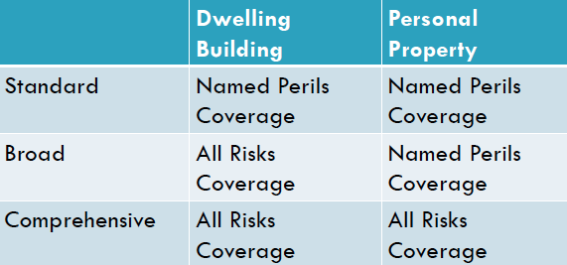

Deductibles
- Deductible is your share of any claim
  - Is a fixed amount indicated on your policy
- The higher your deductible the lower your premium since insurance company is responsible for less of your loss
- People are generally more careful if the cost of being careless is higher
- Fewer small claims means less administrative costs for insurer

How much coverage do you need?
- Determine the value of the contents of your home
  - Actual cash value- cost less depreciation
  - Replacement value- repair or replace with new items of like kind and quality
Auto Insurance Categories
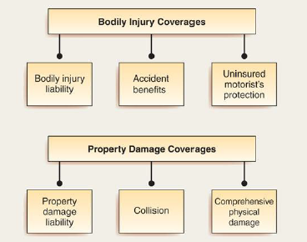

No-Fault Insurance
- No fault concepts are widely misunderstood
- Fault is determined in every incident for the purpose of premium calculation
- Each driver collects from their own insurance company
  - Medical expenses, lost wages and related injury costs
  - Damage to your vehicle to extent you were not at fault
- Intended to provide faster settlement of claims and reduce costs
- Systems vary from province to province

Risks Assumed and Coverage Available
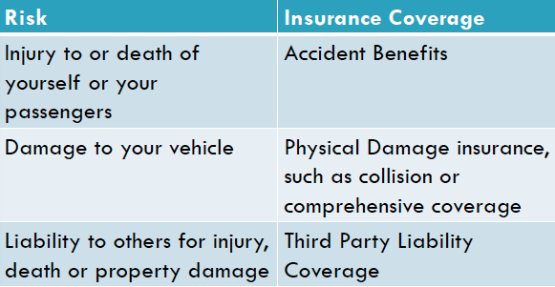
Automobile Insurance Coverage
Property Damage
- Collision or Upset Coverage
  - When your car is in an accident, collision insurance pays for damage to your automobile
  - Amount collected is limited to the actual cash value of the car at the time of the loss
- Comprehensive Coverage
  - Covers damage to your vehicle that is not caused by a collision, such as fire, theft, vandalism, glass breakage, hail or windstorm

Auto Insurance Premium Factors
Factors that affect the amount of premium you pay include;
- Limits of coverage
  - Some coverage’s are mandatory
    - Minimum $200,000 liability limit, accident benefits
    - Higher limits are recommended
    - Physical damage is optional unless finance contract requires coverage as security for loan
- The Automobile itself
  - Uses new CLEAR system in Ontario
    - Cost to repair or replace
    - Make and Model, style of vehicle, safety record
- Use of Vehicle
  - Pleasure, business or farming
  - Distance driven to work
- Rating territory
  - Accident, theft, and vandalism rates in the area where you live
  - Insurance generally higher in urban areas
- Driver classification
  - Age, gender, marital status, driving record, and driving habits
- Assigned risk pool for people who are considered high risk drivers

Reducing Automobile Insurance Premiums
- Find out how much it will cost to insure a car before you buy it
- Compare companies
- Increase your deductibles
- Look for discounts
  - Establish and maintain a good driving record
  - Install security derives such as a car alarm
  - If you have more than one vehicle insure them both with the same company

Ch.9 Life Insurance

The Purpose of Life Insurance
- The purpose of life insurance is to protect someone who depends on you from financial loss related to your death. Proceeds may be used to;
  - Pay off a home mortgage or other debts at time of death
  - Provide lump-sum payments through an endowment to children when they reach a specific age
  - Provide an education or income for your children
  - Make charitable bequests upon your death
  - Provide a retirement income

The Principle of Life Insurance
- Mortality tables provide odds on your dying, based on your age and sex
- Your premium is based on your life expectancy and the projections for the payouts for persons who die
- Adjustable for factors that increase/decrease an individual’s risk and various administration fees for the company

Determining Your Life Insurance Needs
- Do you need life insurance?
  - Do you have people you need to protect financially?
  - Do you have a partner who works?
- What are your objectives for life insurance?
  - How much money do you want to leave your dependents should you die today?
  - When you retire what income do you need?
  - How much will you be able to pay for your insurance program?

Estimating Your Life Insurance Requirements
- The Income Replacement Method
  - Typically, you will need 70% of your salary for seven years while family adjusts
$______ current income x 7 = $______ x .70= $________
  - Assumes a “typical” family with NO liquid assets available that would otherwise reduce your life insurance needs
- The “Family Need” Method
  - More thorough than the first method because it also considers employer provided insurance, Government benefits and income and assets
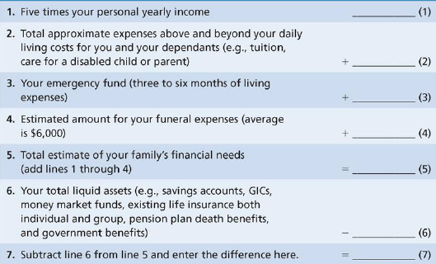

Types of Life Insurance
Term Life Insurance
- Protection for a specified period of time
- If you don’t pay premiums, coverage stops
  - A renewability option means that at the end of the term you can renew the policy without having a physical
  - Conversion option allows you to change your policy from term to whole life without a physical
  - Term to 100- remains in effect to age 100
    - Level premium costs significantly less than permanent insurance
- With decreasing term insurance your premium stays the same, but the amount of coverage decreases as you age

Permanent Life Insurance
- Purchased to cover lifelong needs
  - Financial expenses, supplementing a survivor’s income, capital gains or providing for dependent children
- Have level premiums which remain the same over lifetime of policy
  - Higher premiums paid in early years held in reserve to offset increased costs in later years
- Reserves also referred to as cash value
  - Amount received after giving up life insurance policy
  - Used if unable to pay premium or borrowed against as loan
- Upon death face value of policy paid out to named beneficiary
- Permanent life insurance has the following variables;
- Whole Life
  - Pays specified premiums as long as he/she lives
  - Pays stipulated sum to beneficiary upon death
  - Has a cash value which is paid out if policy given up
- Universal Life Policy
  - Combines term insurance and investment elements
  - Can pay variable premium amounts
  - Increased cash value reflects interest earned; guaranteed not to be less than specific amount
  - Uses current interest rates and can be changed to reflect prevailing rate changes
  - Death benefits flexible
  - Can change premium without changing coverage
- Variable Life Policy
  - Premiums guaranteed
  - Value equals performance of investment fund or other index
  - Minimum death benefit guaranteed but can increase
  - Risk of poor investments
- Endowment Life Insurance
  - Coverage from beginning of contract to maturity
  - Guarantees payment of specified sum even if insured still alive

Factors Affecting Premium
Consider the following factors when pricing life insurance premium;
- Amount of insurance
- Health class
- Age
- Gender
- Marital status
- Occupation
- Recreation

Other Types of Life Insurance Policies
- Group life insurance
  - Term insurance often provided by the employer
  - No physical is required
- Credit life insurance
  - Debt is paid off if you die
  - Protects the lender

Life Insurance Contract Provisions
- Naming your beneficiary, and contingent beneficiaries
- Length of grace period for late payments
  - Usually 28-31 days
- Reinstatement for a lapsed policy if it has not been turned in for cash
  - Must again qualify as an acceptable risk
- Non-forfeiture clause prevents the forfeiture of future benefits if you drop the policy
- Incontestability clause stipulates that after the policy has been in effect for a period of time that company cannot dispute its validity
- Suicide clause during first two years
  - Death benefit equals amount of premium paid
- Automatic Premium loan uses the cash value to pay the premium if you do not pay it
- Misstatement of age provision
  - Will pay benefits premium would have bought if age were correct
- Policy loan provision to borrow against cash value
- A Rider to a policy modifies its coverage by adding or excluding conditions or alter benefits;
  - Waiver of premium disability benefit
  - Accidental death benefit- double indemnity
  - Guaranteed insurability option
  - Critical illness
  - Joint, last to die
Buying Life Insurance
- Look at your present and future sources of income, savings, group life insurance, group annuities and government benefits
- Determine from whom to buy your policy;
  - Examine both private and public sources
  - Look up the company’s rating
  - Agent and direct insurer v. broker

Obtaining and Examining a Policy
- Submit application to company
  - Personal information, type of policy and limits if coverage
  - Medical history (may require examination)
- Examining a Policy
  - Before purchase
    - Read every word of contract
    - Get full explanation of terms of provisions
  - After purchase
    - Can cancel policy within 10 days without penalty
    - Make copies for lawyers and beneficiaries
Choosing Settlement Options
- Options are the choices for how you want the money paid out
- Lump-sum payment is most common
- Limited instalment plan
  - In equal instalments for a specific number of years after your death
- Life income option
  - Payments to the beneficiary for life
- Proceeds left with the company
  - Pays interest to the beneficiary

Should you Switch Policies?
- Consumers lose millions because they don’t hold cash life policies long enough or they purchase the wrong policy
- Switch if benefits exceed costs of getting another physical and paying policy set up costs
  - Are you still insurable?
  - Can you get all the provisions you want?

