September 18th
Chapter 3- Personal Income Tax
Tax deduction- comes off your income
Tax credit- amount that gets deducted off a tax owing
Refundable tax credit- cause you go into a refund position
Non-refundable tax credit- takes you down to $0, but not into a refund position

Tax and Financial Planning
- About 1/3 of each dollar you earn goes to pay taxes
- An effective tax strategy is vital for successful financial planning
- Understanding tax rules and regulations can help you maximize after-tax cash flows and net worth
To help you cope with the many types of taxes you should
- Know current tax laws as they affect you
- Make employment, purchase and investment decisions that leave you with the greatest after tax cash flows and net worth
- Maintain complete tax records
Four types of Taxes
- Taxes on purchases
  - Sales tax
- Taxes on property
  - Personal property tax
- Taxes on wealth
  - Capital gains (losses)
- Taxes on earnings
  - Income tax
Filing Your Federal and Provincial Income tax
- Determine whether you are required to file a return
  - Students should file even if they do not expect a return to get GST/QST refunds and provincial tax credits
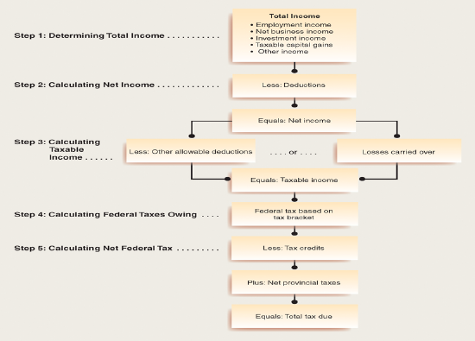

Income Tax Fundamentals
Step 1: Determining Total Income
- Total income consists of five main components
  - Employment income
  - Net business income
  - Investment income
  - Taxable capital gains
  - Other income- retirement income, Old age security, education-related payments
Step 2: Calculating Net Income
- Net income reduced by certain deductions
  - Contributions to RRSP and RPP
  - Union and professional dues
  - Child care expenses
  - Disability support deductions
  - Moving expenses
  - Other deductions- business investment loss, spousal and child support payments, interest paid on loans, employment expenses
Step 3: Calculating Taxable Income
- Additional deductions and losses carried forward from prior years
  - Capital gains deductions
  - Net capital loss of prior years
  - Other deductions
  - Capital gain or loss—when you buy on the stock market then resell, the difference is a loss or gain
Step 4: Calculating Federal Taxes Owing
- Taxable income is basis for computing amount of your income tax owing
- Tax rates and tax credits are used to compute taxes payable
- Marginal tax rate
  - Is rate of tax paid on the next dollar of taxable income
- Average tax rate
  - Total tax due divided by total income
Step 5: Net Federal Tax
- Tax credit an amount subtracted directly from the amount of taxes owing
- Non-refundable tax credits are subtracted from the amount of taxes owed by can never reduce federal tax below zero
- Refundable tax credits are refunded to individuals they quality even if their tax liability is zero
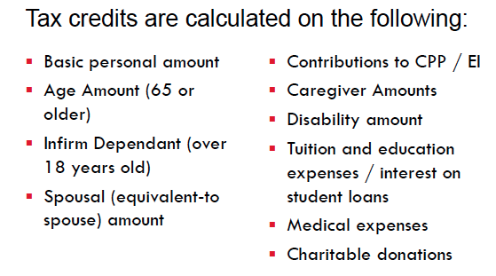
Making Tax Payments
- Source Withholding
  - Employees withhold from source to pay income tax, CPP and Employment Insurance contributions
  - Reported to you on your T4
  - Can reduce source withholding
- Instalment Payments
- Deadlines and Penalties
  - Must file by April 30 of each year
  - Automatic 5% penalty on balance owing if late
Tax Planning Strategies
- Tax planning/avoidance is the use of legitimate methods to reduce one’s taxes
- Tax evasion is the use of illegal actions to reduce one’s taxes
- To maximize after tax cash flow some strategies should be considered
- Every year the CRA modifies tax return and filing laws
- Tax Free Saving Account (TFSA)
  - Can open a TFSA at the age of 18
  - Program began in 2009 and annual contributions were limited to $5000
    - Regardless of amount contributed to RRSP/RSP
    - Unused room can carry forward
  - Can contribute up to $5500 annually starting in 2013
  - Contributions grow tax free
    - Withdrawals are tax free as well
    - Withdrawals create contribution room for future years
  - Gains/withdrawals not considered when determining eligibility for federal income tax benefits (OAS) or credits
  - TFSA is subject to same investment restrictions as RRSP/RSP
TFSA Calculation
In 2010, John (19) opened a TFSA with a contribution of $2000
He made the following transactions
- 2010 withdrew 500
- 2011 contributed 6000
- 2011 withdrew 5000
- 2012 withdrew 1000
Unused contribution room 2011= 7500
Add 2011 withdrawal= 5000
2012 contribution limit= 5000
Remaining contribution room in 2012= 17,5000

Maximizing the benefits of deduction’s and tax credits
- Be aware of current tax laws and regulations
- Use contributions to retirement plans to defer taxes on income
  - Maximize your contribution each year
- Interest on funds used to earn taxable income is tax deductible
- Capital losses incurred can be subtracted from capital gains

Tax Deferral Techniques
- Defer taxation of income until a later date when combined average tax rate may be lower
- During deferral period investment income earned can be reinvested tax free
  - Registered retirement savings plan
  - Registered pension plans
  - Individual pension plan
  - Deferred profit sharing plan
  - Investing in capital assets—don’t have to pay until you sell your asset
  - Registered education savings plan

Income Splitting Techniques
- Unlawful to invest in name of lower income earning spouse or minor child to have income taxed at lower rate
- Legal means of income splitting include;
  - Contributions to spousal RRSP
  - Splitting CPP/QPP benefits with spouse—only get if working, so it can be split between spouses
  - High income spouse plays living expenses and lower income spouse invests
  - Open registered education savings plans
  - Invest federal child tax benefit
  - Transfer asset to adult child

Ensuring that your portfolio is tax efficient
- Interest income fully taxed at marginal tax rate
  - Hold such investments in RRSP
- Dividends and capital gains are taxed less heavily
- Interest for loans made for investment purposes are tax deductible (subject to certain conditions)

What if your return is audited?
- A tax audit is a detailed examination of your return for Canada customs and revenue agency
  - More information is required
  - keep detailed records; receipts, cancelled cheques, evidence to prove amounts claimed
- Desk audit: inquiry mailed asking you to clarify or document
- Field audit: agents visit to have access to records
  - May request only specific information
  - Generally not cause for alarm
Audit Rights
- May only request specific information
- Reassessment cannot go back more than three years except in cases of fraud or misrepresentation

** INCOME YOU CAN BE TAXED ON
- Interest Income
- Dividends
- Capital Gains
Tax rate 25%, $1000
- $1000 x 0.25= $250 tax payable
- Dividends $1000
  - Gross up: take all dividends and gross them up
    - Gross up is 45% (multiply dividend income by 1.45)
    - $1000 x 1.45= 1450 (taxable income)
  - Tax rate: $1450 x .25 = $362.50 tax
  - Dividend tax credit rate 18.97%
    - 1450 x .1897 = 275 dividend tax credit
  - Reduced taxes payable to $87.50
- Capital Gains
  - Purchase stock $1000 (cost)
  - Sell stock $2000 (proceeds)
  - Capital gain is $1000
  - Taxable gain (50%), $500
  - Tax rate 25%
  - Total Tax $125
- Capital Losses ($1000)
  - Net your capital losses against your capital gains
  - Capital loss carries forward forever

