September 11/13
Chapter 1
Financial Planning Process
- Determine current financial situation
- Develop financial goals
- Identify alternative courses of action
- Evaluate alternatives
  - Consider
    - Life situation
    - Personal values
    - Economic factors
  - Asses
    - Risk
    - Time value of money
  - Consider opportunity cost – what a person gives up by making a choice
- Create and implement a financial action plan
- Re-evaluate and revise the financial plan

Types of Risk
Economic and Product Risk
- Interest Rate Risk: changing interest rates affect your costs when you borrow and your benefits when you invest
  - Option: fixed interest rate
- Inflation risk: rising prices cause lost buying power
  - Option: lock in a price
- Liquidity risk: some investments may be more difficult to convert to cash or sell without significant loss in value
  - Option: more money in a savings account
- Product risk: products may be flawed or services may not meet your expectations. Retailers may not honour their obligations
  - Option: Get a warranty, buy quality goods
Personal Risk
- Risk of death: premature death may cause financial hardship to family left behind
  - Option: Get life insurance
- Risk of income loss: Your income could stop as a result of job loss or because you fall ill or are hurt in an accident
  - Option: Emergency funds
- Health Risk: Poor health may increase your medical costs. At the same time, it may reduce your working capacity or life expectancy
- Asset and Liability Risk: Your assets may be stolen or damaged. Others may sue you for negligence or for damages cause by actions
  - Options: auto, home insurance

Developing Personal Finance Goals
Financial goals are influenced by:
- Values and attitudes towards money
- Time frame
  - Short term goal: achieved with the next year or so
  - Intermediate goal: two to five years
  - Long term goal: more than five years off
- Type of financial need that drives your goal
- Life situation
Life Cycle Approach
- Early years (until mid-30’s)
  - Focus on creating an emergency fun, saving for down payment on house, purchasing life insurance, start thinking about retirement
- Middles years (mid-30’s to mid-50’s)
  - Focus on building wealth by paying down mortgage and increasing savings and investments
- Middle years (50+)
  - Focus is on providing an adequate retirement fund
- Retirement Years
  - Focus is on efficient management of previously acquired wealth
SMART Goals
- Be stated in Specific, Measurable terms
- Indicate the type of Action
- Be Realistic
- Have a Time frame

Influences on Personal Financial Planning
Market Forces
- Supply and demand
- Production costs and competition
Financial institutions
- Influence of the Bank of Canada
- Provide services that facilitate financial activities in our economy
- Accept savings, handle chequing accounts, sell insurance and make investments on behalf of others
Global Influences
- Financial activities of foreign investors and competition from foreign companies
Consumer Prices
- The value of the dollar
- Changes in inflation (rise in general level of prices)
- Mainly causes by increase in demand without increase in supply
- Harmful to people on fixed incomes
- Can adversely affect people who lend money
Consumer Spending
- The demand for goods and services by individuals and households influences employment opportunities (more jobs)
- Reduced spending causes unemployment
Interest Rates
- Represent the cost of money
- The cost of credit when you borrow
  - Borrowing increases demand and interest rates rise
- The return on your money when you save or invest
  - Saving and investing increase the supply of money and interest rates decrease

Opportunity Costs and the Time Value of Money
Financial Opportunity Costs
- Consider the time value of money; the increases in an amount of money as a result of interest earned
  - When you spend, save, invest or borrow you should consider the time value of the money as an opportunity cost
  - Spending money from your savings account means lost interest earnings
  - Borrowing to make a purchase means the opportunity cost of paying interest on a loan

Interest Calculations
Simple Interest: interest compounded on the principal, excluding previously earned interest
- I = P x R x T
- Ex) $500 on deposit at a 6% annual interest rate for two years will earn you $60. (500x0.06x2)

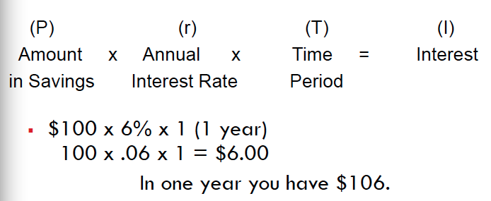

Compound Interest: Interest that is earned over previously earned interest
- Each time interest is added to the principal, the new interest computed on the new balance
- Ex) $500 on deposit at 6% annual interest rate for two years will earn $61.80. (500 x 0.06= 30 in the first year and 530 x 0.06= 31.80 in the second year)

Future Value of Money
- Is the amount to which current savings will increase based on certain interest rate and certain time period
- Calculations involve compounding since interest is earned on previously earned interest
- Can be computed for a single amount or a series of deposits
  - Annuity- a series of equal amounts (withdrawals or deposits) made at regular time intervals
- Start investing now to take advantage of the future value of money
Present Value of Money
- Current value of a future amount based on a certain interest rate and certain time period
- Present value calculations are also called discounting
- Allows you to determine how much to deposit now to obtain desired future amount
- Can be computed for a single amount or a series of deposits

Chapter 1A-Appendix
Financial planners are categorized based on the method of compensation
- Free-only planners
  - Flat rate (hourly)
- Fee-and-commission planners
- Commission-only planners
  - They get money from mutual fund, or insurance company
Chapter 1-B page 43
FV= future value
PV= present value
FV=PV x factor

Ex) $2000 in 5 years @ 4%
FV=2000(1.217)=2,434

Ex) (annuity) p44
$800 receive every year for 8 years @ 7%

FV=PV(annuity factor)
FV=800(10.26)=$8,208

Pg 45
PV of $1000 in 4 years @ 6%
PV=FV (factor)
PV= 1000(0.792)= $792

Pg 46 (annuity)
$500/yr for 10 years @ 8%
PV=FV (factor)
PV= 500(6.71)
=$3,355

CHAPTER 2: Money Management Strategy
Major Money Management Activity
- Store and maintain personal financial records and documents
- Create personal financial statements (balance sheets and cash flow statements)
- Create and implement a plan for spending saving (budgeting)
Personal Balance Sheet
A financial statement that reports what an individual or family owns or owes; also called a net worth statement
Items of Value (what you own)- Net Worth (Your wealth) = Amounts Owed
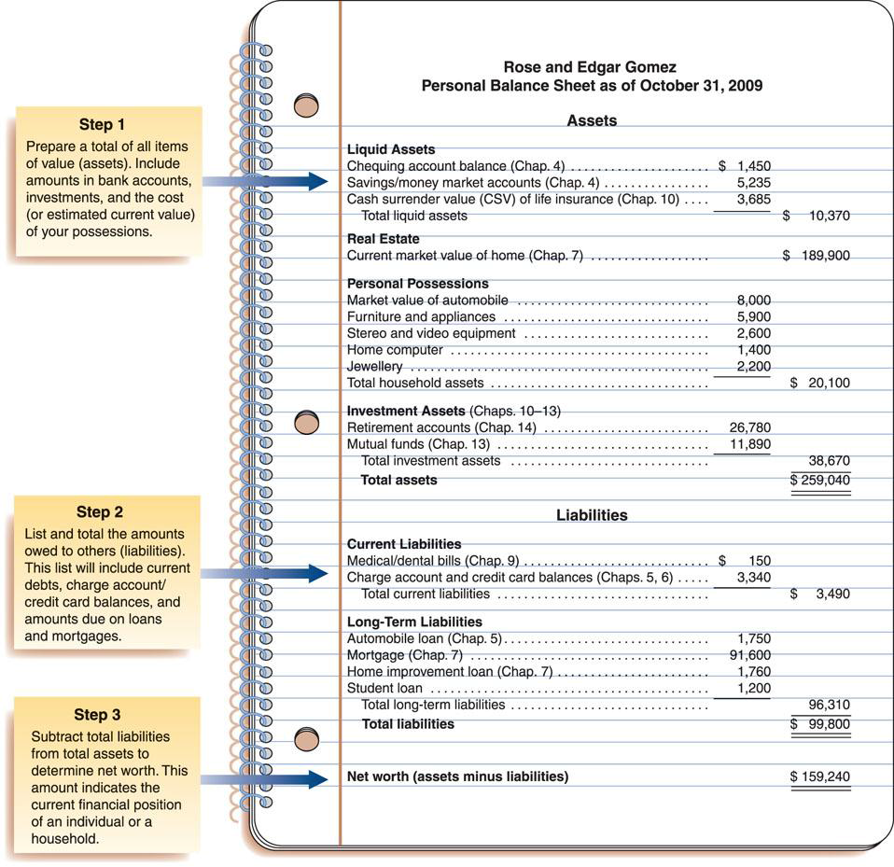
Analyzing Your Current Financial Situation
Your Balance Sheet
- Measure your progress toward your financial goals
  - Save and invest on a regular basis
- Identify how your assets are distributed among different categories
  - Each asset has its purpose
- Calculate your current asset allocation
  - Allocation of financial assets between cash, fixed income and equity investments
- Identify whether your invests are tax efficient
  - Provide you with highest after-tax return
- Identify assets that may be lost, stolen, damaged or destroyed
  - May require insurance coverage
- Summarize the types and extent of your indebtness
  - Borrowed to finance depreciating or appreciating assets
  - Many cred cards may inflate you debt ratio
Your Cash Flow Statement
- Compiling your latest cash flow statements will
  - Highlight your sources of income
  - Reveal whether you are overspending
  - Help assess your spending and saving patterns
Ratios for Evaluating Financial Progress
Debt Ratio: Liabilities/Net Worth
- Show relationship between debt and net worth
Current Ration: Liquid Assets/Current Liabilities
- A high current ration is desirable to have cash available to pay bills
Liquidity Ratio: Liquid assets/ monthly expenses
- Indicates the number of months in which living expenses can be paid if an emergency arises (6 months is desirable)
Debt Payments Ratio: Monthly payments/ take-home pay
- Indicates how much of a persons’ earnings goes for debt payments
Savings Ratio: Amount saved each month/ gross income
- Financial experts recommend monthly savings of at least 10%

Budgets
A specific plan for spending income
Purpose:
- Live within your budget
- Spend your money wisely
- Prioritize and attain your financial goals
- Prepare for financial emergencies
- Develop wise financial management habits
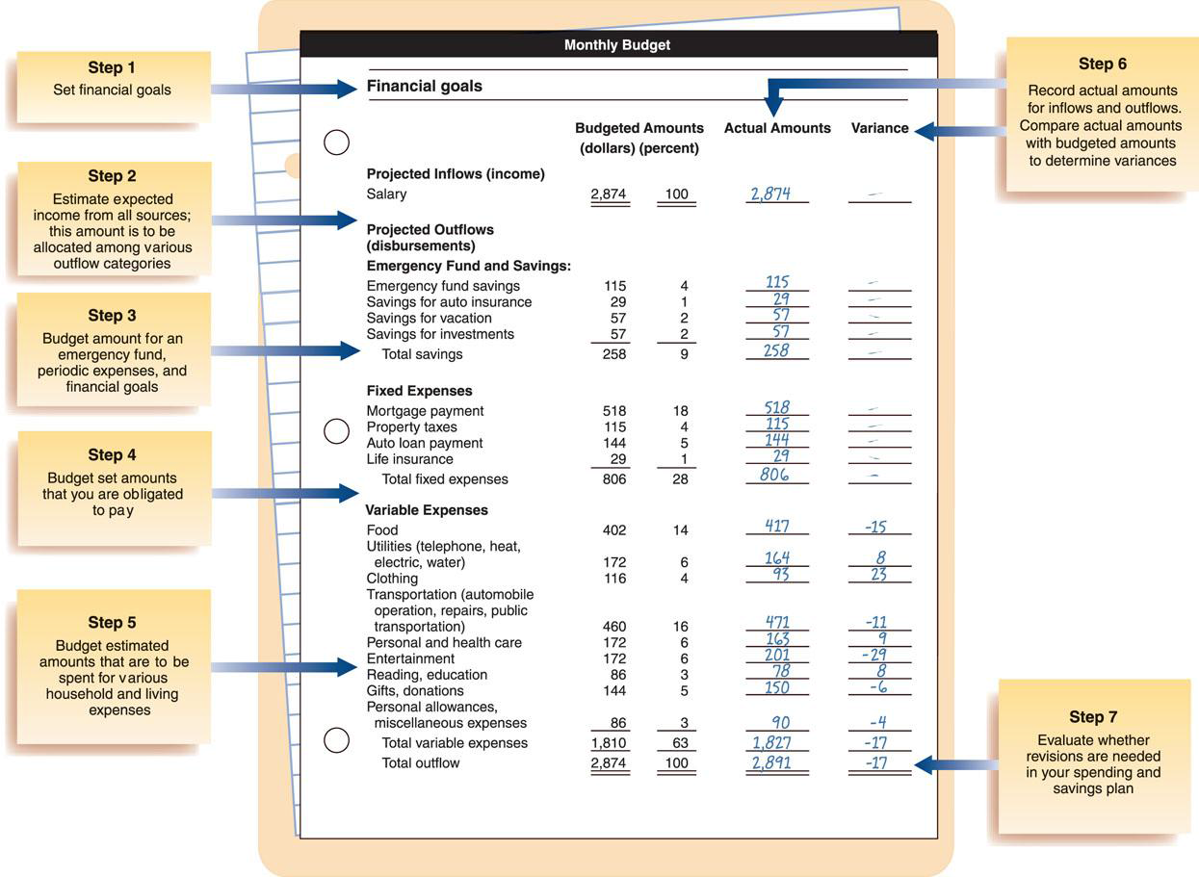
Budgets are well planned, realistic, flexible and clearly communicated
Selecting a Saving Technique
- Should make regular periodic savings deposits
- Can be a percentage of income (5-10%) or specific dollar amount
  - Automatic debit from your account and have funds transferred to an investment account
  - Payroll deduction
  - Direct deposit

Dual-Income Households
- Pooled income
  - Incomes combined and bills paid from pool
- Sharing the bills
  - Each responsible for predetermined bills
- 50/50
  - Each contribute equally to pool
- Proportionate Contribution
  - Each contribute percentage of his/her income

