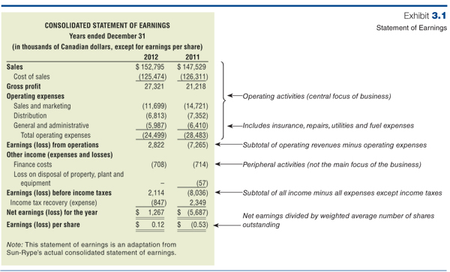
Also can do REV then OERATING EXP then NET EARNINGS

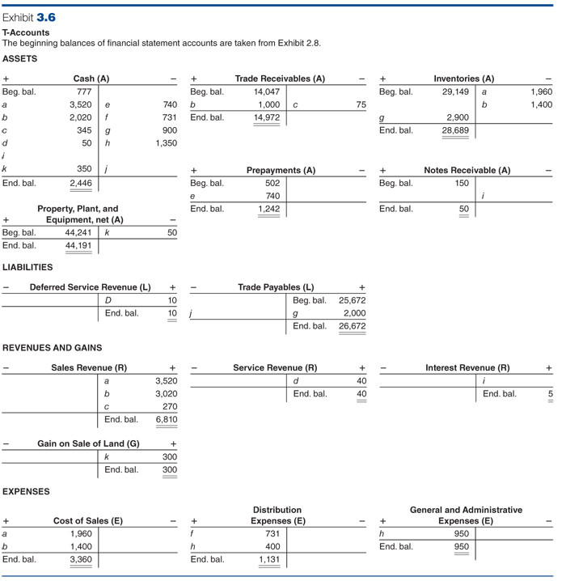

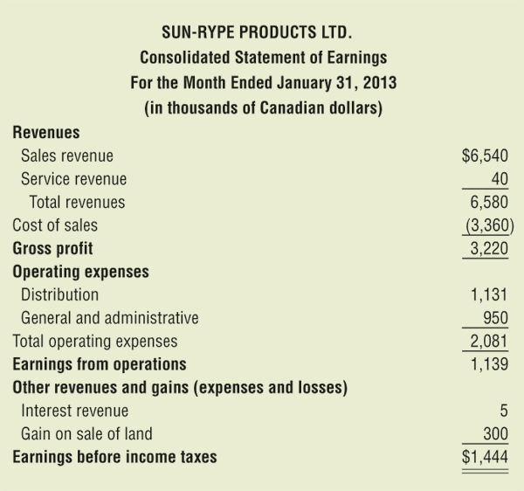

Notice that the Statement of Earnings is considered to be “before adjustments”. In the next several chapters we will see that many financial accounts must be adjusted at the end of the period. For example, the company may have incurred interest on its debt, but the interest is not paid until the end of the year. In this case we would be required to accrue interest for one month so we do not violate the matching process.
Specifically to Sun-Rype, this statement of earnings is not yet adjusted for all revenues earned or expenses incurred in January. For example,
• The prepayments account includes rent and insurance covering January, and future months, but the expenses are not yet recorded for the amounts used in January. This is true of the equipment used during the month as well. Until adjusted, assets are overstated and expenses are understated.
• We have not calculated income taxes for the amount incurred in January and owed within the next quarter. Thus, both expenses and liabilities are understated.

