Cell Membranes

Fluid Mosaic Model
- developed by singer and Nicholson in 1972
- illustrates that the membrane is made up of fluid lipid molecules in which proteins are embedded and freely floating

Function
- Define boundaries; selectively permeable barrier
- Localisationa nd Organization
  - Scaffold for biochemical activities (enzymes
  - Ex. Mitochondria
- Regulation of Solute Transport
  - In and out of cell or organelles
  - Uphill or downhill
  - Ex. Na+ K+ ATPase
- Cell to Cell Communication
  - Recognition and attachment (adhesion) between cells, or the exchange of materials
  - Gap junctions, plasmodesmata

EXAMPLES

Plasma Membrane of Schwann cell (myelin sheath) (lipid rich)
- 18% protein
- 82% lipid
Inner Mitochondrial membrane (protein rich)
- 76% protein
- 24% lipid
Normal Cells
- 50/50 proteins and lipids

Membrane Structure

In the Fluid Mosaic Model
- the lipid/protein assembly are held together in a thin sheet by non-covalent bonds
- lipid bilayer forms the basic structure
- 2 fluid lipid layers- structural backbone and permeability barrier
- consists of a mosaic of proteins responsible for different functions depending on the cell (~10 nm thick)

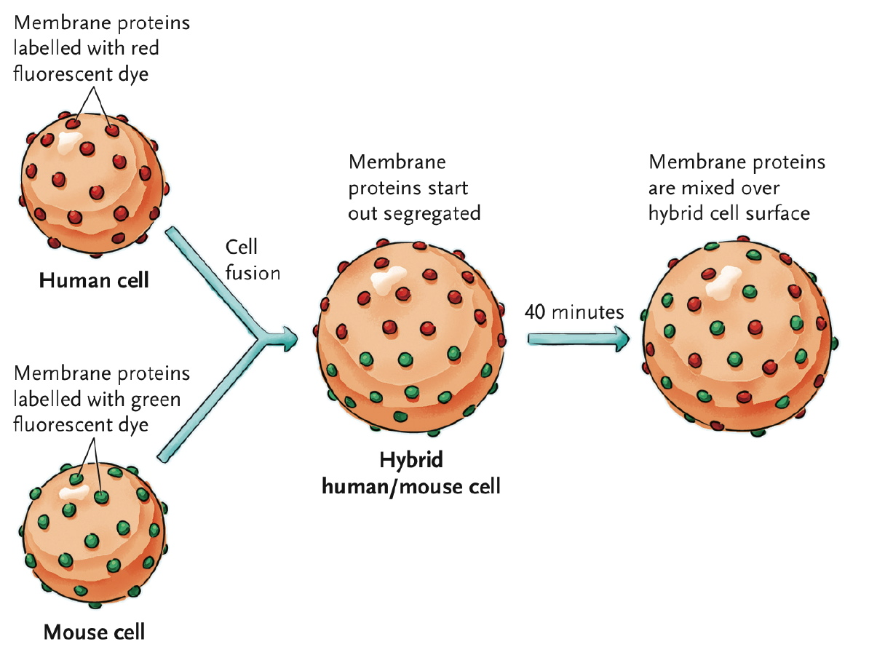
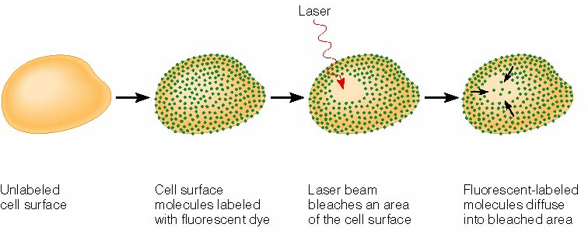

The Lipid Bilayer (backbone of membrane)
- discovered by Gorter and Grendel in 1925
- key component of the permeability barrier
- Bilayer therefore has 2 layers
- Composition:
  - Phosphoglyercides
    - Serine, choline, ethanolamine, inositol
    - 16-18 C
    - saturated (all single bonds- max # of hydrogens) or unsaturated (kinked with double bonds)
    - glycerol backbone with 2 fatty acids, polar head group (hydrophilic) consisting of a phosphate and an R group
    - amphipathic
  - Glycolipids (signaling)
    - Single sugars or oligosaccharides (lipids that have sugar groups attached)
    - Marker (ex. ABO blood groups)- cell to cell recognition
    - Tend to be found in the outer layer of the lipid bilayer facing the extracellular environment (since they signaling molecules)
    - Account for less than 1% of the total membrane lipids (very small)
  - Sterols
    - Cholesterol, phytosterols, ergosterols
    - Absent in prokaryotes
    - Protists may have different sterols depending on what type of protists they are
    - Mildly amphiphatic molecules- hydrophobic tails, hydrophilic end (OH), ring structures attached to the hydrophobic tails
    - Equally distributed in either half of bilayer
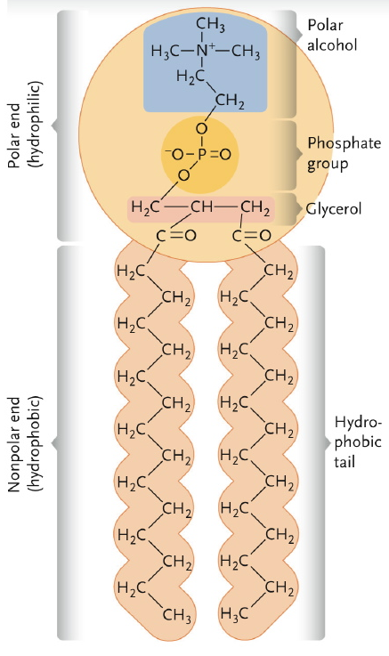
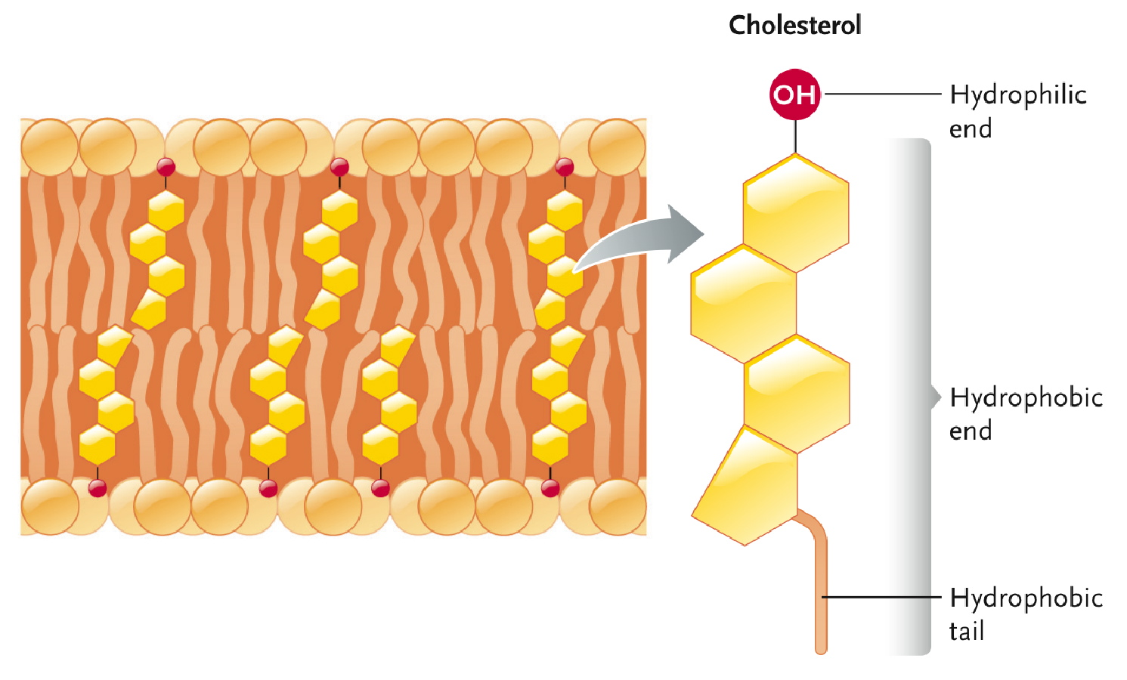

Properties:

Membrane Asymmetry
- lipids distributed unequally between the two leaflets
- established during membrane biogenesis
- flip-flops(rare, hydrophilic must pass hydrophobic therefore thermodynamically unfavorable) vs. rotation (spin in their position) and lateral diffusion (easily move among membrane)
- sterols are one of the few that will be roughly equal between the two layers
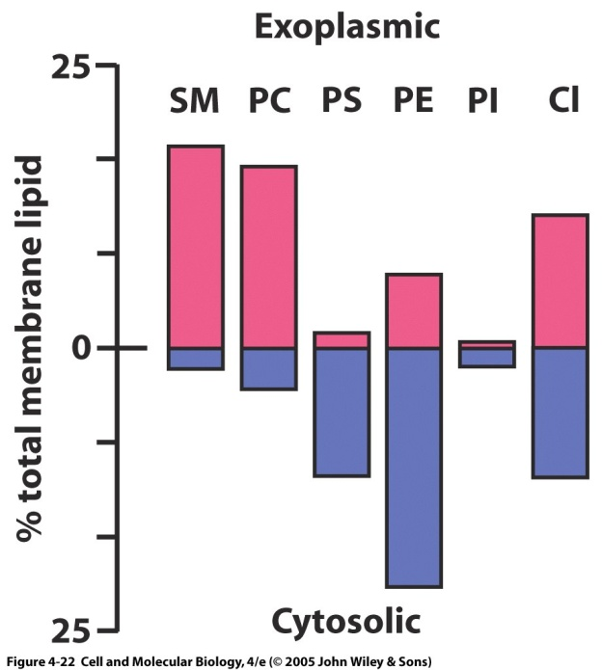
**Glycolipids would be higher on the outer layer if they were on the chart (singalling), however it would still be a very small bar

Properties:

Membrane Fluidity
- membranes need to have a good fluidity to them, can’t be too fluid or not enough fluid
  - fluid nature essential for function
  - fluid reflects
    - C chain length
      - Long=less fluid, short=more fluid
    - Saturation
      - Saturated more pack= less fluid, unsaturated unpack= more fluid
    - Head polarity
      - Less polar PC= less fluid, More polar PE= more fluid
    - Sterols
      - Act as buffers, ridged structure allows more fluidity when cold, and less fluidity when warm
    - Temperature
      - High temp= high fluidity, low temp= low fluidity

Homeoviscous Adaptation
- membrane composition is adjusted according to the temperature to maintain fluidity

Ex. Dietary adjustments of the semi-palmated sandpiper
- flys for 3 days straight over the atlantic ocean
- stop in the bay of fundy to feed on mudshrimp which are high in PUFA (polyunsaturated fatty acids)
- this increases the unsaturated fatty acids in the membranes to increase flight endurance
- easier to fuel the muscles with fatty acids when they are in the membranes

Experiment continued with quails
- quails consumed PUFA rich diet which resulted in a 58-90% increase in aerobic enzyme activities

Concluded:
- dietary lipids regulate membrane fluidity
- mimic effected of endurance training in boosting the aerobic capacity of muscle

Membrane Proteins
- the mosaic component of the fluid mosaic model
- less fluid then lipids (usually anchored to something into or out of the cell)
- functions include
  - transport (moving things across membrane)
  - enzymes (inner mitochondrial membrane for example)
  - signal transuction (detect sensation)
  - attachment/recognition

3 Types:

Integral Membrane Proteins
- Amphipathic with one or more hydrophobic regions
- usually transmembrane (embedded in the membrane and cross right over)
- transmembrane domain regions typically alpha helix of 20-30 hydrophobic aa residues
- mostly carrier proteins
- difficult to remove from membrane without breaking the membrane itself

Peripheral Membrane Proteins
- located on one side or the other
- membrane-asociated through non-covalent interactions
- dynamic relationship with the membrane
- give structure to the membrane a lot (when on the intercellular layer)

Lipid Anchored Membrane proteins
- membrane –assocoiated though covalent linkages to phospholipids
- fatty acid anchored
  - intracellular orientation (extending into the cytoplasm)
- GPI anchor- carbohydrate attached to it
  - Extra cellular orientation
  - Covalent linkage
  - Can be removed by cleaving with an enzyme called phospholipase C (breaks anchor to carbohydrate)

