Review of Macromolecules

Carbohydrates

Polymers of monosaccharides (polysaccharides)
- energy storage (ex. Starch in plants, glycogen in animals)
- structural (ex. Chitin, cellulose)

Monosaccharides
- Cn H2n On (n= 3-7)
- Trioses, pentoses and hexoses most common
- Linear vs. ring configuration
- Asymmetrical C isomers

**minor difference of hydroxyl group decides difference of starch and cellulose being digested**

Glycosidic Bonds
- reaction that occurs between carbon 1 and carbon 4 of adjacent molecule (hydroxyl groups react)
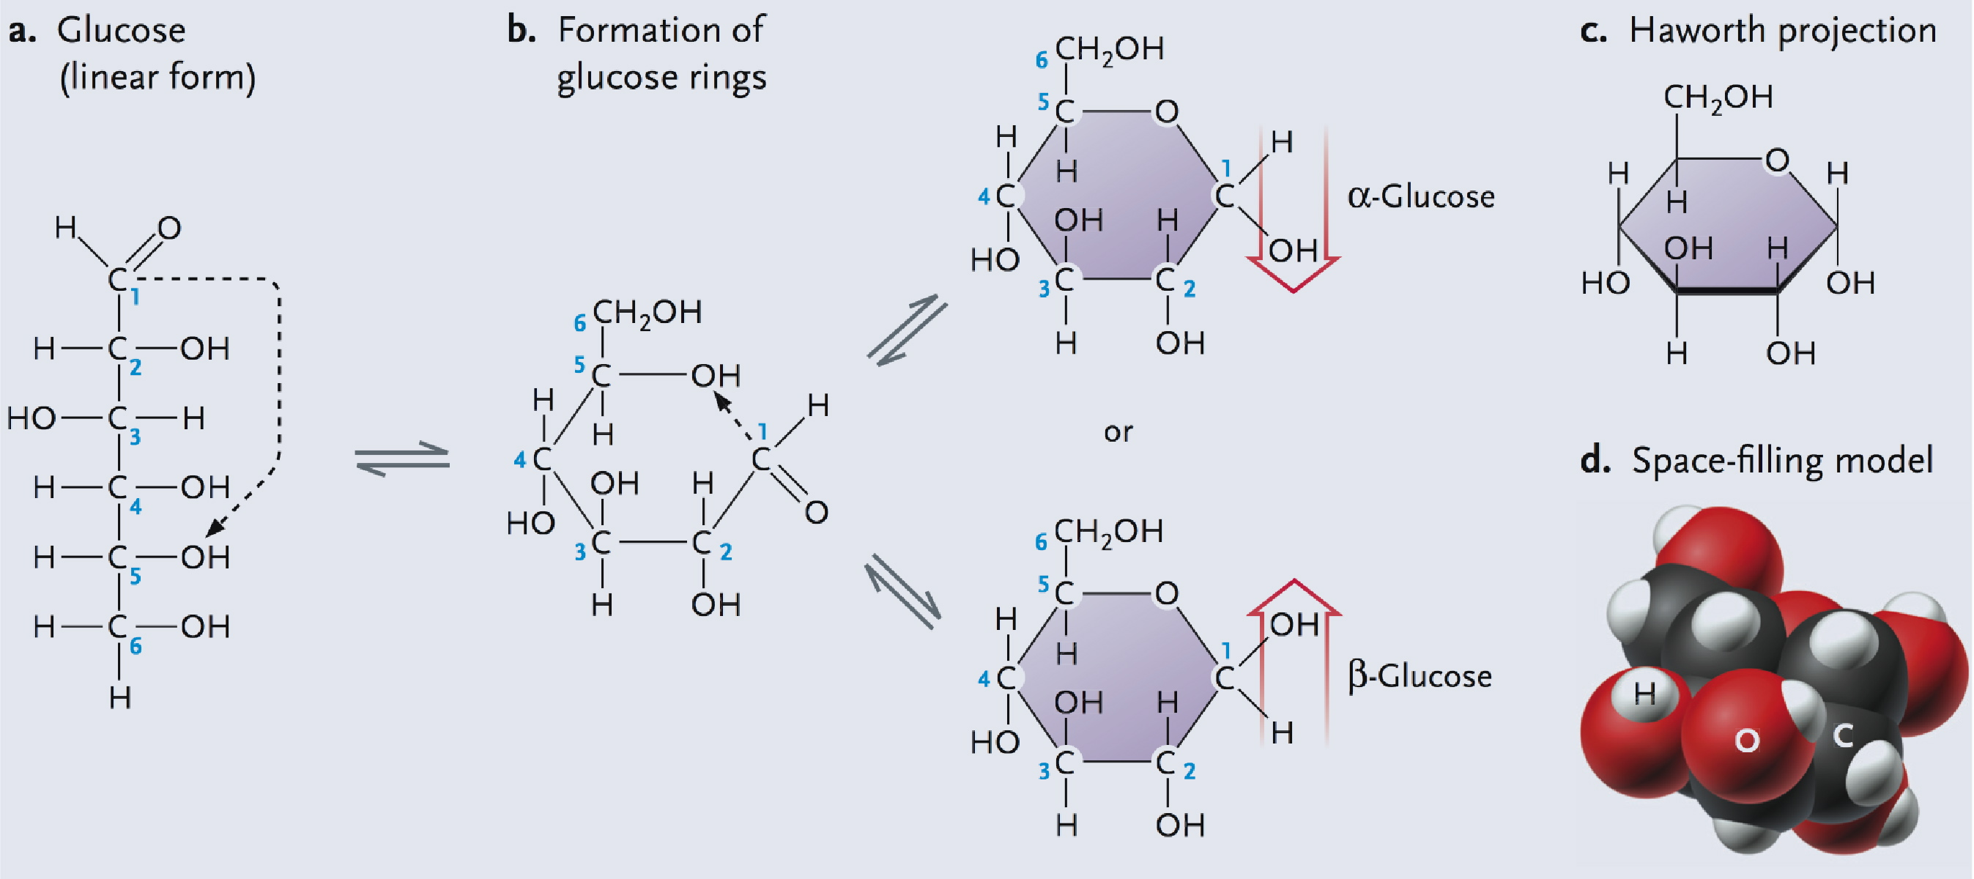
- alpha-D-glucose beta-D-glucose
- “only one form in each cell*
- alpha bonds create starch molecules and can be broken down, however our bodies lack the enzyme to break down beta bonds, therefore cellulose cannot be broken down

Nucleic Acids
- polymers of nucleotides
- informational molecules (type and order of units important to cell)
- DNA vs. RNA (2 types of nucleic acids)
- Contain nucleotides
  - 5 C sugar (ribose or deoxyribose) + nitrogeneous base (connected to carbon 1 on sugar) + phosphate groups
  - Nitrogen Bases consist of Purines (adenine, guanine: double ring) and Pyrimidines (cytosine, thymine and uracil)
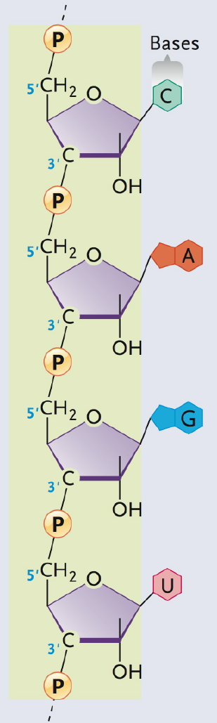
  - Sugar + Nitrogeneous base = Nucleoside

Phosphate group from adjacent nucleotide attach to 5’ prime end, will react with a 3’ carbon of an adjacent sugar (phosphodiester bond) to create a phosphate backbone.
  - Nucleoside
    - adenosine (sugar is ribose) or deoxyadenosine (sugar is deooxyribose)
    - guanosine or deoxyguanosine
    - cytidine or deoxyctidine
    - deoxythymidine
    - uridine
**add mono, di, or tri phosphate to tell how many phosphate groups are added**

RNA single stranded
DNAdouble helix (found by Watson and Crick)

In double helix, nitrogeneous bases line up and form 2 hydrogen bonds between A & T, and 3 hydrogen bonds between G & C.

Proteins
- polymers of amino acids (order matters)
- wide array of functions
  - enzymes (carbonic anhydrase)
  - structural (keratin, collagen)
  - motility (actin)
  - transport in and out of cell (Na+, K+, ATPase)
  - regulatory (transcription factors, hormones)
  - receptors (B-adrenoreceptors)
  - defensive (antibodies)

Amino Acids (protein monomers)
- around 20
- amino acids can be modified after in the protein
- central carbon (theta carbon), assymetric in most cases (symmetric when R group in hydrogen)
  - carboxyl group
  - amino group
  - H atom
  - Side chain (R group)
- cell use L form, polysaccharides uses D form
- R group:
  - Properties of amino acid determined by R group
    - Nonpolar
    - Polar, uncharged
    - Polar, acidic (negative charge)
    - Polar, basic (positive charge)
    - Reactive functional groups

- Common Functional Groups:
Chemical Formula | Name | Properties
-OH | Hydroxyl group | Neutral, polar
-C=O | Carbonyl group | Neutral, polar
-SH | Sulphhydryl group (highly reactive, form disulphide bridges- linking two amino groups through covalent bond) | Neutral, polar
-COOH | Carboxyl group | -ve charge at cellular pH
-PO32- | Phosphate group | -ve charge at cellular pH
-NH2 | Amino group | +ve charge at cellular pH

- Polypeptide
  - Peptide bond
  - N-terminus vs. C-terminus
  - Average 400-500 aa residues (for a typical protein)
  - at one end we have an exposed amino group –amino end (N-terminus), at the other end there will be a carboxyl exposed- carboxyl end (C-terminus)
chain > 50 amino acids = polypeptide; chain < 50 = peptide

- From polypeptide to protein…
  - One or more polypeptides folded into native conformation (the most stable 3-D conformation)–unique sequence, unique native conformation (key to the proteins function)
    - monomeric (single polypeptide)
    - multimeric (more polypeptide chains, example hemoglobin-2 alpha, 2 beta)
      - homomeric (same chains)
      - heteromeric (different chains –like alpha and beta)

- Conformation is dependant on covalent and noncovalent interactions in the backbone and/or R groups
  - Conformational changes
  - Denaturation (loses its biological function (can be from mild changes in pH or ionic strength) causes it to lose its native conformation
- Protein Structure
  - Primary structure
    - aa sequence, 20^n possibilities where n=# aa
  - Secondary structure
    - hydrogen bonding in backbone (forms these bonds)
    - alpha helix (up and down the backbone) vs. Beta pleated sheet (between sections)
    - motifs, e.g. hairpin loop, helix-turn-helix
  - Tertiary structure
    - overall shape or conformation
    - interactions between R groups (forms these bonds)
- disulphide bridge
- hydrogen bonds, ionic bonds, hydrophobic interactions (weak bonds), van der Waals interactions (weak bonds-if you get enough of them they can be important and strong)
- Relative contributions of 2 degrees and 3 degrees?
- fibrous vs. globular proteins
- Disulphide bridge-strong bond that stabilizes tertiary structure
- most develop a globular shape-ones with very extensive tertiary structures that are important, some get a fibrous shapes (typically happens in proteins with very extensive secondary structure that are important- keratin protein structures- alpha helix)
    - Domains
- some have two domains, one upper and one lower. One will bind the substrate, another will bind the costructure, binding them together
- they are at the tertiary level of structure
- within domains, you find smaller units of repeated structure that are analogous to secondary structures (smaller within the larger units)

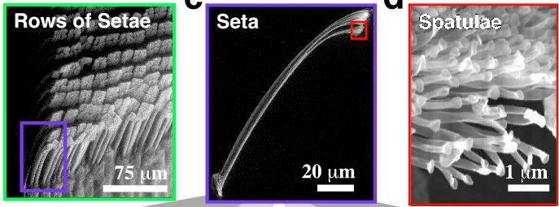

**Geckos use vanderwall forces to walk on walls (have microscopic hairs on their feet, billions of them)**

Quaternary Structure
- interactions of subunits to form multimeric proteins
- multiprotein complexes where individual subunits come together to form a mature protein.

Lipids
- macromolecules
  - not polymers (no repeated unit structure)
  - insoluble in water, soluble in non polar solvents (shared property that groups them together
  - used for energy storage, membrane structure, and signaling
- types
  - 6 main classes
    - fatty acids
      - hydrocarbon chains with carboxyl group
      - 14-22 C’s commonly
      - building blocks of phospholipids
      - amphipathic (one region: hydrophobic-hydrocarbon chain, other region: hydrophilic-carboxyl group)
      - saturated (single bonds) vs. unsaturated (double bonds between adjacent carbons)
    - phospholipids
      - structural components of membranes
      - consist of two fatty acids joined at a polar head group
      - phosphoglycerides: most common in cellular membranes
        - glycerol
        - 2 fatty acids linked covalently to glycerol
        - phosphate attached to 3rd carbon
        - hydrophilic R group
        - amphipathic (phosphate and R group- hydrophilic, while fatty acid and carbon chains are hydrophobic)
    - steroids
      - 4 ringed hydrocarbon skeleton
      - dissolve in organic solvents (not water)
      - only found in eukarotic cells (not in prokaryotes)
      - sterols: most common in cells
        - 4 ringed carbon backbone
        - hydroxyl on one end (hydrophilic)
        - carbon chained tail (hydrophobic)
        - **have both signaling and structural roles
          - Cholesterol (animals)
          - Phyosterols (plants)
          - Ergosterol (fungi)

