CHAPTER 9: DEVELOPING A PERSONAL FITNESS PLAN

7 STEPS OF DEVELOPING A PERSONAL FITNESS PLAN
- Set Goals
- This allows you to track your progress and enjoy measurable changes brought by the program

- 2 types of goals: General (improve posture, lower chronic disease, improve one of the 5 components) & short-term (reduce BMI, increase VO_{2,} number of push-ups)
  - To develop short-term goals, make them SMART (specific, measureable, attainable, realistic, time specific)

- Measure progress every 3 months with physical assessment tests

- Select Activities
  - Include exercises that develop all the health related components of fitness. Select at least one activity per component
    - CR endurance – continuous rhythmic movements of large muscle groups
    - MS&E – training against resistance
    - Flex – stretching the major muscle groups
    - BC – sensible diet with regular exercise including CR and resistance training to balance fat-muscle ratio

  - Cross-training: Using several different activities to develop a particular physical fitness component. – e.g.: cardio = swimming + running + cycling

  - Factors to be considered when selecting activities:
    - Fun & interest
    - Current skill & fitness level
    - Time & convenience
    - Cost
    - Special health needs

  - Skills is an important factor because a beginner might not be able to sustain enough in the activity to develop a fitness component

  - Beginners/those with low fitness should start with activities that require no skill such as walking, jogging, etc. to develop their cardio before trying to better themselves at a skill

- Apply FITT Principle
- Cardio:
  - 150 minutes per week of moderate-intensity physical activity (e.g. brisk walking) or 75 minutes per week of vigorous-intensity activity (e.g. jogging).
  - 3-5 times per week
  - Intensity: note target heart rate zone or RPE
  - Total workout time of 20-60 minutes, in a single session or multiple sessions of 10 or more minutes
  - Calorie cost: way of checking whether the total duration you have set for a cardiorespiratory endurance session is appropriate. It is defined as the amount of energy used to perform a particular activity. It is usually expressed in kcal/min/kg of body weight.
    - Energy Expenditure x Body Weight x Exercise Duration
    - For beginners of cardio, it should be 100-150 kcal per workout. The goal should be about 300 kcal per workout.

- Muscular strength & endurance:
  - At least 2 non-consecutive days per week of strength training
  - 1 or more sets of 8-12 repetitions of 8-10 exercises that work all major muscle groups
  - Intensity: weights that are heavy enough to fatigue while keeping proper form for all repetitions

- Flexibility:
  - When muscles are warm at least 2-3 days per week (ideally 5-7) for all major muscle groups
  - Stretch to point of slight tension or mild discomfort and hold for 15-30 seconds
  - 2-4 repetitions of each exercise

- Set up a System of Mini-Goals & Rewards
- This keeps the program on track because you set specific, short goals for each step that satisfy you as you go. It allows enables better tracking of your progress and boosts your chances of success.

- Break specific goals into several steps, and set a target date for each step. Allow several weeks between mini-goals

- Include Lifestyle Physical Activity in Your Program
- Daily physical activity is simple but important when improving overall wellness.

- Specify ways to be more active during your daily routine.

- Maybe use a health journal to track your activities.

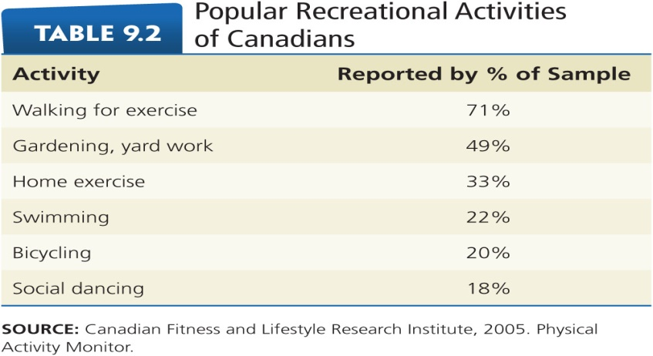

- Develop Tools for Monitoring Your Progress
- This will help you remember your ongoing commitment to your program and give you a sense of accomplishment

- You can graph weekly or monthly progress

- You can reassess cardio, muscular strength and endurance to see overall fitness
- Do it every 3 months or so during improvement phase of program

- Compare results for same assessments over time
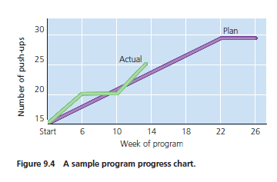

- Make a Commitment
- Final step is to sign a contract that will assist you in your commitment to being physically active.

- Keep it visible to remind you of your commitment and find a witness if possible.

PUTTING YOUR PLAN INTO ACTION
- Start Slowly & Increase Fitness Gradually
- Overzealous exercising can result in discouraging discomfort and injuries

- Once your body has adjusted to your starting level of exercise, slowly increase the amount of overload – small increases are key.

- Increase duration and frequency before intensity

- Find an Exercise Buddy
- Makes exercise more enjoyable and increases your chances of sticking with the program

- Find a partner with similar goals and general fitness level

- Ask for Support from Others
- Leads to greater chance of exercising consistently

- Good communication about importance, etc. will help others become more supportive about time you spend on your workout

- Vary Your Activities
- Make your program more fun over the long term by participating in various activities you enjoy

- Also vary within the activity – take different jogging routes, switch partners

- Cross-training:
  - Reduces risk of injury and overtraining because the same muscles, bones and joins are not continuously subjected to the stresses of the same activity
  - Can be done either by choosing different activities on different days or by alternating activities within a single workout.

- Cycle Duration & Intensity of Your Workouts
- Periodization of training: Athletes vary intensity & duration of workouts

- Exercise lightly sometimes and intensely other times

- Improves fitness quickly and makes the program more varied and enjoyable

- Adapt to Changing Environment & Schedules
- Don’t use outside forces as excuses to drop out of your program

- Expect Fluctuations and Lapses
- Don’t let off days or lapses discourage you. Instead, feel a renewed commitment for your fitness program

- Choose Other Healthy Lifestyle Behaviours
- Choose a nutritious diet, avoid smoking and overconsumption of alcohol, stay hydrated, and sleep well.

EXERCISE GUIDELINES FOR LIFE STAGES
Regular, appropriate exercise is safe and beneficial for many people with chronic conditions such as
- Arthritis
- Asthma
- Diabetes
- Heart disease and hypertension
- Obesity
- Osteoporosis

Children & Adolescents
- Only 7% of Canadian children and youth aged 5-17 are physically active enough to meet Canada’s Physical Activity Guidelines of at least 60 minutes of moderate to vigorous physical activity per day.

- This leads to alarming rates in overweight and obese children and adolescents

- Keep these guidelines in mind for children and adolescents:
- Provide opportunities for physical activity and minimize sedentary activities
- Choose dynamic activities during family outings
- For children under 12, emphasize skill development and fitness
- For adolescents, combine participation and training in lifetime sports with traditional, competitive sports
- Make sure kids are developmentally capable of participating in an activity
- Make sure kids get plenty of water when exercising in heat and dressed properly in the cold

Pregnant Women
- See physician
- Continue mild-to moderate exercise routines (usually 100-160 exercise heart rate)
- Avoid exercising vigorously or to exhaustion, especially during third trimester
- RPE levels of 11-13 are appropriate
- Favour non or low weight bearing exercises
- Avoid exercise on your back that restricts blood flow to the uterus and avoid prolonged periods of motionless standing
- Avoid exercise that could cause loss of balance
- Avoid activities in extremes of pressure
- Drink plenty of fluids and exercise in well-ventilated areas
- Do 3-5 of Kegels daily; tighten for 5-15 seconds. This helps incontinence and post birth recovery
- After birth resume pre-pregnancy exercises routines gradually

Older Adults
- Similar guidelines, with a lower intensity
- Those over 65 should take part in at least 2.5 hours of moderate-to-vigorous intensity aerobic activity each week
- Should add bone and muscle strengthening activities involving major muscle groups at least twice each week
- Should perform flexibility exercises at least 2 days per week for at least 10 minutes
- Exercises that improve balance should be performed 2 days per week
- Drink plenty, dress appropriately, warm up and cool down.

Maintain Your Program: Fit for Life
- Be safe
- Have several exercise options
- Keep an exercise journal
- Reward yourself
- Choose other healthy lifestyle behaviors

SAMPLE PROGRAMS – THEMES
- Equipment and Technique
- Variations leading to CV improvement and when to progress
- Application of fitness principles
- Awareness of health benefits / calories expended
- Adding adequate Muscular + Flexibility exercise to balance and support the activity
- Callisthenic exercise program (circuit)



