CHAPTER 4: MUSCULAR STRENGTH & ENDURANCE

Muscular strength = the amount of force a muscle can produce with a single maximum effort

Muscular endurance = the ability of a muscle or group of muscles to remain contracted (sustain a level of muscular force) or to contract repeatedly

Basic Physiology and the Effects of Strength Training
Muscles move the body and enable it to exert force because they move the skeleton. When a muscle contracts (shortens), it moves a bone by pulling on the tendon that attaches the muscle to the bone. When a muscle relaxes (lengthens), the tension placed on the tendon is released and the bone moves back to its starting position.

Muscle Fibers
- Muscles consist of individual muscle cells, or muscle fibers, connected in bundles

- A single muscle is made up of many bundles of muscle fibres

- Muscle fibres are made up of smaller units called myofibrils. These contain actin and myosin filaments which slide together and contract the fiber

- Strength training increases the number of myofibrils and the size of muscle fibers - hypertrophy

- Inactivity reverses the process – atrophy

- Slow-twitch fibers (red)
  - Fatigue resistant
  - Don’t contract as rapidly and forcefully as fast-twitch fibers
  - Rely primarily on aerobic oxidative energy system

- Fast-twitch fibers (white)
  - Fatigue more quickly than slow-twitch fibers
  - Contract rapidly and forcefully
  - Rely more on non-oxidative energy system

- Intermediate fibers
  - Fatigue, force, fuel system between slow + fast-twitch

- Endurance activities like jogging tend to use slow-twitch fibers

- Strength and power activities like sprinting use fast-twitch fibers

Motor Units
- A motor nerve (that initiates movement) connected to a number of muscle fibers

- When a motor nerve calls on its fibers to contract, all fibers contract to their full capacity

- The number of motor units recruited depends on the amount of strength required

- Strength training improves the body’s ability to recruit motor units – a phenomenon called muscle learning – which increases strength even before muscle size increases

Physiological Effects of Strength/Weight Training
- Increased muscle mass and size of muscle fibers
- Increased utilization and coordination of motor units
- Increased strength of tendons, ligaments, and bones
- Increased storage of fuel in and blood supply to muscles
- Improvements in blood fat levels and biochemical processes
- Increased blood supply to muscles and improved blood vessel health
- Increased muscle endurance

Benefits of Muscular Strength and Endurance
Improved performance of physical activities

Injury prevention (maintaining posture, mechanics)

Improved body composition

Enhanced self-image and quality of life

Improved muscle and bone health with aging

Prevention and management of chronic disease

Metabolic and Heart Health

Assessing Muscular Strength and Endurance
- Muscular strength is assessed by determining repetition maximum (1 RM), the maximum resistance that can be lifted one time.

- Muscular endurance assessed by counting the maximum number of repetitions (or length) of a muscular contraction

Creating a Successful Strength Training Program

Static versus Dynamic Strength Training Exercises
- Static (isometric) exercise
  - Muscle contraction without a change in the length of the muscle or the angle in the joint on which the muscle acts
  - 6 second contractions
  - 5-10 repetitions
  - Don’t develop strength throughout a joint’s full range of motion
  - Useful for strengthening muscles after an injury or surgery

- Dynamic (isotonic) exercise
  - Muscle contraction with a change in the length of the muscle
  - Most valuable for developing strength that can be transferred to other forms of physical activity
  - Can be performed with free weights, weight machines, or a person’s own body weight
  - Two kinds:
    - Concentric contraction - muscle applies force as it shortens
    - Eccentric/plyometric contraction - muscle applies force as it lengthens
  - Types:
    - Constant resistance: constant load throughout a joint’s range of motion (e.g free weights)
    - Variable resistance: changing load to provide maximal resistance throughout a joint’s range of motion (machines)
    - Eccentric loading: placing load on a muscle as it lengthens
    - Plyometrics: sudden eccentric loading and stretching followed by a concentric contraction
    - Speed loading: moving a load as rapidly as possible (e.g. kettlebells)
    - Isokinetic exercise: exerting force at a constant speed against an equal force (specialized machines)

Creating a Successful Weight Training Program
- Choosing equipment: Weight machines vs. free weights
  - Resistance is provided by both types
  - Exercise machines
    - Safer, convenient, and easy to use
  - Free weights
    - Require more care, balance, and coordination
    - Strength transfers to daily activities and sports skills

- Workouts with resistance bands and stability balls also build strength + require / develop other skills

Choosing Equipment
- Workouts with resistance bands and stability balls also build strength + require / develop other skills
- Calisthenic exercises use body weight and positioning to create resistance (push-ups, curl-ups, pilates, yoga, etc.)
- Core training (muscles in torso and upper legs) valuable for body alignment, back health, accurate exercise technique

Applying the FITT Principle

Frequency
- 2-4 days per week
- At least 1 day of rest between workouts
- Split routine – work different muscles on different days

Intensity
- Choose a weight heavy enough to fatigue your muscles but light enough to complete the repetitions in proper form
- Lift weights as heavy as 80% of your RM for strength
- Lift 40-60% of your RM for endurance, for more repetitions
- For both, do about 70% or do sets of both
- Try to select a load that causes the muscle to reach a state of complete fatigue at a given volume (sets + reps
Time
- For heavy weights, do 5-6 repetitions
- For light weights, do 15-20 reps
- For general fitness, try to do 8-12 reps of each exercise (1 set min)
- Older and frailer people should do 10-15 with a lighter weight
- Rest between sets (approx. 1-3 minutes)
- Training volume: total load lifted during weight training: reps x weight x sets

Type
- 8-10 exercises working all major muscle groups
- Balance exercises between agonist and antagonist muscle groups
  - Agonist: muscle that contracts
  - Antagonist: opposing muscle that much relax and stretch to allow the contraction
- Exercise large muscle groups before small one as to not to overload the large ones after

Warm up & Cool down
- Do both a general warm up and lighter muscle exercises
- Cool down 5-10 minutes after by resting and stretching
- Bring up workout if for 2 consecutive workouts you can do 2 more reps

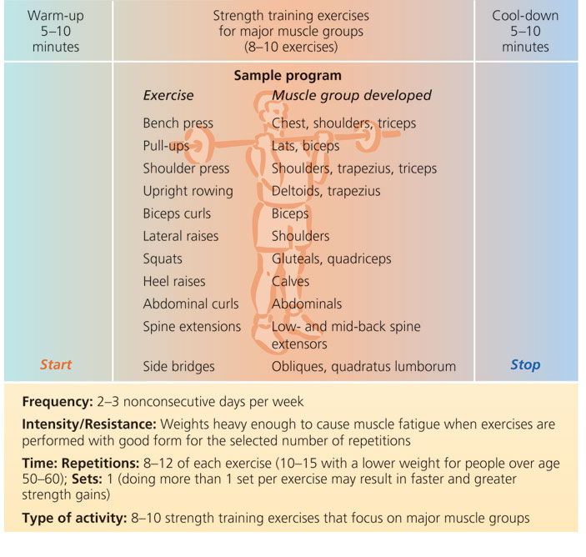

Selecting Exercises
- If training for a particular sport, include exercises to strengthen the muscles important for optimal performance and the muscles most likely to be injured
- Perform exercises involving more than 1 joint (multiple joints) before those that use single joints
- Include strength training for “core” muscles. Core strength links the steps in the kinetic chain of prime movers, assisting muscles, antagonist/cooperating muscles, and stabilizing muscles (or groups of muscles). It’s important to train core muscles which transmit forces and connect upper and lower body actions and stabilize the spine.

More Advanced Strength Training Programs
- Performing more sets of a smaller number of repetitions with a heavier weight
- Cycle training (periodization) by varying type and amount of exercise per workout or per set
- Consult a coach certified by the National Strength and Conditioning Association or another reliable source

Weight Training Safety
- Use proper lifting techniques
- Use spotters and collars with free weights
- Be alert for injuries
- Body position = control your centre of gravity, base of support, and maintain effective body alignment

Signs of Overtraining in Response to Heavy Resistance Training
- Lack of progress
- Decreased performance
- Chronic fatigue
- Decreased coordination
- Chronic muscle soreness
- Treatment: Add more days of recovery (rest) between workouts & more variety to your program.

Muscular Strength & Premature Death Risk Reduction
- Strong scientific evidence of positive long term health impact of muscular strength training.
- Positive impact at all ages, increases with age.
- Decreased risks in all areas: CVD, Diabetes, Cancer,
- Inverse relationship between muscular strength and metabolic syndrome.
- Benefits of combined cardio/muscular training still evident.
Gender Differences
- Greater strength of the average male primarily the result of larger mass and muscle size
- Differences greater in upper body
- Only 1-2% difference when cross sectional area is accounted for
- Strength per kg
- Differences in muscular power and strength explained by testosterone levels, and neural activation speed
- Hormonal differences limit potential amount of growth due to training
- Issues relating to loss of lean muscle mass
- Osteoporosis
- Elderly females and functional impairment

Training Suggestions
- Circuits
- Varying volume and load
- Exercise modifications
- Working with a partner
- Rest a crucial factor in making progress

Supplements & Drugs
- Some supplements can be taken when the goal is to increase muscle growth
  - E.g. steroids, proteins, amino acids (last 2 are metabolic optimizing meals)
- There is no need for extra protein intake when weight training
- Side effects of anabolic steroids:
  - Liver damage and tumors
  - Reduced HDL
  - High blood pressure, heart disease, cancer
  - Depressed immune function
  - Psychological disturbances
  - Depressed sperm and testosterone production; breast development in males
  - Masculinization in women and children
  - Premature closure of bone growth centers
- Some supplements can be taken to speed recovery from training
- Some can be used to increase training intensity and overcome fatigue (e.g. amphetamines, caffeine)
- Some can be taken to increase endurance
- Some are taken to aid weight control
- Remember:
  - Do you need a supplement at all?
  - Is the product safe and effective?
    - What studies have been done?
    - What has the research shown?
  - Can you be sure that the specific product is of high quality?

Natural Health Products
- Regulated since 2004 by Health Canada
- NHPs cannot be also classified as controlled substances and drugs
- Licensed NHPs distributors can make health claims, must monitor themselves.

