CHAPTER 3: CARDIORESPIRATORY ENDURANCE

Basic Physiology of Cardiorespiratory Endurance Exercise

The Cardiorespiratory System
Consists of the heart, the blood vessels, and the respiratory system (air passages, trachea, bronchi, and lungs) This system circulates blood through the body, transporting oxygen, nutrients, and other key substances to the organs and tissues that need them. It also carries away waste products so they can be used or expelled.

The Heart
Four-chambered, fist-sized muscle located just beneath the ribs under the sternum (breast-bone). Its role is to pump oxygen-poor blood to the lungs and oxygenated blood to the rest of the body.

Blood actually travels through two separate circulatory systems:
- Ride Side: pumps blood to the lungs in what is called pulmonary circulation
- Left Side: pumps blood through the rest of the body in systemic circulation.
Total circulation goes from the upper right atrium, to the lower right ventricle, to the lungs, to the upper left atrium, down to the lower left ventricle, through the aorta (body’s largest artery), to the body.

The period of the heart’s contraction is called systole and the period of relaxation is called diastole. Blood pressure, the force exerted by blood on the walls of the blood vessels, is created by the pumping action of the heart. Blood pressure is greater during systole than during diastole. Normal blood pressure readings for a young, healthy male are approx. 120 mm Hg (systolic) and 80 mm Hg (diastolic). Women typically display blood pressure readings that average 10 to 20 mm Hg below men (likely related to height – higher in taller individuals).

The heartbeat – the split-second sequence of contractions of the heart’s four chambers – is controlled by nerve impulses. These signals originate in a bundle if specialized cells in the right atrium called the pacemaker or sinoatrial node.

The Blood Vessels
Classified by size & function:
- Veins: carry blood to the heart
  - Thin walls

- Arteries: carry blood away from the heart
  - Thick elastic walls that enable them to expand and relax with the volume of blood being pumped through them

- Capillaries: very small blood vessels (one cell thick) that deliver oxygen and nutrient rich blood to the tissues and pick up oxygen-poor, waste-laden blood.

- Coronary arteries: two large vessels (right and left) that branch off the aorta and supply the heart muscle with oxygenated blood. (Blocking of a coronary artery is a leading cause of heart attacks)

The Respiratory System
- Supplies oxygen to the body and carries off carbon dioxide – a waste product of body processes – and helps regulate acid produced during metabolism.

- Air passes in and out of the lungs as a result of pressure changes brought about by the contraction and relaxation of the diaphragm and rib muscles. As air is inhaled, it passes through the nasal passages, throat, larynx, trachea (windpipe), and bronchi into the lungs.

- Alveoli: tiny, thin-walled air sacs in the lungs through whose walls gases such as oxygen and carbon dioxide diffuse in and out of the blood. These gases are exchanged between alveoli and capillaries in the lungs. Carbon dioxide passes from blood cells into the alveoli, where it is carried up and out of the lungs (exhaled)

- The lungs expand and contract about 12-20 times a minute at rest

The Cardiorespiratory System at Rest and During Exercise
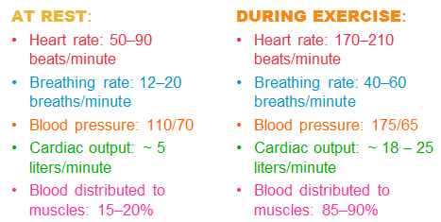

- During exercise, the heart’s stroke volume increases (heart pumps out more blood each beat)

Energy Production
- Metabolism: the sum of all chemical processes necessary to maintain the body
  - Metabolic rate: rate at which your body uses energy. (increases during physical activity)

Energy from Food
- The body converts chemical energy from food into substances that cell can use as fuel. These fuels can be used immediately or stored for later use. The body’s ability to store food is critical.

- 3 classes of energy-containing nutrients:
  - Carbohydrates
    - During digestion, most are broken down into the simple sugar glucose
    - Some glucose remains circulating in the blood and can be used as a quick source of fuel to produce energy
    - Glucose can be converted to glycogen and stored in the liver, muscles, and kidneys.
    - If glycogen stores are full and the need for immediate energy is met, remaining glucose is converted to fat
  - Fats
    - Excess energy from dietary fat is stored as body fat
  - Proteins
    - Used primarily to build new tissue, but it can be broken down for energy or incorporated into fat stores
    - Only a significant energy source when the others are lacking

ATP: The Energy ‘Currency’ of Cells
Adenosine Triphosphate
- When a cell needs energy, it breaks down ATP, a process that releases energy in the only form the cell can use directly.

- Cells store a small amount of ATP; when they need more, they create it through chemical reactions that utilize the body’s stored fuels – glucose, glycogen, and fat.

- When you exercise, your cells need to produce more energy so your body mobilizes its store of fuel to increase ATP production

The Immediate (Explosive) Energy System
- Provides energy rapidly but only for a short period of time.

- Used to fuel activities that last for about 10 or fewer seconds

- The components of this system include existing cellular ATP stores and creatine phosphate, a chemical that cells can use to make ATP.

The Non-Oxidative (Anaerobic) Energy System
- Used for high-intensity activities lasting for about 10 seconds to 2 minutes

- Creates ATP by breaking down glucose and glycogen

- Anaerobic system - does not require oxygen to produce energy

- Capacity to produce energy is limited, but it can generate a lot of ATP in a short period of time

- Most important energy system for intense exercise

- Three limiting factors:
  - Body’s supply of glucose is limited – feeling faint
  - Increases in hydrogen and potassium ions cause fatigue
  - Creates metabolic acid

- Exercise training increases the body’s ability to cope with metabolic acid. Improved fitness allows you to exercise at higher intensities before the abrupt build-up of metabolic acids – a point called lactate threshold

- One metabolic acid, called lactic acid is often linked to fatigue during intense exercise. However, it is an important fuel at rest and during exercise.

The Oxidative (Aerobic) Energy System
- Used during any physical activity that lasts longer than about 2 minutes

- Aerobic system - requires oxygen to generate ATP

- Cannot produce energy as quickly as the other two systems, but it can supply energy for much longer periods of time.

- In this system, ATP production takes place in cellular structures called mitochondria. Because this can use carbohydrates or fats to produce ATP, the body’s store of fuel for this system are much greater than those for the other two.

- Carbohydrates are favoured during more intense exercise (over 65% max capacity) and fats are favoured for mild, low-intensity activities.

- During a prolonged exercise session, carbs are the predominant fuel at the start of the workout, but fat utilization increases over time

- Fit individuals use a greater proportion of fat as fuel because increased fitness allows people to do activities at lower intensities. This is an important adaption because glycogen depletion is one of the limiting factors for the oxidative energy system – thus, a fit individual can exercise longer before glycogen is depleted and muscles become fatigued.

- Oxygen is another limiting factor. The oxygen requirement of this energy system is proportional to the intensity of exercise.
- There is a limit to the body’s ability to increase oxygen use; maximal energy consumption, or VO_{2max.} This is influenced by genetics, fitness status, gender and age. Depends on many factors, such as the capacity of blood to carry oxygen, the rate at which oxygen is transported to the tissues, and the amount of oxygen that cells extract from the blood.

- VO_{2max} determines how intensely a person can perform endurance exercise and for how long, and it is considered the best overall measure of the capacity of the cardiorespiratory system

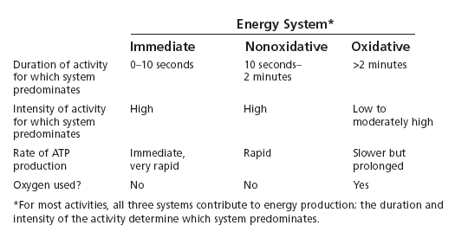

Physical Fitness & Energy Production
- Unfit people cannot increase their metabolic rate substantially or generate the energy need for powerful or sustained exercise.
  - They are less capable of delivering oxygen and fuel to exercising muscles
  - They can’t burn as many calories during or after exercise
  - They are less able to cope with lactic acid and other substances produced during intense physical activity that contribute to fatigue
  - They become fatigued more rapidly

- When designing an exercise program, focus on the energy system most important to your goals. Because improving the functioning of your cardiorespiratory system is critical to overall wellness, endurance exercise that utilizes the oxidative energy system is important.

Benefits of Cardiorespiratory Endurance

Improved Cardiorespiratory Functioning
- In the short-term, the body responds better to the challenge of exercise.

- In the long-term, permanent adaptions are made. These improvements reduce the effort required to do everyday tasks and make the body better able to respond to physical challenges.

- Endurance exercise enhances the heart’s health by:
  - Maintaining or increasing the heart’s own blood and oxygen supply
  - Increasing the heart’s muscle function, so it pumps more blood per beat. This keeps the heart rate overall lower.
    - The resting heart rate of a fit person is often 10-20 bpm lower than that of an unfit person
  - Strengthening the heart’s contractions and thus participating in an increase in overall cardiac output
  - Increasing the heart’s cavity size in young adults
  - Increasing blood volume so the heart pushes more blood intro the circulatory system during each contraction
  - Reducing blood pressure

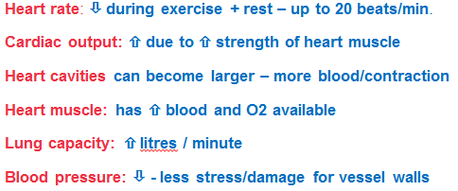

Improved Cellular Metabolism
- Regular endurance exercise improves the body’s metabolism, down to the cellular level, enhancing your ability to produce and use energy efficiently

- Fitness programs that best develop metabolic efficiency include both long-duration, moderately intense endurance exercise and brief periods of more intense effort

- Cardio training improves metabolism by doing the following:
  - Increasing the number of capillaries in the muscles. This supplies the muscle with more fuel and oxygen and eliminates more quickly waste products. Greater capillary density also helps heal injuries and reduces muscle aches.
  - Training muscles to make the most of oxygen and fuel so they work more efficiently
  - Increasing the size and number of mitochondria in muscle cells, increasing cells’ energy capacity
  - Preventing glycogen depletion and increasing the muscles’ ability to use lactic acid and fat as fuels
  - Protecting your cells from chemical damage by agents called free radicals.
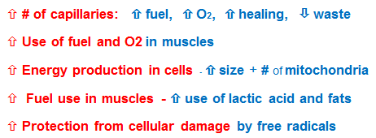

Reduced Risk of Chronic Disease
- Cardiovascular disease. Cardiorespiratory endurance lowers your risk of CVD by doing the following:
  - Promoting a healthy balance of fats in the blood. Exercise raises levels of ‘good cholesterol’ (HDL) and lowers levels of ‘bad cholesterol’ (LDL)
  - Reducing blood pressure
  - Enhancing the function of the cells that line the arteries (endothelial cells)
  - Reducing inflammation
  - Preventing obesity and type 2 diabetes

- Cancer
  - Exercising reduces the risk of colon cancer and possibly reduces the risk of breast and reproductive organs cancer in women

- Type 2 Diabetes
  - Exercise metabolizes (burns) excess sugar and makes cells more sensitive to the hormone insulin, which is involved in the regulation of blood sugar levels
  - It also helps curb obesity, factor in type 2 diabetes
  - Exercise improves control of blood sugar levels in people with the disease

- Osteoporosis
  - Disease that results in loss of bone density and poor bone strength
  - Affects women especially

  - Weight-bearing exercises help build bone during teens and twenties
  - Exercise promotes denser bones & lessens risk of injury

- Death from All Causes
  - Physical inactivity is as important as a risk factor as smoking, high blood pressure, obesity, and diabetes

Better Control of Body Fat
- Endurance exercise burns calories directly, and, if intense enough, continues to do so by rising resting metabolic rate for several hours following an exercise session. A higher metabolic rate means that it is easier for a person to maintain a healthy weight or to lose weight.

Improved Immune Function
- Immune system: physiological processes that protect us from disease

- Moderate endurance exercise boosts immune function, whereas overtraining depresses it

- Physically fit people get fewer colds and upper respiratory tract infections

- Exercise affects immune function by influencing levels of specialized cells and chemicals involved in the immune response

- It can also be strengthened by eating well, managing stress and sleeping properly.

Improved Psychological and Emotion Well-Being
- Participating in regular endurance exercise leads to social, psychological and emotional benefits.
  - Enhanced self-image
  - Socialization
  - Fun
  - Lessening of anxiety, depression, stress, anger, etc.
  - Improved mood
  - Improved sleep

Combining Muscular and Cardiovascular Exercise
- Counterproductive in terms of performance?
- Risks associated with long term high intensity strength training
- Benefits of a combined approach

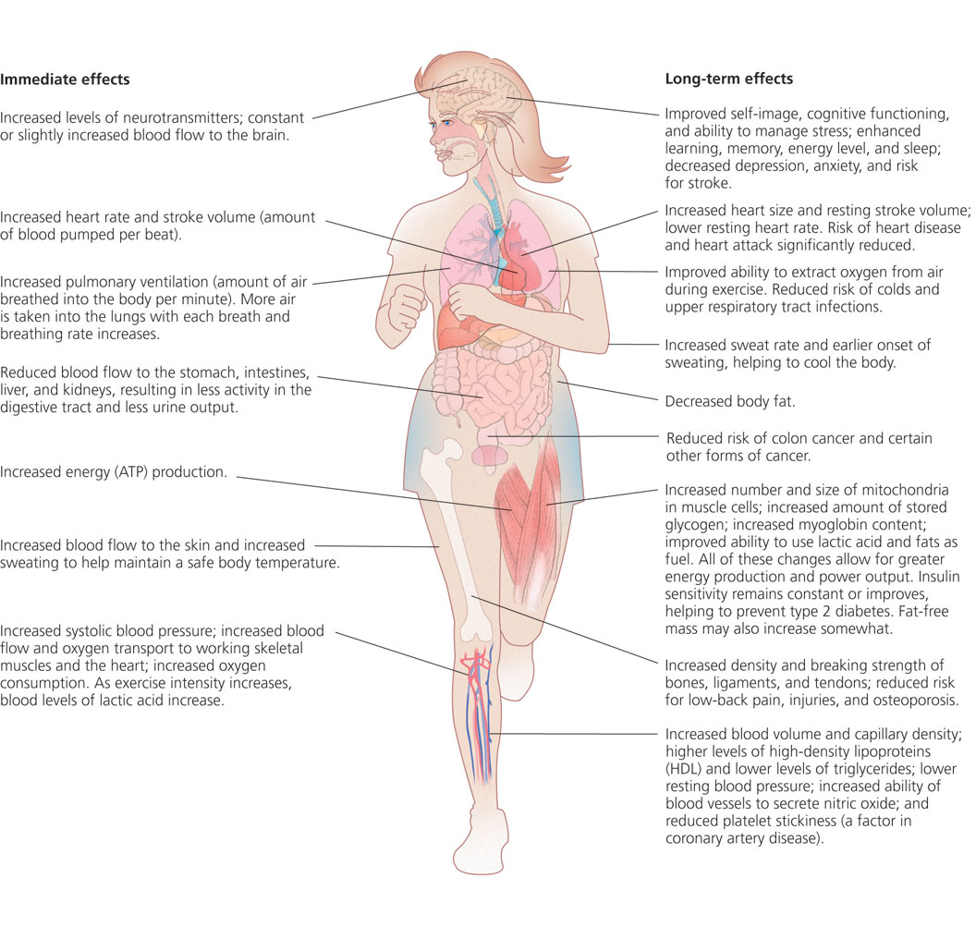
Assessing Cardiorespiratory Fitness
- The best quantitative measure of cardiorespiratory endurance is maximal oxygen consumption, expressed as VO_{2max,} the amount of oxygen the body uses when a person reaches maximum ability to supply oxygen during exercise (measured in ml of oxygen used per minute for each kg of body weight)

- Maximal oxygen consumption can also be measured precisely in a lab but it is expensive and time-consuming

- Several assessment tests provide estimates within 10-15% of lab results

Choosing an Assessment Test
- 1.6 km walk test: amount of time it takes to walk 1.6 km and heart rate at the end of the walk
- 3-minute step test: step continually then monitor heart rate during recovery
- 2.4 km run-walk test: amount of time
- Leger’s 20m shuttle run: try to reach higher stages (like beep test)
- Enhanced creativity and intellectual functioning test

Monitoring Your Heart Rate
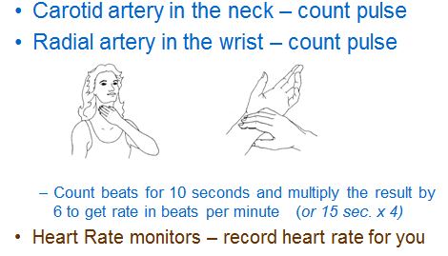
Developing a Cardiorespiratory Endurance Program
- SMART goals
- Set your starting frequency, intensity, and duration at appropriate levels
- Choose suitable activities
- Warm up and cool down
- Adjust your program as fitness improves

Setting Goals
- Use results of assessment tests to set a specific oxygen consumption goal

- Through endurance training, an individual might be able to improve maximal oxygen consumption by about 10-30%

- You can also monitor progress with resting heart rate, it should decrease by 10-15 bpm after about 4-6 weeks of training

- You can also set time/distance goals, or minimum time per week spent training

- Include qualitative goals such as sleeping better or having more energy

Applying the FITT Equation
- Frequency: at least 150 minutes of moderate to vigorous physical activity
  - Distributed 3-5 times a week

- Intensity
  - Target heart rate zone: 65-90% of your maximum heart rate (220-age times percentage). Start at lower percentage if unfit.
  - Ratings of perceived exertion: subjective perception
  - Talk test: are you too winded to be able to talk?
  - Heart Rate Reserve – alternative method for calculating target heart rate – the difference between maximum heart rate and resting heart rate
    - Using this method, target heart rate is equal to resting heart rate plus between 50% (40% for very unfit people) and 85% of heart

- Time/Duration: total duration of 30-60 minutes
  - Can take place in a single session or in multiple sessions lasting 10 minutes or more
  - 45-60 minutes for low intensity, 20 for high
  - Longer duration, low-to-moderate intensity activities generally result in more gradual gains in maximal oxygen consumption

- Type: activities that include the rhythmic use of large muscle groups for an extended period of time

Warming Up & Cooling Down
- Warming Up (usually 5-10 minutes)
  - Muscles work better when warmed up – enhanced performance and lower risk of injury
  - Increase heart rate gradually, raise body temp.
  - Redirect blood flow to working muscles
  - Spread synovial fluid within joints, preventing injuries to their surface
  - Includes low intensity whole-body movements similar to those in the activity that will follow
  - Don’t stretch, it increases the energy cost and interferes with muscle and joint receptors

- Cooling Down (usually 5-10 minutes)
  - Blood flow and respiration return to normal
  - Relaxation for muscles
  - Decrease intensity gradually during cool-down

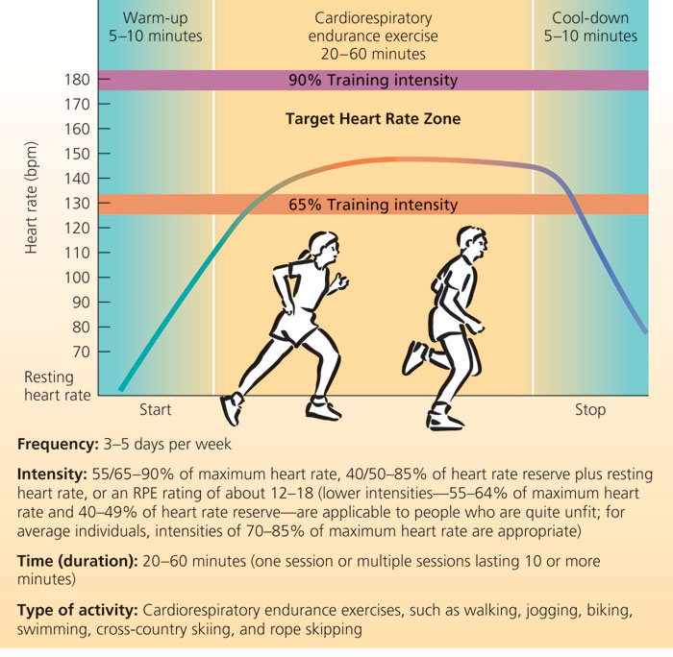

Building Cardiorespiratory Fitness
- Rate of improvement depends on age, health status, initial level of fitness, motivation and genetics.

- Initial phase (1–4 weeks):
  - 3–4 days per week
  - Low end of target HR zone
  - 20–30 minutes

- Improvement phase (1–6 months):
  - 3–5 days per week
  - Middle to upper end of target HR zone
  - 25–40 minutes duration.
  - Increase 5–10 min. every 2–3 weeks

Maintaining Cardiorespiratory Fitness
- Continue to exercise at the same intensity on 3 non-consecutive days per week
- If you have to stop, start the program again at a lower level
- Cross-training maintains motivation and reduces injury (+ expands specific and general physical benefits and activity skills)

Exercise Safety and Injury Prevention

Heat
- Use caution in high heat or humidity (over 25°C and/or 60% humidity); lower your intensity and/or add rest breaks
- Exercise morning or evening
- Drink plenty of fluids; check weight before and after exercise
- Avoid supplements and beverages containing stimulants
- Wear clothing that “breathes”
- Slow down or stop if you feel uncomfortable
- Dehydration: excessive loss of fluid
- Hyponatremia: excessive consumption of fluids
- Heat cramps: sudden development of muscle spasms and pain
- Heat exhaustion: heat illness related to dehydration from exertion in hot weather

Cold
- Hypothermia: low body temperature due to exposure to cold conditions
- Frostbite: freezing of body tissues characterized by pallor, numbness, and a loss of sensation
- Prevention:
  - Don’t stay out in very cold temperatures (consult wind chill values)
  - Wear appropriate clothing - layers + breathable

Poor Air Quality
- Poor air quality can decrease exercise performance; it especially affects those with respiratory problems
- Do not exercise outdoors during a smog alert or if air quality is poor

Injuries
- Consult a Physician for serious injuries + those that do not improve within a reasonable amount of time
- Managing minor exercise injuries: (P)RICE(S)
  - Physician (consult for diagnosis, treatment)
  - Rest
  - Ice
  - Compression
  - Elevation
  - Support (taping, etc.) if needed when resuming activity

