CHAPTER 2: BASIC PRINCIPLES OF PHYSICAL FITNESS

Physical Activity and Exercise for Health and Fitness
Canadian Activity Levels
Overall, 52.5 % are moderately active, but two thirds agree that leading a healthy lifestyle can lead to long-term health benefits.
Contributing factors:
- Gender
  - Women of all age groups are less likely to be physically active than men and the older women become, the wider the gap between the genders
- Age
- Income level
  - Those with higher incomes are more likely to be at least moderately active than those with lower incomes

Possible Barriers to Increased Activity
- Lack of time and resources
- Social and environmental influences
- Lack of motivation and commitment
- Fear of injury (although the risks of inactivity are greater than that of activity)

Physical Activity on a Continuum
Physical activity is essential to health and confers wide-ranging health benefits, but exercise is necessary to significantly improve physical fitness

Physical Activity: Any body movement carried out by the skeletal muscles and requiring energy. Different types of physical activity can vary by ease of intensity. These movements can include participation in sport-based, leisure, or work-related activities.

Exercise: Planned, structured, repetitive movement of the body designed to improve or maintain physical fitness

Physical Fitness: a set of physical attributes that allows the body to respond or adapt to the demands and stress of physical effort – to perform moderate-to-vigorous levels of physical activity without becoming overly tired.
Levels of fitness depend on such physiological factors as the heart’s ability to pump blood and the energy-generating capacity of the cells. These factors depend of genetics (a person’s inborn potential for physical fitness) and behavior (getting enough physical activity to stress the body and cause long-term physiological changes.

Lifestyle Physical Activity for Health Promotion
Canadian Physical Activity Guidelines:
- Children aged 5-11 and youth aged 12-17 should accumulate at least 60 minutes of moderate-to-vigorous intensity physical activity daily.
- Adults aged 18+ should accumulate at least 150 minutes of moderate-to-vigorous intensity aerobic physical activity per week, in bouts of 10 minutes or more.
  - Expend about 150 calories—equivalent to 30 minutes of brisk walking—on most days
  - Participate in muscle and bone strengthening activities

Health Canada:
- Recommends all Canadians expend an average of 3.0 kcal/kg/day for optimal health benefits
  - This average expenditure can be accomplished by engaging in endurance, flexibility, and strength activities

Lifestyle Physical Activity for Health Promotion + Weight Management
- Engage in 60 or more daily minutes of activity to prevent unhealthy weight gain
- Engage in 60-90 daily minutes of activity to maintain weight loss

Exercising to Develop Physical Fitness
- Lifestyle physical activity improves health but may not improve fitness (issues of “overload” must be considered - what level of overload will cause adaptation?)
- A structured, formal exercise program improves physical fitness and provides even greater health improvements

How Much Physical Activity is enough?
The amount of activity needed depends on an individual’s health status and goals. People should exercise long and intensely enough to improve physical fitness. Regular physical activity, regardless of the intensity, makes you healthier and can help protect you from many chronic diseases. Although you get many health benefits of exercise simply by being more active, you obtain even more benefits when you are physically fit. In addition to the long term health benefits, fitness also significantly contributes to quality of life.

- Moderate-intensity versus high-intensity exercise
- Continuous versus intermittent exercise
- Low-intensity exercise improves health but may not be very beneficial for improving physical fitness

Benefits of Exercise on Brain Health
- Improves cognitive function
- Neutralize negative effects of poor nutrition
- Neurogenesis
- Neuroplasticity
- Delayed onset of disease
- Mental health contributor

Examples of (Moderate) Physical Activity
Moderate physical activity is good for the CV system, muscular system, body composition and stress management.
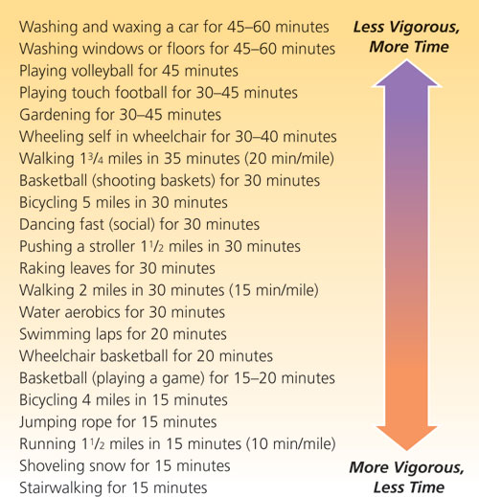

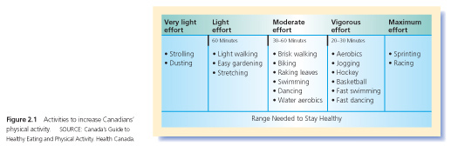

Health-Related Components of Physical Fitness
Health-related fitness contributes to your capacity to enjoy life, helps your body withstand physical and physiological challenges, and protects you from chronic disease.

Cardiorespiratory Endurance: the ability of the body to perform prolonged, large-muscle, dynamic exercise at moderate-to-high levels of intensity.
Depends on the following factors:
- Ability of the lungs to deliver oxygen from the environment to the bloodstream
- Capacity of the heart to pump blood
- Ability of the nervous system and blood vessels to regulate blood flow
- Capability of the body’s chemical systems to use oxygen and process fuels for exercise

Series of Steps
Each becomes more efficient (greater volume + faster speed = VO₂)
- Air in
- O₂ extracted
- O₂ transferred to blood
- O₂ sent to heart
- O₂ pumped out to tissues in blood
- O₂ extracted from blood
- O₂ used by tissues

When levels of cardiorespiratory fitness are low, the heart has to work very hard during normal daily activities and may not be able to work very hard enough to sustain high-intensity physical activity in an emergency. As cardiorespiratory fitness improves, related physical functions also improve:
- Heart pumps more blood per heartbeat
- Resting heart rate slows
- Blood volume increases
- Bloody supply to tissues improves
- The body can cool itself better
- Resting blood pressure decreases

Endurance training also improves the functioning of the chemical systems, particularly in the muscles and liver, thereby enhancing the body’s ability to use energy supplied by food and to do more exercise with less effort from the oxygen transport system.

Poor cardiorespiratory fitness is linked with;
- Type 2 diabetes
- Colon cancer
- Stroke
- Depression
- Anxiety

A moderate level of cardiorespiratory fitness can even help compensate for certain health risks, including excess body fat: People who are lean but who have low cardiorespiratory fitness have been found to have higher death rates than people with higher levels of body fat who are otherwise fit.
You can develop cardiorespiratory endurance through activities that involve continuous, rhythmic movements of large-muscle groups, such as the legs. Such activities include walking, jogging, cycling, and aerobic dancing.
Muscular Strength: the amount of force a muscle can produce with a single maximum effort (1 Repetition Maximum (RM) =100 % effort)
It depends on factors such as the size of muscle cells and the ability of nerves to activate muscle cells. Muscles keep the skeleton in proper alignment, preventing back and leg pain and providing the support necessary for good posture.
Muscle tissue is an important element of overall body composition. Greater muscle mass means a higher rate of metabolism (the sum of all vital processes by which food energy and nutrients are made available to and used by the body) and faster energy use. It can also help with stress and self-confidence.
Maintaining strength and muscle mass is vital for healthy aging. Older people tend to experience a decrease in both number and size of muscle cells: a condition called sarcopenia. Many of the remaining muscle cells become slower, and some become non-functional because they lose their attachment to the nervous system. Strength training (resistance/weight training) helps maintain muscle mass and function and possibly helps decrease the risk of osteoporosis (bone loss) in older people, which greatly enhances their quality of life and prevents life-threatening injuries.

Muscular Endurance: Ability to resist fatigue and sustain a given level of muscle tension – that is, to hold a muscle contraction for a long period of time or to contract a muscle over and over again.
It depends on such factors as the size of muscle cells, the ability of muscles to store fuel, and the bloody supply to muscles.
Muscular endurance is important for good posture and injury prevention. Good muscular endurance in the trunk muscles is more important than muscular strength for preventing back pain.
Muscular endurance helps people cope with daily physical demands and enhances performance in sports and work

Flexibility: Ability to move the joints through their full range of motion. (Joint structures and functions vary, so have different ranges and types of movements)
It depends on joint structure, length and elasticity of connective tissue, and nervous system activity.
Flexible, pain-free joints are important for health and well-being. Inactivity causes the joints to become stiffer with age. Stiffness, in turn, often causes older people to assume unnatural body positions that can stress joints and muscles. Stretching exercises can help ensure a healthy range of motion for all major joints.

Body Composition: The proportion of fat and fat-free mass (muscle, bone, and water) in the body.
Healthy body composition involves a high proportion of fat-free mass and an acceptably low level of body fat, adjusted for age and gender. A person with excessive body fat, especially fat in the abdomen, is more likely to experience the following health problems and more:
- Heart disease
- Insulin resistance
- High blood pressure
- Stroke
- Joint problems
- Type 2 diabetes
- Gallbladder disease
- Blood vessel inflammation
- Some types of cancer
- Back pain.

Fat is needed, but is not a working tissue. The best way to lose fat is through a lifestyle that includes a sensible diet and exercise. The best way to add muscle mass is through resistance training. Large changes in body composition aren’t necessary to improve health; even a small increase in physical activity and a small decrease in body fat can lead to substantial health improvements.

Skill-Related Component of Fitness (tends to be sport-specific)
- Speed (movements in short periods of time)
- Power (exerting force rapidly, strength/speed)
- Agility (quickly and accurately changing body positions)
- Balance
- Coordination (accurate motor tasks and smooth body movements w/ senses)
- Reaction time

Principles of Physical Training: Adaptation to Stress

Specificity: The training principle that the body adapts to the particular type and amount of stress placed on it.
The body adapts to the particular type and amount of stress placed on it. The greater the demands made on it, the more it adjusts to meet those demands. Over time, immediate, short-term adjustments translate into long-term changes and improvements. To develop a particular fitness component, one must perform exercises specifically designed for that component. The goal of physical training is to produce these long-term changes and improvements in the body’s functioning. Some transfer is possible, but incomplete – will not produce equal effectiveness.
Specificity also applies to the skill-related fitness components.
A well-rounded exercise program includes exercises geared to each component of fitness, to different parts of the body, and to specific activities or sports.

Progressive Overload / Adapting to Amount of Training
Placing increasing amounts of stress/overload on the body causes adaptations that improve fitness. Progression is critical.
The amount of overload is very important. Too little will have no effect, and too much might cause injury or problems with the immune system or hormone levels. The point where it is too much is highly individual. For every type of exercise, there is a training threshold at which fitness benefits begin to occur, a zone within which maximum fitness benefits occur, and an upper limit of safe training.

The amount of exercise needed depends on:
- The individual’s current level of fitness
- The person’s genetically determined capacity to adapt to training
- His or her fitness goals
- The component being developed

Beginners should start at the lower end of the fitness benefit zone and fitter individuals at the higher end of the fitness benefit zone. Progression is critical because fitness increases only if the volume and intensity of the workouts increase. Exercising at the same intensity every training session will maintain fitness but will not increase it, because the training stress is below the threshold required to produce adaptation.

FITT Principle
The amount of overload needed to maintain or improve a particular level of fitness for a particular fitness component is determined through four dimensions, represented by the acronym FITT: Frequency, Intensity, Time, and Type.

Frequency: How often?
Developing fitness requires regular exercise. Optimum exercise frequency, expressed in number of days per week, varies with the component being developed and the individual’s fitness goals. For most people, a frequency of 3-5 days per week for cardiorespiratory endurance exercise and for resistance and flexibility training should be the goal of a general fitness program.
An important consideration in determining appropriate exercise frequency is recovery time, which is also highly individual and depends on factors such as:
- Training experience
- Age
- Intensity of training
Intense workouts need to be spaced out during the week to allow sufficient recovery time. On the other hand, you can exercise every day if your program consists of moderate-intensity exercise.

Intensity: How Hard?
Fitness benefits occur when a person exercises harder than his or her normal level of activity.
To develop cardiorespiratory endurance, a person must raise his or her heart rate above normal.
To develop muscular strength, one must lift a heavier weight than normal.
To develop flexibility, one must stretch muscles beyond their normal length.

Time: How Long?
Fitness benefits occur when you exercise for an extended period of time.
For cardiorespiratory endurance exercise, 30-60 minutes is recommended. Exercise can take place in a single session or in several sessions of 10 or more minutes. The greater the intensity of exercise, the less time needed to obtain fitness benefits.
For high-intensity exercise, 30-40 minutes is appropriate
For moderate-intensity exercise, 45-60 minutes may be needed.
To build muscular strength, muscular endurance, and flexibility, similar amounts of time are advisable, but these exercises are more commonly organized in terms of a specific number of repetitions of particular exercises.

Type: Mode of Activity?
The type of exercise in which you should engage varies with each fitness component and with your personal fitness goals.
To develop cardiorespiratory endurance, you need to engage in continuous activities involving large-muscle groups.
Resistive exercises develop muscular strength and endurance.
Stretching exercises build flexibility.

Adaptability & Reversibility
S.A.I.D.: Specific Adaptations to Imposed Demands combines concepts of adaptability (homeostatis – the body’s natural adaptive response) and specificity, where exercise is a “positive” stressor.

Reversibility: Fitness is a reversible adaptation. Fitness improvements are lost when demands on the body are lowered (the body adapts to reduced demand). If you stop exercising, up to 50% of fitness improvements are lost within 2 months. However, not all fitness levels reverse at the same rate.
Strength fitness can be maintained by doing resistive exercise as infrequently as once a week. Cardiovascular and cellular fitness reverse sometimes within just a few days or weeks.
Skill components and technique tend to remain but may later need refinement – will be affected by disuse, lack of practice, and reduced fitness.

Individual Differences – Limits on Adaptability
Everyone is NOT created equal from a physical standpoint. There are large individual differences in ability to improve fitness, body composition, and sports skills. The body ability to transport and use oxygen can be improved by only about 5-25% through endurance training.

Designing Your Own Exercise Program / Behaviour Change
- Get Medical Clearance

- Assess Yourself: Assess your current level of physical activity and fitness for each of the five health-related components. The results of the assessment tests will help you set specific fitness goals and plan your fitness program.

- Set Goals: They must be important enough to keep you motivated. Let them be SMART: Specific, Measurable, Attainable, Realistic, Time frame specific.

- Choose Activities for a Balanced Program
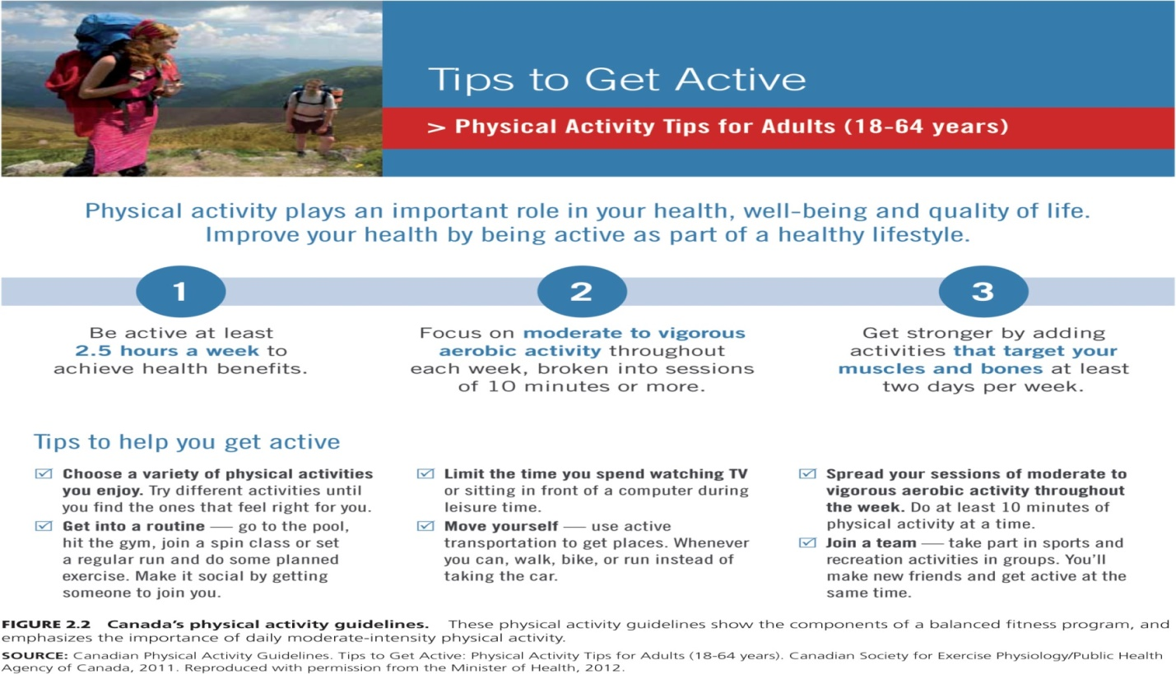

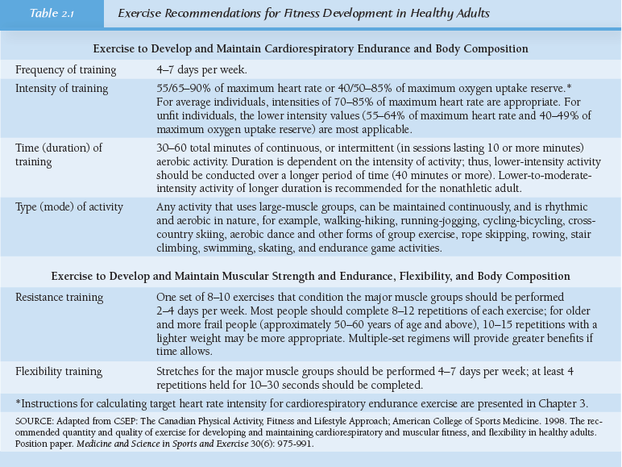

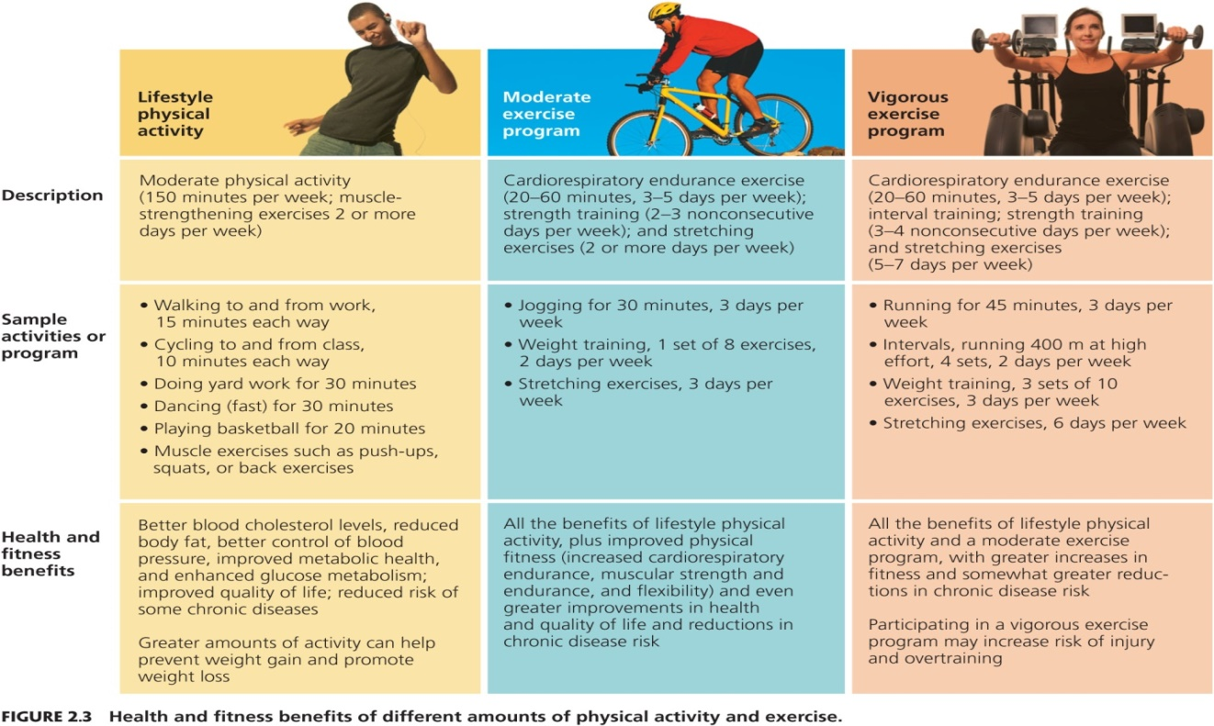

Physical Activity Pyramid
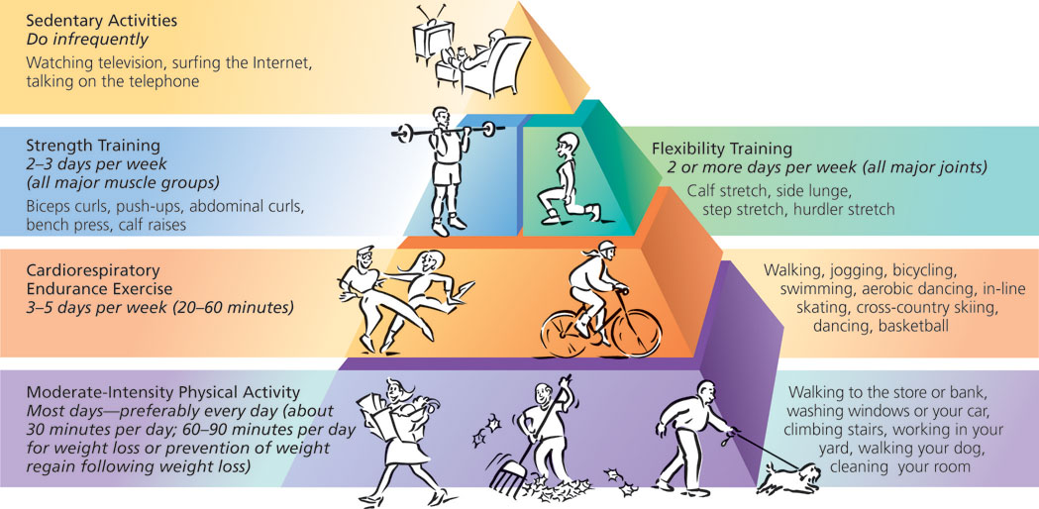
Guidelines for Training
- Train the way you want your body to change – type of exercise must match results desired
- Train regularly – follow research guidelines
- Start slowly, and get in shape gradually; do not over-train, increase duration and frequency before increasing intensity. (avoid “too much, too soon”) (3 phases - Beginning/making progress/maintenance). Overtraining is characterized by lack of energy, aching muscles and joints, and decreased physical performance.
- Warm up before exercise. It can decrease your chances of injury by helping your body gradually progress from rest to activity. A good warm-up can increase muscular temperature, reduce joint stiffness, bathe the joint surfaces in lubricating fluid, and increase blood flow to the muscles, including the heart.
- Cool down after exercise. During exercise, as much as 90% of circulating blood is directed to the muscles and skin, up to as little as 20% during rest. If you suddenly stop moving after exercise, the amount of blood returning to your heart and brain might be insufficient, and you may experience dizziness, a drop in blood pressure, or other problems.
- Exercise safely (technique, equipment, etc.)
- Listen to your body, and get adequate rest
- Cycle the volume and intensity of your workouts (e.g. be training lightly one workout, you can train harder the next). Take care to increase the volume and intensity of your program gradually – never more than 10% per week.
- Try training with a partner
- Vary your activities (“cross-training” concept)
- Train with a partner
- Train your mind (nurture habits, commitment, etc)
- Fuel your activity appropriately. Good nutrition, including rehydration and re-synthesis of liver and muscle carbohydrate stores, is part of optimal recuperation from exercise. Consume enough calories to support your exercise program without gaining body fat.
- Have fun. Be patient and prioritize enjoyment and gradual achievement of results
- Keep your exercise program in perspective – reasonable standards and perseverance
- Track your progress, for effective management and motivation

Choosing a Fitness Center
- Convenience
- Atmosphere
- Safety
- Trained personnel
- Cost
- Effectiveness

DO LABS 2.1, 2.2, 2.3

