Sep. 8th
ADM1300

Case method: rational, logical, decision-making process.
What is a case? :
- Real life business problem
- Theoretical concepts to an actual situation
- Develop decision-making skills

Case format (view case study guide):

- Executive Summary (5%)
- Max 1 page
- Single spaced
- Why do we have an executive summary?

- Critical Assumptions (5%)
- Needed due to lack of information (text

Case Format (cont’d):

- Problem Statement (20%)
- Satellite problems/ central problem(s)
- Implications on the organization
- Implications on the personnel
(Read case and find main issue, secondary problem, based on themes in the course)

- Alternative solutions (35%)
- Title
- Description [provide concept or theory that alternative relates too (structure, advertising method etc.)]
- Pros/cons (positive/negative of alternative)
- Analysis
- (i.e: Alternative 1: Title, description, pros/cons…)
- Recommended Solution (10%)
- Why is your selected alternative better than others
- Address personnel and org. situation
(possible of repeated information)

- Implementation (15%)
- Detailed action plan of recommendation (be creative, opputunity to throw in your own thoughts)
- Immediate; short-term; long-term (basically make up the time and whats going to happen during that time) - be detailed –
(i.e: have a meeting with management about marketing plan, why what where who etc.)

- Grammar/Spelling (10%)

Key Factors when preparing:
- Are my assumptions reasonable?
- Do I really understand the problem?
- Have I looked at all viable alternatives?
- Is my decision realistic? Does it proceed in a logical fashion?
- Have I outlined reasonable methods as to how my solution can be implemented?

Sep 11th
ADM1300
Sample case: Blackcherry enterprises

- Make reasonable assumptions
- List all problems
- Determine central problem
- Alternatives (2min) available
- Recommendation
- Implement recommended solution
Case summary:
- Fast growing brick manufacture in the US and Can
- Actively expanding its market pot
- Director of Operations traveling a lot to find new opportunities
- Director using Blackberry to increase info flow and respond to problems
- Flow of info has increased - messages causing problems.

Assumptions:
- Not a one-man operation - medium sized enterprise - probably more than 50.
- C.D Pitt actually knows how to use the Blackberry device
- Leading his part in the company – in an au
- Hierarchy (chain of command)

Problem Statements:
- Increasing company costs
- Customers receiving unwanted merch
- Issues with prod. levels / sale oppur. being lost.

Central Problem:
- Dissemination and misinterpretation of communication generated by the Director of Operations (Idea of communication)

Implications:
On the organization:
- More hours being consumed than required
- Increase in costs due to miscommunication
- Decrease overall profits
- Reputation in industry will be tarnished
On the personnel:
- Low morale of employment due to frustration
- Increase in Pitt’s level of frustration
- Delivery people are late
- Employees will leave org.

Alternatives:

- Change org. structure (Variety of structures could be proposed)
- Change org support system – (communication flow)

Recommended Solution:
Change organizational structure:
- Propose new structure based on reading from text/ extra research
- Why is solution better than others?
- How does it solve primary problem?

Implementation:
***Must be detailed action plan… ideas included…***

- Immediate (0-6months)
- Face-to-face meeting with top management
- Develop new structure to meet stakeholder needs

- Short-term (6 months to 1 year)
- Communicate and implement new structure
- Ensure all employees are aware.

- Long-term (1 year+)
- Get feedback on how new structure works
- Make improvements where necessary
- Reward employees who have worked hard
- Continue expanding operations
- Create management trainee program (or some form of internal promo strategy)

Sep 15th
ADM1300
Chapter 7: Managers and Managing

Management: Process of using resources (people, techno, etc.) to achieve organizational goals effectively and efficiently.

Efficiency: Amount of resources incurred to produce goods and services (doing things right)

Effectiveness: How well organization is meeting its goals (doing right things)

Managerial Functions:
***Henri Fayol- first to describe what are management functions/ what should they be doing:
- Planning (Goals/Course of action)
- Organizing (Structuring workplace to achieve goals)
- Leading/Directing
- Controlling (Essential to assess outcomes)

- Planning:
- Process of looking forward
- Used to select goals and a course of action
- 5 broad steps: Establish goals, is there a gap?, develop plan, implement plan, assess.

- Organizing:
- Structuring workplace to achieve goals
- Mobilize resources
- Creates org. structure (Formal system of relationships –functional vs. geo)

- Directing/Leading:
- Managers articulate vision/ strategy of org.
- Must use: power, persuasion, communication, and motivation.
- Result: Employees work in harmony/ Employees perform at a high level

- Controlling:
- Essential to asses outcomes
- Evaluates how org. is doing in achieving goals
- Allows org. to regulate efficiency and effectiveness
- Also allow managers to measure themselves in other 3 areas.

Planning function:
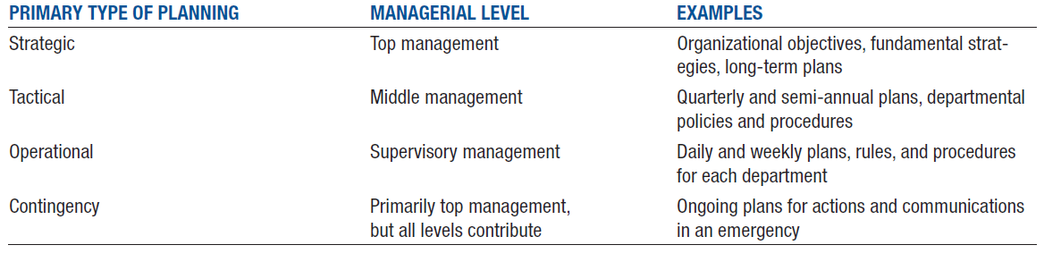
Steps in planning process:
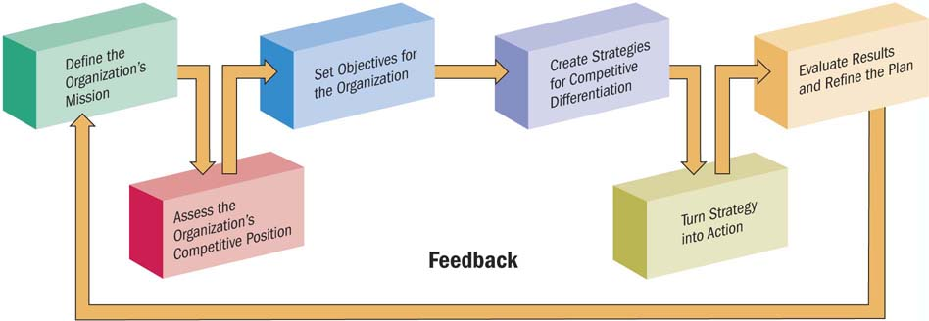

Vision and mission statements:

Vision: A company’s dream for the long-term.

Mission: Written description of an orgs. purpose and aims. (Highlight operations, products/services we offer, customers)
SWOT analysis:
- Strengths
- Loyalty,
- Marketing,
- Recognition,
- Financial etc.

- Weaknesses
- Repairs,
- Costly
- Incompatibility of good/service,
- Reliance on other companies,
- Patent infringement, etc.

- Opportunities:
- New product ideas (payment devices)
- More companies using products
- Marketing etc.

- Threats:
- Key competitor innovation
- Lower cost of competitor products
- Negative media attention, etc.

Creating SMART goals:
- Specific
- Measurable
- Agreed upon
- Realistic
- Timely

The leadership function:
- Autocratic: Centred on the boss, little consultation of employees
- Democratic: Includes employees in decision making (empowerment)
- Free-rein: Minimal supervision, employees make most decisions.

Corporate Culture:
- System of shared meaning. (Values, behaviours, etc.) that determines how employees act.
- Distinguishes one organization from another.
- Is the “glue” that bonds an organization?
- “The way we do things around here”
- “The way we do things within an organization” “Set of values/beliefs” “Strong fundamentals”

Sep 18th
ADM1300: Chapter 6 and 5

Entrepreneurship and Options for Business Ownership:
Sole proprietorships, Partnerships, and Corporations

The entrepreneur:
- Seeks a profitable opportunity
- Recognize and seize an opportunity
- Many Characteristics:
- Vision
- Passion/Energy
- Self-confidence
- Tolerance for failure/unknown
- Creative/innovative, etc.
- Strict Process:
- Idea
- Screening (adds value, competitive advantage, marketable, low exit costs)
- Development
- Develop a business plan

Why Entrepreneurship?

- Being your own boss – own rules, etc.
- Financial success -
- Job security? – Regular job fails… screwed, benefits (health), pension, etc.
- Quality of life? –

Sole Proprietorships:
- When management and ownership of a business are one and the same.
- Typically employ less than 50 people
- The oldest form of legal ownership in Canada (i.e.: house cleaning)

Advantages:
- Easy to form/dissolve
- GUV preferential treatment
- Sole claim on all profits (losses)
- Personal incentive/satisfaction
- Pays only personal income tax= federal and provincial… more income, more tax
- Secrecy

Disadvantages:
- Unlimited liability (Responsible for debt obligations)
- Lack of continuity (Uncertainty of duration)
- Time commitment
- Difficulty in raising monies
- Management limitations (competencies)

Sep 22nd
ADM1300: Chapter 6 and 5

Partnerships:
When 2+ people combine their financial, managerial, and technical abilities to operate a business

Types of partnerships:
- General: All partners = unlimited liability (all responsible for data obligations) (only held responsible for the amount/percentage you’ve invested in the company.)
- Limited: One partner must have unlimited liability. (Responsible for everything)
- Joint venture: Established for a specific project

Advantages:
- Easy to form
- Larger availability of money
- Diversification of management skills (don’t have to be good at everything)
- Shared risk
- Personal interest/Satisfaction
- Decision making

Disadvantages:
- Unlimited liability
- Distribution of profits
- Management difficulties
- Difficult to withdraw investment (death, simple withdraw)

Corporations:
- A legal entity whose assets and liabilities are separate from owners.
- It’s an artificial being, existing only in the eyes of the law.
- Articles of incorporation must be drawn
(Name an address of corporation - Objectives of corp. - Type/Number of shares to be issued – Number of directors)

Control of the Corporation:
- Shareholders
- Board of directors
- Senior Management

- The Shareholders:
- Owners of corp.
- Share= Unit of ownership
- Basically, two classifications of shareholders:
- Common: have voting rights but don’t receive preferential treatment regarding dividends (more risk, higher gains)
- Preferred: No voting rights, claim to dividends before common shareholders (less risk, guaranteed dividends)

Rights of a Common Shareholder
- To vote for Board
- Hold/Sell any share registered in name
- Share in assets on a pro rata basis
- Pre-emptive right (right to maintain percentage ownership of business)
- Inspect the books

Board of Directors:
- Members from both inside/outside companies
- Sets long-term objectives of the corp.
- Oversees/evaluates job of senior mgmt..

Corporation – Advantages:
- Limited liability
- Easier to obtain capital
- Easier to transfer ownership
- Length of life; continued existence
- Greater efficiency of management
- Easier to expand.

Corporation – Disadvantages:
- Double taxation (org is taxed on profits they make)
- Employee – owner separation
- Large number of guv restrictions
- Extensive paperwork
- Must publish annual reports

Types of corporations:

- Private:
- Shareholders are limited to fifty (50)
- Can not sell shares without approval of the Board of Directors
- General public is not permitted to buy shares from a Private Corp.

- Public:
- Form of Corp. CAN BE owned by more than fifty shareholders
- Can issue shares on the financial Markets.
- Usually owned by hundreds or thousands of shareholders
- Crown:
- A business that is owner and operated by the GUV (fed or prov)
- Form of public ownership where the Guv owns and operates a business on behalf of the general public.
- (i.e: Canada Post)
Crown Purpose: Some believe cetain sectors of economy are too important to be left inn hands of private firms / Provides services which would not likely be offered by others

Franchising:
- Franchisee purchases right to sell product/ service of franchisor
- Business for yourself: NOT BY YOURSELF
- 1000 franchiso companies in CAN/ 70,000 outlets in CAN
- Employs over 1m people In CAN
- 110Bil in sales in CAN
Advantages:
- Training and management assistance
- Personal ownershio
- Nationally recongnized name
- Financial advice and assistance
Disadvantages:
- Large Start-up Costs
- Share your profits
- Management regulation
- Coattail Effect – your success is tied to the franchisors performance.

Non-profit Organizations:
- Provide services rather than earn profit
- Not owned by GUV entity
- Solicit donations
- (i.e: Lions Clubs)

