Chapter 7: Human Memory
- 3 key processes involved in memory
  - Encoding (getting information in)
    - Involves forming a memory code
    - Requires attention
  - Storage (maintaining it)
  - Retrieval (getting it out)

ENCODING: GETTING INFORMATION INTO MEMORY
The Role of Attention
- Involves focusing awareness on a narrowed range of stimuli or events. Selective attention is critical to every day functioning
- If attention were distributed equally among all stimulus inputs life would be chaotic
  - We need to focus and screen out most things in order to pay attention
- “cocktail party phenomenon”
  - At a cocktail there are many different conversations going on, and although you may not be paying attention to the other conversations, if someone calls your name you will hear it
- The “cocktail party phenomenon” suggests that attention involves late selection, based on the meaning of input
- Science proved that early selection, late selection and intermediate selection can happen, meaning its flexible rather than fixed
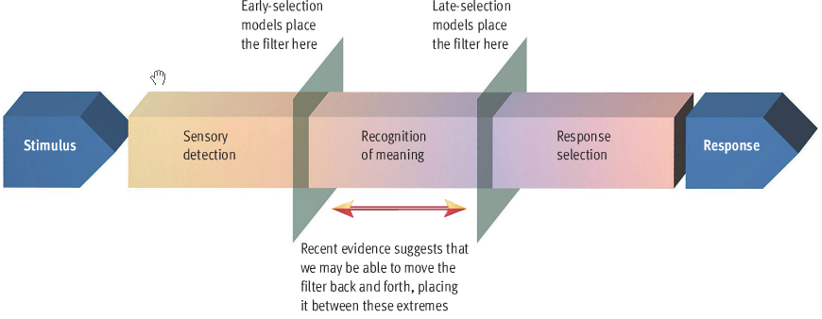
- Brain can only effectively handle one attention consuming task at a time
  - When multitasking they are switching their attention back and forth rather than processing it simultaneously
  - Ex. Driving and talking on the phone is dangerous because you pay more attention to the phone

Levels of Processing
- Believe how people attend to information are the main factors influencing how much they remember
- Craik and Lockhart propose that incoming information can be processed in 3 progressively deeper levels: structural, phonemic, and semantic encoding
  - Eg. If words are flashed on a screen structural encoding registers on how they were printed (size, font colour, length), phonemic encoding emphasizes what the word sounds like, semantic encoding emphasizes the meaning of verbal input
- Levels-of-processing theory: proposes that deeper levels of processing result in longer lasting memory codes
- Deeper processing leads to enhanced memory
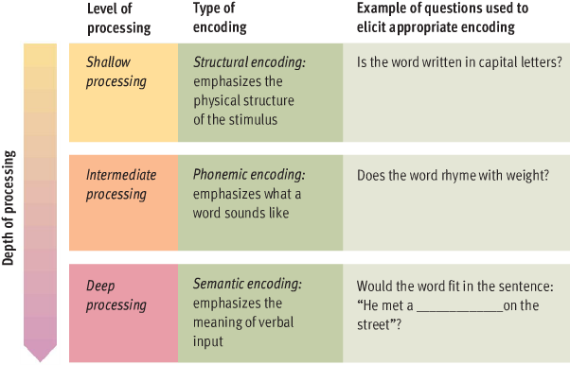
Enriching Encoding
- Other dimensions to encoding that can enrich encoding process and therefore improve memory: elaboration, visual imagery and self-referent coding
- Elaboration
  - Semantic encoding can be enhanced through elaboration
  - Its liking a stimulus to other information at the same time of encoding
  - Ex. You read that phobias are caused by classical conditioning and then you link that fact to your fear of spiders
- Visual imagery
  - Imagery: creating visual images to represent the word your trying to remember
  - Used to enrich encoding
  - Allan Paivio
    - easier to form images on concrete objects rather than abstract concepts and this ease of image forming affects memory
    - imagery facilitates memory because it provides a second kind of memory code
    - dual-coding theory: memory is enhanced by forming semantic and visual codes, since either can lead to recall
- Self-referent encoding
  - Making material personally meaningful can enrich encoding
  - Involves deciding how or whether information is personally relevant
  - Ex. If you ride the bus every day and you still prob don’t have all the bus stops memorized because you haven’t made the effort to it
  - Enhances recall by promoting additional elaboration and better organization of information

STORAGE: MAINTAINING INFORMATION IN MEMORY
- Both Aristotle and Plato compared memory to a block of wax that differed in size and hardness for various individuals
  - Remembering was like stamping an impression into the wax, as long as the image remained in the wax, the memory would remain intact
- Richard Atkinson and Richard Shifftin
  - According to their model, information passes through 2 memory storage buffers: sensory store and short term store, before it transfers into long term store
  - The 3 memory stores are viewed as functionally distinct types of memory not anatomical structures in the brain

Sensory Memory
- Preserves information in its original sensory form for a brief time, usually only a fraction of a second
- Allows the sensation of a casual pattern, sound, or touch to linger for a brief moment after the sensory stimulation is over
- Ex. With vision you perceive an afterimage rather than the actual stimulus. Ex. With a sprinkler if you make a figure 8 you will see the whole image of a figure 8 even though the light source is only at a single point
  - Sensory memory preserves the image long enough for you to see the continuous circle
- Memory trace in visual sensory store decays in about ¼ of a second

Short Term Memory (STM)
- Limited-capacity store that can maintain unrehearsed information for up to 20 seconds
- There is a way to maintain information in your short-term storage indefinitely, by rehearsal
- Rehearsal: the process of repetitively verbalizing or thinking about the information
  - Maintenance rehearsal: maintaining the information in consciousness
  - Elaborative rehearsal: increasing the probability that you will retain the information in the future
- Something always distracts you and breaks the rehearsal loop
- Durability of storage
  - Without rehearsal, information in short term memory is lost in less than 20 seconds
  - Loss of information from short term memory is due to decay of memory traces and interference from competing material
- Capacity of storage
  - George Miller pointed out the “7 plus or minus 2” rule
  - People can only recall only about 7 items in tasks that require them to remember unfamiliar material
  - Affects person’s ability to perform tasks in which you need to mentally juggle various pieces of information
  - You can increase the capacity of your short term memory by combining stimuli into larger ordered units called chunks
  - Chunk: group of familiar stimuli stored as a single unit
    - To successfully chunk letters a person must be able to recognise the things as a familiar unit
    - Ex. NF-BCT-VC-BCIB-M is hard but when you chunk it like NFB-CTV-CBC-IBM its easier
      - In this case information was taking from long term and put into short term memory
    - Longshort isn’t unusual, people take information out of long term to evaluate and understand information that they are working with in short term memory
- Short-Term Memory as “Working Memory”
  - It is not limited to phonemic encoding as originally thought
  - Decay is not the only process responsible for the loss of information from STM
  - According to Alan Baddeley, working memory is a limited capacity storage system that temporarily maintains and stores information by providing an interface between perception, memory and action
  - Baddeley’s model of working memory consists of 4 loops
    - Phonological loop
      - Represents all the STM in earlier models
      - Component at work when you use recitation to temporarily memorize a phone number
      - Baddeley believes it evolved to facilitate the acquisition of language
    - Visuospatial sketchpad
      - Temporarily hold and manipulate visual images
      - At work when you mentally rearrange the furniture in your room or when you map out a route to where you need to travel
    - Central executive system
      - Controls the development of attention, switching the focus of attention and diving attention as needed
    - Episodic buffer
      - Temporary, limited-capacity store
      - allows the various components of working memory to put together information
      - serves as an border between working memory and long term memory
  - 2 key characteristics that originally define short term memory: limited capacity and storage duration are still present in the concept of working memory but Braddeley’s model has evidence that STM handles a greater variety of functions
  - Working memory capacity (WMC): refers to one’s ability to hold and manipulate information in conscious attention
    - Influenced by hereditary
    - People carry in how well they can juggle information in their working memory while fending off distractions
    - High correlation with cognitive abilities: reading comprehension, reasoning

Long Term Memory (LTM)
- Unlimited capacity store that can hold information over lengthy periods of time
- Some say you can store it here forever, and that forgetting is caused because people can’t retrieve it
- Wilder Penfield
  - Triggered long lost memories through electrical stimulation of temporal part of brain
  - Patients then described vivid descriptions
- Flashbulb memories: unusually vivid and detailed recollections of momentous events
  - Ex. People know exactly where they were and what they were doing when Michael Jackson died or when the twin towers fell
  - Example of permanent storage
- Yet these lines of evidence show LTM isn’t permanent
  - Memories activated in Penfield’s study were just hallucinations and not real memories
  - Flashbulb memories are not accurate or special
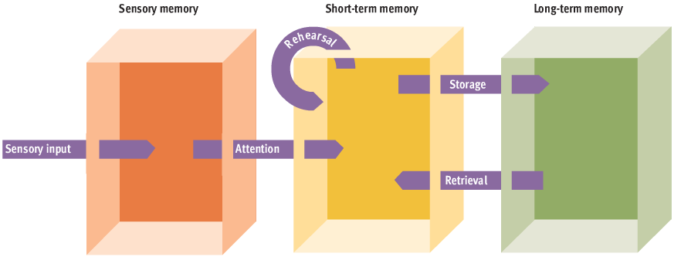

How is Knowledge Represented and Organised in Memory?
- Clustering and conceptual hierarchies
  - Clustering: the tendency to remember similar or related items in groups
    - Bousfield showed this is used when recalling lists
  - Conceptual hierarchy: multilevel classification system based on common properties among items
    - Factual information organised like this
    - Kind of like what I’m doing with these notes, they have a title, categories and subcategories
- Schemas
  - Organised cluster of knowledge about a particular object of event abstracted from previous experience with the object or event
  - Ex. University kids have schemas for what their professors offices look like
  - People are more likely to remember things if they are constant with their schemas
  - Inverse is also true, people sometimes recall things that violate their schema-based expectations
    - Ex. If you saw a slot machine in a prof’s office you would remember it
  - Rational schemas: representations of typical events surrounding interpersonal interactions
    - Affect the way you process information about yourself and others
- Semantic networks
  - Nodes representing concepts, joined together by pathways that link related concepts
    - Mind map (shorter line, stronger connection)
  - Explains why thinking about one word can make a closely related word easier to remember
    - Ex. Butter and bread
  - Spreading activation: process of thinking about a word and thoughts naturally going to related words
- Connectionist networks and parallel distributed processing (PDP) models
  - Brain depends on parallel distributed processing- simultaneous processing of the same information that is spread across network of neurons
  - Connectionist/parallel distributes processing (PDP): assume cognitive processes depend on patterns of activation in highly interconnected computational networks that resemble neural networks
  - These nodes act like neurons and can send excitatory or inhibitory signals to other units
  - PDP asserts that specific memories correspond to particular patters of activation
  - Semantic vs. connectionist
    - Semantic: specific nodes=specific concepts or pieces of knowledge
    - Connectionist: piece of knowledge is represented in a particular activation of networks
      - Information lies across strength of connections

RETRIEVAL: GETTING INFORMATION OUT OF MEMORY
Using Cues to Aid Retrieval
- Tip-of-the-tongue phenomenon: temporary inability to remember something you know, accompanied by a feeling that is just out of reach
- Occurrence increases with age
- Constitutes a failure in retrieval
- Memory can be jogged with retrieval cues
Reinstating the Context of an Event
- Encoding specificity principle: memory for information would be better when the conditions during encoding and retrieval were similar
- Ex. When thinking about what you had for breakfast 2 days ago you think about where you were sitting and who you were with
- This involves working with context cues
  - They facilitate the retrieval of information
  - Ex. If you return to a place after many years you remember many forgotten memories
- State/mood dependant effect: effect of matching the person’s internal state of encoding at the retrieval phase is just a special case of the encoding specificity principle
  - Ex. If you were intoxicated when the event occurred you have to try and recall the memory by being in a similar state

Reconstructing Memories and the Misinformation Effect
- Your memories are sketchy and may include details that never really occurred
- Add new details that fit with your own schema
- Misinformation effect: occurs when participants recall of an event they witnessed is altered by introducing misleading post-event information
  - 3 stages:
    - Subjects view an event
    - Exposed to information about this event, some which is misleading
    - Third stage: recall of original event is tested to see if their post event information altered their memory
  - Ex. 2 people shown video one asked how fast the cars were going when they hit each other and the other asked when they smashed each other and later realised the person that was asked using smashed added broken glass to their memory because of their schema

Source Monitoring and Reality Monitoring
- Marcia Johnson studied this
- Reality monitoring: process of deciding whether memories are based on external sources (one’s perceptions of actual events) or internal sources (one’s thoughts and imagination)
  - Engage in this when trying to remember if event actually happened or you only thought it happened
  - Ex. Did I take my vitamins today? Or no
- Source monitoring: involves making attributions about the origins of memories
  - Source of many mistakes when people try to remember their experiences
  - Have to make decisions at the time of retrieval about where the memories came from
  - Ex. Did I read that in the Mississauga News or Brampton Guardian?
- Source monitoring error: memory derived from one source is misattributed to another source
  - Ex. Might think the fact your roommate told you came from the psychology textbook
- Destination memory: recalling whom one has told what
  - More fragile because when transmitting information, people are self-focused on their message, leaving less attention capacity to remember who they are telling it to

FORGETTING: WHEN MEMORY LAPSES
- Forgetting is adaptive
- It can reduce competition among memories that can cause confusion

How Quickly We Forget: Ebbinghaus’s Forgetting Curve
- Hermann Ebbinghaus: first people so study forgetting
- Forgetting curve: graphs retention and forgetting over time
- Drop in retention during first few hours, therefore most forgetting occurs very rapidly after learning something
- When memorizing something more meaningful, the forgetting curve isn’t as steep
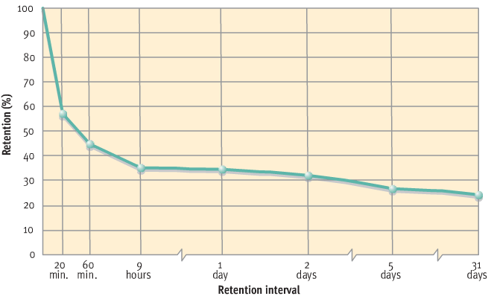
Measures of Forgetting
- Retention: refers to the proportion of material retained (remembered)
- Retention interval: length of time between the presentation of materials to be remembered and the measurement of forgetting
- 3 methods used to measure forgetting are:
  - Recall: reproduce information on their own without any cues
    - Ex. If you were given a list of 25 things and you were told to memorize it then write on the paper what you remember
  - Recognition: select previously learned information from an array of options
    - Ex. From a list of 100 words you were told to choose the 25 you had to memorize
  - Relearning: memorize information a second time to determine how much time or how many practice trials are saved by having learned it before

Why We Forget
- Factors that may affect encoding, storage, and retrieval process
- Ineffective encoding
  - Information may not have been stored in memory in the first place
  - Aka pseudoforgetting because you forget something you never learned
  - Usually due to lack of attention
  - Even if memory codes are formed, it could be ineffective or inappropriate encoding
  - Ex. Although you look at a penny all the time, when asking to point out a real penny from fakes, it is hard
- Decay
  - Forgetting occurs because memory traces fade with time
  - Time produces forgetting
  - Haven’t been able to prove decay causes long term memory forgetting
    - Shown that forgetting doesn’t depend on the amount of time that’s passed but the amount, complexity and type of info that subjects have had to assimilate during the retention interval
  - Interference: negative impact of competing information on retention
- Interference
  - People forget information because of competition from other material
  - Greatest when intervening material is similar to test material
  - Decreasing similarity should reduce interference and cause less forgetting
  - Ex. It’s easier to memorise 5 lists when they are all very different compared to if they were the same
  - 2 types:
    - Retroactive interference: occurs when new information impairs the retention of previously learned information
      - Occurs between with the original learning and the retest on that learning
    - Proactive interference: occurs when previously learned information interferes with the retention of new information
      - Rooted in learning that comes before exposure to the test material
- Retrieval failure
  - Remember things that you were unable to recall at an earlier time
  - Retrieval failures may be more likely when a mismatch occurs between retrieval cues and the encoding of the information your searching for
    - Ex. If a sound of a word was emphasized during encoding then an effective retrieval cue would be to emphasize the word again
  - Encoding specificity principle: the value of a retrieval cue depends on how well it corresponds to the memory code
  - Transfer-appropriate processing: occurs when the initial processing of information is similar to the type of processing required by the subsequent measure of retention
    - Ex. Subjects given list of words and a task that required either semantic or phonemic processing. Semantic processing yielded higher retention when testing emphasized semantic factors and phonemic with phonemic factors. Therefore retrieval failures more likely when there is a poor fit between the processing done during encoding and processing invoked by the measure of the retention
- Motivation and forgetting
  - Freud said people keep embarrassing, unpleasant painful memorised buried in unconscious
  - Says memories were there all along, just retrieval was blocked by unconscious avoidance tendencies
  - Motivated forgetting: the tendency to forget things one doesn’t want to think about
    - Freud terminology: repression
    - Repression: keeping distressing thoughts and feelings buried in the unconscious

7 Sins of Memory: How Memory Goes Wrong
- Daniel Schacter
Sins of omission (can’t bring the memory to mind) | Transience | Simple weakening of memory overtime
Sins of omission (can’t bring the memory to mind) | Absent-mindedness | Failure to pay attention
Sins of omission (can’t bring the memory to mind) | Blocking | Temporary problem. Fail to retrieve an item of information such as someone’s name when we meet them
Sins of commissions (memory present but its incorrect or unwanted) | Misattribution | Assign memory to wrong source
 | Suggestibility | Memory distorted because of misleading questions
 | Bias | Inaccuracy due to the effect of our current knowledge on out reconstruction of the past
 | Persistence | Unwanted memories or recollections that you can’t forget (it haunts you)
- Each of the sins has an upside

IN SEARCH OF THE MEMORY TRACE: THE PHYSIOLOGY OF MEMORY
The Neural Circuitry of Memory
- Some research suggests memory formation results in alterations in synaptic transmissions
  - Specific memories depend on chemical changes that occur at specific synapse
- Specific memories may depend on localized neural circuits
  - Memorise create unique reusable pathways
- Long term potentiation (LTP) long lasting increase in neural excitability at synapses along a specific neural pathway
- Neurogenesis: the formation of new neurons
  - New brain cells constantly being formed in the dentate gyrus of the hippocampus
  - New neurons are more excitable than mature neurons

Anatomy of Brain
- Organic amnesia: extensive memory loss due to head injury
- 2 basic types of amnesia:
  - Retrograde amnesia: loss of memories for events that occurred prior to the onset of amnesia
  - Anterogrande amnesia: loss of memories for events that occur after the onset of amnesia
    - H.M had this after he had surgery to help him relieve seizures
      - Unable to form long term memories for future events
- Hippocampus region
  - Critical for long term memory
  - Medial temporal lobe memory
  - Plays key role in consolidation of memories
    - Consolidation: hypothetical process involving the gradual conversation of information into durable memory codes stored in long term memory
- Amygdale seems to be critical for the formation of memories for learned fears

SYSTEMS AND TYPES OF MEMORY
Implicit verses Explicit Memory
- Implicit memory: retention is exhibited on a task that does not require intentional remembering
  - Incidental, unintentional remembering
- Explicit memory: intentional recollection of previous experience
  - Conscious, assessed directly, best assessed with recall or recognition measures of retention
  - Affected by age, amnesia, drugs, and implicit isn’t

Declarative verses Procedural Memory
- Declarative memory: handles factual information
  - Words definitions, names, faces, events, concepts
- Procedural memory: actions, skills, operation and conditioned responses
  - How to ride a bike, typing
- Rules of tennis is declarative memory but how to hit and serve is procedural

Semantic verses Episodic Memory
- Divisions form declarative memory
- Episodic memory system: chronological, or temporarily dates recollection of personal experiences
  - What you’ve done, seen, heard and when
  - Like an autobiography
- Semantic memory system: general knowledge that is not tied to the time when the information was learned
  - Ex. Christmas is December 25, dogs have 4 legs
  - Stored undated
  - Like an encyclopedia

Perspective verses Retrospective Memory
- Prospective memory: remembering to perform actions in the future
  - Ex. Walk the dog, call someone, turn off your lawn sprinkler
- Retrospective memory: remembering events from the past or previously learned information

PERSONAL APPLICATION
- Mnemonic devices: methods used to increase the recall of information
- Testing effect: testing enhances retention
- Over learning: continued rehearsal of material after you first appear to have mastered it
- Serial position effect: occurs when subjects show better recall for items at the beginning and end of a list rather than in the middle
- Massed practice: studying all at once
- Distributed practice: studying over a period of time
- Link method: forming a mental image of items to be remembered in a way that links them together
- Method of loci: taking an imaginary walk along a familiar path where images of items to be remembered are associated with certain locations
- Key word method: associate a concrete word with an abstract word and generate an image to represent the concrete word
  - Ex. Garden for the name Gorden
- Memory is a reconstructive process and eyewitness recall is likely to be distorted by the schemas that people have for various events
- Witness recall of events is routinely distorted by information introduced after the event
- Hindsight bias: tendency to mould our interpretation of the past to fit how accurately it turned out
- Overconfidence effect: overconfidence in the reliability of their memory

