Chapter 3: The Biological Bases of Behavior
- Nervous system is a complex communication network in which signals are being transmitted, received and integrated

Nervous tissue
- Nervous system is living tissue composed of cells
- Cells fall under 2 categories:
Glia | Neurons
- Cells found throughout nervous system that provide support for neurons  - Smaller then neurons but outnumber them  - Supply nourishment to neuron, remove waste, and provide insulation | - Individual cells that receive, integrate and transmit information  - Permit communication within nervous system  - Soma (cell body) contains cell nucleus  - Dendrites-specialized in receiving info  - Axon: transmits signals away from soma to other neurons or muscles  - Myelin sheath : insulating material made from glial cells that cover the axon  - Terminal buttons: end of axon, release neurotransmitters  - Synapses: point where neurons interconnect and info is shared from one neuron to another

Neuron at rest
- Hodgkin and Huxley learnt impulse is electrochemical reaction
- Inside and outside neuron there are ions, since membrane is semi-permeable some of the ions go through
- Concentration gradient means stored potential energy
- Resting potential: stable negative change when cell is inactive

Action Potential
- When neuron stimulated channels in membrane open up allowing ions to flow in creating action potential
- Absolute refractory period: time where action potential just occurred so another one cant occur for a certain amount of time

All or none law
- All action potentials are the same size
- Weaker stimuli don’t produce smaller action potentials
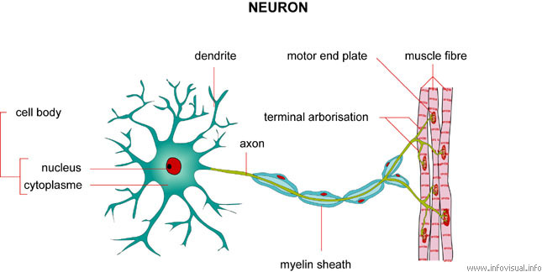
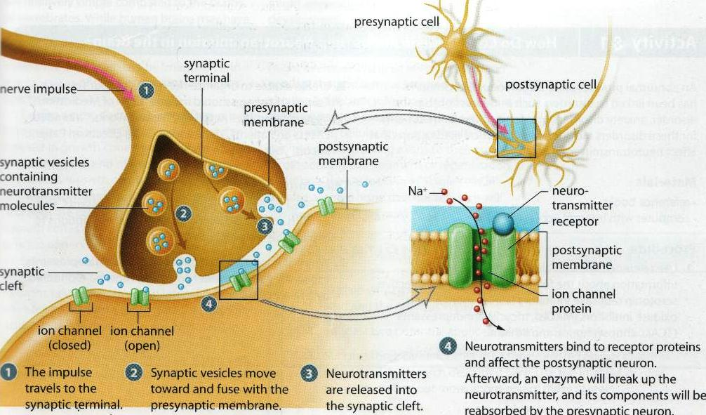
- They can however affect rate of which they fire

Synapse
- 2 neurons don’t actually touch, separated by synaptic cleft
- Synaptic cleft: gap between terminal button of one neuron and cell membrane of another
- Signals have to cross this in order for communication
- Presynaptic neuron: neuron that sends signal
- Postsynaptic neuron: neuron that receives signal
- Action potential triggers release of neurotransmitters
- There stored in synaptic vesicles
- Postsynaptic potential (PSP): voltage change at receptor site on postsynaptic cell membrane
  - Not like all or none law, they increase or decrease in size
- 2 types of messages can be sent:
  - Excitatory: increases likelihood that neuron will fire action potential
  - Inhibitory: decreases likelihood that neuron will fire action potential
  - Excitatory adds up and inhibitory cancels it out and needs to see if enough excitatory for action potential to move on
- After response, neurons will drift away, be broken down by enzymes, or be reabsorbed through reuptake
- Synaptic pruning: removal of old or less-active synapse

Neural networks
- Donald Hebb
  - Realized neurons don’t act alone in influencing behavior, but instead are linked in a network
  - Hebbian Learning Rule: talks about these linkages and how they might operate and come about
- Neurotransmitters work at specific synapses
  - Like lock and key transmitter has to fit into receptor site
- There are so many neurotransmitters because it makes communication more precise

Acetylcholine (ACh)
- Only transmitter between motor neurons and voluntary muscles
- Every move you make depends on Ach
- Not enough: memory loss
- Nicotine is an ACh agonist
- Agonist: chemical that mimics the action of a neurotransmitter
- Antagonist: chemical that opposes the action of a neurotransmitter
  - This means that muscles won’t be able to move

Monoamines
- Includes 3 neurotransmitters: dopamine, norepineprine and serotonin
- Dopamine: used by neurons that control voluntary movements
  - Loss of such neurons causes parkinsonism (tremors, muscular rigidity, reduced control over voluntary movements)
- Serotonin: plays prominent role in sleep and wakefulness and eating behavior
  - Can be related to aggression in humans
  - Low levels cause eating disorders and OCD
- Low levels of norephinephrine and serotonin cause depression

GABA and Glutamate
- GABA widely distributed in the brain
  - Involved in regulation of anxiety ad disturbances in GABA contribute to anxiety disorders
  - Produce only inhibitory postsynaptic potentials
- Glutamate also widely spread out in brain
  - Always has excitatory effects
  - Contribution to memory and learning
  - Disturbances lead to schizophrenic disorders

Endorphins
- Morphine (pain killer) binds to specialized receptors in brain
- Endorphins: internally produced chemical s that resemble opiates in structure and effect
- Endogenous opioids contribute to modulation of eating behavior and body’s response to stress
- Opiate drugs like heroin and morphine produce pleasurable feelings of euphoria
  - Explains why drug is abused
- Body’s endorphins also give pleasurable feelings
  - “runners high”

Peripheral Nervous System
- Nerves that lie outside brain and spinal cord
- Nerves: bundle of neuron fibers (axons) that are routed together
- Subdivided into:
Somatic nervous system | Autonomic nervous system
- Nerves that connect voluntary skeletal muscles to sensory receptors  - Carry info from receptors in skin, muscles and joints to CNS and from CNS to muscles  - Afferent nerve fibers: axons that carry info to the CNS  - Efferent nerve fibers: axons that carry info from CNS to peripheral part | - Nerves that connect to heart, blood vessels, smooth muscles and glands  - Controls automatic, involuntary functions we don’t think about like heart rate, digestion  - Fight or flight response  - Split up into sympathetic and parasympathetic  - Sympathetic: mobilizes body’s resources for emergencies  - Slows digestion, blood drains from peripheral  - Parasympathetic: conserves bodily resources  - Slows heart rate, reduces blood pressure, promotes digestion

Central nervous system
- Consists of brain and spinal cord
- Protected by enclosing sheaths called meginges
- Cerebrospinal fluid: nourishes brain and provides cushion
- Spinal cord
  - Connects brain to rest of body
  - Extension of brain
  - Damage prevents signals from being transmitted

Research methods involving brain
- Electrical recordings
- Electrical activity of brain can be recorded like electrical readings of axon were recorded by Hodgkin and Huxley
- Electroencephalograph (EEG): device that monitors electrical activity of brain over time by means of recording electrodes attached to surface of scalp
- Attached to skull and brain waves recoded
- Lesioning
- Case study method
- Problems with studying brain is that everyone’s severity is different and their past experiences
- Lesioning involves destroying piece of brain
  - Inserts electrode in brain and passes high frequency electric current through it to burn tissue and disable structure
- Electrical stimulation of brain (ESB)
- Involves sending weak electrical current to brain to activate/stimulate it
- Surgeons may use this after they cut skull open so they don’t slice through critical areas
- Wilder Penfield specialty was surgical treatment of epilepsy
  - During surgery patients stayed awake and so he could map out brain activity
- Transcrainial magnetic stimulation
- New technique that permits scientists to temporarily enhance/depress activity in specific area of brain
- Magnetic field increases or decreases excitability of neurons to create “virtual lesions”
- Suppress activity of certain part of brain and activates another area by getting the person to do a specific task to see if the virtual lesion interferes with working part of brain

Brain scanning
- Computerized tomography (CT): x-ray of brain structure
- Positron emission tomography (PET): maps actual brain activity over time and can examine brain function
- Magnetic resonance imaging (MRI): uses magnetic fields, radio waves to map out structure
  - Provide better image then CT scan
- Functional magnetic resonance imaging (fMRI): monitors blood flow and oxygen consumption in brain to identify high activity

Hindbrain
- Medulla: in charge of unconscious but vital functions
  - Circulation of blood, breathing, maintaining muscle one
- Pons: connects brain stem with cerebellum
- Cerebellum: critical to coordination of movement and to sense equilibrium
  - Allows you to put arm out wide then touch your nose
  - Drunk drivers asked to do this because it’s the first structure that stops working
  - Damage disrupts fine motor skill

Midbrain
- Lies between hindbrain and forebrain
- Contains area concerned with vision and hearing
- Includes dopamine releasing neurons
- Reticular formation: runs through hind and mid brain
  - Contributes to muscle reflexes, breathing, pain perception
  - Sleep and arousal

Forebrain
- Largest and most complex region
- Cerebrum: seat of complex thoughts
- Cerebral cortex: wrinkled surface of cerebrum , outer layer of brain
- Thalamus: all sensory info except smell must get through in order to get to cerebral cortex
  - Integrates info from various senses
- Hypothalamus: regulates basic biological needs
  - Lies beneath thalamus
  - Controls autonomic nervous system
  - Serves link between brain and endocrine system
  - Regulates: fighting, fleeing, feeding and mating

Limbic system
- Don’t know which structure is a part of this
- Involved in regulation of memory, emotion and motivation
- Hippocampus: play a role in memory processes
  - Consolidation of memories for factual information
  - Prediction and imagination
  - Defect: leads to defects in predictive ability

Cerebrum
- Largest and most complex part of brain
- Learning, remembering, thinking, conscious
- Cerebral cortex: outer layer
- Corpus callosum: connects 2 hemispheres of brain
- Each hemisphere divided into 4 parts called lobes
  - Occipital lobe: visual signals, visual possessing
  - Parietal lobe: registers sense of touch, sense of space
  - Temporal lobes: auditory processing
  - Frontal lobe: controls movement of muscles

Plasticity of brain
- Refers to brains ability to change structure and function
- Experience can sculpt structure
  - Ex. Musicians who use fingers, that part of brain enlarged
- Damage to one part of brain increases/enlarges other
- Adult brain can generate new neurons
  - Neurogenesis: formation of new neurons

Hemispheres
- Left side: verbal processing
  - Language, speech, reading, writing
  - Called it dominant half
  - Controls and communicates with right side of body
- Right: non verbal processing
  - Spatial, musical, visual recognition, colours, puzzles and perception of others emotions
  - controls left side of body

Split-Brain research
- Split-brain surgery: bundle of fibers that connect hemisphere is cut to reduce severity of seizures
- When study they showed patients picture quickly on one side
- When flashed on one side, the person wasn’t able to name/describe same object when flashed on opposite side
- Prob: people they studied had epilepsy so there brain wasn’t normal to begin with and only studied 10 people
- Maryse Lassonde is researching about people who just never had a corpus collosum
  - Realized the older you get the more mature and capable you corpus callosum
- Perceptual asymmetries: left-right imbalances between then cerebral hemispheres in the speed of visual or auditory processing

Endocrine system
- Glands that release hormones into bloodstream
- Hormones help control bodily functions
- Neural function are very fast compared to hormonal messages which take time and are less specific since they can act on many target cells
- Hormone release is pulsatile: released many times a day in short bursts
- Controlled by NS through hypothalamus which is connected to pituitary gland
- Pituitary gland: releases hormones, “master gland”
- Oxytonin: hormone released by pituitary gland which regulates reproductive behavior
  - Triggers contractions, stimulates breast milk
  - Study showed that it increases males empathy, and their trust

Hereditary and behavior
- Genes affect behavior
- Chromosomes: strand of DNA molecules that carry genetic info (23 pairs of chromosomes, come together to make 46)
- Zygote: single cell formed by egg and sperm
- Homozygous condition: 2 genes in specific pair are same (child does show that trait)
- Heterozygous condition: 2 genes in specific pair are different (doesn’t show trait)
- Dominant: gene tats expresses
- recessive gene that is masked
- genotype: person’s genetic makeup
- phenotype: way in which a person’s genotype is manifested in observable characteristics
  - can change over time
- polygenic inheritance: influenced by more than one pair of genes

Research methods to investigate hereditary influence
- Family studies
- examine blood relatives to see how much they resemble one another in a specific trait
- closer family have a more similar genetic makeup and have a more similar environment similarity
- twin studies
- assess hereditary influence by comparing resemblance of identical twins and fraternal twins with respected trait
- identical (monozygotic) twins: come from same zygote that splits in 2
  - so same genotype
- fraternal (dizygotic) twins: 2 eggs 2 sperms 2 diff zygotes
  - 50% genetic relatedness
- Can provide better evidence that trait influenced by hereditary compared to family studies
- Adoption studies
- Assesses hereditary influence by examining resemblance between adopted children and both biological and adoptive parents
- Hereditary and environment have influence on intelligence
- Adopted kids resemble adopted parents because of environment and also genetic factors prob influenced he trait
- Genetic mapping
- Process of determining location and chemical sequence of specific genes on specific chromosomes

Hereditary and environment
- Epigenetic: study of heritable changes in gene expression that don’t involve modification of DNA sequence

Darwin’s insights
- Not the first person to describe evolution
- Natural selection is why things evolve
- Noticed:
  - Organisms vary in many ways
  - Some of these differences are heritable
  - Organisms produce off springs at a pace that’s faster than the availability of food, shelter, resources
  - Organisms with heritable trait produce more off springs
- Survival of the fittest
- Process of natural selection works on populations not organisms
- Makeup of genetic pool shaped by: genetic drift, mutations, and gene flow
  - Genetic drift: random fluctuations in gene frequencies due to chance
  - Mutation: spontaneous, heritable change in DNA
  - Gene flow: happens when organisms leave and enter gene pool
- Adaptation: inherited characteristic that increases in pop because it solved problem of survival
- Inclusive fitness: sum of individuals reproductive success

