UNIVERSITY OF OTTAWA
CLASS: PHY_____

STUDENT #:______________

NAME:__________________
Principles of Physics
PHY1321/1331 WINTER 2014
Dr. A. Czajkowski

Assignment9:
Thermal Physics II: Heat and Work, First Law of Thermodynamics

Assigned: Nov 18 14:30 Due: November 29 19:00

1. An aluminum calorimeter with a mass of 100 g contains 250 g of water. The calorimeter and water are in thermal equilibrium at 10.0°C. Two metallic blocks are placed into the water. One is a 50.0-g piece of copper at
80.0°C. The other block has a mass of 70.0 g and is originally at a temperature of 100°C. The entire system stabilizes at a final temperature of 20.0°C. (a) Determine the specific heat of the unknown sample. (b) Guess the material of the unknown, using the data from the textbook or www.
SOLUTION:
(a) Qcold = −Qhot

(m c m c T Tw w + c c)( f − c) = −m c T TCu Cu ( f − Cu) − m c T Tunk unk f( − unk)

where w is for water, c the calorimeter, Cu the copper sample, and unk the unknown.

250 g1.00 calg C 100 g 0.215 calg C 20.0 10.0 C(⋅° ) ⁺ (⋅° )( − )°
⁼ ⁻(50.0 g 0.0924 calg C 20.0 80.0 C 70.0 g)(⋅° )( − )° ⁻( )c_{unk}(20.0 100− )°C
2.44 10× ³ cal 5.60 10 g C⁼ ( × ^{3 ⋅°} )c_{unk}
0.435 calg C⋅°
or cunk =.
beryllium
(b) The material of the sample is .

2 A 1.00-kg block of copper at 20.0°C is dropped into a large vessel of liquid nitrogen at 77.3 K. How many kilograms of nitrogen boil away by the time the copper reaches 77.3 K? (The specific heat of copper is 0.092 0 cal/g·°C. The latent heat of vaporization of nitrogen is 48.0 cal/g.)

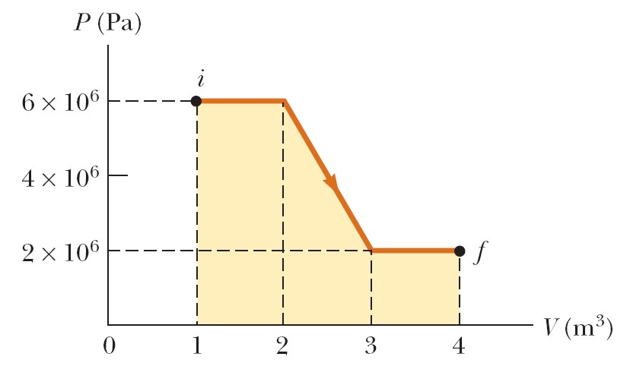
Q m c T m L= Cu Cu∆ = N2 ( vap)N
2
1.00 kg 0.0920 calg C 293 77.3 C(⋅° )( − )° = m (48.0 calg)

m = 0.414 kg

3. (a) Determine the work done on a fluid that expands from i to f as indicated in Figure (b) How much work is performed on the fluid if it is compressed from f to i along the same path?

P20.24 (a) _{W} ⁼⁻∫PdV

_{W} ⁼ ⁻(6.00 10× ⁶ Pa 2.00 1.00 m)( − ) ³ +
−(4.00 10× ⁶ Pa 3.00 2.00 m)( − ) ³ +
−(2.00 10× ⁶ Pa 4.00 3.00 m)( − ) ³
 | f→
(b) W _{f i→} = | +12.0 MJ

W = −12.0 MJ
4. Assume that the Earth’s atmosphere has a uniform temperature of 20°C and uniform composition, with an effective molar mass of 28.9 g/mol. The number density of molecules depends on height according to n_{V} (y) = n₀e−mgy / k_{B}T
where n₀ is the number density at sea level, where y = 0. This result is called the law of atmospheres.
Commercial jetliners typically cruise at an altitude of 11.0 km. Find the ratio of the atmospheric density there to the density at sea level.

^{n y}( ) = e−mgykT_{B} = e−MgyN kT_{A B} = e−MgyRT

n₀
= e⁻(28.9 10× ⁻³ kgmol9.8 m s 11 10 m 8.314 JmolK 293 K)( ²)( × ^{3⋅} )( )

)
(

= e−1.279 = 0.278

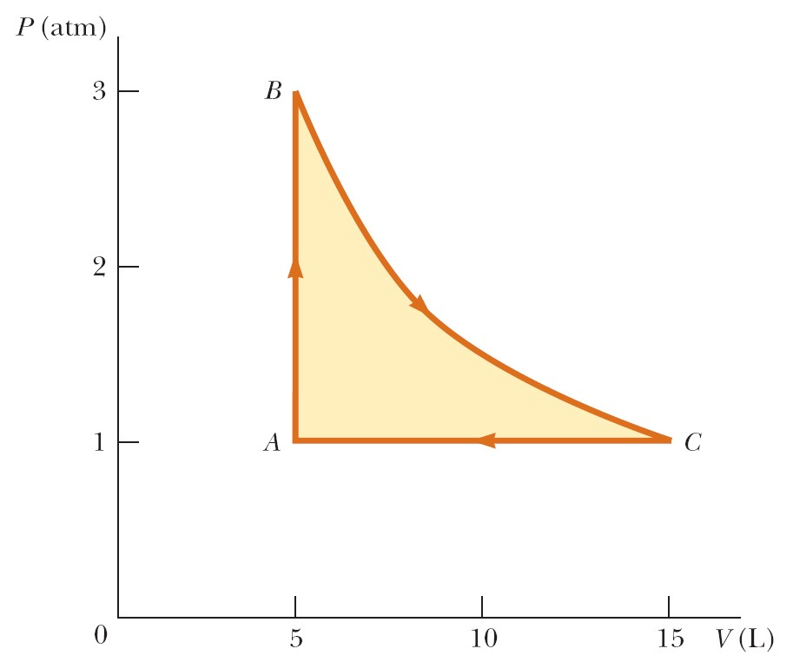
5 A sample of monatomic ideal gas occupies 5.00 L at atmospheric pressure and 300 K. Its state is represented by point A in Figure P17.75. It is heated at constant volume to 3.00 atm (point B). Then it is allowed to expand isothermally to 1.00 atm (point C) and at last compressed isobarically to its original state. (a) Find the number of moles in the sample. (b) Find the temperature at points B and C and the volume at point C. (c) Assuming that the specific heat does not depend on temperature, so that E_{int} = 3nRT/2, find the internal energy at points A, B, and C.
(d) Tabulate P, V, T, and E_{int} at points A, B, and C. (e) Now consider the processes A
→ B, B → C, and C → A. Describe just how to carry out each process experimentally. (f) Find Q, W, and ∆E_{int} for each of the processes. (g) For the whole cycle A → B → C → A, find Q, W, and ∆E_{int}.

^{PV} (^{1.013 10}× ⁵ Pa 5.00 10 m)( × ⁻³ ³)

(a) n = = = 0.203 mol
RT (8.314 JmolK 300 K⋅ )( )
(b) T TB = A  PPAB  = 300 K  1.003.00 = 900 K

T T_{C} ⁼ _{B} = 900 K

V V=  TC  = 5.00 L 900300 = 15.0 L C A  TA 
Eint, A = 3nRTA = 3(0.203 mol 8.314 JmolK 300 K)( ⋅ )( ) = 760 J
2 2
E_{int, B} = E_{int, C} ⁼ ³nRT_{B} ⁼ ³(0.203 mol 8.314 JmolK 900 K)( ⋅ )( ) = 2.28 kJ
2 2
P (atm) | V(L) | T(K) | E_{int} (kJ)
A 1.00 | 5.00 | 300 | 0.760
B 3.00 | 5.00 | 900 | 2.28
C 1.00 | 15.00 | 900 | 2.28
(d)

- For the process AB, lock the piston in place and put the cylinder into an oven at 900 K. For BC, keep the sample in the oven while gradually letting the gas expand to lift a load on the piston as far as it can. For CA, carry the cylinder back into the room at 300 K and let the gas cool without touching the piston.
- For AB: W = 0 ∆Eint = Eint, B −Eint, A = (2.28 0.760 kJ− ) = 1.52 kJ

Q = ∆E_{int}−W = 1.52 kJ
B

A

C

V

C

V

i

=

4

L

V

(
L
)

Adiabatic

For ^{BC}: ∆E_{int} = 0 , ^{W} = −nRT_{B}ln^{V}_{V}^{C}B 
W = −(0.203 mol 8.314 JmolK 900 K ln)(⋅ )( ) (3.00) = −1.67 kJ

Q = ∆E_{int}−W = 1.67 kJ
For CA: ∆Eint = Eint, A −Eint, C = (0.760 2.28− ) kJ= −1.52 kJ
W = − ∆P V = −nR T∆ = −(0.203 mol 8.314 JmolK 600 K)(⋅ )(− ) = 1.01 kJ

Q = ∆E_{int}−W = −1.52 kJ 1.01 kJ− = −2.53 kJ
(g) We add the amounts of energy for each process to find them for the whole cycle.
QABCA = +1.52 kJ 1.67 kJ 2.53 kJ+ − = 0.656 kJ
W _{ABCA} = 0 1.67− kJ 1.01 kJ+ = −0.656 kJ
(∆E_{int}⁾_{ABCA} = +1.52 kJ 0 1.52 kJ+ − = 0

6 4.00-L sample of a diatomic ideal gas with specific heats ratio =1.40, confined to a cylinder, is carried through a closed cycle. The gas is initially at 1.00 atm and at 300 K. First, its pressure is tripled under constant volume. Then, it expands adiabatically to its original pressure. Finally, the gas is compressed isobarically to its original volume. (a) Draw a PV diagram of this cycle. (b) Determine the volume of the gas at the end of the adiabatic expansion. (c) Find the temperature of the gas at the start of the adiabatic expansion. (d) Find the temperature at the end of the cycle. (e) What was the net work done on the gas for this cycle?

Solved in during the lecture: see the lecture notes

P

3 P_{i}

- See the diagram at the right.

P_{i}
- PV PVB Bγ = C Cγ

γ = i Cγ

3PV PVi i
VC = (31γ)Vi= (357)Vi= 2.19Vi
V_{C} = 2.194.00( L) = 8.77 L

(c) PV nRT_{B B} = _{B} = 3PV_{i i}= 3nRT_{i}

T_{B} = 3T_{i}= 3300( K) = 900 K
- After one whole cycle, T T_{A} = _{i}= 300 K .
- In ^{AB}, Q_{AB} = nC V n R T T_{V} ∆ =  ₂5  (3 _{i}− _{i}) = (5.00)nRT_{i}
Q_{BC} = 0 as this process is adiabatic
PV nRT PC C = C = i(2.19Vi) = (2.19)nRTi

so ^{T}_{C} = 2.19^{T}_{i}

Q_{CA} = nC T n R T_{P}∆ ⁼  ⁷₂  ( _{i}− 2.19T_{i}) = −( 4.17)nRT_{i}
For the whole cycle,
QABCA = QAB +QBC +QCA = (5.00 4.17− )nRTi= (0.829)nRTi
(∆Eint)ABCA = 0= QABCA +W ABCA
W = −Q = −(0.829)nRTi= −(0.829)PVi i
ABCA ABCA
W _{ABCA} = −(0.829 1.013 10 Pa 4.00 10⁾( × ⁵ )( × ⁻³ ³ m ) = −336 J

