CLASS: PHY_____

STUDENT #: _________________

NAME: ______________________
UNIVERSITY OF OTTAWA
Principles of Physics
PHY1321/WINTER 2014

Dr. A. Czajkowski
Assignment8: Fluid Dynamics and Thermal Physics I

Assigned: Nov 11 14 14:30 Due: November18 19:00

1 A large storage tank, open at the top and filled with water, develops a small hole in its side at a point 16.0 m below the water level. If the rate of flow from the leak is 2.50 × 10^{–3} m³/min, determine (a) the speed at which the water leaves the hole and (b) the diameter of the hole.

Assuming the top is open to the atmosphere, then

P P₁ = ₀.

Note P P₂ = ₀.
Flow rate =2.50 10× −3 m min 4.17 10 m s3= × −5 3.
- A₁>> A₂ so v₁<<v₂ Assuming v₁=0,
ρv2 ρ
P₁+ 1 +ρgy P1= 2+ v22 +ρgy2
2
2
v₂ ⁼ (2gy₁)12 ⁼ 29.80 16.0( )( ⁾12 = 17.7 m s
= A v2 2 = π4d2 (17.7 4.17 10) = × −5 m s3
- Flow rate
1.73 10× ⁻³ m
d==1.73 mm

2. A village maintains a large tank with an open top, containing water for emergencies. The water can drain from the tank through a hose of diameter 6.60 cm. The hose ends with a nozzle of diameter 2.20 cm. A rubber stopper is inserted into the nozzle. The water level in the tank is kept 7.50 m above the nozzle. (a) Calculate the friction force exerted on the stopper by the nozzle. (b) The stopper is removed. What mass of water flows from the nozzle in 2.00 h? (c) Calculate the gauge pressure of the flowing water in the hose just behind the nozzle.

P14.40 Take point  at the free surface of the water in the tank and  inside the nozzle.
(a) With the cork in place P₁+ρgy₁+ 1ρv P₁² = ₂+ρgy₂⁺ ¹ρv₂² becomes
2 2 F
water
F
air
f
P₀+1000 kg m 9.8 m s 7.5 m³² + =0 P₂+ +0 0; P P₂− ₀ =7.35 10× ⁴ Pa. For the stopper ∑F_{x} =0
Fwater−Fair− =f 0
PA PA f₂ − ₀ =
27.9 N
f=7.35 10× 4 Pa 0.011 mπ( )2 =

  - Now Bernoulli’s equation gives P₀ + 7.35 10× ⁴ Pa+ 0= P₀ + 0+ ¹(1000 kg m ³ ²)v₂
2
v₂ = 12.1 m s

The quantity leaving the nozzle in 2 h is
× 4
ρ ρV = Avt2 = (1000 kg m 3)π(0.011 m 12.1 m s7200 s= 3.32 10 kg)2().
  - Take point 1 in the wide hose and 2 just outside the nozzle. Continuity: Av A v1 1 = 2 2
_{π} 6.6₂ cm ²_{v}1 =_{π} 2.2 cm ²_{12.1 m s}
2
12.1 m s
v₁ = = 1.35 m s
9

P₁ +ρgy1 + 1ρv P12 = 2 +ρgy2 + 1ρv22
2 2
P₁ + 0+ 1(10003)()2 = P0 + 0+ 1(1000 kg m 12.1 m s3)()2 kg m 1.35 m s
22
× 4
P P₁ ⁻ ₀ = 7.35 10× ⁴ Pa 9.07 10 Pa 7.26 10 Pa− × ² =

3 An automobile tire is inflated with air originally at 10.0°C and normal atmospheric pressure. During the process, the air is compressed to 28.0% of its original volume and the temperature is increased to 40.0°C. (a) What is the tire pressure? (b) After the car is driven at high speed, the tire air temperature rises to 85.0°C and the interior volume of the tire increases by 2.00%. What is the new tire pressure (absolute) in pascals?
(a) Initially, PV nRTi i= i i (1.00 atm )V nRi= i (10.0 273.15+ ) K
Finally, PV n RTf f= f f Pf(0.280V nRi) = i (40.0 273.15+ ) K
0.280P 313.15 K
Dividing these equations, _{f} =
1.00 atm 283.15 K
giving P_{f} = 3.95 atm
4.00 10× ⁵ Paabs.( )
or P_{f} =.

(b) After being driven Pd(1.02 0.280)( V nRi) = i (85.0 273.15+ ) K
4.49 10× ⁵ Pa
P_{d} = 1.121P_{f} =
4. Just 9.00 g of water is placed in a 2.00-L pressure cooker and heated to 500°C. What is the pressure inside the container?

P = nRTV =  18.09.00 g mol mol K g   8.314 J  2.00 10773× K−3 m 3 = 1.61 MPa = 15.9 atm

- A cylinder is closed by a piston connected to a spring of constant
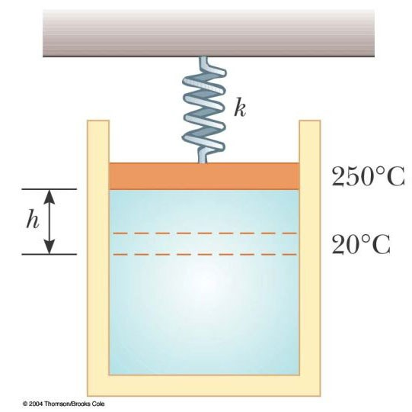
2.00 × 10³ N/m (see Fig. P19.50). With the spring relaxed, the cylinder is filled with 5.00 L of gas at a pressure of 1.00 atm and a temperature of 20.0°C. (a) If the piston has a cross-sectional area of 0.010 0 m² and negligible mass, how high will it rise when the temperature is raised to 250°C? (b) What is the pressure of the gas at 250°C?

(a) PV0 = PV′ ′ T T′

V V Ah′ = +
P P′ = 0 + kh A
P₀ + ^{kh}A  (V Ah PV+ ) = ₀  ^{T}_{T}′
(1.013 10× ⁵ N m 2.00 10 N m² + × ⁵ ³h)
(5.00 10× −3 m 3 +(0.0100 m 2)h)
= (1.013 10× 5 N m 5.00 10 m2)( × −3 3) 523293 K K 
0.169 m
2000h² + 2013 397 0h− = _{h}= −2013 2689± =
4000

kh 5 (2.00 10× 3 N m )(0.169)
(b) P P′ = + = 1.013 10× Pa⁺ 2
A 0.0100 m

1.35 10× ⁵ Pa
P′ =

