CLASS: PHY_____

STUDENT #: _________________

NAME: ______________________
UNIVERSITY OF OTTAWA
Principles of Physics
PHY1321/1331 WINTER 2014
Dr. A. Czajkowski
Assignment 7: FLUIDS: STATICS

Assigned: Nov 4 14:30 Due: November 11:00

1. The small piston of a hydraulic lift has a cross-sectional area of 3.00 cm² and its large piston has a crosssectional area of 200 cm² . What force must be applied to the small piston for the lift to raise a load of 15.0 kN?
(In service stations, this force is usually exerted by compressed air.)
p₁ = p₂ | F1 = F2  A1 A2 | F1 = A1  A₂ | F₂ = ³ 15000N = 225N  200

2 Small piston of a hydraulic lift ( filled with water) has diameter 10 cm.

- What should be the diameter of the large piston so that the force of 100N can just balance the male African Elephant (Loxodonta Africana) of mass =5500kg at the same level.
- What additional force needs to be applied to the small piston to lift elephant to 0.3m above the previous level?

- A = F1 A = 5500(9.8)N (10cm)2 = 5500(9.8)cm2
1 2
F₂ 100N

A₂h = A₁(∆h) ⇒ h = ^{A1} (∆h)
A2
- V = A₂(h +∆h) F = gVρ

ANS: F=

- A spherical aluminum ball of mass 1.26 kg contains an empty spherical cavity that is concentric with the ball. The ball just barely floats in water. Calculate (a) the outer radius of the ball and (b) the radius of the cavity
Outer radius R may be calculated from the following: Inner shell may be obtain using the known density of aluminum
M

cm
M
R
M
R
M
V
M
V
Mg
g
V
Mg
B
water
water
water
water
water
70
6.
4
3
3
4
0
0
3
3
=
=
=
=
=
=
−
=
−
πρ
ρ
π
ρ
ρ
ρ

cm
M
R
r
M
R
r
M
r
R
r
R
V
M
Al
Al
Al
um
Alu
74
5.
4
3
3
4
3
4
3
4
3
4
1
3
4
3
4
3
3
3
3
3
3
3
3
min
=
−
=
−
=
−
=
−
=
=
πρ
ρ
π
π
π
π
ρ
π
π
ρ

- Given are four objects of the same volume. They are all in equilibrium in the tank of water. Rank them according to their masses.
M1
M2
M3
M4
M1 is the smallest of the four as it requires the smallest Buoyant force to stay on the top afloat.M2 and M3 are equal since they both displace the same amount of water and stay submerged in the state of equilibrium. M4 might be of the same mass as M3 (and M3) just placed at the bottom with normal force =0, or it might be bigger than M3, in which case the normal force from the bottom would be bigger than 0)

- Object of mass m and volume V is completely submerged in water by the mass-less, rigid rod attached to the ceiling above open container. What is the tension in the rod when the density of the object is:

- Half of the water density?
m,V
- Same as the water density?
- Twice the water density?

SOLUTION:
T+B−mg=0 T =mg−B T =mg−Vρg

- m = ¹ ρ⇒ρ= ₂ ^{m} T = mg −V2 ^{m} g =−mg
- =ρ⇒ρ= ^{m} m  - V  - = 2ρ⇒ρ= ^{1 m} m  - 2 V |  | T = mg −V ^{m} g = 0  V  T = mg −V ^{m} g = ¹ mg  2V 2
V 2 V V

ANS: a) –mg ( magnitude mg and directed down!)
- 0
- ½ mg (magnitude ½ mg and directed up)

20.0 cm
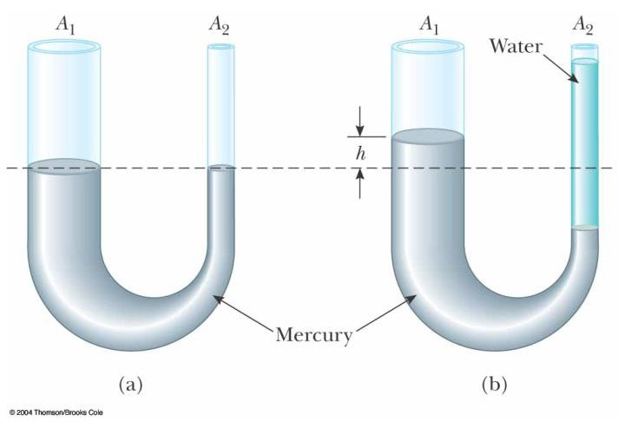
6. Mercury is poured into a U-tube as in Figure P14.18a. The left arm of the tube has cross-sectional area A₁ of 10.0 cm², and the right arm has a crosssectional area A₂ of 5.00 cm². One hundred grams of water are then poured into the right arm as in Figure P14.18b. (a) Determine the length of the water column in the right arm of the U-tube. (b) Given that the density of mercury is 13.6 g/cm³, what distance h does the mercury rise in the left arm?
B
T
mg

(a) Using the definition of density, we have
^{h}w = Am₂^{ρ}water_{water} =5.00 cm 1.00 g cm₂100( g 3) =
(b)
Sketch (b) at the right represents the situation after the water is added. A volume (A h₂ ₂) of mercury
has been displaced by water in the right tube. The additional volume of mercury now in the left tube is
A h₁ . Since the total volume of mercury has not changed,
A¹
A h A h₂ ₂⁼ ₁ or h₂ = h (1)
A₂
At the level of the mercury–water interface in the right tube, we may write the absolute pressure as:
P P= 0+ρwaterghw The pressure at this same level in the left tube is given by

P P= 0+ρHggh h P( + 2) = 0+ρwaterghw

which, using equation (1) above, reduces to ρHgh1+ A1=ρwaterhw
 A2 ρ
or h= waterhw .
ρHg 1
0.490 cm
(1.00 g cm 20.0 cm3)( )
(
)
2
1
A
A
+
(
)
10.0
5.00
+
(
Thus, the level of mercury has risen a distance of h==
3)
13.6 g cm 1
above the original level.

