CLASS: PHY_____

STUDENT #: _________________

NAME: ______________________
UNIVERSITY OF OTTAWA
Principles of Physics
PHY1321/1331 WINTER 2014
Dr. A. Czajkowski
Assignment 5: WORK AND ENERGY

Assigned: Oct14 14:30 Due: October21 19:00

1. A skier of mass 70.0 kg is pulled up a slope by a motor-driven cable. (a) How much work is required to pull him a distance of 60.0 m up a 30.0° slope (assumed frictionless) at a constant speed of 2.00 m/s? (b) A motor of what power is required to perform this task?
- ∑W =∆K , but ∆ =K 0 because he moves at constant speed. The skier rises a vertical
distance of (60.0 m sin30.0 30.0 m) °= . Thus,

2.06 10× ⁴ J
W_{in} =−W _{g} ⁼ (70.0 kg 9.8 m s 30.0 m)(²)( ) == 20.6 kJ .

- The time to travel 60.0 m at a constant speed of 2.00 m/s is 30.0 s. Thus,

W 2.06 10× ⁴ J
686 W
P_{input}= = ==0.919 hp .
∆t 30.0 s

2. A 40.0-kg box initially at rest is pushed 5.00 m along a rough, horizontal floor with a constant applied horizontal force of 130 N. If the coefficient of friction between box and floor is 0.300, find (a) the work done by the applied force, (b) the increase in internal energy in the boxfloor system due to friction, (c) the work done by the normal force, (d) the work done by the gravitational force, (e) the change in kinetic energy of the box, and (f) the final speed of the box.

∑F ma_{y} = _{y} : n−392 N =0
n=392 N
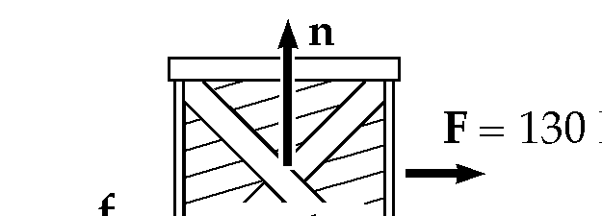

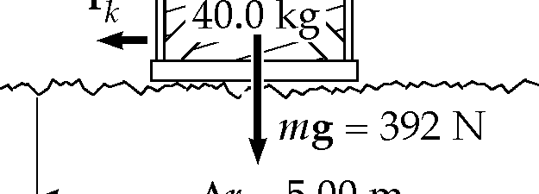
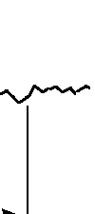
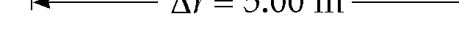

f_{k}=µ_{k}n= (0.300 392 N 118)( ) = N

- W _{F} = ∆F rcosθ= (130 5.00)( )cos0°= 650 J
- ∆E_{int}= ∆ =f x_{k} (118 5.00)( ) = 588 J (c) W_{n} = ∆n r_{cos}θ= (392 5.00)( )cos90°= 0
- W _{g} =mg r∆ _{cos}θ= (392 5.00)( )_{cos}(−90°) = 0
- ∆ =K K Kf− i=∑Wother−∆Eint
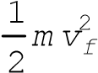− =0 650 J 588 J 0 0− + + = 62.0 J

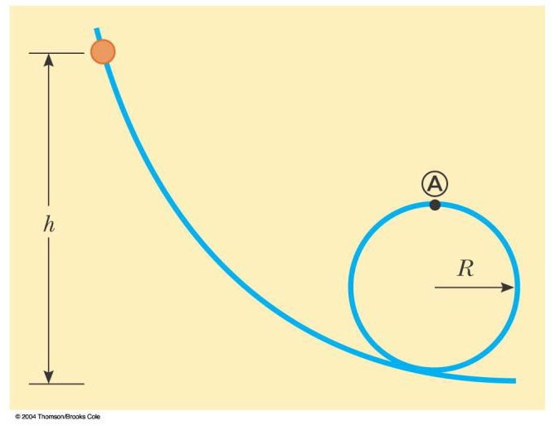
3. A bead slides without friction around a loop-the-loop (Fig. P8.5). The bead is released from a height h = 3.50R. (a) What is its speed at point A? (b) How large is the normal force on it if its mass is 5.00 g?

U K U K_{i}+ _{i}= _{f}+ _{f}: mgh 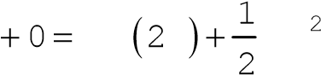mg R mv
g 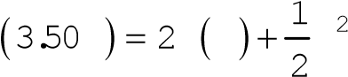R gR v
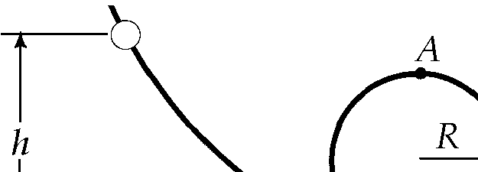
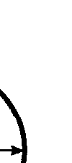
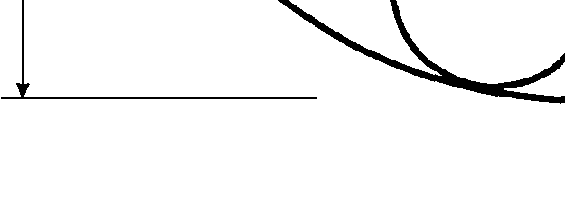

v² v
∑F m= : n mg m+
3.00
v
gR
=

2
=
R R

v²  3.00gR 
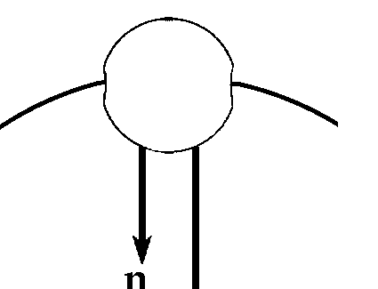

^{n m}=  ^{R} −g m=  _{R} −g=2.00mg n=2.005.00 10 kg 9.80( × ⁻³ )( m s²)
= 0.0980 N downward
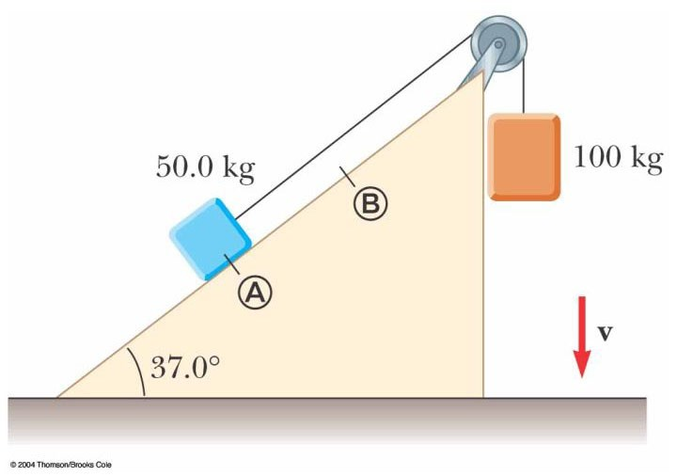
4. A 50.0-kg block and 100-kg block are connected by a string as in Figure P8.36. The pulley is frictionless and of negligible mass. The coefficient of kinetic friction between the 50-kg block and incline is 0.250. Determine the change in the kinetic energy of the 50-kg block as it moves from A to B, a distance of 20.0 m

∑F n mg_{y} = − cos37.0 0°=
∴ =n mgcos37.0 400 N°= f n=µ =0.250400 N 100( ) = N
− ∆ =∆f x E_{mech}
(−100 20.0)( ) =∆U_{A} +∆U_{B} +∆K_{A} +∆K_{B}
∆U_{A} =m gh h_{A} ( f− _{i}) = (50.0 9.80 20.0sin37.0 5.90 10)( )( ° =) × ³
∆U_{B} =m gh h_{B} ( f− _{i}) = (100 9.80 20.0)( )(− ) =−1.96 10× ⁴
∆KB = 1m v vB f( 2− i2) = mB ∆KA = ∆2 K_{A}
(
)
2
2
1
2
A
A
f
i
K
mvv
∆
=
−
2 m_{A}
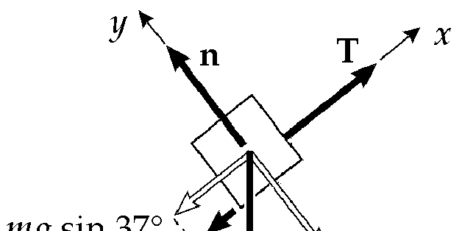

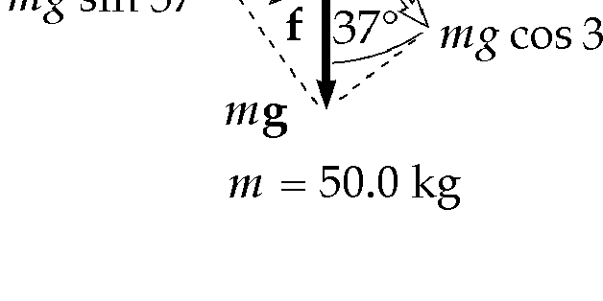
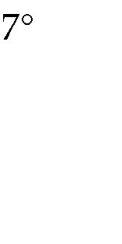
Adding and solving, ∆K_{A} = 3.92 kJ .

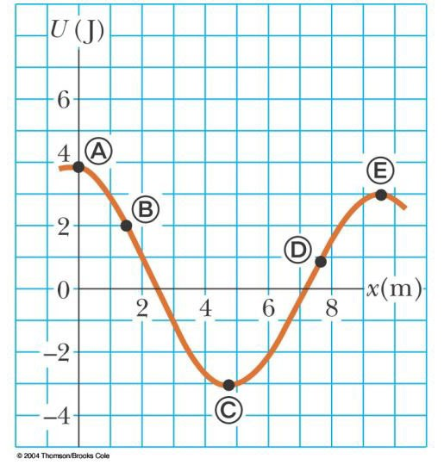
5 For the potential energy curve shown in Figure P8.45, (a) determine whether the force F_{x} is positive, negative, or zero at the five points indicated. (b) Indicate points of stable, unstable, and neutral equilibrium. (c) Sketch the curve for F_{x} versus x from x = 0 to x = 9.5 m.
A
B
C
D
E
x
(
m
)
F
x

P8.45 (a) F_{x} is zero at points A, C and E; F_{x} is positive at point B and negative at point D.

(b) A and E are unstable, and C is stable.

