CLASS: PHY_____

STUDENT #: _________________

NAME: ______________________
UNIVERSITY OF OTTAWA
Principles of Physics
PHY1321/1331 WINTER 2014
Dr. A. Czajkowski
Assignment 4: FORCES II

Assigned: Oct 7 14:30 Due: October14 19:00

1 A coin placed 30.0 cm from the center of a rotating, horizontal turntable slips when its speed is 50.0 cm/s. (a) What force causes the centripetal acceleration when the coin is stationary relative to the turntable? (b) What is the coefficient of static friction between coin and turntable?

- static friction
- ma f n mgˆ ˆ ˆi i j= + + (−ˆj) ∑Fy = = −0 n mg
v2
thus _{n mg}= and ∑F m_{r}= = =_{f n mg}µ µ= . r
2
Then µ= v2 = (50.0 cm s) = 0.0850 .
rg (30.0 cm 980 cm s)( 2)

2 A 4.00-kg object is attached to a vertical rod by two strings, as in Figure P6.11. The object rotates in a horizontal circle at constant speed 6.00 m/s. Find the tension in (a) the upper string and (b) the lower string.

Solution:
F mg_{g} = ⁼ (4 kg 9.8 m s 39.2 N)(²) =
1.5 m
sinθ=
2 m θ= 48.6°
r= (2 _{m cos48.6 1.32 m}) °=

∑F max = x = mv2
r (4 kg 6 m s)( ) ∑ _{y}
² F ma= _{y}
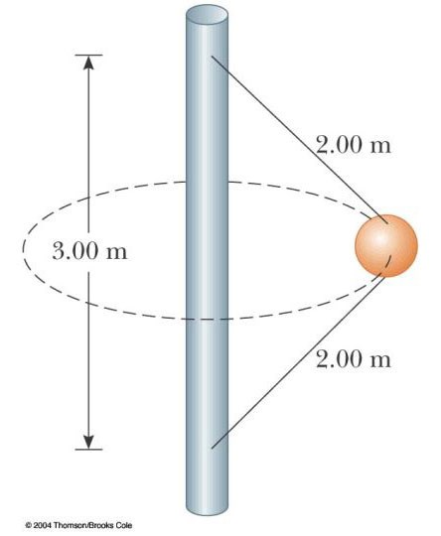
T_{a}cos48.6°+T_{b}cos48.6°= +T_{a}sin48.6°−T_{b}sin48.6 39.2 N 0°−
=

θ

39.2
N

T
a

T

b

forces

v

a

c

1.32 m
39.2 N
109 N T T_{a}− _{b} = =52.3 N
T T_{a}+ _{b} = =165 N sin48.6°
cos48.6°

- To solve simultaneously, we add the equations in T_{a} and T_{b}:
motion
T T T Ta+ b+ a− b =165 N 52.3 N+

217 N
108 N
T_{a}= =
2
56.2 N
- T_{b}=165 N −T_{a}=165 N 108 N− =
3 A crate of eggs is located in the middle of the flat bed of a pickup truck as the truck negotiates an unbanked curve in the road. The curve may be regarded as an arc of a circle of radius 35.0 m. If the coefficient of static friction between crate and truck is 0.600, how fast can the truck be moving without the crate sliding?

_{n mg}= since a_{y} =0
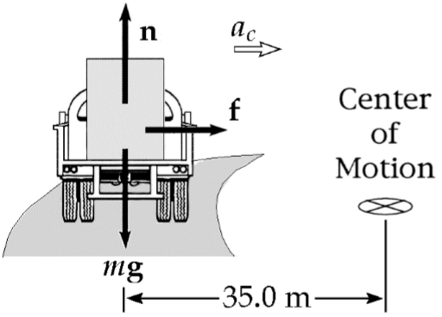
The force causing the centripetal acceleration is the frictional force f.

mv²
From Newton’s second law f ma= _{c}= . r
But the friction condition is _{f}≤µ_{s}n
mv²
i.e., ≤µ_{s}mg r
_{v}≤ µ_{srg} = 0.60035.0 m 9.80( ⁾( m s²) v≤ 14.3 m s

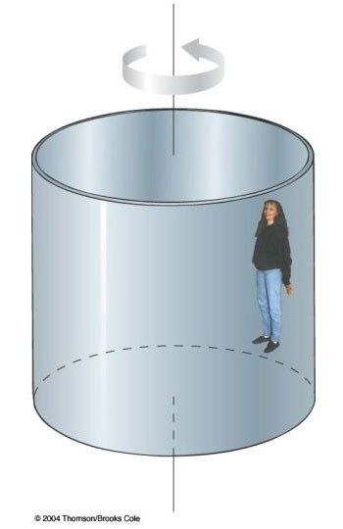
- A ride in an amusement park consists of a large vertical cylinder that spins about its axis fast enough that any person inside is held up against the wall when the floor drops away . The coefficient of static friction between person and wall is µs, and the radius of the cylinder is R. (a) Show that the maximum period of revolution necessary to keep the person from falling is T = (4π²Rµs/g)^{1/2}. (b) Obtain a numerical value for T if R = 4.00 m and µs = 0.400.
How many revolutions per minute does the cylinder make?

mv²
  - n= f mg− =0
R

2πR
_{f}=µ_{s}n v=
T

rev
23.6 min

T =
2
4
s
R
g
πµ

  - _{T} = 2.54 s

# min 2.54 s minrev 1 rev 60 s=   =

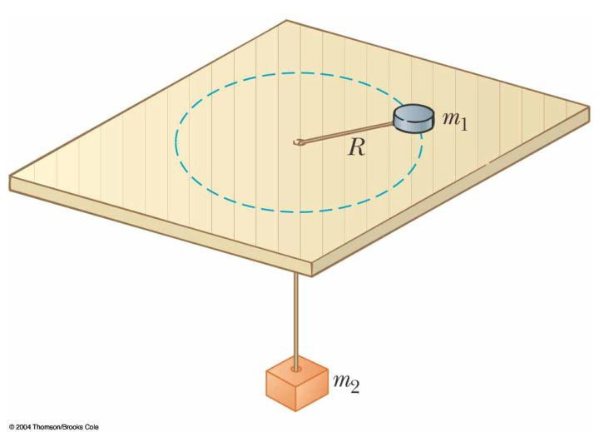
- An air puck of mass m1 is tied to a string and allowed to revolve in a circle of radius R on a frictionless horizontal table. The other end of the string passes through a hole in the center of the table, and a counterweight of mass m2 is tied to it (Fig. P6.58). The suspended object remains in equilibrium while the puck on the tabletop revolves. What is (a) the tension in the string? (b) the radial force acting on the puck? (c) the speed of the puck?

SOLUTIONS:
Since the object of mass m₂ is in equilibrium, ∑F T m g_{y} = − ₂ =0
or ^{T} = m g₂ .

(b) The tension in the string provides the required centripetal acceleration of the puck.

Thus, F T_{c}= = m g₂ .

m v² (c) From
1
c
F
R
=

2
1
1
c
RF
m
gR
v
m
m


=
=




.

we have

