CLASS: PHY_____

STUDENT #: _________________

NAME: ______________________
UNIVERSITY OF OTTAWA
Principles of Physics
PHY1321/1331 WINTER 2014

Dr. A. Czajkowski
Assignment 3: FORCES

Assigned: Sept 30 14:30 Due: October 7 19:00
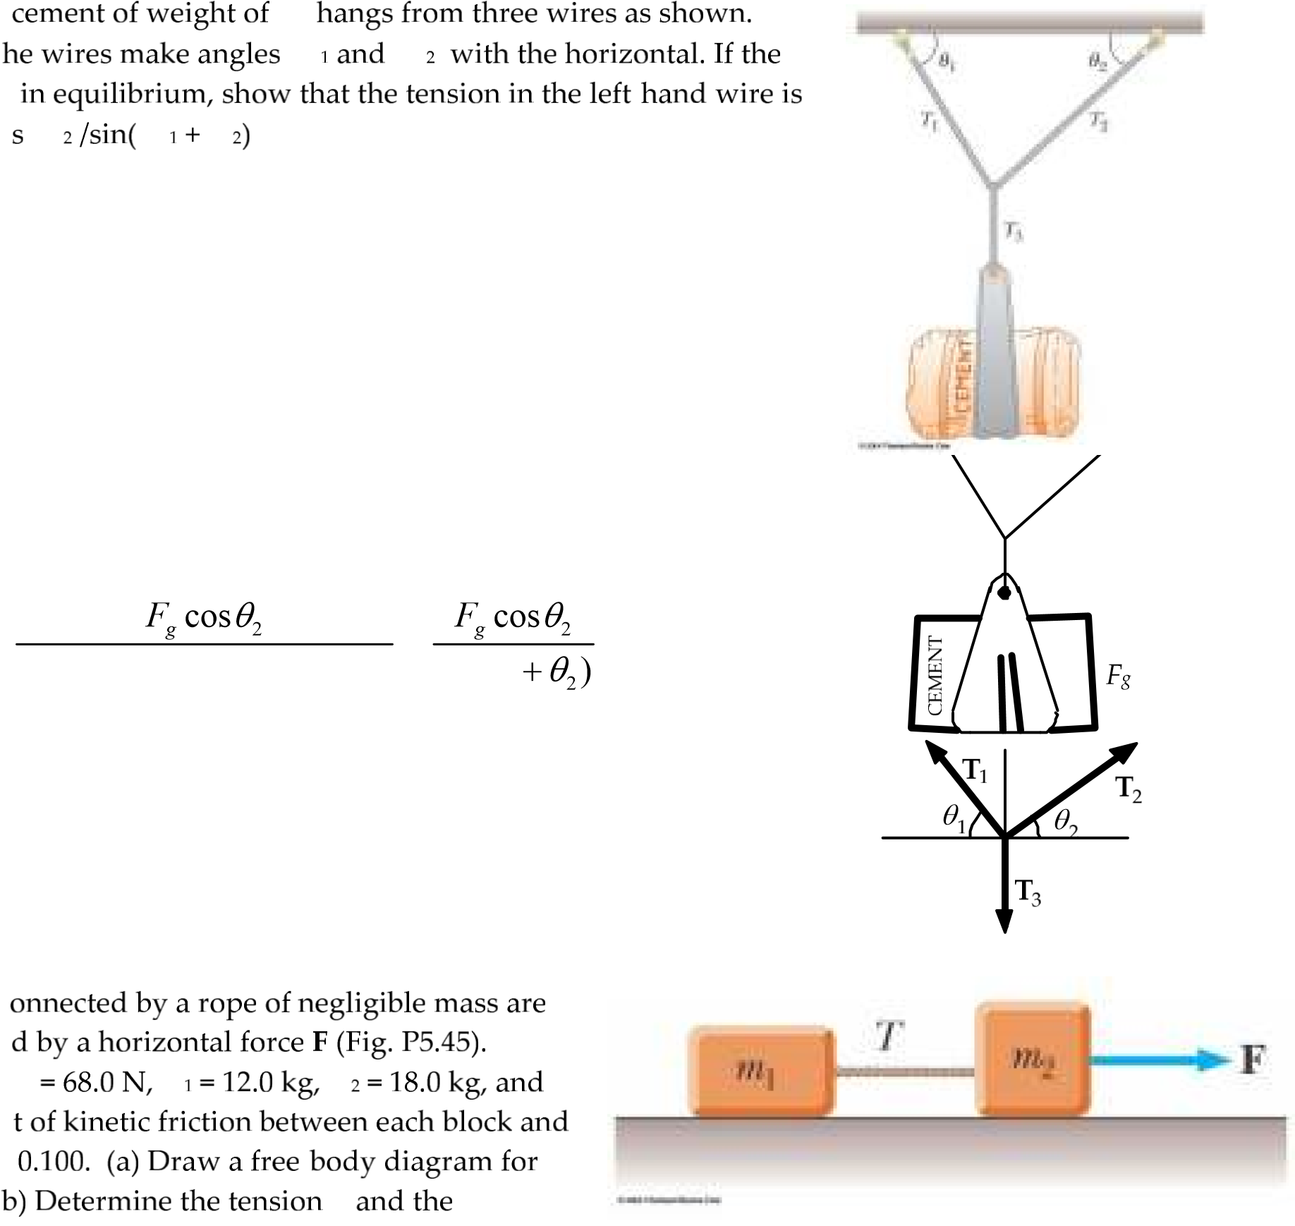
Fg
θ θ
T Fg θ θ θ

T F₃ = _{g} (1)
T₁sinθ₁+T₂sinθ₂ = F_{g} (2)
^{T}₁cosθ₁=^{T}₂cosθ₂ (3)

Eliminate T₂ and solve for T₁
T₁ = =

(sinθ₁cosθ₂ + cosθ₁sinθ₂) sin(θ₁

F m m
T
See Figure to the right

68.0− −T m g m aµ ₂ = ₂ (Block #2)

T m g m a−µ ₁ = ₁ (Block #1)

Adding,

68.0−^{µ}(m m g m m a₁+ ₂) = ( ₁+ ₂)
68.0
1.29 m s²
27.2 N
a= −µg=
T
m
1
m
2
T
F
m
1
n
1
T
m g
1
= 118 N
f = n
k
µ
1
1
m
2
n
2
F
m g
2
= 176 N
f = n
k
µ
2
2
(m m₁+ ₂)
T m a m g= 1 +µ 1 =

3 You are pushing a wooden crate across the floor at constant speed. You decide to turn the crate on end, reducing by half the surface area in contact with the floor. In the new orientation, to push the same crate across the same floor with the same speed, the force that you apply must be about

A four times as great B twice as great C equally great D half as great E one-fourth as great

As the force required before the change of orientation.
/TO GET ANY MARKS YOU NEED TO EXPLAIN YOUR REASONING in FEW SENTENCES BELOW./

g
µs θ P
µ_{s}F_{g} secθ
P =
1−µ_{s} tan θ
P µs
Fg θ
The crate is in equilibrium, just before it starts to move. Let the normal force acting on it be n and the friction force f_{s}.
Resolving vertically: | n F P= _{g}+ sinθ
Resolving Horizontally: | Pcosθ= f_{s}
But, | fs≤µsn
i.e., Pcosθ µ≤ _{s g}(F P+ sin^{θ})
or | P(cosθ µ θ µ− _{s}sin ) ≤ _{s g}F .
Divide by cosθ: | P(1−µ θ µ_{s}^{tan} ) ≤ _{s g}F secθ.
µ_{s g}F secθ
^{P}minimum =
1−µ θ_{s}tan
Then .

- 400100( N sec) θ
(b) P =
- 0.400− tanθ
θ(deg) | 0.00 |  | 15.0 | 30.0 | 45.0 | 60.0
P N( ) | 40.0 |  | 46.4 | 60.1 | 94.3 | 260

If the angle were 68.2° or more, the expression for P would go to infinity and motion would become impossible.

n T+ sinθ−mg=0
With motion impending,
f=µ_{s}(mg T− sin^{θ})

And

µ^{s}mg
So that: T = . cosθ µ θ+ _{s}sin

To minimize T, we maximize cosθ µ θ+ _{s}sin

- θ=tan⁻¹µ_{s}=tan 0.350⁻¹ = 19.3°

0.3501.30 kg 9.80( )( m s²)
- T ==
cos19.3 0.350sin19.3°+ °

Tcosθ µ µ θ− _{s}mg T+ _{s} sin 0=
d
(cosθ µ θ+ ssin ) = =−0 sinθ µ θ+ scos . d_{θ}

4.21 N

