HOW TO DEAL WITH INTEGRALS IN PHYSICS?
Only small part of the material presented here will be actually used in class. This material will be tested during your first midterm – but it will contribute only to part of your bonus grade!
Also, the proper discussion of integrals will be done in your calculus class in this and the next semester.
The basic idea as outlined here is very useful in understanding of many fine points outlined in the textbook.
Finally: nobody ever failed physics due to a lack of full understanding of integrals. Also, nobody missed an A+ for the same reason!

The key concept is that of the value of the linear integral of the function as the area under the curve!

It is expected that everybody to be able to use geometry to find simple integrals this way! Anything beyond this that you might learn from me will be a nice extra!

HOW TO DEAL WITH INTEGRALS IN PHYSICS?

Calculus is integral part of Physics.

Differential and Integral Calculus were invented by Sir. Isaac
Newton and Gottfried Wilhelm Leibniz as a language of
Mechanics. (XVII/XVIII century)

In the XIXth century, calculus was put on a much more rigorous footing by mathematicians such as Gauss, Cauchy, Riemann, and Weierstrass.

From its emergence in XVII century calculus continues to make various concepts in physics easier to comprehend. Trying to avoid calculus in physics typically leads to confusion.

Fortunately, all students in this class already know basic differential calculus from high-school.

It is somewhat different story when it comes to integral calculus.

The proper introduction of the integrals with all necessary tricks and practicing, is left to your calculus Class.

In this class we will need only the key ideas, and the simplest integrals. What follows is an attempt to deliver this content.

Everything that you will ever need to know about integrals in first year Physics:

- Indefinite Integrals as the anti-derivatives

- Geometric Interpretation of the Definite Integral of a
Function

- Fundamental Theorem of Calculus

- Examples

- Integrals frequently encountered in Physics:

Path, Work, Moment of Inertia, Change in Entropy,

THE FIRST FUNDAMENTAL THEOREM OF
CALCULUS

Integrals as the anti-derivatives

If we know how to find derivative of the fundamental function,
we should be able to find the integral If:
f=dF

dt F=∫fdt
We are looking for such function F (called fundamental function) that the function f is its derivative !

Example:
Find integral ∫t³dt

SOLUTION:
f(t)=t³
dF =t³ ? What is the function of F(t) such that
dt

Let’s try F(t)=t4 dF =4t3 dt
not quite what we are looking for! (we want t³ not 4t³ !)
So…
Let’s try F(t) =¼t⁴ and…
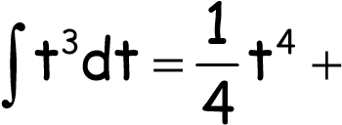const.
Function f(t) | F =∫fdt
A | At + const.
at^{n} | 1  a t^{n+1} +const.  n+1
cos(t) | sin(t) + const.
sin(t) | -cos(t) + const.
1  a t | a ln (t) + const.
aebt | a _{bt} e _{b} + const.

Example: Find ∫fdt in following cases:
c) | f(t) = e^{-3t} |  |  | d) | f(t) = 3e^{3t} − 4e^{-t}
e) | f(t) = 15 4t |  |  | f) | f(t) ⁼ ¹  4t
g) | f(t) = 52t t |  |  | h) | g'(t)  f(t) =  g(t)
i) | f(t) =5 |  |  | j) f(t) = x
a) ^{f(t)} 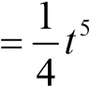 b) f(t) =3t⁷ − 4t⁵ −3t² +7t +3

Geometrical Interpretation of Integral

Many important physics quantities are defined as integrals For example:
x_{f}
W= ∫F_{x}dx
x_{i}
Work done by acting force F_{x} between initial (x_{i}) and final position (x_{f}) is defined as as the area under the curve F_{x}(x):
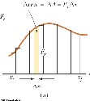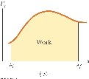

Geometric Interpretation of Integral implies the following’ x2 x3 x3 x2 x1

∫F_{x}dx+ ∫F_{x}dx= ∫F_{x}dx ∫F_{x}dx=−∫F_{x}dx
x1 x2 x1 x1 x2

Examples:
Find the area under the curve and identify the integral in following cases:

Volume(10⁻³m³) Y=f(x)
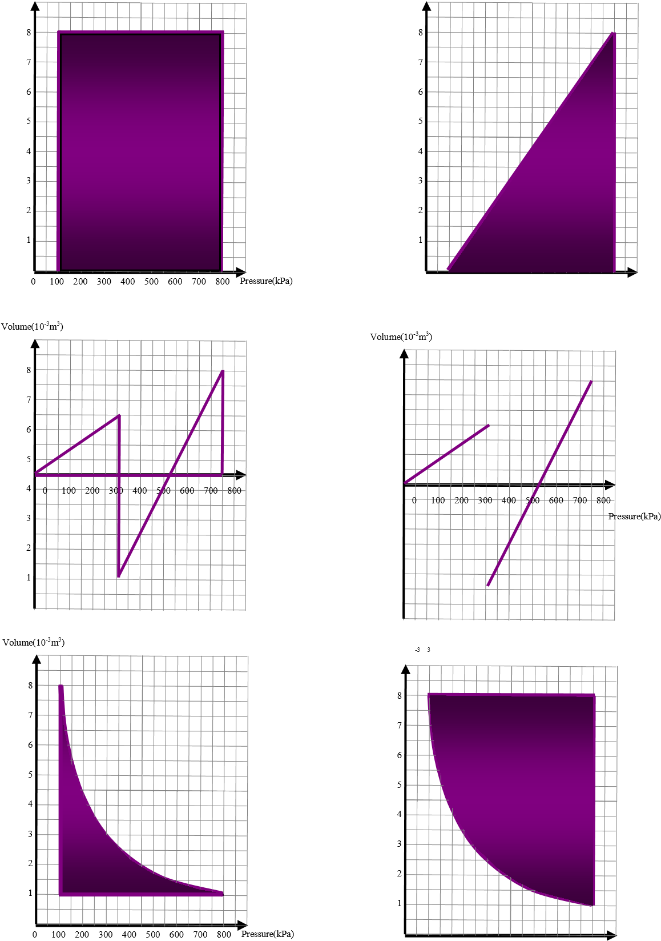
0 100 200 300 400 500 600 700 800 X (m)

8
7
6
5
Pressure(kPa) 4
3
2
1
Volume(10 m )

0 100 200 300 400 500 600 700 800 Pressure(kPa)
THE SECOND FUNDAMENTAL THEOREM OF
CALCULUS

Let’s So that:
f = dF F=∫fdt

dt

t_{f}
∫fdt ⁼[F(t)]^{t}_{ti}^{f} =F(t)^{t}_{t}i^{f} =F(t_{f})−F(t_{i})
ti

To find the value of the definite integral one only needs to find the fundamental function F(t) (antiderivative of f(t) ! ) and then simply substitute the upper and lower limits of integration and subtract them.

Examples:
t_{f}
fdt
Find ∫ in following cases:
t_{i}
b) | f(t) = 3t⁷ − 4t⁵ −3t² +7t +3 t_{i}= 0 |  |  |  |  | t_{f} = 2
c) | f(t) = e^{-3t} |  |  | t_{i}= +∞ |  | t_{f} = 0
d) | f(t) = 3e^{3t} − 4e^{-t} |  |  | t_{i}= 1 |  | t_{f} = 2
e) | f(t) ⁼ ¹₅  4t |  |  | t_{i}= 0 |  | t_{f} = 2
f) | f(t) ⁼ ¹  4t |  |  | t_{i}= 1 |  | t_{f} = 2
a) f(t) = t⁵ t_{i}= 0 t_{f} = 2

Find following
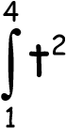dt 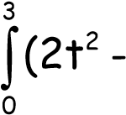1)dt 3 3
1 dt
∫ 2 ^{dt} ∫ t
3t
₋₁ ₀
t_{f}
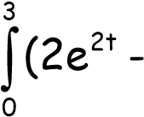
3∫dt 1)dt

t_{i} 350 V_{f} dT dV
∫ 2 nRT∫ V
T
₁₀₀ _{V}i
t t
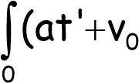
∫(a)dt' )dt'

0

LIST OF SOME OF PHYSICAL QUANTITIES
DEFINED AS INTEGRALS:

Function | Corresponding Integral
W (work) | W =∫^{x}i^{f} Fdx  x
I (Impulse)  (change of linear momentum) | I = ∆p =∫^{t}i^{f} Fdt  t
Moment of Inertia | I= ∫R²dm  Vol
Volume | V= ∫dxdydz  Vol
Speed | t_{f}  v= ∫adt  t_{i}
Distance traveled | t_{f}  ∆x= ∫vdt  t_{i}
Entropy Change | T_{f}  ∆S = ∫ dQT  T_{i}

Final remarks:

This is a small part if what students will be learning in introductory calculus classes.
We focused an simplest integrals and avoided substitutions, integrating by parts etc.
Students will learn that even though it is always possible to find derivative of a function, finding of the integral is frequently tricky or impossible. (An arbitrary integral may be found using numerical methods only!)

This content will be also discussed during part of the first DGD.

KINEMATICS

MOTION IN ONE AND TWO DIMENSIONS

KINEMATICS I
Definitions for 1-D and 3-D motions
Kinematic Equations for 1-D motion
Free Fall
Motion Diagrams

Kinematics II

Projectile Motion
Uniform Circular Motion
Non-uniform Circular Motion
Relative Velocity

5 DEMONOSTRATIONS

- Independent Motion Principle
- Projectile Motion
- Projectile Motion with varying g-value
- Uniform Circular Motion
- Falling Monkey Demo

20 Suggested Problems

10 Quiz Questions

READING ASSIGNMENT: Chapters 2 and 4
Kinematics describes motion while ignoring the agents that caused the motion

Concept of Motion and Independence of Motion Principle

Motion:
Change of position of a body (or body elements) with respect to some selected frame of reference.
Independence of motion principle:
Any complex 3-D motion may be described by considering motion along each of the spatial coordinates independently.

Types of Motion
Translational Motion: all parts (elements) of a body undergo the same change of position do this together.

Rotational Motion: the body changes orientation in space.

Vibrational Motion: the body oscillates about the equilibrium position

Any more complex types of motions might be analyzed as a combination of two or more simple motions:
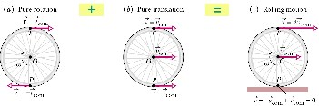
Concept of a Particle /Material Point/
Frequently we can effectively describe the TRANSLATIONAL MOTION of a body using the idealization of a particle (dimensionless point of the same mass as a body,/material point/) By doing it we are neglecting various effects, which are related to the body physical dimensions ( such as air-resistance, buoyancy, as well as possible body rotational effects).

M

Particle (mate
rial point|)

of mass M

Fundamental definitions for 1-D motion: Kinematic Equations – for particle moving under constant acceleration

2
2
0
0
lim
lim
)
(
dt
x
d
dt
dx
dt
d
dt
dv
t
v
a
t
a
t
avg
t
=






=
=
∆
∆
=
→
∆
→
∆
=
•
→
∆
→
∆
=
=
∆
∆
=
=
x
dt
dx
t
x
v
t
v
t
avg
t
lim
lim
0
0
)
(
t
x
erval
int
time
nt
displaceme
v
v
avg
∆
∆
=
=
〉
〈
=
t
s
∆
=
=
interval

time
distance

total
speed

average
1
2
1
2
t
t
v
v
t
v
erval
int
time
velocity
in
change
a
a
avg
−
−
=
∆
∆
=
=
〉
〈
=
i
f
x
x
x
−
=
∆
•

The kinematic equations may be used to solve any probl
em involving one-dimensional motion with

Fundamental definitions for 3-D motion (vectors!):
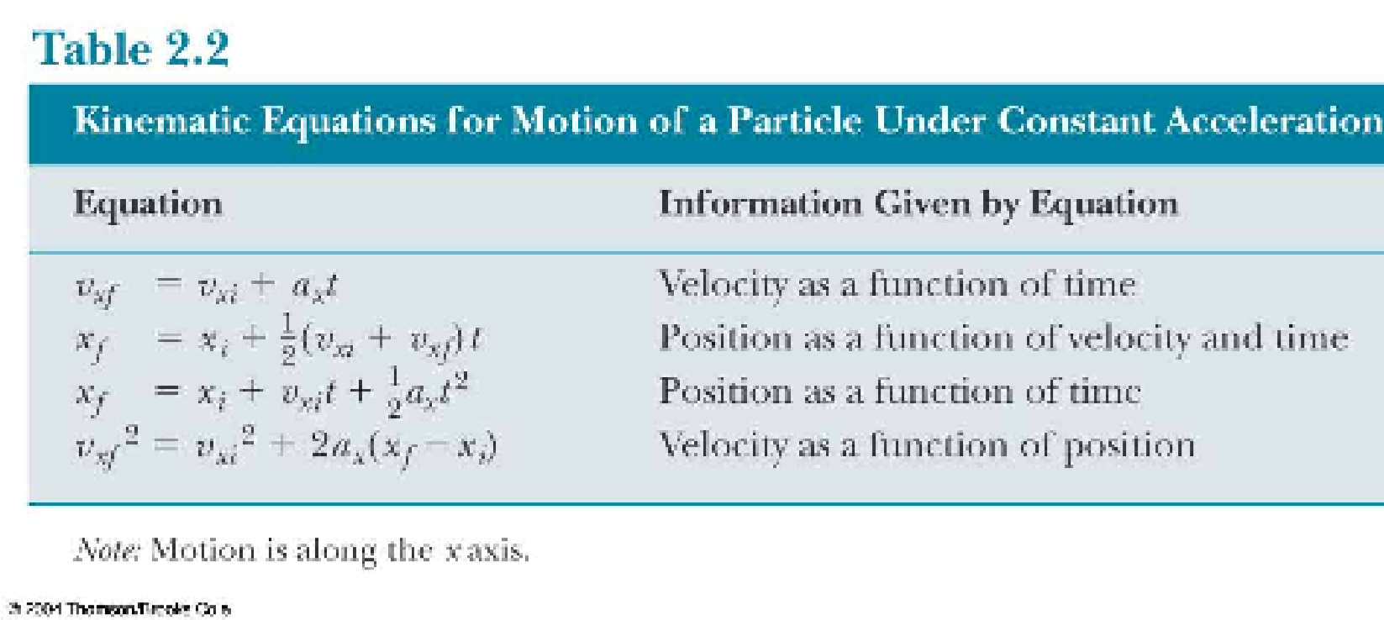
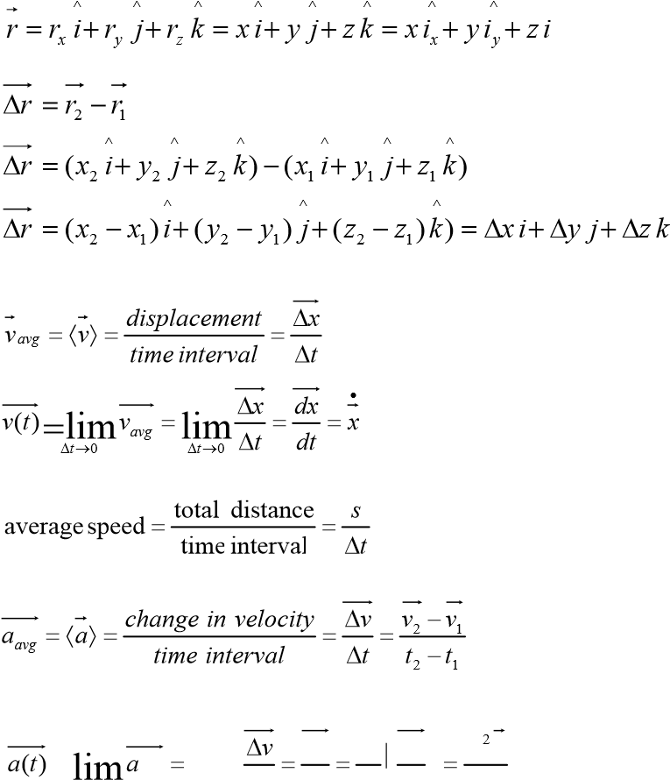
^_{z} r = (r_{x} ,r_{y} ,r_{z} ) = (x, y,z)
- a constant acceleration
- You may need to use two of the equations to solve one problem
- Many times there is more than one way to solve a problem

^ ^ ^ In the case of 3-D motion with constant acceleration the same equations describe each coordinate separately!

=∆t→0 avg lim∆t→0 ∆t dvdt dtd  dxdt  ddt2x

Example of one dimensional motion with constant
acceleration: Free Fall

A freely falling object is any object moving freely under the influence of gravity alone.

It does not depend upon the initial motion of the object

  - Dropped – released from rest
  - Thrown downward
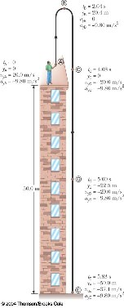
  - Thrown upward
  - The acceleration of an object in free fall is directed downward, regardless of the initial motion
  - The magnitude of free fall acceleration is g = 9.80 m/s2
  - g decreases with increasing altitude
  - g varies with latitude
  - 9.80 m/s2 is the average at the Earth’s surface
  - We will neglect air resistance
  - Free fall motion is constantly accelerated motion in one dimension
  - Let upward be positive
  - Use the kinematic equations with ay = -g = -9.80 m/s2

Example from the textbook

- Initial velocity at A is upward (+) and acceleration is g (-9.8 m/s2)
- At B, the velocity is 0 and the acceleration is g (-9.8 m/s2)
- At C, the velocity has the same magnitude as at A, but is in the opposite direction
- The displacement is –50.0 m (it ends up 50.0 m below its starting point)

READING OF THE x(t), v(t), AND a(t) MOTION DIAGRAMS
Practice questions with the clickers!

Two dimensional motion: projectile motion

In projectile motion the horizontal motion and the vertical motion are independent of each other:
They do not affect each other and may be considered separately

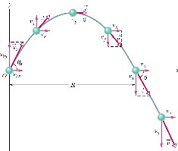

The path of a projectile that is launched at t=0 (x0 =0, y0 =0) with initial velocity v0 (vx,vz) Initial velocity and velocities at various points along its path are shown R= range is the horizontal distance the projectile has traveled when it returns to
its launch height

Projectile Motion Analyzed

Horizontal motion:
There is no acceleration in the horizontal direction.
At any time t, the projectile’s horizontal displacement x-x₀ from the initial position x₀ is given by:

x− x₀ = v_{0x}t = (v₀ cosθ)t ; because v_{0x} = (v₀ cosθ)
Vertical Motion:
This is motion of a body shot up vertically with an initial speed of v_{0y} and experiencing constant gravitational acceleration directed downward
y − y₀ = v_{0y}t − ¹ gt² = (v₀ sinθ)t − ¹ gt² ; because v_{0y} = (v₀ sinθ)
2 2
Equation of the Projectile Trajectory
To find the equation of the projectile’s path (trajectory) of the form y= y(x) we will eliminate t from x = x(t) and y = y(t) equations

- =(v0 cosθ)t + x0x0 x
= 0 t = y₀ = 0 v0cosθ2
- = (v₀ sinθ)t −gt + y₀

which leads to the | following expression for y as a function of x
y = (v₀ sinθ) ^{x} − ¹ g( ^{x} )² = (tanθ)x − ^{g} ₂ x² THIS IS THE EQUATION
v₀ cosθ 2 v₀ cosθ 2(v₀ cosθ)
OF A PARABOLA!!

= θ − g 2
y (tan )x θ 2 x 2(v₀ cos )

- Find the algebraic expression for the horizontal range

The horizontal range R of the projectile is the horizontal distance the projectile has traveled when it returns to its initial (launch) height.
To find R let’s put (x-x₀) = R, and y-y₀ =0 in our equations for projectile motion

R = x− x0 = (v0 cosθ)t

R = t
(v₀ cosθ)
0 = y − y₀ = (v₀ sinθ)t − ¹ gt² ₂
0 = (v0 sinθ) (v0 cosR θ) t − 12 g2(v0 cosR θ2)
0 = (v0 sinθ) (v0 cosR θ) t − 12 g (v0 cosR θ)
Rv₀ sinθ gR²
=
v₀ cosθ 2(v₀ cosθ)²
₂
Rsinθ= 2R g 2 ÷ R  cosθ 2v₀ (cosθ)  cosθ
÷
sinθ= 02R g  2v02gcosθ
2v cosθ 
- 2
2v₀ sinθcosθ v₀ sin2θ
R = =
g g
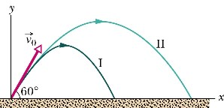
2 Show that the vertical velocity component v_{y} obeys the equation for the free fall 2[(v₀ sinθ)t]g = 2[(y − y₀ )+ gt² ]g = 2(y − y₀ )g +(g t)²
[v_{y} (t)]² = (v₀ sinθ− gt)² = (v₀ sinθ)² −2(v₀ sinθ)gt +(gt)² v_{y}( )t = v_{0y} − gt = (v₀ sinθ)− gt
[v_{y} (t)]² = (v₀ sinθ)² −[(2(y − y₀ )g +(g t)² ]+(gt)²
[v_{y} (t)]² = (v₀ sinθ)² −(2(y − y₀ )g −(g t)² +(gt)²

[v_{y} (t)]² = (v₀ sinθ)² −2(y − y₀ )g

Effects of the Air: Real Projectiles

 | VACUUM  II | AIR  I
RANGE | 177m | 99m
MAXIMUM  HEIGHT | 77m | 53m
TIME OF FLIGHT | 7.9s | 6.6s

In reality the projectile motion is more complex than we assumed. There is a air resistance depending on the shape of the projected object and proportional to the square of the speed Real ballistic trajectories are not parabolic!

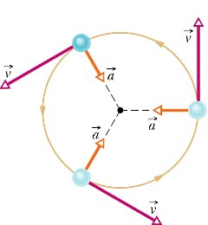
Uniform Circular Motion

Particle is in uniform circular motion if it travels around a circle a circular arc at constant (uniform
)speed

Even though the speed is constant the particle is accelerating.

Magnitude of centripetal acceleration

2 v a = a=
r
Period of rotation (T)

_{T =} 2πr
v Circular Motion

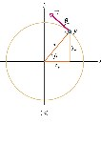
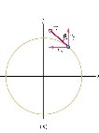
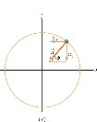
Derive equations for uniform circular motion.

This means that
acceleration vector
a
is directed along the radius
r
, toward
the circle’s centre!
^
^
)
(
)
(
j
r
x
v
i
r
y
v
v
p
p
+
−
=
^
^
^
^
)
sin
(
)
cos
(
)
(
)
(
j
v
r
v
i
v
r
v
j
v
r
v
i
v
r
v
a
x
y
Θ
−
+
Θ
−
=
+
−
=
r
v
r
v
r
v
r
v
a
a
a
a
a
a
y
x
y
x
2
2
2
2
2
2
2
2
2
2
2
2
)
cos
(
)
sin
(
)
sin
(
)
cos
(
=
Θ
+
Θ
=
=
Θ
−
+
Θ
−
=
+
=
+
=
=
θ
ϕ
θ
θ
θ
ϕ
=
=
−
−
=
=
tan
)
cos
(
)
sin
(
tan
2
2
r
v
r
v
a
a
x
y
Show that the acceleration direction is truly towards the centre.

^ ^ ^ ^ v = v_{x} i+v_{y} j = (−vsinΘ)i+(vcosΘ) j

cos Θ vvy Θ = − vvx andvy = dydt ;vx = dxdt = ;sin

^{x}p Θ= y^{p} cos Θ= and sin
r r

Non-uniform Circular Motion

The radial acceleration associated with changes in the direction of the velocity is

ar = v2
r
When the speed varies, there is also an acceleration along the tangent to the path. This is tangential acceleration

a =
dt
dv
t

So that total acceleration is:
a(t) = a_{r} + a t

In the special case of motion in a circle, it is convenient to use polar unit vectors

a(t) = a_{r} r^ + dvt θ^ dt
Θ is a unit vector tangent to the circle at each instant,

r is a unit vector directed radialy outward the centre of motion

Magnitudes of these vectors are constant (=1) but their directions change constantly in time

Relative Motion

Two observers moving relative to each other generally do not agree on the outcome of an experiment
For example, observers A and B below see different paths for the ball

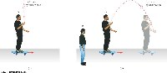

The motion of any body has to be described relative to some frame of reference such as ground, centre of the Earth etc.

In our work up to this point we have always assumed that this frame of reference by itself is not moving. This is often not realistic assumption ( everything is in motion!), and it is often necessary to describe motion of one body with respect to another body moving with respect to “resting “frame of reference.
Two observers A and B watch the same car P passing by. Observer B moves with a constant speed v_{BA} with respect to A.
At some instant both A and B measure the P position and velocity. How will their observation relate to each other?
Taking derivative of both sides of this equation we get:

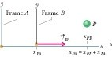
xPA = xBA + xPB

dxPA = dxPB + dxBA dt dt dt
vPA =vPB +vBA Relative Motion

What about the acceleration?
To find out let’s take derivative of the equation describing velocity relationship:
vPA = vPB +vBA
dvPA dvPB dvBA vBA=const dvPA dvPB
= + ⇔ = ⇔ aPA = a dt dt dt dt dt PB

CONCLUSION:
Observers in two different reference frames, moving at constant velocity relative to each other, will measure the same acceleration for moving particle.
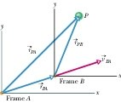
Relative motion in 3-D:

PB
BA
PA
r
r
r
+
=
BA
PB
PA
v
v
v
+
=
PB
PA
PB
PA
const
v
BA
PB
PA
a
a
dt
v
d
dt
v
d
dt
v
d
dt
v
d
dt
v
d
BA
=
⇔
=
⇔
+
=
=

We may easily generalize these 1-D results to 3-D

Suggested Problems

1. Particle moves from initial position r_{i} to final position r_{f} in 2.0s
^ ^ ^ ^ ^ ^ r_{i} = 2i−6 j+ k ; r_{f} = 4i+7 j−k

a) Find average velocity vector during this move, b) Find the magnitude of the average velocity vector

2. Time dependent vector r(t) describes the position of the Particle A at any instant of time:
2 ^ ^ ^ r_{i} (t) = 2t i−6t j+ 2t k
- Find x ,y, z components of instantaneous velocity v(t) vector.
- Find magnitude of the velocity vector at time t=2s

- An ion’s position vector is initially r = 5.0i - 6.0j +2.0k, and 10s later it is r = -2.0i + 8.0j -2.0k, all in meters. What is its average velocity during this time interval ?

- The position of an electron is given by r = (3.00t) i – (4.00t) j +(2.00)k,/ t in second and r in meters
/
  - What is the electron’s velocity v?
  - What is electron’s velocity at t=2s (in unit-vector notation)?
  - What is a magnitude and angle relative to the positive direction of the x axis?

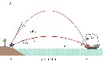
- Pirate ship 560m from a fort defending the harbor entrance of an island. A defense canon, located at sea level, fires grenade at initial speed of v0= 82m/s.
  - At what angle from the horizontal must grenade be fired to hit the ship?
  - How far should the pirate ship be from the cannon if it is to
be beyond the maximum range of the cannonballs?

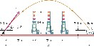
- Figure below illustrates the flight of a human cannonball over three Ferris wheels located as shown and each 18 meters high. The acrobat is launched with speed v0 =26.5m/s at the angle of θ0 =53o up from the horizontal and with an initial height of 3.0 meters above the ground. The net on which he lands is at the same height.

- An Earth satellite moves in a circular orbit 640 km above Earth’s surface with a period of 98 .0 min. What are:
  - Speed
  - The magnitude of centripetal acceleration of the satellite

- When a large star becomes a supernova, its core may be compressed so tightly that it becomes a neutron star, with a radius of about 20km. The neutron star rotates once every second.
  - What is the speed of a particle on the stars equator
  - What is the magnitude of the particle’s centripetal acceleration
  - What is the speed and magnitude of the particle’s centripetal acceleration if it is at 45o above the equator.

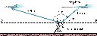
- A radar station detects an airplane approaching directly from the east. At first observation the range to the plane is 360m at 40o above the horizon. The airplane is tracked for another 123o in the vertical east-west plane, the range at final contact being 790 m. Find the displacement of the airplane during the period of observation.

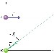
- Particle A moves along the line y=30 m with a constant velocity v of magnitude 3.0m/s and directed parallel to the positive x axis. Particle B starts at origin with zero speed and constant acceleration a (of magnitude0.40m/s2) at the same instant that particle A passes the y axis. What angle θ between a and the positive axis would result in a collision between these two particles?

- What angle of launch results in a maximum horizontal range for projectile?

- The speed of a car moving along a circular track of radius 50m is increased uniformly in time.
When the car is east of the center, its total acceleration is 10m/s2 at 37o W of N. (a) Find its radial and tangential accelerations (b) How long does it take to return to the same point?

- a) Object A has a velocity of (2i+j) m/s while object B has a velocity of (-i+5j)m/s.
What is the velocity of B relative to A?
b) Object A is moving east at 3m/s while object B is moving north at 4m/s What is the velocity of A relative to B?

- The maximum height from which a person can safely jump is 2.45 m.
What is the maximum allowable landing speed for a parachutist

- A body covers 64% of the total distance fallen in the last second. From what height did it fall?

- Cheetah can reach 105km/h is 2 s and maintain this speed for 15 s .After this time it must rest. An antelope can reach 90km/h in 2 s and sustain it for a long time. Suppose they are initially separated by 100m and the antelope reacts in 0.5s.
  - can cheetah get the antelope?
  - if not, how close does it get? Assume both start from the rest.

- A climber can estimate the height of a cliff by dropping a stone and noting the time at which he hears the impact on the ground. Suppose this time is 2.5s. Find the height of the cliff under the following conditions:
  - by assuming the speed of sound is large enough to be ignored
  - by taking the speed of the sound to be 330m/s.

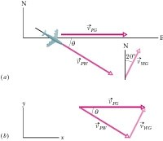
- A plane moves due east (directly toward the east) while the pilot points the plane somewhat south of east, toward a steady wind that blows from the northeast. The plane has velocity vPW relative to the wind with an airspeed (speed relative to the wind) of 215km/h directed at angle θ south of east.
The wind has velocity vWG relative to the ground with a speed of 65.0km/h directed 20o east of north. What is the velocity vPG of the plane relative to the ground, and what is θ?

- A car speeds up as it turns from traveling due south to heading due east. When exactly halfway around the curve, the car’s acceleration is 20° north of east. What are the radial and tangential components of the acceleration at that point?

20. A 5.0-m-diameter merry-go-round is initially turning with a 4.0 s period. It slows down and stops in 20 s.
- Before slowing, what is the speed of a child on the rim?
- How many revolutions does the merry-go-round make as it stops?

DEMONSTRATION RELATED PROBLEMS

The falling monkey is shot at by a projectile launched at 40 degrees above horizontal at horizontal distance of 4 meters from the tree.
Knowing that the monkey is hit while being 30cm below the branch from which it was released, find the speed of the bullet.

The projectile is launched on the inclined smooth surface towards the target. The launcher barrel is at (0,0) the target is at (50, 25), the speed of the projectile is 10cm/s. The projectile is aimed at 70 deg above the horizontal find the angle of the incline for which the projectile makes it into the target.

FORCES NEWTONS LAWS OF DYNAMICS

What is Force?

Categories of Forces and Fundamental Forces In Nature
Newton’s Laws of Dynamics
Newton’s Law of Universal Gravitation
Weight
Other Forces Frequently Encountered in Mechanics:
Normal Force, Apparent Weight, Tension
Friction, Centripetal Force
Fictitious Forces
Free Body Diagrams
DEMO 1: Inertia
DEMO 2: Action-Reaction
DEMO 3: Second Law
DEMO 4: Fish scale for tension measurements
DEMO 5: Friction Demonstration
DEMO 6: Loop the Loop
DEMO 7: Free pulleys and mechanical advantage

10 quiz questions

14 Suggested Problems

READING ASSIGNMENT: Chapters 5 and 6

What is Force?
( at this level we do not have a good answer…)
Forces are what cause any change in the velocity of an object. A force is that which causes an acceleration (Textbook “definition”)

The net force is the vector sum of all the forces acting on an object.
Also called total force, resultant force, or unbalanced force

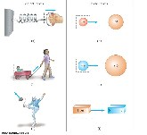
Classes of Forces /superficial categorization/
- Contact forces involve physical contact between two objects
- Field forces act through empty space – No physical contact is required

Thing to remember: On the most fundamental level all forces are field forces !!

Fundamental Forces in Nature
All interactions known in nature may be explained using the following four fundamental forces:
- Gravitational force
  - Between two objects with masses
- Electromagnetic forces
  - Between two charges
(responsible for all of the chemistry and bio-chemistry)
- Strong force
  - Between quark particles (hold nuclei together)

- Weak forces
  - Between Leptons,

Newton’s Laws of Mechanics

I Law
- If an object does not interact with other objects, it is possible to identify a reference frame in which the object has zero acceleration
•
  - This is also called the law of inertia
  - It defines a special set of reference frames called inertial frames,
  - We call this an inertial frame of reference
  - Any reference frame that moves with constant velocity relative to an inertial frame is itself an inertial frame
  - A reference frame that moves with constant velocity relative to the distant stars is the best approximation of an inertial frame
  - We can consider the Earth to be such an inertial frame although it has a small centripetal acceleration associated with its motion

- In the absence of external forces, when viewed from an inertial reference frame, an object at rest remains at rest and an object in motion continues in motion with a constant velocity

  - Newton’s First Law describes what happens in the absence of a force
  - Also tells us that when no force acts on an object, the acceleration of the object is zero

Inertia and Mass

- The tendency of an object to resist any attempt to change its velocity is called inertia
- Mass is that property of an object that specifies how much resistance an object exhibits to changes in its velocity
- Mass is an inherent property of an object
- Mass is independent of the object’s surroundings
- Mass is independent of the method used to measure it
- Mass is a scalar quantity
- The SI unit of mass is kg

Mass vs. Weight

- Mass and weight are two different quantities
- Weight is equal to the magnitude of the gravitational force exerted on the object – Weight will vary with location

II Law
When viewed from an inertial frame, the acceleratio
n of an object is directly proportional
to the net force acting on it and inversely proport
ional to its mass
-
Force is the cause of change in motion, as measure
d by the acceleration

a
m
F
F
i
=
=
∑

∑F is the net force: this is the vector sum of all the forces acting on the object
Newton’s Second Law can be expressed in terms of components:
∑F_{x} =ma_{x} ∑F_{y} =ma_{y} ∑F_{z} =ma_{z}

III Law
•
F₁₂ | = | −F₂₁
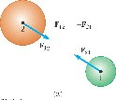
• If two objects interact, the force F12 exerted by object 1 on object 2 is equal in magnitude and opposite in direction to the force F21 exerted by object 2 on object 1

Note on notation: F_{AB} is the force exerted by A on B

Newton’s Third Law, Alternative Statements

- Forces always occur in pairs
- A single isolated force cannot exist
- The action force is equal in magnitude to the reaction force and opposite in direction
One of the forces is the action force, the other is the reaction force
It doesn’t matter which is considered the action and which the reaction

The action and reaction forces must act on different objects and be of the same type

Units of Force: newton (SI) 1N=kgm/s²

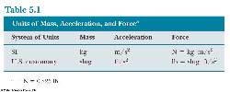

Newton’s
Universal Law of Gravity
r
r
r
M
M
G
F
2
2
1
=
Two point-like masses attract each other with the force that is proportional to the product of their masses divided by the square of the distance between them.

G = 6.673(10) x10⁻¹¹ Nm²/kg² gravitational constant M1, M2= masses 1 and 2 r= distance between M1 and M2

The Universal Law is also true in this form for the spherical distribution of masses.
(spheres, with r being the distance between their centres)

Using it Newton was able to obtain Kepler’s Laws
(which were established by Kepler based on Tycho de Brache observations)
Being able to describe interaction between the apple and the Earth by the same mechanism (by the same formula in fact!) as the movement of planets orbiting the Sun, was a great success of Newton which marked the beginning of modern science.

Weight (F_{g}, W, mg)

Using The Universal Law of Gravitation we may find the the gravitational force, Fg, with which object of mass m interacts with Earth.
If the object is close to the Earth surface ( within few kilometers) we may write:

gm
m
R
M
G
R
m
M
G
F
Earth
Earth
Earth
Earth
_{g}
=
=
=
2
2

Where Fg is the force that the earth exerts on an object. This force is directed toward the center of the earth
- Its magnitude is called the weight of the object
- Weight = |Fg|= mg
•
M  G Earth₂  REarth | =g
- g and therefore the weight, is less at higher altitudes (bigger R)
- Because it is dependent on g, the weight varies with location
- Weight is not an inherent property of the object

Tension
When a cord ( or a rope or other such object) is attached to a body and pulled taut, the cord pulls on the body with a force T directed away from the body and along the cord. This force is called tension.
The cord is said to be in a state of tension (or to be under tension)
The tension in the cord is the magnitude T of the force on the body. For example, if the
force on the body has magnitude T=100N, then the tension in the cord is 100N

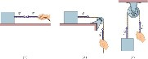

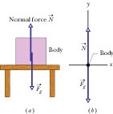
Normal Force
When a body presses against the surface, the surface (even seemingly rigid surface) deforms and pushes back on the body with a normal force N that is perpendicular to the surface.

Apparent Weight
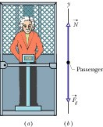
The weight W of a body is equal to the magnitude Fg of the gravitational force on the body. The weight of a body must be measured when the body is not accelerating vertically relative to the ground.
If one measures the weight in an accelerating frame of reference it will be different.
∑

We will call it apparent weight. The magnitude of the apparent weight of the body is the magnitude of the
resultant force exerted on it by a supporting surface

Forces of Friction

- When an object is in motion on a surface or through a viscous medium, there will be a resistance to the motion
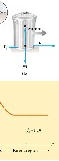
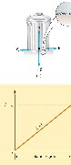
  - This is due to the interactions between the object and its environment
- This resistance is called the force of friction

- Static friction acts to keep the object from moving
- If F increases, so does ƒs
- If F decreases, so does ƒs
- ƒs ≤ µ_{s} n where the equality holds when the surfaces are on the verge of slipping
  - Called impending motion

- The force of kinetic friction acts when the object is in motion
- Although µk can vary with speed, we shall neglect any such variations
- ƒk = µk n

- Friction is proportional to the normal force
  - ƒs = µs n and ƒk= µk n
These equations relate the magnitudes of the forces, they are not vector equations

The force of static friction is generally greater than the force of kinetic friction The coefficient of friction (µ) depends on the surfaces in contact
The direction of the frictional force is opposite the direction of motion and parallel to the surfaces in contact
The coefficients of friction are nearly independent of the area of contact
Centripetal Force


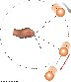
A force, Fr , is directed toward the center of the circle This force is associated with an acceleration, ac
Applying Newton’s Second Law along the radial direction gives

2
= = v
F mac m r

A force causing a centripetal acceleration acts toward the center of the circle
It causes a change in the direction of the velocity vector If the force vanishes, the object would move in a straight-line path tangent to the circle
The force causing the centripetal acceleration is sometimes called the centripetal force
This is not a new force, it is a new role for a force

It is a force acting in the role of a force that causes a circular motion
(We will see that any force could take that role : Tension Normal Force, Weight, Friction as well as components of these forces!)

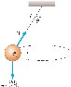
We will analyze following three cases in which the role of the centripetal force is played by various forces:

Conical Pendulum
The object is in equilibrium in the vertical direction and undergoes uniform
circular motion in the horizontal direction v is independent of m

v = Lgsinθ θtan

Motion in a Horizontal Circle
- The speed at which the object moves depends on the mass of the object and the tension in the cord
- The centripetal force is supplied by the tension
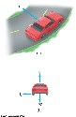
v = Tr_{m}

Object (car) negotiating horizontal (flat) curve
The force of static friction supplies the centripetal force.
The maximum speed at which the car can negotiate the curve is

v = µgr
Note, this does not depend on the mass of the car
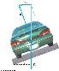
Object (car) negotiating banked curve

These are designed with friction equaling zero
There is a component of the normal force that supplies the centripetal force
v2 tanθ= _{rg}

Loop-the-Loop
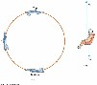
This is an example of a vertical circle
At the bottom of the loop (b), the upward force experienced by the object is greater than its weight

n_{bot} = mg1+ ^{v2} 
 rg 
At the top of the circle (c), the force exerted on the object is less than its weight

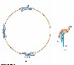
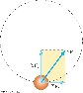
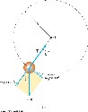
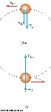
 v2  ntop = mg −1
 rg 
Non-Uniform Circular Motion
The acceleration and force have tangential components

F_{r} produces the centripetal acceleration
F_{t} produces the tangential acceleration ΣF = ΣF_{r} + ΣF_{t}

- The gravitational force exerts a tangential force on the object
– Look at the components of Fg
- The tension at any point can be found

T = m v2 + g cosθ
 R 

Top and Bottom of Circle

Find the minimum v_{top} for which the bob will make it through the highest position

EXAMPLES OF FREE BODY DIAGRAMS:
starting point for problem solving in dynamics
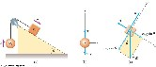
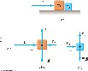
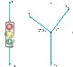
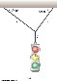
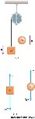
2
1

4

3

Fictitious Forces
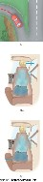
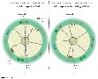
A fictitious force results from an accelerated frame of reference A fictitious force appears to act on an object in the same way as a real force, but you cannot identify a second object for the fictitious force

“Centrifugal” Force
From the frame of the passenger (b), a force appears to push her toward the door
From the frame of the Earth, the car applies a leftward force on the passenger
The outward force is often called a centrifugal force
– It is a fictitious force due to the acceleration associated with the car’s change in direction

“Coriolis Force”

This is an apparent force caused by changing the radial position of an object in a rotating coordinate system
The result of the rotation is the curved path of the ball

Although fictitious forces are not real forces, they can have real effects
- Examples:
  - Objects in the car do slide
  - You feel pushed to the outside of a rotating platform
  - The Coriolis force is responsible for the rotation of weather systems and ocean currents

Fictitious Forces in Systems moving with linear acceleration

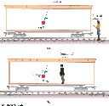
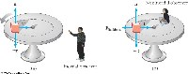
- The inertial observer (a) sees
∑Fx = T sinθ= ma

∑F_{y} = T cosθ−mg = 0

- The noninertial observer (b) sees

∑F 'x = T sinθ− Ffictitious = ma
∑F '_{y} = T cosθ− mg = 0

Fictitious Forces in a Rotating System

According to the inertial observer (a), the tension is the centripetal force
₂
T = mv r
The non-inertial observer (b) sees
2
mv
T − F_{fictitious} = T − r = 0

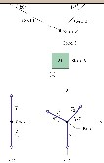
Suggested Problems
- A block B of mass M=15.0 kg hangs by a cord from a knot K of mass mk, which hangs from a ceiling by means of two other cords. The cords have negligible mass, and the magnitude of the gravitational force on the knot is negligible compared to the gravitational force on the block. What are the tensions in the three cords?

- A 70-kg person stands on a scale in an elevator that accelerates upward at 2 m/s2.
- What is the scale reading?
- What is the person’s weight?
- According to the third law, what is the reaction to the person’s weight? On what body does it act?

3 A person of mass 75 kg stands on a scale in an elevator. What can you infer about the motion if the scale reads:
(a) 735 N? (b) 600 N? (c) 900 N?

- A rocket has a net acceleration of 2.4 m/s2 directed at 60 degree above the horizontal. What is the apparent weight of an 80 kg astronaut near the earth’s surface?

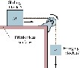

- A block S (the sliding block) has mass M=3.3 kg. The block is free to move along a horizontal frictionless surface such as an air table. This first block is connected by a cord that wraps over a frictionless pulley to a second block H (the hanging block), with mass m = 2.1 kg. The cord and pulley have negligible masses compared to the blocks (they are “massless”). The hanging block H falls as the sliding block S accelerates to the right.
Find
(a) the acceleration of the sliding block, (b) the acceleration of the hanging block, (c) the tension in the cord.

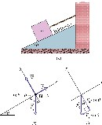
- A cord holds a stationary block of mass m=15 kg, on a frictionless plane that is inclined at angle θ=27º (a) What are the magnitudes of the force T (vector) on the block from the cord and the normal force N (vector) on the block from the plane?

(b) We now cut the cord.
As the block then slides down the inclined plane, does it accelerate? If so, what is it acceleration?

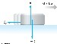
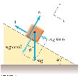
- A hockey puck on a frozen pond is given an initial speed of 20.0m/s. If the puck always remains on the ice and slides 115m before coming to rest, determine the coefficient of kinetic friction between the puck and the ice

- Suppose that the block is placed on a rough surface inclined relative to the horizontal, as shown. The incline angle is increased until the block starts to move. Show that by measuring the critical angle θ_{C} at which this slipping just occurs , we can obtain µ_{s}.

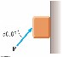

- A block of mass 3.00 kg is pushed up against a wall by a force P that makes a 50.0° angle with the horizontal as shown in Figure. The coefficient of static friction between the block and the wall is 0.250. Determine the possible values for the magnitude of P that allow the block to remain stationary.

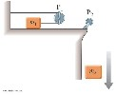
- An object of mass m1 on a frictionless horizontal table is connected to an object of mass m2 through a very light pulley P1 and a light fixed pulley P2 as shown in Figure P5.34. (a) If a1 and a2 are the accelerations of m1 and m2, respectively, what is the relation between these accelerations? Express (b) the tensions in the strings and (c) the accelerations a1 and a2 in terms of the masses m1, and m2, and g.

- A train of four blocks is being pulled across a frictionless floor by force F (vector).
What total mass is accelerated to the right by (a) force F (vector)
- cord 3
- cord 1
- rank the blocks according to their accelerations, greatest first (e) rank the cords according to their tension, greatest first.
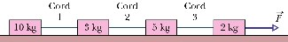

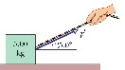
12 A 5 kg block is pulled along a horizontal frictionless floor by a cord that exerts a force of magnitude F=12N at an angle θ=25º above the horizontal. (a) What is the magnitude of the block’s acceleration?
- The force magnitude F is slowly increased. What is its value just before the block is lifted (completely) off the floor?
- What is the magnitude of the block’s acceleration just before it is lifted (completely) off the floor?

13 Find reading on the scale in of the following cases:

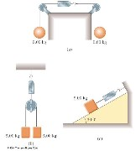

Scalar Product of Two Vectors
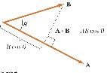
• The scalar product of two vectors is written as A . B

– It is also called the dot product
- A·B = A B cos θ
– q is the angle between A and B
- The scalar product is commutative – A·B = B·A
- The scalar product obeys the distributive law of multiplication
- A·(B + C) = A·B + A·C

Dot Products of Unit Vectors
^{ˆ}⋅k^{ˆ} =1
iˆ⋅iˆ = ˆj ⋅ ˆj = k

iˆ⋅ ˆj = iˆ⋅k^{ˆ} = ˆj ⋅k^{ˆ} = 0

Using component form with A and B:
- = A_{x}ˆi + A_{y}ˆj + A_{z}k^{ˆ}
- = B_{x}ˆi + B_{y}ˆj + B_{z}kˆ
A ⋅B = AxBx + AyBy + AzBz

Suggested Problems (Homework):

- Demonstrate that the component formula for scalar product may be obtained from the scalar product definition.

❒ 
- A force F = (6i^{ˆ} − 2^{ˆ}j) N acts on a particle that undergoes a displacement ∆r = (3i^{ˆ} + ^{ˆ}j) m. Find (a) the work
❒ 
done by the force on the particle and (b) the angle between F and ∆r .

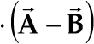
❒   
- For A = 3iˆ + ˆj − kˆ , B = −iˆ + 2ˆj + 5kˆ , and C = 2ˆj − 3kˆ , find C.

❒ 
- Using the definition of the scalar product, find the angles between (a) A = 3i^{ˆ} − 2^{ˆ}j and B = 4i^{ˆ} − 4^{ˆ}j (b)    
A = −2ˆi + 4ˆj and B = 3_{i}ˆ − 4ˆj + 2_{k}ˆ , and (c) A = _{i}ˆ − 2ˆj + 2_{k}ˆ and B = 3ˆj + 4_{k}ˆ .

ENERGY AND WORK

Energy and The Law of Conservation of Energy
System and Environment
Work

Kinetic Energy and Work – Kinetic Energy Theorem
Potential Energy of a System
Gravitational Potential Energy
Elastic Potential Energy
Conservative and non-conservative forces
Potential Energy Diagrams
Power

7 DEMOS

Demo 1 Work
Demo 2 Conservation of Energy in the Pulley System
Demo 3 Mechanical Energy Conversion
Demo 4 Pendulum
Demo 5 Hot wheel car
Demo 6 Mass on the spring
Demo 7 Ball on the parabolic track

12 suggested Problems

8 quiz questions

READING ASSIGNMENT: Chapters 7 and 8

Energy and the Law of Conservation of Energy

The concept of energy is one of the most important topics in science
- Every physical process that occurs in the Universe involves energy and energy transfers or transformations
- Energy is not easily defined

One of the fundamental Laws of Nature is the Law of Conservation of Energy

In the isolated system total energy is conserved (constant)

This means that energy cannot be created or destroyed
If the total amount of energy in a system changes, it can only be due to the fact that energy has crossed the boundary of the system by some method of energy transfer (system is not isolated)

- The energy approach to describing motion is particularly useful when the force is not constant • A common approach involving the Law of Conservation of Energy relies on energy budget: summing up of the energy in various forms before and after event
This could be extended to biological organisms, technological systems and engineering situations While discussing the energy problems in real world one frequently uses the concept of system and its surroundings. It is a critical skill is to be able to identify the system and environment surrounding it.

System
- A system is a small portion of the Universe. We will ignore the details of the rest of the Universe. A valid system may: be a single object or particle, or be a collection of objects or particles, or be be a region of space, vary in size and shape

Environment
- There is a system boundary around the system
  - The boundary is an imaginary surface
  - It does not necessarily correspond to a physical boundary
- The boundary divides the system from the environment
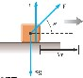
– The environment is the rest of the Universe

Work
- The work, W, done on a system by an agent exerting a constant force on the system is the product of the magnitude, F, of the force, the magnitude ∆r of the displacement of the point of application of the force, and cos θ, where θ is the angle between the force and the displacement vectors: W = F∆r cosθ
The displacement is that of the point of application of the force
A force does no work on the object if the force does not move through a displacement
The work done by a force on a moving object is zero when the force applied is perpendicular to the displacement of its point of application

- The system and the environment must be determined when dealing with work
- If a system interacts with its environment, this interaction can be described as a transfer of energy across the system boundary
– This will result in a change in the amount of energy stored in the system

The environment does work on the system means that there is work by the environment on the system – this will determine the sign of the resulting work
- If the work is done on a system and it is positive, energy is transferred to the system
- If the work done on the system is negative, energy is transferred from the system

- The sign of the work is easily established by checking the direction of F relative to ∆r
Work is positive when projection of F onto ∆r is in the same direction as the displacement
Work is negative when the projection is in the opposite direction

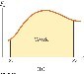
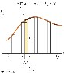
- The normal force, n, and the gravitational force, m g, do no work on the object cos θ = cos 90° = 0
- The force F does do work on the object

- Work is a scalar quantity
- The unit of work is a joule (J) 1 joule = 1 newton . 1 meter
J = N · m

Work As a Scalar Product: W =F⋅∆r

Work Done by a Varying Force
- Assume that during a very small displacement, ∆x, F is constant
- For that displacement, W ~ F ∆x
- For all of the intervals,
∆ →xlim0∑f Fx∆ =x ∫xx f F dxx W ≈ ∑Fx∆x x x _{f}
xi i xi

Work Done By Multiple Forces
- If more than one force acts on a system and the system can be modeled as a particle, the total work done on the system is the work done by the net force
•
∑W =Wnet =∫xxf (∑F dxx )
i
- If the system cannot be modeled as a particle, then the total work is equal to the algebraic sum of the work done by the individual forces
Wnet = ∑Wbyindividual forces
WORK SUMMARY:

single object
∆r
F
W
⋅
=

∑
⋅
=
∆r
F
W
i

Constant force and the
same angle between force
and displacement

∫
⋅
=
dr
F
W

Varying force and angle
between force and
trajectory

i multiple objects W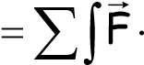dr

Work is an Energy Transfer Mechanism

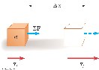


Other Ways to Transfer Energy Into or Out of A System

- Work – transfers by applying a force and causing a displacement of the point of application of the force
- Mechanical Waves – allow a disturbance to propagate through a medium
- Heat – is driven by a temperature difference between two regions in space
- Matter Transfer – matter physically crosses the boundary of the system, carrying energy with it
- Electrical Transmission – transfer is by electric current
- Electromagnetic Radiation – energy is transferred by electromagnetic waves

Various forms of Energy

Internal Energy*
Kinetic Energy Potential Energy
Kinetic Energy
- Kinetic Energy is the energy of a particle due to its motion
- K = ½ mv²
K is the kinetic energy m is the mass of the particle v is the speed of the particle
A change in kinetic energy is one possible result of doing work to transfer energy into a system
x f x f
Calculating the work associated with the net force ^{W =} ∫_{xi} ∑^{F dx =} ∫_{xi} ^{ma dx}
Work-Kinetic Energy Theorem _{v f}
W ⁼ ∫v mvdv
i
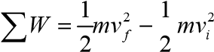
The Work-Kinetic Energy Principle states:

ΣW = K_{f} – K_{i} = ∆K

- In the case in which work is done on a system and the only change in the system is in its speed, the work done by the net force equals the change in kinetic energy of the system.
- We can also define the kinetic energy K = ½ mv²

Potential Energy
- Potential energy is energy related to the configuration of a system in which the components of the system interact by forces
- There are four main forms of potential energy, related to the four fundamental interactions:
  - Gravitational
  - Electromagnetic
  - Chemical
  - Nuclear

Most common examples include:
  - elastic potential energy – stored in a spring
  - gravitational potential energy
  - electrical potential energy

Gravitational Potential Energy
- Gravitational potential energy U is associated with distance R between two objects of masses M and m:
Mm
- U = G
R

- In the vicinity of Earth surface gravitational field is constant and perpendicular to the Earth surface. At the height y above the Earth, the object of mass m has the potential energy U
given by:
U = gmy
- Assume the object is in equilibrium and moving at constant velocity

Calculating work associated with the gravitational force acting
- The work done on the object is done by Fapp and the upward displacement is

W = (Fapp )⋅∆r
W = (mgˆj)⋅(yb − ya )ˆj
W = mgy_{b} − mgy_{a}

The quantity mgy is identified as the gravitational potential energy, U
- The gravitational potential energy depends only on the vertical height of the object above Earth’s surface
- In solving problems, you must choose a reference configuration for which the gravitational potential energy is set equal to some reference value, normally zero
  - The choice is arbitrary because you normally need the difference in potential energy, which is independent of the choice of reference configuration

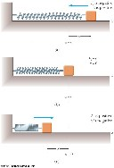
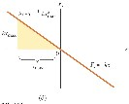
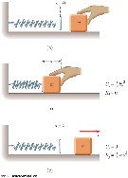
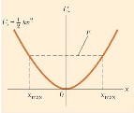
Elastic Potential Energy U_{s} = ½ kx²

Elastic Force and Hooke’s Law

- The force exerted by the spring is Fs = - kx x is the position of the block with respect to the equilibrium position (x =
0) k is called the spring constant or force constant and measures the
stiffness of the spring
This is called Hooke’s Law. When x is positive (spring is stretched), F is negative. When x is 0 (at the equilibrium position), F is 0 When x is negative (spring is compressed), F is positive. The force exerted by the spring is always directed opposite to the displacement from equilibrium F is called the restoring force
If the block is released it will oscillate back and forth between –x and x

• Calculate the work as the block moves from xi = - xmax to xf = 0
x _{f} 0 1 2
Ws = ∫xi F dxx = ∫−xmax (−kx dx) = 2kxmax
•
The total work done as the block moves from –xmax to xmax is zero

Elastic Potential Energy is associated with a spring The force the spring exerts (on a block, for example) is Fs = - kx
The work done by an external applied force on a spring-block system is
W = ½ kx_{f}² – ½ kx_{i}²
The work is equal to the difference between the initial and final values of an expression related to the configuration of the system

- This expression is the elastic potential energy: Us = ½ kx²
- The elastic potential energy can be thought of as the energy stored in the deformed spring
- The stored potential energy can be converted into kinetic energy
- The elastic potential energy stored in a spring is zero whenever the spring is not deformed (U = 0 when x = 0) The energy is stored in the spring only when the spring is stretched or compressed
- The elastic potential energy is a maximum when the spring has reached its maximum extension or compression
- The elastic potential energy is always positive x² will always be positive

Conservative and non- conservative Forces

- The mechanical energy of a system is the algebraic sum of the kinetic and potential energies in the system
E_{mech} = K +U

- The statement of Conservation of Mechanical Energy for an isolated system is K_{f} + U_{f} = K_{i}+ U_{i}
An isolated system is one for which there are no energy transfers across the boundary

- System in which the mechanical energy is conserved is called conservative system—the forces acting in such system are conservative forces!

- The work done by a conservative force on a particle moving between any two points is independent of the path taken by the particle

- The work done by a conservative force on a particle moving through any closed path is zero
  - A closed path is one in which the beginning and ending points are the same

- Examples of conservative forces:
  - Gravitational force
  - Elastic force

- We can associate a change in a potential energy for a system with a work done by any conservative force acting on the system W_{C} = - ∆U

Conservative Forces and Potential Energy
- we defined a potential energy function, U, in such way that the work done by a conservative force equals the decrease in the potential energy of the system • The work done by such a force, F, is
x_{f}
W_{C} ⁼ ∫ F dx_{x} = −∆U
x_{i}

∆U is negative when F and x are in the same direction
- The conservative force is related to the potential energy function through
dU
Fx = −
dx
•
- The x component of a conservative force acting on an object within a system equals the negative of the potential energy of the system with respect to x Check:
Look at the case of potential energy of a deformed spring
Look at the case of potential energy of body acted on by the gravitation.

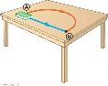
Nonconservative Forces
- A nonconservative force does not satisfy the conditions of conservative forces
- Nonconservative forces acting in a system cause a change in the mechanical energy of the system
Example : force of friction
- The work done against friction is greater along the red path than along the blue path
- Because the work done depends on the path, friction is a
- nonconservative force
Potential Energy Diagrams U(x)

For a conservative systems a great deal of information about the system might be conveyed by a simple potential energy diagram. This concept is extremely useful in the Quantum Mechanical treatment of molecules and atoms.

Total energy E= K+U
Total energy of the system E is represented by a straight horizontal line E=const
U is represented by the graph U(x)
K is dfifference between E and U , K= E-U(x)

Equilibrium

When the net force acting on the particle is zero system is in equilibrium. _{F}x =−^{dU}
Since the force is related to the potential energy U(x) by dx

The Equilibrium points happen when the slope of the tangent to U(x) is zero

Stable Equilibrium ( located in the local minimum of the U(x)
The system is in stable equilibrium if a small deviation from the equilibrium position results in emergence of the forces which bring the system back to equilibrium.

Unstable Equilibrium
Small deviation from the equilibrium position results in emergence of the forces which further pull the system away from the equilibrium.
Neutral Equilibrium
As the small deviation from the equilibrium occurs, no forces are appear.

Turning points
Points on the diagram where the speed is 0 so (K=0) and the sign of the forces acting on the system

PHY 1321/1331
change.

x(m)
Potential Energy in Molecules
- There is potential energy associated with the force between two neutral atoms in a molecule which can be modeled by the Lennard-Jones function

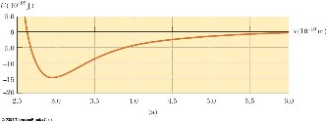

12
6
4
()
Ux
x
x
σσ






∈
−
=















- We could find the minimum of the function (by taking the derivative and setting it equal to 0) to find the separation for stable equilibrium
- The graph of the Lennard-Jones function shows the most likely separation between the atoms in the molecule (at minimum energy)

- The force is repulsive (positive) at small separations
- The force is zero at the point of stable equilibrium
- The force is attractive (negative) when the separation increases
- At great distances, the force approaches zero

Power

- The time rate of energy transfer is called power
- when the method of energy transfer is work the average power is given by
_{W}
P = ∆_{t}
Power Generalized
- Power can be related to any type of energy transfer
- In general, power can be expressed as

P = dE dt
- dE/dt is the rate rate at which energy is crossing the boundary of the system for a given transfer mechanism

Instantaneous Power
- The instantaneous power is the limiting value of the average power as Dt approaches zero
_{lim} W dW
P =∆→t 0 ∆t = dt
- This can also be written as

Units of Power P = dWdt = F ⋅ drdt = F v⋅
- The SI unit of power is called the watt
- 1 watt = 1 joule / second = 1 kg . m2 / s2
- A unit of power in the US Customary system is horsepower
- 1 hp = 746 W
- Units of power can also be used to express units of work or energy
- 1 kWh = (1000 W)(3600 s) = 3.6 x106 J

Energy and the Automobile
- The concepts of energy, power, and friction help to analyze automobile fuel consumption
- About 67% of the energy produced in combustion is lost in the engine • About 10% is lost due to friction in the transmission, drive shaft, bearings, etc.
– About 6% goes to internal energy and 4% to operate the fuel and oil pumps and accessories
- This leaves about 13% to actually propel the car

Suggested Problems

1. Find the scalar product of the vectors in Figure P6.5.

- Particle is subject to a force F_{x} that varies with position as shown in Figure P6.11. Find the work done by the force on the particle as it moves (a) from x = 0 to x = 5.00 m, (b) from x = 5.00 m to x = 10.0 m, and (c) from x = 10.0 m to x = 15.0 m. (d) What is the total work done by the force over the distance x = 0 to x = 15.0 m?

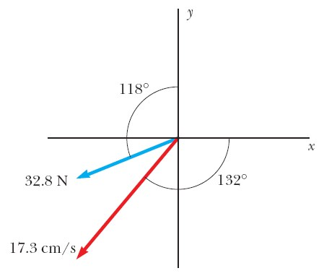
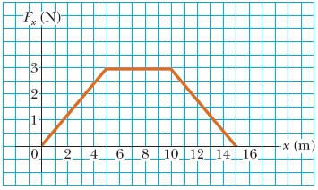
- A 15.0-kg block is dragged over a rough, horizontal surface by a 70.0-N force acting at 20.0° above the horizontal. The block is displaced 5.00 m, and the coefficient of kinetic friction is 0.300. Find the work done on the block by (a) the 70-N force, (b) the normal force, and (c) the gravitational force. (d) What is the increase in internal energy of the block–surface system owing to friction? (e) Find the total change in the block’s kinetic energy.


- The ball launcher in a classic pinball machine has a spring that has a force constant of 1.20 N/cm (Fig. P6.55). The surface on which the ball moves is inclined 10.0° with respect to the horizontal. The spring is initially compressed 5.00 cm. Find the launching speed of a 100-g ball when the plunger is released. Friction and the mass of the plunger are negligible.

- The skier (mass m) stands on the top of the hemispherical mountain (radius R). She slides down with no friction. Find the height above the ground where she looses contact with the ground.
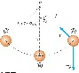
.Express the height in terms of R./

- Using energy approach find the tension at points: A and B

- A 2-kg block slides down a rough surface inclined at 30deg. In traveling 50 cm its speed changes from 1m/s to 2m/s. find the work done by
  - a) gravity
  - b) friction
  - c) What is the coefficient of kinetic friction?

- A 650-kg elevator starts from rest. It moves upward for 3.00 s with constant acceleration until it reaches its cruising speed of 1.75 m/s. (a) What is the average power of the elevator motor during this period? (b) How does this power compare with the motor power when the elevator moves at its cruising speed?

- 10.0-kg block is released from point in Figure P7.51. The track is frictionless except for the portion between points B and B , which has a length of 6.00 m. The block travels down the track, hits a spring of force constant 2 250 N/m, and compresses the spring 0.300 m from its equilibrium position before coming to rest momentarily. Determine the coefficient of kinetic friction between the block and the rough surface between and .

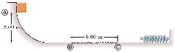
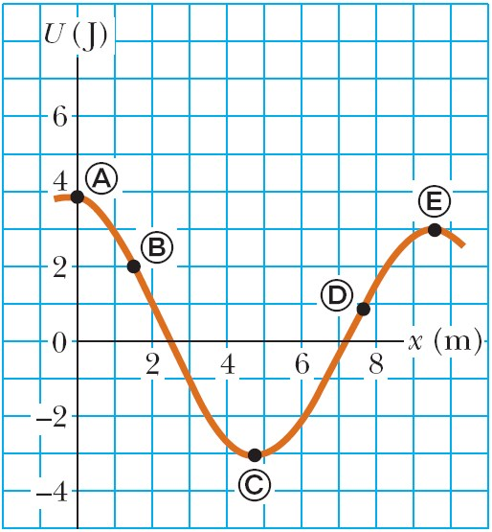
10

For the potential energy curve shown in Figure P7
.39
, (a) determine
whether the force
F

is positive, negative, or zero at the five points
indicated. (b) Indicate points of stable, unstable, an
d neutral equilibrium. (c)
Sketch the curve for
F
x

versus
x
from
x
=
0 to
x
=
9.5 m.
x

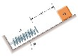
- An object of mass m starts from rest and slides a distance d down a frictionless incline of angle θ. While sliding, it contacts an unstressed spring of negligible mass as shown in Figure P7.16. The object slides an additional distance x as it is brought momentarily to rest by compression of the spring (of force constant k). Find the initial separation d between the object and the spring.


- . A circus trapeze consists of a bar suspended by two parallel ropes, each of length ℓ, allowing performers to swing in a vertical circular arc (Fig. P7.11). Suppose a performer with mass m holds the bar and steps off an elevated platform, starting from rest with the ropes at an angle θ_{i} with respect to the vertical. Suppose the size of the performer’s body is small compared to the length ℓ, she does not pump the trapeze to swing higher, and air resistance is negligible. (a) Show that when the ropes make an angle θ with the vertical, the performer must exert a force mg(3 cos θ – 2 cos θ_{i}) so as to hang on. (b Determine the angle θ_{i} for which the force needed to hang on at the bottom of the swing is twice the performer’s weight.

LINEAR MOMENTUM

Linear Momentum

Conservation of Linear Momentum
Impulse and Momentum
Collisions
Ballistic Pendulum
Rocket Propulsion

5 DEMONSTRATIONS

- Ballistic Pendulum
- Elastic vs. Inelastic Collisions on Air Track
- Pool/Air Hockey
- Basketball + tennis ball
- Rocket Propulsion

9 Suggested Problems

8 Quiz Questions

READING ASSIGNMENT: chapter 9

Linear Momentum

The linear momentum of a particle or an object of mass m moving with a velocity v is defined as

p=mv

Linear momentum is a vector quantity. Its direction is the same as the direction of v The SI units of momentum are kg · m / s Momentum can be expressed in component form:
p_{x} = mv_{x} p_{y} = mv_{y} p_{z} = m v_{z}

Newton’s Second Law
Newton called the product mv the quantity of motion of the particle
Newton’s Second Law can be used to relate the momentum of a particle to the resultant force acting on it with constant mass

Σ_{F} = _{ma} = _{m} dv = d(mv) = d p dt dt dt

The time rate of change of the linear momentum of a particle is equal to the net force acting on the particle. This is the form in which Newton presented the Second Law It is a more general form than the one we used previously.
This form also allows for mass changes!
Applications to systems of particles are particularly powerful.

Conservation of Linear Momentum

Whenever two or more particles in an isolated system interact, the total momentum of the system remains constant
The momentum of the system is conserved, not necessarily the momentum of an individual particle

This also tells us that the total momentum of an isolated system equals its initial momentum

Since foranisolated system:ΣF = ma = 0 (noexternal forces)
:0
dt
p
d
have
We
=
So: p = const.

Conservation of momentum can be expressed mathematically in various ways

ptotal 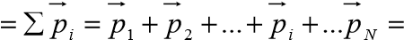 const

In component form, the total ∑ p_{initial} =∑ p _{final} momenta in each direction are independently
conserved

p = p
initialx finalx
pinitialy = p finaly
p
z = p final
initial z
Conservation of momentum can be applied to systems with any number of particles

Impulse and Momentum
From Newton’s Second Law, F = dp/dt
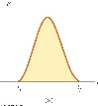
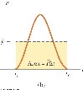
Solving for dp gives dp = Fdt
Integrating to find the change in momentum over some time interval
∆ =p p _{f} −p_{i} ⁼∫t^{t f} Fdt =I

i
The integral is called the impulse, I, of the force F acting on an object over ∆t
This equation expresses the impulse-momentum theorem: The impulse of the force F acting on a particle equals the change in the momentum
of the particle
This is equivalent to Newton’s Second Law

More About Impulse

- Impulse is a vector quantity
- The magnitude of the impulse is equal to the area under the force-time curve
- Dimensions of impulse are M L / T
- Impulse is not a property of the particle, but a measure of the change in momentum of the particle
- The impulse can also be found by using the time averaged force
- I =F_{avg} ∆t
- This would give the same impulse as the time-varying force does

Finding Impulse using the F vs t diagrams: quiz practice.

Collisions
Characteristics
- We use the term collision to represent an event during which two particles come close to each other and interact by means of forces
- The time interval during which the velocity changes from its initial to final values is assumed to be short
- The interaction force is assumed to be much greater than any external forces present
  - This means the impulse approximation can be used

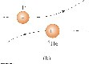
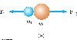
- Collisions may be the result of direct contact
- The impulsive forces may vary in time in complicated ways
  - This force is internal to the system
- Momentum is conserved

- The collision need not include physical contact between the objects
- There are still forces between the particles
- This type of collision can be analyzed in the same way as those that include physical contact

Types of Collisions

- In an elastic collision, momentum and kinetic energy are conserved
  - Perfectly elastic collisions occur on a microscopic level
  - In macroscopic collisions, only approximately elastic collisions actually occur
- In an inelastic collision, kinetic energy is not conserved although momentum is still conserved
  - If the objects stick together after the collision, it is a perfectly inelastic collision

- In an inelastic collision, some kinetic energy is lost, but the objects do not stick together
- Elastic and perfectly inelastic collisions are limiting cases, most actual collisions fall in between these two types

Momentum is conserved in all collisions

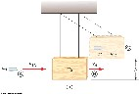

Ballistic Pendulum: other configurations

Bullet hits the stationary block
from the bottom. Highest position
of the block after the collision
is recorded

Bullet hits the stationary block ( on
frictionless surface from the side
The block then moves on a rough
surface (known uk) by a certain
distance.
Bullet hits the stationary block on
the edge of the table ( no friction).
After the collision block lands
at certain distance from the edge.

Bullet hits the stationary block

from the side The block moves up the incline
to certain highest position. There might be a
friction or not. Also various shapes of the
incline are possible

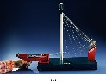
Ballistic Pendulum
Given the situation on the diagram. find the Find the v1A and the amount of energy lost in this collision.
(take h=5cm, m1=10g, m2=1kg)

Version of the above problems include situations in which the target is moving before the collision as well as the cases in which the bullet penetrates the target and emerges from it with diminished speed
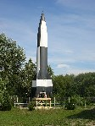
Rocket Propulsion
Invented by Chinese between Xth and XIIth century rocket is a device propelled forward thanks to the backward emitted gases. During their conquest the Mongols spread the use of the rockets through Asia and Eastern Europe.
The Principle of Operation:

Conservation of Linear Momentum ( equivalently: III Law of Mechanics)

As the gases ∆M are ejected through the nozzle the rest of the rocket is propelled. The rocket thrust is given by

e
v
dt
dm
F
=

The basic equation ( Tsiolkovsky Equation ) for rocket propulsion is:

v
f
- v
i
= v
e
ln(M
i
/M
f
)

M_{i} is the initial mass of the rocket plus fuel
M_{f} is the final mass of the rocket plus any remaining fuel
The speed of the rocket is proportional to the exhaust speed v_{e} dm
is the burn rate of the rocket
dt
Rocket is an excellent example of dynamics of a body with varying mass.

Suggested Problems

- The archer is standing on a frictionless surface (ice). He shoots an arrow (50g) with initial speed of 50m/s. What is the speed of the archer?
F(N)
- The body of mass 10 kg and velocity V_{x}=10m/s is moving on a 5 frictionless surface. Find the velocity of the body after an impulse ₄ presented on the diagram acts on it.
3
- On a frictionless track abject 1 has mass M1=1kg and speed 2 v1 5m/s object2 has massM2=2kg and speed 3m/s. Solve ₁ this problem in all three possible initial configurations.
⁰ ₁ 2 3 4 5 6 7 ₈ t(s)

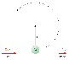
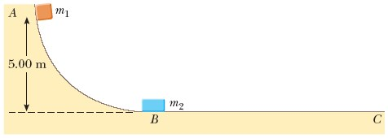
- As shown in Figure P8.18, a bullet of mass m and speed v passes completely through a pendulum bob of mass M. The bullet emerges with a speed of v/2. The pendulum bob is suspended by a stiff rod of length ℓ and negligible mass. What is the minimum value of v such that the pendulum bob will barely swing through a complete vertical circle?

- Two blocks are free to slide along the frictionless wooden track ABC shown in Figure P8.16. A block of mass m₁ = 5.00 kg is released from A.
Protruding from its front end is the north pole of a strong magnet, repelling the north pole of an identical magnet embedded in the back end of the block of mass m₂ = 10.0 kg, initially at rest. The two blocks never touch. Calculate the maximum height to which m₁ rises after the elastic collision.


- A tennis ball of mass 57.0 g is held just above a basketball of mass 590 g. With their centers vertically aligned, both are released from rest at the same time, to fall through a distance of 1.20 m, as shown in Figure P8.23. (a) Find the magnitude of the downward velocity with which the basketball reaches the ground. Assume that an elastic collision with the ground instantaneously reverses the velocity of the basketball while the tennis ball is still moving down. Next, the two balls meet in an elastic collision. (b) To what height does the tennis ball rebound?

- A 7.00-g bullet, when fired from a gun into a 1.00-kg block of wood held in a vise, penetrates the block to a depth of 8.00 cm. This block of wood is next placed on a frictionless horizontal surface, and a second 7.00-g bullet is fired from the gun into the block. To what depth will the bullet penetrate the block in this case?

- Derive of the thrust Equation and Tsiolkovsky Equation for simple rocket.

9 Halloween Problem (for Life Science Students)

80 kg vampire and 250kg werewolf clash during the Feat of Strength part of the annual celebration of Festivus. The werewolf velocity just before the clash is 20m/s and is directed downwards, while the vampire velocity at the moment of the collision is 50m/s and is directed upwards. They clash in midair exactly 10 meters above the ground.
Knowing that the vampire starts sucking the werewolf ‘s blood as soon as she collides with him, and remembering that once on ground again, the werewolf will overpower her even at the half of its usual strength [1], find the winner of this deadly contest.

NOTE:

- Suction speed of an adult vampire feasting on the werewolf is 1.5liter/second [1] Adult werewolf has about 10 l. of blood. [2]
- Current research shows that werewolf strength is proportional to square root of the volume of blood it still possess. [3]

References:
- “Midnight at science faculty: the true identities of your science profs.” Dr. A. Kul, A. van Pire,
Diaries 76 p23-27 (2005)

- “Emotional life of poisonous plants, /Table 8.5/p451/ Dr. M. Caligari, publ. Hinderband and Sons (1923).

- “The search for the Higgs Boson—ghost effects in accelerators.” N. Osfer, A. Tu, Nature 47, p.998-1001 (2003).

Dear Students:
Above dilemma proves my point once again: physics is terribly important in all real life situations.
Solve this problem carefully and next year place your bets smartly!

Yours truly,
Dr. Andrzej Czajkowski

CENTRE OF MASS

Definition

Centre of Mass Coordinates for Discrete Mass Distribution
Centre of Mass Coordinates for Continuous Mass Distribution
CM Velocity Momentum and Acceleration
II Law for CM
Objects of High Degree of Symmetry

4 DEMONSTRATIONS

DEMO 1 Finding the Centre of Mass
DEMO 2 Centre of Mass of Extended Object
DEMO 3 Against the wall demo
DEMO 4 Object moving uphill

8 Suggested Problems

6 Quiz Question

READING ASSIGNMENT: Chapter 9

Centre of Mass: Definition

There is a special point in a system or object, called the center of mass, that moves as if all of the mass of the system is concentrated at that point. The system will move as if an
external force were applied to a single particle of mass M located at the center of mass

CM of Discrete Mass System (System of point-like particles)
The coordinates of the center of mass are
∑m xi i ∑m yi i ∑m zi i
xCM = i yCM = i zCM = i
M M M
– where M is the total mass of the system
The center of mass can be located by its position vector, rCM
∑mi ir
rCM = i
M

ri is the position of the i th particle, defined by

r_{i} = + +x_{i}ˆi y_{i}ˆj z_{i}kˆ
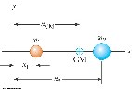
Both masses are on the x-axis
The center of mass is on the x-axis The center of mass is closer to the particle with the larger mass

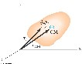
Center of Mass for Continuous Mass Distributions Extended Object

Think of the extended object as a system containing a large number of particles The particle distribution is small, so the mass can be considered a continuous mass distribution The coordinates of the center of mass of the object are.

1 1
xCM = ∫xdm yCM = ∫ydm
M M

= 1
z ∫zdm
CM
M

- An extended object can be considered a distribution of small mass elements, Dm
- The center of mass is located at position rCM

The center of mass of any symmetrical object lies on an axis of symmetry and on any plane of symmetry!

Velocity and Momentum of a System of Particles
The velocity of the center of mass of a system of particles is
∑m vi
v_{CM} = _{dr}CM = i i
dt M

The momentum can be expressed as

MvCM = ∑i mivi = ∑i pi = ptot

The total linear momentum of the system equals the total mass multiplied by the velocity of the center of mass

dvCM 1
aCM = dt = M ∑i miai

The acceleration of the center of mass can be found by differentiating the velocity with respect to time
The acceleration vector can be related to a force vector
• If we sum over all the internal forces, they cancel in pairs and the net force on the system is caused only by the external forces

= ∑
MaCM Fi
i

- Since the only forces are external, the net external force equals the total mass of the system multiplied by the acceleration of the center of mass:
ΣFext = MaCM
- The center of mass of a system of particles of combined mass M moves like an equivalent particle of mass M would move under the influence of the net external force on the system

Newton’s Second Law for a System of Particles
•
- The total linear momentum of a system of particles is conserved if no net external force is acting on the system
- Mv_{CM} = p_{tot} = constant when ΣF_{ext} = 0

Objects of high degree of symmetry, with uniform mass
distribution

Rods, circles, squares, rectangles and triangles have their mass centres at their geometrical centres

Suggested Problems

1. A 5.0 kg is point mass is placed in the center of the coordinate system. 4.0 kg point mass is at the point (-2,4,2), and 3.0 kg point mass is at (-2,0,2). Find the position of the centre of mass of this system.

- A 4.0 kg equilateral triangle, 2.0kg circle 6.0kg square and 1.0kg rod form a system shown on the diagram on a side. What is the centre of mass of this system.
3m=Lrod=Dcircle=Wtriangle=Wsquare

- A 5 kg body moves along the x axis with a velocity of 4 m/s. A 3 kg body moves along the x axis with a velocity of 3 m/s. Find the momentum in kg m/s of the center of mass of the system

- The same object as in the (2) are put in a different configuration Find the centre of mass of the new system.

- Find the centre of mass of a 5 kg circle (R=4m) with a square (r=2m) cut out from it as shown.

- The grenade (m=0.1kg) is projected at 37° with speed v=50m/s. On its descent it explodes into two parts of unequal masses m1=.03kg and m2=0.07kg.
Knowing that both parts of the grenade hit the level ground at the same time, find the place where second of the fragments landed if the first one landed 300m from the place it was projected.

7. A tennis player receives a shot with the ball (0.060 0 kg) traveling horizontally at 50.0 m/s and returns the shot with the ball traveling horizontally at 40.0 m/s in the opposite direction. (a) What is the impulse delivered to the ball by the racquet? (b) What work does the racquet do on the ball?

8 Find the centre of mass of rod mass m length L
- having uniform mass distribution λ=M/L=const.
- having a linearly changing mass distribution λ= λ₀x; express λ₀ as function of M and L

ROTATIONS I

Rotational Motion of Rigid Body

Angular Position and Angular Displacement Angular Velocity and Angular Acceleration
Rotational Kinematics
Rotational Kinetic Energy
Moment of Inertia
Parallel Axis Theorem

DEMO 1: Rotating wheel ( link between v_{cm} and v_{lin} of the rim for rolling motion )
DEMO 2: racing of the two rolling objects DEMO 3: chain rolling
DEMO 4: Moment of Inertia for rotating objects

4 Mid-lecture Quiz Questions

6 Suggested Problems

READING ASSIGNMENT: CHAPTER 10

ROTATIONAL MOTION: DEFINITIONS
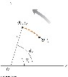
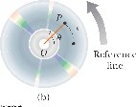

Symbols:
θ angular position
ω angular speed α angular acceleration

∆θ=θ_{f} -θ_{i} ANGULAR DIPLACEMENT

Average Instantaneous

ω= =  t f −ti ∆t  ω ω_{f} − _{i} ∆ω | ∆→t  ∆t dt  ∆ω ω  α≡ ^{lim} = d

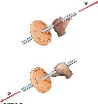
θ θf − i ∆θ ω≡ lim ∆θ θ= d
t
dt
∆
α= = ∆→t 0 t f −ti ∆t

Strictly speaking, the speed and acceleration (ω,α) are the magnitudes of the velocity and acceleration vectors.

The directions are actually given by the right-hand rule

Rotational Kinematics

Under constant angular acceleration, we can describe the motion of the rigid object using a set of kinematic equations

These are similar to the kinematic equations for linear motion
The rotational equations have the same mathematical form as the linear equations

ω ω αf = _{i} + t

θ θ ω αf = i + it +t2

ω ω αθ θ2f = i2 + 2 ( f − i )

θ θ ω ω_{f} = _{i} + ( _{i} + _{f} )t

Relationship Between Angular and Linear Quantities

- Displacements s=θr

- Speeds v =ωr

- Accelerations a =αr aC = ^{v2} = rω²
r
v is the linear speed of the element of the rigid body rotating with angular speed of ω at distance r from the axis of rotation.
a is the tangential linear acceleration of the element of the rigid body rotating with the angular acceleration α at distance r from the axis of rotation
- Every point on the rotating object has the same angular motion
- Every point on the rotating object does not have the same linear motion

Speed and Acceleration Note
- All points on the rigid object will have the same angular speed, but not the same tangential speed
- All points on the rigid object will have the same angular acceleration, but not the same tangential acceleration
- The tangential quantities depend on r, and r is not the same for all points on the object
- The tangential component of the acceleration is due to changing speed
- The centripetal component of the acceleration is due to changing direction
- Total acceleration can be found from these components

Rotational Kinetic Energy
Consider and object of many discrete material points rotating about some axis
with an angular speed ω,

Such object has rotational kinetic energy even though it may not have any translational kinetic energy!

- Each particle has a kinetic energy of
= 1mivi2
K
2

- Since the tangential velocity depends on the distance, r, from the axis of rotation, we can substitute v_{i} = ω_{i} r
•
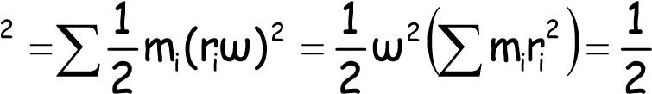
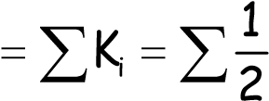
KmvIω²
i i

- The total rotational kinetic energy of the rigid object is the sum of the energies of all its particles

- There is an analogy between the kinetic energies associated with linear motion
(K = ½ mv ²) and the kinetic energy associated with rotational motion (K_{R}= ½Iw²)

- Rotational kinetic energy is not a new type of energy, the form is different because it is applied to a rotating object.

- The units of rotational kinetic energy are Joules (J)

Moment of Inertia
In the equation for rotational energy we have introduced a new definition:

Moment of Inertia (I)

2 i i
I⁼∑mr

Moment of Inertia for Discrete Mass Distribution

I=∑mr²

i i

Moment of inertia is an analog of a mass in rotational mechanics.
It reports on how difficult is it to rotationally accelerate the body.
Turns out that it is not just the mass that matters but also its distribution – how far are the point masses from the axis of rotation!

- The dimensions of moment of inertia are ML² and its SI units are kg.m²

Moment of Inertia for Continuous Mass Distribution


r
dm
- We can calculate the moment of inertia of an object more easily by assuming it is divided into many small volume elements, each of mass dm
- We can rewrite the expression for I in terms of dm

I= ∫r²dm

volume
If mass density is constant, the integral can be evaluated with known geometry, otherwise its variation with position must be known
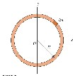
Moment of Inertia of a Uniform Thin Hoop

Moment of Inertia of a Uniform Rigid Rod

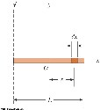
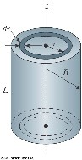
Moment of Inertia of a Uniform Solid Cylinder

Since the moment of inertia of an object is a function of the distance to the axis of rotation each object has an infinite number of the possible moments of inertia!

The unique value of I is the moment of inertia calculated with respect to the axis containing the Centre of Mass I_{CM}

It turns out that an arbitrary axis ay be related to the axis through the centre of mass by the parallel-axis theorem.
It is very important as it allows to calculate arbitrary I if I_{CM} is known, and if the distance d between the two axes is known.

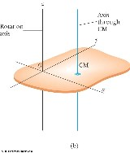
Parallel-Axis Theorem

I_{O} = I_{CM} + MD²

I is about any axis parallel to the axis through the center of mass of the object
I_{CM} is about the axis through the center of mass D is the distance from the center of mass axis to the arbitrary axis

- The axis of rotation goes through O
- The axis through the center of mass is shown
- The moment of inertia about the axis through O would be

MOMENTS OF INERTIA FOR VARIOUS REGULAR OBJECTS
 | LINEAR (1-d) |  | ROTATIONAL ( fixed axis)
 | dx dv v = a = dt dt  F_{net} =∑F = ma  if a = const.  x_{f}  Work W ⁼ ∫ F_{x}dx  x_{i}  Kinetic Energy K  Power P = Fv  Linear momentum  Net force F = ^{dp}  dt | x = x₀ + x₀t +at² v = v₀ +at v² = v₀² + 2a(x− x₀)  = 1 mv²  2  p = mv | dθ dω ω= α= dt dt τnet =∑τ= Iα  if α= const. 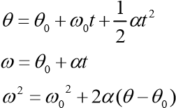  θ_{f}  Work W ⁼ ∫τ_{x}dθ  θ_{i}  Kinetic Energy K = 1 Iω²  2  Power P =τω  Angular momentum L = Iω  Net force τ= ^{dL}  dt
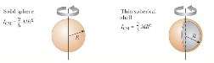
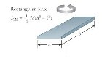
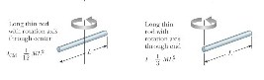
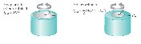
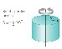

FORMULA SUMMARY
Suggested Problems

- A car traveling on a flat (unbanked) circular track accelerates uniformly from rest with a tangential acceleration of 0.70 m/s2. The car makes one-quarter of the way around the circle before it skids off the track. Determine the coefficient of static friction between the car and track from these data.

- A rotating wheel requires 3.00 s to rotate through 37.0 revolutions. Its angular speed at the end of the 3.00-s interval is 98.0 rad/s. What is the constant angular acceleration of the wheel

- A solid sphere and a disk (the same radii R and the same masses M) are released from the same point on the incline. Given that they roll without the slipping which one has greater speed at the bottom?

- Find moment of inertia of composite objects

  - M1 = 5kg at (3,4); M2 = 3kg at (6,8) rotating about the z axis
  - two balls rotating about the line tangent to one of them (M, R)
  - two identical rods (M.L) welded together to form T rotating about axis parallel to one
  - two identical rods (M.L) welded together to form T rotating about axis containing one of them

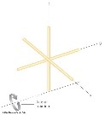
- Three identical thin rods, each of length L and mass m, are welded perpendicular to one another as shown. The assembly is rotated about an axis that passes through the end of one rod and is parallel to another. Determine the moment of inertia of this structure.

- Using simple geometric arguments and knowledge of fundamental calculus obtain the relations linking angular and linear displacement velocity and acceleration for rigid body

Vector Product

Vector Product of Two Vectors. (Cross Product)

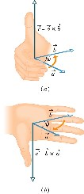
^
Unit vector normal to the plane of vectors
A

and
B.

n
sinθ
B
A
B
A
C
=
×
=
^
n

θ

n

z
z
y
y
x
x
z
y
x
i
A
i
A
i
A
k
A
j
A
i
A
A
ˆ
ˆ
ˆ
ˆ
ˆ
ˆ
+
+
=
+
+
=
z
z
y
y
x
x
z
y
x
i
B
i
B
i
B
k
B
j
B
i
B
B
ˆ
ˆ
ˆ
ˆ
ˆ
ˆ
+
+
=
+
+
=

C = A×B = (A_{x}i^{ˆ}+A_{y}j^{ˆ}+A_{z}k)^{ˆ} ×(B_{x}i^{ˆ}+B_{y}j^{ˆ}+B_{z}k)^{ˆ} =

(AyBz −AzBy )iˆ+(Az Bx −AxBz )jˆ+(AxBy −AyBx )kˆ

C[Cx,Cy,Cz]
Summary: C_{x} =AyBz −AzBy

Cy =AzBx −AxBz Cz =AxBy −AyBx
You could also use pseudo-matrix method
(if you know matrices)

A j _{y}=
x
x
3)
(1
z
x
z
x
2)
(1
z
y
z
y
1)
(1
z
y
x
z
y
x
B
A
k
1)
(
B
B
A
A
1)
(
B
B
A
A
i
1)
(
B
B
B
A
A
A
k
j
i
B
A
C
−
+
−
+
−
=
=
=
×
=
∧
+
∧
+
∧
+
∧
∧
∧
B_{y}
^ ^ ^

=(A_{y}B_{z} −A_{z}B_{y})i+(A_{z} B_{x} −A_{x}B_{z})j+(A_{x}B_{y} −A_{y}B_{x})k
Suggested Problems:

- What is the geometric interpretation of the magnitude of the cross product?

- Find cross products of following vectors

i) A (1,0,0) B (2,0,0) ii) C (2,2,2) D (1,2,-5) iii) E (1,0,0) F (0,1,0) iv) G (1,3,2) H (-2,0,0) v) I (0,0,1) J (0,2,0) vi) K (2,-3,0) L (0,0,1)

3 Use definition of cross product to obtain the expression for vector product for Cartesian components

ROTATIONS II

Torque

Newton’s Laws for Rotational Dynamics
Work in Rotational Motion
Angular Momentum

DEMO 1: | torque
DEMO 2: | rotating platform /angular momentum/
DEMO 3: | atom trapping
DEMO 4: | gyro effects
DEMO 5: | falling ladder

6 Quiz Questions

12 Suggested Problems

READING ASSIGNMENT: Chapter 11 and 12

Torque

Whenever we are dealing with extended body – we need to take into account not only the direction and magnitude of forces acting on it but also we need to consider where are these forces applied to this body.
Therefore it makes sense to define the torque which reports on the effect of the force-lever arm combination. “Torques will be present whenever the body tend to rotate with acceleration”

- Torque is a vector of magnitude given by
- τ = r F sin Φ = F d
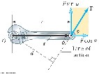
  - F is the magnitude of the force
  - Φ is the angle the force makes with the horizontal
  - d is the moment arm (or lever arm)

  - The moment arm, d, is the perpendicular distance from the axis of rotation to a line drawn along the direction of the force
- d = r sin Φ

- The horizontal component of F (F cos Φ ) has no tendency to produce a rotation
- Torque will have direction
  - If the turning tendency of the force is counterclockwise, the torque will be positive
  - If the turning tendency is clockwise, the torque will be negative

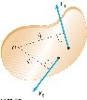
Net Torque
The force F1 will tend to cause a counterclockwise rotation about O
The force F2 will tend to cause a clockwise rotation about O

∑τ=τTOT =τ1 +τ2 = F1 d1 + F2d2

Torque vs. Force
- Forces can cause a change in linear motion
  - Described by Newton’s Second Law
- Torques can cause a change in rotational motion
  - The effectiveness of this change depends on the force and the moment arm
  - The change in rotational motion depends on the torque

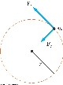
Torque Units
- The SI units of torque are N.m
Although torque is a force multiplied by a distance, it is very different from work and energy
The units for torque are reported in N.m and not changed to Joules

Torque and Angular Acceleration
- Consider a particle of mass m rotating in a circle of radius r under the influence of tangential force Ft
- The tangential force provides a tangential acceleration:

F_{t} = ma_{t}
The magnitude of the torque produced by Ft around the center of the circle is τ = F_{t} r = (ma_{t}) r = (mrα)r= αmr²=αI
- Since mr ² =I is the moment of inertia of the particle, τ = Ia

The torque is directly proportional to the angular acceleration and the constant of proportionality is the moment of inertia
This is the Newton’s II Law of Dynamics for rotational motion

Torque and Angular Acceleration, Extended Objects

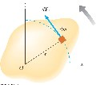
Consider the object consists of an infinite number of mass elements dm of infinitesimal size Each mass element rotates in a circle about the origin, O
Each mass element has a tangential acceleration

- From Newton’s Second Law

– dF_{t} = (dm) a_{t}

- The torque associated with the force and using the angular acceleration gives

dτ = rdF_{t} = ra_{t} (dm) = (rα)r(dm)= α(dm)r²

Integrating

dτ= α(dm)r²

- We find the net torque τ= αI

- This is the same relationship that applied to a particle
- The result also applies when the forces have radial components
  - The line of action of the radial component must pass through the axis of rotation
  - These components will produce zero torque about the axis

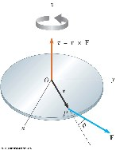
The Vector Product and Torque

- The torque vector lies in a direction perpendicular to the plane formed by the position vector and the force vector

τ=r×F

The torque is the vector (or cross) product of the position vector and the force vector

Vector Product:

^
C =A×B = A Bsinθn
C = A×B = (A_{x}i^{ˆ}+A_{y}j^{ˆ}+A_{z}k)^{ˆ} ×(B_{x}i^{ˆ}+B_{y}j^{ˆ}+B_{z}k)^{ˆ} =

(AyBz −AzBy)iˆ+(Az Bx −AxBz)jˆ+(AxBy −AyBx)kˆ

Torque Vector Example

Given the force and arm
F = (2.00^{ˆ}i +3.00^{ˆ}j) N
r = (4.00^{ˆ}i +5.00^{ˆ}j) m
Torque is

τ= r × F =[(4.00ˆi +5.00 )N] [(2.00ˆj × ˆi +3.00 )m]ˆj
= [(4.00)(2.00)ˆi × +ˆi (4.00)(3.00)ˆi ×ˆj

+(5.00)(2.00)ˆj i× +ˆ (5.00)(3.00)ˆi ×ˆj
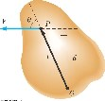
= 2.0_{k}ˆ N m⋅

We may use the right-hand rule to determine the direction of the torque:
– The tendency of the force to cause a rotation about O depends on F and the moment arm d

Static Equilibrium
- Equilibrium implies the object is at rest (static) or its center of mass moves with a constant velocity (dynamic)
- Static equilibrium is a common situation in engineering
- Principles involved are of particular interest to civil engineers, architects, and mechanical engineers

Conditions for Equilibrium
- The net force equals zero ΣF = 0
– If the object is modeled as a particle, then this is the only condition that must be satisfied
- The net torque equals zero Σ τ = 0
– This is needed if the object cannot be modeled as a particle

Rotational Equilibrium
- Need the angular acceleration of the object to be zero
- For rotation, Στ = Ia
– For rotational equilibrium, Σ τ = 0
- This must be true for any axis of rotation

Equilibrium Summary
- There are two necessary conditions for equilibrium
- The resultant external force must equal zero: ΣF = 0
  - This is a statement of translational equilibrium
  - The acceleration of the center of mass of the object must be zero when viewed from an inertial frame of reference
- The resultant external torque about any axis must be zero: Στ = 0
  - This is a statement of rotational equilibrium
  - The angular acceleration must equal zero

Static vs. Dynamic Equilibrium
- In this chapter, we will concentrate on static equilibrium
– The object will not be moving
- Dynamic equilibrium is also possible
– The object would be rotating with a constant angular velocity
- In either case, the Στ = 0

Equilibrium Equations
- We will restrict the applications to situations in which all the forces lie in the xy plane
– These are called co-planar forces since they lie in the same plane
- There are three resulting equations
ΣF_{x} = 0 ΣF_{y} = 0
Στ _{z} = 0
Axis of Rotation for Torque Equation • The net torque is about an axis through any point in the xy plane
- The choice of an axis is arbitrary
- If an object is in translational equilibrium and the net torque is zero about one axis, then the net torque must be zero about any other axis

Center of Gravity

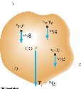
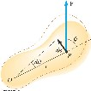
All the various gravitational forces acting on all the various mass elements are equivalent to a single gravitational force acting through a single point called the center of gravity (CG)

- The torque due to the gravitational force on an object of mass M is the force Mg acting at the center of gravity of the object
- If g is uniform over the object, then the center of gravity of the object coincides with its center of mass
- If the object is homogeneous and symmetrical, the center of gravity coincides with its geometric center

Work in Rotational Motion

- Find the work done by F on the object as it rotates through an infinitesimal distance ds = r dθ

- dW = F . d s = (F sin Φ ) r dθ

dW = τ dθ

W = τ θ for constant torque acting on rotating body

The radial component of F does no work because it is perpendicular to the displacement

Power in Rotational Motion
Power in Rotational Motion

- The rate at which work is being done in a time interval dt is

dW dθ
- Power = dt =τ τωdt =

- This is analogous to P = Fv in a linear system

Angular Momentum

Consider a particle of mass m located at the vector position r and moving with linear momentum p

dp r×∑F = ∑τ=r×
dt
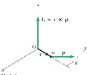
The instantaneous angular momentum L of a Adding the term ^{dr} ×_{p} particle
relative to the dt origin O is defined as the d(r p× ) cross product ∑τ= of the particle’s dt instantaneous
position vector r and its instantaneous linear momentum p

L = r× p

- The torque is related to the angular momentum
– Similar to the way force is related to linear momentum

∑τ= dL dt
- This is the rotational analog of Newton’s Second Law Στ and L must be measured about the same origin
This is valid for any origin fixed in an inertial frame

- The SI units of angular momentum are (kg.m²)/ s
- Both the magnitude and direction of L depend on the choice of origin
- The magnitude of L = mvr sin Φ Φ is the angle between p and r
- The direction of L is perpendicular to the plane formed by r and p

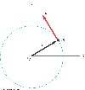
Angular Momentum of a Particle

- The vector L = r x p is pointed out of the diagram
- The magnitude is
L = mvr sin 90o = mvr
– sin 90o is used since v is perpendicular to r
- A particle in uniform circular motion has a constant angular momentum about an axis through the center of its path

Angular Momentum of a System of Particles
The total angular momentum of a system of particles is defined as the vector sum of the angular momenta of the individual particles

L_{TOT} = L₁ + L₂ +...+ L_{n}

By taking derivative with respect to time we get:

dLTOT ∑Li ∑ i
= = = τ dt dt
•
- Any torques associated with the internal forces acting in a system of particles are zero

dL
∑τexternal dt
=

The net external torque acting on a system about some axis passing through an origin in an inertial frame equals the time rate of change of the total angular momentum of the system about that origin

The resultant torque acting on a system about an axis through the center of mass equals the time rate of change of angular momentum of the system regardless of the motion of the center of mass

This applies even if the center of mass is accelerating, provided t and L are evaluated relative to the center of mass
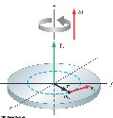
Angular Momentum of a Rotating Rigid Object

Each particle of the object rotates in the xy plane about the z axis with an angular speed of w
The angular momentum of an individual particle is Li = mi ri2 w
L and w are directed along the z axis
To find the angular momentum of the entire object, add the angular momenta of all the individual particles

L_{z} = ∑ ∑L_{i} = m r_{i i}²ω ω= I
i i
This also gives the rotational form of Newton’s Second Law
∑ ext dLz dω τ = dt = I dt = Iα

The rotational form of Newton’s Second Law is also valid for a rigid object rotating about a moving axis provided the moving axis:
- passes through the center of mass
- is a symmetry axis
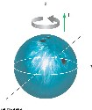
If a symmetrical object rotates about a fixed axis passing through its center of mass, the vector form holds: L = Iw
– where L is the total angular momentum measured with respect to the axis of rotation

The angular momentum of a bowling ball

The momentum of inertia of the ball is 2/5MR ² The angular momentum of the ball is L_{z} = Iω
The direction of the angular momentum is in the positive z direction

Conservation of Angular Momentum

The total angular momentum of a system is constant in both magnitude and direction if the resultant external torque acting on the system is zero
Net torque = 0 -> means that the system is isolated

L_{tot} = constant or L_{i} = L_{f}
For a system of particles, L_{tot} = SLn = constant
If the mass of an isolated system undergoes redistribution, the moment of inertia changes
The conservation of angular momentum requires a compensating change in the angular velocity
I_{i} w_{i} = Iω
This holds for rotation about a fixed axis and for rotation about an axis through the center of mass of a moving system
The net torque must be zero in any case

Conservation Laws in Mechanics:

In the course of the semester we learned about three fundamental Laws of Nature:

- Conservation of Energy: E_{i} = E_{f}
- Conservation of Linear Momentum: p_{i} = p_{f}
- Conservation of Angular Momentum: L_{i} = L_{f}

All of the above state that in the isolated system the above qualities are conserved !

Suggested Problems:

- A block of mass m =2kg can slide down a frictionless 53º incline but is connected to a pulley of mass M = 4kg and radius R=0.5m, as shown. The pulley may be treated as a disk. Find: a) the angular acceleration of the pulley.
  - the speed of the block after it has slid 1m starting from rest.

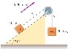
- Two blocks, as shown in Figure P10.37, are connected by a string of negligible mass passing over a pulley of radius 0.250 m and moment of inertia I. The block on the frictionless incline is moving up with a constant acceleration of 2.00 m/s². (a) Determine T₁ and T₂, the tensions in the two parts of the string.
  - Find the moment of inertia of the pulley.

- A turntable has a mass of 2kg and a radius of 15cm. When the motor is switched off it takes 20s to stop from an initial 331/2rpm. What is the power needed to maintain 331/3rpm? Treat the turntable as a solid disk.

- A uniform beam of length 8.00m and weight 200N is Attached to a wall by as pin connection. Its far end is supported by cable that makes an angle of 53 deg with the horizontal. Find the tension in the cable and the force exerted by the wall on the beam .

- The uniform ladder of length l and mass m rests against a smooth vertical wall. If a coefficient of static friction between the ladder and ground is µ=0.40 find the minimum angle θmin such that the ladder will not slip.

- A man of mass m=80kg runs at speed u=4m/s along the tangent to a disk-shaped platform of mass M=160kg and radius R=2m. The platform is initially at rest but can rotate freely about the axis through its center. Find the new angular velocity after the man step on the platform.
(treat the man as particle)

- A uniform rod of length L and mass M is pivoted freely at one end. What is the angular acceleration of the rod when it is at the angle θ to the vertical? What is the tangential linear acceleration of the free and when the rod is horizontal? The moment of inertia of the rod about one end is 1/3ML²
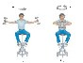
- A student sits on a freely rotating stool holding two weights, each of mass 3.00 kg (Fig. P10.48). When his arms are extended horizontally, the weights are 1.00 m from the axis of rotation and he rotates with an angular speed of 0.750 rad/s. The moment of inertia of the student plus stool is 3.00 kg · m² and is assumed to be constant. The student pulls the weights inward horizontally to a position 0.300 m from the rotation axis. (a) Find the new angular speed of the student. (b) Find the kinetic energy of the rotating system before and after he pulls the weights inward.

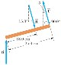
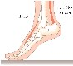
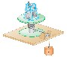
- When a person stands on tiptoe (a strenuous position), the position of the foot is as shown in Figure P10.70a. The total gravitational force on
❒ 
the body F_{g} is supported by the force n exerted by the floor on the toes of one foot. A mechanical model for the situation is shown in 
Figure P10.70b, where  T is the force exerted by the Achilles tendon on the foot and R is the force exerted by the tibia on the foot. Find the values of T, R, and θ when F_{g} = 700 N.

- This problem describes one experimental
method for determining the moment of inertia of an irregularly shaped object such as the payload for a satellite. Figure P10.15 shows a counterweight of mass m suspended by a cord wound around a spool of radius r, forming part of a turntable supporting the object. The turntable can rotate without friction. When the counterweight is released from rest, it descends through a distance h, acquiring a speed v. Show that the moment of inertia I of the rotating apparatus (including the turntable) is mr²(2gh/v² – 1).

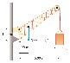
11. A crane of mass 3 000 kg supports a load of 10 000 kg as shown in Figure P10.32. The crane is pivoted with a frictionless pin at A and rests against a smooth support at B. Find the reaction forces at A and B.

12 A common demonstration, illustrated in Figure P10.63, consists of a ball resting at one end of a uniform board of length ℓ, hinged at the other end, and elevated at an angle θ. A light cup is attached to the board at r_{c} so that it will catch the ball when the support stick is suddenly removed. (a) Show that the ball will lag behind the falling board when θ is less than 35.3°. (b) Assume that the board is 1.00 m long and is supported at this limiting angle. Show that the cup must be 18.4 cm from the moving end.
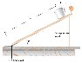

INTRODUCTION TO THERMODYNAMICS

WHAT IS THERMODYNAMICS?

State Variables
Macroscopic vs. Microscopic
O^{th} Law of Thermodynamics
Temperature and Pressure
Thermal expansion of solids and fluids
(Reading Assignment)

DEMO 1: ATMOSPHERIC PRESSURE: CAN DEMO 2: Guernicke Experiment
DEMO 3: Oil + water in the U-Tube
DEMO 4: Thermal Expansion of Solids

4 Mid-lecture Quiz Questions

7 Suggested Problems

READING ASSIGNMENT: Chapter 19

State Variables
Macroscopic vs. Microscopic

A state variable is an element of the set of variables that describe the state of a dynamical system.

Temperature, pressure, internal energy, enthalpy, entropy are examples of state variables in a thermodynamics system.

These are macroscopic variables
(attributable to the large ensembles of atoms/molecules)
In case of simple mechanical systems, position coordinates and their derivates are typical state variables. These are microscopic variables
(attributable to single atoms/molecules)

ONE OF THE MAJOR ACCOMPLISHMENTS OF THE
THEROY OF STATISTICAL MECHANICS WAS
OBTAINING STATE VARIABLES FROM
MICROSCOPIC VARIABLES DESCRIBING AVERAGE SINGLE MOLECULE!

- Zeroth Law of Thermodynamics

- If objects A and B are separately in thermal equilibrium with a third object C, then A and B are in thermal equilibrium with each other

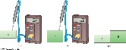
- Object C (thermometer) is placed in contact with A until they achieve thermal equilibrium
  - The reading on C is recorded

- Object C is then placed in contact with object B until they achieve thermal equilibrium
  - The reading on C is recorded again
–
- If the two readings are the same, A and B are also in thermal equilibrium

- IF TWO OBJECTS ARE IN THERMAL EQUILIBRIUM THERE IS NO ENERGY TRANSFER BETWEEN THEM ( THEY HAVE THE SAME TEMPERATURE)

Thermal Contact

- Two objects are in thermal contact with each other if energy can be exchanged between them
- The exchanges we will focus on will be in the form of heat or electromagnetic radiation
- The energy is exchanged due to a temperature difference

Thermal Equilibrium

• Thermal equilibrium is a situation in which two objects would not exchange energy by heat or electromagnetic radiation if they were placed in thermal contact • The thermal contact does not have to also be physical contact

TEMPERATURE

Temperature

- We associate the concept of temperature with how “hot” or “cold” an objects feels
- Our senses provide us with a qualitative indication of temperature
- Our senses are unreliable for this purpose
- We need a technical definition of temperature

- Temperature can be thought of as the property that determines whether an object is in thermal equilibrium with other objects
- Two objects in thermal equilibrium with each other are at the same temperature
– If two objects have different temperatures, they are not in thermal equilibrium with each other

Thermometers

- Thermometer is a device used to measure the temperature of a system.
- In order to be effective thermometer needs to fulfill following general conditions
  - Thermometer needs to have some linearly temperature dependant physical parameter
  - Needs to have small “heat capacity”
  - (by introducing it into the system we will change the system temperature – we want that change to be negligible!

- Thermometers are based on the principle that some physical property of a system changes as the system’s temperature changes.
- These properties include:
- The volume of a liquid
- The dimensions of a solid
- The pressure of a gas at a constant volume
- The volume of a gas at a constant pressure
- The electric resistance of a conductor
- The color of an object
- A temperature scale can be established on the basis of any of these physical properties
- A thermometer can be calibrated by placing it in contact with some natural systems that remain at constant temperature
- Common systems involve water.
- A mixture of ice and water at atmospheric pressure called the ice point of water.

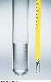

Liquid in glass Thermometers
- A common type of thermometer is a liquid-in-glass
- The material in the capillary tube expands as it is heated
- The liquid is usually mercury or alcohol
- Inaccurate far from the calibration points
- Useful only in the -30 to 80 C

Thermocouple Thermometers • Commonly used in variety of environments from low -250C to +1900C.
- Utilize the thermoelectric effect:
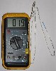
- when conductor is subjected to a thermal gradient, it will generate a voltage.
- Any attempt to measure this voltage necessarily involves connecting another conductor to the "hot" end. This additional conductor will then also experience the temperature gradient, and develop a voltage of its own which will oppose the original.
- The magnitude of the effect depends on the metal in use.
- Using a different metal to complete the circuit creates a circuit in which the two legs generate different voltages, leaving a small difference in voltage available for measurement. That difference increases with temperature, and can typically be between 1 and 70 microvolts per degree Celsius (µV/°C) for the modern range of available metal combinations.
- Certain combinations have become popular as industry standards, driven by cost, availability, convenience, melting point, chemical properties, stability, and output. This coupling of two metals gives the thermocouple its name.

TEMPERATURE SCALES

Celsius Scale
- The ice point of water is defined to be 0º C
- The steam point of water is defined to be 100º C
- The length of the column between these two points is divided into 100 increments, called degrees

Fahrenheit Scale
- A common scale in everyday use in the US
- Named for Daniel Fahrenheit
- Temperature of the ice point is 32 ºF
- Temperature of the steam point is 212 ºF
- There are 180 divisions (degrees) between the two reference points

Kelvin (absolute) Scale

- Absolute zero is used as the basis of the absolute temperature scale
- The size of the degree on the absolute scale is the same as the size of the degree on the Celsius scale
- The absolute scale is also called the kelvin scale
- Named for William Thomson, Lord Kelvin
- The triple point temperature is 273.16 K
- No degree symbol is used with kelvins
- The kelvin is defined as 1/273.16 of the difference between absolute zero and the temperature of the triple point of water

Conversions:

- Celsius and Kelvin have the same size degrees, but different starting points

T_{C} = T – 273.15

- Celsius and Fahrenheit have different sized degrees and different starting points

TF =9TC +32
5

Ice point temperatures: 0oC = 273.15 K = 32º F

Steam point temperatures: 100ºC = 373.15 K = 212º F

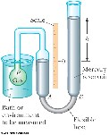
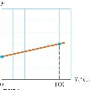

Constant Volume Gas Thermometer

- The physical change exploited is the variation of pressure of a fixed volume gas as its temperature changes
- The volume of the gas is kept constant by raising or lowering the reservoir B to keep the mercury level at A constant
- The thermometer is calibrated by using a ice water bath and a steam water bath
- The pressures of the mercury under each situation are recorded
- The volume is kept constant by adjusting A
- The information is plotted
- To find the temperature of a substance, the gas flask is placed in thermal contact with the substance
- The pressure is found on the graph
- The temperature is read from the graph

Absolute Zero

- The thermometer readings are virtually independent of the gas used
- If the lines for various gases are extended, the pressure is always zero when the temperature is
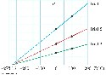
- –273.15o C
- This temperature is called absolute zero

- The absolute temperature scale is now based on two new fixed points (adopted by in 1954 by the International
Committee on Weights and Measures)
  - One point is absolute zero
  - The other point is the triple point of water
- This is the combination of temperature and pressure where ice, water, and steam can all coexist
- The triple point of water occurs at
0.01º C and 4.58 mm of mercury
- This temperature was set to be 273.16 on the absolute temperature scale
  - This made the old absolute scale agree closely with the new one
  - The units of the absolute scale are kelvins
- The figure at right gives some absolute temperatures at which various physical processes occur
- The scale is logarithmic
- The temperature of absolute zero cannot be achieved
  - Experiments have come close

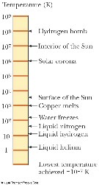
Energy at Absolute Zero
- According to classical physics, the kinetic energy of the gas molecules would become zero at absolute zero
- The molecular motion would cease
  - Therefore, the molecules would settle out on the bottom of the container
- Quantum theory modifies this and shows some residual energy would remain
  - This energy is called the zero-point energy

BIG QUESTION :
How does one measure T=10⁶ K or higher?

PRESSURE
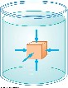
- The pressure P of the fluid at the level to which the device has been submerged is the ratio of the force to the area

p = F
A
- Pressure is a scalar quantity
  - Because it is proportional to the magnitude of the force
- If the pressure varies over an area, evaluate dF on a surface of area dA as dF = P dA
- Unit of pressure is pascal (Pa)

1Pa
⁼ 11Nm₂

Pressure in the uniform static fluid is constant at the same level

The pressure p at a depth h below a point in the liquid at which the pressure is p₀ is greater by an amount ρgh.

p =p₀ +ρgh

- The liquid has a density of ρ./ We assume the density is the same throughout the fluid./

- If the liquid is open to the atmosphere, and P0 is the pressure at the surface of the liquid, then P₀ is atmospheric pressure
- P0 = 1.00 atm = 1.013 x 10⁵ Pa

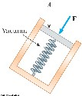
Measuring Pressure
- The spring is calibrated by a known force
- The force due to the fluid presses on the top of the piston and compresses the spring
- The force the fluid exerts on the piston is then measured

Barometer

- Invented by Torricelli
- A long closed tube is filled with mercury and inverted in a dish of mercury
– The closed end is nearly a vacuum
- Measures atmospheric pressure as
- One 1 atm = 0.760 m (of Hg)

Manometer

- A device for measuring the pressure of a gas contained in a vessel
- One end of the U-shaped tube is open to the atmosphere
- The other end is connected to the pressure to be measured
- Pressure at B is P₀+ρgh
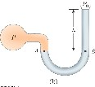
- P = P₀ + ρgh
- P is the absolute pressure
- The gauge pressure is P – P₀
  - This is also ρgh
  - This is what you measure in your tires

IMPORTANT QUESTIONS:
1What is the total force acting on human body associated with the atmospheric pressure? 2What is the origin of atmospheric pressure?

THERMAL EXPANSION OF SOLIDES AND LIQUIDS:
READING ASSIGNMENT

Length:

∆L=(L_{f} −L_{i})=αL_{i}(T_{f} −T_{i})=αL_{i}∆T

Volume:

∆V =(V_{f} −V_{i})=βV_{i}(V_{f} −V_{i})=βV_{i}∆T

Area:

∆S=(S_{f} −S_{i})=γS_{i}(S_{f} −S_{i})=γS_{i}∆T

Read the relevant material in the textbook
Find out the meaning of all the equations and variables above

Answer the following questions:

- How do α (linear expansion coefficient) and β (average coefficient of volume expansion) relate to each other?

- How do α (linear expansion coefficient) and γ (average coefficient of area expansion) relate to each other?

SUGGESTED PROBLEMS

Temperature Scales

1 At what absolute temperature the temperatures measured using Celsius scale and Fahrenheit Scale are equal?

2. On a Strange temperature scale, the freezing point of water is –15.0°S and the boiling point is +60.0°S. Develop a linear conversion equation between this temperature scale and the Celsius scale. 2S_JS_E 6
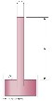
Pressure:

- Blaise Pascal duplicated Torricelli's barometer using a red Bordeaux wine, of density 984 kg/m3, as the working liquid (Fig. P14.17). What was the height h of the wine column for normal atmospheric pressure? Would you expect the vacuum above the column to be as good as for mercury?

- Mercury is poured into a U-tube as in Figure P14.18a. The left arm of the tube has cross-sectional area A1 of 10.0 cm2, and the right arm has a crosssectional area A2 of 5.00 cm2. One hundred grams of water are then poured into the right arm as in Figure
  - Determine the length of the water column in the right arm of the U-tube.
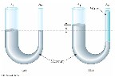
  - Given that the density of mercury is 13.6 g/cm3, what distance h does the mercury rise in the left arm?

Change of length with temperature
- A CERTAIN TELESCOPE FORMS AN IMAGE OF PART OF A
CLUSTER OF STARS ON A SQUARE SILICON CHARGE-COUPLED DETECTOR (CCD) CHIP 2.00 CM ON EACH SIDE. A STAR FIELD IS FOCUSED ON THE CCD WHEN IT IS FIRST TURNED ON AND ITS TEMPERATURE IS
20.0°C. THE STAR FIELD CONTAINS 5 342 STARS SCATTERED UNIFORMLY. TO MAKE THE DETECTOR MORE SENSITIVE, IT IS COOLED TO –100°C. HOW MANY STAR IMAGES THEN FIT ONTO THE CHIP? THE AVERAGE COEFFICIENT OF LINEAR EXPANSION OF SILICON IS 4.68×10^{–6} (°C)^{–1}.

- A copper wire and a lead wire are joined together, end to end. The compound wire has an effective coefficient of linear expansion of 20.0 × 10^{–6} (°C)^{–1}. What fraction of the length of the compound wire is copper?

- A steel rod undergoes a stretching force of 500 N. Its cross-sectional area is 2.00 cm². Find the change in temperature that would elongate the rod by the same amount as the 500-N force does. Consult the tables for proper values of expansion coefficients. .

IDEAL GAS LAW

What is the ideal gas?
Ideal Gas Law pV Diagrams for Ideal Gas

pV Diagrams for Various Gas Transformations

DEMO 1: Atmospheric Pressure: Can DEMO 2: Liquid Nitrogen + Helium filled balloon.

4 Mid-lecture Quiz Questions

8 Suggested Problems

READING ASSIGNMENT: 19

IDEAL GAS

- An ideal gas is a theoretical gas composed of a set of randomly-moving point particles that interact only through elastic collisions.
- The ideal gas concept is useful because it obeys the ideal gas law, a simplified equation of state, and it yields to analysis under statistical mechanics.
- It is a gas in which the interatomic forces within the gas are very weak
  - We can imagine these forces to be nonexistent
- Note that there is no equilibrium separation for the atoms
  - Thus, no “standard” volume at a given temperature
  - For a gas, the volume is entirely determined by the container holding the gas
- Equations involving gases will contain the volume, V, as a variable

Equation of State
- It is useful to know how the volume, pressure and temperature of the gas of mass m are related
- The equation that interrelates these quantities is called the equation of state
  - These are generally quite complicated
  - If the gas is maintained at a low pressure, the equation of state becomes much easier
  - This type of a low density gas is commonly referred to as an ideal gas

Gas Laws
- When a gas is kept at a constant temperature, its pressure is inversely proportional to its volume (Boyle’s law)
- When a gas is kept at a constant pressure, its volume is directly proportional to its temperature (Charles and Gay-Lussac’s law)

Ideal Gas Law
- The equation of state for an ideal gas combines and summarizes the other gas laws

PV=nRT
This is known as the ideal gas law
- P pressure
- V volume
- n number of moles of substance n=N/N_{A}
- T temperature
- R is a constant, called the Universal Gas Constant
- R = 8.314 J/mol · K = 0.08214 L · atm/mol · K
- From this, you can determine that 1 mole of any gas at atmospheric pressure and at 0º C is taking 22.4 liters of volume.

The Mole
- The amount of gas in a given volume is conveniently expressed in terms of the number of moles
- One mole of any substance is that amount of the substance that contains Avogadro’s number of constituent particles
  - Avogadro’s number N_{A} = 6.022 x 10²³
  - The constituent particles can be atoms or molecules
- The number of moles can be determined from the mass of the substance: n = m /M
  - M is the molar mass of the substance
  - m is the mass of the sample
  - n is the number of moles

IDEAL GAS EQUATION IN ALTERNATIVE FORM

•
- The ideal gas law is often expressed in terms of the total number of molecules, N, present in the sample:

PV = nRT = (N/N_{A}) RT = Nk_{B}T

- k_{B} is Boltzmann’s constant
- k_{B} = 1.38 x 10-23 J/K
- It is common to call P, V, and T the thermodynamic variables of an ideal gas

Phase Space and PV Diagrams
Pressure (105Pa)
- If the system has well-defined Pressure, Volume and Temperature, we are able to represent its state at every ₈ moment in time as a point on a P-V , P-T
i

f

or V-T diagram. ₇
- The change of these parameteres corresponds to the change of the ⁶ coordinates in such “phase space
diagram” ⁵
- PV diagram is used when the pressure and volume are known at each step of ⁴ the process.
- The state of the gas at each step can be ³ plotted on a graph called a PV diagram
2 • This allows us to visualize the process through which the gas is ₁ progressing
- The curve is called the path
Pressure-volume diagram is used to describe a 0 1 2 3 4 5 6 7 8
thermal cycle involving the following two _{Volume (liters)} variables:
Volume (on the X axis) Pressure (on the Y axis)

This is in fact enough information to fully describe a simple system from a thermodynamic standpoint. Each point on the diagram has coordinates (V,p) which fully describe the ideal gas system at any point of time.

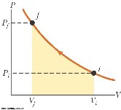
The diagrams are useful when one wants to calculate the work done by the system, the integral of the pressure with respect to volume. One can often
quickly calculate this using the PV diagram as it is simply the area enclosed by the cycle.

Suggested Problems:

Ideal Gas Equation

- Show that 1 mole of any gas at atmospheric pressure and at 0º C is taking 22.4 liters of volume

- 100 grams of oxygen and 100 grams of hydrogen gas occupy separate, equal sections of 200 liter tank. The divide is removed and the gases are allowed to mix and react with each other. The temperature is kept constant at 110 °C, throughout the process a) find the pressure of each gas in the separate containers
b) find the pressure after the reaction ends.

- A popular brand of cola contains 6.50 g of carbon dioxide dissolved in 1.00 L of soft drink. If the evaporating carbon dioxide is trapped in a cylinder at 1.00 atm and 20.0°C, what volume does the gas occupy?

- The mass of a hot-air balloon and its cargo (not including the air inside) is 200 kg. The air outside is at 10.0°C and 101 kPa. The volume of the balloon is 400 m³. To what temperature must the air in the balloon be heated before the balloon will lift off? (Air density at 10.0°C is
1.25 kg/m³.)

- Just 9.00 g of water is placed in a 2.00-L pressure cooker and heated to 500°C. What is the pressure inside the container?

6. A tank having a volume of 0.100 m³ contains helium gas at 150 atm. How many balloons can the tank blow up if each filled balloon is a sphere 0.300 m in diameter at an absolute pressure of 1.20 atm?

- At 25.0 m below the surface of the sea (ρ= 1 025 kg/m³), where the temperature is 5.00°C, a diver exhales an air bubble having a volume of 1.00 cm³. If the surface temperature of the sea is 20.0°C, what is the volume of the bubble just before it breaks the surface?

- Long-term space missions require reclamation of the oxygen in the carbon dioxide exhaled by the crew. In one method of reclamation, 1.00 mol of carbon dioxide produces 1.00 mol of oxygen and 1.00 mol of methane as a byproduct. The methane is stored in a tank under pressure and is available to control the attitude of the spacecraft by controlled venting. A single astronaut exhales 1.09 kg of carbon dioxide each day. If the methane generated in the respiration recycling of three astronauts during one week of flight is stored in an originally empty 150-L tank at –45.0°C, what is the final pressure in the tank?

FIRST LAW OF THERMODYNAMICS

Work
Heat
Internal Energy
Conservation Of Energy
First Law of Thermodynamics

DEMO 1 Heating of the drill
DEMO 2 Heat –work equivalence experiment

2 Mid-lecture quiz questions
4 Suggested Problems

READING ASSIGNMENT: Chapter 20

CONSERVATION OF MECHANICAL ENERGY

If we dealing with a system that conserves Mechanical Energy
(Which means that there are no losses) We can state the

The Law of Conservation of Mechanical Energy:

in the absence of losses the Total Mechanical Energy of the system is constant.

The only two forms of Mechanical Energy available to macroscopic bodies are Potential Energy(U) and Kinetic Energy (K)

Thus we can state our Conservation Law in the following form:

K+U=E=const

WORK in MECHANICS

Work is an energy transfer associated with the change of mechanical energy.
For simple body work is defined as product of acting Force and displacement of that body.

dW
= Fdx

Work = Change in Mechanical Energy

W =∆K+∆U

Everyday experience makes us aware of unavoidable nature of losses.

Effects such as: friction, drag, viscosity dissipate energy and diminish amount of mechanical energy of the system, eventually bringing all motion to a stop.

The loss of mechanical energy is accounted for if one adds heat and the increase of the system’s internal energy to the balance.

We will now find out more about these Heat and Internal Energy

HEAT:

- Heat is a byproduct of friction. Whenever the Kinetic Energy is lost due to friction losses we will observe the system and the surroundings to “heat up.”
•
- Heat is defined as the transfer of energy across the boundary of a system due to a temperature difference between the system and its surroundings.

- The term heat will also be used to represent the amount of energy transferred by this method

INTERNAL ENERGY

- Internal energy is all the energy of a system that is associated with its internal structure (its microscopic components).
- Today we know that on fundamental level these components are its atoms and molecules.

- The system is viewed from a reference frame at rest with respect to the center of mass of the system.
- The kinetic energy due to its motion through space is not included.

- Internal energy does include kinetic energies due to:
  - Random translational motion
  - Rotational motion
  - Vibrational motion
- Internal energy also includes potential energy between molecules.

Mechanical Equivalent of Heat

- Joule established the equivalence between mechanical energy and internal energy
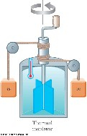
- His experimental setup is shown at right
- The loss in potential energy associated with the blocks equals the work done by the paddle wheel on the water.
- Joule found that it took approximately 4.18 J of mechanical energy to raise temperature of 1g of water by 1ºC.
- Later, more precise, measurements determined the amount of mechanical energy needed to raise the temperature of 1g of water from 14.5ºC to 15.5ºC
- 1 cal = 4.186 J
  - This is known as the mechanical equivalent of heat
  - The “Calorie” used for food is actually 1 kilocalorie
- In the US Customary system, the unit is a BTU (British Thermal Unit)

- One BTU is the amount of energy transfer necessary to raise the temperature of 1 lb of water from 63oF to
64oF

- The standard in the text is to use Joules

- Thermodynamics and mechanics were considered to be separate branches – Until about 1850
  - Experiments by James Joule and others showed a connection between them
- A connection was found between the transfer of energy by heat in thermal processes and the transfer of energy by work in mechanical processes
- The concept of energy was generalized to include internal energy
- The Law of Conservation of Energy emerged as a universal law of nature

The Law of Conservation of Energy
In the isolated system the total energy (sum of all forms of energy) is constant
The First Law of Thermodynamics:

Expresses the conservation of energy for thermodynamic systems.
Change of the Internal Energy(E_{int}) is due to two transfer mechanisms:
Heat(Q) and Work (W)

∆E
int
=
W + Q

System

Heat transferred out
of the system
Heat transferred
into
the system
Work
transferred
into
Work
transferred
out
of the system
the system

∆E_{int}= ∆W + ∆Q
First Law of Thermodynamics in Differential Form:

For small incremental quasi-static transfer

dE
int
=
dQ + dW

NOTE:

First law in its differential form is very useful in obtaining of the thermodynamic relations.
We will use it a lot in this course!

UNITS of ENERGY HEAT AND WORK

SI unit of energy is Joule:
1J =1Nm ( Newton times meter)
Heat and work are measured using the same units as energy

Other important and widely used energy units are:

1Btu=1054J
Calorie-cal – used in thermodynamics, chemistry and biomechanics
Electron Volt – eV – used in quantum physics and chemistry, spectroscopy
Wavenumber -cm⁻¹-(reciprocal centimeter) used in widely in spectroscopy HOMEWORK:
Fill the conversion table below

 | J | cal | eV | cm⁻¹
J | 1
cal | 4.186 | 1
eV | 1.6x10⁻¹⁹ |  | 1
cm⁻¹ |  |  |  | 1

1cal = 4.186J 1eV=1.6x10⁻¹⁹J

Suggested Problems:

Note : some of the problems below may require violation of the II law of thermodynamics

- The system performed 70J of work on the outside environment while receiving the 80J of heat from it and expelling 20J of heat. What is the net change of the internal energy of the system?

- The thermal engine (system operating in a cyclic fashion) performs 150 J of work while receiving 500 J of heat from heat reservoir. How much heat does the engine expel to the cold reservoir?

- One liter cylinder contains 1 mole of the ideal gas molecules having the average kinetic energy of 0.1eV. What is the total internal energy of this gas?

- 1 mole of ideal gas has total internal energy of 200J. What is the average kinetic energy (in eV) of one molecule of this gas?

HEAT

Heat

Specific Heats and Molar Specific Heats
Phase Changes and Latent Heat
Calorimetry

Adiabatic Process in the Ideal Gas

Heat Transfer Mechanisms

Demo 1: Calorimetric Measurements
Demo 2: Radiation Convection and Conductance
Demo 3: Radiating Bodies

12 Suggested Problems

READING ASSIGNMENT: chapter20

HEAT

- Heat is defined as the transfer of energy across the boundary of a system due to a temperature difference between the system and its surroundings
- The term heat will also be used to represent the amount of energy transferred by this method

- Historically, the calorie was the unit used for heat
  - One calorie is the amount of energy transfer necessary to raise the temperature of 1 g of water from 14.5oC to 15.5oC
- The “Calorie” used for food is actually 1 kilocalorie
- In the US Customary system, the unit is a BTU (British Thermal
Unit)
  - One BTU is the amount of energy transfer necessary to raise the temperature of 1 lb of water from 63°F to 64°F
- The standard in the text is to use Joules

The Heat Capacities and Specific Heats

Various bodies require different amounts of energy to be heated by the same temperature difference. Heat capacity reports on that property of the body .

- The heat capacity, C, of a particular sample is defined as the amount of energy needed to raise the temperature of that sample by 1ºC
- If energy Q produces a change of temperature of ∆T, then
Q = c ∆T

Specific Heat

- Specific heat, c, is the heat capacity per unit mass
- If energy Q transfers to a sample of a substance of mass m and the temperature changes by ∆T, then the specific heat is
- The specific heat is essentially a measure of how insensitive a substance is to the addition of energy
- The greater the substance’s specific heat, the more energy that must be added to cause a particular temperature change
- The equation is often written in terms of Q : Q = m c ∆T

Specific Heat versus Molar Specific Heat

Q = m c ∆T | specific heat expression (m mass in kg) c specific heat
Q = Nm₁ c ∆T | mass = N ( the number of molecules) x m₁ ( mass of a single molecule)
N  Q = ^{A} Nm₁ c ∆T N_{A}  N  Q = N m c ∆T | N  I am allowed to multiply any expression by (1= ^{A} )  N_{A}
I am allowed to change the order of multiplication
_{A 1}
N_{A}
 N 
  N_{A}  A 1 | I am allowed to group products in brackets
Q = nM c ∆T | N  I am using n = ^{A} ( number of moles) and M = N_{A}m₁(molar mass)  N_{A}
Q = nC ∆T | specific molar heat expression ( n amount of substance in moles) C = Mc is a molar specific heat of the substance
Q = (N m ) c ∆T

this expression is very useful in discussion of the ideal gas thermodynamics

∆T

nC

Q
=

Molar Specific Heat of Gases

It has been found experimentally that during the isobaric and isovolumetric gas transitions two gases exhibit two different molar heat capacities Cp and CV

Consequently two different expressions for heat need to be used in these transitions

Q = nC_{V} ∆T when V = const.

Q = nC_{p} ∆T when p = const.

Q = m c ∆T

SIGN CONVENTION
If the temperature increases:
Q and ∆T are positive
Energy transfers into the system

If the temperature decreases:
Q and ∆T are negative
Energy transfers out of the system

Specific Heat Variation with Temperature

- Technically, the specific heat varies with temperature
T_{f}
- The corrected equation isQ = m ∫c dT
T_{i}
- However, if the temperature intervals are not too large, the variation can be ignored and c can be treated as a constant
For most substances there is only about a 1% variation between 0º and 100ºC

Specific Heat of Water

- Water has the highest specific heat of common materials

- This is responsible for many weather phenomena

    - Moderate temperatures near large bodies of water
    - Global wind systems
    - Land and sea breezes

Phase Changes and Latent Heats of Transformation

  - A phase change is when a substance changes from one form to another – Two common phase changes are
  - Solid to liquid (melting)
  - Liquid to gas (boiling)
  - During a phase change, there is no change in temperature of the substance
  - Different substances react differently to the energy added or removed during a phase change – Due to their different molecular arrangements
  - The amount of energy also depends on the mass of the sample
  - If an amount of energy Q is required to change the phase of a sample of mass m,
  - L = Q /m
  - The quantity L is called the latent heat of the material
    - Latent means “hidden”
    - The value of L depends on the substance as well as the actual phase change
- The energy required to change the phase is Q = ± mL

- The latent heat of fusion is used when the phase change is from solid to liquid
- The latent heat of vaporization is used when the phase change is from liquid to gas
- The positive sign is used when the energy is transferred into the system – This will result in melting or boiling
- The negative sign is used when energy is transferred out of the system
– This will result in freezing or condensation

Graph of Ice to Steam
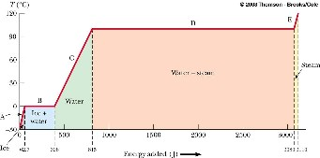

How much energy is needed to convert one gram of ice at –30.0ºC to 1g of steam at 120ºC?

Part A ( Warming up the Ice)
- During phase A, the temperature of the ice changes from –30.0ºC to 0ºC

• Use Q = mi ci ∆T In this case, 62.7 J of energy are added

Part B (Melting: Phase change )
- Once at 0ºC, the phase change (melting) starts
- The temperature stays the same although energy is still being added
- Use Q = mi Lf
– The energy required is 333 J the total energy moves from 62.7 J to 396 J
Part C (Warming up the water )
- Between 0ºC and 100ºC, the material is liquid and no phase changes take place
- Energy added increases the temperature
- Use Q = m_{w}c_{w} ∆T

– 419 J are added The total is now 815 J
Part D- Boiling (phase change)
- At 100ºC, a phase change occurs (boiling)
- Temperature does not change
- Use Q = m_{w} L_{v}

– This requires 2260 J The total is now 3070 J
Part E- Warming up the steam
- After all the water is converted to steam, the steam will heat up
- No phase change occurs
- The added energy goes to increasing the temperature
- Use Q = m_{s}c_{s} ∆T
  - In this case, 40.2 J are needed
  - The temperature is going to 120º C The total is now 3110 J

Molecular View of Phase Changes

Phase changes can be described in terms of the rearrangement of molecules (or atoms in an elemental substance)

- Liquid to Gas phase change
  - Molecules in a liquid are close together
  - The forces between them are stronger than those in a gas
  - Work must be done to separate the molecules
  - The latent heat of vaporization is the energy per unit mass needed to accomplish this separation

- Solid to Liquid phase change
  - The addition of energy will cause the amplitude of the vibration of the molecules about their equilibrium position to increase
  - At the melting point, the amplitude is great enough to break apart bonds between the molecules
  - The molecules can move to new positions
  - The molecules in the liquid are bound together less strongly than those of the solid
  - The latent heat of fusion is the energy per unit mass required to go from the solidtype to the liquid-type bonds

- The latent heat of vaporization is greater than the latent heat of fusion
  - In the liquid-to-gas phase change, the liquid-type bonds are broken
  - The gas molecules are essentially not bonded to each other
- It takes more energy to completely break the bonds than to change the type of bonds

Calorimetry
- The technique for measuring specific heat involves heating a material, adding it to a sample of water, and recording the final temperature is known as calorimetry,
- A calorimeter is a device in which this energy transfer takes place
- The system of the sample and the water is isolated
- Conservation of energy requires that the amount of energy that leaves the sample equals the amount of energy that enters the water
  - Conservation of Energy Gives a Mathematical Expression of This:

Qcold= -Qhot

The negative sign in the equation is critical for consistency with the established sign convention Since each Q = mc∆T, csample can be found by: s = m cw w (Tf −T)w ) c
m T_{s} ( s −Tf
  - technically, the mass of the container should be included, but if mw >>m_{container} it can be neglected

Adiabatic Process in the Ideal Gas

We are ready to discuss the last important process of ideal gas.

Adiabatic Process Is the process in which no heat is exchanged with the surroundings!

It may be proven that in such process

pV^{γ}=const where γ >1

We will soon demonstrate that this is true!

Heat Transfer Mechanisms: Reading Assignment
(Self study!)

Thermal Conduction:
Energy transfer by the heat ( on microscopic level it is caused by the exchange of kinetic energies of molecules of two bodues in thermal contact)
P=kAdTdx

Radiation:
energy transfer by the electromagnetic radiation emitted from the body

P =σAeT⁴

Convection: energy transfer by the movement of high T substance into low T substance. Takes form of convection currents.

Suggested Problems:

- A 2.5 kg aluminum is heated to 92°C and then dropped into 8 kg of water at 5°C. Assuming that water metal system is thermally isolated what is the system equilibrium temperature?
- A 20g copper calorimeter contains 100g of water at 30°C. Into this is poured a 40 g of glass beads which have been heated to a temperature of 100°C. The final equilibrium temperature of the whole system is 40°C. What is the specific heat for the glass?
- A water heater is operated by solar power. If solar collector has an area of 6.00m², and the Intensity delivered by sunlight is 550W/m², how long does it take to increase the temperature of 1m³ of water from 20°Cto 60°C?
- A 1kg of ice at -30° C is added to 10 kg of steam at 500°C. answer the following questions:
  - What is the phase of the system of ice + steam if no heat escaped from it.
  - What is the final temperature when the equilibrium is established
- A 5g lead bullet travelling with v=1200m/s embeds in the 1kg block of ice at (-1°C). Knowing that practically all of the kinetic energy of the bullet is converted to heat find the final temperature of the bullet + ice system. How much water was produced during the melting?
- Two speeding lead bullets each of mass 5 g and temperature of 20°C collide head on at speeds of 500m/s each. Assuming a perfectly inelastic collision and no loss of energy to the atmospheres, describe the final state of the two bullet system.
- The Nova laser at Lawrence Livermore National Laboratory in California is used in studies of initiating controlled nuclear fusion (Section 45.4). It can deliver a power of 1.60 × 10¹³ W over a time interval of 2.50 ns. Compare its energy output in one such time interval to the energy required to make a pot of tea by warming 0.800 kg of water from 20.0°C to 100°C.
- A combination of 0.250 kg of water at 20.0°C, 0.400 kg of aluminum at 26.0°C, and 0.100 kg of copper at 100°C is mixed in an insulated container and allowed to come to thermal equilibrium. Ignore any energy transfer to or from the container and determine the final temperature of the mixture.
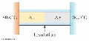
- A bar of gold is in thermal contact with a bar of silver of the same length and area (Fig.). One end of the compound bar is maintained at 80.0°C while the opposite end is at 30.0°C. When the energy transfer reaches steady state, what is the temperature at the junction?
- A glass window pane has an area of 3.00 m² and a thickness of 0.600 cm. If the temperature difference between its faces is 25.0°C, what is the rate of energy transfer by conduction through the window.
11. The surface of the Sun has a temperature of about 5 800 K. Radius of the Sun is 6.96 × 10⁸ m. Calculate the total energy radiated by the Sun each second. Assume that the emissivity is 0.965.
12 The tungsten filament of a certain 100-W light bulb radiates 2.00 W of light. (The other 98 W is carried away by convection and conduction.) The filament has a surface area of 0.250 mm² and an emissivity of 0.950. Find the filament’s temperature. (The melting point of tungsten is 3 683 K.)

WORK IN THERMODYNAMIC PROCESSES

Work as integral
Work in PV Diagrams

Demo 1: Finding work in compression
Demo 2: Finding work in Joule’s Experiment

4 Mid-lecture quiz questions
7 Suggested Problems

READING ASSIGNMENT: chapter20

Work in Thermodynamics
- Work can be done on a deformable system, such as a gas
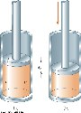
- Consider a cylinder with a moveable piston
- A force is applied to slowly compress the gas
  - The compression is slow enough for all the system to remain essentially in thermal equilibrium
  - This is said to occur quasi-statically

- The piston is pushed downward by a force F through a displacement of dr:

→ →  

dW = F⋅dr = −Fj ⋅dyj = −Fdy = −pAdy = −pdV
- A.dy is the change in volume of the gas, dV
- Therefore, the work done on the gas is dW = -P dV

Interpreting dW = - P dV

- If the gas is compressed, dV is negative and the work done on the gas is positive
- If the gas expands, dV is positive and the work done on the gas is negative
- If the volume remains constant, the work done is zero • The total work done is:
f f

W=∫dW=∫−pdV
i i
Work in PV Diagrams
• The work done on a gas in a quasi-static process that takes the gas from an initial state to a final state is the negative of the area under the curve on the PV diagram, evaluated between the initial and final states
– This is true whether or not the pressure stays constant
The work done does depend on the path taken!

Work Done By Various Paths between the same i and f

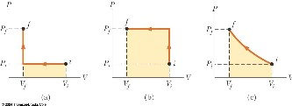
Each of these processes has the same initial and final states The work done differs in each process

The work done depends on the path
Example:

Find the expressions for work in ideal gas transformations:

Isobaric Process | p=const
Isovolumetric Process | V= const
Isothermal Process | T=const
Adiabatic Process | Q=0

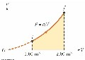
Suggested Problems

1 A sample of ideal gas is expanded to twice its original volume of 1.00 m³ in a quasi-static process for which P = αV ², with α = 5.00 atm/m⁶, as shown in Figure P20.23. How much work is done on the expanding gas?

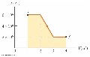
2. One mole of an ideal gas does 3 000 J of work on its surroundings as it expands isothermally to a final pressure of 1.00 atm and volume of 25.0 L. Determine (a) the initial volume and (b) the temperature of the gas.

- (a) Determine the work done on a fluid that expands from i to f as indicated in Figure P20.24. (b) What If? How much work is performed on the fluid if it is compressed from f to i along the same path?

- A 4 liter sample of a diatomic gas with γ =1.4 confined
to a cylinder, is carried through a closed cycle. The gas is initially at 1.00atm. and 300K. First, its pressure is tripled under constant volume. Then it expands adiabatically to its original pressure. Finally the gas is compressed isobarically to its original volume.
a) draw pV diagram of this cycle b) Determine the volume of the end of the adiabatic expansion
- Find the temperature of the gas at the start of the adiabatic expansion
- Find the temperature at the end of the cycle
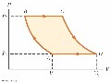
- What was the net work done on the gas for this cycle

- An ideal gas is carried through a thermodynamic cycle consisting of two isobaric and two isothermal processes as shown in Figure P20.69. Show that the net work done on the gas in the entire cycle is given by
Wnet =−P1(V2 −V1)ln P2
P1

- A cylinder containing n mol of an ideal gas undergoes an adiabatic process. (a) Starting with the expression W =⁻∫PdV and using the condition PV ^{γ} = constant, show that the work done on the gas
is: W =γ1−1(Pf V f −PiVi )
(b) Starting with the first law of thermodynamics in differential form, prove that the work done on the gas is also equal to nC_{V} (T_{f} – T_{i}). Show that this result is consistent with the equation in part (a).

7 One mole of an ideal gas is heated slowly so that it goes from the PV state (P₀, V₀), to (3P₀, 3V₀), in such a way that the pressure is directly proportional to the volume. (a) How much work is done on the gas in the process? (b) How is the temperature of the gas related to its volume during this process?
Summary of Thermodynamics of Gas Transformations I SUMMARY TABLE FOR GAS TRANSITIONS

Using the First Law of Thermodynamics together with definition of work and internal energy we should be able to fill a following table:

Process | W | Q | ∆E
V = const.
P = const.
T = const.
Q = 0

Three important questions remain:

- What is the relation between Cv and Cp?
- What is the relation between Cv, (or Cp), and R in the ideal gas?
3What is γ (gamma) in adiabatic transformation and how come

pV^{γ}= const.?

SUGGESTED PROBLEMS
1 Prove that pV^{γ}=const. for adiabatic process.
/Use the first law of Thermodynamics and Ideal gas low in their differential forms./

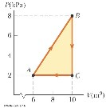
2. A gas is taken through the cyclic process described in Figure P20.30. (a) Find the net energy transferred to the system by heat during one complete cycle. (b) What If? If the cycle is reversed—that is, the process follows the path ACBA— what is the net energy input per cycle by heat?

- One mole of an ideal gas is contained in a cylinder with a movable piston. The initial pressure, volume, and temperature are P_{i}, V_{i}, and T_{i}, respectively. Find the work done on the gas for the following processes and show each process on a PV diagram: (a) an isobaric compression in which the final volume is one-half the initial volume, (b) an isothermal compression in which the final pressure is four times the initial pressure, (c) an isovolumetric process in which the final pressure is three times the initial pressure
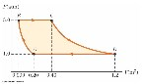
- A sample of an ideal gas goes through the process shown in Figure P20.32. From A to B, the process is adiabatic; from B to
C, it is isobaric with
100 kJ of energy entering the system by heat. From C to D, the process is isothermal; from D to A, it is isobaric with 150 kJ of energy leaving the system by heat. Determine the difference in internal energy E_{int,B} – E_{int,A}.

- An ideal gas initially at 300 K undergoes an isobaric expansion at 2.50 kPa. If the volume increases from 1.00 m³ to 3.00 m³ and 12.5 kJ is transferred to the gas by heat, what are (a) the change in its internal energy
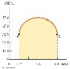
- A sample of an ideal gas is in a vertical cylinder fitted with a piston. As 5.79 kJ of energy is transferred to the gas by heat to raise its temperature, the weight on the piston is adjusted so that the state of the gas changes from point A to point B along the semicircle shown in Figure P20.33. Find the change in internal energy of the gas.

7. An ideal gas initially at P_{i}, V_{i}, and T_{i} is taken through a cycle as in
Figure P20.38. (a) Find the net work done on the gas per cycle. (b) What is the net energy added by heat to the system per cycle? (c) Obtain a numerical value for the net work done per cycle for 1.00 mol of gas initially at 0°C.
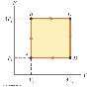
KINETIC THEORY OF GASES I

Microscopic Reasons for Macroscopic Effects

Pressure and Temperature as functions of microscopic variables

Derivation of the Ideal Gas Equation from Newtonian Mechanics applied to molecules moving at average velocities

Equipartition Theorem

DEMO 1: light turbine
DEMO 2: temperature of vacuum

4 mid-lecture quiz question

6 Suggested Problems

READING ASSIGNMENT: Chapter 21

We will see how Pressure and Temperature are really functions of microscopic variables such as average velocity, or average kinetic energy.

We will derive the Ideal Gas Equation from Newtonian Mechanics applied for average velocities!

Finally we will have a first look at Equipartition Theorem.
(We will look at it again later)

We will answer one of the important questions questions:

What does it mean that the temperature is 10⁶K or higher?

We will also see why it is so important to discuss the speed, velocity and energy distributions.

WARNING:

This is one of the most “theoretical” of all lectures in your first year Physics Course !

/It is also one of the most important ones!/

Kinetic Theory of Gases /Ludwig Boltzmann/
(Molecular Model of an Ideal Gas)
- The Kinetic Theory of Gases was developed before the molecular physics!
- As the matter of fact it was one of the theories which introduced the idea of microscopic particles from which all matter is build!
- The proponent of this theory was Ludwig Boltzmann, who because of it was ridiculed and suffered form long lasting depression.

Postulates:

The ideal gas is made of microscopic particles (molecules) which may be treated as point particles.

The number of molecules in the gas is very large, and the average separation between them is large compared with their dimensions.

The molecules obey Newton’s Laws of motion. Their motion in the container is random.

The molecules interact only by short range forces during the elastic collisions.

The molecules make elastic collisions with the walls.
The gas under consideration is pure substance: all molecules are identical.

Pressure and Temperature as functions of microscopic variables

- Consider single molecule of gas moving freely in the square box container with a velocity of magnitude v

- If we pick one dimension to discuss this motion ( say x- direction). We have v_{x} = vcosθ xcomponent of velocity in x–direction

The molecule will collide elastically with the wall of the container:
That means that after the collision it will have velocity -v_{x}

The resulting change of linear momentum is:

∆p=p_{f}-p_{i}=-mv_{x}-mv_{x}=-2mv_{x}

Using Newton’s Second Law. We may relate this to the force exerted by the wall on the molecule:
∆p 2mv_{x}
F= =−
∆t ∆t
But:
v_{x} = L_{x}
∆t
So:
F = −2mvx = −2mvx = −2mvx2 = − mvx2
∆t 2L_{x} 2L_{x} L_{x}
v_{x}
This is the average force exerted by the wall on the molecule
By the virtue of the Third Newton’s Law the force exerted by the molecule on the wall is equal and of opposite direction
F = mvx2
L_{x} Pressure exerted by one molecule is given by:
mvx2
p = F = Lx = mvx2 = mvx2 = mvx2
1
A A AL_{x} L_{y}L_{z}L_{x} V
The pressure exerted by N molecules moving with average v_{x}. is given by
= Np₁ = Nmv^{x2}
p
V
It is a good moment to think about the properties of the ideal gas molecules. Based on the fact that the gas is isotropic, the average movements of molecules in each dimension should be identical.
This means that the average velocity components in every direction: x,y, and z are equal!
vx2 = vy2 = vz2 = v2 since vx2 + vy2 + vz2 = v2
The expression for pressure takes following form: p =NmVvx2 =13NmVv2 pV =13Nmv2 = 31 N221 mv2 = 23N21 mv2 = 23N(Ekin ) pV=23N(Ekin )=23NN_{A} NAEkin =n23NAEkin 

pV =n2NAEkin 
3 

This is the relationship between pressure, volume and number of particles and their average kinetic energy obtained based on the Newtonian Mechanics applied gas molecules!
(It better be correct or something is very wrong with classical mechanics)

Lets compare this result with the ideal gas equation:

pV =nRT =n(RT)

This equation has been confirmed by countless experiments with real gases. It holds!
Since the left sides of both equations are identical, so must be the right sides!

This enforces the following identity:

(RT)=23NAEkin 
RT =NAEkin
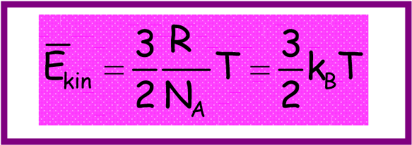
We have thus obtained the key relations between pressure p and average kinetic energy of molecules as well as temperature T and the average kinetic energy of molecules.
Discussion:

Thus far we have obtained set of very interesting results!

- Pressure. Our intuitive belief that pressure is caused by molecules colliding with the wall has been confirmed and given proper mathematical expression: Overall pressure depends on the number density of molecules and their average kinetic energy

p = 23NV 21mv2  = 23NV (Ekin )

- Temperature. It turns out the temperature is actually a direct measure of the average kinetic energy of gas molecules. The faster the molecules move about the higher is the temperature!

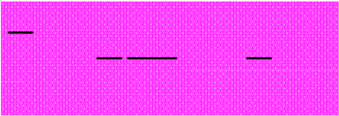
Ekin =32NR_{A} T=23kBT

- Total internal energy of ideal gas:
Total internal energy of the gas composed out of the material points is simply a product of number of gas particles and their average kinetic energy!

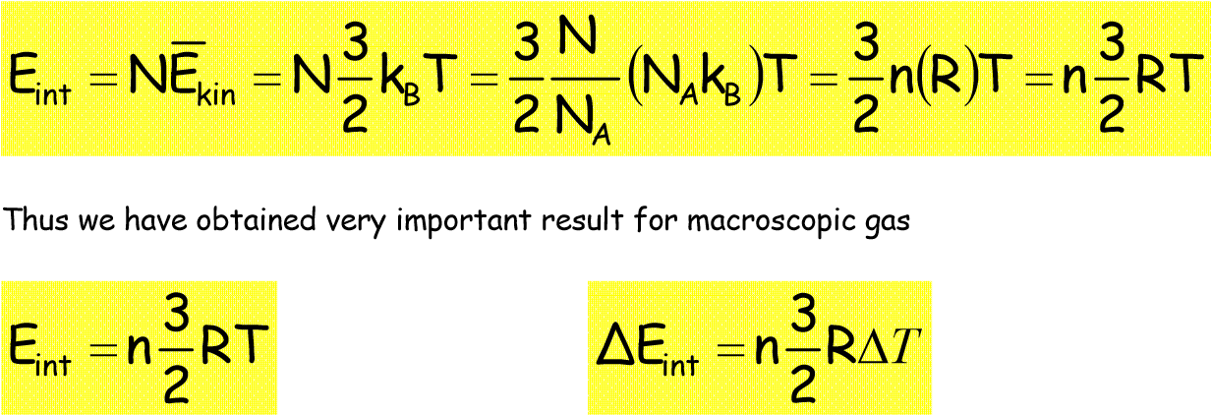
The change of internal energy ∆E_{int} does not depend on the fashion in which the change was accomplished!
(∆E_{int} is path independent – E_{int} is state variable)

Equipartition Theorem:


Each degree of freedom of molecule contributes ¹ k_{B}T to the
2
total average energy of the molecule.

This is very important result of Statistical Mechanics
It rises the following important question:

What constitutes the degree of freedom of a molecule?

Before we answer this question, lets look at what does this theorem mean for the ideal gas.

The ideal gas molecule has only one way to store its energy:
via kinetic energy!

This is due to a fact that ideal gas molecule is a material point— it has no energy structure. /It has no structure!/

Average kinetic energy of ideal gas single molecule is given by
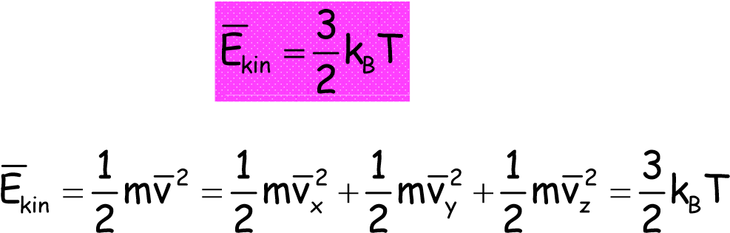

In isotopic gas each average of the velocity coordinate contributes the same amount to kinetic energy (as they are equal on average)

So that:

mv 2 = 1 mv2 = 1 mv 2 = 1k T x 2 y 2 z 2 B

Each term mv_{xyz}² in the total energy expression of the molecule brings ¹ k_{B}T to the total
2
average energy of the molecule.

This means that the degree of each degree of freedom is associated with terms likemv_{xyz}² .

Equipartion Theorem Explanation:

Every term in the expression for total energy of the molecule that is proportional to square of the linear coordinate or the square of the derivative of the linear coordinate may be considered the degree of freedom of a molecule and
contributes ¹ k_{B}T to the average total energy of the molecule! 2

Suggested Problems:

1 The following are the total energy expressions for certain molecules:

a)

v
m
2
1

v
m
2
1
v
m
2
1
E
2
z
2
y
2
x
kin
+
+
=

b)

I
2
1
I
2
1
v
m
2
1

v
m
2
1
v
m
2
1
E
2
y
2
x
2
z
2
y
2
x
kin
ω
ω
+
+
+
+
=

c)
2
osc
2
2
y
2
x
2
z
2
y
2
x
kin
v
k
2
1
z
k
2
1

I
2
1
I
2
1
v
m
2
1

v
m
2
1
v
m
2
1
E
+
+
+
+
+
+
=
ω
ω

d)

v
m
2
1
v
m
2
1
E
2
y
2
x
kin
+
=

e)
2
x
2
x
2
x
2
z
2
y
2
x
kin
osc
osc
osc
v
m
2
1
v
m
2
1
v
m
2
1
z
k
2
1

y
k
2
1
x
k
2
1
E
+
+
+
+
+
=

i) Find the total average energy of each of these molecules ii) Find the internal energy of 1 mole of each of these gases

- What is the total average energy of a molecule having f degrees of freedom?
What is the internal energy of n moles of gas made of such molecules?
How does it compare to the internal energy of n moles of ideal gas?

- 5 moles of ideal gas occupy a volume of 1m³ under a pressure of 1atm.
i) Find average kinetic energy of single molecule of an ideal gas under the pressure of 1atm. ii) using this result find the temperature of the gas
iii) find the temperature of the gas using ideal gas equation

- 5 moles of gas made of the molecules having 11 degrees of freedom, occupy a volume of 1 m³ under the pressure of 1 atm
i) find the total internal energy of 5 moles of such gas ii) find the temperature of the gas
iii) Try to find the temperature of the gas using ideal gas equation Comment on your results.

- Find the average kinetic energy of a hydrogen molecule at:
i) 10K ii)100K iii) 300K iv) 1000K v)10⁶K

- The most energetic particle ever recorded had kinetic energy of 10TeV What is the temperature of the gas that corresponds to such energy?

KINETIC THEORY OF GASES II

Velocity and Energy Distributions

Review of Statistics

Discrete Distributions

Continuous Distributions

Maxwell-Boltzmann Velocity Distribution Function

Boltzmann Energy Distribution Function

6 Mid Lecture Quiz questions
8 suggested Problems

READING ASSIGNMENT: Chapter 21

DISTRIBUTIONS AND STUFF

0
10
20
30
40
50
60
Test
final
1
2
test
3
test
A
B
C
D
E
F
If you know how to answer the questions posed below you know how to deal with the distributions

- Q1 What is the probability that a randomly chosen student obtained F on the first test • Q2: What is the probability that a randomly chosen student obtained grade below B on second test?
- Q3: What is the most probable grade for the final?
- Q4: What is the lowest grade obtained on the third test?
- Q5: What was the class average for the 2 test?
- Q6: What is rms grade for First Test?
- Q7: What the heck does the rms mean ???

Probability Distribution Function 40
How do we find class average for test 1? ₃₅

First we need to attribute ³⁰ numerical values to letter grades ₂₅

A= 90 ²⁰
B= 80 ₁₅
C= 70
D= 60 ¹⁰
E= 50 ₅
F= 25

Next we need to find how many students received part⁰ icular grades
A
B
C
D
E
F
A= 90  B= 80  C= 70  D= 60  E= 50 |  | 10 15  35 25  15 | 1Test

F= 25 0 Total number of students is 100

Class average is calculated from the following formula

Avg. = 90x10/100+80x15/100+70x35/100+60x25/100+15x50/100+25x0/100

∑(grade)_{i} ×(numberofstudentswiththatgrade)_{i =}∑_{x}i n_{i} totalnumberofstudents _{i} N
Where: n^{i} =P_{i} =P(x_{i}) is the probability of random student obtaining certain grade x_{i}
N

P(x) is called probability distribution function !

Discrete Probability Distribution Functions

Thus we have obtained very important result

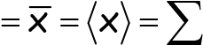
ni =∑xiP(xi) xavgxi i N _{i}

In a similar fashion one may find the average of “square of x”

x2avg =x2 = x2 =∑xi2 ni =∑xi2P(xi) i N _{i}
In general the average of any function h(x) is given by:

h(x)_{avg} =h(x)= h(x) =∑h(x_{i})^{ni} =∑h(x_{i})P(x_{i}) i N _{i}
Continuous Probability Distribution Function

- F(x) is properly defined probability distribution function if: F(x)dx is the probability of finding the parameter x in the interval (x, x + dx), and F(x) is normalized:
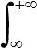
F(x)dx =1

- To find the probability of x being between values of a and b we need to use integral: b
Then the probability P_{ab}(x) of x being between a and b is given by ∫_{a} ^{F(x)dx}

b
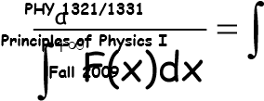
∫ F(x)dx _{b} P_{ab}(x)= a F(x)dx
−∞

Area under the curve

a b
For continuous probability distributions defined by function F(x), we have the following:

b
x=x_{avg} = x =∫a xF(x)dx
x2 = x2avg = x2 = ∫^{b}x²F(x)dx
a

b
h(x)=h(x)= h(x) =∫ h(x)F(x)dx
a
Maxwell-Boltzmann distribution

Maxwell Boltzmann speed distribution is the function describing probability of finding particular molecule having value of speed in the interval (v;v+dv).

P =Nv =4π( m )32v2e−2mvkT2dv ^{v} N 2πkT

T - temperature k - Boltzmann constant (k_{B}) v – molecule speed m – mass of the molecule N – total number of molecules
N_{v –} number of molecules having speed v in the interval (v;v+dv)

Note the temperature dependence!

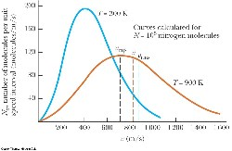

∫
∫
−
−
=
=
=
=
b
a
2
kT
mv
2
2
3
b
a
kT
2
mv
2
2
3
ab
dv
e
v
)
kT
2
m
(
4
dv
e
v
)
kT
2
m
(
4
b)
v
a;
(
v
P
2
2
π
π
π
π

Maxwell Boltzmann speed distribution: characteristic features:

At low speeds the function resembles parabola ( v2 term dominates exponential term is close to 0) As velocity increases the exponent dominates resulting in maximum and exponential tail of the function.

The most probable speed V_{MP} is the speed which the distribution reaches maximum. It may be found by taking simple derivative of the distribution function

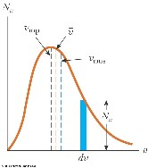dv
The average velocity is found from :

The root mean square speed

∫
∫
∫
+
∞
−
+
∞
−
+
∞
=
=
0
2
kT
mv
3
2
3
0
2
kT
mv
2
2
3
v
e
v
)
kT
2
m
(
4
dv
e
v
)
kT
2
m
(
v4
dv
vP
2
2
π
π
π
π
0
∫
∫
+
∞
−
∞
+
=
=
=
0
kT
2
mv
2
2
3
2
v
2
2
2
dv
e
v
)
kT
2
m
(
4
v
dv
P
v
v
v
2
π
π
0
2
2
2
rms
v
v
v
v
=
=
=
M
2
RT
m
2
kT
v
mp
=
=
M
3
RT
m
3
kT
v
rms
=
=

vavg = 8kT = 8RT πm πM

Boltzmann Energy Distribution

2 1 3 − E

P = ( ) 2 Ee kTdE E π kT

This distribution may be obtained from the speed distribution by simple substitution and differentiation

It is valid for all forms of energy not just kinetic

Contains information about the energy distribution in the situation when many different energy levels are available

Question:

What is the most probable energy at given temperature T?

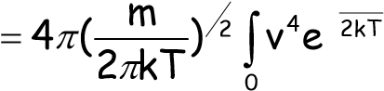
3 +∞ −mv2

dv

SUGGESTED PROBLEMS
- Demonstrate that v = 2kT ₌ 2RT mp
m M

- Using the value of Gaussian integrals ( mathematical appendix) verify the following relations

vrms = 3kT = 3RT vavg = 8πkTm = 8πRTM m M

- Find Vmp, V rms, V avg for the following cases:

    - Hydrogen at T = 2K, T = 300K, T = 900K, T = 10000K
    - Nitrogen at T = 2K, T = 300K, T = 900K, T = 10000K

- Given is distribution of speeds of cars at 417 Highway as measured by OPP.

    - Is this a discrete or continuous distribution?
    - Find the Vmp, Vrms, Vamg
    - Find the probability that a randomly picked car will have speed larger than 120km/h
    - Find the probability that a randomly picked car will have speed larger than 90km/h and less then 110km/h

- Find the ratio of molecules having velocity = 2v_{mp} to those with velocity = v_{mp} 6 Repeat these calculations for following pairs:

    - 2vrms and vrms
    - vmp and vrms
    - 2vavg and vavg
    - vmp and vavg

  - Calculate kT energy for following temperatures :

a)1K b) 20K c) 100K d) 300K e) 900K f) 5000K

Express your answer in i)Joules, ii) electronVolts (eV), iii) cm⁻¹

  - Certain molecule has the rotational energy levels spaced by 10cm⁻¹
(E₀=0, E₁=10, E₂=20 etc)

Given are 50000 molecules of the gas

    - Find the population of each of these levels at every temperature in point (7)
    - Find the level(s) with the highest population at each of these temperatures

SOLUTION TO THE Cv(T) DIAGRAM PUZZLE

This diagram was known since early XIX century. (The steam engine development required knowledge of the Cv values at various temperatures!)

But the XIX century thermodynamics and the kinetic theory of gases failed to yield correct value for these important coefficients

Not only the values of Cv were different for different molecules they also were changing with the temperature!

Equipartition Theorem hinted towards the following answer :

Different molecules have different number of degrees of freedom associated with their energy structure which results in different Cv values for various molcular gases.

But why the diatomic molecules do not have C_{V} = 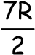for all T ??

Are molecules changing their structure with the temperature?

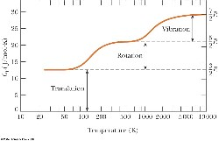
What is the meaning of the diagram below:

As you recall we left this issue un-answered.
We are now almost ready to understand this result with the help of Boltzmann Energy distribution.

Before we do we need to remind ourselves of one thing that we know but the XIX century engineers did not know

We need to recall that molecules and atoms have a discrete ( quantized ) energy structure.

Tentative Energy Structure of Molecules

ELECTRONIC VIBRATIONAL ROTATIONAL
E3

times magnification
100

times magnification
10
E2

E1

E0
ROTATIONAL ENERGY LEVELS ARE SEPARATED BY energy gaps of the order of 0.01 eV
VIBRATIONAL ENERGY LEVELS ARE SEPARATED BY energy gaps of the order of 0.1 eV ELECTRONIC ENERGY LEVELS ARE SEPARATED BY energy gaps of the order of 1-7eV Exercise
Calculate the temperature T for which kT = 2 eV ANS: T = 23 188 K !
Calculate the temperature T for which kT= 0.1 eV ANS: T = 1 159 K ! Calculate the temperature T for which kT=0.01eV ANS: T = 116 K !

The temperature necessary for electronic level excitation are so high that they never had practical implications for classical thermodynamics

In the case of systems with quantized internal energy structure (such as atoms and molecules) Boltzmann Energy distribution tells us how many molecules will occupy different energy levels at given temperature!

Comparison of the same two energy level systems under different temperatures

This explains a great mystery of Cp and Cv dependence on temperature for real gases such as Oxygen or Nitrogen!

At very low temperature these gases have Cv of ideal gas!
This means that their rotational energy levels have not been “switched on” in low temperatures (few Kelvin)

As a result they can only occupy the lowest rotational energy level preventing them from using higher rotational energy levels (and 2 additional degrees of freedom!) in their heat capacity formula!
Their C_{V} = 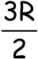 is the same as for ideal gas with no internal structure!

As the temperature increases (to few hundreds of Kelvin) the molecules are now capable to populate the higher rotational energy levels – only now they can truly rotate! ( this gives them these extra two rotational degrees of freedom! ) Their C v is given by C_{V} = 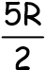
With further increase of the temperature (around 1000K) the molecules may start access another energy structure – vibrational (and additional two vibrational degrees of freedom available to them!)
C_{V} = 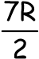

HEAT ENGINES

SECOND LAW OF THERMODYNAMICS

2 DEMONSTRATIONS

4 QUIZ QUESTIONS

12 SUGGESTED PROBLEMS

READING ASSIGNMENT: Chapter 22

Heat Engine

- A heat engine is a device that takes in energy by heat and, operating in a cyclic process, expels a fraction of that energy by means of work
- A heat engine carries some working substance through a cyclical process

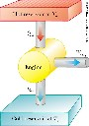

- Since it is a cyclical process, ∆Eint = 0
  - Its initial and final internal energies are the same
- Therefore, Qnet = Weng
- The work done by the engine equals the net energy absorbed by the engine
- The work is equal to the area enclosed by the curve of the PV diagram
  - If the working substance is a gas

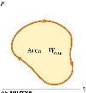

Thermal Efficiency of a Heat Engine

- We can think of the efficiency as the ratio of what you gain to what you give

Efficiency = whatwhatweyoupaywantforit

- Thermal efficiency is defined as the ratio of the net work done by the engine during one cycle to the energy input at the higher temperature

- In practice, all heat engines expel only a fraction of the input energy by mechanical work
- Therefore, their efficiency is always less than 100%
  - To have e = 100%, Q_{C} must be 0

Second Law: Kelvin-Planck Form
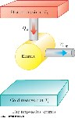
- It is impossible to construct a heat engine that, operating in a cycle, produces no other effect than the absorption of energy from a reservoir and the performance of an equal amount of work
  - Means that Qc cannot equal 0
- Some Qc must be expelled to the environment
  - Means that e cannot equal 100%

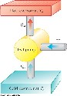
Heat Pumps and Refrigerators
- Heat engines can run in reverse
  - This is not a natural direction of energy transfer
  - Must put some energy into a device to do this
  - Devices that do this are called heat pumps or refrigerators
- Examples
  - A refrigerator is a common type of heat pump
  - An air conditioner is another example of a heat pump
- Energy is extracted from the cold reservoir, QC
- Energy is transferred to the hot reservoir, Qh
- Work must be done on the engine, W

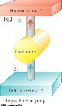
Second Law – Clausius Form

- It is impossible to construct a cyclical machine whose sole effect is to transfer energy continuously by heat from one object to another object at a higher temperature without the input of energy by work
- Or – energy does not transfer spontaneously by heat from a cold object to a hot object
•
- Takes energy from the cold reservoir
- Expels an equal amount of energy to the hot reservoir
- No work is done
- This is an impossible heat pump

Coefficient of Performance
- The effectiveness of a heat pump is described by a number called the coefficient of performance (COP)
- In heating mode, the COP is the ratio of the heat transferred in to the work required

_{COP =} energy transferred at high temp = Q_{h} work done by heat pump W

COP, Heating Mode
- COP is similar to efficiency
- Qh is typically higher than W
  - Values of COP are generally greater than 1
  - It is possible for them to be less than 1
- We would like the COP to be as high as possible

COP, Cooling Mode
- In cooling mode, you “gain” energy from a cold temperature reservoir

- A good refrigerator should have a high COP
  - Typical values are 5 or 6

FIRST AND SECOND LAWS OF THERMODYNAMICS

- First Law is an expression of Conservation of Energy
- There is class of processes which do not violate Conservation of Energy, yet they never occur. (Boiled Egg is difficult to be un-boiled, shattered glass very rarely becomes whole again, the stone which has been dropped down from certain height, on a soft ground, very seldom cools down an rises back to its original position) WHY?

The Second Law of Thermodynamics
- Establishes which processes do occur spontaneously and which do not occur
- Some processes can occur in either direction according to the first law
- They are observed to occur only in one direction
- This directionality is governed by the second law

Irreversible Processes
- An irreversible process is one that occurs naturally in one direction only
- No irreversible process has been observed to run backwards
- An important engineering implication is the limited efficiency of heat engines
Reversible and Irreversible Processes
- A reversible process is one in which every point along some path is an equilibrium state, and one for which the system can be returned to its initial state along the same
path
- An irreversible process does not meet these requirements
  - All natural processes are known to be irreversible
  - Reversible processes are an idealization, but some real processes are good approximations
- A real process that is a good approximation of a reversible one will occur very slowly- the system is always very nearly in an equilibrium state
- A general characteristic of a reversible process is that there are no dissipative effects that convert mechanical energy to internal energy present
  - No friction or turbulence, for example
Summary:
The reversible process is an idealization : all real processes on Earth are irreversible

Carnot Engine

- A theoretical engine developed by Sadi Carnot
- A heat engine operating in an ideal, reversible cycle (now called a Carnot cycle) between two reservoirs is the most efficient engine possible
  - This sets an upper limit on the efficiencies of all other engines

Carnot’s Theorem
•
- No real heat engine operating between two energy reservoirs can be more efficient than a Carnot engine operating between the same two reservoirs
  - All real engines are less efficient than a Carnot engine because they do not operate through a reversible cycle
  - The efficiency of a real engine is further reduced by friction, energy losses through conduction, etc.

Carnot Cycle Overview of the processes in a Carnot cycle

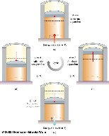
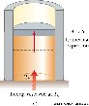
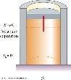
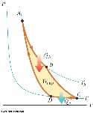
- A -> B is an isothermal expansion
- The gas is placed in contact with the high temperature reservoir, Th
- The gas absorbs heat |Qh|
•
- The gas does work WAB in raising the piston

- B -> C is an adiabatic expansion
- The base of the cylinder is replaced by a thermally nonconducting wall
- No heat enters or leaves the system
- The temperature falls from Th to Tc
- The gas does work WBC
- The gas is placed in contact with the cold temperature reservoir

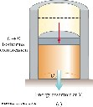
- C -> D is an isothermal compression
- The gas expels energy Qc
- Work WCD is done on the gas

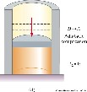
- D -> A is an adiabatic compression
- The gas is again placed against a thermally nonconducting wall, so no heat is exchanged with the surroundings
- The temperature of the gas increases from Tc to Th
- The work done on the gas is WDA

Efficiency of a Carnot Engine

- Carnot showed that the efficiency of the engine depends on the temperatures of the reservoirs

T
c
h
c
h
c
Q
Q
T
T
−
=
=
1
e_{Carnot} Temperatures must be in Kelvins
T h
- All Carnot engines operating between the same two temperatures will have the same efficiency

- Efficiency is 0 if Th = Tc
- Efficiency is 100% only if Tc = 0 K
    - Such reservoirs are not available
    - Efficiency is always less than 100%
- The efficiency increases as Tc is lowered and as Th is raised
- In most practical cases, Tc is near room temperature, 300 K
– So generally Th is raised to increase efficiency

Carnot Cycle in Reverse
- Theoretically, a Carnot-cycle heat engine can run in reverse
- This would constitute the most effective heat pump available
- This would determine the maximum possible COPs for a given combination of hot and cold reservoirs
•
- In heating mode: COP_{C} =

- In cooling mode: COP_{C} = ^{Q}
h
h
h
c
Q
T
W
T
T
=
−
c
c
T
=
W Th −T c
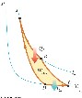
Carnot Cycle, PV Diagram

- The work done by the engine is shown by the area enclosed by the curve, W_{eng}
- The net work is equal to |Q_{h}| – |Q_{c}|
2 ∆E_{int} = 0 for the entire cycle

Exercise:
Obtain the efficiency formula for Carnot Engine

OTHER TYPES OF ENGINES ( READING ASSIGNMENT: SELF STUDY)

STIRLING ENGINE
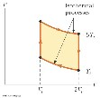
In 1816 Robert Stirling, a Scottish clergyman, patented the Stirling engine, which has found a wide variety of applications ever since. Fuel is burned externally to warm one of the engine’s two cylinders. A fixed quantity of inert gas moves cyclically between the cylinders, expanding in the hot one and contracting in the cold one.
A Stirling engine is easier to manufacture than an internal combustion engine or a turbine. It can run on burning garbage. It can run on the energy of sunlight and produce no material exhaust.

OTTO’S ENGINE
Four stroke combustion engine
(This the ideal version of Gasoline combustion engine used today)
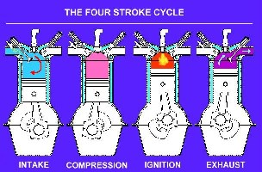
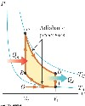

Diesel Engine:
Create the short note ( less than a page on Diesel Engine)

SUGGESTED PROBLEMS

- Given is Starling Engine represented by the diagram Consider n mol of an ideal monatomic gas being taken once through the cycle, consisting of two isothermal processes at temperatures 3T_{i} and T_{i} and two constant-volume processes. Determine, in terms of n, R, and T_{i}, (a) the net energy transferred by heat to the gas and (b) the efficiency of the engine.

- Given is Otto Engine

 | T (K) | P (kPa) | V (cm³) | Eint
A | 293 | 100 | 500
B  C  D  A | 1 023
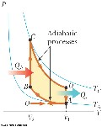
The compression ratio of an Otto cycle, as shown in Figure below, is V_{A}/V_{B} = 8.00. At the beginning A of the compression process, 500 cm³ of gas is at 100 kPa and 20.0°C. At the beginning of the adiabatic expansion the temperature is T_{C} = 750°C. Model the working fluid as an ideal gas with E_{int} = nC_{V}T = 2.50nRT and γ = 1.40.

- Fill in this table to follow the states of the gas:

- Fill in this table to follow the processes:

 | Q (input) | W(output) | ∆ Eint
A→B
B→C
C→D
D→A
ABCDA

- Identify the energy input Q_{h}, the energy exhaust Q_{c}, and the net output work W_{eng}.
- Calculate the thermal efficiency.
- Find the number of crankshaft revolutions per minute required for a one-cylinder engine to have output power 1.00 kW = 1.34 hp.
Note that the thermodynamic cycle involves four piston strokes.

3 An ideal gas is taken through a Carnot cycle. The isothermal expansion occurs at 250°C, and the isothermal compression takes place at 50.0°C. The gas takes in 1 200 J of energy from the hot reservoir during the isothermal expansion. Find (a) the energy expelled to the cold reservoir in each cycle and (b) the net work done by the gas in each cycle.

- The exhaust temperature of a Carnot heat engine is 300°C. What is the intake temperature if the efficiency of the engine is 30.0%?

- A Carnot heat engine uses a steam boiler at 100°C as the high-temperature reservoir. The lowtemperature reservoir is the outside environment at 20.0°C. Energy is exhausted to the lowtemperature reservoir at the rate of 15.4 W. (a) Determine the useful power output of the heat engine. (b) How much steam will it cause to condense in the high-temperature reservoir in 1.00 h?

- A heat engine takes in 360 J of energy from a hot reservoir and performs 25.0 J of work in each cycle. Find (a) the efficiency of the engine and (b) the energy expelled to the cold reservoir in each cycle.

- A heat engine performs 200 J of work in each cycle and has an efficiency of 30.0%. For each cycle, how much energy is (a) taken in and (b) expelled as heat?

- A particular heat engine has a useful power output of 5.00 kW and an efficiency of 25.0%. The engine expels 8 000 J of exhaust energy in each cycle. Find (a) the energy taken in during each cycle and (b) the time interval for each cycle.

- Heat engine X takes in four times more energy by heat from the hot reservoir than heat engine Y. Engine X delivers two times more work, and it rejects seven times more energy by heat to the cold reservoir than heat engine Y. Find the efficiency of (a) heat engine X and (b) heat engine Y.
- Suppose a heat engine is connected to two energy reservoirs, one a pool of molten freezing 1.00 g of aluminum and melting 15.0 g of mercury during each cycle. The heat of fusion of aluminum is 3.97 × 10⁵ J/kg; the heat of fusion of mercury is 1.18 × 10⁴ J/kg. What is the efficiency of this engine?

11 A heat engine operating between 200°C and 80.0°C achieves 20.0% of the maximum possible efficiency. What energy input will enable the engine to perform 10.0 kJ of work?

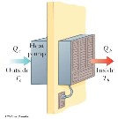
12. A heat pump, shown in Figure P22.26, is essentially an air conditioner installed backward. It extracts energy from colder air outside and deposits it in a warmer room. Suppose that the ratio of the actual energy entering the room to the work done by the device’s motor is 10.0% of the theoretical maximum ratio. Determine the energy entering the room per joule of work done by the motor, given that the inside temperature is 20.0°C and the outside temperature is –
5.00°C

ENTROPY

SECOND LAWS OF THERMODYNAMICS

3 DEMONSTRATIONS: Movies
6 Class Quiz Questions
4 Suggested Problems

READING ASSIGNMENT: Chapter 22

Entropy

- Entropy, S, is a state variable related to the second law of thermodynamics
- The importance of entropy grew with the development of statistical mechanics
- A main result is isolated systems tend toward disorder and entropy is a natural measure of this disorder

Entropy and the Second Law

- Entropy is a measure of disorder
- The entropy of the Universe increases in all real processes
- This is another statement of the second law of thermodynamics

Entropy and Heat
- The original formulation of entropy dealt with the transfer of energy by heat in a reversible process
- Let dQ_{r} be the amount of energy transferred by heat when a system follows a reversible path • The change in entropy, dS is:
dS = dQr
T
- The change in entropy depends only on the endpoints and is independent of the path followed
- The entropy change for an irreversible process can be determined by calculating the change in entropy for a reversible process that connects the same initial and final points
- dQr is measured along a reversible path, even if the system may have followed an irreversible path
- The meaningful quantity is the change in entropy and not the entropy itself
- For a finite process,
∆S =Sf −Si = ∫dQr
T
- The change in entropy of a system going from one state to another has the same value for all paths connecting the two states
- The finite change in entropy depends only on the properties of the initial and final equilibrium states

∆S for a Reversible Cycle
dQ=0

∆S=S_{f} −S_{i} =∫ T
This integral symbol indicates the integral is over a closed path
This demonstrates that ∆S depends on only the initial and final states and not the path between the states

• In general, the total entropy and therefore the total disorder always increases in an irreversible process

The total entropy of an isolated system undergoes a change that cannot decrease.

This is another statement of the second law of thermodynamics

- If the process is irreversible, then the total entropy of an isolated system always increases
  - In a reversible process, the total entropy of an isolated system remains constant
–
- The change in entropy of the Universe must be greater than zero for an irreversible process and equal to zero for a reversible process

Heat Death of the Universe

- Ultimately, the entropy of the Universe should reach a maximum value
- At this value, the Universe will be in a state of uniform temperature and density
- All physical, chemical, and biological processes will cease
  - The state of perfect disorder implies that no energy is available for doing work
  - This state is called the heat death of the Universe

∆S for a Quasi-Static, Reversible Process
- Assume an ideal gas undergoes a quasi-static, reversible process
- Its initial state has T_{i} and V_{i}
- Its final state has T_{f} and V_{f}
f  ∆S =∫dQr  T  i | T  =nC_{V}ln ^{f}  T_{i} | V  +nRln ^{f}  V_{i}
- The change in entropy is
∆S in Thermal Conduction Process

- The cold reservoir absorbs Q and its entropy changes by Q/T_{c}
- At the same time, the hot reservoir loses Q and its entropy changes by Q/T_{h}
- Since T_{h} > T_{c} , the increase in entropy in the cold reservoir is greater than 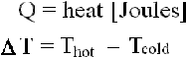the decrease in entropy in the hot reservoir
- Therefore, ∆S_{U} > 0
  - For the system and the Universe

∆S in a Free Expansion
- Consider an adiabatic free expansion
- Q = 0 but cannot be used since that is for an irreversible process
- For an isothermal process, this becomes

∆S =∫f dQr =nRlnVf
- Since Vf > Vi , ∆S is positive _{i} T Vi
- This indicates that both the entropy and the disorder of the gas increase as a result of the irreversible adiabatic expansion

∆S in Calorimetric Processes
- The process is irreversible because the system goes through a series of non-equilibrium states
- Assuming the specific heats remain constant and no mixing takes place:
•
- f f f f f

∆S =∫ dQ = ∫ dQ1 −∫ dQ2 =∫ m1 c1dT −∫ m2c2dT =m1 c1ln Tf + m2c2ln Tf
i T T₁ T T₂ T T₁ T T₂ T T1 T2

–
– If mixing takes place, this result applies only to identical substances
∆S will be positive and the entropy of the Universe increases

Microstates vs. Macrostates.
Modern Statistical Mechanics

- A microstate is a particular configuration of the individual constituents of the system • A macrostate is a description of the conditions from a macroscopic point of view
  - It makes use of macroscopic variables such as pressure, density, and temperature for gases
THERE ARE MANY MICROSTATES REALIZING EACH MACROSTATE
- For a given macrostate, a number of microstates are possible
- It is assumed that all microstates are equally probable
- When all possible macrostates are examined, it is found that macrostates associated with disorder have far more microstates than those associated with order

Microstates vs. Macrostates, Probabilities

- The probability of a system moving in time from an ordered macrostate to a disordered macrostate is far greater than the probability of the reverse
  - There are more microstates in a disordered macrostate
- If we consider a system and its surroundings to include the Universe, the Universe is always moving toward a macrostate corresponding to greater disorder
- We can treat entropy from a microscopic viewpoint through statistical analysis of molecular motions
- A connection between entropy and the number of microstates (W) for a given macrostate is:

S = k_{B} ln W

The more microstates that correspond to a given macrostate, the greater the entropy of that macrostate

- This shows that entropy is a measure of disorder

Entropy, Marble Example

- Suppose you have a bag with 50 red marbles and 50 green marbles
- You draw a marble, record its color, return it to the bag, and draw another
- Continue until four marbles have been drawn
- What are possible macrostates and what are their probabilities? Entropy, Marble Example, Results


- The most ordered microstates are the least likely
- The most disordered microstate is the most likely

Entropy Dice Example:
Consider 2 dice throw. There is 11 possible outcomes:
How many different ways one can obtain each result?

Total 1 | - 0 combinations
Total 2 | - 1 combination (1,1)
Total 3 | - 2 combinations (1,2); (2,1)
Total 4 | - 3 combinations (1,3); (2,2);(3,1)
Total 5 | - 4 combinations (1,4); (2,3);(3,2);(4,1)
Total 6 | - 5 combinations (1,5); (2,4);(3,3);(4,2);(5,1)
Total 7 | - 6 combinations (1,6); (2,5);(3,4);(4,3);(5,2);(6,1)
Total 8 | - 5 combinations (2,6); (3,5);(4,4);(5,3);(6,2)
Total 9 | - 4 combinations (3,6); (4,5); (5,4);(6,3)
Total 10 | - 3 combinations (4,6); (5,5); (6,4)
Total 11 | - 2 combinations (5,6); (6,5)
Total 12 | - 1 combination (6,6)

If we consider the total number thrown to be a macrostate then we see right away that 7 is the most probable macrostate. 2 and 12 are the least probable macrostates. 1, 13 and larger numbers are impossible macrostates

Entropy, Molecule Example

- One molecule in a two-sided container has a 1-in-2 chance of being on the left side
- Two molecules have a 1-in-4 chance of being on the left side at the same time
- Three molecules have a 1-in-8 chance of being on the left side at the same time
- Consider 100 molecules in the container
- The probability of all of the molecules to congregate in the half (left) of the container (½)¹⁰⁰
- The probability of separating 50 fast molecules on one side and 50 slow molecules on the other side is (½)¹⁰⁰
- If we have one mole of gas, this is found to be extremely improbable
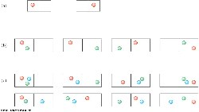

Entropy and the arrow of time

The “natural direction of irreversible processes results in the perceived “arrow of time.”

Observing the irreversible processes run in the opposite direction would appear to the observer as running backward in time.

Such “local time inversions” are not strictly speaking forbidden but they are very unlikely to happen.

Boltzmann famously predicted that if the universe was old enough and large enough such local time inversions could and in fact should be observed.

SUGGESTED PROBLEMS

1Demonstrate that the change of entropy in the quasi-static revoersble process is indeed given by:
∆S =∫f dQr =nCVlnTf +nRln Vf i T Ti Vi

2 A 1.00-mol sample of H₂ gas is contained in the left-hand side of the container shown in Figure P22.45, which has equal volumes left and right. The right-hand side is evacuated. When the valve is opened, the gas streams into the right-hand side. What is the final entropy change of the gas? Does the temperature of the gas change?

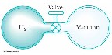
- A 1.00-mol sample of a diatomic ideal gas, initially having pressure P and volume V, expands so as to have pressure 2P and volume 2V. Determine the entropy change of the gas in the process.
- A 2.00-L container has a center partition that divides it into two equal parts, as shown in Figure P22.46. The left side contains H₂ gas, and the right side contains O₂ gas. Both gases are at room temperature and at atmospheric pressure. The partition is removed and the gases are allowed to mix.
What is the entropy increase of the system?

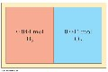

EXTRA READING FOR SERIOUS STUDENTS ONLY:

Once the Entropy of the system is established one may use the Maxwell’s Relations to obtain other
Thermodynamic Potentials:

S - The Entropy
U - The internal energy | dU = TdS - pdV
H - The Enthalpy | dH = TdS + Vdp
A - The Helmholtz’ Free Energy | dA = -SdT - Vdp
G - The Gibbs’ Free Energy  State variables: | dG = -Sdt + Vdp
V – volume; P – pressure; | T - temperature

The four most common Maxwell relations are the equalities of the second derivatives of each of the four thermodynamic potentials, with respect to their thermal natural variable (temperature T or entropy S ) and their mechanical natural variable (pressure p or volume V ) where the potentials as functions of their natural thermal and mechanical variables are:
∂T = − ∂p     ∂V_{S} ∂S_{V} |  | ∂TS =+∂∂VSp   ∂p   
∂S =+ ∂p      ∂V_{T} ∂T_{V} |  | ∂SV =−∂∂TVp  ∂p  

There are more relations to be obtained,

The enthalpy and free energy are very important in discussion of chemical in bio-chemical processes!

You will see more of these as you progress through the senior courses.

FLUIDS I

FLUID STATICS

Concept of Pressure Hydrostatic Pressure
Pascal’ Law
Buoyancy

Archimedes Law

DEMO 1: ATMOSPHERIC PRESSURE: CAN
DEMO 2: TWO BALLOONS AND LIQUID NITROGEN
DEMO 3: FLOATING BOAT

3 Mid-lecture Quiz Questions

5 Suggested Problems

READING ASSIGNMENT: Chapter14

WHY DO WE WANT TO STUDY FLUIDS?

- Meteorology and climatology: large scale air and ocean currents
- Astrophysics: stellar magneto-hydrodynamics
- Medicine: Arteries and veins
- Hydraulics
- Aerodynamics
- Everyday life: soccer, baseball and golf!

Statics and Dynamics with Fluids

- Fluid Statics :Describes fluids at rest
- Fluid Dynamics: Describes fluids in motion
- The same physical principles that have applied to statics and dynamics of solid objects up to this point will also apply to fluids

Forces in Fluids

- Fluids do not sustain shearing stresses or tensile stresses
- The only stress that can be exerted on an object submerged in a static fluid is one that tends to compress the object from all sides
- The force exerted by a static fluid on an object is always perpendicular to the surfaces of the object

Pressure vs. Force
- Pressure is a scalar and force is a vector
- The direction of the force producing a pressure is perpendicular to the area of interest

PRESSURE (review from the beginning of the semester)
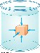
- The pressure P of the fluid at the level to which the device has been submerged is the ratio of the force to the area
•
p = F
A

- Pressure is a scalar quantity
  - Because it is proportional to the magnitude of the force
- If the pressure varies over an area, evaluate dF on a surface of area dA as dF = P dA
- Unit of pressure is pascal (Pa)
1N
1Pa _{= 1m}2

Pressure in the uniform static fluid is constant at the same level

The pressure p at a depth h below a point in the liquid at which the pressure is p₀ is greater by an amount ρgh.
p = p +ρgh
0
Pascal’s Law

- The pressure in a fluid depends on depth and on the value of P0
- An increase in pressure at the surface must be transmitted to every other point in the fluid
- This is the basis of Pascal’s law
P₁ = P₂
Named for French scientist Blaise Pascal _{F}1 _{F}
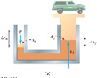
- A change in the pressure applied to a fluid is transmitted undiminished to = ²
1
2
A A every point of the fluid and to the walls of the container

Pascal’s Law: Application Diagram of a hydraulic press (right)
- A large output force can be applied by means of a small input force
- The volume of liquid pushed down on the left must equal the volume pushed up on the right

- Since the volumes are equal,

- Combining the equations,
  - which means W1 = W2

  - This is a consequence of Conservation of Energy

- OTHER APPLICATIONS: Hydraulic brakes, Car lifts, Hydraulic jacks, Forklifts

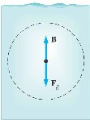
Buoyant Force

- The buoyant force is the upward force exerted by a fluid on any immersed object
- The parcel is in equilibrium
- There must be an upward force to balance the downward force
- The upward force, B, must equal (in magnitude) the downward gravitational force
- The upward force is called the buoyant force
- The buoyant force is the resultant force due to all forces applied by the fluid surrounding the parcel

Archimedes Principle

B=Fbuoyant =M displaced g=Vρfluid g

The magnitude of the buoyant force always equals the weight of the fluid displaced by the object

Archimedes Principle explained
- The pressure at the top of the cube causes a downward force of p_{t} A
- The pressure at the bottom of the cube causes an upward force of p_{b} A
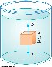

B=F_{b} −F_{t} = p_{b} A− p_{t} A= (p_{b} − p_{t} )A=
=[(p₀ + y_{b}ρ_{f} g)−(p₀ + y_{t}ρ_{f} g)]A=

= (y_{b} −y_{t} )ρ_{f} gA=hAρ_{f} g =Vρ_{f} g =Mg

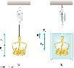
SUGGESTED PROBLEMS

- Ancient CSI:
Tyrant of Syracuse suspected the jeweler cheated him on his last order: making of golden diadem. Archimedes was (supposedly) asked, to find a way to determine whether the crown was made of pure gold. Crown’s weight in air = 7.84 N
Weight in water (submerged) = 6.84 N


- The small piston of a hydraulic lift has a cross-sectional area of 3.00 cm² and its large piston has a cross-sectional area of 200 cm².
  - What force must be applied to the small piston for the lift to keep the load of 15.0kN so that the two pistons are at the same level?
  - What would be the force needed to rise this load by two meters above
the ground? (Take the fluid to be an oil of density 900kg/m3)

- What fraction of the iceberg is below water?

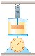
- A beaker of mass m_{b} containing oil of mass m₀ and density ρ₀ rests on a scale. A block of iron of mass m_{Fe} is suspended from a spring scale and completely submerged in the oil as shown in Figure P15.55. Determine the equilibrium readings of both scales.

- Decades ago, it was thought that huge herbivorous dinosaurs such as
Apatosaurus and Brachiosaurus habitually walked on the bottom of lakes, extending their long necks up to the surface to breathe. Brachiosaurus had its nostrils on the top of its head. In 1977, Knut Schmidt-Nielsen pointed out that breathing would be too much work for such a creature. For a simple model, consider a sample consisting of 10.0 L of air at absolute pressure 2.00 atm, with density 2.40 kg/m³, located at the surface of a freshwater lake. Find the work required to transport it to a depth of 10.3 m, with its temperature, volume, and pressure remaining constant. This energy investment is greater than the energy that can be obtained by metabolism of food with the oxygen in that quantity of air.

FLUIDS II

FLUID DYNAMICS

Continuity Equation
Bernoulli’s Principle
The Bernoulli’s Principle as a Form of the Work-
Energy Theorem

DEMO 1: | SYRINGE
DEMO 2: | MILK CARTON WITH A PUNCHED HOLE
DEMO 3: | VENTURI TUBE
DEMO 4: | LIFT
DEMO 5: | MAGNUS EFFECT
DEMO 6: | ATOMIZER
DEMO 7: | PIOTOT TUBE (SETUP WITH U-TUBE)

3 Mid-lecture Quiz Questions

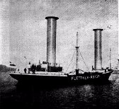
5 Suggested Problems

READING ASSINGMENT: Chapter 14

Types of Fluid Flow

- Laminar flow

  - Steady flow
  - Each particle of the fluid follows a smooth path.
  - The paths of the different particles never cross each other.
  - The path taken by the particles is called a streamline.

- Turbulent flow

  - An irregular flow characterized by small whirlpool like regions.
  - Turbulent flow occurs when the particles go above some critical speed.

Viscosity

- Characterizes the degree of internal friction in the fluid
- This internal friction, viscous force, is associated with the resistance that two adjacent layers of fluid have to moving relative to each other
- It causes part of the kinetic energy of a fluid to be converted to internal energy

Ideal Fluid Flow

There are four simplifying assumptions made to the complex flow of fluids to make the analysis easier

- The fluid is nonviscous – internal friction is neglected
- The flow is steady – the velocity of each point remains constant
- The fluid is incompressible – the density remains constant
- The flow is irrotational – the fluid has no angular momentum about any point

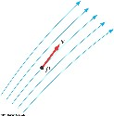
Streamlines
  - The path the particle takes in steady flow is a streamline
  - The velocity of the particle is tangent to the streamline
  - A set of streamlines is called a tube of flow

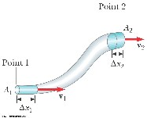
Equation of Continuity

  - Consider a fluid moving through a pipe of nonuniform size (diameter)
  - The particles move along streamlines in steady flow
  - The mass that crosses A1 in some time interval is the same as the mass that
crosses A2 in that same time interval

SINCE: m₁ = m₂ ρA₁v₁ = ρA₂v₂

  - Since the fluid is incompressible, r is a constant A₁v₁ = A₂v₂

This is called the equation of continuity for fluids
The product of the area and the fluid speed at all points along a pipe is constant for an incompressible fluid

Equation of Continuity: Implications

  - The speed is high where the tube is constricted (small A)
  - The speed is low where the tube is wide (large A)
  - The product, Av, is called the volume flux or the flow rate
  - Av = constant is equivalent to saying the volume that enters one end of the tube in a given time interval equals the volume leaving the other end in the same time
    - If no leaks are present

Bernoulli’s Equation

  - As a fluid moves through a region where its speed and/or elevation above the Earth’s surface changes, the pressure in the fluid varies with these changes
  - The relationship between fluid speed, pressure and elevation was first derived by Daniel Bernoulli
  - Consider the two shaded segments
  - The volumes of both segments are equal
  - The net work done on the segment is W =(P₁ -P₂)V
  - Part of the work goes into changing the kinetic energy and some to changing the gravitational potential energy. The change in kinetic energy:
    - ∆K =½ mv₂² -½ mv₁²
    - There is no change in the kinetic energy of the un-shaded portion since we are assuming streamline flow
    - The masses are the same since the volumes are the same.

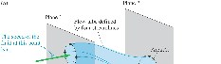
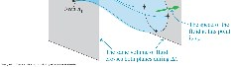
        - Streamline flow around a moving airplane wing
        - Lift is the upward force on the wing from the air
        - Drag is the resistance
        - The lift depends on the speed of the airplane, the area of the wing, its curvature, and the
angle between the wing and the horizontal

Lift – General

        - In general, an object moving through a fluid experiences lift as a result of any effect that
causes the fluid to change its direction as it flows past the object
        - Some factors that influence lift are:
          - The shape of the object

          - The object’s orientation with respect to the fluid flow
– Any spinning of the object
      - The change in gravitational potential energy: ∆U = ρgy2 − ρgy1. – The texture of the object’s surface
      - The work also equals the change in energy
      - ^{Combining:} W =(P₁ -P₂)V =½ mv₂2 -½ mv₁2 + ρgy2 − ρgy1. Golf Ball: Magnus Effect

      - The ball is given a rapid backspin
      - Rearranging and expressing in terms of density: • _{The dimples increase friction}
P₂ + ½ ρv₂2 + ρgy2 =P 1 + ½ ρv12 + ρgy1. • It travels farther than if it was not spinning – Increases lift

Atomizer
Bernoulli’s Principle

      - A stream of air passes over one end of an open tube
P ½ ρv ² + ρgy =P + ½ ρv ² + ρgy . • The other end is immersed in a liquid
+
22 2 1 1 1 •• The moving air reduces the pressure above the tube The fluid rises into the air stream
• The liquid is dispersed into a fine spray of droplets

More Common Expression of Bernoulli’s Principle

P + ½ ρv² + ρgy =const.

Applications of Fluid Dynamics

SUGGESTED PROBLEMS

- A hypodermic syringe contains a medicine with the density of water. The barrel of the syringe has a cross-sectional area A = 2.50 × 10^{–5} m² and the needle has a cross-sectional area a = 1.00 × 10^{–8} m². In the absence of a force on the plunger, the pressure everywhere is 1 atm. A force 
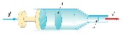
F of magnitude 2.00 N acts on the plunger, making medicine squirt horizontally from the needle. Determine the speed of the medicine as it leaves the needle’s tip.

- A horizontal pipe 10.0 cm in diameter has a smooth reduction to a pipe 5.00 cm in diameter. If the pressure of the water in the larger pipe is 8.00 × 104 Pa and the pressure in the smaller pipe is 6.00 × 104 Pa, at what rate does water flow through the pipes?
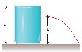
- A large storage tank with an open top is filled to a height h₀. The tank is punctured at a height h above the bottom of the tank (Fig. P15.33). Find an expression for how far from the tank the exiting stream lands.

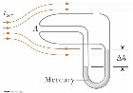
- A Pitot tube can be used to determine the velocity of air flow by measuring the difference between the total pressure and the static pressure Fig. P14.49. If the fluid in the tube is mercury, density Hg = 13 600 kg/m3, and h = 5.00 cm, find the speed of air flow. (Assume that the air is stagnant at point A and take air = 1.25 kg/m3.)

- A U-tube open at both ends is partially filled with water. Oil having a density 750 kg/m3 is then poured into the right arm and forms a column L = 5.00 cm high. (a) Determine the difference h in the heights of the two liquid surfaces.
(b) The right arm is then shielded from any air motion while air is blown across the top of the left arm until the surfaces of the two liquids are at the same height (c). Determine the speed of the air being blown across the left arm. Take the density of air as 1.29 kg/m3.

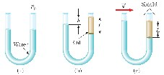

DGD Schedule for PHY1321

Tuesday DGD 10:30-11:30 MacDonald Hall (MCD) | Room: 146
Tuesday DGD 10:30-11:30 Desmarais Building (DMS) | Room: 1140
Wednesday DGD 10:30-11:30 Desmarais Building (DMS) | Room: 1130
Wednesday DGD 10:30-11:30 Technology & Engineering SITE | Room: H0104
Wednesday DGD 10:30-11:30 Lamoureux Hall (LMX) | Room: 219

Despite what the program coordinator software is telling you, it does not matter which class DGD you are attending!

Most likely we will close down one of these sessions after the first month! (the least attended one!)

DGD PROBLEMS:

- NOT ALL OF THE PROBLEMS WILL BE SOLVED IN FULL
SOME QUESTIONS WILL BY JUST ANALYSED AND THE PLAN OF ATTACK WILL BE PRESENTED DURING THE DGD. STUDENTS SHOULD FINISH THESE PROBLEMS ON THEIR OWN.

- In some cases the material in DGD will be discussed ahead of the material studied and discussed in class. ( There also will be cases when certain topics will be studied only during the DGD and not during the lecture). In such instance please make sure to inform the TA about it, and remain calm!
TA might want to give you five minute intro into the material and you will still benefit from the analysis of the problem.

- Reading the assigned problems before DGD will surely help you in understanding what TA is doing.!

I recommend that students actually try to solve these questions before the DGD!
The first DGD is held on Sept 15 and Sept16 It will cover:
The overview of your math self-test ( 25min) | READING ASSIGNMENT
Vectors (25 min.) | READING ASSIGNMENT
Simple Integrals (30min) | SOLVING PROBLEMS LEFT  UNFINISHED FROM CLASS

DGD Schedule for PHY1331

Tuesday DGD 10:30-11:30 Simard Hall (SMD) Room: 224 Tuesday DGD 10:30-11:30 Simard Hall (SMD) Room: 425
Wednesday DGD 10:30-11:30 Louis Pasteur (LPR) Room: 155

Despite what the program coordinator software is telling you, it does not matter which class DGD you are attending!

Most likely we will close down one of these sessions after the first month! (the least attended one!)

DGD PROBLEMS:

1 NOT ALL OF THE PROBLEMS WILL BE SOLVED IN FULL
SOME QUESTIONS WILL BY JUST ANALYSED AND THE PLAN OF ATTACK WILL BE PRESENTED DURING THE DGD. STUDENTS SHOULD FINISH THESE PROBLEMS ON THEIR OWN.

3 In some cases the material in DGD will be discussed ahead of the material studied and discussed in class. ( There also will be cases when certain topics will be studied only during the DGD and not during the lecture). In such instance please make sure to inform the TA about it, and remain calm!
TA might want to give you five minute intro into the material and you will still benefit from the analysis of the problem.

3 Reading the assigned problems before DGD will surely help you in understanding what TA is doing.!

I recommend that students actually try to solve these questions before the DGD!

The first DGD is held on Sept 15 and Sept16 It will cover:
The overview of your math self-test ( 25min) READING ASSIGNMENT
Vectors (25 min.) READING ASSIGNMENT
Simple Integrals (30min) SOLVING PROBLEMS LEFT
UNFINISHED FROM CLASS

DGD SCHEDULED DATES:

DGD I Math Review Solutions, Vectors, Simple Integrals
Sept.15 Tuesday  DGD II Kinematics |  | Sept 16 Wednesday
Sept.22 Tuesday  DGD III Forces |  | Sept. 23 Wednseday
Sept. 29 Tuesday  DGD IV Energy |  | Sept. 30 Wednesday
Oct. 6 Tuesday |  | Oct. 7 Wednesday

DGD V Linear Momentum and Centre Of Mass
Oct. 13 Tuesday Oct. 14 Wednesday

DGD VI Discussion of TEST 2 Oct. 20 Tuesday Oct. 21 Wednesday

DGD VII Rotations I
Oct. 27 Tuesday Oct. 28 Wednesday

DGD VIII Rotations II and Thermodynamics I Nov. 3 Tuesday Nov. 4 Wednesday

DGD IX Thermodynamics II
Nov. 10 Tuesday Nov. 11 Wednesday

DGD X Thermodynamics III (( Maxwell’s – Boltzmann Distribution)
Nov 17 Tuesday Nov.18 Wednesday

DGD XI: Thermodynamics IV (Entropy)
Nov. 24 Tuesday Nov. 25 Wednesday

DGD XII: Fluids
Dec. 2 Tuesday Dec. 3 Wednesday

DGD I Review of High school Math, Vectors, Elementary Integrals)

HIGH SCHOOL MATH REVIEW:
Self-test (Try to solve these problems within 70 minutes). Solutions and discussion will be provided during the first DGD.
1Solve three equations below:

2x-y-9 = 0 4y+x = 8
2x+6z=3

- When will two linear equations have no solutions?
When will they have one solution?
When will there be infinite number of the solution?

Illustrate your answers with examples

- Solve quadratic equation below:
4x²-4x+4=0

- Find the angle A

5
Find the angle A
A
25

40

40

65

- Solve 2 =32
1
2
4
+
+
x
x
40

A
a=7
b=8

2x−1

- Solve8 ^{x+1} =2^{x−1}

- Find the slope of a line tangent to parabola

y(t) = 2t² −3t +4 at t=5s

df 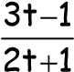
- Find dt of f(t)=eat t=2s

- Simplify
tansin2αα 2α-1) cot12α (1−tan2α) (cos
- Solve :

(2cos2x-1)(1+3cos2x) = 0; for 0<x<90

- Cylinder is inside a sphere of Radius R. Find the height and radius of the cylinder that maximize its volume.

BONUS
13* Using the definition of logarithm demonstrate their well known properties :

- log_{c}x-log_{c}y =log_{c} ^{x}
y

- log_{c}x +log_{c}y =log_{c}xy

- log_{c}x^{m} = mlog_{c}x

Vectors (chapter 3)

36. Ch1. A plane flies from base camp to Lake A, 280 km away in the direction 20.0° north of east. After dropping off supplies, it flies to Lake B, which is 190 km at 30.0° west of north from Lake A. Graphically determine the distance and direction from Lake B to the base camp.

❒ 
38.Ch1. Each of the displacement vectors     A and  B shown in Figure P1.38 has a magnitude of  
3.00 m. Find graphically (a) A+B, (b) A−B, (c) B−A , and (d) A− 2B. Report all angles counterclockwise from the positive x axis.
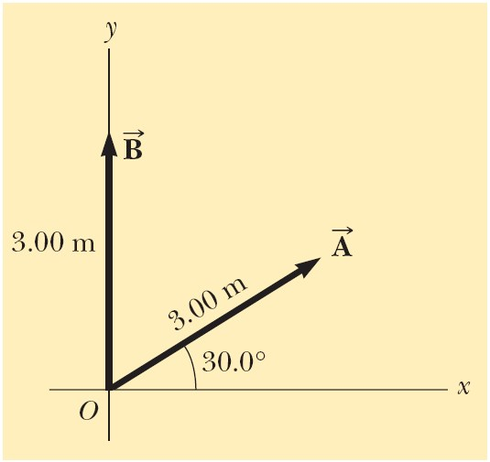 Figure P1.38 Problems 1.38 and 1.48.  
48.Ch1. Use the component method to add the vectors   A and B shown in Figure P1.38. Express the resultant A+B in unit-vector notation.

❒    
For the vectors A = 2.00ˆi+ 6.00ˆj and B = 3.00ˆi− 2.00ˆj , (a) draw the vector sum C = A+B and     
the vector difference D = A −B . (b) Calculate C and D, first in terms of unit vectors and then in terms of polar coordinates, with angles measured with respect to the positive x axis.
❒     
45.Ch1 Consider the two vectors A = 3_{i}^{ˆ} − 2^{ˆ}j and B =−^{ˆ}i− 4^{ˆ}j. Calculate (a) A+B, (b) A−B, (c)        
A+B , (d) A−B , and (e) the directions of A+B and A−B.

❒  
46.Ch1 Consider the three displacement vectors A =(3^{ˆ}i+3^{ˆ}j) m, B =(iˆ−4ˆj) m, and C =(−2ˆi+5ˆj)
m. Use the component method to determine (a) the ma    gnitude and direction of the vector    
D = A+B+C and (b) the magnitude and direction of E =−A−B+C .

ELEMENTARY INTEGRALS:
Function f(t) | F=∫fdt
A | At + const.
at^{n} | 1  a t^{n+1} +const.  n+1
cos(t) | sin(t) + const.
sin(t) | -cos(t) + const.
1  a t | a ln (t) + const.
aebt | ªe^{bt} + const.  b

Example: Find ∫fdt in following cases:
a) | f(t) =2t³ |  |  | b) f(t) = 2t⁶ −2t⁴ −2t² +3t +2
c) f(t) =2e^{4t} −3 d) f(t) = e^{2t} − 4e^{-3t} e) f(t) =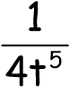
f) f(t) = ₄¹_{t} g) f(t) ⁼ ⁵_{t}2^{t} h) f(t) ⁼ g'_{g(t)}(t)
i) f(t) =5 j) f(t) =x

Let’s So that:

f=dF F=∫fdt dt

t_{f} fdt ⁼[F(t)]^{tf} =F(t)^{tf} =F(t )−F(t)
∫ _{tit}i _{f} _{i}
t_{i}

t_{f}
^{fdt}
Find ∫ in following cases:
t_{i}
- f(t) ^{=t4} t_{i}= -1 t_{f} = 3
- f(t) =2t⁶ −4t⁵ −3t³ +2t+1 t_{i}= 0 t_{f} = -2
- f(t) =2t⁶ −4t⁵ −3t³ +2t+1 t_{i}= -2 t_{f} = 0
- f(t) =e^{-3t} t_{i}= +∞ t_{f} = 0
- f(t) =3e^{3t} −4e^{-t} t_{i}= 1 t_{f} = 2
- f(t) ⁼ 4¹t₅ t_{i}= 0 t_{f} = 2
- f(t) ⁼ 4¹t t_{i}= 1 t_{f} = 2

Find following
4 3
∫t2dt ∫(2t2-1)dt
1 0 3 3 1 dt ∫ dt ∫
-13t2 0 t
t_{f} 3
3∫dt ∫(2e^{2t} -1)dt

t_{i} 0 350 V_{f} dT dV
∫ 2 nRT∫ V
T
₁₀₀ _{V}i
t t
∫(a)dt' ∫(at'+v₀)dt'
0 0

DGD II KINEMATICS (chapter 2 and 4)

- An object moves along the x axis according to the equation x(t) = (3.00t² – 2.00t + 3.00) m, where t is in seconds. Determine (a) the average speed between t = 2.00 s and t = 3.00 s, (b) the instantaneous speed at t = 2.00 s and at t = 3.00 s, (c) the average acceleration between t = 2.00 s and t = 3.00 s, and (d) the instantaneous acceleration at t = 2.00 s and t = 3.00 s.

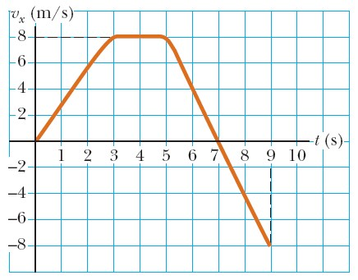
- A student drives a moped along a straight road as described by the velocity versus time graph in Figure P2.14. Sketch this graph in the middle of a sheet of graph paper. (a) Directly above your graph, sketch a graph of the position versus time, aligning the time coordinates of the two graphs. (b) Sketch a graph of the acceleration versus time directly below the v_{x}-t graph, again aligning the time coordinates. On each graph, show the numerical values of x and a_{x} for all points of inflection. (c) What is the
acceleration at t = 6 s? (d) Find the position (relative to the starting point) at t = 6 s. (e) What is the moped’s final position at t = 9 s?

- Speedy Sue, driving at 30.0 m/s, enters a one-lane tunnel. She then observes a slow-moving van 155 m ahead traveling at 5.00 m/s. Sue applies her brakes but can accelerate only at –2.00 m/s² because
the road is wet. Will there be a collision? If yes, determine how far into the tunnel and at what time the collision occurs. If no, determine the distance of closest approach between Sue’s car and the van.

- A test rocket is fired vertically upward from a well. A catapult gives it initial speed 80.0 m/s at ground level. Its engines then fire and it accelerates upward at 4.00 m/s² until it reaches an altitude of 1 000 m. At that point its engines fail and the rocket goes into free-fall, with an acceleration of – 9.80 m/s². (a) How long is the rocket in motion above the ground? (b) What is its maximum altitude? (c) What is its velocity just before it collides with the Earth? (You will need to consider the motion while the engine is operating separately from the free-fall motion.)

- The small archerfish (length 20 to 25 cm) lives in brackish waters of Southeast Asia from India to the Philippines. This aptly named creature captures its prey by shooting a stream of water drops at an insect, either flying or at rest. The bug falls into the water and the fish gobbles it up. The archerfish has high accuracy at distances of 1.2 m to 1.5 m, and it sometimes makes hits at distances up to 3.5 m. A groove in the roof of its mouth, along with a curled tongue, forms a tube that enables the fish to impart high velocity to the water in its mouth when it suddenly closes its gill flaps. Suppose the archerfish shoots at a target that is 2.00 m away, measured along a line at an angle of 30.0° above the horizontal. With what velocity must the water stream be launched if it is not to drop more than 3.00 cm vertically on its path to the target?

- A train slows down as it rounds a sharp horizontal turn, slowing from 90.0 km/h to 50.0 km/h in the 15.0 s that it takes to round the bend. The radius of the curve is 150 m. Compute the acceleration at the moment the train speed reaches 50.0 km/h. Assume that it continues to slow down at this time at the same rate.

- The pilot of an airplane notes that the compass indicates a heading due west. The airplane’s speed relative to the air is 150 km/h. The air is moving in a wind at 30.0 km/h toward the north. Find the velocity of the airplane relative to the ground.

- A Coast Guard cutter detects an unidentified ship at a distance of 20.0 km in the direction 15.0° east of north. The ship is traveling at 26.0 km/h on a course at 40.0° east of north. The Coast Guard wishes to send a speedboat to intercept the vessel and investigate it. If the speedboat travels 50.0 km/h, in what direction should it head? Express the direction as a compass bearing with respect to due north.

DGD III FORCES (chapters 5 and 6)


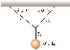
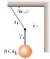
- Figure P4.24 shows loads hanging from the ceiling of an elevator that is
moving at constant velocity. For each case draw free body diagrams. Write down Newton’s Law in component form. Find the tension in each of the three strands of cord supporting each load.

❒
- An object of mass M is held in place by an applied force F and a pulley system as shown in Figure P4.45. The pulleys are massless and frictionless. F ind (a) the tension in each section of rope, T₁, T₂, T₃,
T₄, and T₅ and (b) the magnitude of F. Suggestion: Draw a free-body diagram for each pulley.

- A block of mass m = 2.00 kg is released from rest at h = 0.500 m above the surface of a table, at the top of a θ = 30.0° incline as shown in Figure P4.44. The frictionless incline is fixed on a table of height H = 2.00 m. (a) Determine the acceleration of the block as it slides down the incline. (b) What is the velocity of the block as it leaves the incline? (c) How far from the table will the block hit the floor? (d) What time interval elapses between when the block is released and when it hits the floor? (e) Does the mass of the block affect any of the above calculations?

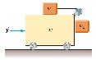
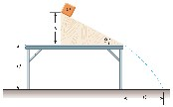

- What horizontal force must be applied to the cart shown in Figure P4.47 so that the blocks remain stationary relative to the cart? Assume that all surfaces, wheels, and pulley are frictionless. (Suggestion: Note that the force exerted by the string accelerates m₁.)

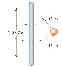
- A 4.00-kg object is attached to a vertical rod by two strings as shown in Figure P5.20. The object rotates in a horizontal circle at constant speed 6.00 m/s. Find the tension in (a) the upper string and (b) the lower string.
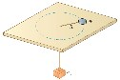
- An air puck of mass m₁ is tied to a string and allowed to revolve in a circle of radius R on a frictionless horizontal table. The other end of the string passes through a hole in the center of the table, and a counterweight of mass m₂ is tied to it (Fig. P5.50). The suspended object remains in equilibrium while the puck on the tabletop revolves. What are (a) the tension in the string, (b) the radial force acting on the puck, and (c) the speed of the puck?


- Before 1960, it was believed that the maximum attainable coefficient of static friction for an automobile tire was less than 1. Then around 1962, three companies independently developed racing tires with coefficients of 1.6. Since then, tires have improved, as illustrated in this problem. According to the 1990 Guinness Book of Records, the shortest time interval in which a piston-engine car initially at rest has covered a distance of one-quarter mile is 4.96 s. This record was set by Shirley Muldowney in September 1989. (a) Assume that, as shown in Figure P5.3, the rear wheels lifted the front wheels off the pavement. What minimum value of µ_{s} is necessary to achieve the record time? (b) Suppose Muldowney were able to double her engine power, keeping other things equal. How would this change affect the elapsed time?

DGD IV ENERGY (chapter 7 and 8)

- A block of mass 2.50 kg is pushed 2.20 m along a frictionless horizontal table by a constant 16.0-N force directed 25.0° below the horizontal. Determine the work done on the block by (a) the applied force, (b) the normal force exerted by the table, and (c) the gravitational force. (d) Determine the total work done on the block.

❒
- A force F = (4xi^{ˆ} + 3_{y}^{ˆ}j) N acts on an object as the object moves in the x direction from the origin to x = 5.00 m. Find the work done on the object by the force.

3. A 100-g bullet is fired from a rifle having a barrel 0.600 m long. Choose the origin to be at the location where the bullet begins to move. Then the force (in newtons) exerted by the expanding gas on the bullet is 15 000 + 10 000x – 25 000x², where x is in meters. (a) Determine the work done by the gas on the bullet as the bullet travels the length of the barrel. (b) If the barrel is 1.00 m long, how much work is done and how does this value compare to the work calculated in (a)?
- A 15.0-kg block is dragged over a rough, horizontal surface by a 70.0-N force acting at 20.0° above the horizontal. The block is displaced 5.00 m, and the coefficient of kinetic friction is 0.300. Find the work done on the block by (a) the 70-N force, (b) the normal force, and (c) the gravitational force. (d) What is the increase in internal energy of the block–surface system owing to friction? (e) Find the total change in the block’s kinetic energy.

- A baseball outfielder throws a 0.150-kg baseball at a speed of 40.0 m/s and an initial angle of 30.0°. What is the kinetic energy of the baseball at the highest point of its trajectory?
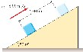
- A 5.00-kg block is set into motion up an inclined plane with an initial speed of 8.00 m/s (Fig. P7.25). The block comes to rest after traveling 3.00 m along the plane, which is inclined at an angle of 30.0° to the horizontal. For this motion, determine (a) the change in the block’s kinetic energy, (b) the change in the potential energy of the block–Earth system, and (c) the friction force exerted on the block (assumed to be constant). (d) What is the coefficient of kinetic friction?
❒
- A single conservative force acting on a particle varies as F = (−Ax+Bx²) ^{ˆ}i N, where A and B are constants and x is in meters. (a) Calculate the potential energy function U(x) associated with this force, taking U = 0 at x = 0. (b) Find the change in potential energy of the system and the change in kinetic energy of the particle as it moves from x = 2.00 m to x = 3.00 m

DGD V Linear Momentum (Chapter 9)

- In research in cardiology and exercise physiology, it is often important to know the mass of blood pumped by a person’s heart in one stroke. This information can be obtained by means of a
ballistocardiograph. The instrument works as follows. The subject lies on a horizontal pallet floating on a film of air. Friction on the pallet is negligible. Initially, the momentum of the system is zero. When the heart beats, it expels a mass m of blood into the aorta with speed v, and the body and platform move in the opposite direction with speed V. The blood velocity can be determined independently (e.g., by observing the Doppler shift of ultrasound). Assume that it is 50.0 cm/s in one typical trial. The mass of the subject plus the pallet is 54.0 kg. The pallet moves 6.00 × 10^{–5} m in 0.160 s after one heartbeat. Calculate the mass of blood that leaves the heart. Assume that the mass of blood is negligible compared with the total mass of the person. (This simplified example illustrates the principle of ballistocardiography, but in practice a more sophisticated model of heart function is used.)

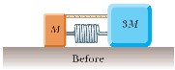
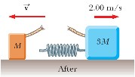
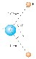
- Blocks with masses M and 3M are placed on a horizontal, frictionless surface. A light spring is attached to one of them, and the blocks are pushed together with the spring between them (Fig. P8.5). A cord initially holding the blocks together is burned; after this, the block of mass 3M moves to the right with a speed of 2.00 m/s. (a) What is the speed of the block of mass M? (b) Find the original elastic potential energy in the spring, taking M = 0.350 kg.

3
Four objects are situated along the
y
axis as follows: a 2.00-kg object is at +3.00 m, a
3.00-
kg
object is at +2.50 m, a 2.50-kg object is at the or
igin, and a 4.00-kg object is at –0.500 m. Where
is the center of mass of these objects?
A water molecule consists of an oxygen atom with tw
o hydrogen atoms bound to it (Fig. P8.34). The
angle between the two bonds is 106°. If the bonds a
re 0.100 nm long, where is the center of mass of

the molecule?

- When it is threatened, a squid can escape by expelling a jet of water, sometimes colored with camouflaging ink. Consider a squid originally at rest in ocean water of constant density 1 030 kg/m³. Its original mass is 90.0 kg, of which a significant fraction is water inside its mantle. It expels this water through its siphon, a circular opening of diameter 3.00 cm, at a speed of 16.0 m/s. (a) As the squid is just starting to move, the surrounding water exerts no drag force on it. Find the squid’s initial acceleration. (b) To estimate the maximum speed of the escaping squid, model the drag force of the surrounding water as described by Equation 5.7. Assume that the squid has a drag coefficient of 0.300 and a cross-sectional area of 800 cm². Find the speed at which the drag force counterbalances the thrust of its jet.

- A cannon is rigidly attached to a carriage, which can move along horizontal rails but is connected to a post by a large spring, initially unstretched and with force constant k = 2.00 × 10⁴ N/m, as shown in Figure P8.58. The cannon fires a 200-kg projectile at a velocity of 125 m/s directed 45.0° above the horizontal. (a) Assuming that the mass of the cannon and its carriage is 5 000 kg, find the recoil speed of the cannon. (b) Determine the maximum extension of the spring. (c) Find the maximum force the spring exerts on the carriage. (d) Consider the system consisting of the cannon, carriage, and projectile. Is the momentum of this system conserved during the firing? Why or why not?

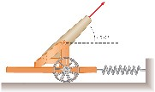

DGD VI Discussion of the MIDTERM TEST

In this DGD held right after the midterm your TA will demonstrate the correct solutions to
the multiple choice part of the test as well as outline the strategy behind the long problems

The answers to the MC part as well as the solutions to the long problems will be posted on the class website

DGD VII Rotational Mechanics ( Chapter 10 )

- A centrifuge in a medical laboratory rotates at an angular speed of 3 600 rev/min. When switched off, it rotates through 50.0 revolutions before coming to rest. Find the constant angular acceleration of the centrifuge.

- During a certain period of time, the angular position of a swinging door is described by θ = 5.00 + 10.0t + 2.00t², where θ is in radians and t is in seconds. Determine the angular position, angular speed, and angular acceleration of the door (a) at t = 0 and (b) at t = 3.00 s.

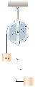
- Consider two objects with m₁ > m₂ connected by a light string that passes over a pulley having a moment of inertia of I about its axis of rotation as shown in Figure P10.17. The string does not slip on the pulley or stretch. The pulley turns without friction. The two objects are released from rest separated by a vertical distance 2h. (a) Use the principle of conservation of energy to find the translational speeds of the objects as they pass each other. (b) Find the angular speed of the pulley at this time.

- A war-wolf or trebuchet is a device used during the Middle Ages to throw rocks at castles and sometimes now used to fling pianos as a sport. A simple trebuchet is shown in Figure P10.19. Model it as a stiff rod of negligible mass, 3.00 m long, joining particles of mass 60.0 kg and 0.120 kg at its ends. It can turn on a frictionless horizontal axle perpendicular to the rod and 14.0 cm from the large-mass particle. The rod is released from rest in a horizontal orientation. Find the maximum speed that the small-mass object attains.

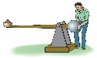

Figure P10.19
- In exercise physiology studies, it is sometimes important to determine the location of a person’s center of mass, which can be done with the arrangement shown in Figure P10.26. A light plank rests on two scales, which read F_{g1} = 380 N and F_{g2} = 320 N. A distance of 2.00 m separates the scales. How far from the woman’s feet is her center of mass?
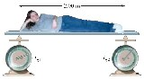
- A potter’s wheel—a thick stone disk of radius 0.500 m and mass 100 kg—is freely rotating at 50.0 rev/min. The potter can stop the wheel in 6.00 s by pressing a wet rag against the rim and exerting a radially inward force of 70.0 N. Find the effective coefficient of kinetic friction between wheel and rag.

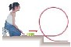
- A tennis ball is a hollow sphere with a thin wall. It is set rolling without slipping at 4.03 m/s on a horizontal section of a track as shown in Figure P10.55. It rolls around the inside of a vertical circular loop 90.0 cm in diameter and finally leaves the track at a point 20.0 cm below the horizontal section. (a) Find the speed of the ball at the top of the loop. Demonstrate that it will not fall from the track. (b) Find its speed as it leaves the track. (c) Suppose static friction between ball and track were negligible so that the ball slid instead of rolling. Would its speed then be higher, lower, or the same at the top of the loop? Explain.

- Diagram shows three uniform objects: a rod, a right triangle, and a square. Their masses and their coordinates in meters are given. Determine the center of gravity for the three-object system.

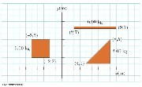

DGD VIII: Rotation Dynamics II Thermodynamics I (Chapters 11, 12, and 19)

- A 60.0-kg woman stands at the rim of a horizontal turntable having a moment of inertia of 500 kg · m² and a radius of 2.00 m. The turntable is initially at rest and is free to rotate about a frictionless, vertical axle through its center. The woman then starts walking around the rim clockwise (as viewed from above the system) at a constant speed of 1.50 m/s relative to the Earth. (a) In what direction and with what angular speed does the turntable rotate? (b) How much work does the woman do to set herself and the turntable into motion?
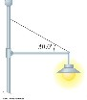
- A 20.0-kg floodlight in a park is supported at the end of a horizontal beam of negligible mass that is hinged to a pole, as shown in Figure P12.12. A cable at an angle of 30.0° with the beam helps to support the light. Find (a) the tension in the cable and (b) the horizontal and vertical forces exerted on the beam by the pole.

- A constant-volume gas thermometer is calibrated in dry ice (that is, carbon dioxide in the solid state, which has a temperature of –80.0°C) and in boiling ethyl alcohol (78.0°C). The two pressures are 0.900 atm and 1.635 atm. (a) What Celsius value of absolute zero does the calibration yield? What is the pressure at (b) the freezing point of water and (c) the boiling point of water?

- In a constant-volume gas thermometer, the pressure at 20.0°C is
0.980 atm. (a) What is the pressure at 45.0°C? (b) What is the temperature if the pressure is 0.500 atm?

- A student measures the length of a brass rod with a steel tape at 20.0°C. The reading is 95.00 cm. What will the tape indicate for the length of the rod when the rod and the tape are at (a) –15.0°C, (b) 55.0°C?

- The density of gasoline is 730 kg/m³ at 0°C. Its average coefficient of volume expansion is 9.60 × 10^{–4}/°C. If 1.00 gal of gasoline occupies 0.003 80 m³, how many extra kilograms of gasoline would you get if you bought 10.0 gal of gasoline at 0°C rather than at 20.0°C from a pump that is not temperature compensated?

- A diving bell in the shape of a cylinder with a height of 2.50 m is closed at the upper end and open at the lower end. The bell is lowered from air into sea water (ρ = 1.025 g/cm³). The air in the bell is initially at 20.0°C. The bell is lowered to a depth (measured to the bottom of the bell) of 45.0 fathoms or 82.3 m. At this depth the water temperature is 4.0°C, and the bell is in thermal equilibrium with the water. (a) How high does sea water rise in the bell? (b) To what minimum pressure must the air in the bell be raised to expel the water that entered?

DGD IX: Thermodynamics II (chapters 19 and 20)

- (a) Show that the density of an ideal gas occupying a volume V is given by ρ = PM/RT, where M is the molar mass. (b) Determine the density of oxygen gas at atmospheric
pressure and 20.0°C.

- Oxygen at pressures much greater than 1 atm is toxic to lung cells. Assume that a deep-sea diver breathes a mixture of oxygen (O₂) and helium (He). By weight, what ratio of helium to oxygen must be used if the diver is at an ocean depth of 50.0 m?

- Long-term space missions require reclamation of the oxygen in the carbon dioxide exhaled by the crew. In one method of reclamation, 1.00 mol of carbon dioxide produces 1.00 mol of oxygen and 1.00 mol of methane as a byproduct. The methane is stored in a tank under pressure and is available to control the attitude of the spacecraft by controlled venting. A single astronaut exhales 1.09 kg of carbon dioxide each day. If the methane generated in the respiration recycling of three astronauts during one week of flight is stored in an originally empty 150-L tank at –45.0°C, what is the final pressure in the tank?

- An aluminum cup of mass 200 g contains 800 g of water in thermal equilibrium at 80.0°C. The combination of cup and water is cooled uniformly so that the temperature decreases by 1.50°C per minute. At what rate is energy being removed by heat? Express your answer in watts.

- A 1.00-kg block of copper at 20.0°C is dropped into a large vessel of liquid nitrogen at 77.3 K. How many kilograms of nitrogen boil away by the time the copper reaches 77.3 K? (The specific heat of copper is 0.092 0 cal/g · °C. The latent heat of vaporization of nitrogen is 48.0 cal/g.)

- An ideal gas is enclosed in a cylinder that has a movable piston on top. The piston has a mass m and an area A and is free to slide up and down, keeping the pressure of the gas constant. How much work is done on the gas as the temperature of n mol of the gas is raised from T₁ to T₂?

7(a) Determine the work done on a fluid that expands from i to f as indicated in Figure P20.24. (b) What If? How much work is performed on the fluid if it is compressed from f to i along the same path?

DGD X: Thermodynamics III (chapter 20)

1. A gas is taken through the cyclic process described in Figure P17.24. (a) Find the net energy transferred to the system by heat during one complete cycle. (b) If the cycle is reversed—that is, the process follows the path ACBA—what is the net energy input per cycle by heat?

2 Consider the cyclic process depicted Problem 1 . If Q is negative for the process BC, and ∆E_{int} is negative for the process CA, what are the signs of Q, W, and ∆E_{int} that are associated with each process?

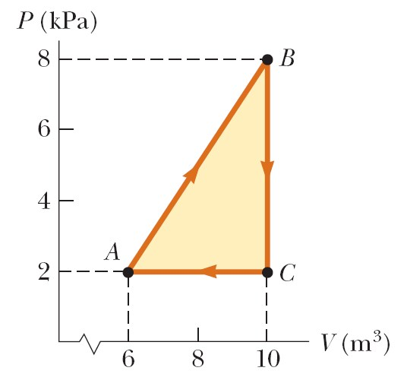
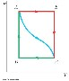
3. In Figure P20.40, the change in internal energy of a gas that is taken from A to C is +800 J. The work done on the gas along path ABC is – 500 J. (a) How much energy must be added to the system by heat as it goes from A through B to C? (b) If the pressure at point A is five times that of point C, what is the work done on the system in going from C to D? (c) What is the energy exchanged with the surroundings by heat as the cycle goes from C to A along the green path? (d) If the change in internal energy in going from point D to point A is +500 J, how much energy must be added to the system by heat as it goes from point C to point D?

4 Fifteen identical particles have various speeds: one has a speed of 2.00 m/s; two have speeds of 3.00 m/s; three have speeds of 5.00 m/s; four have speeds of 7.00 m/s; three have speeds of 9.00 m/s; and two have speeds of 12.0 m/s. Find (a) the average speed, (b) the rms speed, and (c) the most probable speed of these particles.

- At what temperature would the average speed of helium atoms equal (a) the escape speed from Earth, 1.12 × 10⁴ m/s, and (b) the escape speed from the Moon,
2.37 × 10³ m/s? (See Chapter 13 for a discussion of escape speed, and note that the mass of a helium atom is 6.64 × 10^{–27} kg.)

- A gas is at 0°C. If we wish to double the rms speed of its molecules, to what temperature must the gas be brought?

- Consider 2.00 mol of an ideal diatomic gas. (a) Find the total heat capacity of the gas at constant volume and at constant pressure assuming the molecules rotate but do not vibrate. (b) What If?
Repeat, assuming the molecules both rotate and vibrate.

- During the compression stroke of a certain gasoline engine, the pressure increases from 1.00 atm to 20.0 atm. If the process is adiabatic and the fuel-air mixture behaves as a diatomic ideal gas, (a) by what factor does the volume change and (b) by what factor does the temperature change? (c) Assuming that the compression starts with 0.016 0 mol of gas at 27.0°C, find the values of Q, W, and ∆E_{int} that characterize the process.

DGD XI Thermodynamics IV (Chapter 22)

- A heat engine takes in 360 J of energy from a hot reservoir and performs 25.0 J of work in each cycle. Find (a) the efficiency of the engine and (b) the energy expelled to the cold reservoir in each cycle.

- A Carnot engine has a power output of 150 kW. The engine operates between two reservoirs at 20.0°C and 500°C. (a) How much energy does it take in per hour? (b) How much energy is lost per hour in its exhaust?

3 A refrigerator has a coefficient of performance equal to 5.00. The refrigerator takes in 120 J of energy from a cold reservoir in each cycle. Find (a) the work required in each cycle and (b) the energy expelled to the hot reservoir.

- A heat engine operating between 200°C and 80.0°C achieves 20.0% of the maximum possible efficiency. What energy input will enable the engine to perform 10.0 kJ of work?

- An ice tray contains 500 g of liquid water at 0°C. Calculate the change in entropy of the water as it freezes slowly and completely at 0°C.

6 A 1.00-kg iron horseshoe is taken from a forge at 900°C and dropped into 4.00 kg of water at 10.0°C. Assuming that no energy is lost by heat to the surroundings, determine the total entropy change of the horseshoe-plus-water system.

- What change in entropy occurs when a 27.9-g ice cube at –12°C is transformed into steam at 115°C?

- The temperature at the surface of the Sun is approximately 5 700 K, and the temperature at the surface of the Earth is approximately 290 K. What entropy change occurs when 1 000 J of energy is transferred by radiation from the Sun to the Earth?

DGD XII Fluids (Chapter 14)

- The human brain and spinal cord are immersed in the cerebrospinal fluid. The fluid is normally continuous between the cranial and spinal cavities. It normally exerts a pressure of 100 to 200 mm of H₂O above the prevailing atmospheric pressure. In medical work, pressures are often measured in millimeters of H₂O because body fluids, including the cerebrospinal fluid, typically have the same density as water. The pressure of the cerebrospinal fluid can be measured by means of a spinal tap as illustrated in Figure P15.16. A hollow tube is inserted into the spinal column, and the height to which the fluid rises is observed. If the fluid rises to a height of 160 mm, we write its gauge pressure as 160 mm H₂O. (a) Express this pressure in pascals, in atmospheres, and in millimeters of mercury. (b) Sometimes it is necessary to determine whether an accident victim has suffered a crushed vertebra that is blocking flow of the cerebrospinal fluid in the spinal column. In other cases, a physician may suspect that a tumor or other growth is blocking the spinal column and inhibiting flow of cerebrospinal fluid. Such conditions can be investigated by means of Queckenstedt’s test. In this procedure, the veins in the patient’s neck are compressed so as to make the blood pressure rise in the brain. The increase in pressure in the blood vessels is transmitted to the cerebrospinal fluid. What should be the normal effect on the height of the fluid in the spinal tap? (c) Suppose compressing the veins had no effect on the fluid level. What might account for that?

- A Styrofoam slab has thickness h and density ρ_{s}. When a swimmer of mass m is resting on it, the slab floats in fresh water with its top at the same level as the water surface. Find the area of the slab.

- Determination of the density of a fluid has many important applications. A car battery contains sulfuric acid, for which density is a measure of concentration. For the battery to function properly, the density must be within a range specified by the manufacturer. Similarly, the effectiveness of antifreeze in your car’s engine coolant depends on the density of the mixture (usually ethylene glycol and water). When you donate blood to a blood bank, its screening includes determination of the density of your blood because higher density correlates with higher hemoglobin content. A hydrometer is an instrument used to determine liquid density. A simple one is sketched in Figure P15.24. The bulb of a syringe is squeezed and released to let the atmosphere lift a sample of the liquid of interest into a tube containing a calibrated rod of known density. The rod, of length L and average density ρ₀, floats partially immersed in the liquid of density ρ. A length h of the rod protrudes above the surface of the liquid. Show that the density of the liquid is given by
ρ0L ρ=
L−h

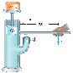
- Piston in Figure P15.11 has a diameter of 0.250 in. Piston has a diameter of 1.50 in. Determine the magnitude F of the force necessary to support the 500 lb load in the absence of friction.

- The Bernoulli effect can have important consequences for the design of buildings. For example, wind can blow around a skyscraper at remarkably high speed, creating low pressure. The higher atmospheric pressure in the still air inside the buildings can cause windows to pop out. As originally constructed, the John Hancock Building in Boston popped window panes, which fell many stories to the sidewalk below. (a) Suppose a horizontal wind blows in streamline flow with a speed of 11.2 m/s outside a large pane of plate glass with dimensions 4.00 m × 1.50 m. Assume that the density of the air is 1.30 kg/m³. The air inside the building is at atmospheric pressure. What is the total force exerted by air on the window pane? (b) If a second skyscraper is built nearby, the air speed can be especially high where wind passes through the narrow separation between the buildings. Solve part (a) again, this time taking the wind speed as 22.4 m/s, twice as high.

- (a) A very powerful vacuum cleaner has a hose 2.86 cm in diameter (Fig. P15.8a). With no nozzle on the hose, what is the weight of the heaviest brick that the cleaner can lift? (b) A very powerful octopus uses one sucker of diameter 2.86 cm on each of the two shells of a clam in an attempt to pull the shells apart (Fig. P15.8b). Find the greatest force the octopus can exert in salt water 32.3 m deep. (Caution: Experimental verification can be interesting, but do not drop a brick on your foot. Do not overheat the motor of a vacuum cleaner. Do not get an octopus mad at you.)




- Figure P15.12 shows Superman attempting to drink water through a very long straw. With his great strength he achieves maximum possible suction. The walls of the tubular straw do not collapse. (a) Find the maximum height through which he can lift the water. (b) Still thirsty, the Man of Steel repeats his attempt on the Moon, which has no atmosphere. Find the difference between the water levels inside and outside the straw.

- Figure P15.37 shows a stream of water in steady flow from a kitchen faucet. At the faucet the diameter of the stream is 0.960 cm. The stream fills a 125-cm³ container in 16.3 s. Find the diameter of the stream 13.0 cm below the opening of the faucet.



