Political Communication Study Guide
Concepts and Key Issues
Several definitions can be assigned to the concept of political communication:Public discussion about the allocation of public resources (revenues), official authority (who is given the power to make legal, legislative and executive decision), and official sanctions (what the states rewards or punished (Denton and Woodward, 1990)
Political communication refers not only to verbal or written statements, but also to visual means of significations such as dress, make-up, hairstyle and logo design e.i., All those elements of communication which might be said to constitute a political image or identity (Graber,1994)
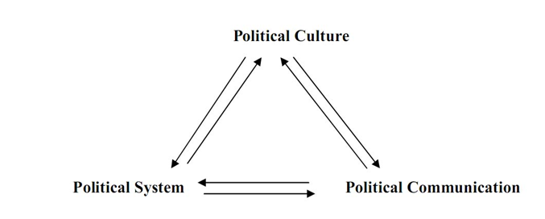
political communication is the space where discourses are exchanged between the three actors who have the legitimacy to speak publicly about politics: politicians, journalists and public opinion through surveys (Wolton, 1989)
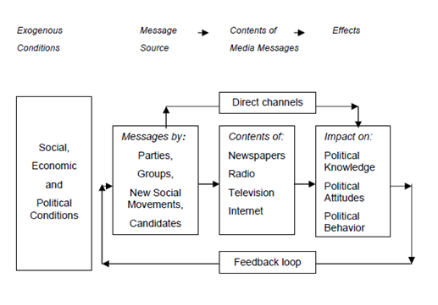

Habermas and the Public Sphere
He noted that the public, to be successful, had to exhibit several essential characteristics: Members of the public had to be of roughly equal status, they had to be educated and informed, they had to debate and decide issues without interference or influence from either the state (government) or from the estates (powerful moneyed interests that negotiated directly with the state and exhibited their agreements to the public for its acquiescence)
He suggested that mass societies in the 20th century showed wide disparity in status among its citizens and serious questions about educational levels and access to information. He further suggested that disparities in wealth had created disparate access to the forms of communication that were assumed to shape debate.
This required that the discussion be conducted independent of influence by state interests, independent of the interests of the estates (moneyed interests), and even without undue emphasis upon parochial private interests.
A self-regulating media system must maintain its independence vis-à-vis its environments while linking political communication in the public sphere with both civil society and the political center; and, second, an inclusive civil society must empower citizens to participate in and respond to a public discourse which, in turn, must not degenerate into a colonizing mode of communication. (Habermas, 2006, p. 420)

Lipman: “Public is too dumb and uninformed to create a mandate for political parties, parties must create a mandate and then convince the public on it, not vice versa”
Dewey on the Power of the Debate:
-If we included the public in discussions on issues and policy then they would be able to form opinions and contribute to solutions.
-Acknowledged the criticism that the public might be too wide spread to come to any type of meaningful consensus on issues
-Accepted lippman’s premise but argued that public debate and social gatherings could increase a public mandate significantly
Dewey on definition of the public:
a public is a group of people who:
1) Face a similar problem.
2) Recognize that the problem exists.
3) Organize to do something about the problem
Hegel’s four desires at the core of human consciousness:
1) The desire to sense Being (the world around us),
2) the desire to change Being (to shape the world),
3) the desire to have the Other yield freedom to the individual’s choice for change, and
4) the desire to have the Other recognize the individual’s freedom to change as universal
Hegel (1977) suggests that human beings fight one another, not simply for change, but, more importantly, for recognition of their freedom to change or project their particular values upon Being and upon each other within the universal of the state.
He suggests that history is the record of this conflict over the idea or project, the particular free acts of individuals or groups that within the State, or the willed idea of the common good.
The Silent Majority
Spiral Of Silence, the fear of expressing perceived minority point of view (Noelle-Neumann, 1974)
In a wide range of settings, people contribute less than the optimal amount of public goods and consume more than their fair share (Ledyard, 1995)
Even in active, successful communities, it is a small core of participants that generate the most content, (Preece ,2000)
Public deliberation and participation is often impeded by dysfuntionctional social-psychological processes; (Ho and McLeod, 2008)
THE FRAMING MODEL
The basis of framing theory is that the media focuses attention on certain events and then places them within a field of meaning.
Framing is an important topic since it can have a big influence and therefore the concept of framing expanded to organizations as well.
Framing theory and the concept of framing suggests that how something is presented (the “frame”) influences the choices people make. This idea is important because it is contrary to the central concept of of rational choice theory.
Framing consists of three main elements : Language, thought and fore thought
-Framing has a lot to do with the term Salience : picking small bits of imformation or words and bringing them to the forefront of the news thus making them seem more important than the rest of the informaton. An example would be repeating a certain word, phrase or idea many times in an article to highlight it’s importance
FRAME BUILDING
Refers to the factors that influence the structural qualities of news frames (de Vreese, 2002).
Factors internal to journalism determine how journalists and news organizations frame issues (Shoemaker & Reese, 1996).
Equally important, however, are factors external to journalism.
The frame-building process takes place in a continuous interaction between journalists and elites (Gans, 1979; Tuchman, 1978) and social movements
FRAME SETTING
Refers to the interaction between media frames and individuals’ prior knowledge and predispositions.
Frames in the news may affect learning, interpretation, and evaluation of issues and events.
MEDIA VS INDIVIDUAL FRAMES
Because frames have to be considered schemes for both presenting comprehending news, two concepts of framing can be specified: media frames and indivuals frames
MEDIA FRAMES
A media frame is a central organizing idea or story line that provides meaning to an unfolding strip of evens
The frame suggests what the controversy is about, the essence of issue
Media frames also serves as working routines for journalists that allow journalists to quickly identify and classify information and to package it for efficient relay to their audiences

INDIVIDUAL FRAMES
They are mentally stored clusters of ideas that guide individuals processing of information (Entman, 1993)
Two frames of references can be used to interpret and process information: Global and long-term political views and short-time and issues related frames of reference
FRAMING TECHNIQUES
1. Metaphor: To give an idea or program a new meaning by comparing it to something else
2. Stories (Myths and legends) : To Frame a subject by anecdote in a vivid and memorable way
3. traditions (Rites, Rituals and ceremonies): To pattern and define an organization at regular time increments to confirm and reproduce values
4.slogans, jargons and catchphrases: To frame subject in a memorable and familiar fashion
5. Artefacts: To illuminate corporate values through physical vestiges (something in a way language cannot)
6.contrasts : To describe a subject in terms of what it is not
7. Spin: To talk about a concept so as to give a positive or negative connotation
WAYS TO DETECT FRAMING IN THE NEWS
Four main criteria suggested by Cappella and Jamieson (1997):
First, a news frame must have identifiable conceptual and linguistic characteristics.
Second, it should be commonly observed in journalistic practice.
Third, it must be possible to distinguish the frame reliably from other frames.
Fourth, a frame must have representational validity (i.e. be recognized by others) and not be merely a figment of a researcher’s imagination (Cappella & Jamieson, 1997, pp. 47; 89).
FRAME AMPLIFICATION
The most basic frame alignment is called frame amplification.
Frame amplification simply denotes 'the clarification and invigoration of an interpretive frame that bears on a particular issue, problem or set of events' (Snow et al., 1986: 469).
Since frame amplification applies to already existing frames, it can only be utilized for frame maintenance, but not for the construction of new frames.
Frame amplification can also fortify the identity of their targets by delivering a strong 'negative' identity (Gamson 1992: 135).
FRAME EXTENSION
Frame extension adds to a frame certain issues or dimensions, which hitherto were of no relevance for it.
The main goal of frame extension is to make the frame more attractive to its potential adherents with different priorities.
FRAMING EFFECTS
A framing effect is usually said to occur when equivalent descriptions of a decision problem lead to systematically different decisions.
They can be gathered in three main categories:
Attribute framing,
Risky choice framing
GOALS FRAMING
In goal framing, subjects are urged to engage in some activity (e.g., wearing seatbelts).
This plea involves a description of either the advantages of participating in the activity or the corresponding disadvantages of not participating.
The most common result is that subjects are more likely to engage in the activity when the disadvantages of not engaging, rather than the advantages of engaging, are emphasized (Levin et al. 1998).
THE AGENDA SETTING MODEL
Core assumptions of agenda setting:
(1) the press and the media do not reflect reality; they filter and shape it;
(2) media concentration on a few issues and subjects leads the public to perceive those issues as more important than other issues.
KEY CONCEPTS OF AGENDA SETTING
The media agenda (policy rankings by importance in the media) influences both the public agenda (rankings in opinion surveys) and the policy agenda (rankings in legislative bodies).
Salience transfer refers to the capacity of the media (or other actors) to influence the relative importance individuals attach to policy issues.
Gatekeeping refers to how media content is controlled. Gatekeeping determines the content of salience transfer.
Priming has to do with drawing attention to certain issues even in a neutral manner.
TYPES OF AGENDAS
Systemic or macro agendas: include the widest range of potential issues that might be considered for action by the government and that might be placed on the public agenda.
Institutional or micro agendas include those issues that are already for consideration of decision makers, legislatures or courts).
AGENDA SETTING EFFECTS:
Media exposure: Wanta & Ghanem (2006) found exposure was a stronger determinant than media credibility or media reliance, which were unrelated; Wanta and Miller (1996) had found exposure to be more important than media credibility. The same study found exposure led to thinking issues were important.
Obtrusiveness refers to the extent that the public has experience with the policy issue. The nor unobtrusive the issue, the more the individual may rely on media exposure for orientation. Zucker (1978) found that salience transfer was greatest for unobtrusive issues.
Need for orientation. Weaver (1977) and others found that some individuals have greater need for policy orientation and thus are more affected by salience transfer. Need for orientation, in turn, is a function of individual interest in the policy topic combined with issue uncertainty

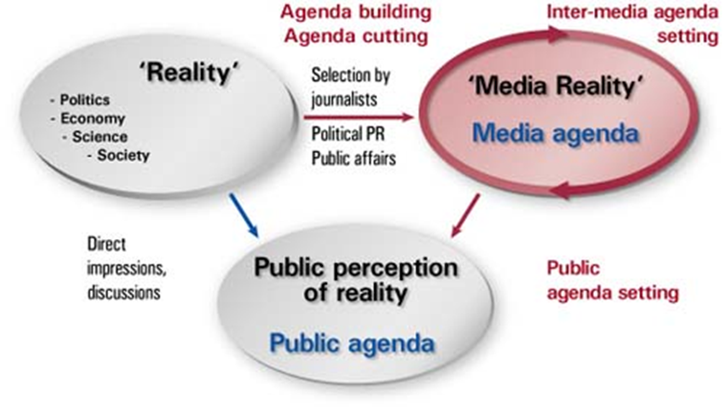

KINGDON’S MODEL OF PROCESS STREAMS
COMPARATIVE MEDIA SYSTEMS
Hard NEWS AND SOFT NEWS
Hard news stories are what we generally think of as traditional news stories. Hard news stories can be factual reports, controversial exposes or the result of investigative reporting.
Soft news : lifestyle, feature, and human interest stories . may have less direct impact on public policy debates than hard news stories but can nonetheless affect public opinion on advocacy issues. A soft news story is a more subtle but often equally effective channel for communicating your advocacy message.
COMPARATIVE MEDIA THEORIES
AUTHORITARIAN THEORY
Parallel with development of printing press
The ruling elite guides the low-intelligence masses
Public dissent and criticism are a threat
Compliance of the press through: Licensing Censorship, Exclusive printing rights Punishment of government critics
LIBERTARIAN THEORY
Diametrically opposed to authoritarian beliefs
Matched freewheeling, rugged early America
Assumes people are intelligent creatures
Government exists to serve the individual
Citizens need to hear all sides of an issue
Government serves best when it serves least
The press should be free from control
SOCIAL RESPONSIBILITY THEORY
Press has right to criticize government
Press also has responsibility to preserve democracy
Properly informing the public
Responding to society’s needs and interests
Press not free to do as it pleases
Government may regulate press in the public interest (example: FCC and broadcasting)

COMMUNIST THEORY
Media are owned by the people (represented by the state)
The purpose of the media is to support the Marxist system and achieve the goals of the state
Works best in a tightly controlled society
Example: use of spillover by BBC, VOA, CNN, and others into Communist countries
DEVELOPMENTAL THEORY
Government can mobilize the media to serve national goals in economic and social development
Goals include: Eradication of disease ,Economic self sufficiency, Political integration, Raising literacy level
Information must be managed by the government
Primarily used in non-democratic developing countries
Losing ground to the social responsibility approach
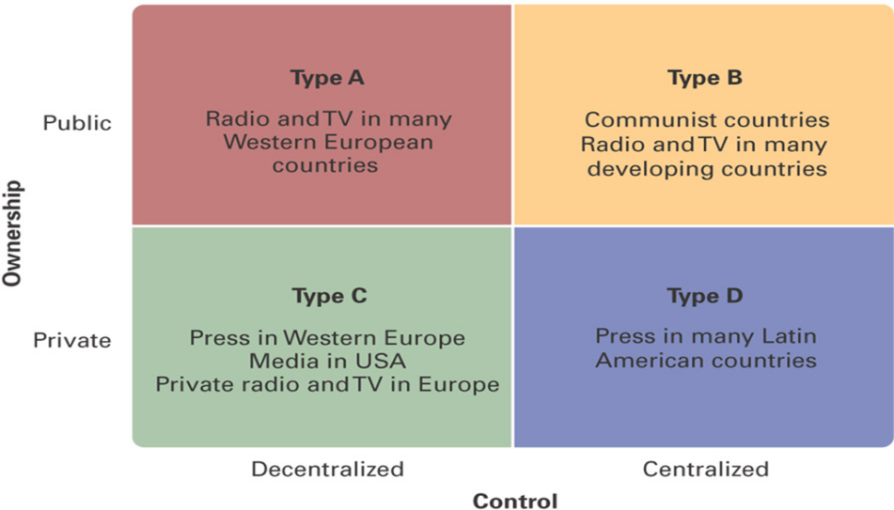

MEDIA AND ELECTION CAMPAIGNS
The Internet and Election Campaigns
The Internet allows for a more intensive form of interaction than traditional media, and therefore it is expected that the Internet will lead to a more open and hence more democratic exchange of political debate (Shah et al. 2001; Sinekopova 2006).
The research on the use of information and communication technologies (ICTs) during electoral campaigns thus far has been concentrated mostly on content analysis (Norris 2003; Ward & Gibson 2003).
It is to be expected that every political party will use its website to promote its own programme and its own candidates (Lusoli 2005).
The Internet user is the new decision-maker, self-made, able to intervene by means of the new communication platforms in the traditional relation of the type transmitter-receiver-transmitter which had existed so far between the political factor, mass media and the electorate (van Dijck 2009, 42-43)
In terms of online and offline involvement of the electorate, as a result of online communication, particularly because of the political blog, De Zuniga, Puig-i-Abril and Rojas (2009) brought evidence to the fact that the blog proves its importance in the online election communication mechanism, being equal in impact to the force of traditional media news on the campaign events of a candidate.
CRITIQUE OF INTERNET CAMPAIGNS
It is used predominantly by individuals and organizations already active in politics, and easier access to information does not appear to lead to greater participation (Davis 1999; Bimber 2001).
Overall, research indicates that existing centers of power are best able to control the technology to further their ends.
Information availability and cheap communications by themselves do not have significant impacts on individual choices for political participation.
(Banning Commenting)
THE MOBILIZATION THEORY
The mobilization theory propounds optimism towards the opportunities of the World Wide Web to affect citizens’ political activity.
This theoretical approach assumes that the Internet has the potential to inform, mobilize and engage citizens who are currently not involved with politics.
the mobilization hypothesis contends that despite the efforts of elites, new communication technologies will decrease the costs of communication and information acquisition and create new, more compelling opportunities for participation thereby empowering new groups, increasing democratic participation, and opening up otherwise difficult to penetrate policy networks.
Research on previous ICT innovations such as computers, broadcast and cable television has for the most part supported the reinforcement hypothesis (Danziger, Duttonet al. 1982; Dutton, Blumler et al. 1987; Abramson, Arterton et al. 1988; Streeter 1997).
Four Main Arguments in Favour of Mobilization Theory
The first argument states that the Internet provides abundant opportunities for political engagement.
Second, Internet lowers the costs of informing oneself and learning about politics and public affairs (Bimber 2000).
Third, the wealth of information presented on the Internet provides citizens with the opportunity to become better informed about politics as they can acquire all the resources necessary to express their views and to participate in public life.
And finally, the Internet is an interactive medium and it has the potential to strengthen the relation between citizens, the political world and intermediary organizations.
THE REINFORCEMENT THEORY
According to this thesis, the Internet does not have the capacity to engage and mobilize citizens in the realm of politics.
Proponents of the reinforcement thesis often claim they can rely on sound empirical research
The reinforcement hypothesis holds that ICTs support the existing distribution of political power because influential individuals and organizations already active in the political process are able to control the diffusion, design, and use of new technologies to support their entrenched interests.
Arguments for:
First, Internet access is unevenly divided, both across and within societies. Moreover, socioeconomic inequalities can also be found in the use of the Internet: even if all groups within societies would have access to Internet, it is clear there will be profound social differences in the way the Internet will be used to retrieve information (Van Dijk 2005; Warschauer 2003).
Second, it has been argued that online politics will only attract citizens who are already interested and engaged in offline politics. Thus, reinforcement based on motivation and interest is conceivable and perhaps even unavoidable: if citizens are not motivated to pay attention to politics, they will refrain from doing so, no matter what kind of information is being offered and no matter what kind of medium is being used.
LIMITS OF THESE FRAMEWORKS
While contrasting the mobilization and reinforcement hypotheses was a useful framework for early analysis of the Internet, it masks the complex relationship between technology and participation, thus impeding theoretical and empirical advances (Stanley and Weare, 2010).
Reinforcement effects and mobilizing effects are not mutually exclusive.
Internet access could mobilize some individuals to take part in new participatory acts in certain political areas, such as organizing protests.
At the same time, in other domains existing political elites maystrategically use the Internet to maintain and strengthen their political positions.
When one considers that both the Internet and political participation are multidimensional concepts, it becomes evident that technology can lead to a mixture of potentially countervailing effects on participation (Stanley and Weare, 2010).
The Internet is a generic communications platform that supports a variety of applications, which potentially compete with traditional broadcast media such as television, point-to-point technologies such as telephony, group communications such as videoconferencing, and information aggregation technologies such as telephone polling (Weare 2002).
At the same time democratic participation encompasses a variety of types of mediating organizations (e.g., political parties, interest groups), participatory acts (e.g., voting, campaign work, contacting officials), and targets to be influenced (e.g., political representatives and agency officials at the local and national levels) (Norris 2002).
Empirical studies of these distinct components of participation decisions offer a more varied picture of technology impacts.
MEDIAS AND DEMOCRACY
-The media’s job is to supply the political information that voters base their decisions on
PRIMING
Closely related to agenda-setting is the effect of priming. Priming refers to the fact that one piece of media information can influence how we interpret subsequent pieces of information by making us tune in to certain areas of thought.
Thus, the news media can influence the criteria by which political candidates are judged by calling attention to some issues and ignoring others before the speech of the candidate (Pan and Kosicky 1997; Hetherington 1996).
The priming effect is often explained in terms of schematic thinking. When evaluating new information or making a decision, people tend to apply the information and schemata that are most readily accessible or available in memory at that moment, rather than conduct a complete and comprehensive search and examination of information.
THE PROPAGANDA MODEL
General Assumptions of Liberal Pluralism
1. Society composed of diverse groups who come together to lobby for and represent their interests before government. This diversity of interests gives balance and strength to the overall society. And all voices can potentially be heard.
2. The power of groups to represent their interests is roughly equal. No one group can dominate any particular issue all of the time.
3. The government acts as an impartial referee on behalf of the general good, helping to achieve fair and just compromises to competing claims.
4. Political life (at the level of the citizen and at the institutional level) is independent from economic life. Rich and poor are equal in the face of government and law.
5. The exercise of power is visible.
Media Assumptions of Liberal Pluralism
1. Media help to give voice to all views and to provide a forum for public debate.
2. Media provide the information necessary for citizens to act.
3. Media are independent of the power of economics and government.
4. Media serve as an independent institution keeping watch over self-serving government and excessive influence of special interest groups.
5. Assumes information as opposed to a social constructivist model of communication.
HERMAN AND CHOMSKY PROPAGANDA MODEL
Manufacturing Consent (1992)
“Propaganda” – broadly equivalent to ideological domination
Chomsky believes in ‘truth’ but it is hidden under ‘necessary illusions’
• The media cultivate common patterns of acceptance in people’s minds
– Through compliant media processes and devices of thought compliance as effective as totalitarian states
– Alternative options are excluded through processes of suppression, falsification and manipulation.
News production process are shaped by a range of factors, encapsulated by the filter element associated with the PM
The model argues that media function as central mechanisms of propaganda in the capitalist democracies and suggests that class interests have ‘multilevel effects on mass-media interests and choices’ (Herman and Chomsky, 1988: 2).
Media, according to this framework, do not have to be controlled nor does their behaviour have to be patterned, as it is assumed that they are integral actors in class warfare, fully integrated into the institutional framework, and act in unison with other ideological sectors, i.e. the academy, to establish, enforce, reinforce and police corporate hegemony ( Mullen & Klaehn, 2010)
1. Commercial basis of dominant news organizations are very expensive to run. Big corporations set the news agenda eg: Reuters, Fox, New York Times
2. Advertising is primary source of income for commercial news organisations – market news to affluent viewers
3. News media rely excessively on ‘expert sources’: politicians, police beat, media releases – these preferred sources exclude independent non‐official sources
4. Flak: threats by politicians or media monitors to punish media outlet for publishing or broadcasting negative stories
5. ‘Ideology of anti‐communism’ helps mobilise populace against a common enemy
POLITICAL MARKETING
Differences between mainstream and Political Marketing
1. unlike every other purchasing decision, all voters make their choice on the same day. Moreover, although there are similarities between opinion polls and brand shares’ tracking methods, the latter are based on actual purchasing decisions while the former are based on hypothetical questions
2. voting choice, unlike any other purchasing decision, has no direct or indirect individual costs attached to it.
3. voters have to live with the collective choice even though it may not have been their preference
4. in elections winner takes all, especially in countries such as the UK where the electoral system is “first past the post”.
5. political parties and candidates are complex intangible products which the voters cannot unbundle and thus they have to decide on the totality of the package
6. in many countries (this applies to Canada as well) it is very difficult to form a new and successful party
7. in most mainstream marketing situations, brand leaders tend to stay in front
POLITICAL MARKETING PROCESS
Stage One: Market Intelligence
The party aims to discover voters’ response to product; who does not support the party but might, so communications can be targeted on them.
Stage Two: Product Design
The party designs its behaviour in response to voter demands, found from Stage 1.
Stage Three: Product Adjustment
The party then adjusts its model product design to consider:
achievability: ensures promises can be delivered in government
internal reaction: history/ideological framework
competition: promotes opposition weaknesses and highlight own strengths
support: focuses on winning support party needs to win power; use
target marketing
Stage Four: Implementation
  - The product design is implemented throughout party. A majority need to broadly accept the new behaviour and comply with it.
Stage Five: Communication
  - This includes the so-called near or long-term campaign but also on-going behaviour.
Stage Six: Campaign
  - The official election campaign period leading up to the election. The party continues to communicate effectively as in Stage 5.
Stage Seven: Election
  - The general election.
Stage Eight: Delivery
The Party will deliver product in government.

BRANDING
Political brand is important than the product
A political brand is more psychological than a functional product, and has an emotional aspect
It is also standing, built on past behaviour, influenced by many different factors, and thus hard to control or change
How voters perceived a brand can affect how they judge that brand’s product; the party brand can affect candidates
All political figures/organisations (politician/party/government/department) can be seen as a brand aspirational
The brand should be clear and coherent; differentiated; reassuring; sincere; trustworthy
It is important to manage the brand’s product life cycle-it should be expected to decline and plan to reconnect as part of a long-term brand relationship
Decontaminate a negative brand before re-branding (e.i. Liberal party)- just a single image can reactivate the negativity in the public mind
ENTERTAINMENT MEDIA AND POLITICAL COMMUNICATION
-Infotainment: combining information with entertainment
POPULISM: As a multi-faceted and highly malleable political ideology, populism mixes elements of core political ideologies, like socialism, liberalism and neo-conservatism, opposition to powerful elites in public life, and advocacy of more real power for "the people.“
POLITICAL APATHY
David Taras’ vision: Tars offers four frameworks or interpretations of how medias shapes public attitudes on politics:
  - Democracy without Citizens: pubic debate is dominated by elites and is not cared for by the general population . News media helps this disenfranchisement by disseminating infotainment which is a watered down version of the real issue
  - Citizens without democracy: citizens are not gullible and can exercise rational choice. Political apathy is a result of highly sensored and sanatized media which shapes a skewed view of reality for the majority of citizens, propaganda model
  - Election campaigns and symbolic Politics
  - Adversarial journalism
PUBLIC OPINION RESEARCH
Public opinion research is the planned gathering, by or for a government institution, for any government purpose, of: opinions; attitudes; perceptions; judgments; feelings; ideas; reactions or; views.
Public opinion research helps the government to better understand Canadian society and to identify citizen needs and expectations. It is used to assess the public's response to proposals or to possible changes or initiatives; to assess the effectiveness of policies, programs and services; to measure progress in service improvement; to evaluate the effectiveness of communication activities such as advertising; and to plan and evaluate marketing initiatives, among other applications.

