The environment of management
Organizational Environment:
Organizational Environment: the set of forces and conditions that can affect the way an organization operates.
-Forces can change over time and are made up of Opportunities and Threats.
Opportunities: openings for managers to enhance revenues or open markets.
-New technologies, new markets and ideas.
Threats: issues that can harm an organization.
-economic recessions, oil shortages.
Forces in the Organizational Environment:
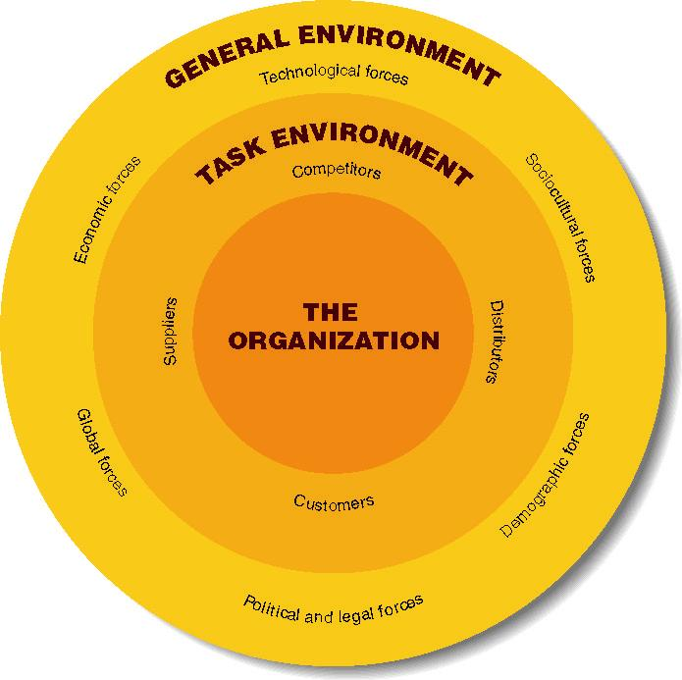
The General Environment
Consists of the wide economic, technological, demographic and similar issues. Managers cannot usually impact or control, forces have profound impact on firm.
Economic forces: affect the national economy and the organization.
-Includes interest rate changes, unemployment rates, economic growth.
-When there is a strong economy, people have more money to spend on goods and services.
The Economic Environment
Key economic goals:
-Economic Growth
-Aggregate Output & Standard of Living
-Gross Domestic Product
-Productivity
-Balance of Trade
-National Debt
Aggregate output- Total quantity of goods & services produced by an economic system during a given period
Standard of living-Total quantity & quality of goods & services that a country’s citizens can purchase with their currency
- Business cycle
  - The typical pattern of short-term
ups and downs in an economy
(peak, recession, trough and recovery)
  - Recession = a period during which aggregate output declines
  - Depression = severe and prolonged recession
Measuring Economic Growth:
- Gross Domestic Product (GDP)
  - value of all goods & services
produced by a national economy
within a given period
through domestic factors of production
- Gross national product (GNP)
  - value of all goods & services
produced by a national economy
within a given period
regardless of production location
Productivity: measure of economic growth that compares production with the resources required
-Increases in productivity = increases in standard of living
-Growth reflected in real GDP growth
Balance of Trade:
Value of all exported products minus the value of imported products
-Positive balance = more exports = economic growth
National Debt: Amount of money that a
government owes its creditors
-Increases by amount of budget deficit
-Can decrease when have budget surplus
-Lower debt = more $ for private investment
Economic Stability
Condition in an economic system in which the amount of money available and the quantity of goods and services produced are growing at about the same rate
Threats-
When Did the Cost of a Hamburger Go Up?
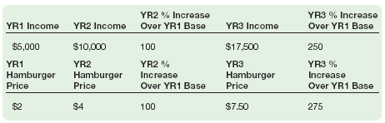
Unemployment
Level of joblessness among people actively seeking work in an economic system
- Inflation
  - widespread price increases in an economic system
- Consumer Price Index (CPI)
  - Measures the changes in prices of typical products purchased by consumers
- Deflation
  - A period of generally
falling prices
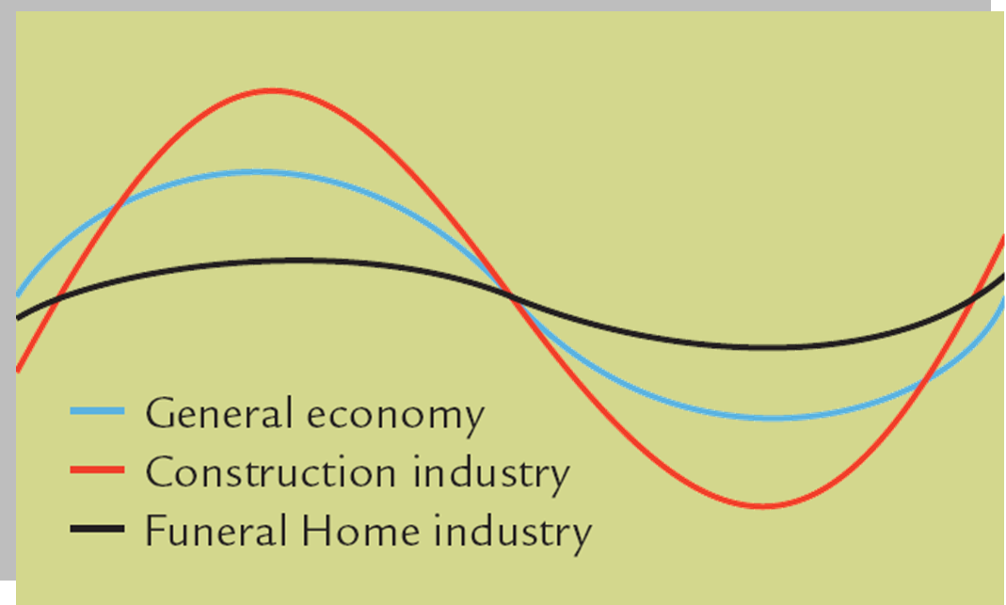
Types of Unemployment:
-Frictional
-Seasonal
-Cyclical
-Structural
Economic Cycles
Good
Economic
conditions
Poor Economic
Conditions
Time
Managing the Canadian Economy:
Fiscal Policies determine how the gov collects and spends revenues.
Monetary policies determine the size of a nations monetary supply. High interest rates = tight monetary policy
Low interest rates = easy monetary policy
Stabilization Policy
Using fiscal & monetary policies to stabilize prices and to smooth out fluctuations in output and unemployment.
The General Environment:
Technological forces: skills & equipment used in design, production and distribution.
-Result in new opportunities or threats to managers.
-Often make products obsolete very quickly.
-Can change how we manage.
Technological Environment:
Technology: All the ways firms create value for their constituents
Research and Development (R & D)
-Basic (pure)
-Applied
Product and Service Technologies-
Technologies employed for creating
products—both physical goods and
services—for customers
R&D intensity = % of sales spent on R&D
Technology Transfer = getting new technology out of lab and into the marketplace
The General Environment:
Sociocultural forces:
Societal values: commonly shared desired end-states
Demographic forces: result from changes in the nature, composition and diversity of a population.
-These include gender, age, ethnic origin, etc.
For example, during the past 25 years, women have entered the workforce in increasing numbers.
-Currently, most industrial countries are aging.
This will change the opportunities for firms competing in these areas.
New demand for healthcare, assisting living can be forecast.
Political and legal forces: result from changes in the political arena.
These are often seen in the laws of a society. Today, there is increasing deregulation of many government-run firms.
Global forces: result from changes in international relationships between countries.
-Perhaps the most important is the increase in economic integration of countries.
-Free-trade agreements (WTO, NAFTA, EU) decreases former barriers to trade.
-Provide new opportunities and threats to managers.
Task Environment
Organization’s most immediate external environment. Typically largest influence on the organization
Managers must understand the fit between the organization and its task environment
Task Environment components -
- Competitors
- Customers
- Suppliers
- Strategic Partners (Distributors)
- Labour (Suppliers)
- Regulators
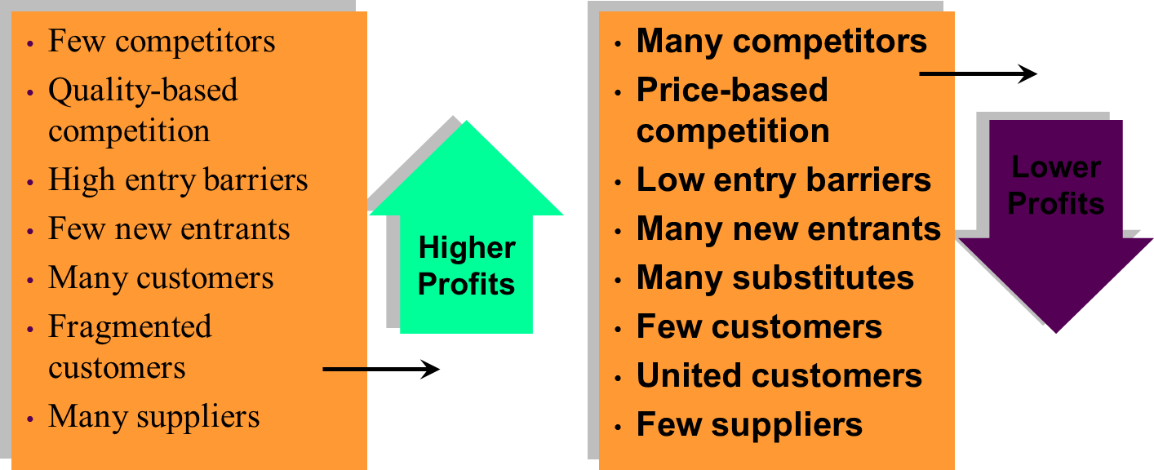
Profits and Industry Forces:
New entrants increase competition. Increased competition leads to lower profits. The fewer the available substitutes, the greater the profits.
Strategic partners work closely with a firm to pursue mutually beneficial goals:
-Limited engagements
-Joint ventures
-Sharing of equity interest
Labour:
When demand exceeds supply, the imbalance can lead to high labour costs or to costly labour shortages.
Labour unions can exert pressure on managers to increase wages and offer other costly benefits, decreasing performance.
Regulators:
-Regulatory agencies are created by government to establish and enforce standards and practices.
-Interest groups are nongovernmental organizations (NGOs) organized to serve members’ interests
-Regulators can influence and sometimes dictate organizational actions
The Business Environment:
Porter’s five forces model is used to analyze the competitive situation in an industry-
- Rivalry Among Existing Competitors
- Threat of Potential Entrants
- Suppliers
- Buyers
- Substitutes

Barriers to Entry and Competition:
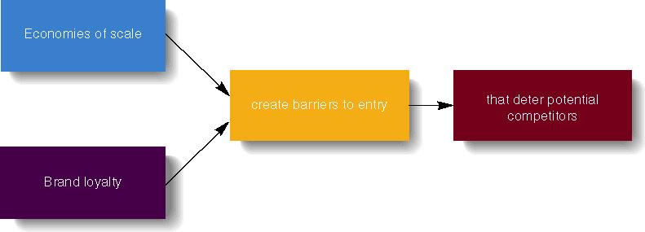

Internal Environment:
Owners: those who have legal rights to the assets of the company.
Board of Directors: individuals elected by shareholders who represent the interests of the shareholders
(Oversee the general management of the company)
Employees
Culture: a learned set of assumptions, values, and beliefs that are taught to newcomers
Managing the External Environment:
Environmental complexity: deals with the number and possible impact of different forces in the environment.
The more forces, the more complex the manager’s job becomes.
Environmental change: refers to the degree to which forms in the task and general environments change over time.
-Change rates are hard to predict.
-The outcomes of changes are even harder to identify.
*Managers can counter environmental threats by reducing the number of forces. All levels of managers should work to minimize the potential impact of environmental forces.


