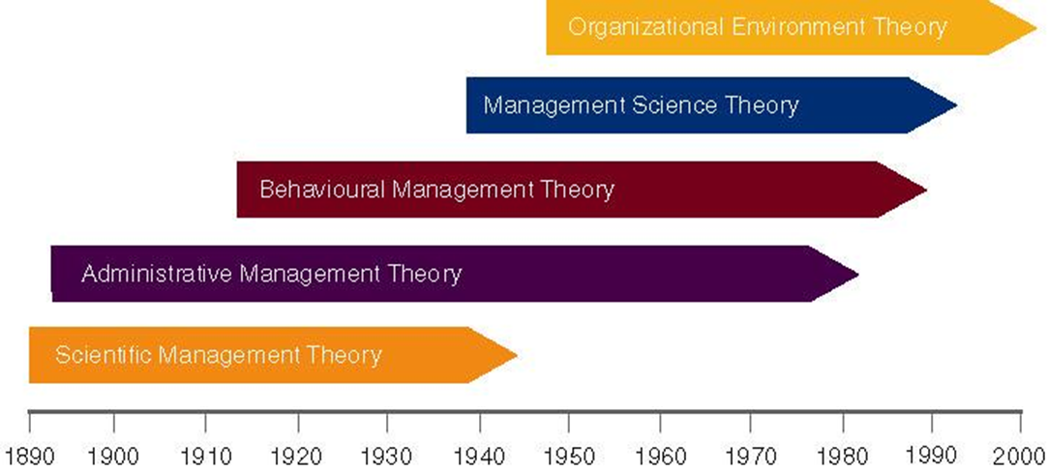
Evolution of Management Theory
Scientific Management Theory:
Modern management began in the late 19th century. Organizations were seeking ways to better satisfy customer needs. Machinery was changing the way goods were produced, and Managers had to increase the efficiency of the worker-task mix.
-Job Specialization
Adam Smith, 18th century economist, found firms manufactured pins in two ways: Craft -- each worker did all steps.
Factory -- each worker specialized in one step.
Smith found that the factory method had much higher productivity.
Each worker became very skilled at one, specific task.
Breaking down the total job allowed for the division of labour.
Scientific Management- Defined by Frederick Taylor, Late 1800s.
“The systematic study of the relationships between people and tasks to redesign the work for higher efficiency.”
Taylor sought to reduce the time a worker spent on each task by optimizing the way the task was done.
Four Principles to increase efficiency:
1. Study the way the job is performed and determine new ways to do it.
2. Codify the new method into rules
3. Select workers whose skills match the rules set in step 2
4. Establish a fair level of performance, and pay for higher performance.
Problems doeeee :
Managers often only implemented the increased output side of taylors plan.
Specialized jobs often became boring and dull, did not allow workers to share in increased output. Workers could purposefully underperform. Management responded by increased use of machines,
THE GILBRETHS
Time and motion studies:
1. Break down each action into components.
2. Find better ways to perform it.
3. Reorganize each action to be more efficient.
Administrative Management Theory:
Seeks to create an organization that leads to both efficiency and effectiveness. Max Weber developed the concept of bureaucracy:
A formal system of organization and administration to ensure effectiveness and efficiency.
Weber developed the Five principles of beuraucracy:
Henri Fayol, developed a set of 14 principles:
1. Division of labour
2. Authority and Responsibility
3. Unity of command
4. Line of authority
5. Centralization
6.Unity of direction
7. Equity
8. Order
9. Initiative
10. Discipline
11. Remuneration of Personnel
12. Stability of Tenure
13. General interest over individual interest
14. Esprit de corps: Share enthusiasm or devotion to the organization.
Behavioural Management Theory:
Focuses on the way a manager should personally manage to motivate employees. Mary Parker Follett: an influential leader in early managerial theory.
-Suggested workers help in analyzing their jobs for improvements.
-The worker knows the best way to improve the job.
-If workers have the knowledge of the task, then they should control the task.
The Hawthorne Studies
Study of worker efficiency at the Hawthorne Works of the Western Electric Co. during 1924-1932.
-Worker productivity was measured at various levels of light illumination.
-Researchers found that regardless of whether the light levels were raised or lowered, productivity rose.
Actually, it appears that the workers enjoyed the attention they received as part of the study and were more productive.
Theory X and Y
Douglas McGregor proposed the two different sets of worker assumptions.
Theory X: Assumes the average worker is lazy, dislikes work and will do as little as possible.
-Managers must closely supervise and control through reward and punishment.
Theory Y: Assumes workers are not lazy, want to do a good job and the job itself will determine if the worker likes the work.
-Managers should allow the worker great latitude, and create an organization to stimulate the worker.
Management Science Theory:
Uses rigorous quantitative techniques to maximize resources.
Quantitative management: utilizes linear programming, modeling, simulation systems.
Operations management: techniques to analyze all aspects of the production system.
Total Quality Management (TQM): focuses on improved quality.
Management Information Systems (MIS): provides information about the organization
Organization-Environment Theory:
Considers relationships inside and outside the organization.
-The environment consists of forces, conditions, and influences outside the organization.
Systems theory considers the impact of stages:
Input: acquire external resources.
Conversion: inputs are processed into goods and services.
Output: finished goods are released into the environment.
The Organization as an Open System:
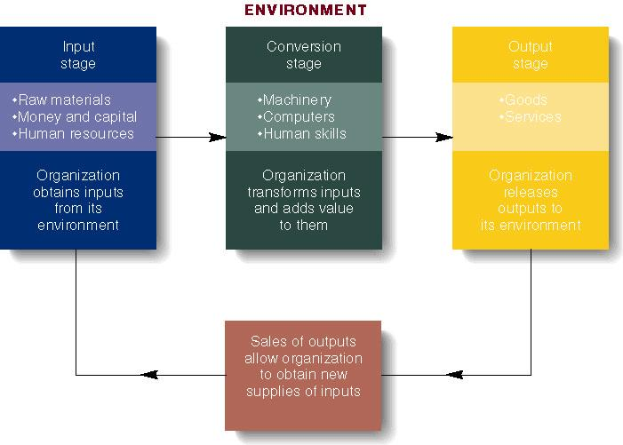
Contingency Theory:
Contingency Theory of Organizational Design:
1. Formal Authority is the power to hold people accountable for their actions, and is derived from the position held in the organization.
2. Positions in the firm should be held based on performance not social contacts or personal interests.
3. Position duties are clearly identified. People should know the level of authority and expectations of their position, and its relationship to other positions in the organization.
4. Lines of authority should be clearly identified. Workers know who reports to who. They should be hierarchical.
5. Rules, Standard Operating Procedures (SOPs), & Norms are used to determine how the firm operates.
    - Sometimes, these lead to “red-tape” and other problems.
- Fayol postulated that all administrative activities could be divided into 6 groups:
  - Technical operations (production/manufacturing)
  - Commercial operations (purchases, sales)
  - Financial operations (finding & controlling capital)
  - Security operations (protecting property & persons)
  - Accounting operations (stock-taking, costing)]
  - Administrative Operations or managerial activities:
    - “foresight, organizing, commanding, coordinating, controlling”
- An open system interacts with the environment. A closed system is self-contained.
  - Closed systems often undergo entropy and lose the ability to control itself, and fails.
- Synergy: performance gains of the whole surpass the components.
  - Synergy is only possible in a coordinated system.
- Assumes there is no one best way to manage.
  - The environment impacts the organization and managers must be flexible to react to environmental changes.
- Technological environments change rapidly, so must managers.
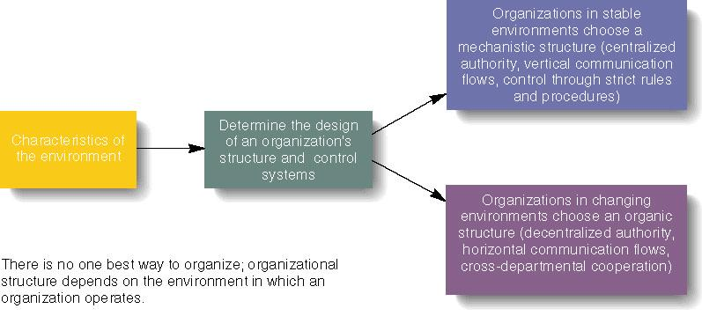
Structures:
Mechanistic Theory X
-Authority is ccentralized at the top
-Employees closely monitored
-Very efficient in stable environment.
Organic Theory Y
-Authority is decentralized throughout employees
-Much looser control than mechanistic
-Managers can react quickly to changing environment

