Chapter: 1 Managing the Business Enterprise
Management: is the process of planning, organizing, leading, and controlling an enterprises financial, physical, human and informational resources to achieve the organizations goals of supplying various products and services.
It is a process of assembling and using sets of resources in a goal directed manor to accomplish tasks in an organization.
Managers are the people responsible for the use of an organizations resources to meet its goals.
Efficiency- Achieving the greatest level of output with a given amount of input. Doing things right
Effectiveness- Achieving the organizational goals that have been set. Doing the right thing. Appropriateness of the goals chosen.
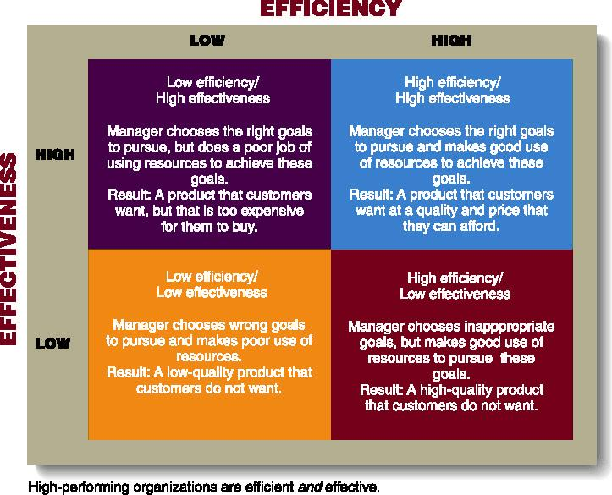
Four Functions of Management:
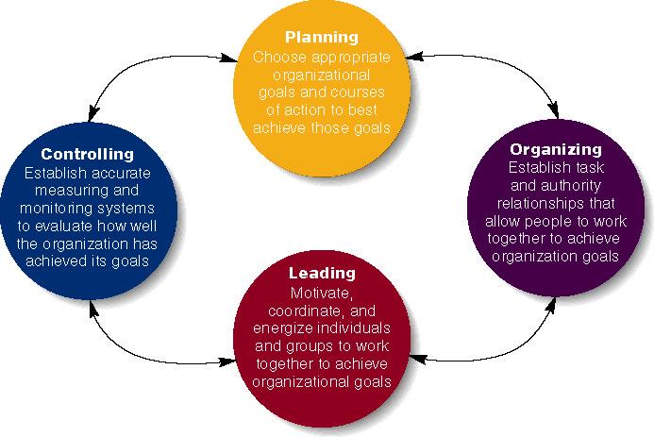
Planning- 3 Steps:
Which goals should be pursued? How should the goal be achieved? How should resources be allocated?
Planning function determines how effective and efficient the organization is and determines the strategy of the organization.
Strategic plans: set by top management, reflect decisions about recourse allocations, company priorities, and the steps needed to meet strategic goals.
Tactical plans: typically involve upper and middle management, they are shorter range plans concerned with implementing specific aspects of the strategic plan.
Operational plans: plans developed by middle and lower level managers that set short term targets for daily weekly or monthly performance.
Organizing- Mobilizing the resources that are required to complete a particular task. Managers create the structure of working relationships between organizational members that best allows them to work together and achieve goals (grouping people into departments, lay out lines of authority and responsibility for members).
Leading/Directing- involves interactions between managers and their subordinates as they both work to meet the firm’s objectives. Managers determine direction, state a clear vision for employees to follow, and help employees understand the role they play in attaining goals. involves a manager using power, influence, vision, persuasion, and communication skills. outcome of the leading function is a high level of motivation and commitment from employees to the organization
Controlling- process of monitoring a firms performance to make sure that it is meeting its goals. managers evaluate how well the organization is achieving its goals and takes corrective action to improve performance. Managers will monitor individuals, departments, and the organization to determine if desired performance has been reached, will also take action to increase performance as required.
Managerial Job Dimensions:
Demands: Activities or duties that must be carried out, standards or levels of minimum performance that must be met.
Constraints: Time, budgets, technology, attitudes of subordinates and legal regulations are all factors that limit the response of the manager.
Choices: Discretionary behavior- How work is to be done, What work beyond that absolutely required will be done, Who will do the work, What initiatives will be undertaken from almost infinite possibilities?
Project team manager-
DEMANDS: develop new product with strong market appeal,
CONSTRAINTS: 12 month deadline for product development.
CHOICES: The organizational structure of the project team, sequencing of project tasks, budget allocation
Fast Foods Restaurant Manager-
DEMANDS: Maintain attractive appearance of restaurant, Keep employee costs as low as possible, Meet standards for speed of service
CONSTRAINTS: Most employees have limited formal education, Federal and state health and safety regulations
CHOICES: Selection of employee to promote to supervisor, Scheduling of shifts and assignments, Local advertising promotions.
Management Levels:
Organizations often have 3 levels of managers:
First-line Managers: responsible for day-to-day operation. They supervise the people performing the activities required to make the good or service.
Middle Managers: Supervise first-line managers. They are also responsible to find the best way to use departmental resources to achieve goals.
Top Managers: Responsible for the performance of all departments and have cross-departmental responsibility. They establish organizational goals and monitor middle managers.
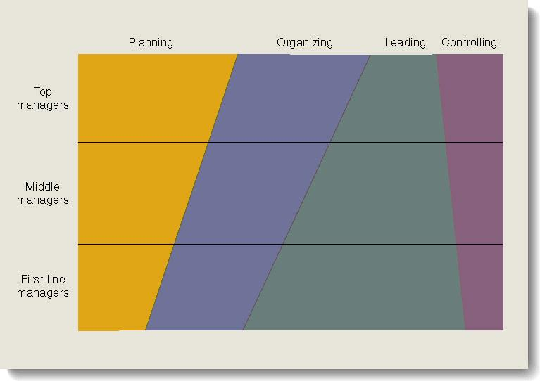
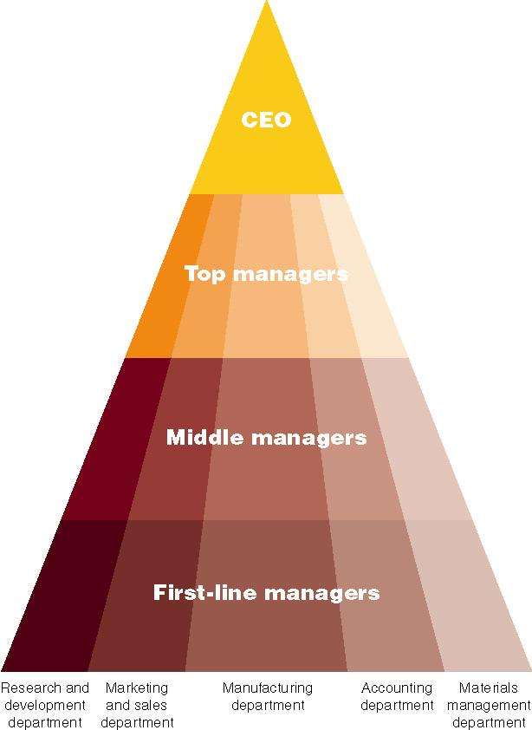
Areas of Management:
Marketing Managers- responsible for getting products and services to buyers
Financial Managers- responsible for managing a firms finances including investments and accounting functions.
Operations Managers: responsible for the production systems that create goods and services-
Human Resources Managers- provide assistance to other managers when they hiring training evaluating performance and determining compensation levels.
Information Managers- responsible for designing and implementing systems that gather, process and disseminate information.
Managerial Roles: Described by Mintzberg (A role is a set of specific tasks a person performs because of the position they hold)
Interpersonal roles- Roles managers assume to coordinate and interact with employees and provide direction to the organization.
Figurehead role: symbolizes the organization and what it is trying to achieve.
Leader role: train, counsel, mentor and encourage high employee performance
Liaison role: link and coordinate people inside and outside the organization to help achieve goals.
Informational Roles- Associated with the tasks needed to obtain and transmit information for management of the organization.
Monitor role: analyzes information from both the internal and external environment
Disseminator role: manager transmits information to influence attitudes and behavior of employees
Spokesperson role: use of information to positively influence the way people in and out of the organization respond to it.
Decisional Roles: Associated with the methods managers use to plan strategy and utilize resources to achieve goals.
Entrepreneur role: deciding upon new projects or programs to initiate and invest.
Disturbance handler role: assume responsibility for handling an unexpected event or crisis.
Resource allocator role: assign resources between functions and divisions, set budgets of lower managers
Negotiator role: seeks to negotiate solutions between other managers, unions, customers, or shareholders.
Managerial Skills
Technical Skills: skills associated with performing specialized tasks within a firm.
Human Relations Skills: skills in understanding and getting along with people.
Conceptual Skills: abilities to think in the abstract, diagnose and analyze different situations, and see beyond the present situation.
Decision-Making Skills: skills in defining problems and selecting the best courses of action.
Time Management Skills: skills associated with the productive use of time.
*All five skills are enhanced through formal education, training, and practice
Conceptual Human and Technical Skills Needed by Three Levels of Management:
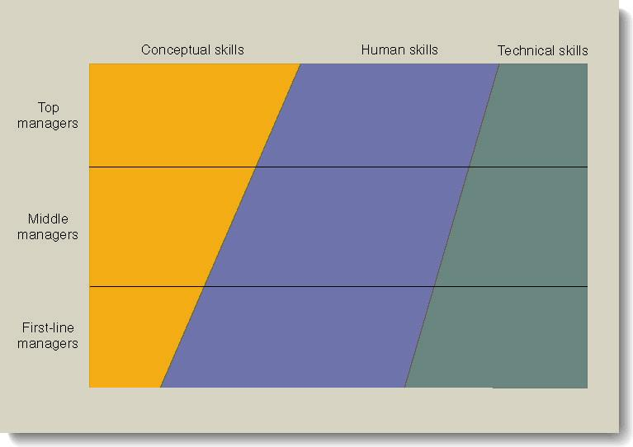
Challenges for Canadian Managers:
-Organizational Size
-The Types of Organizations
-The Political and Legal Climate
-Managing a Diverse Workforce
Management Challenges in a Global Environment:
-Increasing number of global organizations.
-Building competitive advantage through superior efficiency, quality, innovation, and responsiveness.
-Increasing performance while remaining ethical managers.
-Using new technologies.
The Building Blocks of Competitive Advantage: 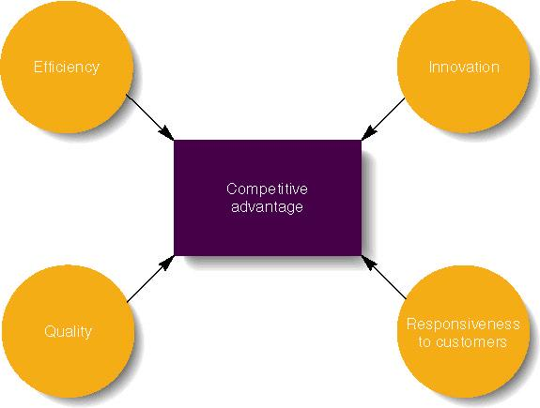
Levels of Strategies
Corporate-Level: Identifies the various businesses that a company will be in, and how these businesses will relate to each other.
Concentration: focusing the company on one product or product line.
Growth: Market Penetration- boosting sales of present products by more aggressive selling in the firms current market. Increasing current efforts in the market segment(s) where the firm already has a presence.
Geographic Expansion- expanding operations in new geographic areas or countries.
Product Development-new and improved products for current markets.
Integration options: Vertical integration-a firm strives to gain ownership of its suppliers or its retailers.
Horizontal integration-a firm strives to gain ownership of its competitors
Diversification Options: Related means adding new related products, Conglomerate means adding new unrelated products.
Investment Reduction: Reducing a company’s investments in one or more lines of its business. Retrenchment is reducing activity or operations, or retreating to core business. Divestment is selling or liquidating one or more of a firms businesses.
Business-Level (Competitive) Strategies:
Cost Leadership- Striving to have the lowest costs in the industry. Ex. Walmart.
Differentiation strategy- Firm tries to be unique in its industry, Volvo has safe cars, apple stresses user friendly computers, Mercedes-Benz emphasizes quality.
Focus strategy-Serving a particular market segment. May involve the use of one of the other generic strategies to serve the needs of the market niche more effectively.
Functional-Level: Identifies the basic courses of action that each department in the firm will pursue so that it contributes to the attainment of the business’s overall goals.
Contingency Planning and Crisis Management:
Contingency Planning- Identifying aspects of a business or its environment that might entail changes in strategy.
Crisis Management- Methods for dealing with emergencies that require immediate attention.

