Strategic management
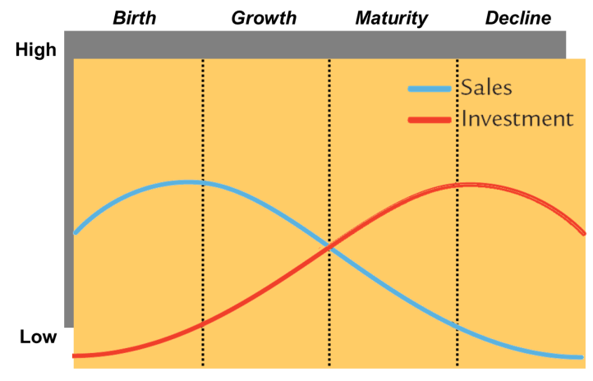
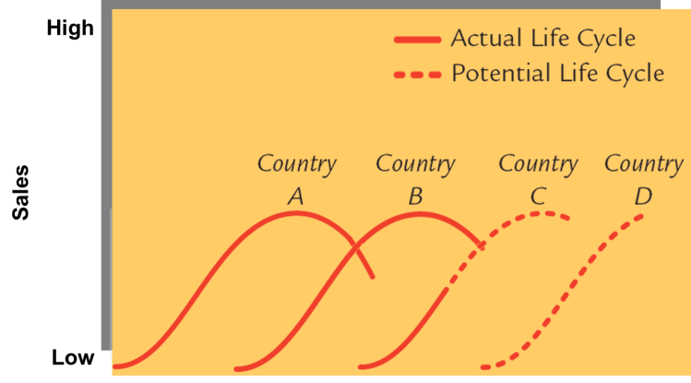
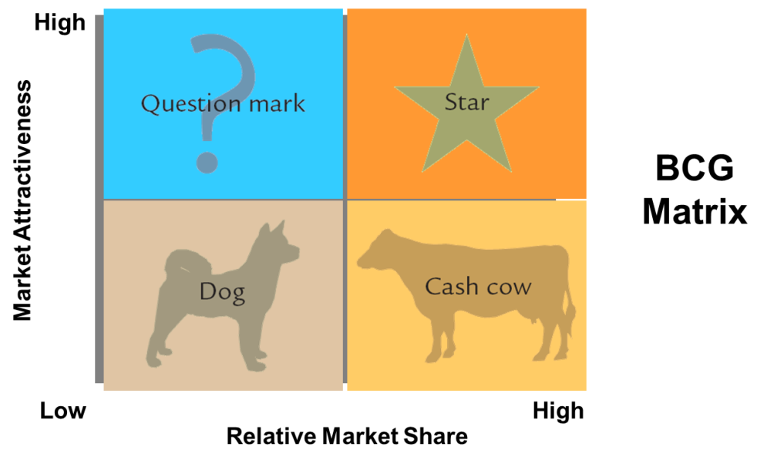
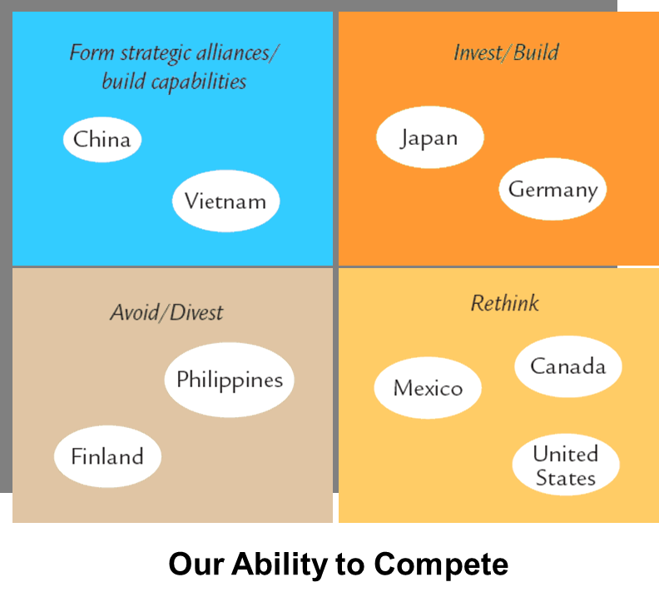
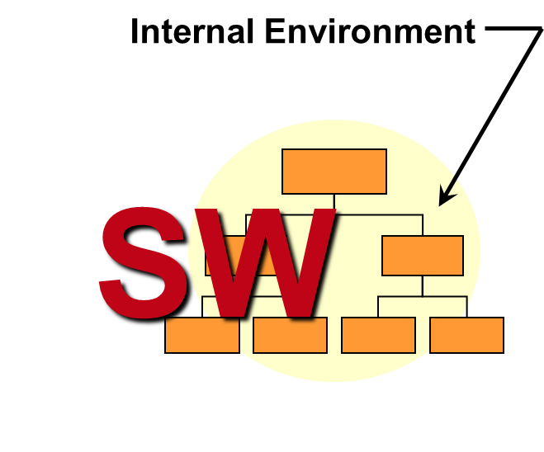
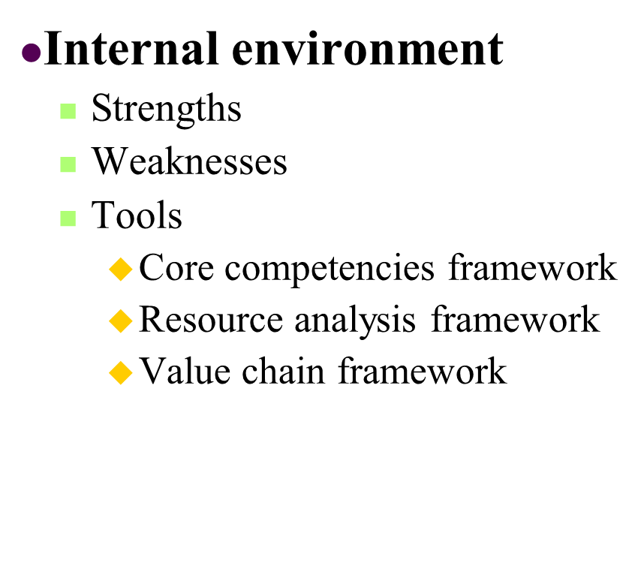
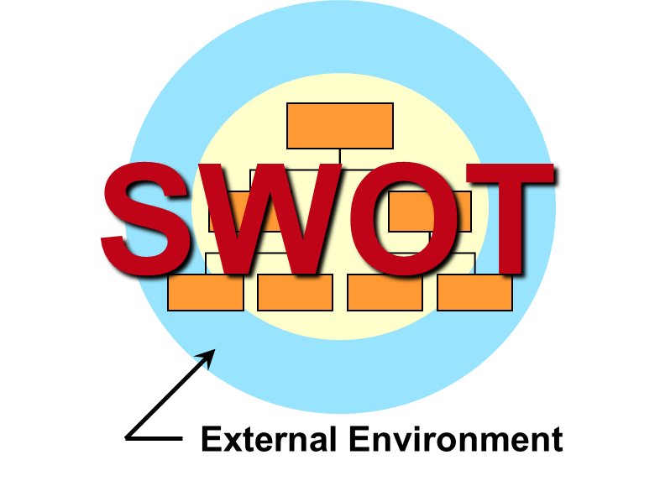
Competitive Advantage:
The ability of a firm to win consistently, i.e. gain greater profits than competitors, over the long term in a competitive situation.
Competitive advantage is created through the achievement of five qualities:
-Superiority
Are you significantly better than your competitors? At what things are you better?
-Inimitability
Managers must create barriers that make it hard for others to copy their superiority advantages
(size, culture, product design, marketing strategies, others)
-Durability
Legally protected (patents, copyrights, brand names), well established (brand image, reputation for quality).
-Non-substitutability
Can the customer’s need that you fulfill be met by alternative means? (Encyclopedias vs. information availability on the Internet) (Premium chocolate taste treat vs. that of premium ice cream)
-Appropriability
Can you actually capture the profits that can be made in the business?
Supernormal returns eg. profits that are above the average for a comparable set of firms, primarily a function of greater‑than‑average cost‑price margins
Strategic management process:
Setting Direction:
Strategic management process is a planning process in which managers
1. Set the organization's general direction and objectives
2. Formulate a specific strategy
3. Plan and carry out the strategy’s implementation
4. Monitor results and make necessary adjustments
Strategic vision: what the organization ultimately wants to be and do. General identity, direction and aspirations of the org.
Should paint a general picture of aspiration and create a strong emotional response in just a few words.
Mission statement articulates the fundamental purpose of the organization, and often contains several components:
-company philosophy
-company identity
-principal products or services
-customers and markets
-geographic focus
-obligations to shareholders
-commitment to employees
NOTE: While companies may have the same purpose, their mission may be different. Example:
the purpose of a consulting business is primarily to seek profit, the mission statement may be: “to provide affordable solutions to small and medium businesses...”
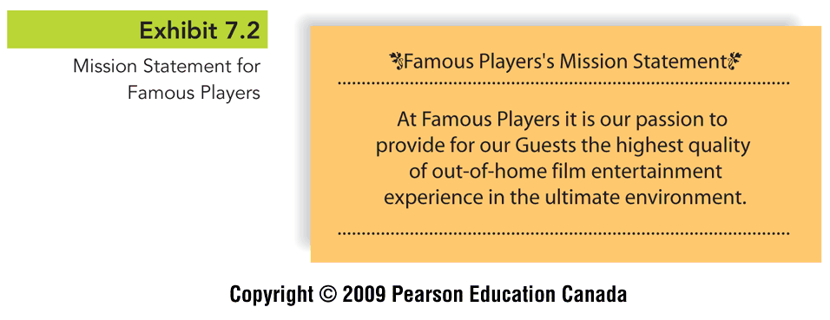
Strategic objectives translate the strategic vision and mission of the firm into concrete and measurable goals.(long term)
Facilitates a firm's ability to:
-Allocate resources appropriately
-Reach a shared understanding of priorities
-Delegate responsibilities
-Hold people accountable for results
Strategic objectives address many issues, such as:
Goals and Strategies:
Goals are performance objectives that a firm plans to achieve. They are the starting point of successfully managing a business. The planned method of reaching a goal is the “strategy”.
Purpose of setting goals:
-Provides direction, guidance and motivation
-Assists in allocating resources
-Helps to define corporate culture
-Helps managers assess performance
Goals are set for various time horizons:
Long-term (5+ years)
Intermediate (1-5 years)
Short term (less than 1)
Formulating a strategy:
Competitive strategy: determining how the company is going to compete and achieve its strategic objectives, mission, and ultimate strategic vision
Generic Strategies: cost leadership, differentiation, scope.
Formulating Strategy
Environmental analysis, organizational analysis. SWOT analysis (internal: strengths and weaknesses) (external: opportunities and threats)
Final step in strategy formulation:
-matching company strengths to environmental opportunities
- minimizing the impact of threats and company weaknesses
Integrating Internal and External Analyses: Product Life Cycle:
The steepness and height of the product life cycle line during growth are a function of how quickly and widely consumers accept the product. The mature stage of the product life cycle occurs when:
- product is yielding its greatest profits
- managers are thus least likely to realize they better have plans for another product, or to take the current one to other markets
New product features and switching costs are key determinants in how steep an existing product’s decline will be.
(The key to success for this strategy is managers’ abilities to correctly identify countries whose sociocultural, technological, economic, and political conditions match the product, and to identify any modifications that could be accomplished economically that would enhance its acceptance in a particular country.)
Portfolio analysis is easy to explain, once the two dimensions or axes have been understood. A company’s first step is to determine where various products are in their life cycle, and then create strategic plans as to where the firm ought to invest.
integrative analysis techniques:
Strategy Implementation:
Seven S’s
1. Strategy
-Plan course of action
-Allocation of firms resources to reach goals
2. Structure
-Basic grouping of reporting relationships and activities
-linking of separate organizational entities
3. Shared values
-Significant meanings or guiding concepts
4. Systems
-Formal processes and procedures
-the way people relate to them
5.Skills
-organizational competencies
-other capabilities residing in the organization
6. Style
-Leadership style of management
-operating style of the organization
-relfection of the norms people act upon
7. Staff
-Recruitment
-Selection
-Development
-socialization
-advancement of people in the organization
Evaluation:
-Annual or even quarterly organizational performance evaluations
-Strategic results by senior managers and operational results by lower-level managers
-Reinforce efforts making positive contribution to results and correct those that are not
  - Revenue growth
  - Profitability
  - Customer satisfaction
  - Market share
  - Financial returns (e.g., return on equity, return on assets)
  - Technological leadership
  - Cash flow
  - Operating efficiency (e.g., costs per unit, expense per employee)

Niche player with average prices and below-average costs that focuses on a segment of customers or a specific geography.
Example: Columbia Sports
Niche player with average costs but commanding premium prices that focuses on the high end and customers in a general or specific geography.
Example: Morgan Motors
General player whose product or service features command premium prices and whose costs are at the industry average.
Example: Sony
General Focused
Scope
General player whose product or service features command industry average prices but whose costs are significantly below the industry average.
Example: Wal-mart
Differentiation Cost -leadership
Strategy
- External environment
  - Opportunities
  - Threats
  - Tools
    - Product life cycle analysis
    - Portfolio analysis
    - Five forces framework
Strategy as a Pattern
-Intended Strategies
Rational, conscious plans of action
Conceived using the strategic management process
-Emergent Strategies
Evolve from behaviors and actions that have had positive consequences

