Chapter 1
Organizational Behavior and Management

Organizations: Social inventions for accomplishing common goals through group effort
(Human behavior, how to manage people, what it exist for, how to bring people together to accomplish goals)

Organizational Behavior: The attitudes and behaviours of individuals and groups in organizations.

Goals of the Field: OB is concerned with Predicting, Explaining and Managing people’s behavior in the context of work.
(Understand why people behave in a certain way)

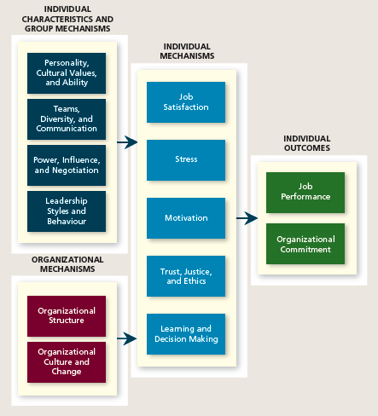

Management is the art of getting things accomplished in organizations through others.
(Managing & Leadership
Managing – kind like view people as machine
Leadership – inspire people (at the same time, maintain the loyalty))

Early Prescriptions Concerning Management
The Classical View: (focus of productivity, technical strategies)
- Strict chain of command
- Technical competence
- Detailed rules, regulations, and procedures
- High specialization
- Centralization of power
(Three types of skills: technical skills, human skills, conceptual ability)
The Human Relations View: (make sure people get along with each other to get better performance)
- Employee alienation
- Limits innovation and adaptation
- Resistance to change
- Minimum acceptable level of performance
- Employees lose sight of the overall goals of the organization
(Start to pay attention to human, e.g. increase/ decrease lighting or heating have influence on employees and productivity)
The Contingency View: (how you can manage people, evaluate the situation individually)
- The contingency approach to management recognizes that there is no one best way to manage.

What do Managers Do?
Informational Roles: Monitor, Disseminator, Spokesperson
Interpersonal Roles: Figurehead, Leader, Liaison
Decision Roles: Entrepreneur, Disturbance handler, Resource allocator, Negotiator

Summary of Managerial Activities:
  - Exchanging Information
  - Handling Paperwork
  - Planning
  - Decision Making
  - Controlling
  - Interacting with Outsiders
  - Socializing/ Politicking
  - Training/ Developing
  - Staffing
  - Motivating/ Reinforcing
  - Managing Conflict

Managerial Minds
Experienced managers use intuition to guide many of their actions:
- To sense that a problem exists
- To perform well-learned mental tasks rapidly
- To synthesize isolated pieces of information and data
- To double-check more formal or mechanical analyses
- GRIP

International Managers
- National culture is one of the most important contingency variables in organizational behaviour.
- The management style and emphasis given to various activities varies greatly across cultures.
- Cultural variations in values affect both managers’ and employees’ expectations about interpersonal interaction.

Management Practices of the Best Companies to Work for in Canada
- Flexible work schedules
- Stock-options, profit-sharing, and bonuses
- Training and development programs
- Family assistance programs
- Career development programs
- Wellness and stress reduction programs
- Employee recognition and reward programs

Chapter 2
Job Performance

Job Performance is Behavior, under employees’ control, contributes positively or negatively, to organizational goals
(Output – Quantity & Quality)

What is Job Performance?
Task Performance
- Behaviours that are directly involved in the transformation of resources into the goods or services
- Included in a job description
- Routine, adaptive and creative
Organizational Citizenship Behaviors
- Voluntary activities that contribute to the organization by improving the work setting
- Interpersonal
- Helping
- Courtesy
- Sportsmanship
- Organizational
- Voice
- Civic virtue
- Boosterism
(If the people are able to do things beyond the job requirement, that is organizational citizenship behavior (positive behavior, not part of job description))
Counterproductive Work Behaviors
- Counterproductive Work Behaviors:
- Behaviours that intentionally hinder organizational goal accomplishment
- Interpersonal
- Organizational

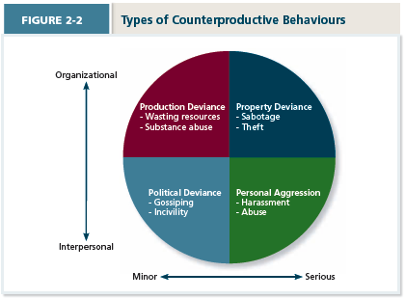

Chapter 3
Organizational Commitment

Organizational Commitment: The desire to remain a member of the organization.
Withdrawal Behavior Low, Organizational Commitment High
Withdrawal Behavior High, Organizational Commitment Low

(Voluntary/ Involuntary Reason to leave the company.
High commitment – stay in the company
Low commitment – leave the company)
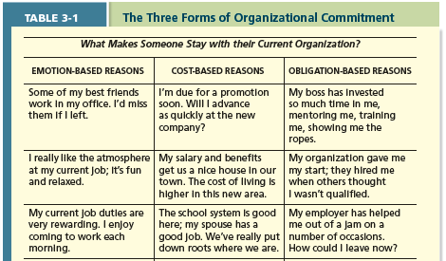

(I. Emotion-Based Reasons: trustworthy friendship, atmosphere, enjoyable working environment
II. Cost-Based Reasons:
III. Obligation-Based Reasons:

I. Affective Commitment: Positive, Stay because they want to
Erosion Model: More intend to leave the company because of fewer friends
Social Influence Model: Diffusion – Friends leave cause sb. Leave
II. Continuance Commitment: Negative, Do not have another choices, to see whether stay is the best choice
III. Normative Commitment: Positive, have obligation to stay in the company (ethical, moral)
Feeling of obligation to remain loyal
Staying because you ought to
Organization’s investment in employees

Reactions to Difficult Situations
Voice & Loyalty – High Commitment
Neglect & Exit – Low Commitment

Types of employees:
- Star: high level of commitment, have knowledge to deal with different situation, use voice, opinion leader
- Citizens: highly commitment, significant value because beyond their responsibilities, voluntary aspects, not wisely concerned as stars, but still loyal
- Lone Wolves: commitment may not high, for themselves, high performance but lack attachment with organization, may leave
- Apathetic: commitment low, minimum effort, will leave

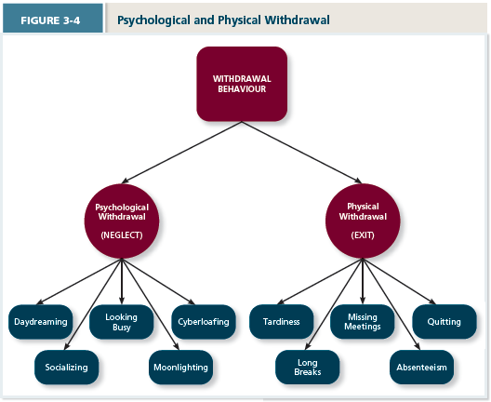

Commitment and Employment Relationships
Psychological contracts: know what people should be getting and return
- Two forms of psychological contracts:
- Relational contracts: Compensation (working relationship) (without it people will eventually leave), get relational return
- Transactional contracts: Benefit
- The impact of downsizing
(Reduce the size of labor force, key point (let people know the signal and what you value, what is expected), people will lose motivation

Summary
- Voluntary turnover is costly
- Three types of commitment (Affective, Continuous, Normative)
- Affective commitment linked with ‘best’ outcomes (emotion-based)
- Strong continuance commitment can “hurt” the organization
- Low commitment withdrawal behaviours (Psychological, Physical)
- Important factor that influences commitment: employee-employer relationship (People like you or not, help build the organizational culture)

Chapter 4
Job Satisfaction

Job Satisfaction: A collection of attitudes that workers have about their jobs.
(Beyond compensation, know what they want)

What Determines Job Satisfaction?
Discrepancy: (psychological contracts, people get what they want)
Fairness: (equity)
Disposition:
Mood and emotion:

Facets of Satisfaction: different elements of the job, have different views towards elements
- Pay
- Promotions
- Supervisors
- Coworkers
- Work tasks (work itself)

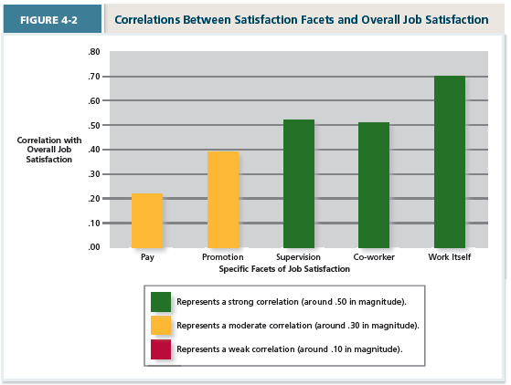

Key Contributors to Job Satisfaction
Mentally challenging work: Important when job is engaging
Adequate compensation:
Career opportunities: chance to prove yourself
People: relationship

What Determines (Overall) Job Satisfaction?
- Disposition
- Value fulfillment (“value-percept theory”)

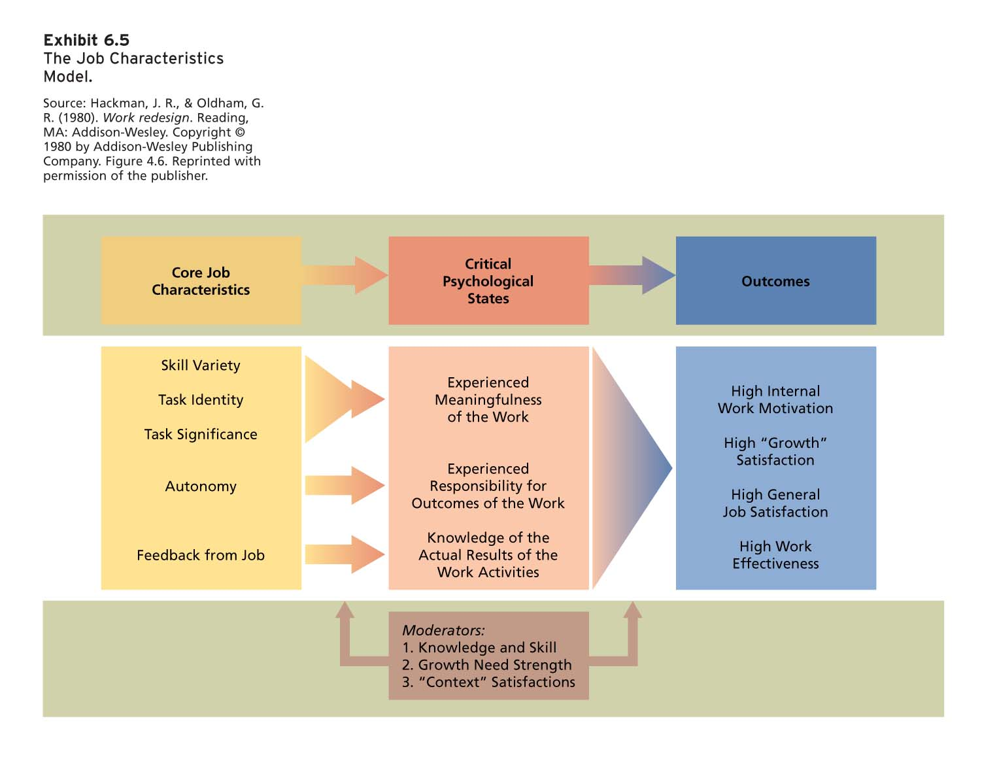
(Skill variety: multiple skills, more – engaging
Task identity: how their individual job contributes to the organization
Task Significance: how the task/ job itself important
Autonomy: freedom, have control on their job
Feedback from the Job: Things like potential to improvement)

Consequences of Job Satisfaction
- Job satisfaction has a number of consequences:
- Less Absence from work (Enjoy the work)
- Less Turnover (e.g. Compensation)
- High Performance
- Easy to See Organizational citizenship behaviour (Voluntary behaviour)
- Customer satisfaction and profit (People more satisfy, maintain quality and standards)

Moods and Emotions
- Moods and emotion differ
- Length of time
- Intensity
- Whether they have a target
- Both can vary over the course of a day
- Both can influence one’s job satisfaction (e.g., on a given day)

- Emotional labour
- Should organizations require emotional labour?
- Emotional contagion

Changing Attitudes
Goldstein and Sorcher recommend three techniques for teaching new behaviours:
- Modelling of correct behaviours (Tell them what to do, more behavioural statements)
- Role-playing of correct behaviours
- Social reinforcement

Chapter 5
Stress
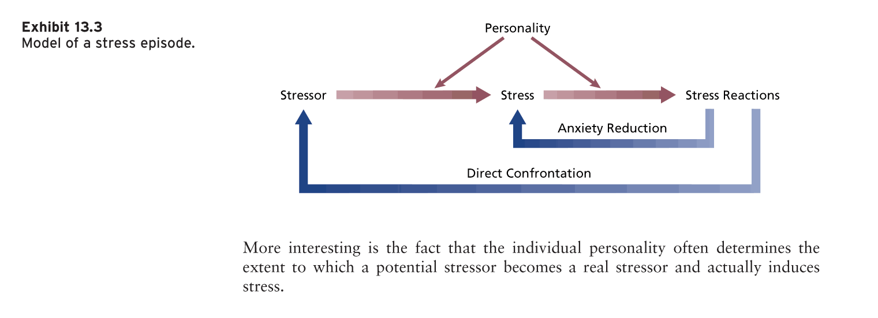
(People feel they are not capable of handling this situation.
Environmental stressor, Organizational Stressor)

Personality determines how to deal with it.
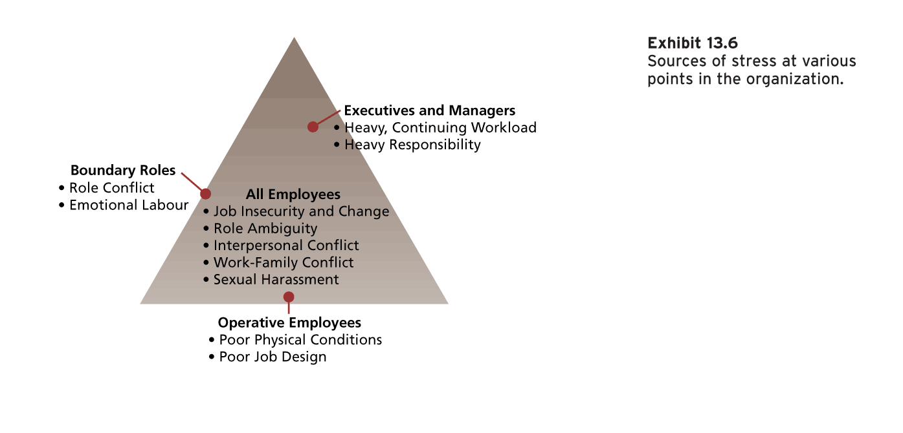
(Not get along with person around- interpersonal conflict
Boundary Roles – Investors, Media, Volunteers)

Work Hindrance Stressors
- Role overload (work load)
- Role conflict
- Role ambiguity
- Work constraints
- Lack of control – without autonomy and flexibility to control
- Work conditions – psychological / physical environment
- Interpersonal conflict – disagreement / miscommunication
- Sexual and psychological harassment
- Daily hassles – everyday little things

Work Challenge Stressors
- Time pressure – capable but not enough time
- Work complexity – complicated
- Work responsibility – not able to reach the goal you set

Non-Work Hindrance Stressors
- Negative life events – things unpleasant so that you cannot concentrate
- Financial uncertainty – no confidence to pay in the long run
- Work-life conflict

Non-Work Challenge Stressors
- Family (friends) time demands
- Positive life events
- Personal development

Reactions to Stress – Strain: the reactions of people who experience organizational stress can be divided into three types:
Psychological reaction
- Anger
- Anxiety
- Frustration
- Depression
- Job dissatisfaction
- Reduced affective commitment
- Difficulty concentrating
- Denial of stressor

- Burnout (extreme psychological strain)
  - Emotional exhaustion
  - Cynicism
  - Low self-efficacy

Physical (physiological)
- Dizziness
- Headache
- Pounding heart
- Stomach distress
- Difficulty sleeping
- Shortness of breath
- Illness and death

Behavioral
- Accidents at work
- Performance changes – lose motivation
- Substance abuse (inc. smoking)
- Absenteeism &Turnover
- Aggression (retaliation) – damage / steal company poverty
- Other counterproductive work behaviours

Reducing & Managing Stress
- Work planning (“family-friendly policies”)
- Decreased/compressed workweek
- Personal days/hours
- Job sharing/Part-time work
- Flextime
- Flexplace/Telecommuting
- Other practices
  - Employee Assistance Programs (EAP)
    - Stress management
    - Time management
    - Rehabilitation
  - On-site daycares or daycare subsidies
  - Gym memberships
  - Connections to health specialists
  - Others

