Module 2: Using the Internet: Making the Most of the Web's Resources
History of the Internet
- Developed for secure military communications
- Evolved from Advanced Research Projects Agency Network (ARPANET)
- Funded by the U.S. government in the 1960s
- Enabled computers at leading universities and research organizations to communicate with each other
The Web vs. the Internet
- The web is part of the internet, distinguished by
  - Common communication protocols
  - Navigation links
- 1989: Web invented by Tim Berners-Lee.
- 1993: Mosaic browser released.
- 1994: Netscape Navigator marked beginning of the web’s major growth.
- 1997: Internet access was global.
Internet Communications
Forms of Internet-based communication include:
- Email
- Instant messaging
- Group communication
- Social networking
- Web logs and video logs
- Wikis
- Podcasts
- Webcasts
Email
- Electronic mail
- Asynchronous communication
- Types of email accounts
  - Client-based (requires client email software)
  - Web-based (does not require software)
- Not private
  - Can be printed or forwarded
  - Can be monitored by employers
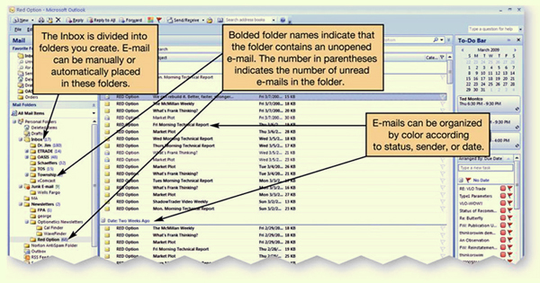

Email Etiquette
- Be concise and to the point
- Use spell-check
- Avoid texting abbreviations
- Include meaningful subject line
- Use smilies (emoticons) sparingly to convey emotion
- Include signature line with contact information
- Do not type in all capital letters, which is interpreted as shouting.

Instant Messaging
- Instant messaging (IM) uses real-time text-based conversations, similar to chat rooms.
- Users set up a list of contacts, often called a buddy list.
- Contacts must be online to participate.
- IM software detects the presence of members who are online.
- Examples include:
  - AOL Instant Messenger
Group Communication
There are many ways you can interact with a wide variety of people online.
- Chat rooms
- Newsgroups
- Blogs and vlogs
- Wikis
- Podcasts and webcasts
- Social networks

Chat Rooms and Newsgroups
- Chat rooms
  - Real-time, text-based conversations
  - Can focus on specific topics or interests or be general interest
  - Username can allow anonymous interaction
- Newsgroups
  - Online discussion forums
  - Members post and reply to messages
  - Create or respond to “threads”

Netiquette
- Introducing yourself when entering a chat room
- Specifically address the person to whom you are talking
- Refrain from swearing, name-calling, and using explicit or prejudiced language
- Do not post the same text repeatedly with the intent to disrupt the chat, a behaviour called flooding.

Web 2.0
- Web interactions among people, software, and data
- Social web where the user is also a participant
- New applications that combine the functions of multiple applications

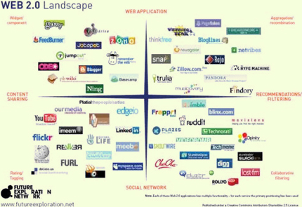
Social Networks
- Used to communicate and share information among immediate friends, and meet and connect with others through common interests, experiences, and friends
Examples:
  - MySpace.com
  - Facebook.com
- Members communicate by voice, chat, IM, and videoconference.
- Growth has been explosive.

Blogs and Vlogs
- Personal journals posted on the Web
- Weblogs (blogs):
  - Primarily text-based
  - Simple to create, read and manage
  - Entries listed on a single page, with most recent entry at the top
  - Searchable
- Video blogs (vlogs):
  - Digital video clips playable on media player software
Wikis
- Wikis: Websites that allow anyone to edit/change their content
  - Provide a source for collaborative writing
  - Eliminate exchanging emails
  - Track revisions
Podcasts
- Podcasts: Compressed audio or video files distributed on the internet
- Really Simple Syndication (RSS) technology allows constant updates for subscribers
- Podcasts are all over the Web.
  - Need aggregator software to gather podcasts
  - Need media player software to play them
- Simple to create
Webcasts
- Webcasts: Broadcasts of audio or video content over the internet
  - Often live
  - Delivered to your computer
  - Use streaming media
Twitter
- Social networking and micro-blogging service that enables you to exchange short text messages in real time with your friends or “followers”
- Twitter messages, called tweets, are limited to 140 characters.
- Businesses are using Twitter to respond to customer queries, or to broadcast new services or products.

Web Entertainment
- Multimedia is anything that involves one or more forms of media in addition to text.
  - All kinds of multimedia are available on the Web and involve forms of media and text.
    - Graphics
    - Audio
    - Video
  - Streaming audio and video can deliver on-demand pictures and sounds. Sites like CNN.com offer clips from their broadcasts.
- Games
  - Multiplayer online games
  - Interact with other players
E-Commerce
E-commerce grows in importance every day, with billions of dollars worth of transactions.
- In business-to-consumer (B2C) transactions, such as amazon.com, the end buyer purchases goods or services over the Internet.
- In business-to-business (B2B) transactions, businesses sell to one another.
- In consumer-to-consumer (C2C) transactions, like ebay.com, consumers sell to one another.
Secure Websites
- Online transactions can be safer than traditional retail shopping.
  - VeriSign is a company that certifies that online transactions are secure. Businesses hire security companies such as VeriSign to certify that their online transactions are secure. Thus, if a website displays the VeriSign seal, you can usually trust that the information you submit to the site is protected.
  - Another indication that a website is secure is the appearance of a small icon of a closed padlock (IE) or key (Netscape) on the status bar at the bottom of the screen.
- Additionally, the beginning of the URL changes from http:// to https://, the s standing for “secure.”

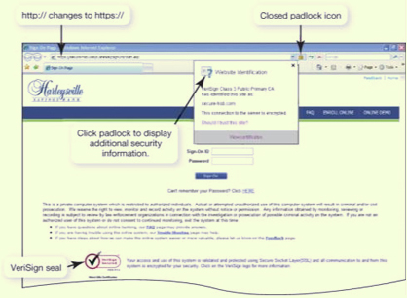
Online Shopping Guidelines
To shop safely online, follow these guidelines:
- Shopping at well-known, reputable sites helps ensure a safe shopping experience. If you are not familiar with a site, check it out with the Better Business Bureau, and also make sure that the company has a phone number and street address before ordering from it.
- Avoid making online transactions when using public computers.
- Pay by credit card, not debit card. Debit cards do not have the same level of protection as credit cards under U.S. federal consumer credit card protection laws. Use a card with a small limit, or consider using a pre-paid credit card.
- Check and print out the return policy. You may need it when filing a complaint to prove what the policy showed at the time of your order. Websites can be changed easily and rapidly and can also be shut down overnight.
Web Browsers
- A Web browser is software installed on your computer system that allows you to locate, view and navigate the Web.
- Graphical
- Enable web navigation
- Popular browsers:
  - Microsoft Internet Explorer
  - Mozilla Firefox
  - Apple Safari
  - Google Chrome
Browser Features
- Quick tabs show thumbnail images of all open web pages in open tabs.
- With tabbed browsing, web pages are loaded in “tabs” within the same browser window. Rather than having to switch between web pages on several open windows, you can flip between the tabs in one window.
- The browser also includes a built-in search box in which you can designate your preferred default search engine. Tools for printing, page formatting and security settings are allocated to a special toolbar.
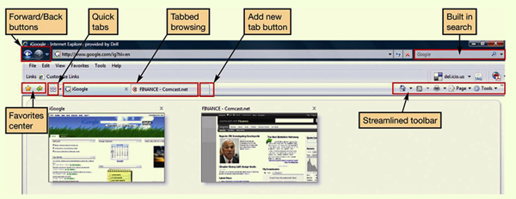

URLs
- A URL is a website’s address. It is composed of several parts that help identify the Web document it stands for.
  - Uniform Resource Locator
  - Unique Web site address
- The first part of the URL indicates the set of rules (or the protocol) used to retrieve the specified document. HTTP is most common. Another popular protocol is FTP.
- The protocol is generally followed by a colon, two forward slashes, www (indicating World Wide Web), and then the domain name. The domain name is also referred to as the host name. At times, a forward slash and additional text follow the domain name. The information after the slash indicates a particular file or path (or subdirectory) within the website.
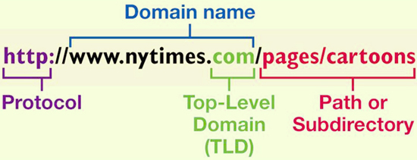

Top-Level Domains
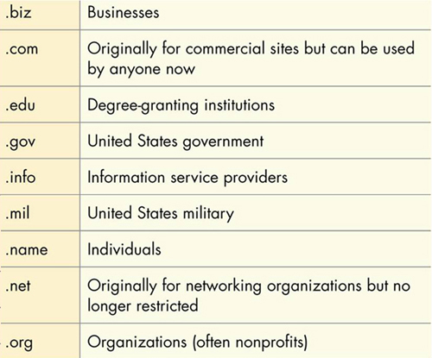
Hyperlinks
- Once you’ve reached a website, you can jump from one web page to another within the website or to another website altogether by clicking on specially coded text called hyperlinks.
- When programming HTML, the web page author can code any word or image to be a hyperlink.
- Generally, text that operates as a hyperlink appears in a different color (often blue) and/or is underlined. Sometimes images also act as hyperlinks.
- When you pass your cursor over a hyperlink, the pointer turns from an arrow into a hand. To retrace your steps, some sites also provide a breadcrumb list — a list of pages within a website that you have visited that usually appears at the top of a page.
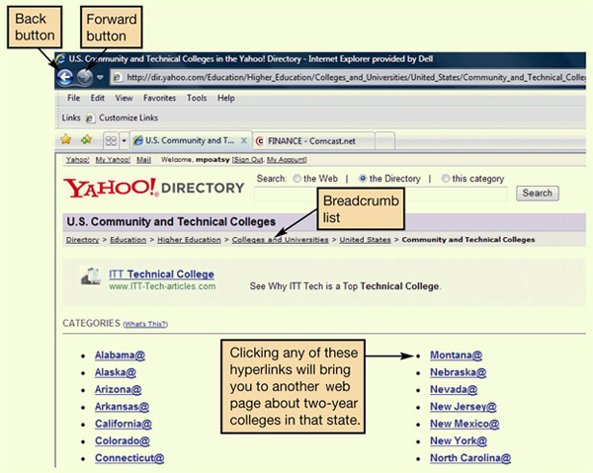

Favorites and Bookmarks
- Allow you to return to web pages
  - IE and Safari = Favorites
  - Firefox and Chrome = Bookmarks
- Stay up to date
  - Live bookmarks (Firefox)
- Organize and share
  - Social bookmarking sites: Websites such as del.icio.us and digg.com provide proprietary toolbars and tagging tools that incorporate into your Web browser and allow you to tag and organize websites using your own keywords.
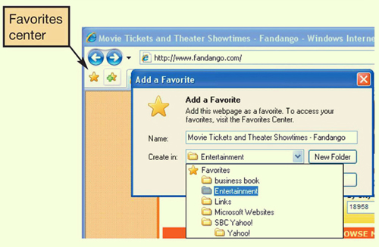

Popular Search Sites

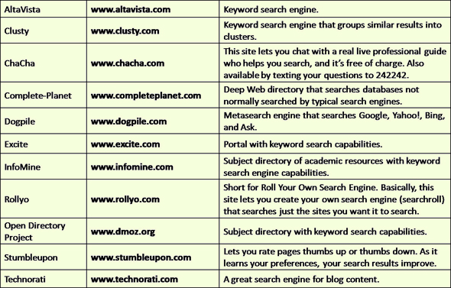

Search Engines
- User types word or phrase into search box.
- Spider or web crawler program scans web pages.
- Results are indexed and sent to the client.
- Different engines produce different hit lists.
- Multimedia search functionality is also available.

Improve Search Results
- Place quotation marks around phrases
- Search within a specific web site
- Enter wild card symbols
- Use the advanced search form

What Can You Borrow from the Web?
- Avoid
  - Plagiarism: Representing someone else’s ideas or words as your own
  - Copyright violation: Using another person’s material for your own economic gain
- Properly credit information you quote or paraphrase
- Obtain written permission from copyright holder

Evaluating Websites
Evaluating the content of a website is important. Before you believe what the site says or take action based on the information presented, several questions need to be answered.
- Who is the author of the article or website sponsor?
- Is the site biased?
- Is the information current?
- Toward what audience is the site geared?
- Are links available?
The same information should exist on at least three different web sites.
Internet Clients and Servers
- The internet is a client/server network.
- Thus, a computer connected to the Internet acts in one of two ways:
  - Client computer
    - Users connected to the internet
    - Requests data and web pages
  - Server computer
    - Stores web pages and data
    - Returns the requested data to the client
- Internet backbone
- IP addresses are the means by which all computers connected to the Internet identify each other.
Connecting to the Internet
To take advantage of the resources the Internet offers, you need a means to connect your computer to it. Home users have several connection options.
Originally, the only means to connect to the Internet was with a dial-up connection. With dial-up connections, you connect to the Internet using a standard telephone line.
However, other connection options, collectively called broadband connections, offer faster means to connect to the Internet. Broadband connections include:
DSL
Cable
Fiber-optic service
Satellite

Broadband Connections
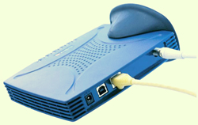
Cable modem
- Cable Internet
  - Uses coaxial cable and a cable modem
  - Fast connection speed
  - Speed depends on number of users
  - Not available in all areas
- Digital Subscriber Line (DSL)
  - Uses telephone lines
  - Faster than dial-up
  - Does not tie up phone line.
  - Requires special DSL modem
  - Not available in all areas
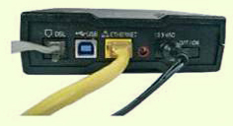
DSL modem
- Satellite
  - Uses satellite dish and coaxial cable
  - Slower than cable or DSL
  - Expensive

Wireless Access
- Increases mobility and productivity
- Requires a Wi-Fi hotspot
- If device is not wireless-ready, wireless adaptors are available.
- Aircards provide wireless access through mobile devices when a Wi-Fi hotspot is not available.

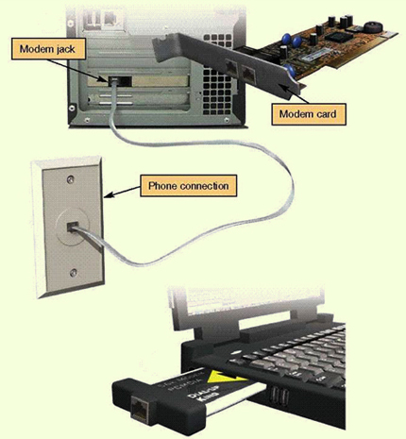
Dial-Up Connections

- Use standard telephone line
- Tie up phone line
- Require a modem to convert analogue and digital signals
- Slowest connection speed (56 Kbps)
- Lowest cost
- Modern computers have internal modems built into the system unit.

Comparing Internet Connection Options
- DSL
  - Average download speed of 1.5 Mbps
  - Maximum download speed of 7 Mbps
  - Lets you access the internet and talk on the same phone line simultaneously
  - Speed drops as you get farther from the phone company's central office
  - Not available on every phone line
- Cable
  - Average download speed of 5 Mbps
  - Maximum download speed of 30 Mbps
  - Speeds are not dependent on distance from central office
  - Line is shared with others in the neighborhood
  - Speeds may vary due to peak/non-peak usage
  - Might require professional installation if cable is not already present
- Fibre optic
  - Average download speed of 20 Mbps
  - Maximum download speed of 50 Mbps
  - Increased speed
  - Service not shared or dependent on distance from central office
  - High cost, but becoming lower as the technology continues to be deployed
  - Not available in all areas

Future of the Internet
- Large scale networking (LSN)
  - Research and development of cutting-edge networking and wireless technologies
- Internet2
  - Project sponsored by universities, government, and industry to develop new internet technologies
  - Internet2 backbone supports transmission speeds of up to 8.8 gigabits per second.
- Internet entrenched in daily life
- Web-based services for personal and professional interactions
- Internet-enabled appliances and systems

Summary Questions
- What is the origin of the internet?
- How can I communicate through the internet?
- How do I communicate and collaborate using web 2.0 technologies?
- What are the various kinds of multimedia files found on the web, and what software do I need to use them?
- What is e-commerce, and what e-commerce safeguards protect me when I am online?
- What is a web browser, and what is a URL and what are its parts?
- How can I use hyperlinks and other tools to get around the web?
- How do I search the internet effectively, and how can I evaluate websites?
- How does data travel on the internet?
- What are my options for connecting to the internet?

