Chapter 7 – Data Bases and Data Warehouses

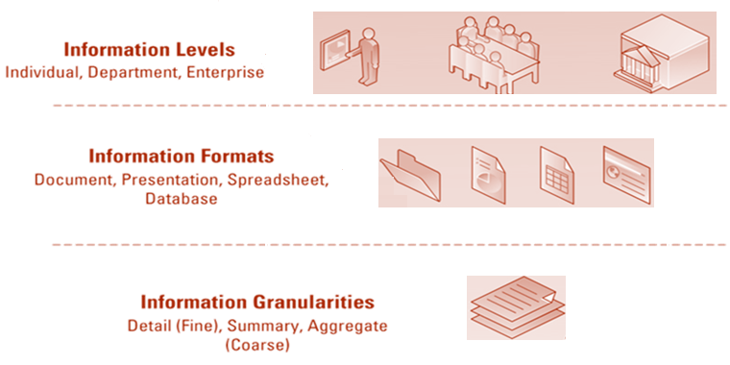
Granularity: the extent of detail within the data and information. Coarse granularity would be highly summarized data.

Real-time data: immediate, up-to-date data.

Real-time information: immediate, up-to-date information.

Real-time system: provides real-time transactional data and or real-time analytical information in response to query requests.

- Business decisions are only as good as the quality of the info used to make them
- Good decisions can directly impact an organization's bottom line

Low Quality Info

Issues with low-quality data: missing data, incomplete data, inaccurate data, duplication of data, and wrong data.

High quality info must be: Accurate, Complete, Consistent, Unique and Timely.

The four primary sources of low-quality info include:
  - Online customers intentionally enter inaccurate info to protect their privacy
  - Data or info from different systems have different entry standards and formats
  - Call centre operators enter abbreviated or erroneous info by accident or to save time
  - Third party and external info contains inconsistencies, inaccuracies, and errors

For customer-facing processes, potential business effects resulting from low quality info include:
  - Inability to accurately track customers
  - Difficulty identifying valuable customers
  - Inability to identify selling opportunities
  - Marketing to nonexistent customers
  - Difficulty tracking revenue due to inaccurate invoices
  - Inability to build strong customer relationships
Database: maintains data about various objects.

Hierarchical database model: data are organized into a tree-like structure that allows repeating data using patent/child relationships; in such a way that it cannot have too many relationships.

Network database model: a flexible way of representing objects and their relationships.

Relational database model: a type of database that stores data in the form of logically related two-dimensional tables.

Entity: a person, place, thing, transaction or event about which data are stored.

Entity class: a collection of similar entities.

Attributes: characteristics or properties of an entity class. Ex: for a customer an attribute could be Customer ID, customer name, Phone.

Primary Key: a field that uniquely identifies a given entity in a table. They are important because they provide a way of distinguishing each entity in a table.

Foreign key: primary key of one table that appears as an attribute in another table and acts to provide a logical relationship between the two tables.

Data warehouse: a logical collection of information - gathered from many different operational databases - that supports business analysis activities and decision-making tasks. The primary purpose of a data warehouse is to aggregate information throughout an organization into a single repository for decision-making purposes.
- A DW is an aggregation of an organization’s data gathered from many sources (ERP, SCM, CRM, website, external sources, etc.)
- A DW provides a platform of consolidated, historical data for analysis
- A DW is an important asset for the organization to maintain efficiency, profitability & competitive advantage

Database advantages

1. Increase Flexibility
- Physical view: deals with the physical storage of data on a storage device such as a hard sick.
- Logical view: focuses on how users logically access data to emet their particular business needs.

2. Increases scalability and performance
- Scalability: how well a system can adapt to increased demands.
- Performance: measures hw quickly a system performs a certain process or transaction.

3. Reduced data redundancy
- Redundancy: duplication of data or storing the same data in multiple places.

4. Increases data integrity
- Data integrity: measure of the quality of data.
- Integrity constraints: rules that help ensure the quality of data.
- Relational integrity constraints: rules that enforce basic and fundamental data constraints.
- Business-critical integrity constraints: enforce business rules vital to and O’s success and often require more insight and knowledge than relational integrity constraints.

5. Increased data security

Database Management System: software through which users and application programs interact with a database.

Data-driven website: interactive Web site kept constantly updates and relevant to the needs of its customers through the use of database.

Integration: allows separate systems to communicate directly with each other.

Forward integration: takes data entered into a given system and sends it automatically to all downstream systems and processes.

Backward integration: takes data entered into a given system and sends it automatically to all upstream systems and processes.

Data Warehouse Fundamentals

Data warehouse: logical collection of analytical information gathered from many different operational databases that support business analysis activities and decision-making tasks.

- Subject-oriented: information is organizes around major subject areas of the company.
- Integrated: information is gathered into a data warehouse from a variety of operational data sources and merged into a coherent and consistent whole.
- Time-variant: all information in a data warehouse is time-stampled with a particular time period.
- Non-volatile: information in a data warehouse is stable and once loaded never changes.
Information cleansing or scrubbing: a process that weeds out and fixes or discards inconsistent, incorrect, or incomplete information. Software tools use sophisticated algorithms to cleanse and scrub the info.

ETL (Extract, Transform & Load) - set of processes by which data is extracted from numerous sources, transformed as appropriate, and loaded into the DW
  - More than half of all development work for DW projects is dedicated to the design and implementation of ETL processes.

Data mart: similar to a DW, but provides summary and historical data for a single department (or subject) rather than an entire organization

After an organization builds a DW and data marts, it uses them to gain insight into its operations, its customers’ behavior & buying habits, etc.

DB contain information in two-dimensional tables
- In a DW and data mart, information is multi-dimensional - it contains layers of columns and rows
  - Dimension - a particular characteristic of the information; an attribute (Products, Stores, Region, Date, etc.)
  - Cube - common term for the representation of multi-dimensional information.

Users can slice and dice the cube to drill down into the information
- Cube A represents store information (the layers), product information (the rows), and promotion information (the columns)
- Cube B represents a slice of information displaying promotion II for all products at all stores
- Cube C represents a slice of information displaying promotion III for product B at store 2

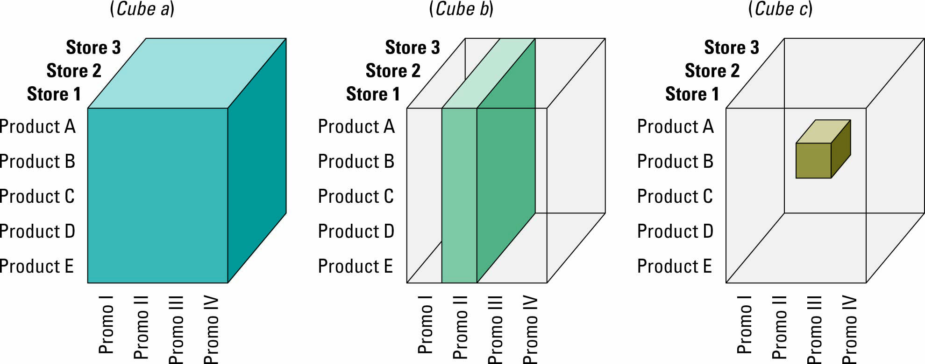
Business Intelligence – Data Mining

Business intelligence: refers to applications and technologies that are used to gather, provide access to, and analyze information to support people’s decision-making efforts. The challenge is to make a decision in an environment that is data rich and information poor.
- Designed to find what queries and reports do not reveal
- Uses algorithms to analyze data in a DW to find patterns and infer rules that can be used to guide decision making

Cluster analysis: technique used to divide info into mutually exclusive groups such that the members of each group are as close as possible to one another.

Association detection: technique used to determine the likelihood of events occurring together at a particular time or following each other.

Statistical analysis: technique to perform such functions as information correlations, distributions, calculations, and variance analysis.

Data In, Data out
- Getting data in is the most challenging aspect of BI, requiring about 80% of the time and effort and generating more than 50% of the unexpected project cost”
- The challenge is due to
  - Poor data quality
  - Politics around data ownership
  - Legacy technology

BI’s operational value:
- Data latency: the duration of time needed to make transactional data ready for analysis.
- Analysis latency: the time from which the analytical info is made available to the time when analysis is complete.
- Decision latency: the time it takes a human to comprehend the analytic result and determine an appropriate action.

Association detection: reveals the degree to which variables are related and the nature and frequency of these relationships.

Market basket analysis: analyzes such items as Web sites and checkout scanner info to detect customer’s buying behavior and predict future behavior by identifying affinities among customers’ choices of products and services.

