BIO1140 StudyFest!! April 12th, 2011
BEFORE
Conduct a major review early enough to allow for a visit to the instructor during his office hours if necessary
Break up the study tasks into manageable chunks,
especially during major reviews prior to exams. Studying three hours in the morning and three in the evening will be more effective than studying at a six hour stretch. Studying while you are mentally fatigued is usually a waste of time
Study the most difficult material when you are alert
DURING
Answer questions in a strategic order: 1. Answer easy questions first
to build confidence, score points, and mentally orient yourself to vocabulary, concepts, and your studies. It may also help you make associations with more difficult questions.
2. Then difficult questions or those with the most point value With objective tests, first eliminate those answers you know to be wrong, or are likely to be wrong, don't seem to fit, or where two options are so similar as to be both incorrect. With essay questions, broadly outline your answer and sequence the order of your points.
AFTER
Review:
Resist the urge to leave as soon as you have completed all the items Review your test to make sure that you
◦ have answered all questions ◦ did not mis-mark answers ◦ did not make simple mistakes

1. Name the five functions of the cell membrane.
1. Define boundaries; selectively permeable barrier
2. Localisation and organisation
-Scaffold for biochemical
activities (enzymes)
-e.g. mitochondria
3. Regulation of solute transport
-In and out of cell and/or organelles
-Uphill or downhill
-e.g. Na+,K+-ATPase
4. Responses to external signals
-Receptors and signal transduction
-e.g. ß-adrenoreceptor
5. Cell-to-cell communication
-Recognition, adhesion, exchange of
materials
-Gap junctions, plasmodesmata
2. Describe what is meant by the “Fluid Mosaic Model”, and why this is applicable to the cell membrane.
Lipid-protein assembly in which components are held together in a
thin sheet by non-covalent bonds
-Two fluid lipid layers
-structural backbone, permeability barrier
-Mosaic of proteins – unique complement responsible for specific functions
- ~10 nm thick
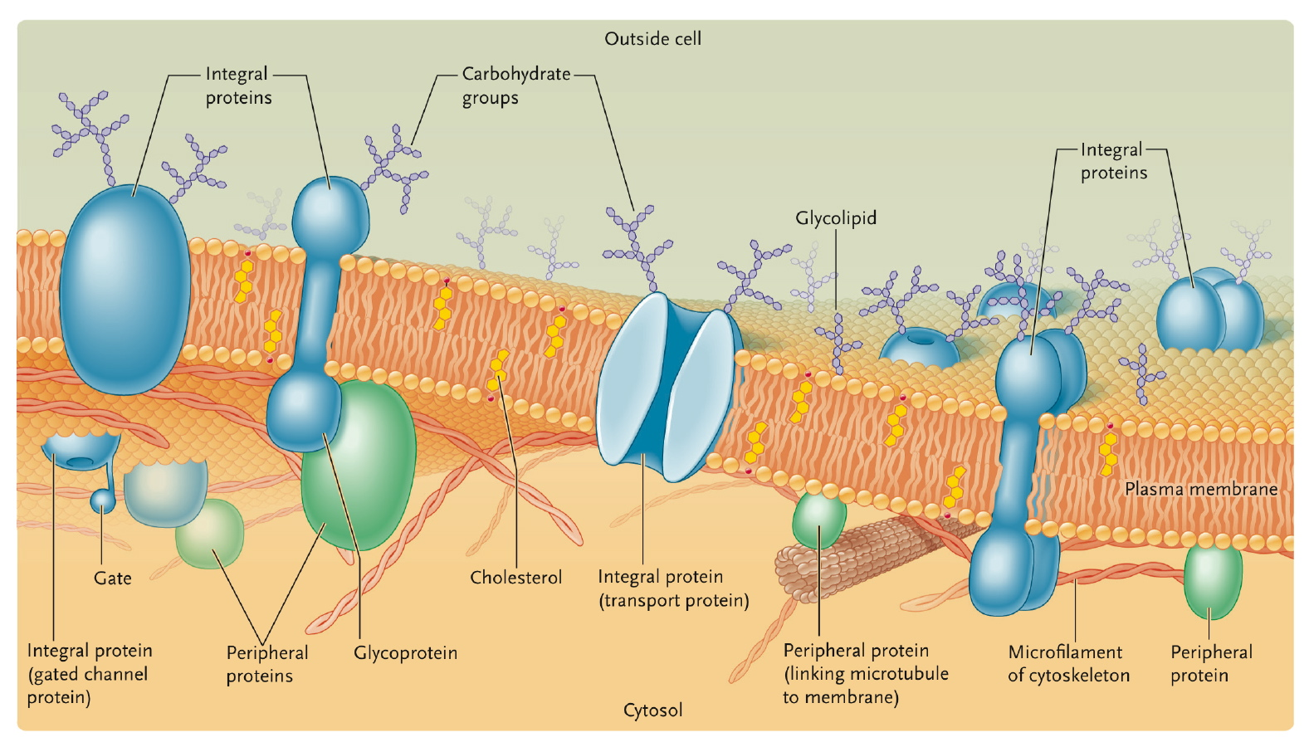
membrane structure according to the fluid mosaic model, in which integral membrane proteins are suspended individually in a fluid lipid bilayer. Peripheral proteins are attached to integral proteins or membrane lipids mostly on the cytoplasmic side of the membrane (shown only on the inner surface in the figure). In the plasma membrane, carbohydrate groups of membrane glycoproteins and glycolipids face the cell exterior.
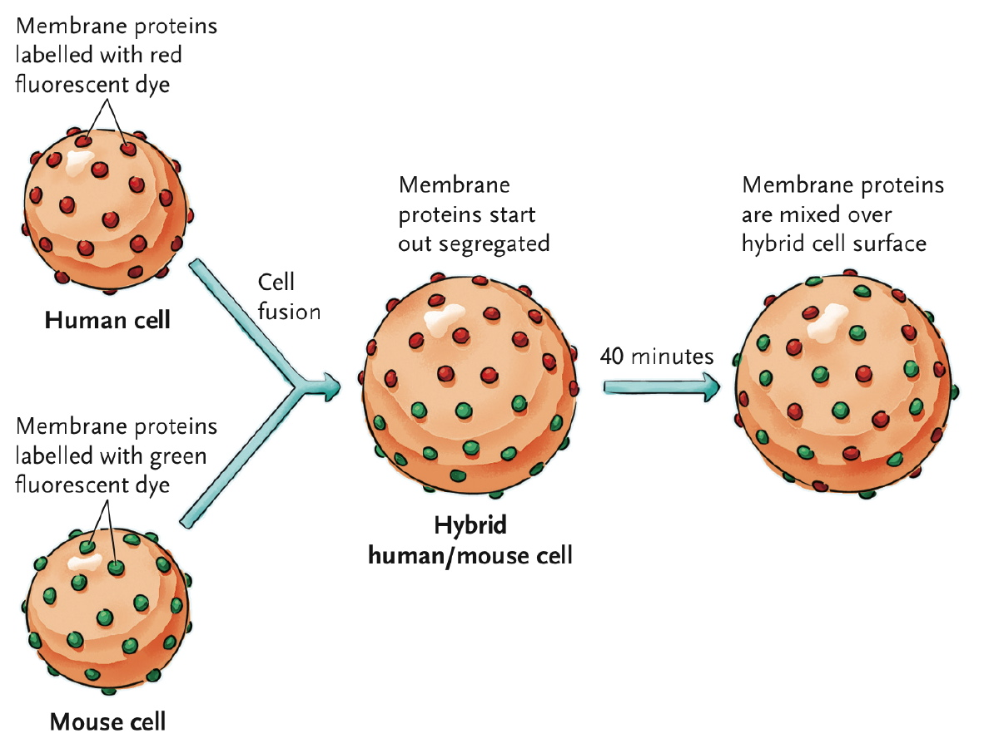
The Frye-Edidin experiment provided evidence that the membrane bilayer is fluid. In the experiment, membrane proteins were found to rapidly migrate over the surface of the hybrid cell.
3. What are some of the key components of the “unit membrane” (Gorter and Grendel, 1925)?
-Lipid bilayer
-Key component of permeability barrier
Composition
-Phosphoglycerides
-serine, choline, ethanolamine, inositol
-16-18 C
-saturated & unsaturated
-Glycolipids
-single sugars or oligosaccharides
-marker (e.g. ABO blood groups)
-Sterols
-Cholesterol, phytosterols
-Absent from prokaryotes

4. What features of the cell membrane allow for increased fluidity (even when temperatures are decreased)?
-Homeoviscous adaptation
-Alterations in lipid composition to maintain membrane fluidity at different environmental temperatures
5. What are the three types of membrane proteins and how are they attached to the cell membrane?
-Integral
-embedded in the phospholipid bilayer,
-Peripheral
-positioned on the surface of a membrane and do not interact with the hydrophobic core of the membrane
-lipid-anchored
-Membrane-associated through covalent linkages to phospholipids
-Fatty-acid anchored
-Intracellular orientation
-GPI anchor (glycosylphosphatidylinositol)
-extracellular orientation
-can be cleaved with phospholipase C
-e.g. type IV carbonic anhydrase

6. What kinds of molecules can get across the cell membrane easily? What kinds cannot? What are the different types of transportation that allow movement across the cell membrane?
EASY
-hydrophobic molecules
-small, uncharged polar molecules

DIFFICULT
-large, uncharged polar molecules
-ions

-different transports are passive transports (simple diffusion and facilitated diffusion) and active transports (primary and secondary)

7. Describe how passive transport works. For simple diffusion, what gradients regulate the transport of:
i. gases ii. ions iii.water
-Spontaneous; based on random movements
-Driven by diffusion gradient (downhill)
-For solutes without a charge concentration
gradient
-For gases partial pressure gradient
-For ions electrochemical gradient
-For water osmotic gradient

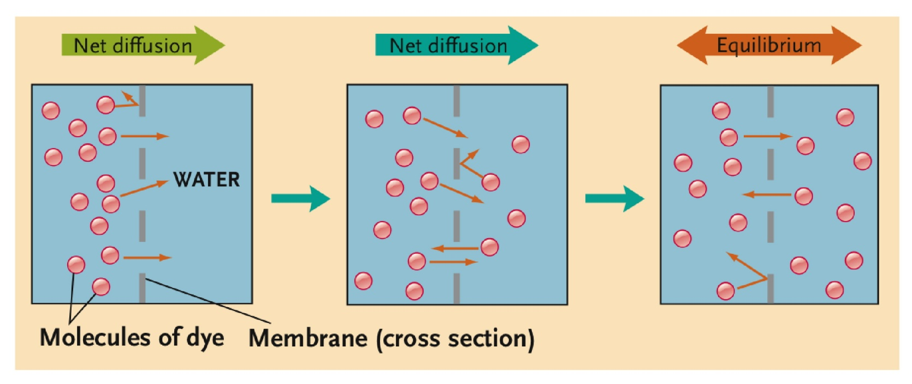
8. What is the difference between: an antiporter, a symporter, and a uniporter?
Symporter: the transported solute moves in the same direction as the gradient of the driving ion
Antiporter: transported solute moves in the direction opposite to the gradient of the driving ion
Uniporter: Uniporter channels open in response to a stimulus and allow the free flow of specific molecules. may not utilize energy other than the solute gradient. Thus they may only transport molecules with the solute gradient, and not against it

9. What is the difference between primary and secondary active transport? What is the difference between p-type and v-type primary transport?
Primary active transport moves positively charged ions, and secondary active transport moves both ions and organic molecules.

P-type: -Move cations (Na⁺, K⁺,
-Ca²⁺, H⁺)
-Reversibly phosphorylated
-e.g. Na⁺,K⁺-ATPase
V-type: -move H⁺ into organelles

The Cytoskeleton
1. What are some of the important functions of the cytoskeleton? What are the 3 main types of filaments found in a cell? What are their primary purposes?
-The provision of structure and support (1)
-Intracellular transport (2)
-The positioning of organelles within the cell (4)
-The generation of force for cell movement
-Contributing to cell division
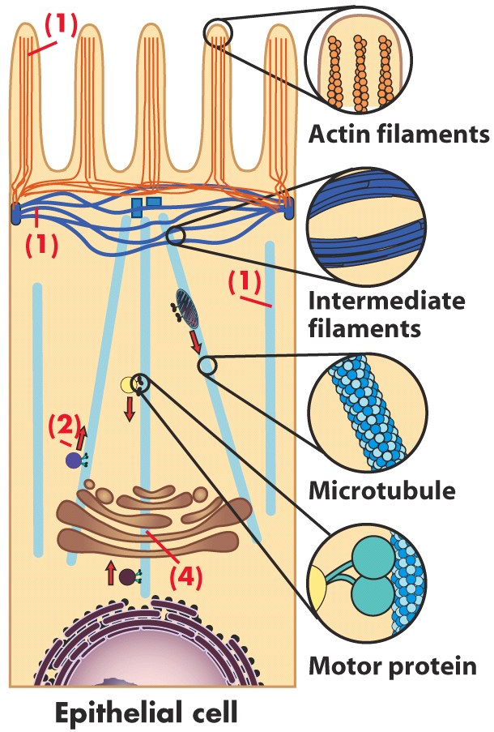
three main filaments:
-microtubule
-intermediate filament
-microfilament
purposes:
-Mechanical strength in animal cells
-e.g. Keratin IFs
Link to desmosomes and hemidesmosomes
Epidermolysis bullosa simplex
-Only nuclear lamins in other eukaryotes

2. Describe the structure of an intermediate filament. What is the difference between: i. Dimer ii. Tetramer iii.Protofilament
iv.Filament
fibres that occur singly, in parallel bundles, and in interlinked networks, either alone or in combination with microtubules, microfilaments, or both.
-Strong, rope-like fibres of 10-12 nm diameter
-Family of fibrous proteins
-e.g. keratin, neurofilament proteins, nuclear lamins
-Tissue specific
-(alpha)-helix domain flanked by variable globular domains
dimer: 2 interfilaments intertwined (coiled)
tetramer: 2 aligned dimers
filament: 8 protofilaments

3. Actin filaments are polymers of the actin protein. What are the two tertiary structures of actin that are found? What is meant by filament is “polar”? What does “treadmilling” mean?
G-actin and F-actin, “treadmilling” occurs when one end of a filament grows in length while the other end shrinks resulting in a section of filament seemingly "moving" across a stratum or the cytosol. This is due to the constant removal of the protein subunits from these filaments at one end of the filament while protein subunits are constantly added at the other end

4. What is the name of the proteins that control the assembly/dissembly of actin filaments? Give some examples, and their specific roles.
Myosins
(ex: -cytokinesis[cell division in animal cells: at the midpoint of the mitotic spindle, a contractile array of microfilaments forms in the middle and basically pinches off the cytoplasm between the two daughter nuclei.],
-cell migration, cell invasion, wound healing (whole cell moving)
-phagocytosis (part of the cell is moving)
These are called cell crawling, rely on polymerization

5. What is myosin? What is different between Myosin I and II? What type of movement is each involved with?
-Heavy chain = globular head + tail
-Move towards + end
myosin I:
myosin II:
6. How are intermediate filaments different from actin filaments?
Actin filaments are much simpler structure than intermediate filaments
-made of 1 protein (actin)
-smallest elements of cytoskeleton (7nm)
-to build:
-actin (U shaped globular protein)
-bonding site for ATP in center of “U”
-G-actin = one single monomer of actin
-F-actin = filamental actin (group of G-actin)
-microfilament=2 chains twisted together
-very easy to break down and put back together (joint with non covalent interactions)

7. What are microtubules? How are they unique/different from the 2 previous structures we have talked about?
-a cytoskeletal component formed by the polymerization of tubulin into rigid, hollow rods about 25 nm in diameter.
-Function more in cell with long hollow straw like structure than a flexible structure, contrary to microfilaments or intermediate filaments

8. What does the structure of a microtubule look like? Can microtubules also undergo treadmilling?
A hollow tubular structure
-yes it can considering the GTP that is being attached to the + end is being hydrolyzed fast enough, if not it will result in instability that causes polymerization and shrinkage.

Extracellular Interactions
1. What is the purpose of the plant cell wall and what are the three classes of molecules that are found within it?
-Provides rigidity and protection, regulates permeability
-Structure involves 3 classes of molecules
-Structural fibres – cellulose microfibrils
-Matrix – polysaccharides (e.g. hemicellulose, pectins)
-Adhesive molecules – pectins

2. What is the difference between primary and secondary plant cell walls?
-primary cell wall
-contains various proteins
-some are structural that contribute to wall’s strength, others are enzymes that catalyze formation and modification of the cell
-is more of a semi-permeable “mesh” than a cement wall
-allows some molecules (ex: water) to pass through into cell)
-space between primary cell wall of adjacent cells is filled with a polysaccharide layer called “the middle lamella”
-secondary cell wall
-often contain lignin (complex water-insoluble polymer which makes cell walls s trong, rigid, and impermeable to water)
-lignin: also very resistant to decomposition, so its presence in cell walls makes the cell more resistant to attack by microbes.

3. There are three main types of methods for cell-to-cell communication in animal cells. What are they called?
-Adhesive (anchoring) junctions: adherens junction, desmosome
-Tight junctions
-Gap junctions

4. Describe the structure of an adhesive junction, and draw a picture.
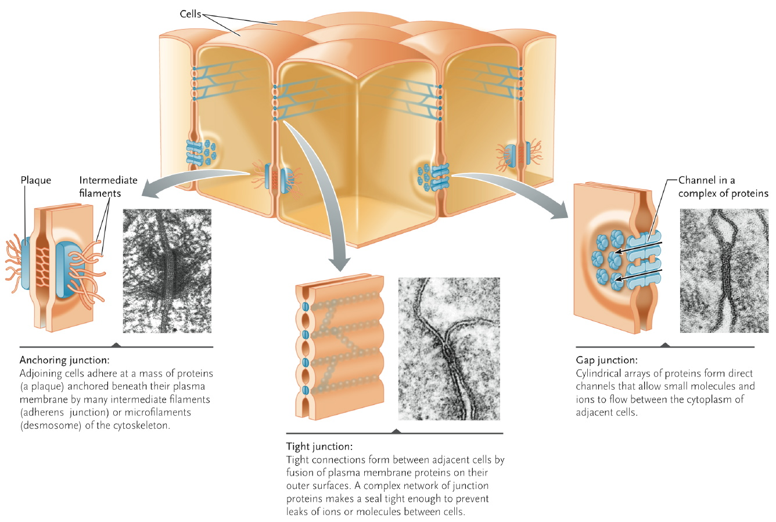
-form buttonlike spots or belts that weld cells together. They are most abundant in tissues subject to stretching, such as skin and heart muscle
5. Describe the functions of a tight junction, and draw a picture.
-seal the spaces between cells, keeping molecules and even ions from leaking between cells. Ex: tight junctions in the tissue lining the urinary bladder prevent waste molecules and ions from leaking out of the bladder into other body tissues.
6. What tissues are gap junctions predominantly found in, and why? What are
connexins/connexons?
Found in muscle and nerve tissue because they are open channels between cells in the same tissue, allowing ions and small molecules to flow freely from one to another (ex : in muscles to let muscles act as a unit)
-connexins : gap junction protein composed of two hemichannels or connexons, 6 connexins together make one connexon.
-connexons : piece of gap junction protein (two together = connexin)
7. What are integrins?
-Heterodimer (a and ß chains)
-Integrate ECM with cytoskeleton
-Extracellular binding site for adhesive glycoproteins
-Intracellular binding sites for linking proteins
-Focal adhesions and hemidesmosomes
-Integrins are receptors that mediate attachment between a cell and the tissues surrounding it

Cell-to-Cell Signaling
1. Describe the various elements of the cell-signaling system.
-in communication that involves intercellular chemical messenger, a controlling cell releases a signal molecule that causes a response of target cells. To respond, the target cell must have a receptor for the specific signal molecule. The target cell processes the signal in three steps: reception, transduction, and response. The series of events from reception to response is called signal transduction

-Signalling molecule (first messenger)
-Reception
-Receptor – membrane, cytosolic or nuclear
-Transduction
-Signalling cascades and second messengers
-Response
-Changes in gene expression
-Changes in activities of enzymes, transcription factors or other regulatory proteins, transporters, cytoskeleton etc
-Termination

2. Describe the structure of membrane receptor signaling systems (i.e. the different
domains, the different types of membrane receptors, etc.)
ligand binding domain is the end that the signalling system binds to
-stress hormone can only respond with stress hormone receptor.. Can’t respond to anything else
-tasting food, odors, cells binding to external chemicals

-Signals are water-soluble chemicals
-Signalling molecule does not enter cell
-Signal removal
-e.g. environmental chemicals,
neurotransmitters, hormones
-Membrane receptors are integral membrane glycoproteins
-Ligand-gated channels
-Receptor tyrosine kinases
-G protein-coupled receptors

3. What happens in signaling cascades?
-p.166
-added phosphate groups either stimulate or inhibit the activity of the target proteins
-change in the target proteins activity leads directly or indirectly to the cellular response
-first kinase catalyzes phosphorylation of the second, which then becomes active and phosphorylates the third kinase, and so on.
-proteins that trigger it could be part of the reaction, enzymes or other cellular reactions, end targets of the signal transduction pathways (such as transport proteins), or, at the most fundamental level, proteins that regulate gene transcription
-effect of protein kinases in signal transduction pathways are balanced or reversed by another group of enzymes called protein phosphatases, which remove phosphate groups from target proteins.
-unlike protein kinases, which are active only when a surface receptor binds a signal molecule, most of the protein phosphatases are continuously active in cells.
-by continually removing phosphate groups from target proteins, the protein phosphatases quickly shut off a signal transduction pathway if its signal molecule is no longer bound at the cell surface

4. Describe what happens with receptor tyrosine kinases, and draw a picture.
the cellular responses triggered by receptor tyrosine kinases are among the most important processes of animal cells. Ex: binding the peptide hormone insuline (regulator of carb metabolism, triggers diverse cellular responses, including effects on glucose uptake, rate of many metabolic reactions, and cell growth and division). Other receptor tyrosine kinases bind growth factors, including epidermal growth factor, platelet-derived growth factor, and nerve growth factor, which are all important peptide hormones that regulate cell growth and division in higher animals.
5. Describe what happens in G-protein coupled receptors, and draw a picture.
Respond to a signal by activating an inner membrane protein called a G protein, which is closely associated with the cytoplasmic end of the receptor. Several hundred types are involved in recognizing and binding odour molecules as part of the sense of smell.
6. Fill in the blanks: i. G proteins are heterotrimers; when GTP is bound, they are on , when it is not bound, it is off.
ii. Gα binds GTP and GDP.
iii. G_{(beta)} and G_{(Y)} form a unit.

DNA, RNA, Structure and Function
1. Fill in the blanks:
i. A base is a purine or a pyrimidine.
ii. A base + a pentose sugar = nucleoside.
iii. A nucleoside + a phosphate = Deoxynucleotide.
2. What is the role of histones in DNA organization? How does DNA organization differ between bacteria, viruses and eukaryotes?
-Histones pack eukaryotic DNA at successive levels of organization (i.e. heirarchical organization)
- Viruses:
Use basic proteins that may be part of the virus particle (capsid).
Bacteria:
Use basic proteins such as “HU”, “IHF”, “H-NS” to form a series of loops called a nucleoid.
Eukaryotes:
Use basic proteins called histones AND a hierarchical organization

3. Describe the bacterial chromosome, as well as the eukaryotic chromosome and how they differ.
Bacterial chromosome:
-Closed, circular molecule of DNA packed into nucleoid
-Replication begins from a single origin, proceeds in both directions
-Plasmids (in many bacteria) replicate independently of the host chromosome

eukaryotic chromosome:
-Consist of DNA complexed with histone and nonhistone proteins, called chromatin.
-DNA wraps around a nucleosome (two molecules each of histones H2A, H2B, H3, H4)
-Linker DNA connects adjacent nucleosomes
-Binding of histone H1 causes nucleosomes to package into a coiled structure (solenoid)
-Nonhistone proteins help control the expression of individual genes

4. What are the two types of chromatin? How are they different? During nuclear division, what do they fold and pack to form?
-Euchromatin (loosely packed region, genes active in RNA transcription)
-Heterochromatin (densely packed masses, genes are inactive)
-Folds and packs to form thick, rodlike chromosomes

5. What are nucleosomes? Draw a picture of the complex
eukaryotic DNA wraps around histones to form nucleosomes.
6. Describe the ʻHistone Codeʼ and itsʼ consequences.
the change from one state to the other affects many genes in the region affected. This is a large scale effect. In some cases an entire chromosome can be silenced – called “genomic imprinting”. See text p334.

Localized methlyation can also occur and effect (inactivate) only one (or a few) genes. In this case the chromatin structure is not changed!

7. What is the purpose of chromatin remodelling?
Chromatin remodeling exposes the promoter which makes the promoter accessible to proteins for transcription initiation.

Replication
1. Fill in the blanks:
i. The DNA structure is antiparallel. DNA strands go from 5’ to 3’.
ii.Synthesis follows the base-pairing rules: A and T, C and G.
iii. One DNA strand is synthesized continuously, the other, discontinuously.
iv. DNA polymerases are the primary enzymes of DNA replication.
v. DNA replication begins at replication origins.
vi. RNA provide a starting point for DNA polymerase to begin synthesizing a new DNA chain.
2. What are the basic enzymes involved in DNA replication and what does each one do?
-Helicase unwinds the DNA
-Primase synthesizes RNA primer (starting point for nucleotide assembly by DNA polymerases)
-DNA polymerases assemble nucleotides into a chain, remove primers, and fill resulting gaps
-DNA ligase closes remaining single-chain nicks

3. Describe how both the lagging and leading strands are replicated. Which one is continuous? Which one is discontinuous?
-As DNA helix unwinds, one template strand runs in a direction allowing new DNA strand to be made continuously in the direction of unwinding (leading strand)
-Other template strand is copied in short lengths that run in the direction opposite to unwinding
-Discontinuous replication produces short lengths, then linked into a continuous strand

4. What are telomeres and what problem do they solve?
-telomeres are the ends of eukaryotic chromosomes
-Short sequences repeated hundreds to thousands of times
(Humans have (TTAGGG) )
-Repeats protect against chromosome shortening during replication
-Chromosome shortening is prevented in some cell types which have a telomerase enzyme (adds telomere repeats to chromosome ends)
-2 & 3
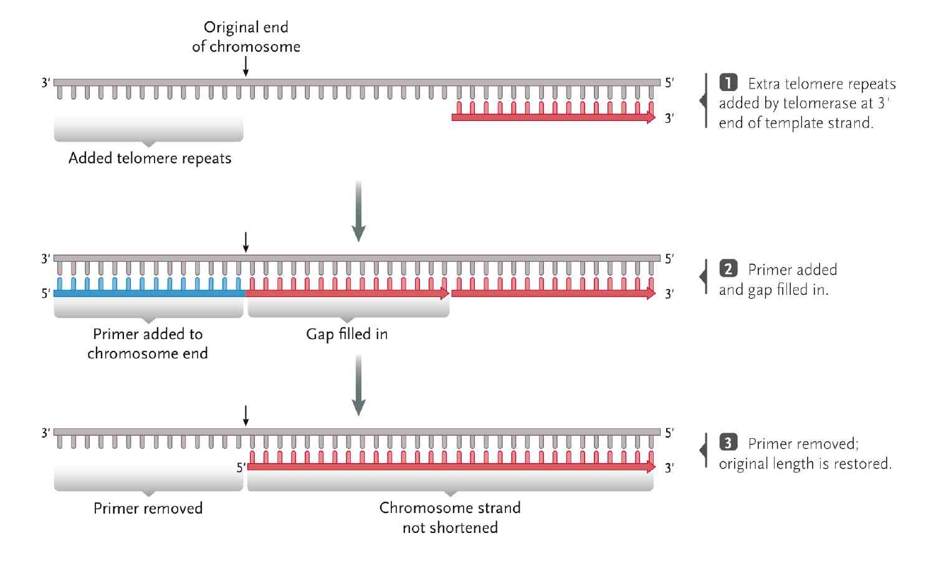

5. What are some of the mechanisms that correct errors in replication/DNA damage?
-Errors inevitably occur, during replication or caused by DNA damage
-Proofreading depends on the ability of DNA polymerases to reverse and remove mismatched bases
-DNA repair corrects errors that escape proofreading or caused by
DNA damaging agents

Transcription
6. What is the difference between transcription and translation?

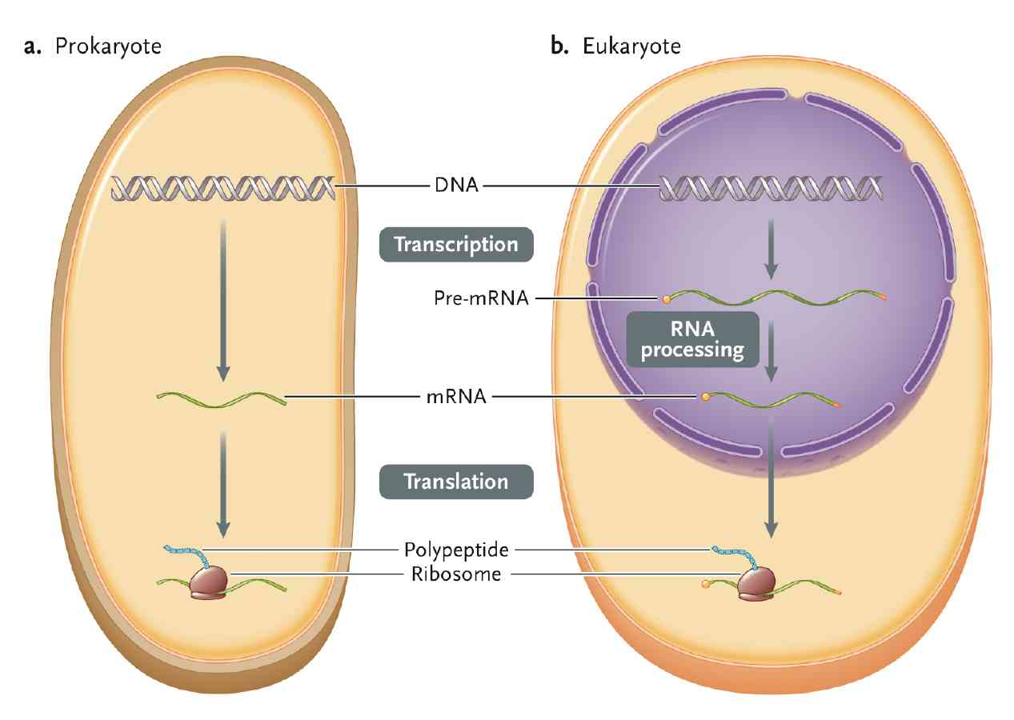
-Transcription
-Sequence in DNA is copied
into a complementary RNA
-Template strand of DNA is
used to create
messenger RNA (mRNA)
or rRNA or tRNA etc.
-Translation
-Sequence mRNA specifies
amino acid sequence
in polypeptide according
to a code.
-Ribosome assembles the
amino acid sequence

7. Why is it so important to have a variety of RNA Polymerases? List their names and where they are found.

Different RNA polymerases function in different locations. Within the nucleus different RNApol transcribe different sets of genes. In order to recognize the correct gene to transcribe, RNApols must recognize different signals in the DNA.
-RNA polymerase I transcribes rRNA in the nucleolus (part of the nucleus)
-RNA polymerase II transcribes mRNA and most snRNAs
-RNA polymerase III transcribes tRNA, 5S rRNA, some snRNAs and scRNAs

8. Define the following: i. Promoter ii. Transcription Unit iii. Terminator.
Promoter: control sequence initiates transcription
Transcription unit: portion of gene that is copied into RNA
Terminator: signals the end of transcription of a gene

9. Provide an overview of the transcription process and the role of RNA polymerase in it.
-catalyses the polymerization of ribonucleoside 5’-triphosphates(rNTP or NTP)
-does not require a primer, transcription is initiated de novo.
-initiates synthesis at ‘promoter’ sequences on DNA, upstream (5’) to the transcription start site. Other sequences such as enhancers can affect transcription.
-adds NTPs at 3’ end of new polynucleotide until it encounters a termination signal at defined sequence and/or structure on the DNA template.
-the “pre-RNA” is “processed” into the mature RNA. In eukaryotes mRNA is
transported to the cytoplasm.

-Rna polymerase moves along the gene from the 5’ end to the 3’ end, separating the two DNA strands to allow RNA synthesis in the 5’ 3’ direction using the 3’ 5’ DNA strand as a template.

10. Describe the steps involved in pre-mRNA processing.
1. RNA cleavage:
In many species rRNA genes are transcribed as one long precursor
containing several genes and intergenic regions. This precursor is
is cleaved into the mature rRNAs while the intergenic regions are discarded.
-45S rRNA precursor (cleavage into ) 28S rRNA + 18S rRNA +5.8S rRNA
-5' end of some tRNAs is removed by RNase P

2. RNA addition:
-After synthesis, the non-templated addition of extra ribonucleotides
(CCA) to some tRNAs.

3. RNA Splicing:
-Many mRNAs in eucaryotes (and a few in procaryotes) have an
intron/exon structure. Removal of introns is necessary prior to translation.
(Actually some non-coding RNAs have introns too!)
-Introns: Non-protein-coding sequences in the pre-mRNA
Exons: Amino acid coding sequences in pre-mRNA
-A complex, the “Spliceosome”, carries out the splicing reactions.
-If a gene has several introns, in some cases “alternative splicing” will
results in different versions of mRNA can be produced.
-In these mRNAs exons are joined in different combinations that can
be translated into different proteins with different functions.
-More information can be stored in the DNA!
-But are these different genes or just different proteins?

4. mRNA Capping:
-A cap attached to the 5´ end of the
mRNA results in more efficient translation. (don’t memorize the structure, just call it a 7MeG cap).

5. Polyadenylation:
-3’ to the signal AAUAAA, polyA polymerase adds ~50-250 adenine nucleotides to form the “Poly(A) tail”
-Proteins bind to the “tail” and protect mRNA from RNA-digesting enzymes

6. Nucleoside modification (Unit 1, slide 18)

7. RNA Editing:
-Specific bases in the RNA are changed. Some examples are
-a C in the RNA becomes a uracil (U) (cytidine deaminase) this can change a codon if in the open reading frame (ORF)
-an A in the RNA becomes an inosine (I): (adenosine deaminase) the ribosome translates I as a G thus changing a codon in the ORF

Translation
11. Fill in the blanks: i. tRNAs are small RNAs of a highly distinctive structure that bring amino acids to the ribosome “adaptor hypothesis”.
ii. ribosomes are rRNA-protein complexes that work as automated protein
assembly machines
iii.Translation initiation brings the ribosomal subunits, mRNA , and the first
aminoacyl-tRNA together.
iv.Newly synthesized polypeptides are processed and folded into
finished form
v. Finished proteins contain sorting signals that direct them to cellular locations
12. What is the three letter code called in DNA? What about in RNA? If it is 5ʼGAC3ʼ in DNA, what will the RNA version look like? What about 5ʼGTC3ʼ?
-DNA: triplet
-RNA: codon
5’GAC3’=5’GAC3’
5’GTC3’=5’GUC3’

13. What are the 3 types of codons? What are their functions?
Start codon: first amino acid recognized during translation, specifies amino acid “methionine”, establishes the reading frame
Sense codon: 61 codons specify amino acids, most AAs specified by several codons (degeneracy or redundancy), ex: CCU, CCC, CCA, CCG all specify proline
Stop codon: end of polypeptide-encoding mRNA sequence, UAA, UAG, UGA (sometimes referred to as “ochre”, “amber” and “opal”, the names relate to their discovery in mutations
14. Describe the stages in translation.
-Initiation
-Ribosome assembled with mRNA molecule and initiator methionine-tRNA
-Initiator tRNA (Met-tRNA) binds to small subunit
-Complex binds to 5´ cap of mRNA, scans along mRNA to find AUG start codon
-Large ribosomal subunit binds to complete initiation
-Elongation
-Amino acids linked to tRNAs added one at a time to growing polypeptide chain
-Aminoacyl-tRNA matching the next codon enters A site
-Peptidyl transferase catalyzes formation of first peptide bond and cleaves tRNA in P site
-Ribosome moves along mRNA to next codon
-Empty tRNA moves from P site to E site, then released
-Newly formed peptidyl-tRNA moves from A site to P site
-A site empty again
-Termination
-New polypeptide released from ribosome
-Ribosomal subunits separate from mRNA
-Begins when A site reaches stop codon
-Release factor (RF) or termination factor binds to A site
-Polypeptide chain released from P site
-Remaining parts of complex separated

Information Flow
1. What is gene regulation? Why is it so important to understanding life?
Gene regulation refers to the regulation of activity and may occur at any level.
qChanges in environment or changes in nutrients
qChanges in make up of cell is response to signals
qIn a multicellular organism, cellular differentiation
qConserve energy
2. Describe gene regulation in prokaryotes; be sure to mention activator and repressor proteins, as well as operons.
Prokaryotic gene expression reflects life history. In many cases rapid, reversible responses to the environment are observed
qRepressor proteins binding to other regulatory DNA sequences may prevent the gene from being expressed.
qActivator proteins binding to other regulatory DNA sequences may turn on expression of the gene.
qAt a smaller scale many genes are organized into operons (one or more operons
may be found within a transcription unit )

3. Name the 4 different levels that the regulation of gene expression occurs at in eukaryotes. What does each level do?
Transcriptional: determines which genes are translated
Posttranscriptional: determines types and availability of mRNAs to ribosomes
Translational: determines rate at which proteins are made
Posttranslational: determines availability of finished proteins

4. What is the transcription complex composed of and what do they do to initiate transcription?
ØBind to TATA box area and recruit RNA polymerase II
ØTranscriptional initiation
complex, low rate (“basal”)
ØActivators bind to promoter proximal elements and
increase transcription rate

5. Fill in the blanks: i. Posttranscriptional regulation controls protein availability
ii. Translational regulation controls the rate of protein production iii. Posttranslational regulation controls the availability of mRNAS to ribosomes

Protein Targetting
1. Using the accompanying diagram, describe the four steps involved with protein targetting.
1. Translation

2. Interaction with receptor & unfolding
-signals on protein (a “signal peptide”)
-proteins aid unfolding (chaperones)

3. Translocation

4. Refolding/processing
-proteases may remove signals

2. Describe how proteins are transported across the ER. What is the nature of the signal peptide? What is the fate of the signal peptide?
The endoplasmic reticulum (ER)
§The mitochondrian
§Outside the cell (in plants the apoplast)
§The chloroplast
§The nucleus
§Golgi and Vesicles

Transport across the membrane into the ER (the lumen) is the first
step for targeting to many locations-ER, Golgi, several vesicles and
outside of the cell. A signal peptide is required, as is a receptor.

In the absence of further information the protein is exported.
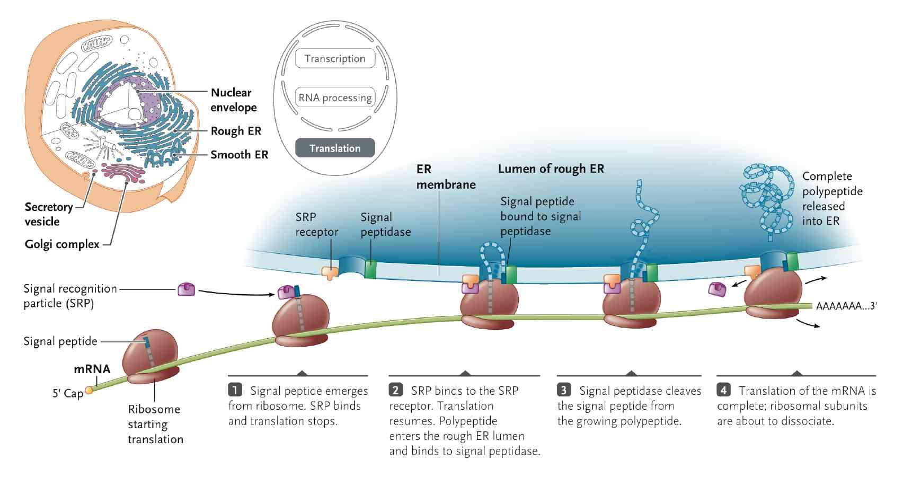
This is referred to as the “default pathway”
Nature of signal peptide
The signal peptide for ER transport is a length of 20-50 aa’s
with a hydrophobic core. These are recognized by the signal
recognition particle and the complex binds to the SRP receptor

fate of signal peptide
When translation resumes the signal peptide is cleaved by the
signal peptidase. We refer to the original protein as the preprotein.
An example: prelysozyme becomes lysozyme when the SP is removed

3. Describe the journey of a protein, starting from the inside of the nucleus, and ending outside the cell.
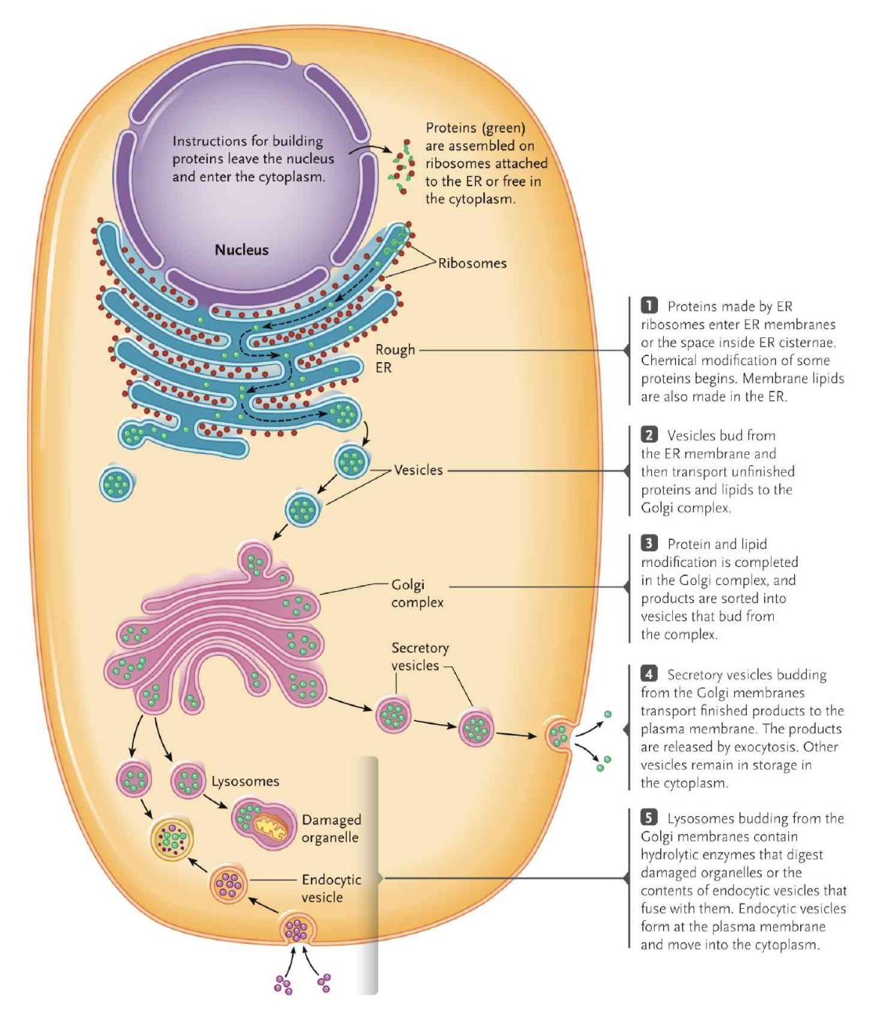

4. In what kinds of systems are there multiple signals? Also, give an example and describe one.
in multiple membrane systems. Ex: mitochondria
-enter matrix (M) via receptor and remove targeting signal with signal peptidase (ex: DHFR)
-enter inter membrane space (IMS) via receptor and remove spacer sequence (ex: cytochrome)

