Written Report
Gatorade: Carbon Fuel

Marketing 201
Section: 02

Prepared by: Student ID #
Anthony Tavormina 6334113
Nicolo Puma 6456057
Lawrence Massa 6221394

Due Date: Date Submitted:
April 5th, 2012 April 5th, 2012

Table of Contents
1.0 Identification of New Product 3
1.1 Idea Sources 3
1.2 Gatorade: Carbon Fuel 3
1.3 Keys to Our Success 4
2.0 Macro-Environmental Impact 5
2.1 Demographic Forces 5
2.3 Economic Forces 5
2.4 Environmental Forces 5
2.5 Political\Legal Forces 5
2.6 Technological Forces 6
2.7 Cultural Forces 6
3. 0 Segmenting & Targeting 7
3.1 Consumer 1 7
3.2 Consumer 2 7
3.3 Primary Target 7
Table 3.1 7
4.0 Secondary Data & Sales Potential 8
4.1 Sources 8
4.2 Potential Sales 9
5.0 Marketing Mix 9
5.1 Product 9
5.2 Price 10
Table 5.1 10
Table 5.2 10
Figure 5.1 11
5.3 Place 11
5.4 Promotion 12
Advertisement 5.1 12
Advertisement 5.2 13
Bibliography 15

1.0 Identification of New Product

1.1 Idea Sources
During our research, we discovered that an intensive nine-week study had been conducted that demonstrates the health benefits of naturally carbonated water. A study group was asked to consume a liter, of naturally carbonated mineral water, every day for nine-weeks. The end results were staggering. At the end of the nine-week study, blood pressures were at a healthier level, cholesterol was lowered and cardiovascular systems were improved (Vanaman, 4). In addition, it has also been found to reduce the chance of heart disease and help against osteoporosis (Vanaman, 4).

1.2 Gatorade: Carbon Fuel
Carbon Fuel will be sold all over North America, therefore Carbon Fuel and Gatorade came to a licensing agreement. This decision is extremely beneficial for the Carbon Fuel brand, which will be partnered up with one of the most powerful forces in the sports beverage industry. Gatorade Carbon Fuel will be a new product line from Gatorade that is expected to hit the market in the summer of 2012. Carbon Fuel is the latest advancements in the world of sport drinks. It guarantees athletes to optimize their performance and perform beyond their natural abilities.
Carbon Fuel is a specially designed capsule that can be added to any water bottle. Once the capsule is submerged in water, it instantly releases its advanced formula and transforms the water into a carbonated sport drink. Most sport drinks that are available on the market use sugars as their main source of energy. This is where Carbon Fuel surpasses its competition. Through extensive scientific research, the Carbon Fuel team has put together a formula composed of elements that are not found in most sport drinks. Each capsule is filled with a balance of vitamins, electrolytes, minerals, and branched-chain amino acids (BCAA), which are all essential for an athlete while performing in a highly physical activity. Each component that is incorporated in the capsule plays it own unique role and together, creates a diabolical remedy.
The vitamins are the main source of energy. Carbon Fuel is packed with both water-soluble and fat-soluble vitamins. The ratio of water-soluble to fat-soluble vitamins is 3:1. The reason for this is because water-soluble vitamins leave a person’s body much quicker that fat-soluble. This ensures that the athlete will always have a high level of vitamins. Many athletes do not realize that they are dehydrated during intense physical activities, however recent NHL studies show otherwise. The test revealed that most NHL players are dehydrated by the start of the third period even though they do not realize it. The electrolytes help ensure that the athlete will not suffer from dehydration which allows the athlete to perform for longer periods of time. The minerals help regulate the blood, ensuring that it has enough oxygen molecules which results in proper organ function.
Although vitamins, minerals, and electrolytes can be in many sport drinks, Carbon Fuel has two unique elements; BCAA and CO2. Carbon Fuel is the only sport beverage on the market that contains the combination of both BCAA and CO2. Branched-chain amino acids were discovered to be extremely valuable when performing physical activities. Research shows that BCAA results in increased strength, muscular endurance and resistance to fatigue, however it has been found to be even more effective with the combination of CO2. There is a misconception about carbonated drinks and health. Many people believe that all carbonated drinks are bad for a person’s health. Although this may be true with most carbonated drinks on the market (such as soft drinks), drinks carbonated with Carbon Dioxide (CO2) have been proven to have many health benefits. The CO2 that is released into the drink acts as bicarbonate that means that it helps balance out the acid levels in a person’s body. This translates to improved organ function which results in reduced muscle exhaustion and improved cardiovascular activity.

1.3 Keys to Our Success
We strongly believe that Carbon Fuel will effectively penetrate the market and quickly gain market share for three fundamental reasons. The first reason is that Gatorade has already established itself in the market as a powerful presence in the eyes of consumers. They are constantly evolving and looking for new and innovative techniques to bring the utmost quality and customer satisfaction. Even with several competitors in the market, Gatorade owns approximately 75% of the market shares (Jones, 2).
Gatorade Carbon Fuel uses the latest technological and scientific advancements to create a product like no other. Unlike other sport drinks, Carbon Fuel is a capsule that transforms any water bottle into carbonated sport drink. This makes the product much more convenient and portable. It is also the only product on the market that combines both branched-chain amino acids and carbon dioxide.
Research has shown that natural vitamins are much more effective that laboratory created vitamins. The reason for this is because your body recognizes natural vitamins much easier than vitamins, which were created in a lab. This allows you to not only completely absorb the nutrients, but enables you to do this at a faster rate. It is for this reason that Carbon Fuel uses only organic sources of vitamins. This ensures that the consumers will achieve maximum results with each use of the product.

2.0 Macro-Environmental Impact

2.1 Demographic Forces
The demographic forces in the macro-environment can prove to be beneficial and affect out product sales in a positive way. 43.5% of Canadians aged 20 to 29 live with their parents (Kotler, 5). Although the typical Canadian between the age of 20 and 29 do not occur a substantial income, nearly 45% of them live with their parents, which means that their expenses are drastically reduced. This results in students being able to afford our products.

2.3 Economic Forces
Since the horrific 2008 economic recession, the North American economy has been on a steady incline. Inflation has risen, minimum wage has increased and the unemployment rate has dropped immensely. The current Canadian unemployment rate is roughly 7.6%, which is extremely close the countries natural unemployment rate (the lowest possible unemployment rate). Canada operating close to its natural unemployment rate means that the Canadian economy is running the way it should be. This also means that the country is operating within the range of its potential output which results is a stronger GDP. This give the consumers strong purchasing powers because wages are increased which results in an increased disposable income. Consumers are exiting the “safety” mode and have returned to their natural spending habits.

2.4 Environmental Forces
People are looking at the world differently than they were 50 years ago. Since pollution is becoming such a big problem, people are becoming much more socially responsible because they are aware of the potential harms that their actions hold. Our product’s packaging is made up entirely of natural eco-friendly recycled material. A recent study done by the Shelton-Group, found that 60% of Americans are looking for greener products (3). This will promote consumers to purchase our products rather than other products because there will be no concern of harming the environment.

2.5 Political\Legal Forces
In order for our product to hit the market, it must first be approved by several organizations. Our product must follow several regulations and policies that are controlled by the country(ies) we will be selling to. Essentially there are three types of rules and regulations. The first type is government regulations that are placed in order to protect the consumer. The main concerns of these laws are the health regulations. These regulations can affect the DNA and core concept of the product. The second types of laws are those that protect competition. These laws are places to help companies protect themselves against unfair competition. The third types of laws are those that are places to protect the interests of the society. If our product does not meet certain requirements and specification of the area we want to target, then we must pull out of the sector, which triggers a decrease in sales.

2.6 Technological Forces
With the help of technological advancements we are able to produce our products in ways that were impossible 50 years ago. We can produce large amounts of our product with extremely low costs. Not only can we produce our product economically efficiently but also we can produce the product in ways that are safe for the environment around us. Producing such a large scale at such a low cost increases profit margins. It also allows us to fulfill the growing demands of the consumers without risk of shortage.

2.7 Cultural Forces
More recently society in general has become more health conscious. We have come to realize how important our mental and physical health actually is. This is fortunate for us in terms of sales, because our product fits well with the health conscious lifestyle. We live in a fast paced world. People don’t have the time nor do they want to spend the money to buy different product to satisfy their wants. This benefits our sales because our product offers many different benefits and advantages for consumers in just one capsule.

3. 0 Segmenting & Targeting

3.1 Consumer 1
Gatorade Carbon Fuel will be targeting two types of consumers. The primary target market is men and women between ages of 15 and 27. This type of consumer is ambitious and dedicated in any sport or physical activity he/she competes in. They strive for perfection in their performance and expect the same in return from the products they use. They are hard working and at times need an extra boost to enhance their endurance and capabilities. They are extremely competitive and do not like to lose. Sports and other physical activities plays a huge role in their lives and takes up a lot of time in their daily schedule. These consumers are loyal and heavy users in view of the fact that physical activities are an important part of their lifestyle.

3.2 Consumer 2
The second target market focuses on men and woman who are less competitive and perform physical activities for health reasons rather than victory. They are extremely health conscious and are generally above the age of 27. Living an active life style and maintaining a physically fit figure is extremely important to them. Although they might not be as competitive and may not perform activities on a daily basis, their age is quickly becoming a factor. They are no longer able to perform the way they once did which is why they are seeking a healthy energy booster. They are very particular with the products they use and do a lot of research before purchasing a product. They are most likely to be a first time user because of the fact that they are extremely picky with what they consume.

3.3 Primary Target
After analyzing and weighing both types of target markets, it is in Carbon Fuel’s best interest to heavily pursue the competitive consumer over the health conscious consumer. The main reason for this decision is because it fits the brands current image perfectly. Gatorade Carbon Fuel is the solution that many athletes are seeking in order to achieve their maximum performance.

Table 3.1
Target Market factors | Segment 1 | Segment 2
Geographic | - North America  - Urban + Suburban | - North America  - Urban + Suburban
Demographic | - Age 15 to 27  - Male + Female | - Age 27+  - Male + Female
Psychographic | - Lifestyle: Achievers, Strivers  - Personality: ambitious, compulsive, energetic, determined, | - Lifestyles: Strugglers, Strivers  - Personality: particular, ambitious
Behavioural | - Occasion: regular  - Benefits: quality, convenience, speed, eco-friendly  - Users: regular users  - User rates: heavy user | - Occasion: regular  - Benefits: quality, convenience, eco-friendly  - Users: potential, first time  - User rates: medium user

4.0 Secondary Data & Sales Potential

4.1 Sources
In our research we came across two interesting and valuable pieces of information. According to the New York Times, 15% of Americans are currently registered to a fitness center or health club (Johnson, 1). This represents a significant portion of our intended market. We have also found that 77% of customers renew their memberships once it expires. In addition to these figures, one must also take into consideration the amount of people that train and perform physical activities in places other than health clubs and fitness centers. We believe that New York Times is a credible source because of its world-renowned reputation.
According to Beverage Daily, Gatorade owns 75% of the entire market share of sport drinks, despite dropping 15.5% in volumes to 895.8 million gallons (Jones, 2). We believe that Beverage Daily is a reliable source because of their professionalism and their research methods. They are award-winning journalists that have proven them selves as a credible source by using secondary scientific research.

4.2 Potential Sales
Gatorades dominant market share gives us a strong foundation to build on. They currently have a stranglehold on the market with a market share of 75%. This is extremely beneficial for our product; seeing as our product is new to the market it is quite convenient that we have a powerful force such as Gatorade backing us up. Having Gatorade license our product helps us get an overview of our potential market size, considering that both of our target markets are fairly similar. According to Beverage Daily, Gatorade plans on making $400 million pre-tax in annual sales. Gatorade plans on making that amount holding 75% of the market share. Our objective is to capture 6.25% of that current market share that Gatorade holds, within the next four years. This will result in a pre-tax sale of roughly $25 million.

5.0 Marketing Mix

5.1 Product
Gatorade Carbon Fuel is the latest in technological advancements for carbonated sport drinks. Unlike other sport drinks, Carbon Fuel is a capsule that can be placed into any source of water. There are three different packages in which the product will be sold. All three-product combinations are packed in the most eco-friendly materials in order to stay active in the “go green” campaign.
The first package is in single form. This is a single capsule that will be packaged individually. The package is made up of low-density polyethylene. This material is the most eco-friendly plastic-type packaging available on the market. This package will be sold as a convenience product. It is relatively cheap and will be purchased with very little buying effort.
The second package is the bundled form. This package includes four capsules that are all individually wrapped. It also includes a stainless steel, re-usable water bottle. The purpose of creating a stainless steel reusable water bottle is to reduce possibilities of future pollution. People do not have to constantly buy and throw away water bottles. This stainless steel water bottle can reused infinitively therefore results in virtually no pollution. This package is targeting first time users because it provides the consumer with a reusable bottle. The bottle also acts as a marketing tool that will be displayed whenever the consumer uses it.
The third package is the bulk form. This package includes twelve individually wrapped capsules that come in a cellulose propionate rectangular box. This product package is for athletes that perform physical activities on a daily basis. Purchasing the bulk form is more convenient for the consumer. This material is the easiest and cheapest material to recycle.
The color theme for all of the Carbon Fuel packages is charcoal with purple highlights. The charcoal color is meant to resemble carbon fiber. Carbon fiber is an extremely strong and lightweight material. This creates a perception in the mind of the consumers of being a top quality product that is dependable.

5.2 Price

Table 5.1
Package | Manufacturer’s Cost | Mark Up | Manufacturer’s  Selling Price
Single | $0.35 | $1.45 | $1.80
Bundle  (4 capsules w/ reusable bottle) | $2.47 | $6.39 | $8.86
Bulk  (12 capsules) | $4.51 | $12.71 | $17.22

Table 5.2
Package | Retailer’s Cost | Mark Up | Retailer’s  Selling Price
Single | $1.80 | $0.69 | $2.49
Bundle  (4 capsules w/ reusable bottle) | $8.86 | $6.13 | $14.99
Bulk  (12 capsules) | $17.22 | $7.35 | $24.57

Our objective is to keep the price of our product below the price ceiling so that Carbon Fuel can maintain a sustainable demand by consumers and retailers. However, prices must remain above the price floor in order that the product remains profitable at all times. In order to achieve these objectives, Carbon Fuel will be using a combination of multiple pricing strategies.
In order to continue Gatorade’s reputable image, Carbon Fuel will be using a value-based pricing strategy in order to achieve a positive perception from potential buyers. In addition, Carbon Fuel’s bundle and bulk packages will utilize the good-value pricing strategy. This assures that our consumers will get the utmost value for their dollar.
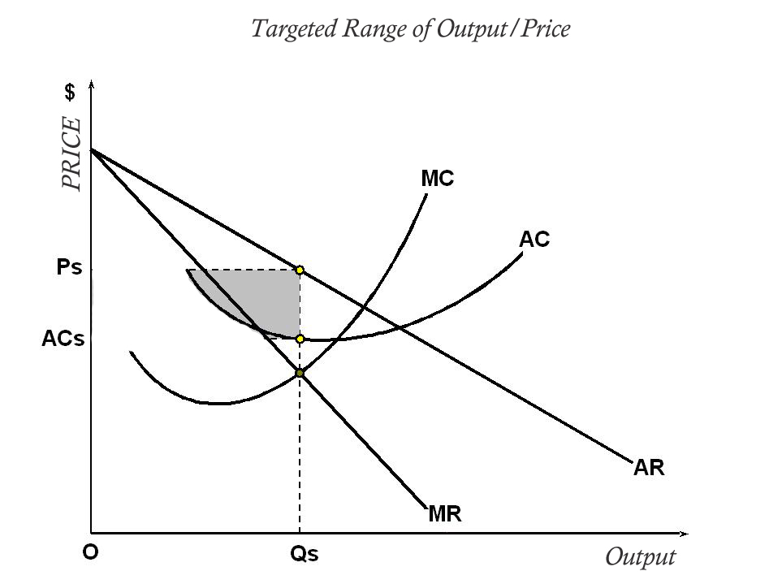
Carbon Fuel will not sell products directly to the consumers. Manufacturers will be selling to the retailers, and retailers will sell to the end consumer. Therefore Carbon Fuel must use the cost based pricing strategy in order to keep the factors of production and distribution in mind when setting the price.

Figure 5.1

5.3 Place
Gatorade Carbon Fuel will be sold in three different categories of retailers; convenience stores, grocery stores, and selected sports stores. To ensure that each category of retailers generates the highest possible sales, each category of retailers will carry the appointed package.
Convenience stores will sell the capsules in a single form. This is a form of plastic packing that contains a single pill. It will be placed on a Carbon Fuel rack that is found on top every cash counter. This will encourage impulse buying and help attract first time customers. In addition to this, convenience stores will also be selling the bundled form that includes a stainless steel water bottle. This will be convenient for customers who do not have a water bottle on them.
Grocery stores will sell all three packages. The individual packages will be sold at the cash counter to promote impulse buying. The bundled package and the bulk package will be sold on shelves in the beverage isles.
Gatorade Carbon Fuel will be sold at two selected sporting goods stores; Dick’s Sporting Goods and Sport Expert. These sporting goods stores are the two biggest sporting retailers in North America. These retailers will give us the greatest market coverage for two reasons. The first reason is that they do not specialize in one sport. They sell a wide variety of products for almost every sport. This creates exposure to every type of athlete. The second reason is that they have retail outlets all across North America. Sports Experts and Dick’s Sporting Goods combine for close to 500 retail outlets. This ensures substantial geographic market coverage.

5.4 Promotion

Advertisement 5.1
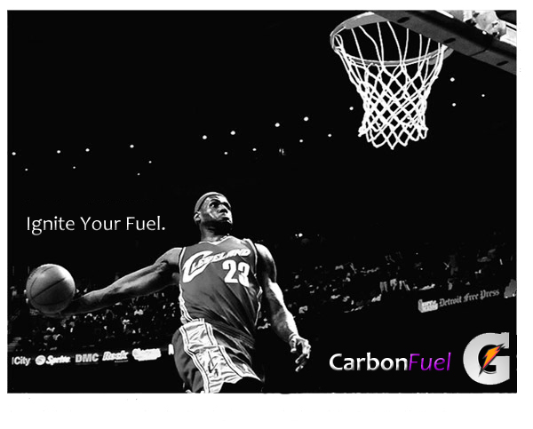
The Carbon Fuel marketing campaign will revolve around the slogan “Ignite Your Fuel”. In order for the campaign to successfully connect with our target market, we will be using celebrity endorsements from the world’s best athletes. The theme in which our campaign will be based upon is motivation. The campaigns are not only meant to attract consumers to our product, but to motivate them to persevere and push themselves through any sport or physical activity that they are passionate about. This will create a subconscious connection with our product and athletes that want to excel above the rest.
Carbon Fuel’s advertising campaign will consist of three primary mediums; television, outdoor, and Internet.
Television advertisements are more appealing to the target market because it stimulates the sense of sound and sight as well as motion. Television advertisements provide great selectivity and mass marketing coverage, however it is the most expensive form of advertising.

Advertisement 5.2
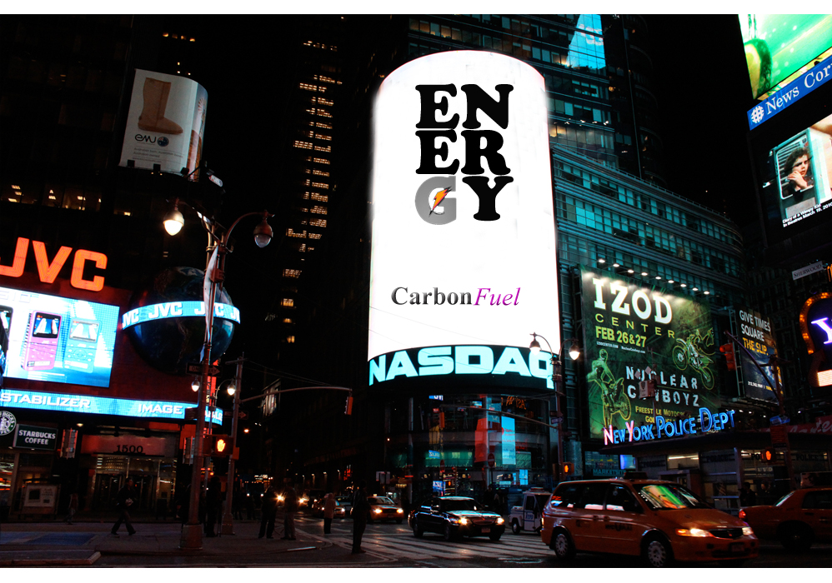
Outdoor advertisements in highly populated markets provide our product with high repeat exposure and visibility. These advertisements will be placed in New York, Montreal, San Francisco, Miami, Toronto, Vancouver, and Chicago.
Internet advertisements can be beneficial because it is a more modern approach; it allows consumers to interact with our marketing campaign. Our Youtube videos will create buzz marketing and it allows for videos to go viral which will increase awareness and reach. We will be placing banners on sports related websites like nhl.com, nba.com, nfl.com, and many more. We also will be creating our very own Carbon Fuel website which consumers can surf and interact with the various features available on the website.
Since Carbon Fuel is a new technology that many people will not be familiar with, we will be using direct marketing by participating in the National Athletics’ Trainer Association trade show. This is the worlds’ biggest public trade show for anything athletic. This will allow us to directly communicate with consumers as well as potential buyers. This trade show provides a perfect opportunity to create intrigue and awareness about the product. It also allows us to explain the product and answer any questions that consumers may have about it.

Bibliography

- Johnson, Lisa. "Only 15% of Americans Belong to Gyms: How You Should Work Out Â» Lisa Johnson Fitness." Only 15% of Americans Belong to Gyms: How You Should Work Out Â» Lisa Johnson Fitness. 15 Feb. 2011. Web. 30 Mar. 2012. <http://www.lisajohnsonfitness.com/only-15-percent-of-americans-belong-to-gyms-how-you-should-work-out/>.

- Jones, Guy M. "Breaking News on Beverage Technology & Markets." BeverageDaily.com. William Reed Business Media, 2 Sept. 2010. Web. 30 Mar. 2012. <http://www.beveragedaily.com/Markets/PepsiCo-plans-to-distribute-Gatorade-direct-to-retailers>.

- "National Survey: Green Is Officially Mainstream â But Consumers Are Confused, Skeptical About Products." National Survey: Green Is Officially Mainstream â But Consumers Are Confused, Skeptical About Products. Business Wire, 30 June 2009. Web. 30 Mar. 2012. <http://www.businesswire.com/news/home/20090630005830/en/National-Survey-Green-Officially-Mainstream-–-Consumers>.

- Vanaman, Bonnie. "Health Effects of Carbonated Water." LIVESTRONG.COM. 2011. Web. 30 Mar. 2012. <http://www.livestrong.com/article/156879-health-effects-of-carbonated-water/>.

- Kotler, Philip, and Philip Kotler. Principles of Marketing. 8th ed. Toronto: Pearson Prentice Hall, 2010. Print.

