MANAGING A GROWING ENTERPRISE - LECTURE 2&3

Marketing and Sales = marriage
- Must get along; Must co-exist
- Sales will always have a complaint
- Sales will always be demanding
- When the company is successful, sales met their numbers
- When the company is unsuccessful, the Marketing Director gets fired

Learning Objectives
- Demonstrate a thorough understanding of the major marketing concepts for small businesses
- Describe basic themes and problems Marketing Managers experience, but again to also identify how these problems (or challenges) can be turned in to service marketing opportunities.
- Present a framework and identify a set of tools for managing service organizations.
- Acquire introductory knowledge of the 8Ps / 9Ps of marketing for a small business.
FIVE Mandatory items to your business
The “given” when starting or running a business!
- PASSION for excellence
- Market Research
- A STRATEGIC marketing and sales plan
- Networking
- Website
The 8 Ps of Marketing
The “8Ps” of marketing are needed to create strategies for meeting customer needs profitably in a competitive marketplace
Traditional Marketing Mix:
- Price
- Product
- Promote
- Place
The “9 Ps” of Marketing
- The “9Ps” of marketing are needed to create strategies for meeting customer needs profitably in a competitive marketplace
- Traditional: Product, Place, Price & Promotion

Extended by service delivery:
- Physical environment
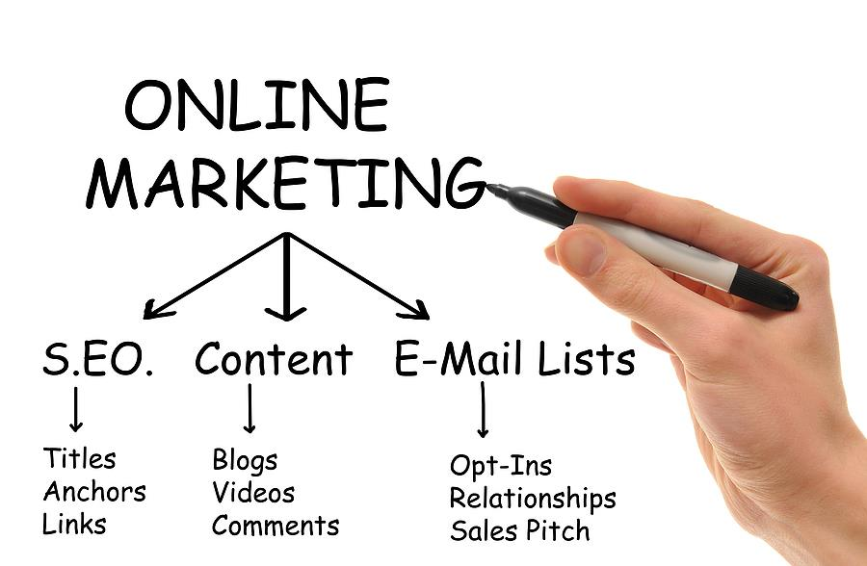
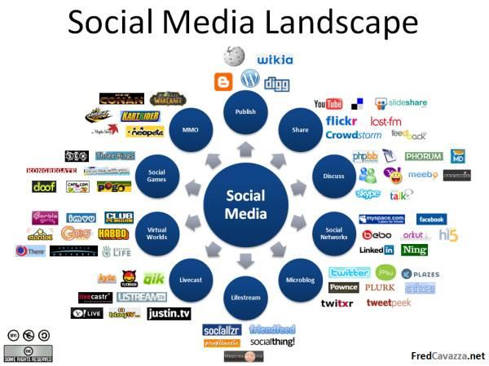
- Process
- People
- Productivity and quality
- pSocial Meda

Expanded Marketing Mix

The 9 Ps of Marketing
- Product Elements
- Place and Time
- Price and Other User Outlays
- Promotion and Education
- Process
- Physical Environment
- People
- Productivity and Quality
- Social Media / Online Marketing

#1 Product/Service
- Embrace all aspects of service performance that create value
- Core product responds to customer’s primary need
- Help customers use core product through array of supplementary service elements
- Creates a service concept that offers value to customers better than competitors
Planning & Creating a Service / Product
- Core Product
Central component that supplies the principal, problem-solving benefits customers seek
- Supplementary Services
Augment the core product, facilitating its use and enhancing its value and appeal

- Add VALUE
Delivery Processes
Used to deliver both the core product and each of the supplementary services

- Add DIFFERENTIATION

#2 Place & Time
- Delivery decisions: Where, When, How
- Geographic locations served
- Service schedules
- Physical channels
- Electronic channels
- Customer control and convenience
- Channel partners/intermediaries

#3 Price
Traditional pricing tasks:
  - Selling price
  - Discounts
  - Premiums
  - Credit terms
Identify and minimize other costs incurred by users:
  - Costs associated with service usage (e.g., travel to service location, parking, phone, babysitting, etc.)
  - Time expenditures, especially waiting
  - Unwanted mental and physical effort
  - Negative sensory experiences

Pricing Stands on 3 Legs
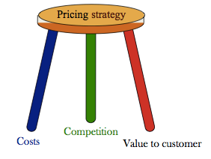

PRICE?
WHAT is YOUR Pricing Strategy?
- Discount vs. Premium?
- High vs Low Volume?
- Competition?
- Promotions vs. Regular Pricing?
ETHICS: Designing Fairness into Price & Revenue Management
- Design clear, logical, and fair price schedules
- Use high published prices and offer opportunities for discounts; rather than quoting lower prices and surprise price increases
- Communicate consumer benefits of revenue management
- Use bundling to include discounts
- Take care of loyal customers
- Use service recovery to compensate for overbooking
#4 Promotion & Advertising
I.E.I.R.
- Informing
- Educating
- Influencing
- Reminding customers (Mattress Mart)

Informing, educating, influencing, reminding customers
i) Marketing communication tools
- Media elements (print, broadcast, outdoor, retail, the Internet, etc.)
- Personal selling, customer service
- Sales promotion
- Publicity/PR
- ii) Imagery and recognition
- Branding
- Corporate design
iii) Content
- – Information, advice
- – Persuasive messages
- – Customer education/training
Brand Identity
What are the top 10 consumer goods “House of Brands”

#4 Promotion & Advertising MESSAGING
Metaphors to Communicate Value
- METAPHOR - A word or phrase that designates one thing is applied to another in an implicit comparison
  - – Should highlight how the service benefits are provided
  - – Prudential Insurance—uses Rock of Gibraltar as symbol of corporate strength
- Metaphors communicate value propositions more dramatically and emphasize key points of difference

Key Selling Messages
- LESS is MORE
- Get to the POINT
- What is your competitive advantage?
- How does your service (or product) bring value?
- How to distinguish your brand from the competition?
Setting Marketing Communications (Advertising) Objectives

Checklist for Advertising Planning: The “5 Ws” Model
- Who is our target audience?
- What do we need to communicate and achieve?
- Where should we communicate this?
- When do communications need to take place?
- How should we communicate this?

Marketing Communications Mix for Services (1)
ADVERTISING
- Print -
- Web -
- Broadcasts/Podcasts/Webcasts -
- Outdoor/Billboard
- Direct Mail
- TV
- Radio
PERSONAL SELLING
- Training
- Customer Service
- Telemarketing
- Word-of-mouth
- PR style of advertising
SALES PROMOTION
- Sampling
- Coupons
- Sign-up rebates
- Gifts
- Prizes
- Promotions

Efficient

Effective

Cost and Return on Investment

Marketing Communications Mix for Services (2)
INSTRUCTIONAL MANUALS
- Website
- Manuals
- Brochures
- Interactive Software
- Voicemail
CORPORATE DESIGN
- Signage
- Interior Décor
- Vehicles
- Equipment
- Stationary
- Uniforms
PUBLICITY & PR
- Press releases & kits
- Press conferences
- Special Events
- Product Launch Events
- Sponsorship
- Media initiated coverage
- Trade Shows & Conferences
Relevant & objective driven

Unique from competition

Measurable with Return on Investment

#5 Process
#6 Physical Environment
Comparison of Hotel Lobbies
Each services environment clearly communicates and reinforces its hotel’s respective positioning and sets service expectations as guests arrive...

#7 People
- Interactions between customers and employees influence perceptions of service quality
- Need the right customer-contact employees, performing tasks well
  - – Job design
  - – Recruiting
  - – Training
  - – Motivation
- Need the right customers for the firm’s mission
  - – Contribute positively to experience of other customers
  - – Possess—or can be trained to have— needed skills (co-production)
  - – Can shape customer roles and manage customer behaviour
Promote your staff?

#8 Productivity & Quality
Productivity and quality must work hand in hand
- Improving productivity key to reducing costs
- Ideally, strategies should be sought to improve both productivity and quality simultaneously—technology often the key
  - – Technology-based innovations have potential to create high payoffs
  - – But, must be user friendly and deliver valued customer benefits
Promote your staff?
#9 Social Media
Social Media ARE Media
- Creation and publishing
- Contribution
- Observation and consumption
Social Media ARE Social
- Conversational
- Collaborative
- Sharable
- Portable
- Networked
Strategic Process for Social Media Implementation
- Observe
- Measure
- Strategy
- Respond
- Respond Create
Components of a Social Media Strategy
Perfect world:
- Part of overall outreach strategy
Best case scenario:
- Reflects other components of an outreach strategy
Components of a Social Media Strategy
Social Media Strategy must:
- Establish the context and explore the current environment
- Identify stakeholders
- Set practical, real objectives
- Explain the approach
- Define the audience
- Define channels, establishes workflow
- Summarize messages, establishes tone
- Outline the budget
The 9 Ps of Marketing
- Product Elements
- Place and Time
- Price and Other User Outlays
- Promotion and Education
- Process
- Physical Environment
- People
- Productivity and Quality
- Online Marketing / Social Media

